# **Chapter 4: Testing**

Testing is a process in which a program is executed in order to find the errors and bugs. It is the process of validation and verification of software or an application. It is performed as to ensure that bug free program and helps in output of quality product. There are various types of testing that helps in finding bugs in program, for this project I have used Black-box testing and unit testing (White box testing). Black box testing doesn’t deal with coding structure and it only focuses on input and output. Test cases should be made for Black box testing. Unit testing or white box testing deals with coding and each functions are tested, to ensure its correctness.

**Black Box Testing**

For black box test:

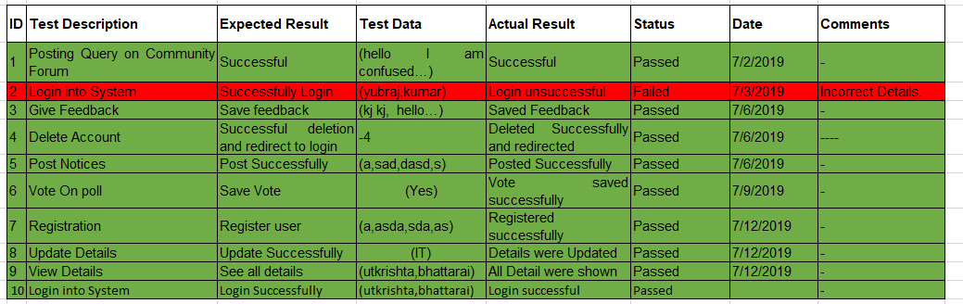

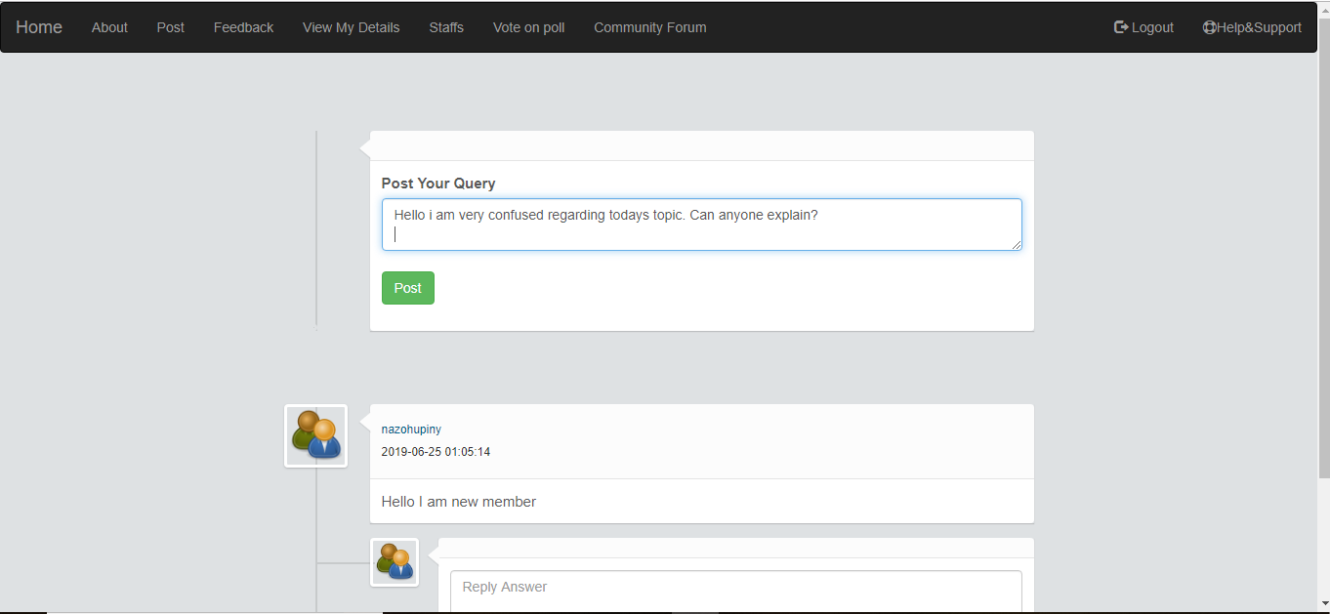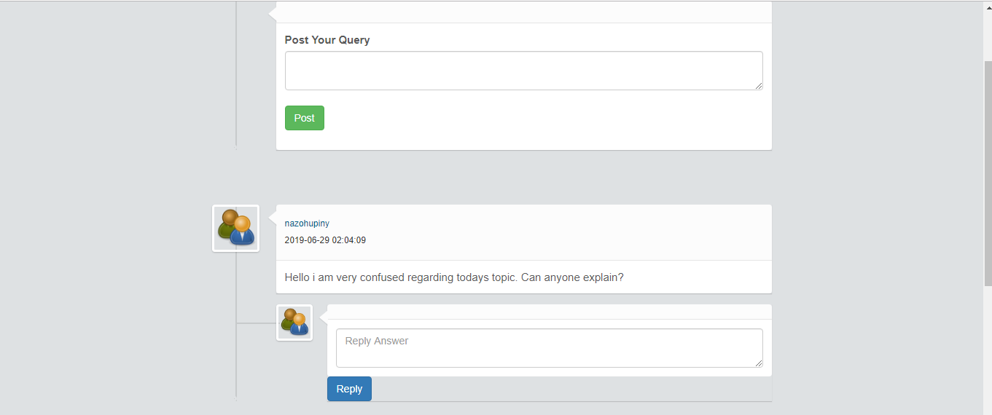

**Successfully posted in community forum.**

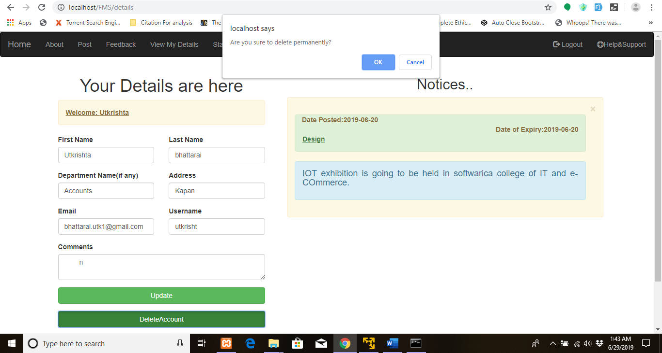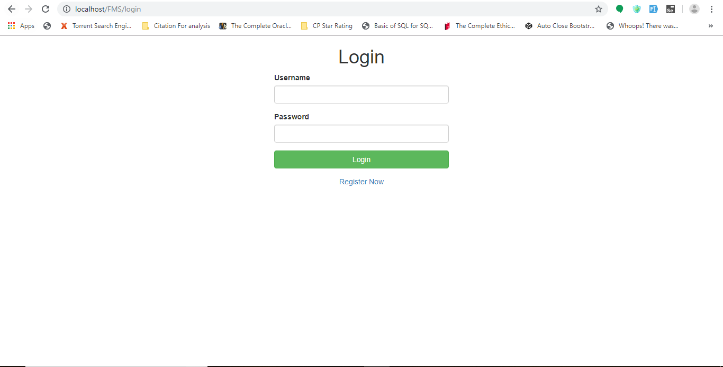

**Account was permanently deleted.**



**Login was unsuccessful.**

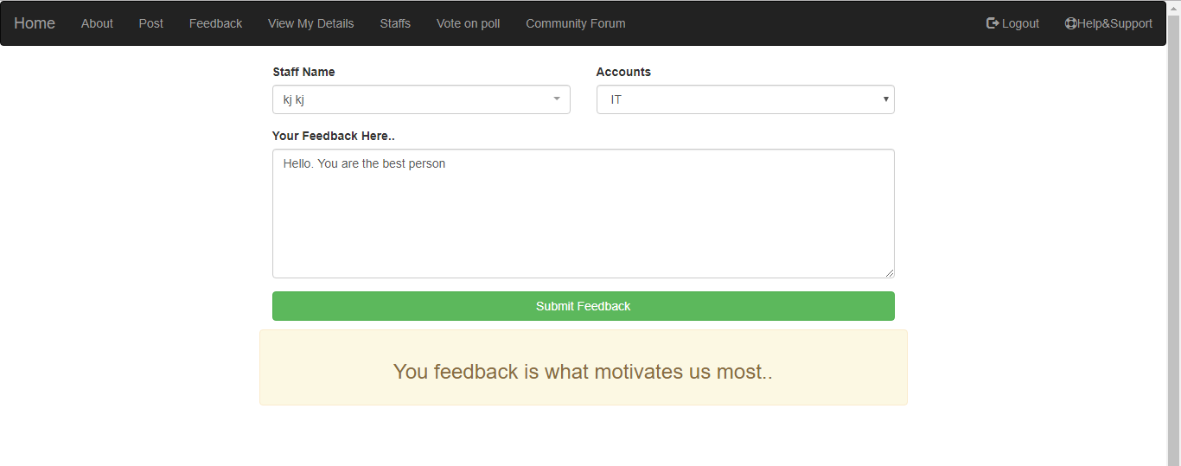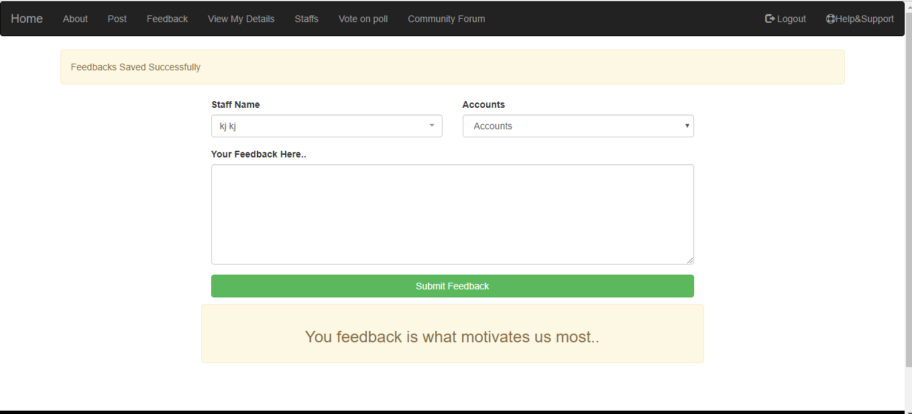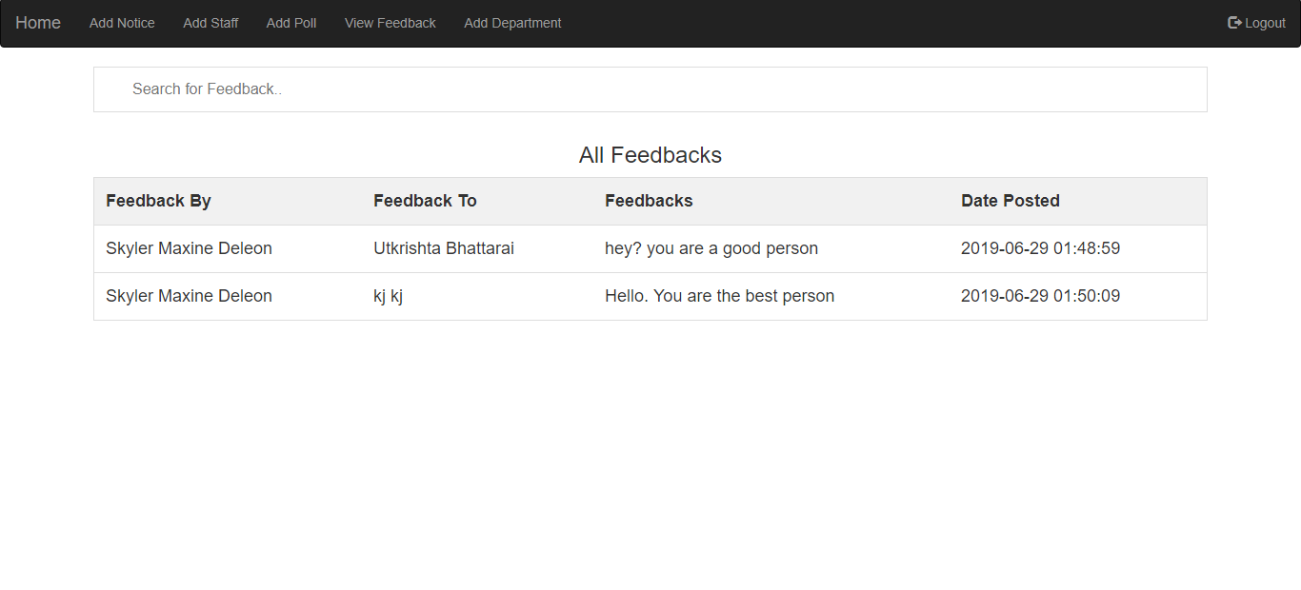

**Feedback was saved successfully.**

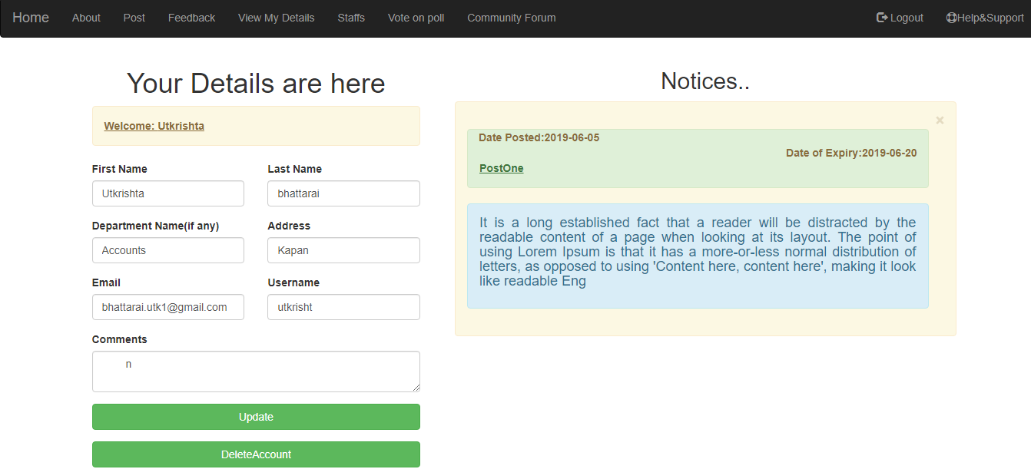

**Details Were Shown.**

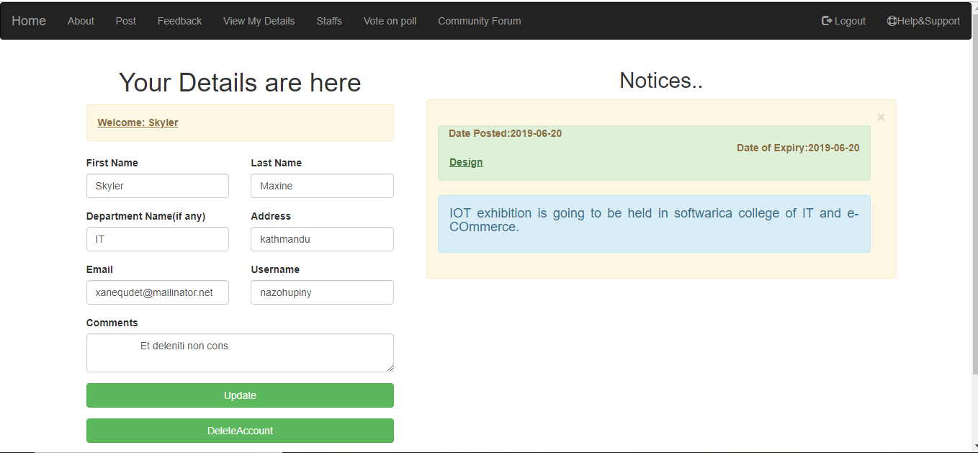

**Successfully Logged out.**

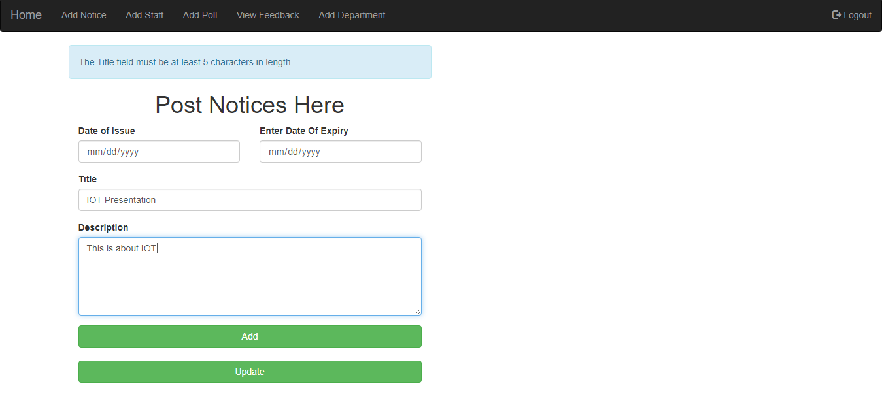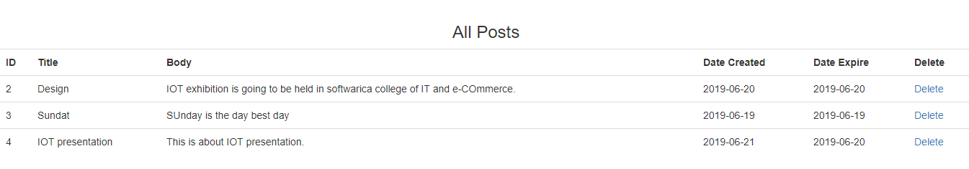

**Post was saved successfully.**

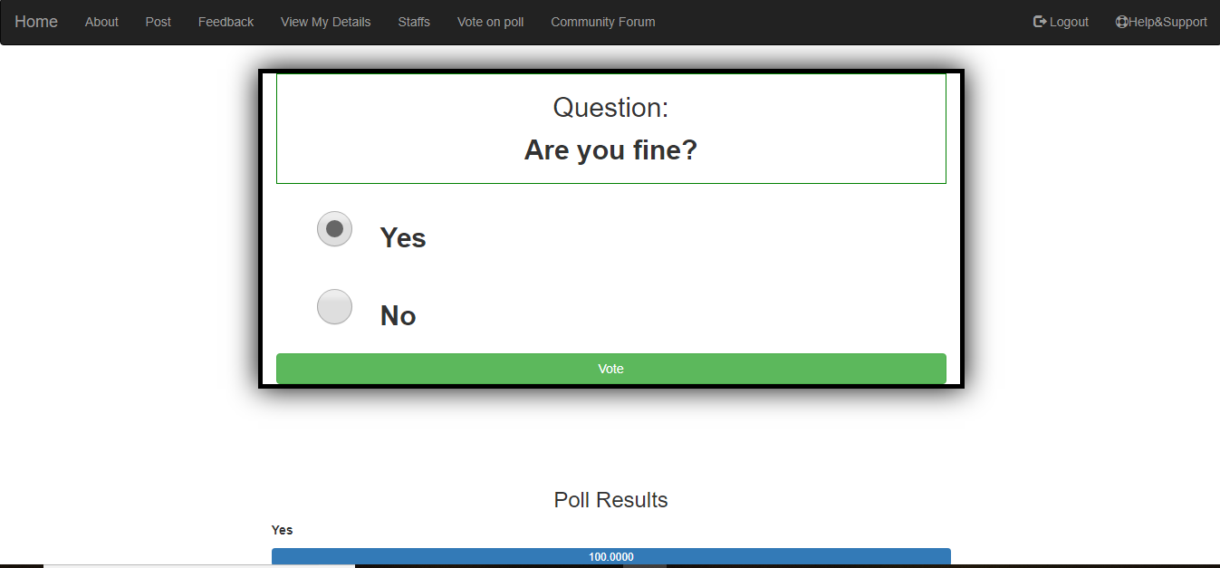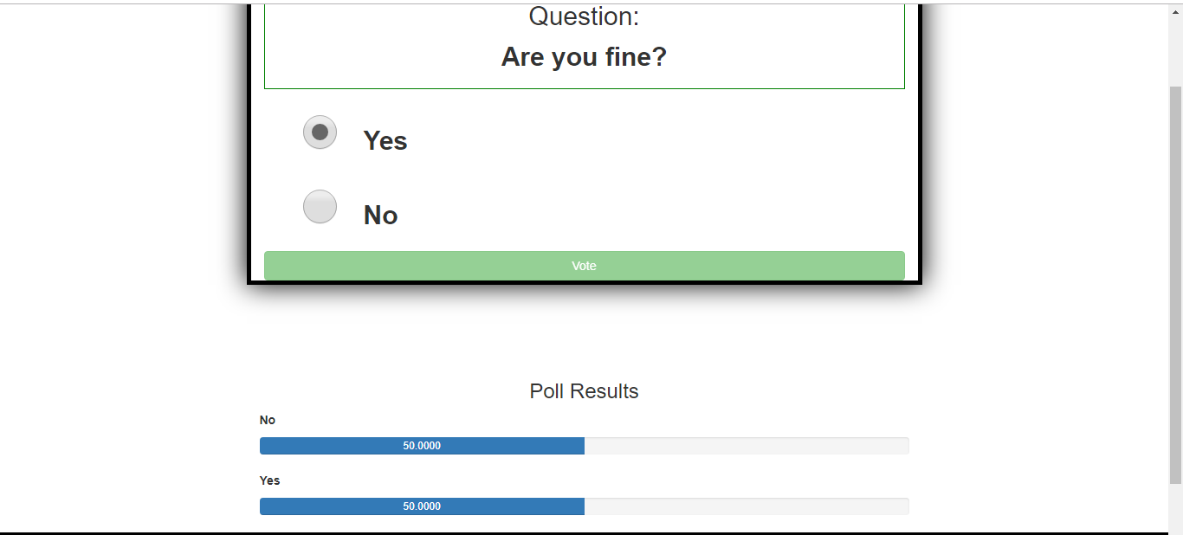

**Voted registered on poll**

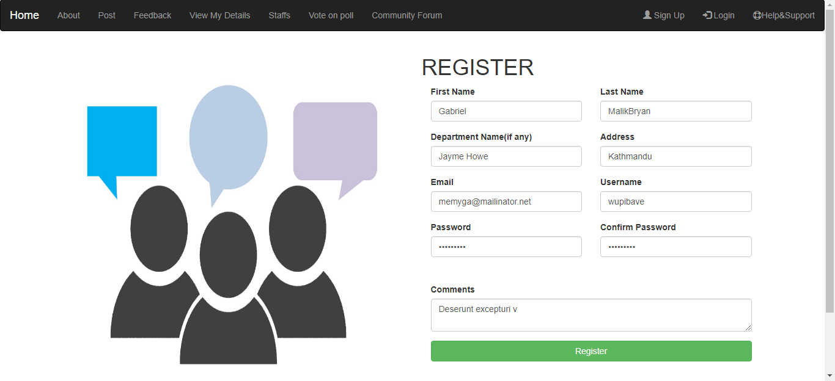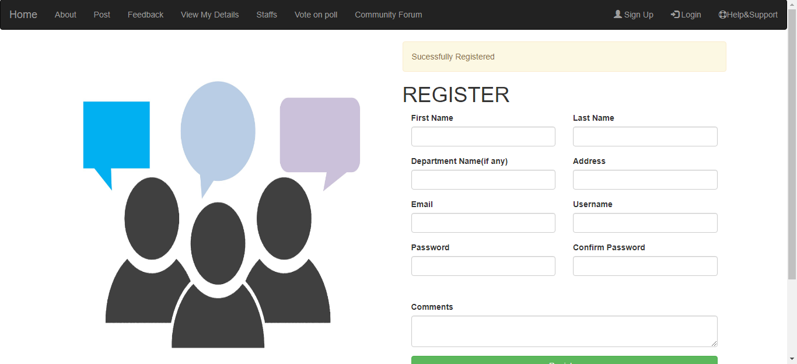

**User Registered Successfully.**

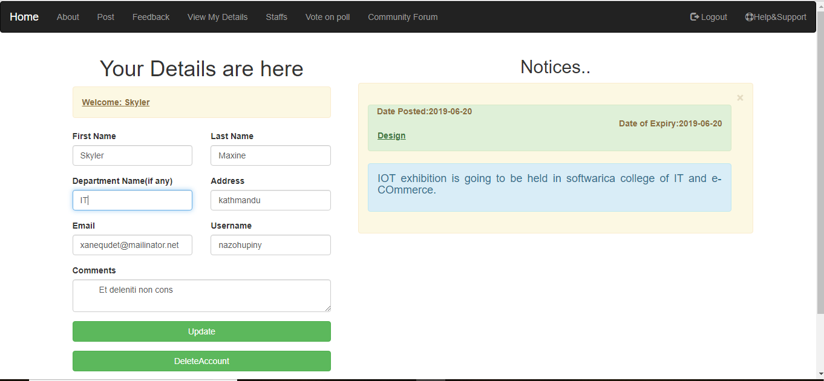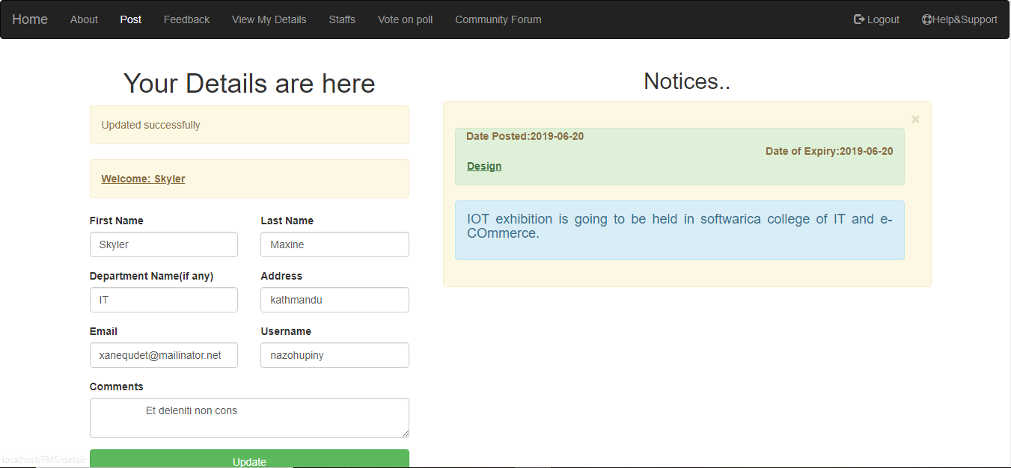

**Details updated successfully.**

**Unit testing**

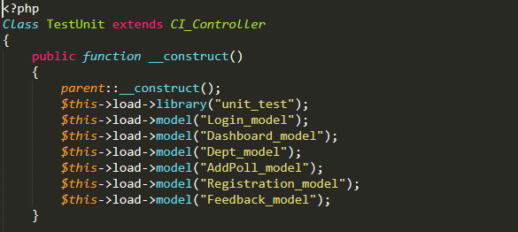

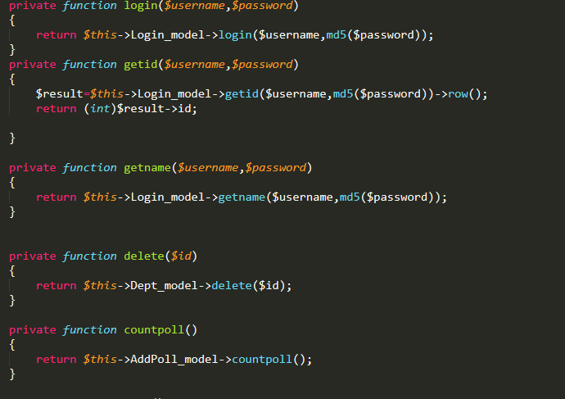

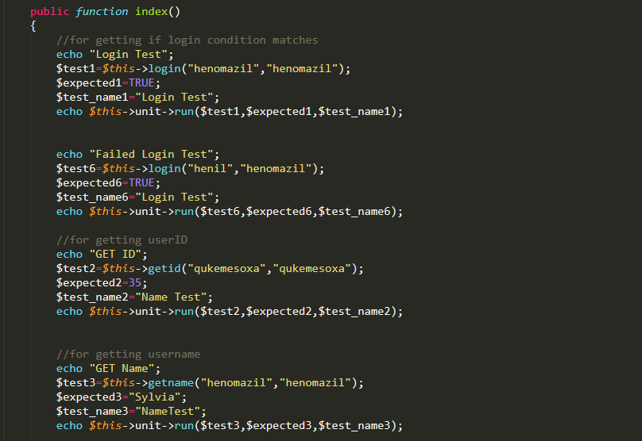

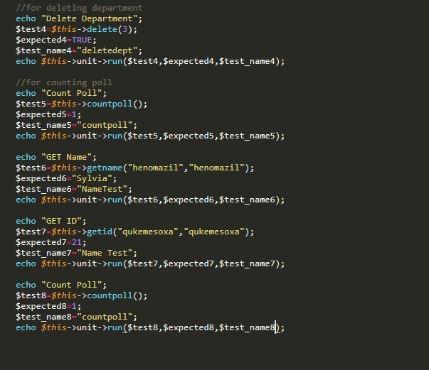

**Output of above test script**

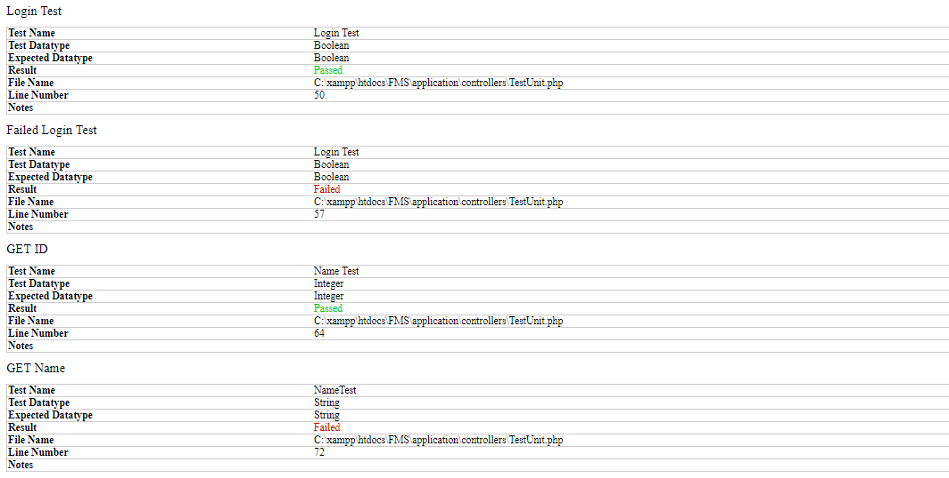

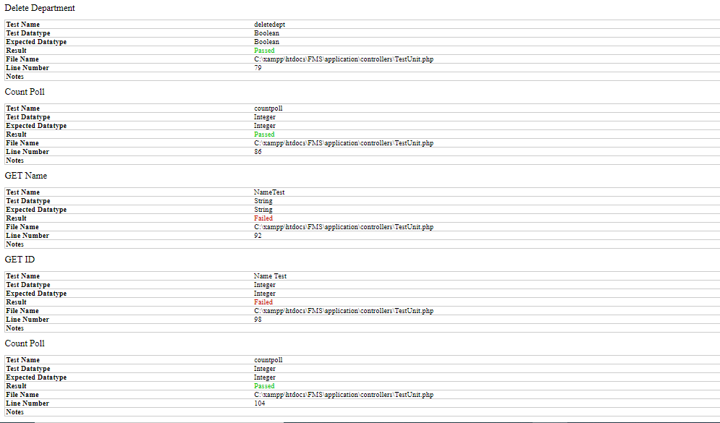

Testing was done.