Chain 2
Exploitation path: NET-02 → WEB-02 → HORIZ-02 → VERT-02 → RE-02 → Root
This chain was designed and implemented by Member 2, combining a network vulnerability, a web vulnerability, a horizontal privilege-escalation vulnerability, a vertical privilege-escalation vulnerability and a reverse-engineering challenge into a single exploitation path that ends in root access on the target machine.
Chained Exploitation Path
The five vulnerabilities form a single attack path against one target (192.168.9.129). The attacker begins with only remote network access and no credentials, and progresses through the layers of the host until they hold root and have recovered every protected secret. Each stage establishes the position needed to reach the next.

Stage 1 — NET-02 (remote network to recon foothold): With only network reach to the host, a scan reveals the rsync daemon on TCP 1873 and the anonymously accessible legacy-sync module. Retrieving network-backup.txt without authentication confirms the host is exposing internal services and data to an unauthenticated attacker, establishing an initial foothold and motivating enumeration of the web applications it hosts.
Stage 2 — WEB-02 (foothold to code execution in the application origin): Probing the exposed support portal on port 8083 uncovers the reflected XSS in the search parameter. Because the injected JavaScript runs in the portal's own origin, a same-origin request to /review reads protected internal content the attacker was never meant to see. This demonstrates code execution inside a trusted context and access to the analyst portal.
Stage 3 — HORIZ-02 (lateral movement between users): Operating in the analyst portal as analyst1, the attacker exploits the IDOR by changing the profile object identifier from 1 to 2, reading analyst2's protected profile. This is sideways movement into another user's context on the same host, widening the attacker's access before escalating locally.
Stage 4 — VERT-02 (low-privileged user to root): With a local foothold as ctfadmin, the attacker abuses the sudo PATH-hijack: the root-run ctf-maintenance script calls cp by bare name, so a malicious cp placed first in PATH executes as root and sets the SUID bit on /bin/dash. Running dash -p then yields euid=0(root), giving full control of the machine.
Stage 5 — RE-02 (root to final obfuscated secret): With full access to the host, the attacker statically analyses the supplied binary (file, strings, nm, objdump), identifies the XOR key 0x5b, and reconstructs the obfuscated flag without executing it — representing the recovery of a final hardened secret stored on the compromised system.

End state: root access on 192.168.9.129 with every protected flag recovered. A single unauthenticated network exposure at the start compounds, stage by stage, into full compromise of the host.
Note: In this lab each stage carries its own independent flag; the chain represents the attacker's progression through the host's layers (network service to web app to app user to system user to root to stored secret) rather than one flag literally unlocking the next.

NET-02 — Anonymous Rsync Information Disclosure
Category: Network vulnerability
Objective: Discover an exposed rsync service and retrieve sensitive files without authentication.
Initial Access: Network access to the vulnerable Kali Linux machine.
Vulnerability: An rsync daemon was exposed on TCP port 1873 with an anonymously accessible module named legacy-sync, permitting unauthenticated read access to files intended for internal synchronisation.
Exploitation steps:
1. Scan the target and identify TCP port 1873.
2. Identify the service as rsync.
3. Enumerate the available rsync modules.
4. Discover the legacy-sync module.
5. List the files exposed by the module.
6. Download network-backup.txt without authentication.
7. Recover the NET-02 flag from the exposed backup.

Flag / Outcome: CITS3006{NET02_ANON_RSYNC}

Evidence:
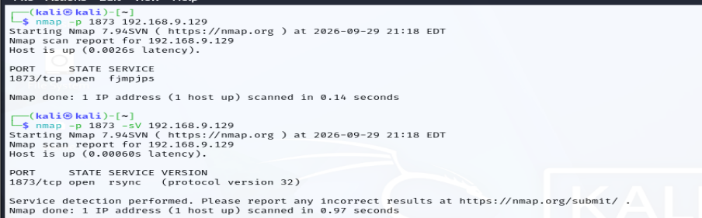
NET02(a): Scanned the target with nmap. A basic scan of port 1873 showed it open (initially mislabelled by port number), and adding -sV for service/version detection correctly identified the service as rsync (protocol version 32) — confirming an rsync daemon listening on the non-standard TCP port 1873.
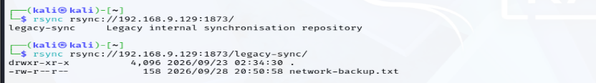
NET02(b): Enumerated the rsync daemon anonymously. Listing the daemon root (rsync rsync://192.168.9.129:1873/) revealed the legacy-sync module ("Legacy internal synchronisation repository"), and listing that module exposed its contents — the file network-backup.txt — all without any credentials.
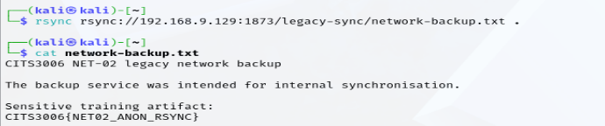
NET02(c): Downloaded the exposed file without authentication (rsync rsync://…/legacy-sync/network-backup.txt .) and read it with cat. The backup, intended for internal synchronisation, disclosed the flag CITS3006{NET02_ANON_RSYNC} — confirming the anonymous rsync information-disclosure vulnerability.

WEB-02 — Reflected Cross-Site Scripting (XSS)
Category: Web vulnerability
Objective: Exploit a reflected XSS vulnerability to execute JavaScript in the CTF portal's origin and access protected same-origin content.
Initial Access: Unauthenticated access to the support-search endpoint.
Vulnerability: The search parameter is reflected directly into the HTML response without output encoding, allowing attacker-controlled JavaScript to execute in the application origin.
Exploitation steps:
1. Submit a JavaScript payload through the search parameter.
2. Confirm the payload is reflected into the HTML response.
3. Execute the payload in a browser and confirm JavaScript execution.
4. Use the same-origin XSS to request the internal review page.
5. Extract the hidden training flag from the review response.
6. Recover the WEB-02 flag.

Flag / Outcome: CITS3006{WEB02_REFLECTED_XSS}
Evidence:
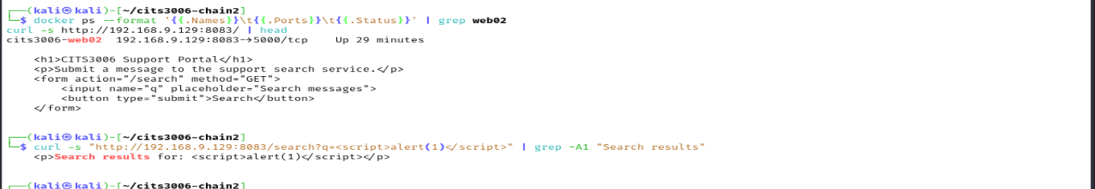
Web(a): WEB-02 container running on 192.168.9.129:8083; the q parameter is reflected unescaped, confirming the XSS
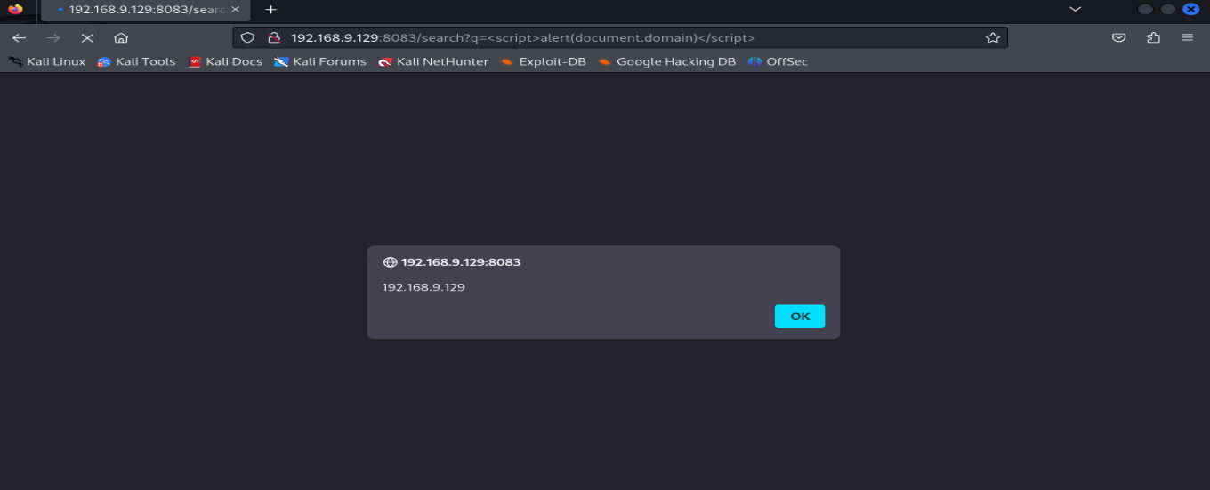
Web(b): Payload executing in the browser — the alert() shows 192.168.9.129, proving script execution in the portal's origin.
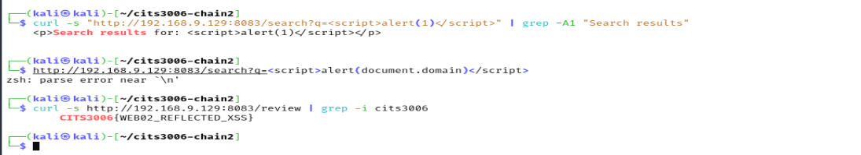
Web(c) : Same-origin access to /review recovers the flag: CITS3006{WEB02_REFLECTED_XSS}.

HORIZ-02 — Insecure Direct Object Reference (IDOR)
Category: Horizontal privilege escalation
Objective: Allow a logged-in low-privileged user to access another user's protected profile.
Initial Access: analyst1
Vulnerability: The profile endpoint verifies that the requester is authenticated but does not verify ownership of the requested profile object.
Exploitation steps:
1. Authenticate to the analyst portal as analyst1.
2. Access analyst1's own profile using object ID 1.
3. Change the object identifier to 2.
4. The application returns analyst2's protected profile information.
5. Recover the HORIZ-02 flag.

Flag / Outcome: CITS3006{HORIZ02_IDOR_OBJECT}
Evidence:
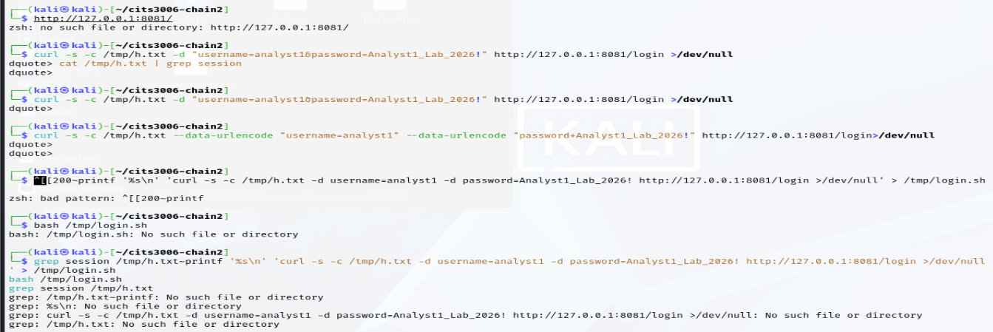
Horiz(a): Initial curl login attempts to the analyst portal. Several attempts failed due to shell quoting errors (unterminated quotes and a mistyped script), producing dquote> prompts and No such file errors. These were corrected in the following steps before the session was successfully established.
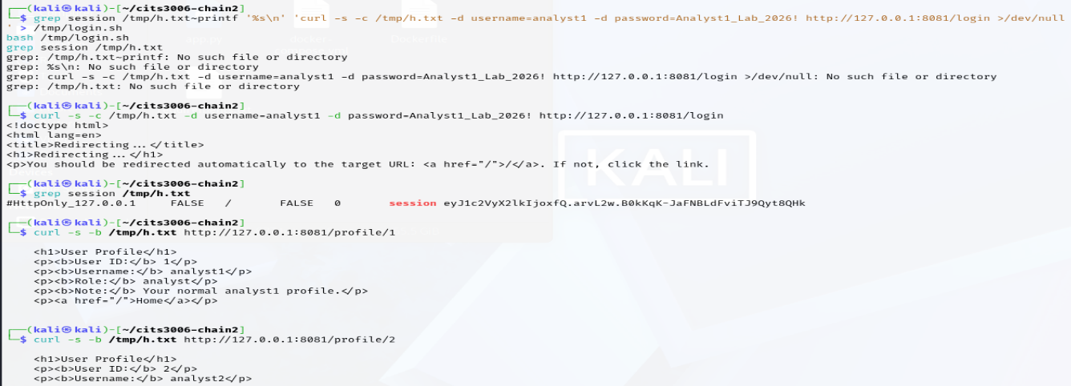
Horiz(b): Logged in to the analyst portal as analyst1 using curl, saving the session cookie to /tmp/h.txt. The grep session output confirms an authenticated session was established. Using that cookie, /profile/1 was requested and returned analyst1's own profile ("Your normal analyst1 profile."), then /profile/2 was requested in the same session.
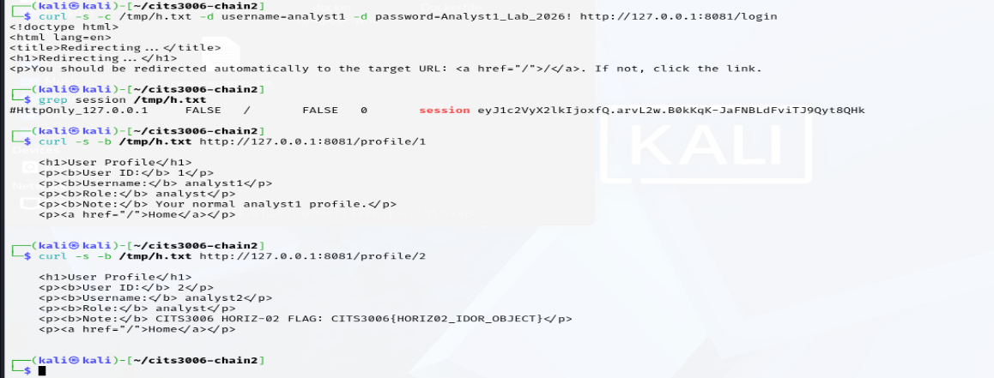
Horiz(c): Using the same analyst1 session, /profile/1 returned analyst1's own profile, and changing the object identifier to /profile/2 returned analyst2's protected profile instead. Because the endpoint checks only that the user is authenticated and not that the profile belongs to them, analyst2's data was disclosed — recovering the flag CITS3006{HORIZ02_IDOR_OBJECT}.

VERT-02 — PATH Hijacking via Privileged Maintenance Script
Category: Vertical privilege escalationObjective: Escalate from ctfadmin to root by exploiting a privileged maintenance script.
Initial Access: ctfadmin
Vulnerability: The root-executed maintenance script invokes the cp command without an absolute path. Because the sudo rule permits a modified PATH, an attacker can place a malicious cp executable earlier in PATH.
Exploitation steps:
1. Create a malicious cp executable in an attacker-controlled directory (it sets the SUID bit on /bin/dash).
2. Place that directory first in PATH.
3. Execute the privileged maintenance script under sudo.
4. The script invokes the attacker-controlled cp with root privileges, setting SUID-root on /bin/dash.
5. Run dash -p to obtain a root shell (euid=0) and recover the flag.

Flag / Outcome: CITS3006{VERT02_PATH_HIJACK}
Evidence:
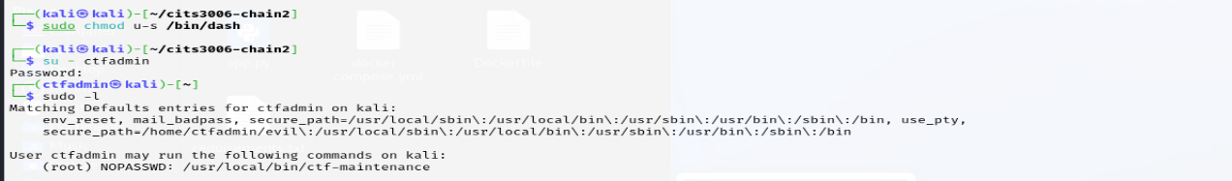
VER(a): Reset the environment and switched to the low-privileged ctfadmin user. Running sudo -l shows ctfadmin may execute /usr/local/bin/ctf-maintenance as root with NOPASSWD, and that its secure_path places /home/ctfadmin/evil first — so PATH is attacker-controllable when the script runs under sudo
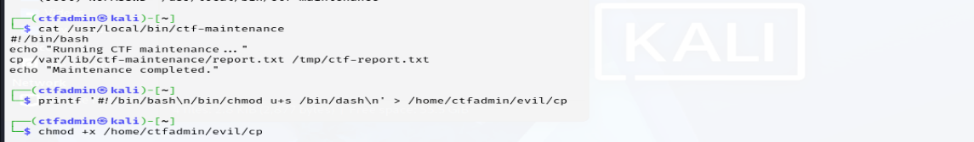
VER(b): Inspected the privileged script: ctf-maintenance calls cp by bare name (not an absolute path), so the command is resolved from PATH at runtime. A malicious cp was then written into /home/ctfadmin/evil that sets the SUID bit on /bin/dash, and made executable.
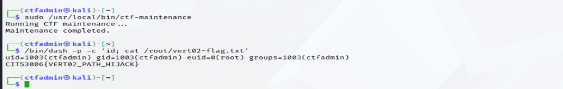
VER(c): Triggered the script with sudo /usr/local/bin/ctf-maintenance; the root-run script executed the attacker's cp, setting SUID-root on /bin/dash. Running dash -p then yielded euid=0(root), and reading the root-only file disclosed the flag CITS3006{VERT02_PATH_HIJACK}.

RE-02 — Obfuscated Secret Recovery
Category: Reverse engineering
Objective: Recover a hidden challenge flag from a native executable containing an obfuscated secret.
Initial Access: The supplied RE-02 executable.
Vulnerability: The flag is not stored as a plaintext string. The executable contains an encoded byte array and reconstructs the secret at runtime using XOR.
Exploitation steps:
1. Identify the binary as an ELF 64-bit executable.
2. Inspect the binary with strings and confirm the flag is not directly exposed.
3. Use nm to identify the decode function, encoded data and key symbols.
4. Use objdump to inspect the decode routine.
5. Identify the XOR key (0x5b) from the disassembly.
6. Extract the encoded bytes from the identified data location.
7. XOR each byte with 0x5b to reconstruct the flag.

Flag / Outcome: CITS3006{RE02_XOR_DATAFLOW}

Evidence:
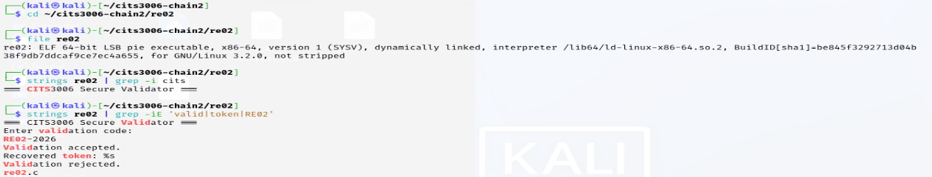
RE(a): Identified the target as an ELF 64-bit executable (not stripped) with file. Running strings | grep cits returned only the program banner "=== CITS3006 Secure Validator ===", and strings | grep valid|token|RE02 showed the visible prompts (RE02-2026, Recovered token: %s) — confirming the flag itself is not present as plaintext.
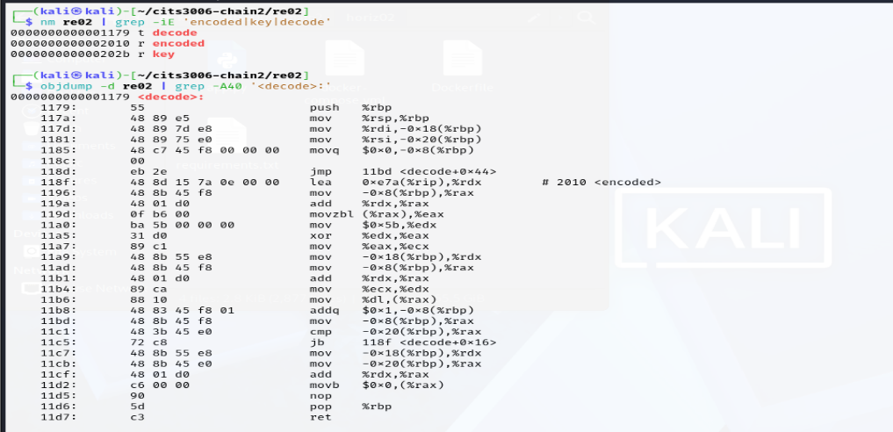
RE(b): Because the binary is not stripped, nm exposed the relevant symbols: the decode function, the encoded array (0x2010) and the key (0x202b). Disassembling decode with objdump -d revealed the deobfuscation loop, which loads each encoded byte and XORs it — the instruction mov $0x5b,%edx followed by xor %edx,%eax identifies the XOR key as 0x5b.
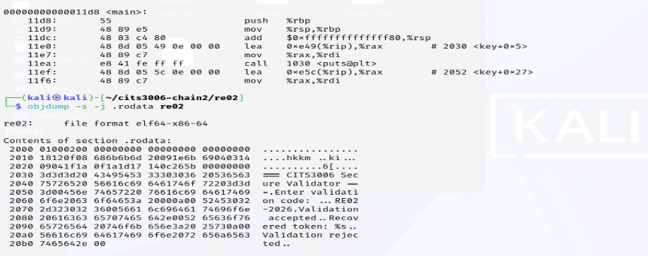
RE(c): Dumped the read-only data with objdump -s -j .rodata. At address 0x2010 the 27 encoded bytes (18 12 0f 08 …) are visible, immediately followed by the key byte 5b at 0x202b, and then the plaintext banner strings — confirming the encoded flag is stored as raw data, separate from the readable strings.
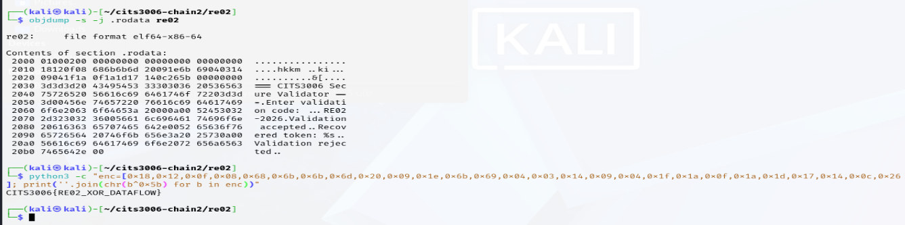
RE(d): Reconstructed the flag by XORing each of the 27 encoded bytes with the key 0x5b in Python. The decode reproduces the program's runtime operation and recovers the hidden flag CITS3006{RE02_XOR_DATAFLOW} — obtained purely through static analysis, without executing the binary or knowing the validation code.

