LEAP-RE T5.3

Scientometric Analysis of Renewable Energy Research-Capacity in Africa
MESRS: … | ZSI: Dietmar Lampert, Elke Dall, Utku B. Demir

Abstract
The present report displays the results of the scientometric study on the renewable energy research-capacity in African countries by focusing on the publications in the 10 years range between 2011-2020. In order to deliver a comprehensive overview, after the analysis of the African countries in their respective African Union regions and international co-publication networks, the study has been broadened into organisational co-publication networks of the selected countries as well as the analysis of the most visible research areas and keywords/ keyword pairs from the selected organisations. Moreover, as a further point of view, renewable energy related publications from the African countries are also categorised under distinct research domains to show the most visible organisational pairings as well as most visible and trending keywords/ keyword pairs in different clusters of scientific areas.

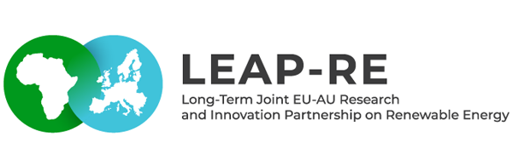

Table of Contents
LEAP-RE T5.3 1
Scientometric Analysis of Renewable Energy Research-Capacity in Africa 1
Abstract 1
1 Introduction 2
2 Methodology 4
2.1 Definitions 4
2.2 Data Source & Methodological Steps 4
3 Results 5
3.1 Overall Figures 5
3.2 Regional Analysis 12
3.2.1 Northern Africa 14
3.2.1.1 Egypt 19
3.2.1.1.1 Cairo University 22
3.2.1.2 Algeria 24
3.2.1.2.1 Renewable Energy Development Center 27
3.2.1.3 Morocco 30
3.2.1.3.1 Mohammed V University 32
3.2.2 Western Africa, Central Africa, Eastern Africa 35
3.2.2.1 Western Africa 36
3.2.2.2 Central Africa 38
3.2.2.3 Eastern Africa 42
3.2.2.4 Selected Institutions and Institutional Co-publication Network 45
3.2.2.4.1 Covenant University (Nigeria) 48
3.2.2.4.2 University of Nigeria 50
3.2.2.4.3 Université de Yaoundé I (Cameroon) 53
3.2.2.4.4 Addis Ababa University (Ethiopia) 56
3.2.2.4.5 Mekelle University (Ethiopia) 59
3.2.3 Southern Africa 65
3.2.3.1 South Africa 67
3.2.3.1.1 University of KwaZulu-Natal 69
3.2.3.1.2 University of Cape Town 71
3.2.3.1.3 Stellenbosch University 73
3.3 Domain Analysis 75
3.3.1 Physical Sciences 75
3.3.2 Technology 79
3.3.3 Life Sciences & Biomedicine 82
3.3.4 Social Sciences and Arts & Humanities 85
4 Conclusion 87
5 References 88

1 Introduction
This study mainly focuses on renewable energy (RE) related research in African countries between 2011-2020. The study has been carried out under the project LEAP-RE (Long-Term Joint European Union - African Union Research and Innovation Partnership on Renewable Energy) Task 5.3: Strategy for RE research-capacity in Africa with the co-lead of MESRS (Ministry of Higher Education and Scientific Research) and ZSI (Centre for Social Innovation).
The results, which will be displayed in the following chapters, are generated through a cleaned, normalised and recategorised dataset created with the data collected from the Clarivate’s Web of Science databases. A comprehensive discussion about the methods can be found in Chapter 2.
Following the explanation of the methodology in the next chapter, Chapter 3 displays the results of the study. After showing the overall figures in Section 3.1 which include a general overview of the yearly RE-related publication output in the African continent, the most visible countries and organisations as well as the distribution of research domains and areas, Section 3.2 focuses on individual African Union Geographic Regions. The regional analysis generally deals with the most visible countries in each region as well as their co-publication networks which also include interregional (partnerships with other African countries from other regions) and intercontinental (partnerships with countries from other continents) collaborations. Furthermore, the analysis also focuses on selected countries in each region to display the most visible organisations and organisational co-publication networks as well. The regional analysis also includes at least 1 selected organisation from each selected country to present the most visible research areas and keyword/keyword pair networks on the organisational level. Finally, Section 3.3 approaches the RE research in Africa from another direction and by splitting publications into research domains in order to discuss the most visible co-publication pairings between organisations as well as most visible keywords/ keyword pairs in each distinct cluster of scientific areas.
The report will be delivered in 3 different formats. An HTML-File which includes the whole scope of the report with interactive visualisations, a PDF-File which is content-wise identical to the HTML-File with static visualisations instead of interactive. And a dashboard where the results will be displayed in a compact mode interactively.

2 Methodology
This chapter mainly deals with the explanation of the methodological definitions, information about the data collection, preprocessing, analysis, and visualisation/ report writing phases.

2.1 Definitions
Research Area/ Research Domain. Research areas are the scientific fields defined by the Web of Science (WoS). Research domains are the 5 parent categories (Physical Sciences, Technology, Life Sciences & Biomedicine, Social Sciences, Arts & Humanities) of the research areas.
Co-publication. A publication that has been produced with the collaboration of at least 2 authors from 2 different organisations.
Interregional co-publication. Interregionality in this Report refers to different African countries from different African Union (AU) regions. An interregional co-publication, therefore, is a paper published with the collaboration of at least 2 authors from African organisations from different regions of Africa.
Intercontinental co-publication. Co-publications of at least 2 organisations located on different continents.
Relative growth rate. A simple indicator of how many folds the number of publications has been increased in comparison with the number of publications in the start year (2011). The equation is simply:
rel_growth_rate:=end_value/start_value

2.2 Data Source & Methodological Steps
The study is based on the data from Clarivate’s Web of Science (WoS) databases. After the unification of the collected RE-related keywords, different types of search queries have been tested on WoS. A search query with over 80% accuracy for the identification of RE-related research has been determined through sampling processes.
The data collected from WoS databases through the decided search query have been turned into a common dataset for the use of all partners collaborating in the study. The generated dataset has been transformed by preprocessing steps like data cleaning, normalisation, reduction, and categorisation. The normalisation of the organisation names is done with the help of the Global Research Identifier Database (GRID).
Following the preprocessing steps, an exploratory data analysis has been carried out and some of the key figures have been visualised to decide for focus points of the study between the partners.
Further data analysis has been carried out accordingly to the joint decision on the report format/ outline planning and visualisations have been designed to work interactively.

3 Results
Following clarification of the motivation and methodology of the scientometric analysis on the renewable energy (RE) related research in Africa, this chapter is dedicated to the presentation of the results under the following 3 sub-chapters:
- Overall Figures
- Regional Analysis
- Domain Analysis
After delivering a general overview on yearly output, the most visible countries and organisations as well as distribution of scientific domains and areas in the RE-related publications in African countries between 2011-2020, Regional Analysis focuses on each of the 5 regions (Northern Africa, Western Africa, Central Africa, Eastern Africa, Southern Africa)3 individually. Analysis of the geographic regions include:
- Most visible countries.
- Regional, interregional, and intercontinental collaboration networks of all countries in the region.
- Collaboration networks of the academic organisations in selected countries4.
- Analysis of the most visible research areas and the correlation network of the keyword/keyword pairs in the RE-related publications of the selected organisations5.
Domain Analysis approaches RE-related research in Africa from a different perspective by analysing the publications under the 5 research domains Physical Sciences, Technology, Life Sciences & Biomedicine, Social Sciences and Arts & Humanities6. Analysis of each domain includes:
- Most visible inter-regional/ intercontinental collaborations between academic organisations.
- Most visible and trending keywords/ keyword pairs.

3.1 Overall Figures

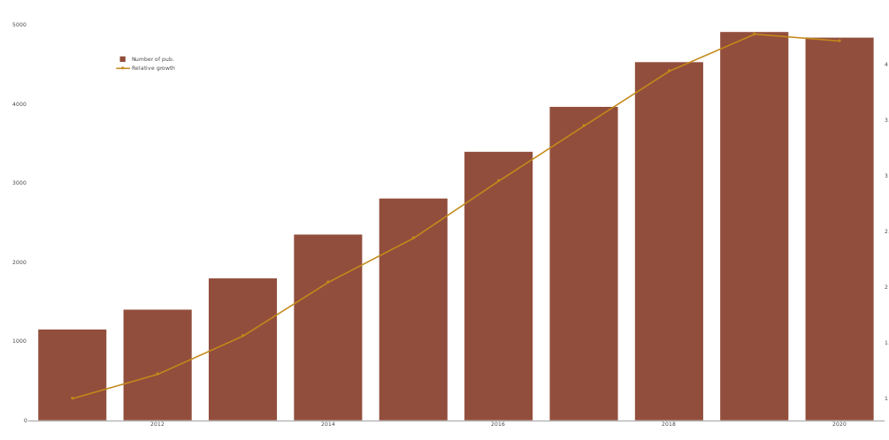
Figure 1: Number of RE-related publications in African countries over the years between 2011-2020

African countries have collaborated in approximately 31k renewable energy (RE) related publications in the 10 years range between 2011-2020. The number of those publications has been constantly increasing until 2019. Slightly declining publication numbers between 2019 and 2020 (see Figure 3.1) is likely caused by the latency in the database entries7 according to the explanation of Web of Science. Even after including the possibly incomplete amount of publications in 2020, the number of RE-related publications from the African countries in total increases from ~1.1k in 2011 to ~4.8k in 2020 which is an increment by factor ~4.2.

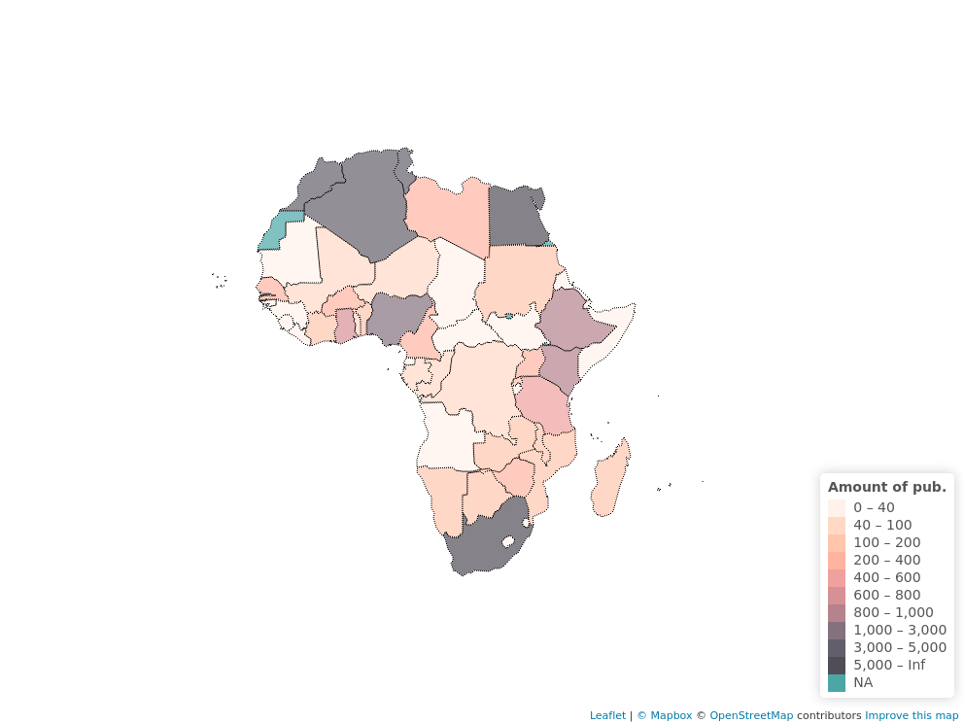Figure 2: Total number of RE-related publications in African countries between 2011-2020

As Figure 2 shows, South Africa and Egypt are the most visible countries with 6.8k and 6.6k RE-related publications respectively. 20 African countries stay under 40 RE-related publications in total between 2011-2020. The most visible countries are distributed diversely on the continent, however, other than the Northern African countries and South Africa only Nigeria contributed to over 1000 RE-related publications (2252 pub.) between 2011-2020.
Although total publication output is a strong indicator of the most visible countries, it does not show the growth rate in the numbers. African countries that show a high increment rate in the number of publications despite having a relatively lower total amount of publications will be analysed in the following chapter.

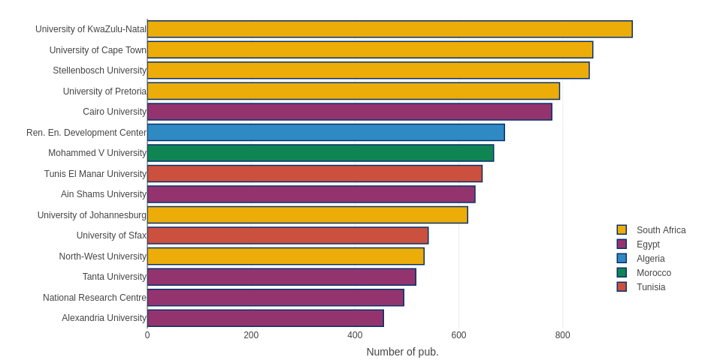Figure 3: Most visible 15 African countries in RE-related publications between 2011-2020

4 of the most visible 5 organisations (University of Kwazulu-Natal, University of Cape Town, Stellenbosch University, and University of Pretoria) in RE-related publications are located in South Africa. Each of them has close to or over 800 publications between 2011-2020, Cairo University from Egypt is following them with ~780 publications. 4 other Egyptian institutions; namely Ain Shams University, Tanta University, National Research Centre of Egypt and Alexandria University are also among the 15 most visible organisations.
Tunis El Manar University and the University of Sfax from Tunisia are also in the most visible 15 organisations with ~650 and ~550 RE-related publications and Mohamed V University, the only organisation from Morocco in the list has ~670 RE-related publications.
Although most of the visible organisations are in general universities, the only organisation from Algeria in the most visible 15 organisations, namely Renewable Energy Development Center is an institution completely dedicated to RE-related research. The total number of RE-related publications of Renewable Energy Development Center is ~700 between 2011-2020.

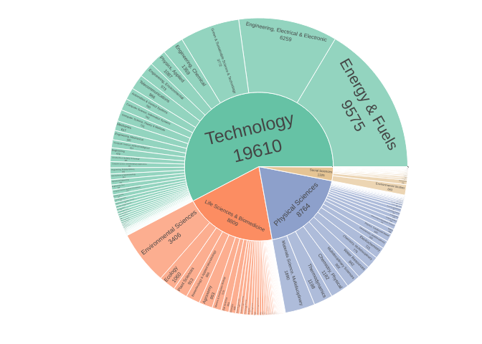Figure 4: Distribution of research domains in RE-related publications of African countries between 2011-2020
Over 50% of the RE-related publications are associated with research areas from the Technology domain. Energy & Fuels is the most visible research area in total followed by Electrical & Electronic Engineering. Other Engineering fields like Chemical, Environmental, Mechanical Engineering are also among the visible research areas. Multidisciplinary discipline Green & Sustainable Science & Technology is the 3. most visible research area in total.
Life Science & Biomedicine and Physical Sciences have a similar number of publications (~8800 pub. both). Environmental Science and Ecology from Life Sciences & Biomedicine as well as Multidisciplinary Materials Science and Thermodynamics from Physical Sciences are also in the 10 most visible research areas.
Social Sciences (1325 pub.) is also not absent in the RE-related publications of African organisations. Environmental Studies is the most visible research area in this domain with 663 publications.
The 5. research domain Arts & Humanities include only 45 publications, therefore, this domain will be analysed together with Social Sciences in Chapter 3.3 Domain Analysis.

3.2 Regional Analysis
Following the overall figures of the RE-related publications in Africa, this section introduces the geographical regions of Africa to broaden the analysis further. Focusing on different regions of Africa prevents the over-representation of already relatively more visible countries in terms of publications and also enables a detailed analysis for individual countries and organisations.
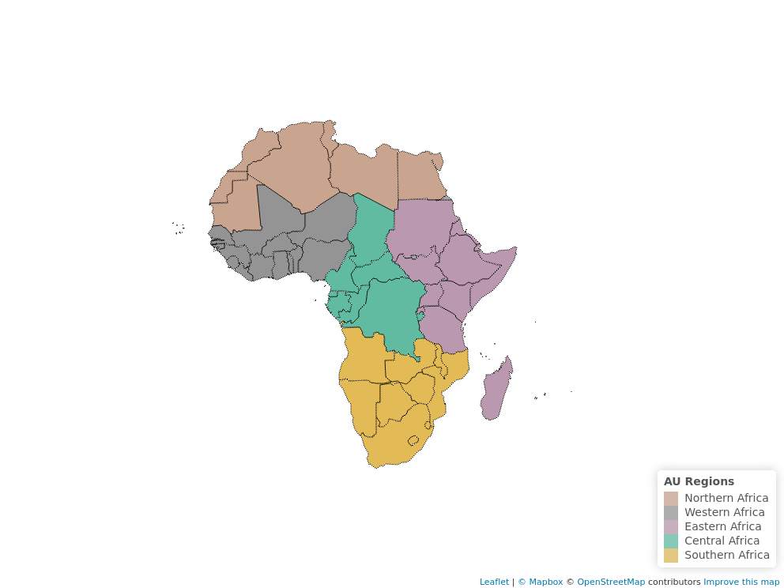Figure 5: African Union Geographic Regions

To determine the African regions, this study uses African Union Geographical Regions instead of the United Nations Statistics Department (UNSD). A presentation of the African Union regions can be seen in Figure 5.
As Figure 6 summarizes, 4 of the most visible African countries in the RE-related publications are from Northern Africa. South Africa has the highest number of RE-related publications (~6900) between 2011-2020, only other member country of Southern Africa in the most visible 15 countries is Zimbabwe with 230 RE-related publications between 2011-2020. Nigeria, Ghana, Senegal from Western Africa; Ethiopia, Kenya, Tanzania, Uganda from Eastern Africa; and Cameroon, the only country from Central Africa, are among the 15 most visible countries following the most visible 5 countries.
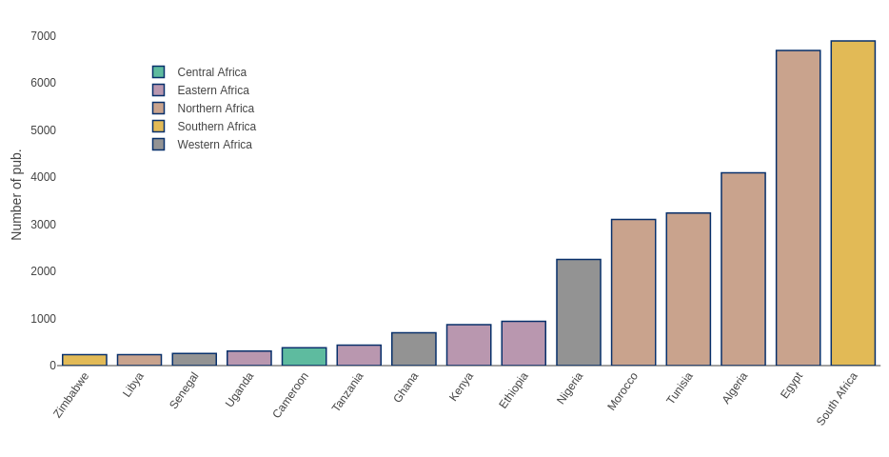Figure 6: The most visible 15 African countries in RE-related publications between 2011-2020

3.2.1 Northern Africa
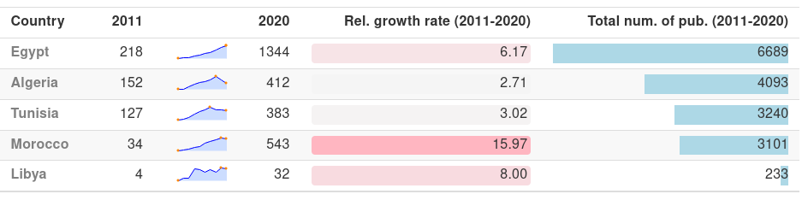Table 1: RE-related publication output in the most visible Northern African countries

Member countries of Northern Africa have collaborated approximately in half of the total number of all RE-related publications (17116 publications out of 31099) in Africa between 2011-2020. 4 of the 5 most visible African countries in RE-related publications are from the northern region; namely Egypt, Algeria, Tunisia and Morocco.
As Table 1 presents, all of the Northern Africa countries increased their number of RE-related publications until 2017. Although, as discussed in the previous chapter, slight declines in the number of publications between 2019-2020 are most likely caused by the delay of document entry into the Web of Science databases, Algeria and Tunisia show an earlier start of the decline in their number of publications starting in 2017 and 2018 respectively. In the case of Libya, however, volatility in the number of publications is expected as their total publication outputs are relatively lower.
Another important observation is in the relative growth rates, Morocco’s number of RE-related publications in 2020 are approximately 16 times higher than the number in 2011. This growth rate is not only the highest in Northern Africa but in the whole continent among the most visible countries in RE-related research.

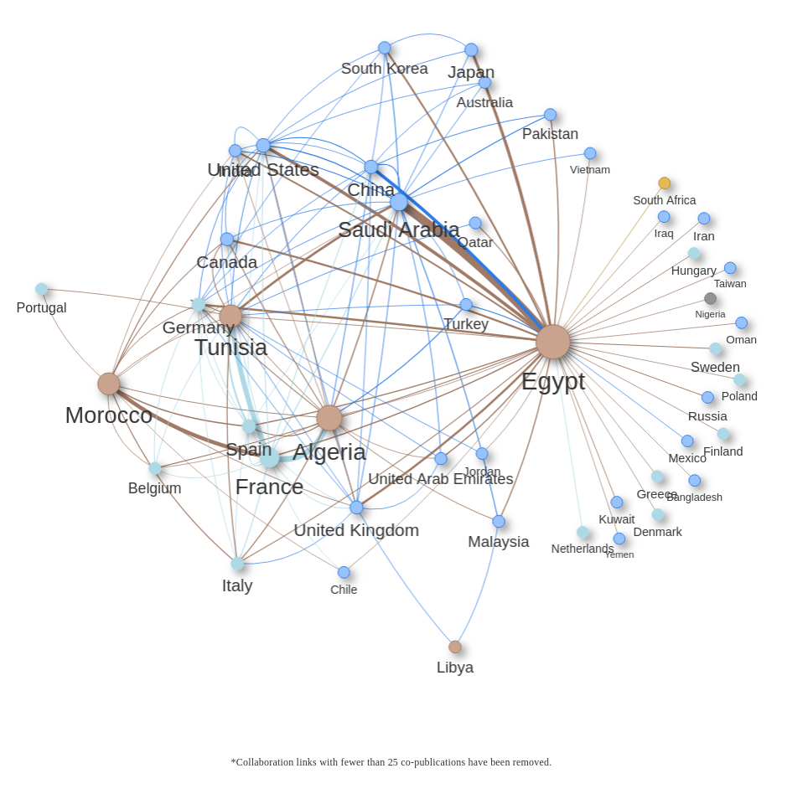Figure 7: Co-publication network of Northern African countries in RE-related publications between 2011-2020
RE-related co-publications of the Northern African countries show a rich international network but the collaboration with other African regions seems to be relatively less dense. Only African countries from other regions which have co-published over 25 RE-related papers with Northern African countries are South Africa (28 pub.) and Nigeria (26 pub.).
Egypt, the most visible country in Northern Africa in terms of RE-related publications, plays a central role in the network with ~6.6k publications in total. The relatively uniform distributed co-publication network of Egypt includes over 10 EU-27 countries as well as a number of countries from other regions of the world like the USA, China, India, United Kingdom. Egypt’s strongest link in the co-publications, however, is with organisations from Saudi Arabia.
Tunisia, Algeria and Morocco have relatively high numbers of collaborations with French organisations with 751, 881 and 601 co-publications respectively. France in general is the most visible EU-27 country in the RE-related co-publications with African countries. Out of France’s ~3250 RE-related co-publications with African countries ~2350 of those have been published with the collaboration of Northern African countries whereas Algeria and Tunisia being the most visible Northern African countries in those collaborations. The closest following EU-27 country in terms of RE-related co-publications is Spain (~580 out of ~820 co-publications with African countries) and Germany (~490 out of 1334 co-publications with African countries).
The 4 mentioned Northern African countries so far, Egypt, Algeria, Tunisia and Morocco are co-publication-wise relatively well interconnected, however, Libya stays out of the co-publication cluster in Northern Africa, from Libya’s 233 RE-related publications in the last 10 years none of the Northern African countries had over 25 co-publications with Libya. Instead, Libya’s most visible collaborators are United Kingdom (38 co-pub.) and Malaysia (29 co-pub.).
Following the given analysis of RE-related publication outputs in Northern Africa; Egypt, Algeria and Morocco have been chosen for the deeper analysis of the individual countries. While Egypt and Algeria hold the highest numbers of RE-related publications in the northern region, Morocco has been mainly chosen for the high growth rate in the number of publications.

3.2.1.1 Egypt
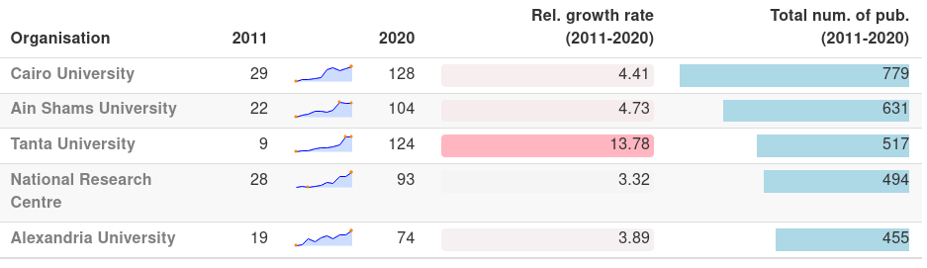Table 2: Re-related publication output of the most visible Egyptian organisations

The most visible Egyptian organisation in the RE-related publications is Cairo University with a total of 779 publications between 2011-2020. All of the most visible 5 organisations of Egypt display a fairly linear growth in the number of RE-related publications. However, Ain Shams University and Tanta University show a stagnation between 2019-2020 which might be caused by the delay of document entries into the Web of Science system as mentioned above. Furthermore, Tanta University, which had yearly fewer than 50 RE-related publications until 2016, published in 2019 and 2020 ~125 RE-related papers, this is a growth rate of ~14 fold with respect to the 9 publications in 2011.

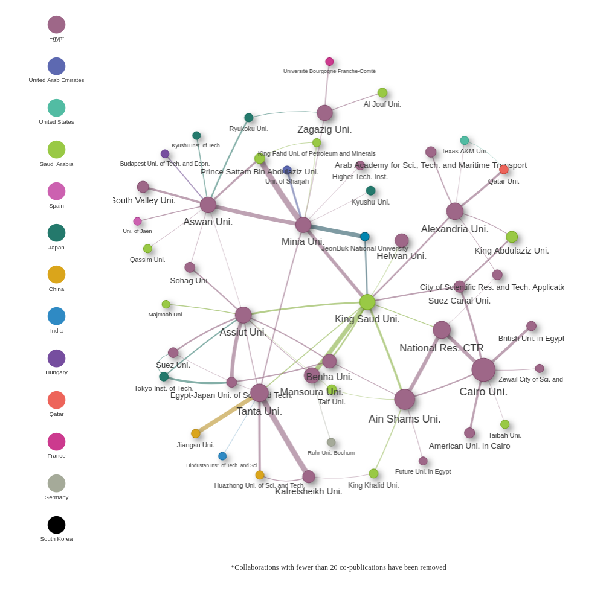Figure 8: Co-publication network in RE-related publications in organisations from Egypt between 2011-2020

The Co-publication network of Egyptian organisations shows a relatively dense collaboration structure between Cairo University, Ain Shams University and National Research Centre of Egpyt. National Research Centre has over 50 co-publications with each of the other universities in that cluster. Cairo University is also in the centre of other 4 Egyptian organisations; namely Suez Canal Uni., British Uni. in Egypt, Zewail City of Sci. Tech and American Uni. in Cairo, with over 20 co-publications each.
Other visible collaboration links are between Minia and Aswan Universities with over 50 publications and between Tanta and Kafrelsheikh Universities with over 70 publications together. In general, collaborations with organisations from Saudi Arabia are highly visible in the network, especially King Saud University is a central node in the network with ~400 RE-related co-publications with Egyptian organisations.
Other than that, East Asian organisations also have a visible presence in the co-publication network of Egypt. Tanta University’s collaborations with Chinese Institutions Jiangsu Uni. and Huazhong Uni include 60 and 40 co-publications respectively. Several Japanese universities have collaborations with Aswan University, Zagazig University, Assiut University, Suez University, Egypt Japan University and Minia University with over 20 co-publications each. Minia University’s collaboration with South Korean institution JeonBuk National University also includes 60 RE-related co-publications between 2011-2020.
Visible organisations from EU-27 countries are Université Bourgogne Franche-Comté of France (over 25 co-publications with Zagazig University), Ruhr University Bochum from Germany (22 co-publications with Mansoura Uni.), Budapest University of Technology and Economics from Hungary and the University of Jaen from Spain (both over 25 co-pub. with Aswan University).

3.2.1.1.1 Cairo University
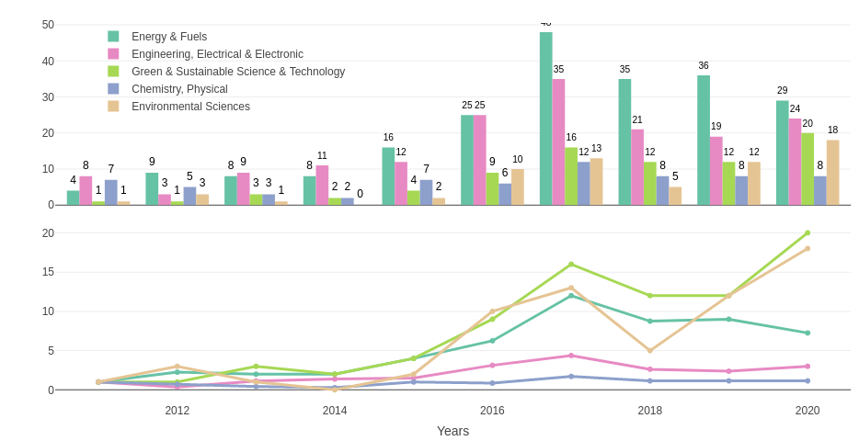Figure 9: Absolute and relative growth of the most visible research areas in RE-related publications of Cairo University between 2011-2020

Looking into the most visible research areas of Cairo University, out of 779 publications in total, the most visible research areas are aligning with the most visible research areas in RE-related publications from African countries in general. Energy & Fuels, as well as Electrical & Electronic Engineering are the most visible research areas in Cairo university, however, the number of RE-related in those areas are not growing in the last years. After the spike in 2017 with ~50 publications, the number of publications from Energy & Fuels has fallen to ~30 publications in 2019 and 2020. Green & Sustainable Science & Technology and Environmental Sciences on the other hand display relatively steady growth in numbers. Considering there was only 1 from each area in 2011, ~20 RE-related publications in 2020 makes those the fastest growing research areas in the RE-related publications of Cairo University.

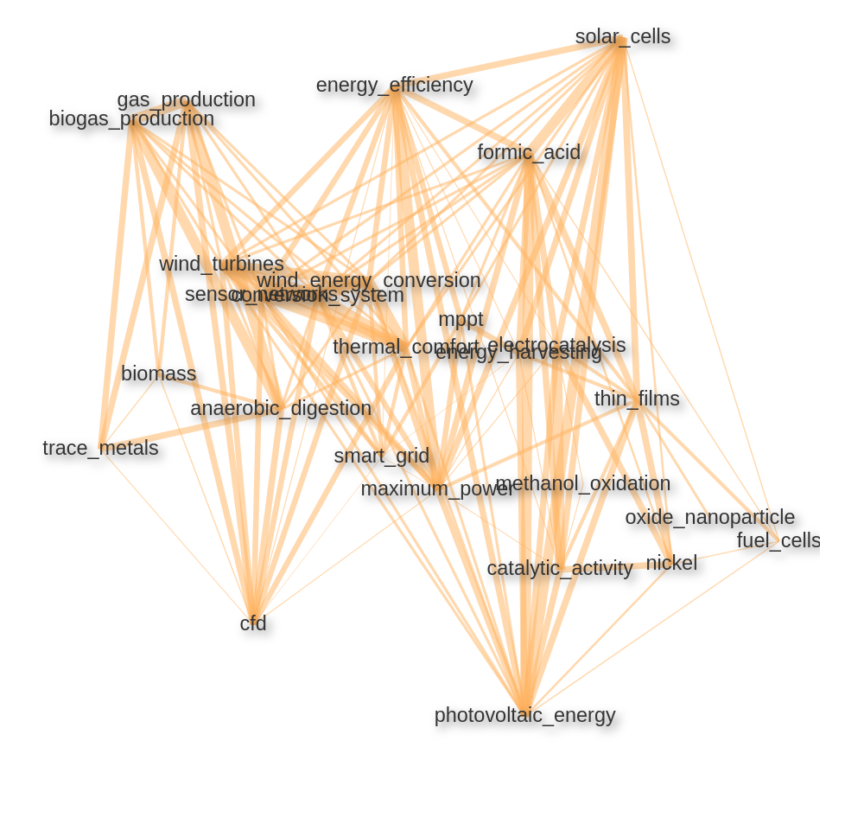Figure 10: Keyword/keyword pair correlation network in RE-related publications of Cairo University

Figure 10 displays the correlation network between the most common keywords and keyword pairs in the RE-related publications of Cairo University. As the clusters on the network graph indicate, there is a strong emphasis on solar energy, photovoltaic systems related keywords in Cairo University’s publications which is widely the case in African countries. In relation, substances and technologies aiming to improve the efficiency of the effectiveness of solar cells like formic acid, MPPT (Maximum Power Point Tracking, an algorithmic DC-DC converter that increases the efficiency of photovoltaic cells) are also among the visible keyword pairs. Other clusters include wind energy-related keywords as well as biogas/biomass related keywords. The approaches like electrocatalysis that aims to increase the output of solar and wind energy are also often mentioned in the RE-related publications of Cairo University.

3.2.1.2 Algeria
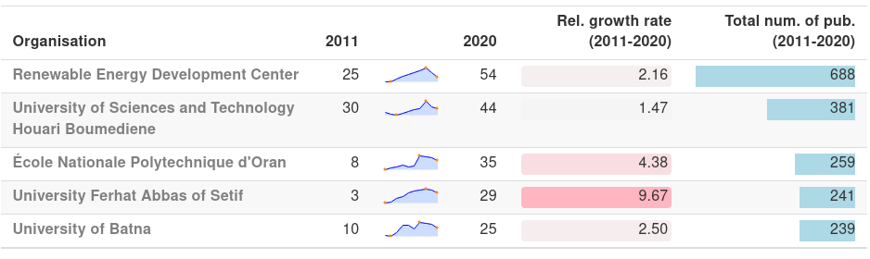Table 3: Re-related publication output of the most visible Algerian organisations

Renewable Energy Development Center, Algeria’s dedicated institution for RE-related research is the most visible Organisation in the country with ~690 publications. However, the number of RE-related publications of the institution is falling after a spike in 2018 with 127 publications. Although the latency in the record entry process in WoS databases might be causing a proportion of the decline, the number of publications in 2020 seems to be less than half of the number in 2018 (54 pub.).
Houari Boumediene University of Sciences is another Algerian institution that publishes RE-related papers consistently. A similar decline in the number of publications like in the case of Renewable Energy Development Center can be observed in the publications of Houari Boumediene University of Sciences after 2018 (from 75 publications to 44 publications in 2020). École Nationale Polytechnique d’Oran University, Ferhat Abbas of Setif and the University of Batna are other organisations with similar numbers of RE-related publications (259, 241, 239 pub. respectively), each of those has increased their yearly RE-related publication output to ~30. The decline in the number of publications after ~2018 can be observed in all of the most visible 5 organisations of Algeria.
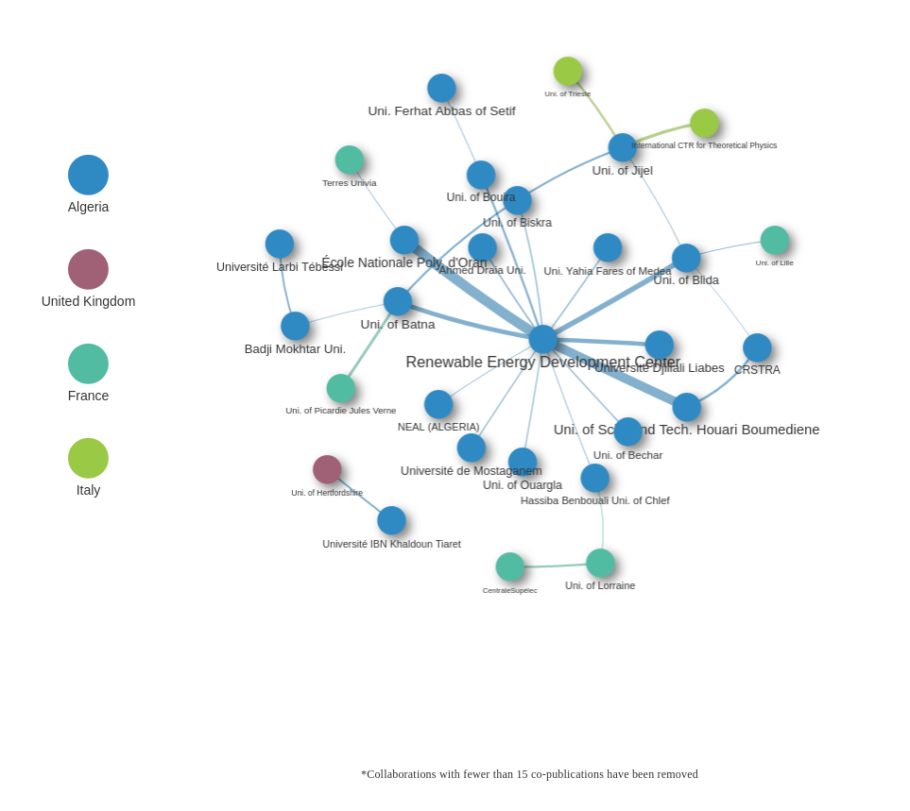Figure 11: Co-publication network in RE-related publications in organisations from Algeria between 2011-2020

Co-publication network of Algerian organisations mostly gathered around Renewable Energy Development Center, the to RE-related research dedicated institution collaborates with a number of other Algerian academic institutions, from which 14 of the collaboration links include close to or over 20 co-publications. The most visible collaborations with Renewable Energy Development Center are with Houari Boumediene University of Sciences and École Nationale Polytechnique d’Oran University, both with an output of over 60 co-publications.
Most of the international collaborators with more than 25 co-publications with Algerian institutions are French, the collaboration between University of Batna and University of Picardy Jules Verne is the most visible one with 27 co-publications between 2011-2020. University of Jijel collaborates often with Italian institutions like University of Trieste (23 co-pub.) and International Centre for Theoretical Physics (28 co-pub.). Other than that, University of Hertfordshire is the only organisation from the UK that has more than 20 RE-related co-publications with an Algerian organisation (University Ibn Khaldon) between 2011-2020.

3.2.1.2.1 Renewable Energy Development Center

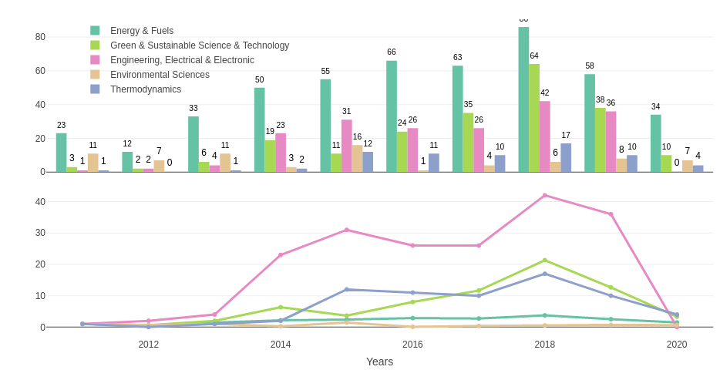Figure 12: Absolute and relative growth of the most visible research areas in RE-related publications of Renewable Energy Development Center between 2011-2020
The most visible research areas in the RE-related publications of Renewable Energy Development Center are Energy & Fuels and Green & Sustainable Science in Technology. All of the most visible 5 research areas are declining in numbers after 2018 which indicates that there was at least some effect caused by the delayed entry of the publications into the Web of Science databases. However, even after the possibly missing publication from the last years Thermodynamics seems to be becoming on of the consistently visible research areas in the RE-related publications of Renewable Energy Development Center. Environmental Sciences which already included relatively high number of publications in 2011 (11 pub.) is also becoming a consistent area despite having volatile yearly number of publications between 2014-2017.
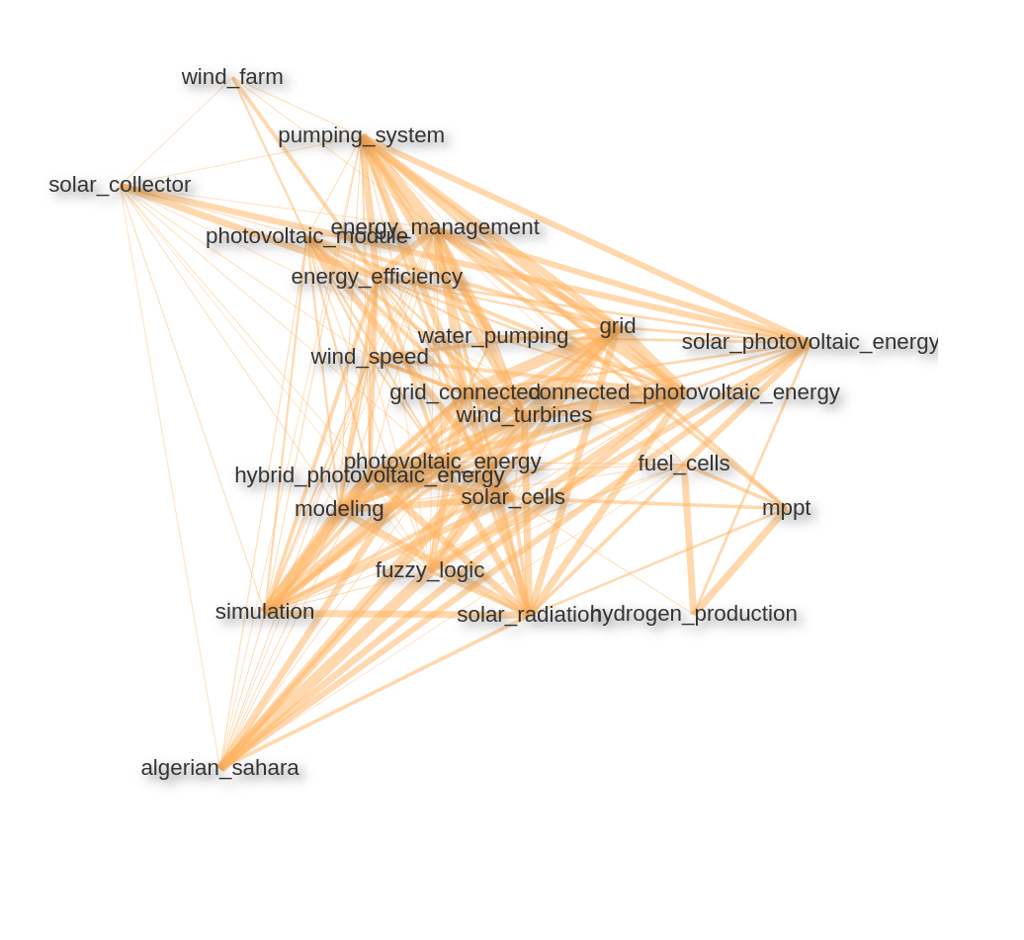Figure 13: Keyword/keyword pair correlation network in RE-related publications of Renewable Energy Development center

Keyword/keyword pair correlation network also displays heavily solar energy-related topics. We are seeing that the exploitation of Algerian Sahara for solar energy production is an often reoccurring theme in the publications of Renewable Energy and Development Center. Wind energy-related topics are also emphasized in the most visible keyword pairs.
The reason, why water pumping systems are relatively highly correlated with the solar energy keywords is the recent technological advances to build photovoltaic water pumps. Algeria is one of the most active countries in Africa that search for photovoltaic water pumping solutions especially for the isolated sites which are not connected to an electrical grid (see Benghanem and Arab (2007) for further reading).

3.2.1.3 Morocco
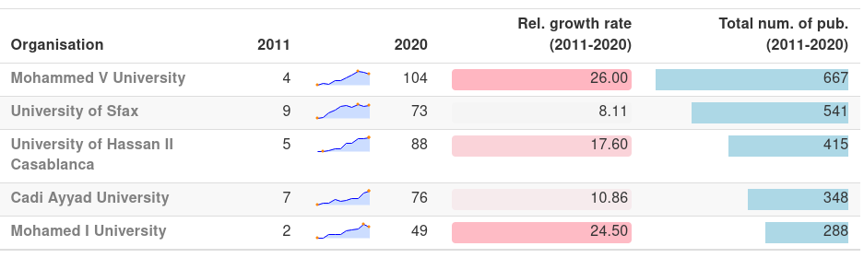Table 4: Re-related publication output of the most visible Moroccan organisations

Morocco has the most rapidly growing number of publications in the 15 most visible African countries in RE-related publications with having 543 publications in 2020 in comparison with 34 RE-related publications in 2011. The same pattern is also observable in the publications of Moroccan Institutions. Each one of the RE-wise most visible 5 organisations in Morocco had 1 digit RE-related publications in 2011 and each of those have published at least ~8 fold of those numbers in 2020.
Mohamed V University is the most visible Moroccan institution in the RE-related publications with 667 publications in total between 2011-2020. There is a slight decline in the number of publications after 2018 but the university still collaborates in over 100 RE-related publications yearly. Mohamed V and Mohamed I Universities are both published in comparison with 2011 ~25 times more in RE-related papers. The University of Sfax, University of Casablanca and Cadi Ayyad University are most visible 2., 3. and 4. organisations respectively

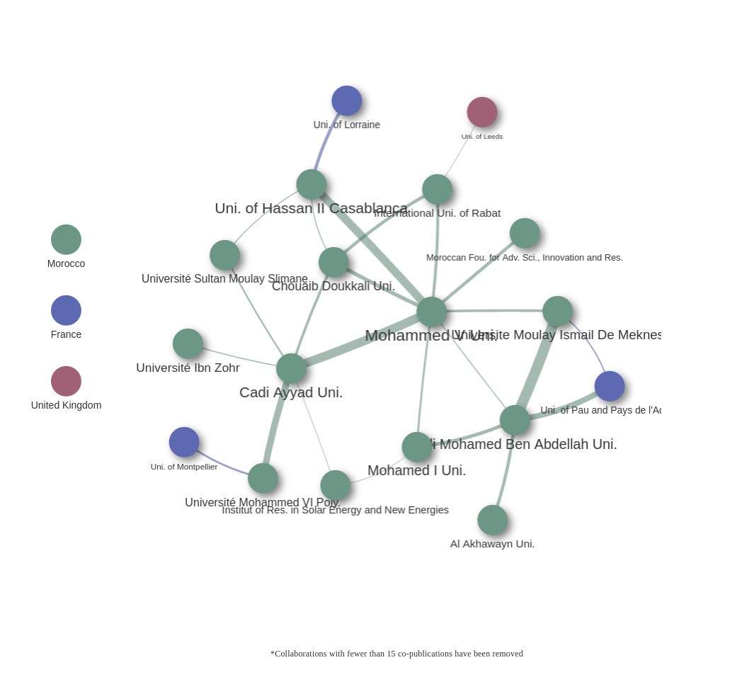Figure 14: Co-publication network in RE-related publications in organisations from Morocco between 2011-2020

Moroccan organisations are well interconnected in RE-related publications. Although Mohamed V University stays in the centre of the network, institutions are evenly distributed. Especially the number of co-publications of Mohamed V Uni. with Cadi Ayyad Uni. and Uni. of Hassan II Casablanca (41 and 39 co-publications respectively) as well as the co-publications between Universite Moulay Ismail de Meknes and Sidi Mohamed Ben Abdellah Uni. (~50 co-publications) are most visible collaborations in Morocco.
Only a few intercontinental collaborations have an output of more than 15 co-publications with Moroccan organisations. Uni. of Lorraine, Uni. of Montpellier and University of Pau and Pays de l’Adour from France, Uni. of Leeds from the UK are the most visible intercontinental collaborators.

3.2.1.3.1 Mohammed V University

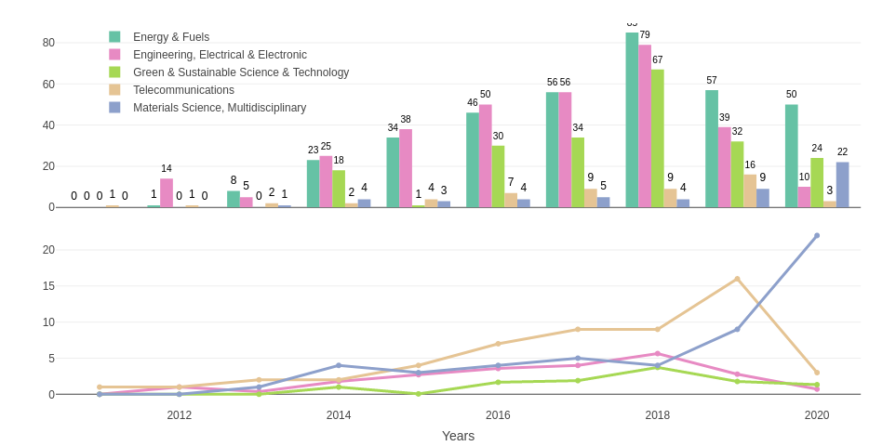Figure 15: Absolute and relative growth of the most visible research areas in RE-related publications of Mohamed V University between 2011-2020

Similar to the other selected universities from the Northern Africa region Energy & Fuels has a strong presence also in the publications of Mohamed V Uni.. Considering, there was no recorded renewable energy-related publication from Mohamed V Uni. in 2011 and only 1 publication in 2012 in Web of Science databases, 2018 shows a strong contrast with 85 RE-related publications to the previous years. Electrical and Electronic Engineering is following Energy and Fuels closely in total RE-related publication from Mohamed V Uni..
Although, there are no recorded publications in Green and Sustainable Science & Tech. before 2014, it stays as the 3. most visible research area in the total numbers. In contrast to the other selected organisations so far one of the most visible research areas in the RE-related publications of Mohamed V University is Telecommunications and publications in Multidisciplinary Material Science are also increasing since 2015. Multidisciplinary Material Science is also the only research area that was increasing in numbers between 2019-2020 in the RE-related publications of Mohamed V University.
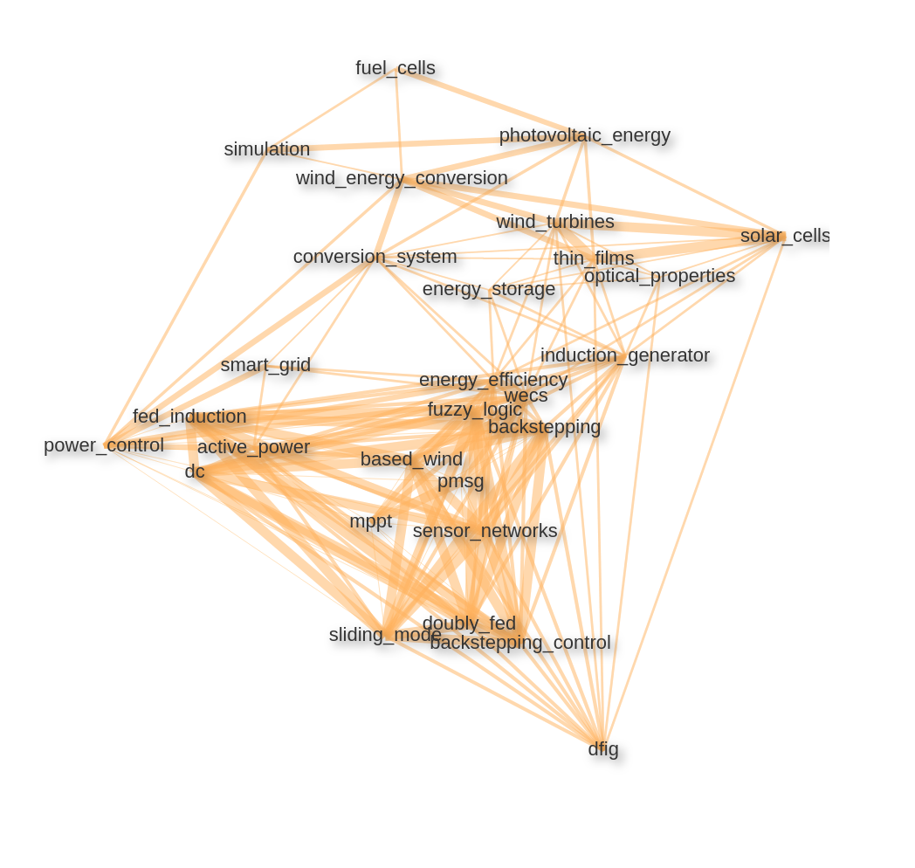Figure 16: Keyword/keyword pair correlation network in RE-related publications of Mohammed V University

The keyword/keyword pair correlation network of Mohamed V University also includes a number of solar energy and wind energy-related themes. Especially different types of conversion systems (wind energy conversion systems Mohamed V University. In relation, hybrid energy approaches like doubly fed induction generator (dfig) or backstepping control system that supports wind tribunes and photovoltaic systems (see E. Ahmed and S. Yuvarajan (2012)) are emphasized. Also, dc-dc converter technologies like MPPT that aims to increase the efficiency of the photovoltaic systems are among the most visible keywords.

3.2.2 Western Africa, Central Africa, Eastern Africa

Western Africa, Central Africa and Eastern Africa are corresponding to a vast area of the African continent, however, on organisational level number of RE-related publications are relatively fewer in comparison. Therefore, although on country level those 3 regions will be analysed individually as in previous sub-chapters, on organisational level; firstly, table of most visible organisations will include organisations from selected 3 countries from each region and organisation network they will include all 3 regions on a single graph.

3.2.2.1 Western Africa
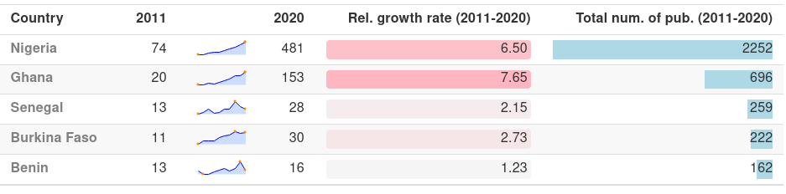Figure 17: RE-related publication output in Western African countries

Western African countries Nigeria and Ghana have been increasing their RE-related publication output in a consistent manner in the 10 years range (see table 3.21) without any stagnation. Although Nigeria’s number of publications in 2011 was already relatively high in comparison (74 pub.), the number of publications in 2020 was ~6.5 fold (481 pub.) of that. In a similar fashion, Ghana has increased its RE-related publication output from 20 in 2011 to 153 in 2020 which is an increment of a factor of ~7.5.
Senegal, the third most visible country in the region shows a volatile progression with a sharp decline in the number of RE-related publications after 2018 from 48 yearly publications to 28. Burkina Faso is following Senegal with relatively less volatility and Benin’s volatile numbers are expected since the total output of RE-related publications is fewer in comparison.
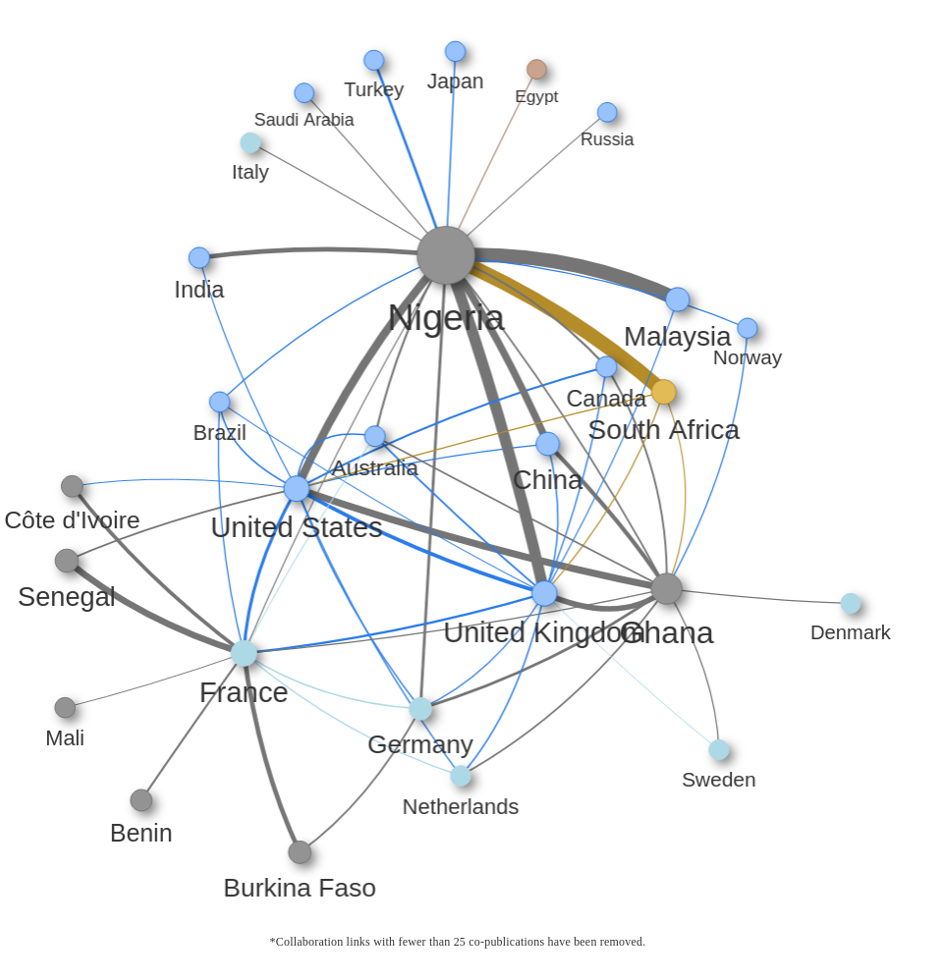Figure 18: Co-publication network of Western African countries in RE-related publications between 2011-2020

Nigeria, the highest of the region in terms of the total number of RE-related publications, is also the centre of mass in the co-publication network of the Western African countries. It is the only Western African country with more than 25 co-publications with a Northern African country (Egypt, 26 co-pub). In a similar manner, together with Ghana, Nigeria is the only Western African Country with more than 25 co-pub. with South Africa (277 pub.).
Ghana and Nigeria have a collaboration link with 40 RE-related co-publications between 2011-2020. However, the collaborations between the two most visible countries in the region with the other countries are relatively sparse. Côte d’Ivoire, Benin, Senegal, Burkina Faso and Mali are mostly engaged in their own cluster. The most visible international partner of that cluster is France. French academic organisations have co-published ~400 papers with Western African countries between 2011-2020 and most of those have been carried out with the mentioned 5 countries. Germany is the second most visible EU-27 country in the region with ~215 co-pub. with Western African countries followed by the Netherlands with 90 co-publications. Those 2 countries along with other EU-27 members like Sweden, Denmark and Italy are mostly engaged with the Nigeria-Ghana cluster.
Especially Nigeria has other international collaborations with relatively high output in terms of RE-related publications. A few examples of those are the collaborations with Malaysia (275 co-pub.), United Kingdom (215 co-pub.), United States (160 co-pub.) and China (40 co-publications).
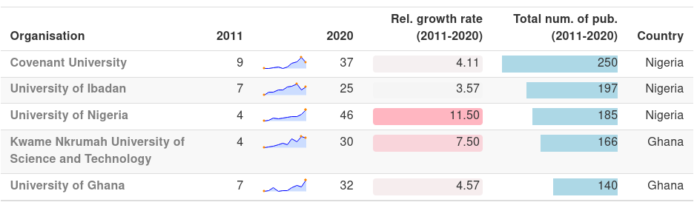Table 5: The most visible organisations from Nigeria, Ghana, Senegal cluster
All of the most visible 3 organisations in the Nigeria, Ghana, Senegal cluster are from Nigeria. The number of RE-related publications of Covenant University, the most visible organisation in the region, seems to be declining presumably because of the latency in document entries into WoS databases after 2019.
Other than Covenant University total RE-related publication outputs of other most visible organisations in Western Africa are relatively close to each other. The University of Nigeria has the highest relative growth rate of 11.5 (from 4 pub. in 2011 to 46 in 2020). Other than the University of Ibadan, the other 3 organisations were also consistently increasing numbers of their Re-related publications despite two Ghanaian organisations showing slightly more volatile progress.

3.2.2.2 Central Africa
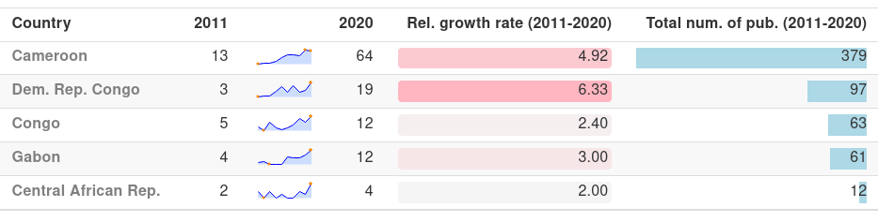Table 6: RE-related publication output in Central African countries

In the Central African region, the publication output in RE-related topics is relatively volatile. Cameroon shows a steady increment between 2011-2020 (see 3.24) with a total output of 379 RE-related publications in 10 years. Other than Cameroon, the total number of RE-related publications in other Central African countries stays under 100 in total between 2011-2020. Democratic Republic of Congo (DRC) is the second most visible country in the region; although DRC displays high volatility in number of yearly RE-related publications, 19 publications in 2020 is over 6 fold of the 3 publications back in 2011. Following 2 countries Republic of Congo and Gabon share similar numbers in general. Both of the countries has a total of ~60 RE-related publications in the 10 years range and the closest following country is Central African Republic with 12 RE-related publications in total.
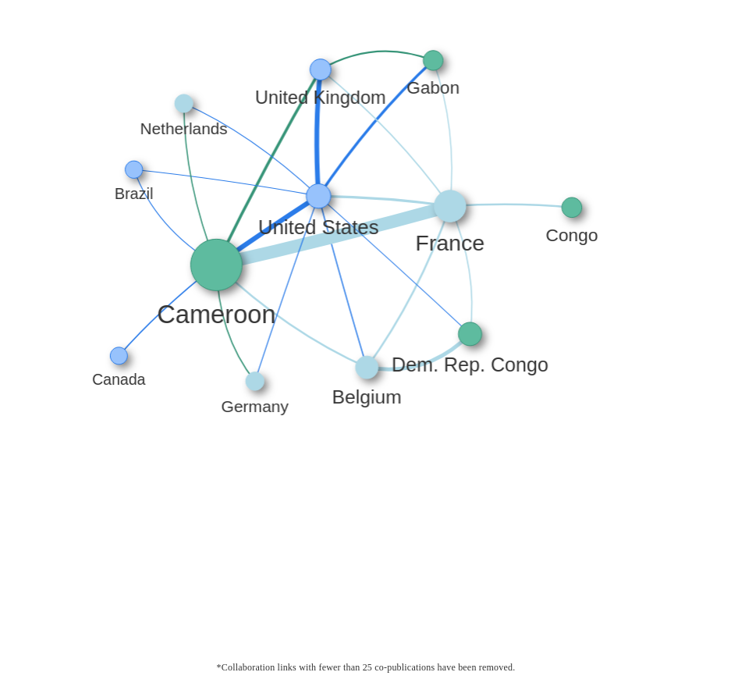Figure 19: Co-publication network of Central African countries in RE-related publications between 2011-2020
Although the publication output is not high in comparison with other regions, most of the publications in Central Africa are produced through intercontinental cooperation.
France is the most visible intercontinental collaborator in the co-publication network in Central Africa with 180 co-pub. in the region; 121 of those co-pub. have been published by collaboration with Cameroon. Belgium is following France with ~90 co-pub. with Central African countries.
All of the visible international collaborators have published at least 25 RE-related co-publications with Cameroon. However, none of the Central African countries seems to have a co-publication link with another Central African country with an output of over 25 publications.
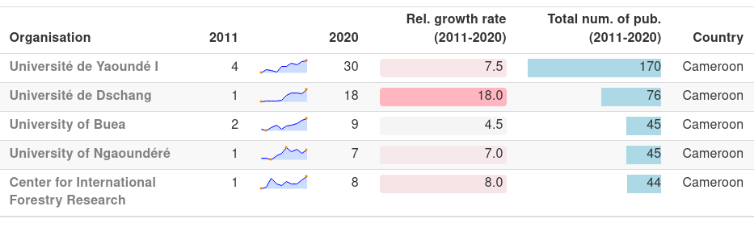Table 7: The most visible organisations from Cameroon, Dem. Rep. Congo, Gabon cluster
In the Cameroon, Dem. Rep. Congo and Gabon cluster, all of the most visible 5 organisations in the region are from Cameroon with the most visible organisation being Université de Yaoundé I with 170 RE-related publications in 2020. None of the organisations in the region has published more than 5 RE-related publications in 2011.
Université de Yaoundé I is followed by Université de Dschang which increased its 1 RE-related publication in 2011 to 18 in 2020 with a total of 76 RE-related publications in the 10-year range. The RE-related publication output of the following 3 organisations; University of Buea, University of Ngaoundéré and University of Douala is still fewer than 10 yearly publications.

3.2.2.3 Eastern Africa
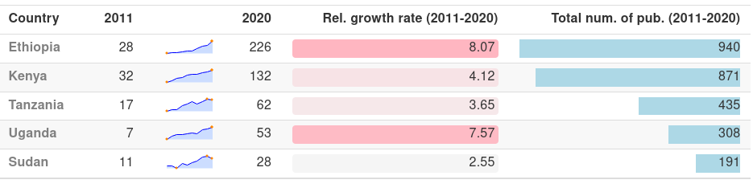Table 8: RE-related publication output in Eastern African countries
The most visible 5 Eastern African countries have been steadily increasing their numbers of RE-related publications. Ethiopia and Kenya are the most visible ones with 940 and 870 publications respectively. Ethiopia’s number of publications in 2020 (226 pub.) is approximately 8 fold the number in 2011 (28).
The second most visible country in the region, Kenya’s yearly output of RE-related publications was also linearly increasing after its already relatively high number in 2011 (32 publications). Tanzania follows Kenya with a fairly stable increment despite having approximately half of Kenya’s total RE-related number of publications. Despite having 7 RE-related publications in 2011 Uganda is 4. most visible country in Eastern Africa after increasing its RE-related publication output ~7.5 fold. Sudan is the 5. most visible country in Eastern Africa with ~200 publications in total.

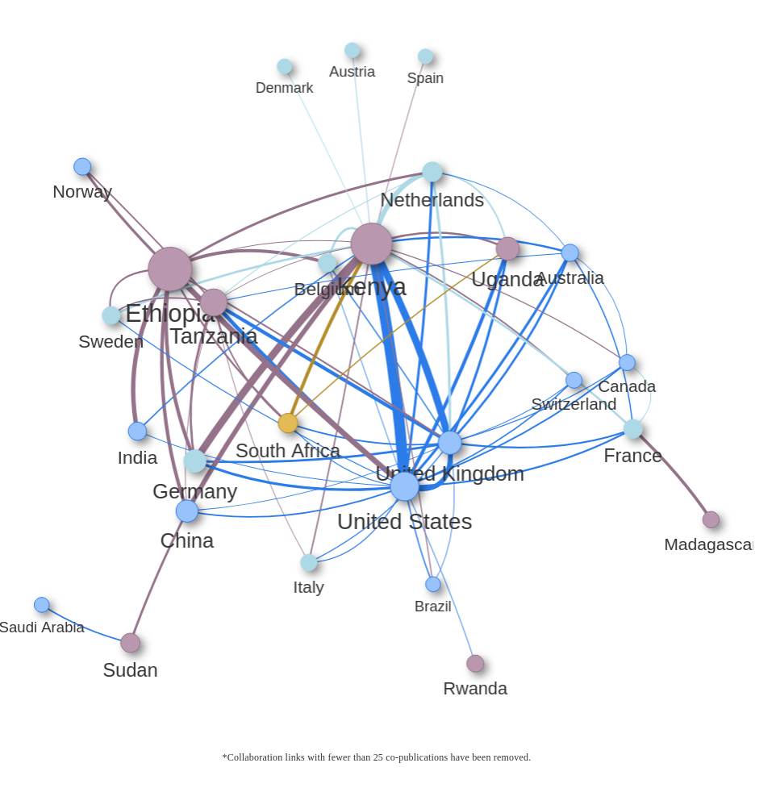Figure 20: Co-publication network of Eastern African countries in RE-related publications between 2011-2020
The 4 most visible countries in Eastern Africa; Ethiopia, Kenya, Tanzania and Uganda are fairly interconnected in terms of RE-related co-publications with each other as well as with international collaborators. A number of EU-27 countries like France, Italy, Germany, Belgium, Sweden, Netherlands, Austria, Spain and Denmark are engaged in co-publications with Eastern African countries. Both Ethiopia and Kenya display a significant number of co-publications with Germany (72 and 134 pub. respectively). Although Ethiopia has the highest number of RE-related publications, Kenya seems to have more international co-publication links with relatively high co-publication output.
Several Eastern African countries have only international collaborations with more than 25 co-publications. That includes Madagascar with France as the only collaborator (63 co-pub.), Rwanda with United States (26 co-pub.), and Sudan with Saudi Arabia and China.
Other than EU countries the United States and the United Kingdom are also visible international partners engaged in RE-related research with Eastern African organisations. The United States has ~500 (out of 2360 co-pub. with African countries) co-publications with the countries of Eastern Africa.
South Africa is the only African country from another region that has more than 25 RE-related co-publications with the Eastern African countries. South Africa’s total RE-related co-publication output with the Eastern African countries between 2011-2020 is 199.
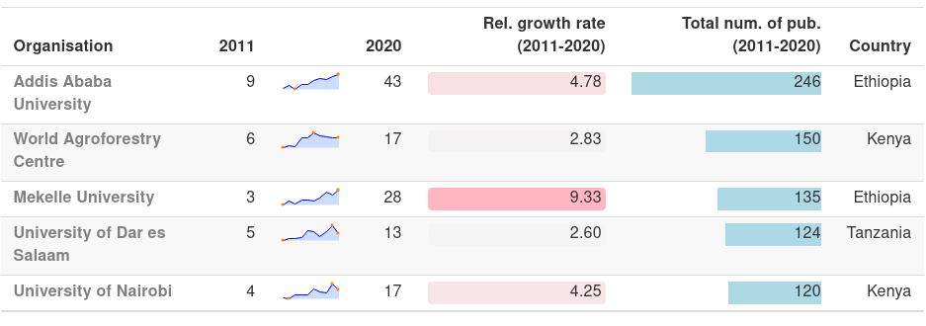Table 9: The most visible organisations from Ethiopia, Kenya, Tanzania cluster
Most visible countries from the selected countries in Eastern Africa, namely Ethiopia, Kenya Tanzania are diverse. Addis Ababa University from Ethiopia is the most visible one with 246 RE-related publications between 2011-2020. The number of publications of Addis Ababa University has been increasing steadily since 2013.
Although World Agroforestry Centre operates in different countries, the main location of the institution is registered as Kenya. World Agroforestry Centre is the second most visible organisation in the Ethiopia, Kenya, Tanzania cluster with a total number of 150 publications between 2011-2020. However, the yearly number of publications are declining since 2016.
Mekelle University of Ethiopia is the third most visible organisation with steady growth in the number of RE-related publications and University of Dar es Salaam is the only organisation from Tanzania in the 5 most visible countries in the selected countries of East Africa followed by the University of Nairobi of Kenya.

3.2.2.4 Selected Institutions and Institutional Co-publication Network
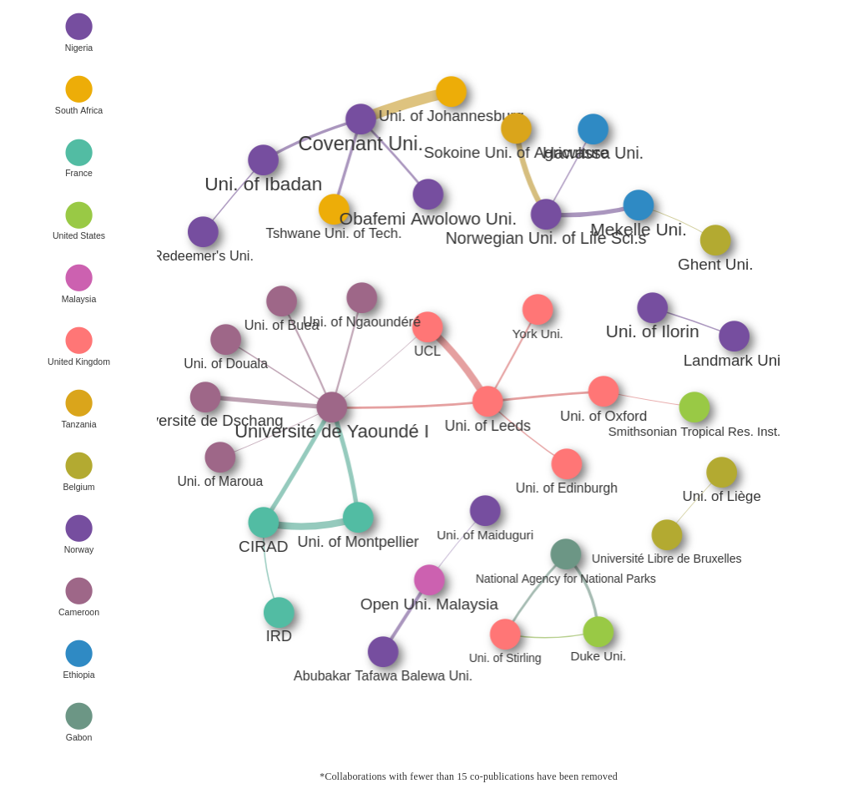Figure 21: Co-publication network of Western, Central, Eastern African organisations in RE-related publications between 2011-2020
Collective organisation network of Western, Central and Eastern African regions displays a couple of interconnected co-publication clusters. Organisations from Cameroon are one of the most visible clusters where Université Yaoundé I stands as a central connection node. Université de Dschang, Uni. of Buea and Université De Ngaoundéré are the other academic organisations from Cameroon which co-published visible amount of RE-related publications with Université Yaoundé I (22, 17 and 17 co-publications respectively). The network of Cameroonian universities is connected to French and British organisations with a visible amount of publications. On the French side Uni. of Montpellier and CIRAD both have 22 co-publications with Université Yaoundé I and on the other side Uni. of Leeds has a collaboration of 18 RE-related co-publications with Université Yaoundé I where other British academic organisations like UCL, Uni. of Oxford and York Uni. are also present in a number of those co-publications.
Nigerian Universities form another visible cluster in the co-publication network whereas Covenant University plays a central role. Uni. of Ibadan and Obafemi Awolowo Uni. both have ~20 co-publications with Covenant University. Also, Covenant University’s collaborations with South African institutions are in the most visible co-pub. connections in the region, University of Johannesburg has co-published 34 RE-related publications with Covenant University.
Other visible collaborations are Norwegian Uni. of Life Sciences’ co-publications with Tanzania’s Sokoine Uni. of Agriculture (24 co-pub.) and with Ethiopia’s Mekelle University (22 co-pub.).

3.2.2.4.1 Covenant University (Nigeria)
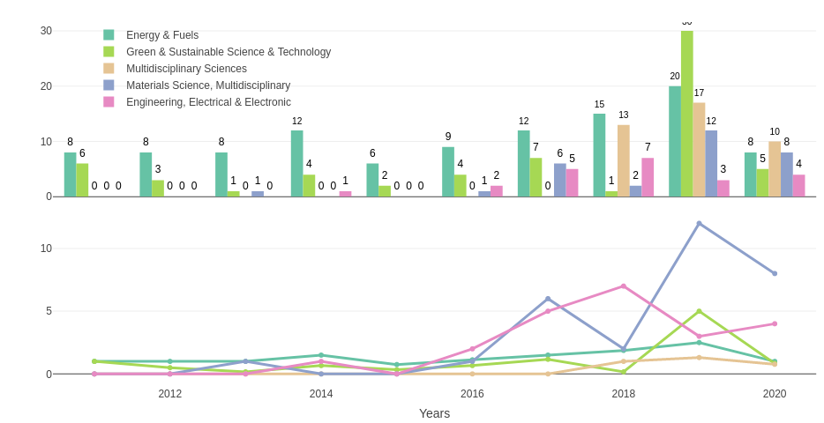Figure 22: Absolute and relative growth of the most visible research areas in RE-related publications of Covenant University between 2011-2020
The most visible research areas are Energy & Fuels and Green & Sustainable Science & Technology respectively in RE-related publications of Covenant University. 2019 is in terms of RE-related publications a peak point for Covenant University, the 2 two most visible areas include 20 and 30 publications respectively in this year.
None of the last three research areas Multidisciplinary Sciences, Material Science and Electrical & Electronic Engineering had more than 1 yearly RE-related publication in Covenant University until 2016. However, although there weren’t any publications in Multidisciplinary Sciences until 2017, the research area has become one of the most visible research areas in Covenant University’s RE-related publications with yearly over 10 publications.

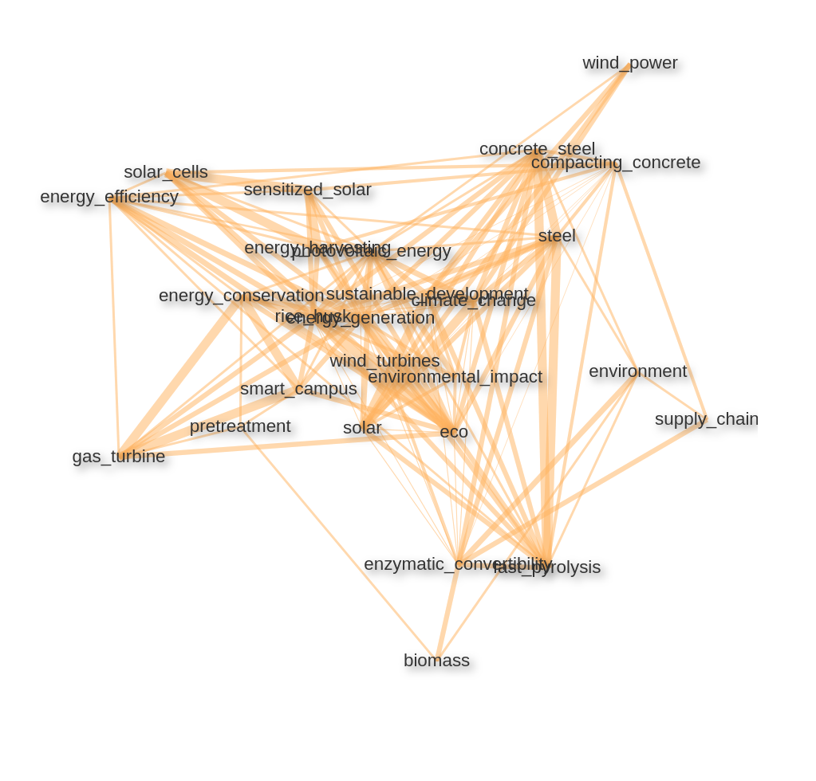Figure 23: Keyword/keyword pair correlation network in RE-related publications of Covenant University
Similar to the research areas keyword/keyword pair correlation network of Covenant University also includes some differing elements. Along with a heavy emphasis on solar and wind energy-related topics, one of the central keyword pairs indicates the research on using rice husk, a byproduct of rice growing, as a biomass fuel. Presumably several mentions of concrete and steel, firstly, relates to the production of those materials with renewable energy, and secondly, as compacting_concrete indicates research on producing environment-friendly forms of (self-) compacting concrete which has more than one benefit for sustainable development (further reading: Long, Gao, and Xie (2015) and Gupta, Siddique, and Belarbi (2021)).
Also, keyword pairs like fast_pyrolysis and enzymatic_convertibility indicate a high number of biomass related studies.

3.2.2.4.2 University of Nigeria

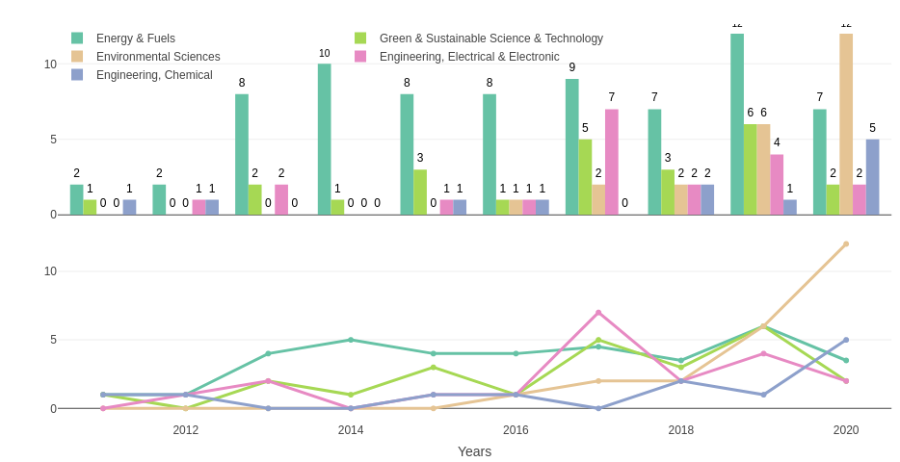Figure 24: Absolute and relative growth of the most visible research areas in RE-related publications of University of Nigeria between 2011-2020
The University of Nigeria also starts with a fairly low number of publications in the now trending research areas. Until 2013 none of the most visible 5 research areas includes a yearly output of over 2 RE-related publications. Energy & Fuels spikes in the later years followed by Green & Sustainable Science & Technology. However, while the two most visible areas are stagnating or declining Environmental Sciences starts to grow in numbers and become together with Chemical Engineering the only areas still rising in 2020.

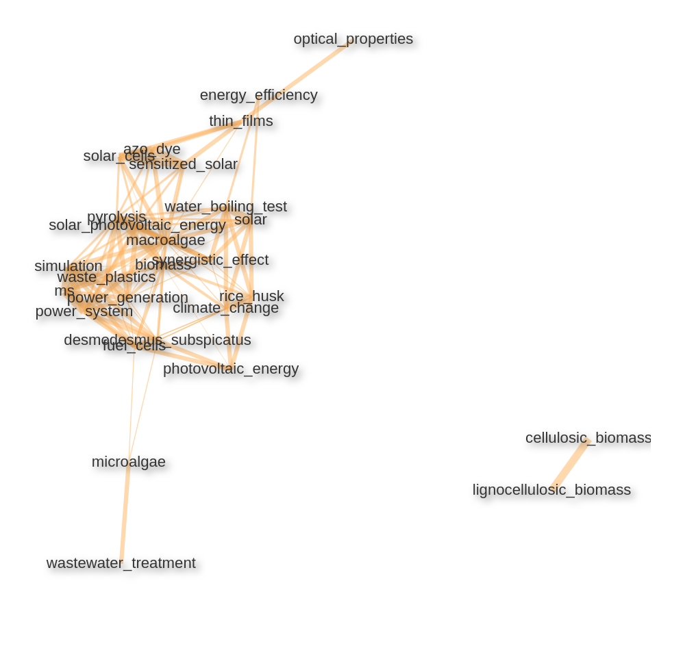Figure 25: Keyword/keyword pair correlation network in RE-related publications of University of Nigeria
The University of Nigeria also includes some unique keyword pairs. Along with the usual emphasized renewable energy forms like solar and wind energy RE-related publications of the University of Nigeria puts high emphasis on biomass related topics. In relation, also micro- and macroalgae are often reoccurring keywords in the RE-related publications of University of Nigeria, these are recently discussed in the renewable energy-related areas because of their potential to be used as biofuel (see Khan, Shin, and Kim (2018)). Also, a couple of keywords pairs indicate wastewater treatment, removal and recycling of waste plastics are also visible topics in the publications of University of Nigeria.

3.2.2.4.3 Université de Yaoundé I (Cameroon)
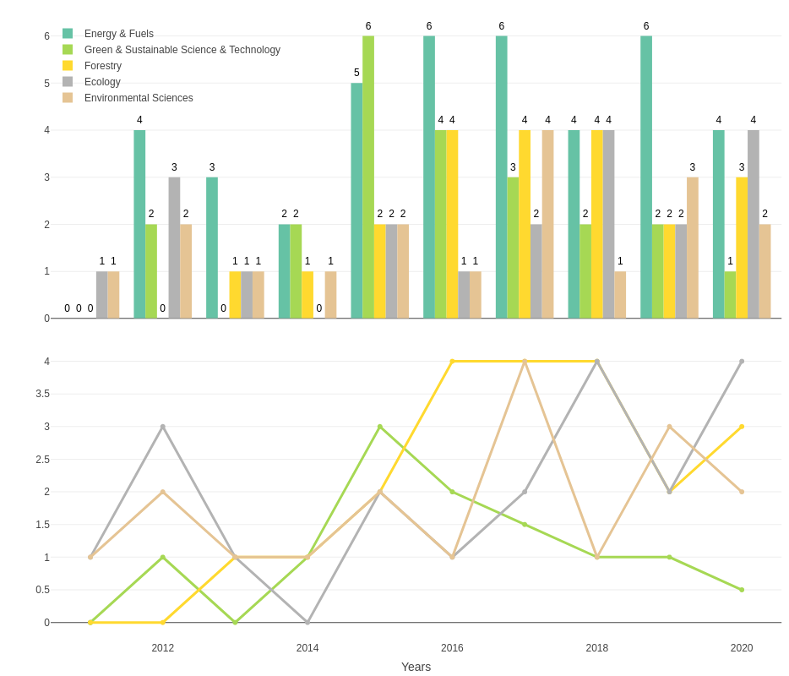Figure 26: Absolute and relative growth of the most visible research areas in RE-related publications of Université de Yaoundé I between 2011-2020
Most visible research areas in the RE-related publications of Université de Yaoundé I are relatively uniformly distributed. Energy & Fuels is the most visible one followed by Green & Sustainable Science & Technology. However, starting with 2015 Forestry, Ecology, and Environmental Sciences gain visibility. Especially the visibility of the research area Forestry is unique to Université de Yaoundé I among the most visible organisations in Africa.

Sadas
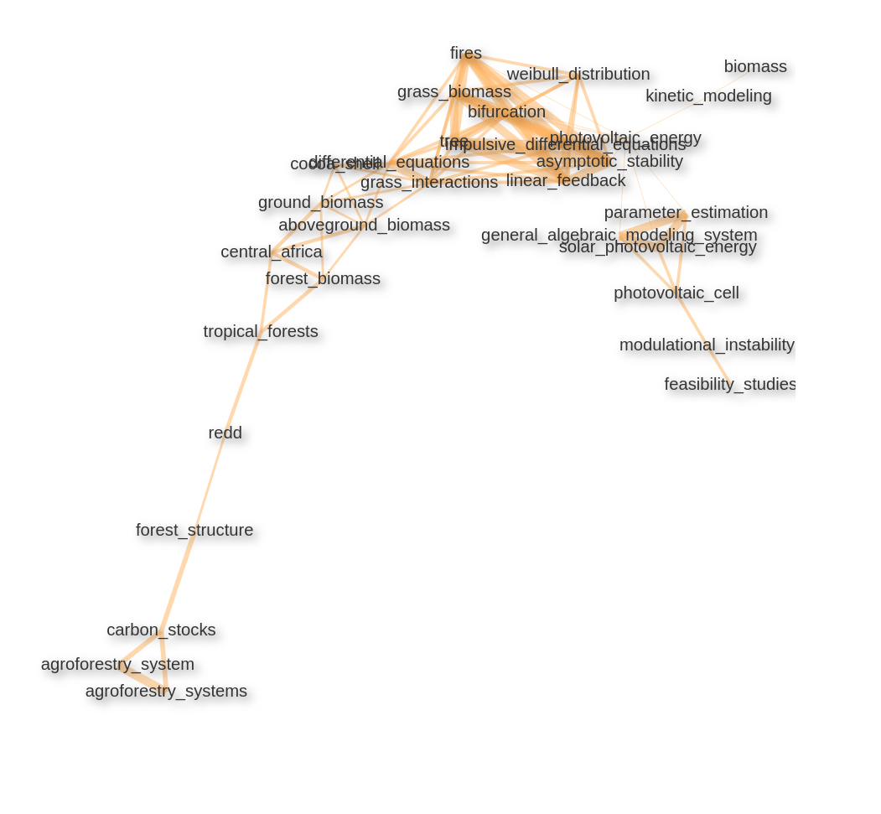Figure 27: Keyword/keyword pair correlation network in RE-related publications of Université de Yaoundé I

Keyword/ keyword pair correlation network also shows the influence of the research area Forestry. Forest/ground biomass research along with tropical forest and forest structure topics shows the main directions of the Forestry research, we also see the use of cocoa shells for green energy often explored in the RE-related research of Université de Yaoundé I.
Other than the biomass and solar energy-related topics keywords also indicates research on different modelling approaches.

3.2.2.4.4 Addis Ababa University (Ethiopia)
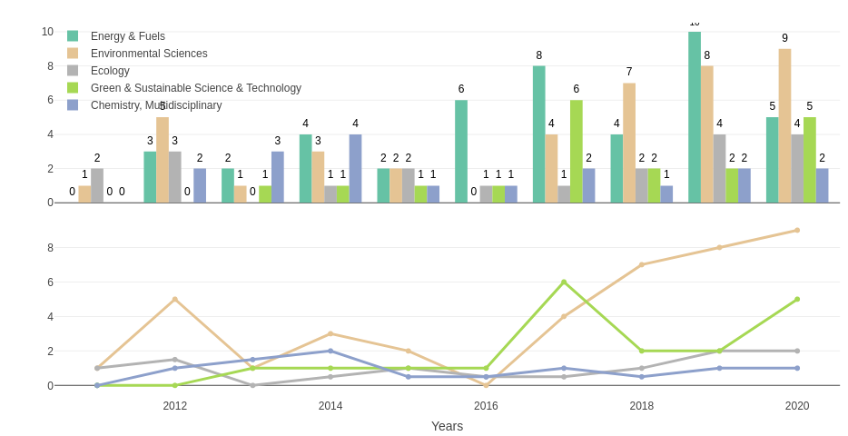Figure 28: Absolute and relative growth of the most visible research areas in RE-related publications of Addis Ababa University between 2011-2020
Similar to the previous visible organisations the most visible research area in the RE-related research of Addis Ababa University is Energy & Fuels. However, Environmental Sciences is the most rapidly increasing area in the number of RE-related publications followed by Ecology, Green & Sustainable Science & Technology, and Multidisciplinary Chemistry.

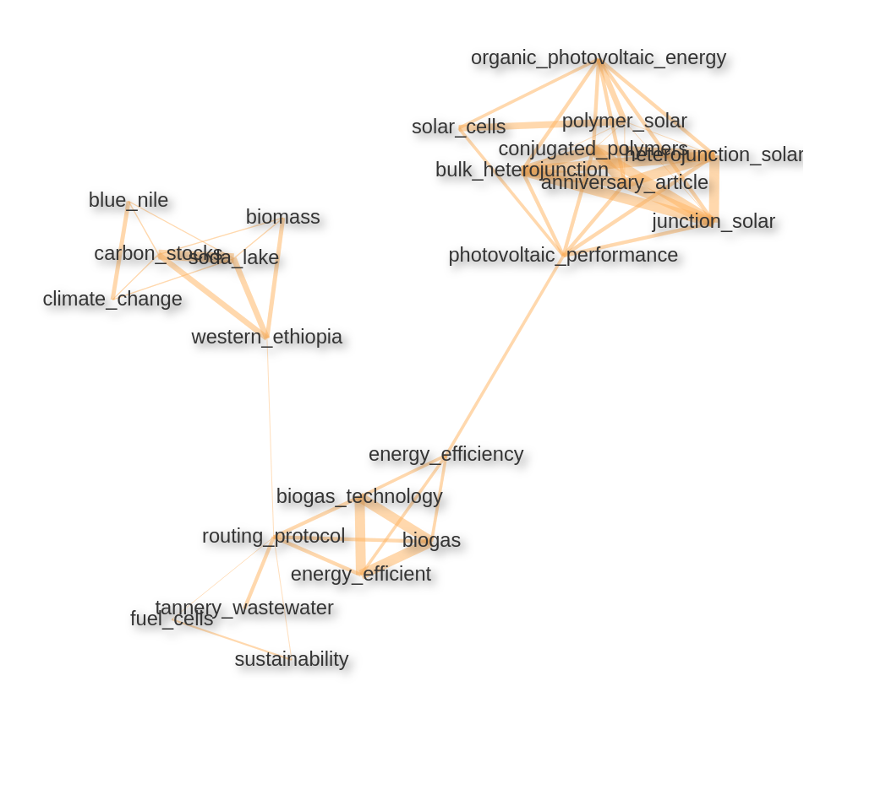Figure 29: Keyword/keyword pair correlation network in RE-related publications of Addis Ababa University
3 clusters of the keyword/keyword pairs in the RE-related publications of Addis Ababa University roughly include biomass, biogas, and solar energy related keywords. In the solar energy cluster, there are keyword pairs that indicate research on different production approaches for photovoltaic components like organic photovoltaic cells (OPV, see Rwenyagila (2017)) and conversion technologies like the heterojunction approach.
In the biomass cluster, there is also the mention of soda lake as there are several soda lakes in the borders of Ethiopia, there is also the Blue Nile Project mentioned which is a massive hydroelectric project on Blue Nile River.

3.2.2.4.5 Mekelle University (Ethiopia)
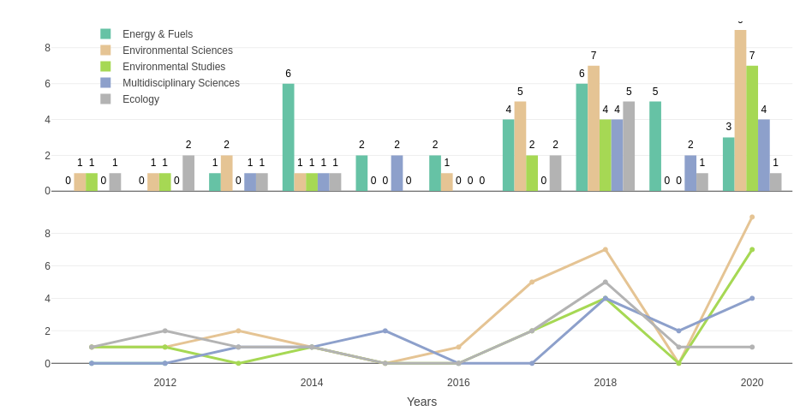Figure 30: Absolute and relative growth of the most visible research areas in RE-related publications of Mekelle University between 2011-2020

The most visible research areas of Mekelle University are Energy & Fuels, Environmental Sciences, Environmental Studies, Multidisciplinary Sciences, and Ecology. Both Environmental Studies and Sciences spike in 2020 after 0 RE-related publications in 2019.
Mekelle University’s keyword pair correlation network displays 2 different clusters which can be roughly labelled as environmental topics and biogas related keywords.
In the first cluster, Ethiopia’s environmental issues like land degradation, diversity of species, water conversation, soil moisture, better land use are the emphasized topics. In relation, there is a high number of publications that mention the use of by-product materials from trees and shrubs as biomass material.
In the second cluster along with the biogas topics, there is an emphasis on health status, indoor air pollution, remote communities like rural Tigray where is an ongoing crisis in the isolated because of the complete isolation from the outer world.

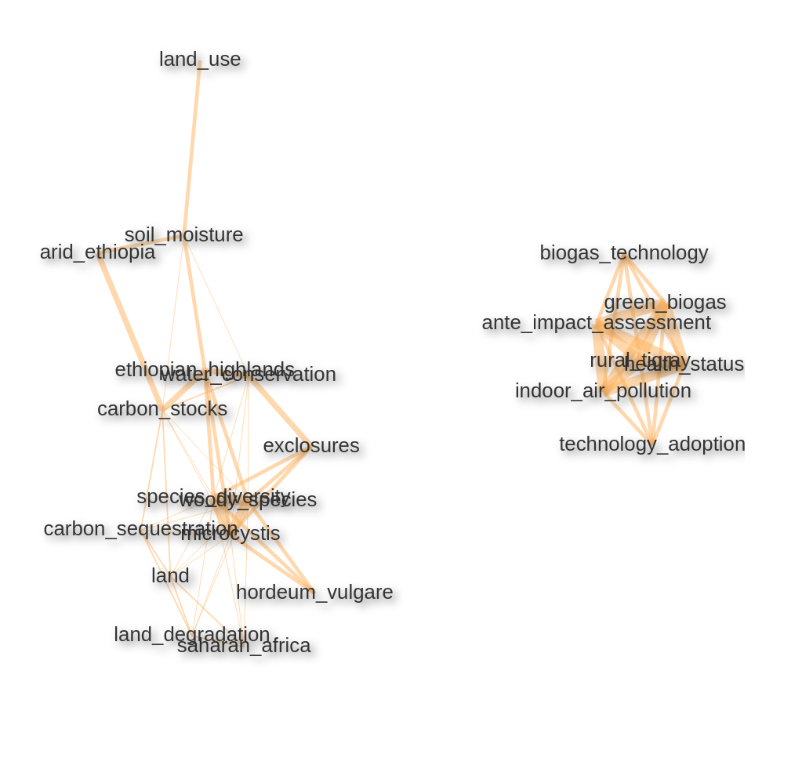Figure 31: Keyword/keyword pair correlation network in RE-related publications of Mekelle University

3.2.3 Southern Africa
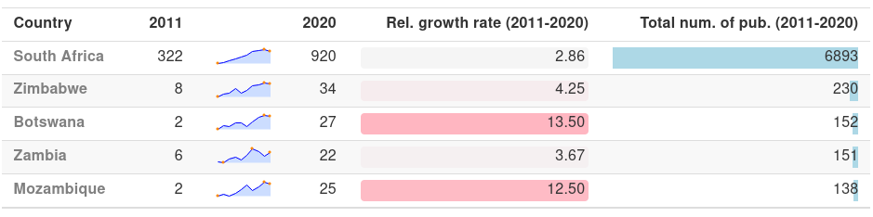Table 10: RE-related publication output in Southern African countries
There is a strong contrast between the Southern African countries in terms of RE-related publication output. While South Africa is the most visible country in the whole continent with ~6900 RE-related publications between 2011-2020 the closest follower Zimbabwe have 230. Other than South Africa and Zimbabwe, the following countries Botswana, Zambia and Mozambique ~150 RE-related publications between 2011-2020 each.
In alignment with the total number of publications, South Africa is the centre of mass in the co-publication network of Southern Africa. All the other visible South African countries have collaborations with South Africa with more than 25 co-publications. South Africa also has strong interregional collaboration with other African countries, which includes Egypt (~30 co-pub.) from Northern Africa; Nigeria (277 co-pub.) and Ghana (27 co-pub.) from Western Africa; Ethiopia (44 co-pub.), Tanzania (38 co-pub.), Uganda (32 co-pub.) and Kenya (68 co-pub.) from Eastern Africa, which makes South Africa the most visible African country also in interregional collaborations. None of the Southern African countries has a collaboration link with more than 25 co-pub. without the involvement of South Africa.
The most visible EU-27 country in the region is Germany with involvement in 373 co-publications. Germany is followed by France with 290 co-pub. and Spain 150 co-publications. However, South Africa’s most visible collaborations are with the United Kingdom and the United States 533 and 701 co-pub. respectively out of United States’ 812 and UK’s 614 co-publications in the region.
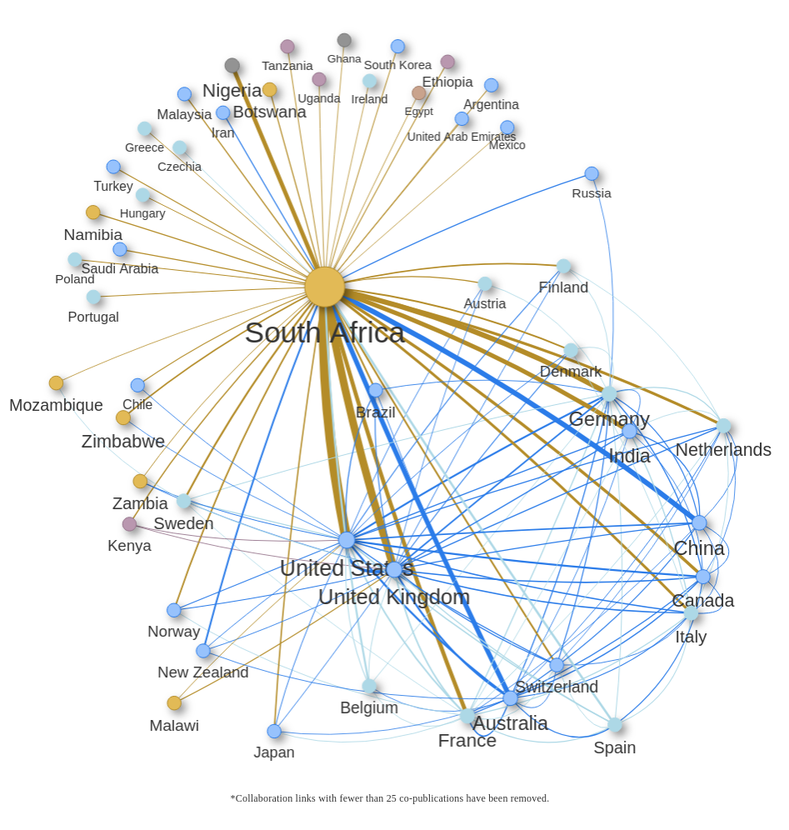Figure 32: Co-publication network of Southern African countries in RE-related publications between 2011-2020

3.2.3.1 South Africa
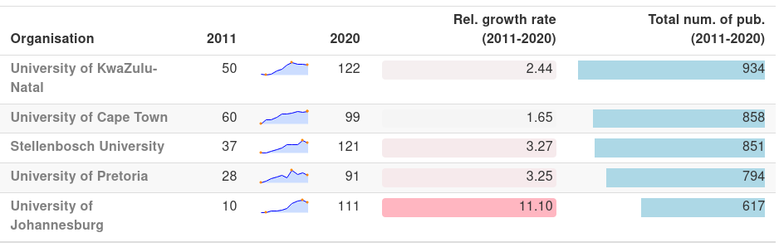Table 11: Re-related publication output of the most visible South African organisations
The most visible 5 organisations in the region are all from South Africa. University of KwaZulu-Natal is the organisation with the highest output of RE-related publications (934 publications). However, the organisation’s RE-related publication output is stagnating since 2017.
University of Cape Town is steadily increasing its RE-related publications since 2011 with a total output of ~860 publications. Stellennosch University is closely following with ~850 RE-related publications between 2011-2020 which despite the decline after 2019 only 1 publication behind University of KwaZulu-Natal. University of Pretoria and University of Johannesburg are following with ~800 and ~620 publications respectively.
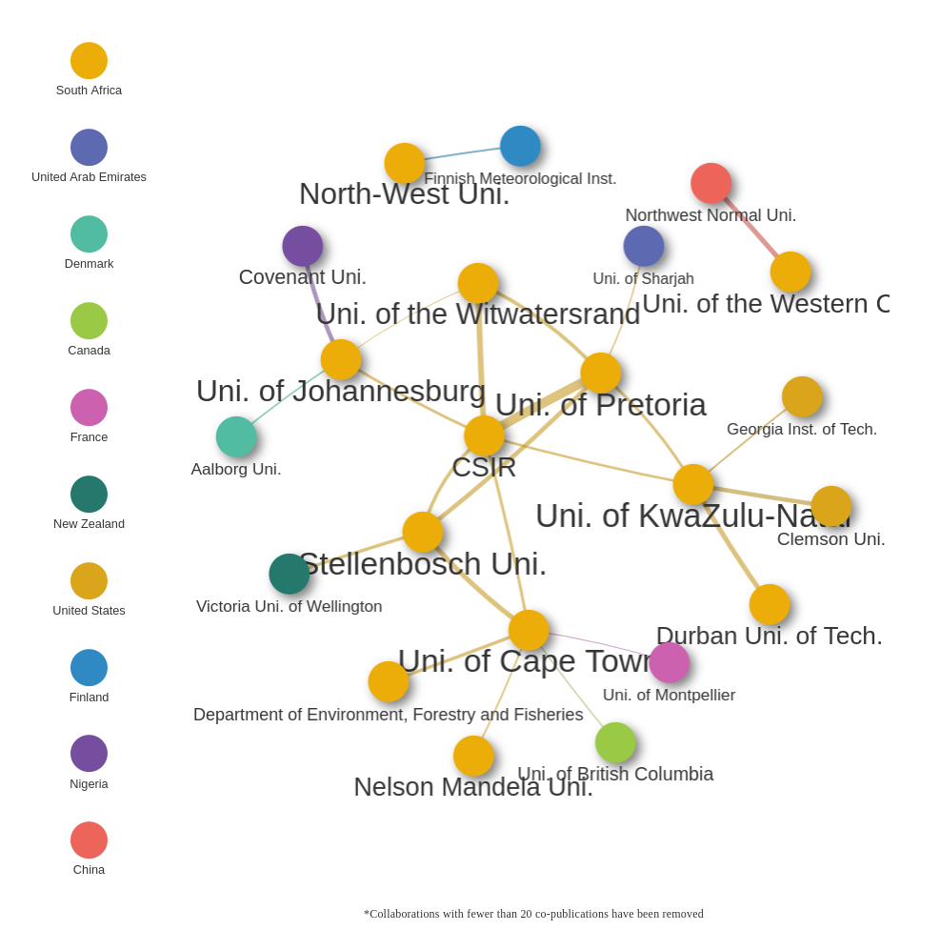Figure 33: Co-publication network of Southern African organisations in RE-related publications between 2011-2020
The Organisation network of South Africa displays a relatively well interconnected co-publication structure with a number of intercontinental collaborators. None of the organisations seems to be the centre of mass in the network.
Some of the notable international collaborations are between China’s Northwest Normal University and University of Western Cape (36 co-pub.), Denmark’s Aalborg University and University of Johannesburg (23 co-pub,), UAE’s Uni. of Sharjah and University of Pretoria (22 co-pub.), New Zealand’s Victoria University of Wellington and Stellenbosch University (~30 co-pub.), France’s University of Montpellier and University of Cape Town (20 co-pub.) and Canada’s Uni. of British Columbia and University of Cape Town (23 co-pub.). Also, as an interregional collaboration between African organisations, Nigeria’s Covenant University has 34 RE-related co-publications with University of Johannesburg.

3.2.3.1.1 University of KwaZulu-Natal
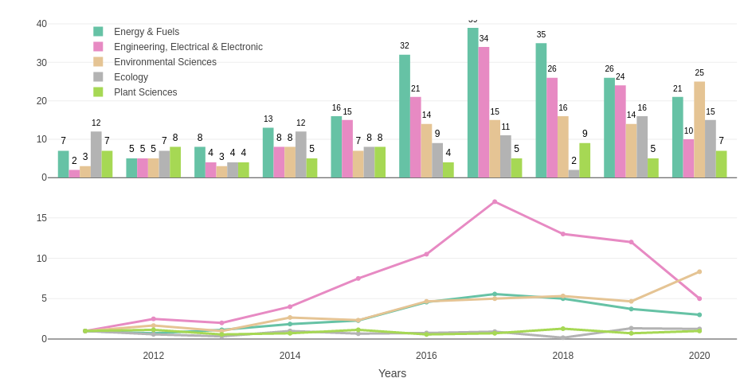Figure 34: Absolute and relative growth of the most visible research areas in RE-related publications of University of KwaZulu-Natal between 2011-2020
The most visible areas in University of KwaZulu-Natal’s publications are Energy & Fuels and Electrical & Electronic Engineering. However, as seen previously in other organisations both of those fields start to decline in numbers after 2017. Instead, the number of publications in Environmental Sciences keeps growing followed by Ecology in a relatively stable manner. Other than this reoccurring pattern University of KwaZulu-Natal has uniquely Plant Sciences as one of the most visible areas.
As unique keyword pairs, University of KwaZulu-Natal’s keyword correlation network includes the mention of estuarine lakes. The exploitation of the tidal energy where salty and freshwater meet is an often discussed topic (see for example Ross et al. (2021)) and the largest estuarine lake in Southern Africa, namely Saint Lucia, is located in South Africa.
Other keyword pairs show great diversity. Generally trending topics like solar and wind energy-related keyword pairs are also present in University of KwaZulu-Natal’s network. As a unique biomass related keyword, c4 grass type is often mentioned in the publications in University of KwaZulu-Natal which ar referring to a specific type of grass that can be used effectively for biofuel production (see van der Weijde et al. (2013)).

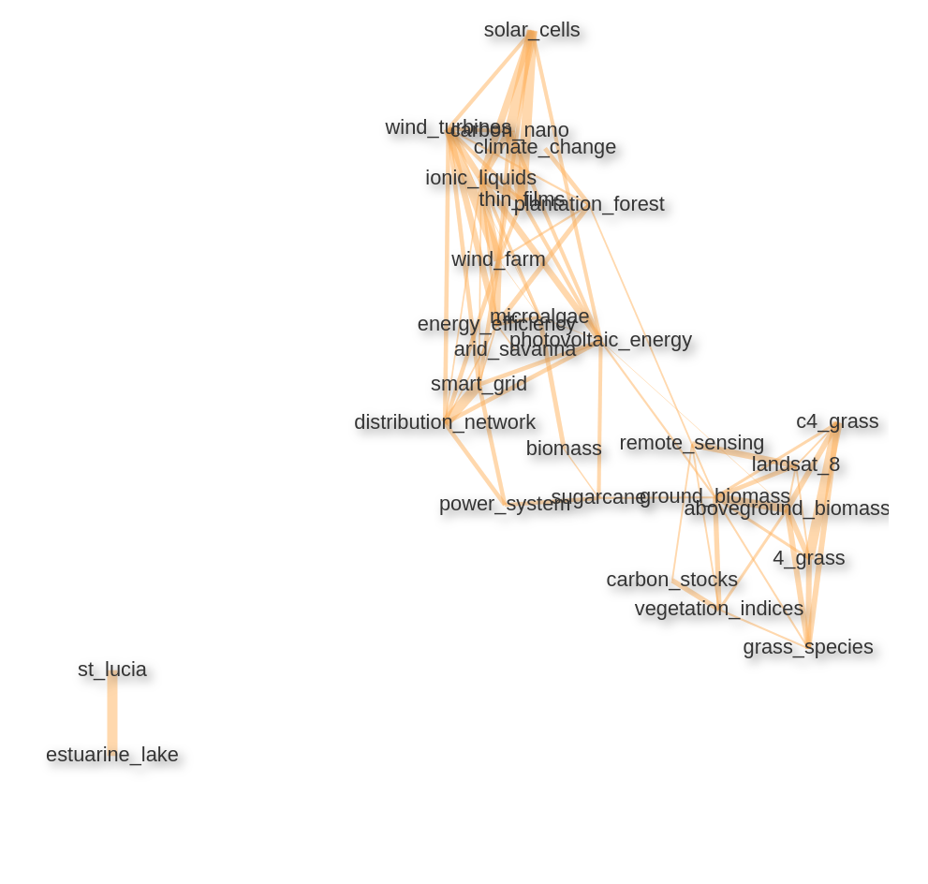Figure 35: Keyword/keyword pair correlation network in RE-related publications of University of KwaZulu-Natal

3.2.3.1.2 University of Cape Town
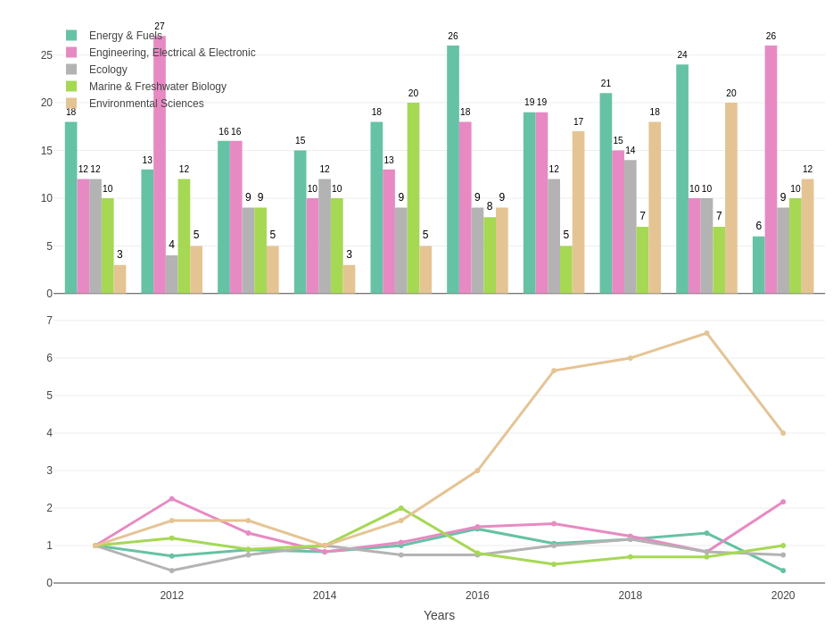Figure 36: Absolute and relative growth of the most visible research areas in RE-related publications of University of Cape Town between 2011-2020
Similar to University of KwaZulu-Natal, the most visible research areas in the RE-related publications of University of Cape Town are Energy & Fuels and Electrical & Electronic Engineering followed by Ecology. Uniquely, the most visible 5 research areas of University of Cape Town include Marine & Freshwater Biology which stays number of publication wise relatively stable over the years. Despite the decline in numbers in 2020 Environmental Sciences is steadily growing in numbers.
University of Cape Town’s keyword/keyword pair network clearly shows the influence of Marine & Freshwater Biology in one of its clusters. Marine ecosystem especially in Southern Benguela is a reoccurring topic in the publications of the University of Cape Town.
Other than that, along with the high emphasis on photovoltaic energy environmental topics like environmental impact and carbon footprint are also visible keyword pairs.

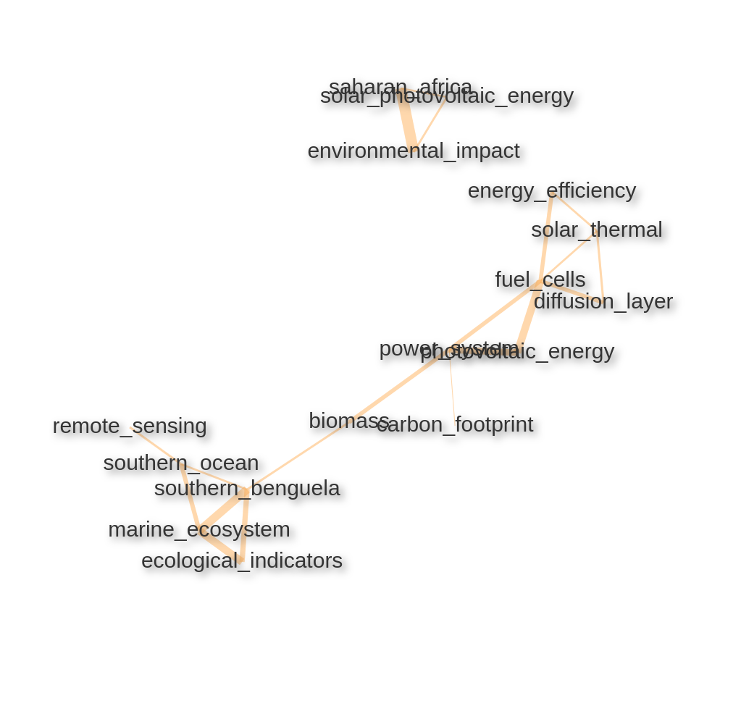Figure 37: Keyword/keyword pair correlation network in RE-related publications of University of Cape Town

3.2.3.1.3 Stellenbosch University
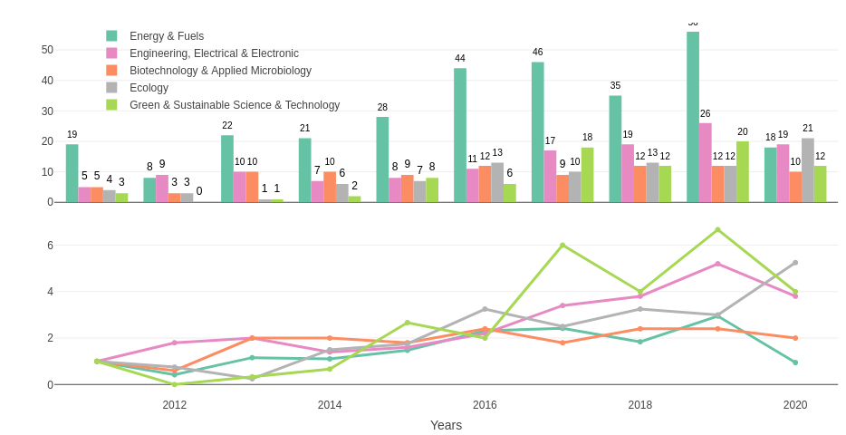Figure 38: Absolute and relative growth of the most visible research areas in RE-related publications of Stellenbosch University between 2011-2020
Similar to the other South African organisations Stellenbosch University’s most visible research areas are Energy & Fuels and Electrical & Electronic Engineering. A unique research area Biotechnology & Applied Microbiology is following the most visible 2 research areas in a consistent manner. Ecology and Green & Sustainable Science & Technology are following those with Ecology having the highest number of publications in 2020.
Wind energy-related keyword pairs are emphasised more in the publications of Stellenbosch University than in any other South African country.
Research on types of yeast like Pichia Pastoris and fungi like Saccharomyces Cerevisiae presumably because of the high number of publications in Biotechnology & Applied Microbiology (see Benjamin, Bakare, and Effiong (2020) and Siripong et al. (2018) for their possible uses for RE).
Other than that, a number of biomass, biogas and bioprocessing methods are also highly emphasised in the RE-related publications of Stellenbosch University.

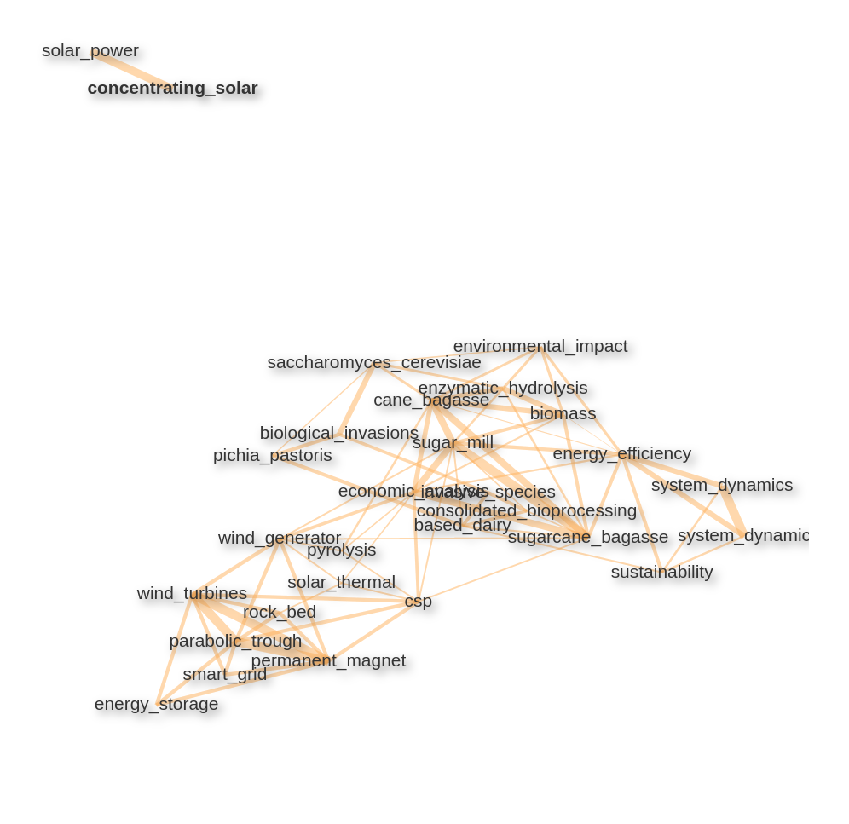Figure 39: Keyword/keyword pair correlation network in RE-related publications of Stellenbosch University

3.3 Domain Analysis
This chapter is mainly interested in analysing RE-related publications of African countries separated into the 5 research domains (Physical Sciences, Technology, Life Sciences & Biomedicine, Social Sciences, and Arts & Humanities) in order to offer a different perspective on the characteristics by reviewing the most visible institutional pairings and trending themes in each category. In order to exclude pairings from the same country institutional pairings have been chosen from the collaborations with at least an interregional partnership.

3.3.1 Physical Sciences
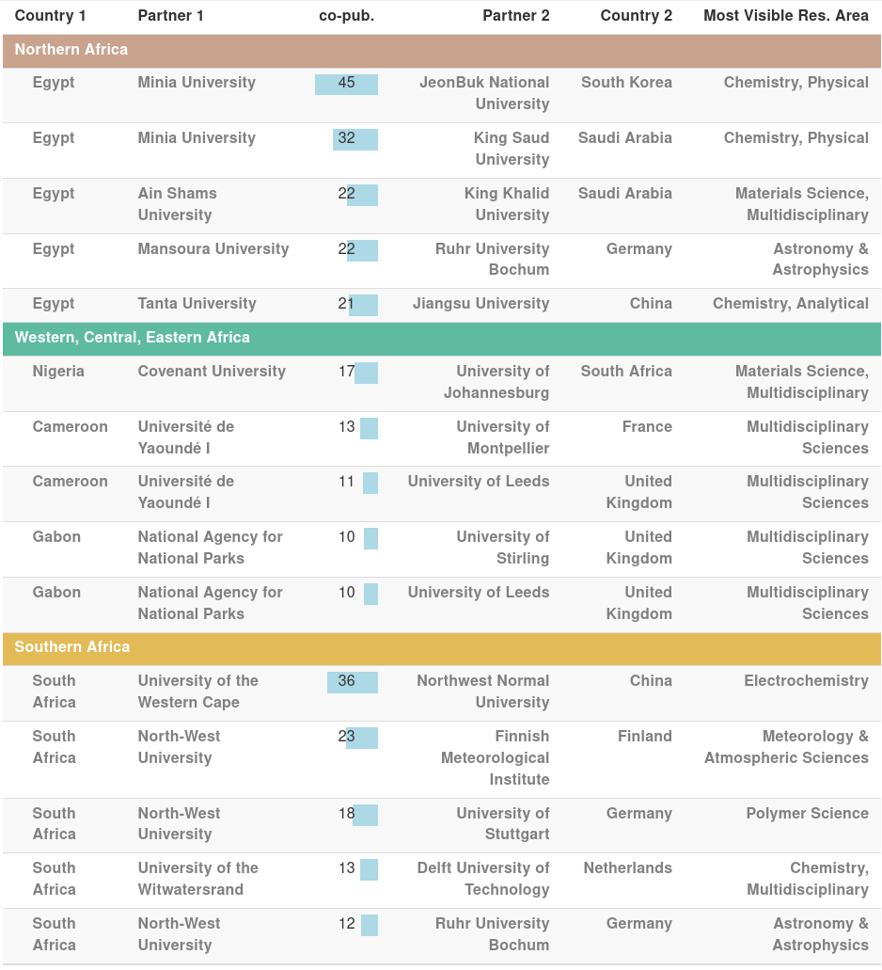Table 12: The most visible co-publication pairings in Physical Sciences
Looking at the international collaborations in the research domain of Physical Sciences the top pairings seems to be the co-publication partnerships between African and East Asian countries. Co-publication partnership between Egypt’s Minia University and South Korea’s JeonBuk National University is the most visible one in terms of RE-related number of co-publications followed by the collaboration between University of the Western Cape of South Africa and China’s Northwest Normal University.
The most visible Co-publication pairings in Northern and South Africa are occupied by Egyptian and South African organisations because of their high number of RE-related publication outputs. Egypt’s high number of co-publications with Saudi Arabian institutions is also visible among the pairings, 2 of the most visible 5 pairings are between Egypt’s Minia and Ain Shams Universities collaboration with Saudi Arabia’s King Saud and King Khalid Universities respectively. 2. and 3. of the 5 most visible pairings in Southern Africa belong to North-West University of South Africa with Finnish Meteorological Institute and University of Stuttgart.
In the Western, Central and Eastern Africa cluster the most visible pairing is between Nigeria’s Covenant University with South African University of Johannesburg which is the only interregional African collaboration in the most visible co-publication collaborations in Physical Sciences. Other than Université de Yaoundé I’s (Cameroon) collaborations with University of Montpellier of France and the UK’s University of Leeds are also in the most visible organisational pairings. University of Leeds has also together with University of Stirling visible co-publication partnership with National Agency for National Parks of Gabon.
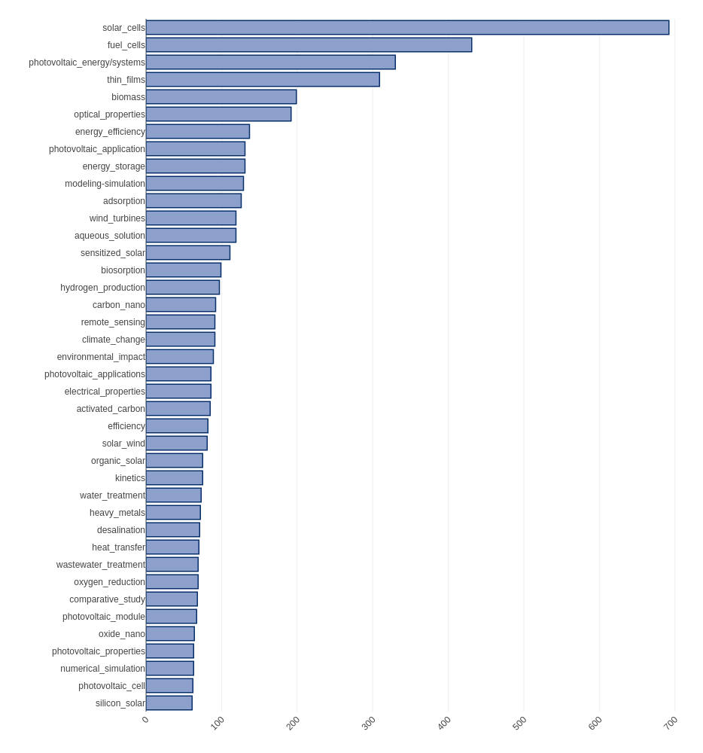Figure 40: The most Visible keywords/ keyword pairs in Physical Sciences
The most visible keywords and keywords pairs in Physical Sciences refer to solar energy and components used in photovoltaic systems like thin films as Figure 40 displays. In relation, those keywords are also increasingly trending in the last years as in Figure 41. One of the rising keyword pairs in the last couple of years is indicating research on the optical properties of different substances which can play a critical role in the advancements in the absorption of solar energy. Similarly, solar adsorption cooling/ refrigeration systems are also often mentioned in RE-related publications in the Physical Science domain.
Technologies like fuel cells that convert the energy from fuels more effectively into electricity in comparison with their less green counterparts like combustion engines are also in the trending keywords. Biomass and wind energy-related keyword pairs are also following the solar energy topics. Other than, using green energy forms to produce hydrogen instead of fossil fuels is also a visible topic in the Physical Science keywords.
Environmental topics are also often mentioned in the RE-related topics. Other than measuring the environmental impact of different kinds of energy production types there are also keyword pairs mentioning water/wastewater treatment, desalination.
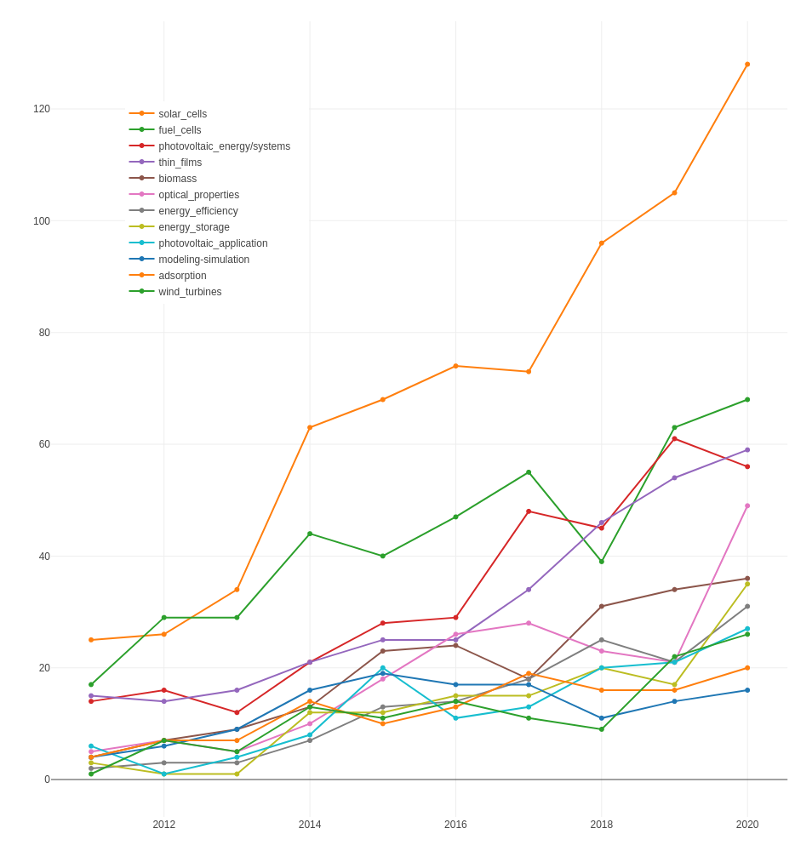Figure 41: The most visible keywords/keyword pairs over the years in Physical Sciences

3.3.2 Technology
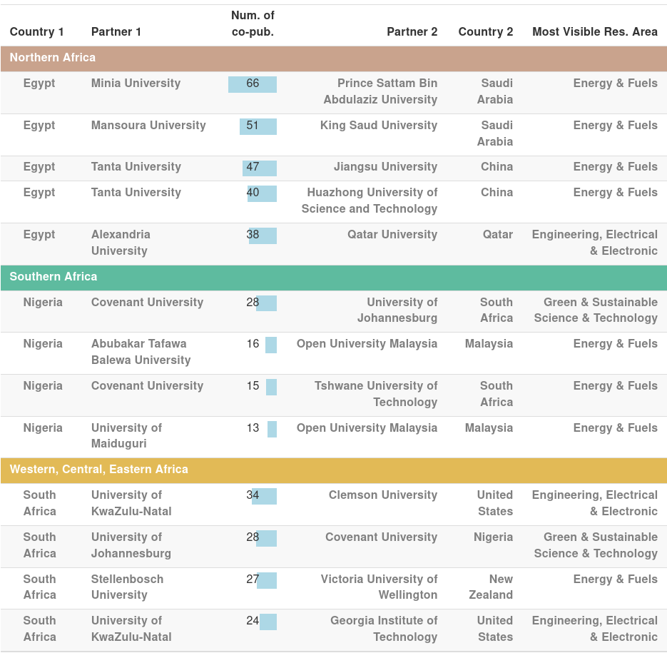Table 13: The most visible co-publication pairings in Technology
2 of the most visible collaborations in the Technology domain are between Egyptian and Saudi Arabian organisations, namely between Minia University and Prince Sattam Bin Abdulaziz University, and between Mansoura University and King Saud University. All of the first 5 most visible pairings are from Northern Africa and specifically from Egyptian universities. Tanta University’s 2 partnerships with Chinese organisations Jiangsu University and Huazhong University of Science and Technology are the most visible 3. and 4. pairings followed by Alexandria University’s collaboration with Qatar University.
All of the most visible pairings in Southern Africa are associated with South African organisations with the most visible one being between University of KwaZulu-Natal and Clemson University from the United States. The following partnership between University of Johannesburg and Covenant University of Nigeria is also the most visible pairing in the Western. Central, Eastern Africa cluster. All of the most visible pairings from this cluster are occupied by the Nigerian Universities. 2 of them are with Malaysian organisations and another one is again between Nigerian Covenant University and South African Tshwane University of Technology.
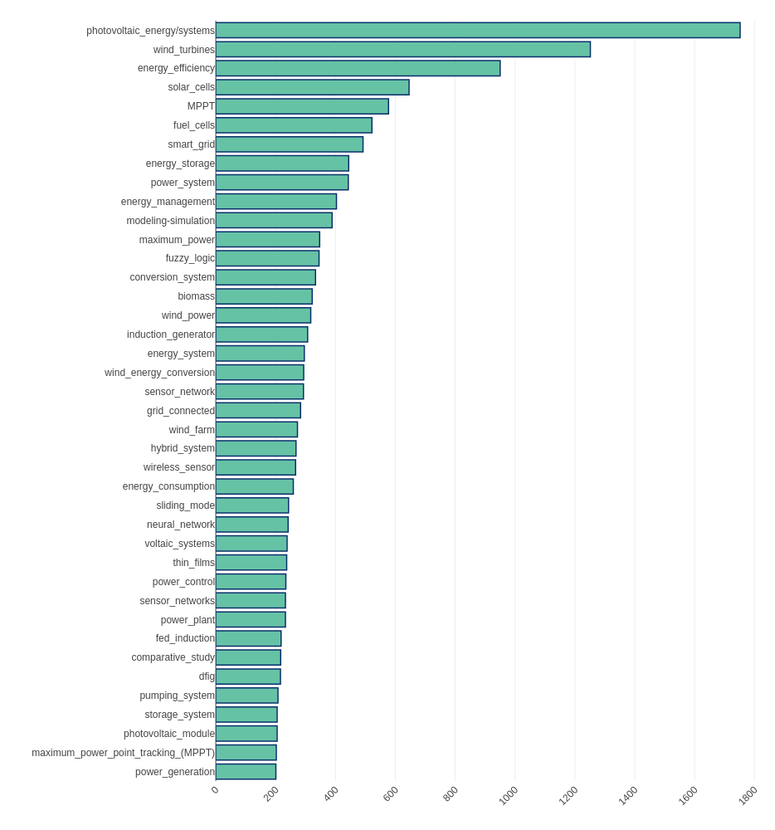Figure 42: The most visible keywords/ keyword pairs in Technology
The most visible keywords and keyword pairs in Technology show similarity to the trending topics in Physical Sciences. Photovoltaic systems, wind tribunes, fuel cells are among the most visible keyword pairs. The maximum power point tracking (MPPT) technique for algorithmic improvement for the energy extraction from (mostly) photovoltaic systems is one of the most often mentioned keywords. Similarly, algorithmic control systems for photovoltaic and wind energy like fuzzy logic are also among the trending keyword pairs in the Technology domain. Research areas under Technology seem to be also focusing heavily on energy management methods like energy storage, conversion, maximization.
As on Figure 42 the most visible keyword pairs under Technology seems to be either stagnating or falling in terms of number of publications after 2017. This might indicate there are other topics growing in Technology related areas which are not apparent yet.

Sd
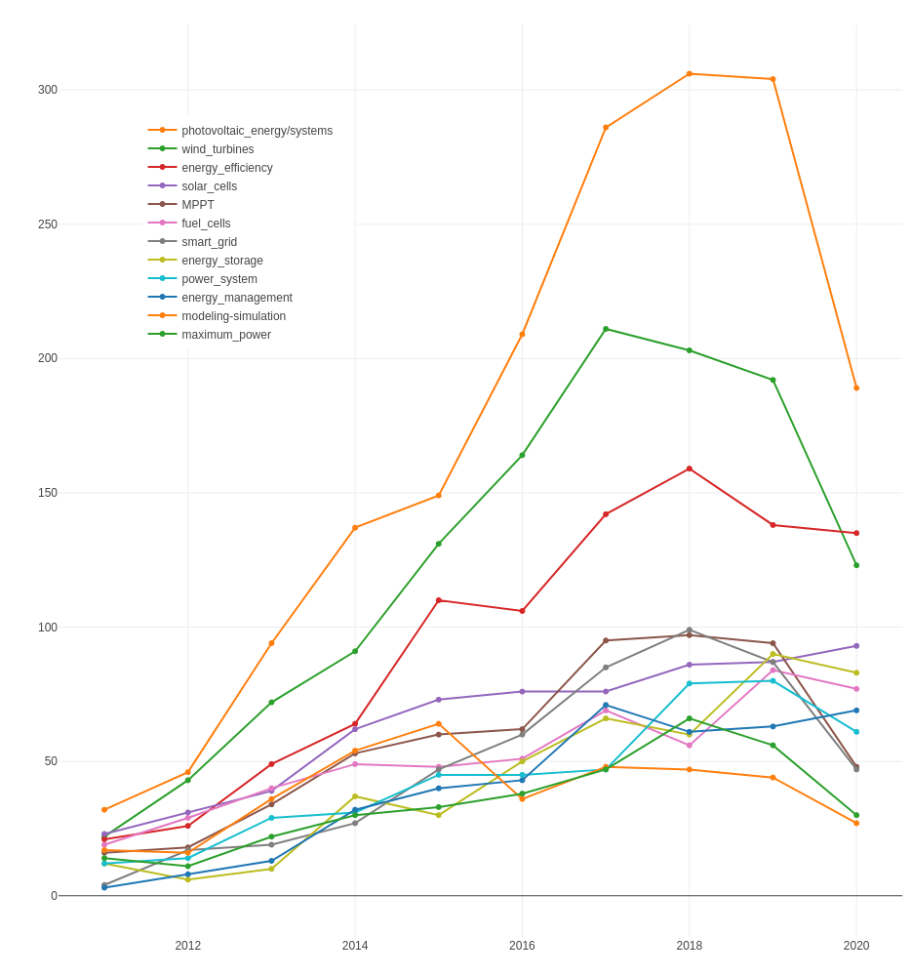Figure 43: The most visible keywords/keyword pairs over the years in Technology

3.3.3 Life Sciences & Biomedicine
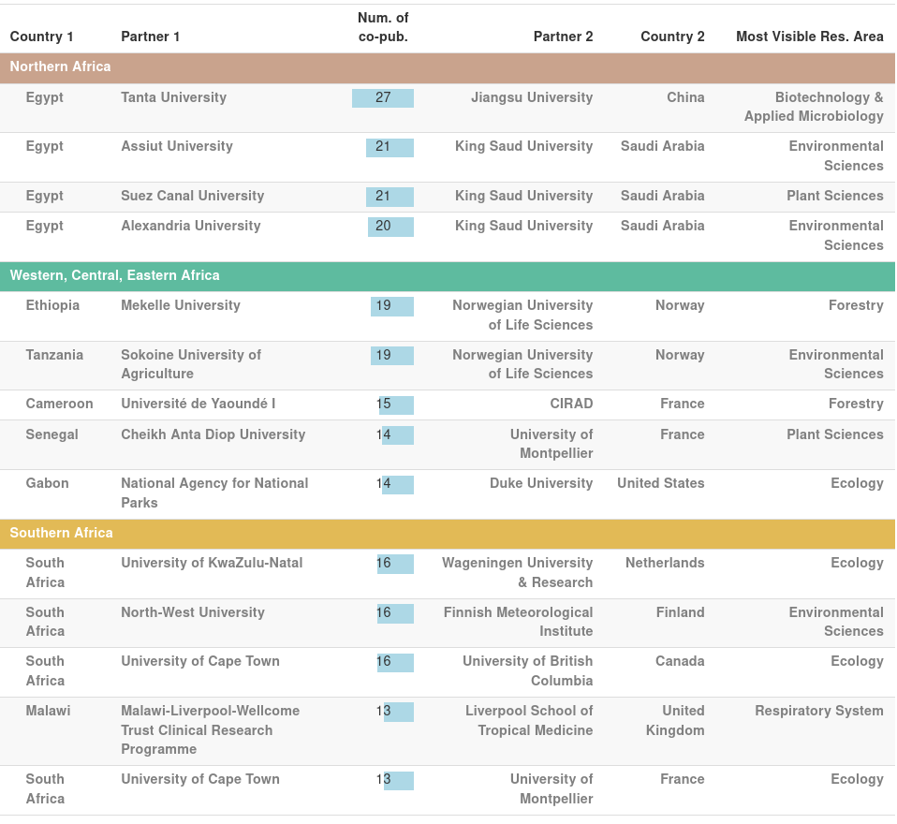Table 14: The most visible co-publication pairings in Life Sciences & Biomedicine
The most visible pairing in Life Sciences & Biomedicine is between Egypt’s Tanta University and Jiangsu University of China. All the following 3 pairings are between Egyptian organisations Assiut, Suez Canal and Alexandria Universities with King Saud University of Saudi Arabia.
2 of the most visible pairings in the West, Central, East Africa cluster are the collaborations between Ethiopian Mekelle University and Tanzanian Sokoine University of Agriculture with Norwegian University of Life Sciences. French organisations CIRAD and University of Montpellier ’s collaborations with Université de Yaoundé I (Cameroon) and Cheikh Anta Diop University (Senegal) are other visible collaborations from the region.
In Southern Africa, the most visible pairing is between University of KwaZulu-Natal of South Africa with the Netherlands’ Wageningen University followed by North-West University’s collaboration with Finnish Meteorological Institute and University of Cape Town’s collaborations with University of British Columbia (Canada).
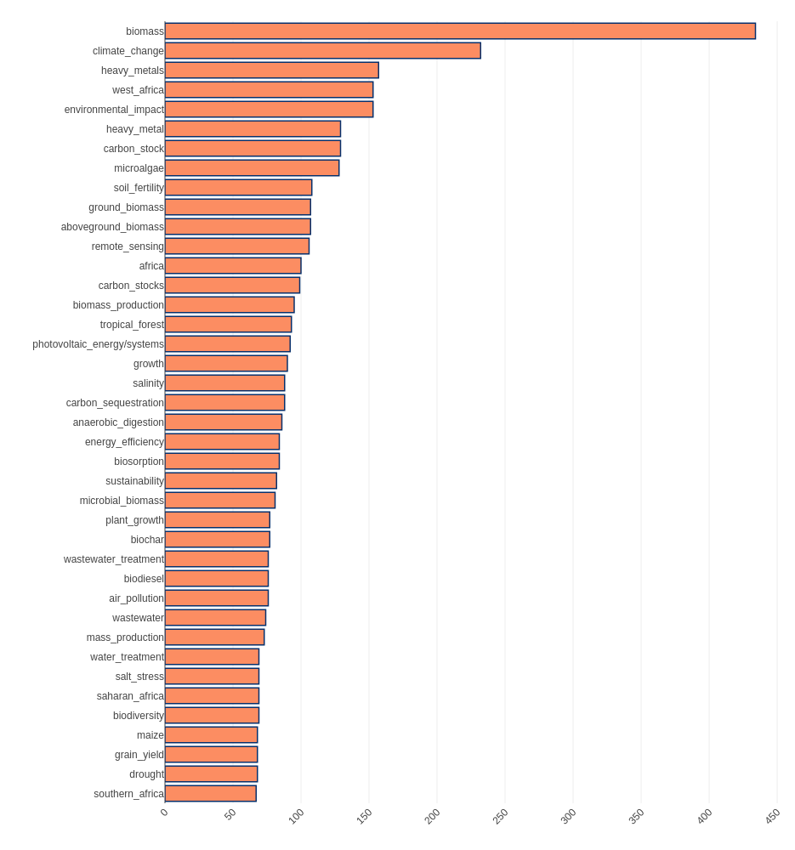Figure 44: The most visible keywords/ keyword pairs in Life Sciences & Biomedicine
Biomass related keywords are by far the most visible ones in the RE-related publications in Life Sciences & Medicine. Climate change and environmental impact related keywords are also among the most often mentioned topics and are increasingly more often mentioned. Also as related trending topics soil fertility, water/wastewater treatment, plant/grain growth topics are heavily emphasised in the RE-related publications under Life Sciences & Biomedicine. Air pollution, as well as heavy metal waste, are also among the visible keywords.

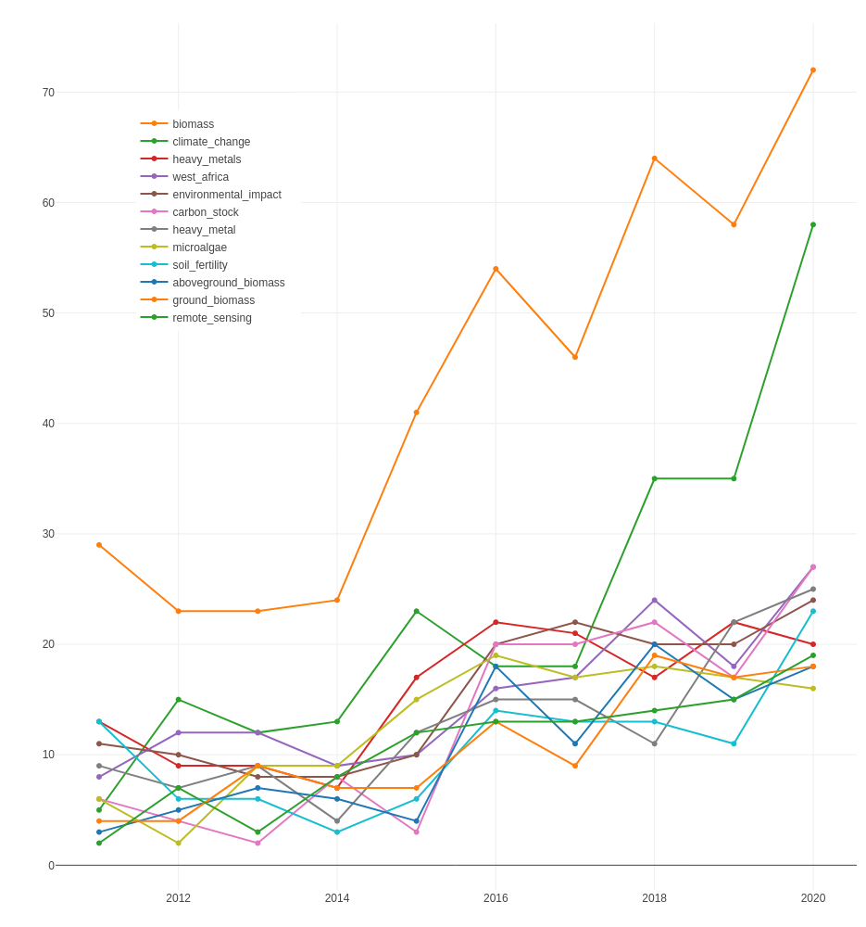Figure 45: The most visible keywords/keyword pairs over the years in Life Sciences & Biomedicine

3.3.4 Social Sciences and Arts & Humanities
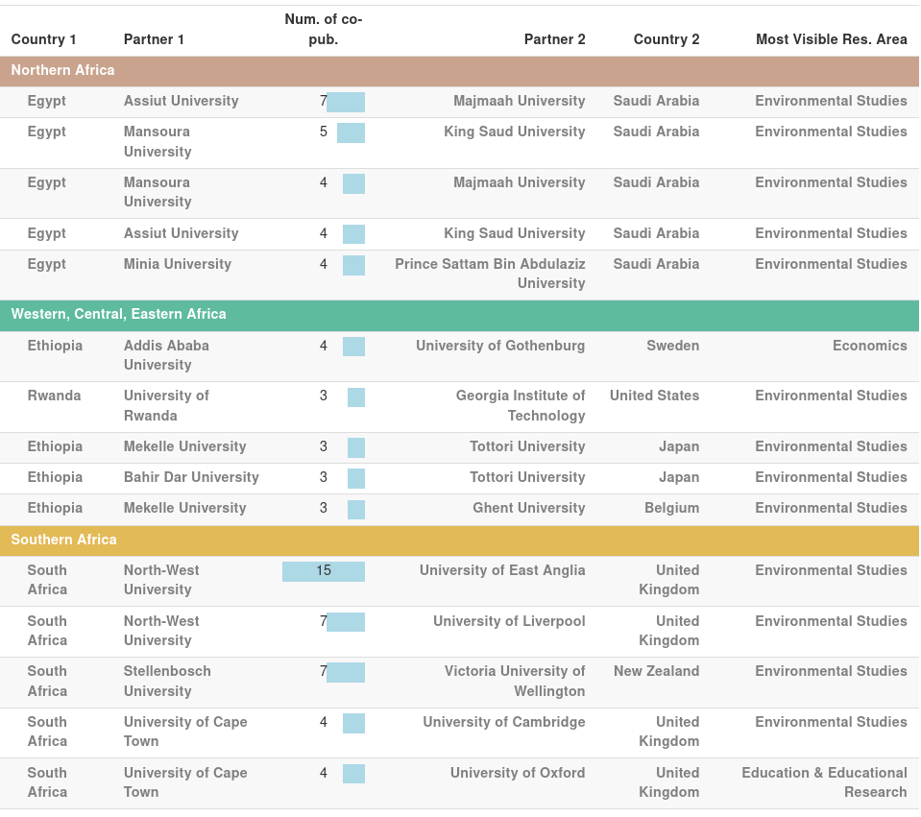Table 15: The most visible co-publication pairings in Social Sciences and Arts & Humanities
The most visible 2 collaboration partnerships in Social Science and Arts & Humanities (SSH) is between South Africa’s North-West University and the UK’s University of East Anglia as well as University of Liverpool. As in the case of almost all of the visible collaborations in SSH the dominant research area in those collaborations is Environmental Studies.
Stellenbosch University’s collaboration with New Zealand’s Victoria University of Wellington and Egypt’s Assiut University’s with Saudi Arabian Majmaah University are other visible pairings in SSH. From the Western, Central, Eastern Africa cluster the most visible pairing is between Addis Ababa University (Ethiopia) and University of Gothenburg (Denmark) which are exceptionally mostly co-published Economics related papers.
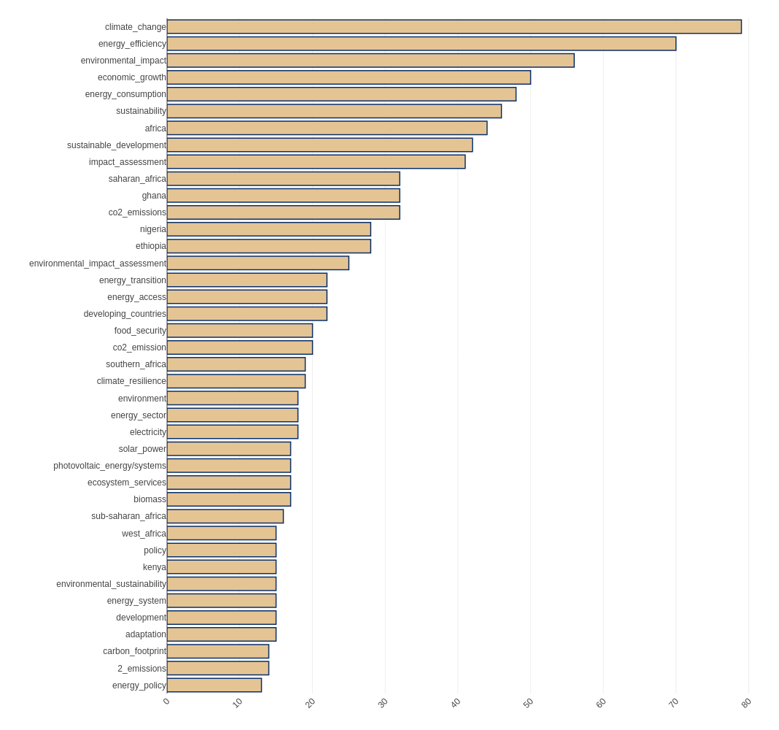Figure 46: The most visible keywords/ keyword pairs in Social Sciences and Arts & Humanities
Climate change related keywords are the most visible cluster in the RE-related keywords from SSH areas. Environmental impact assessment, climate resilience, environmental sustainability, CO_2 emissions are just a few of those. In relation, energy consumption, strategy and policy are also emphasised keyword pairs in RE-related SSH publications from African organisations.
Another cluster of keywords indicates discussion about the economic aspect of renewable energy innovations as well as the economic impact of climate change related issues.
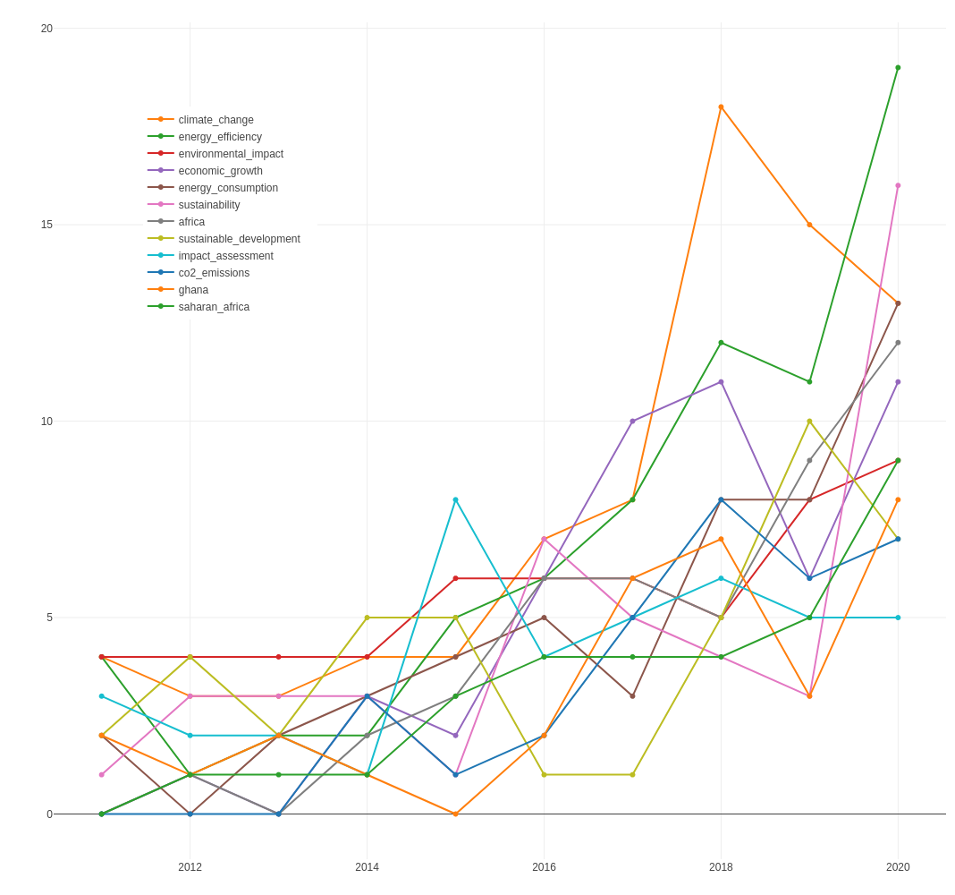Figure 47: The most visible keywords/keyword pairs over the years in Social Sciences and Arts & Humanities

4 Conclusion
This study has aimed to achieve a comprehensive analysis of the renewable energy research capacity in Africa. Although renewable energy research is a fairly broad topic and solely relying on scientometric research cannot cover all of its aspects, the study results yielded some important observations about the general situation of RE research capacity in African countries.
The number of RE-related publications is increasing in every region of Africa. Although Northern and Southern Africa publishing the biggest part of the total RE-related publications in Africa, lots of countries from Western, Central and Eastern Africa are increasing their output rapidly.
African regions seem to be fairly well interconnected in their individual regions and several of them show a considerable amount of co-publications with intercontinental partners. However, in general, there is a lack of interregional collaboration in the African continent. Only some of the most visible countries appear in other regions as one of the most visible collaborators. In relation, a number of African countries also tend to collaborate with a specific cluster of intercontinental partners with very little diversity.
The content of the RE-related publications in Africa displays a strong emphasis especially on solar energy related science and technology in recent years followed by wind energy and biomass related topics. Furthermore, African academic organisations also increasingly research geographical specifications of their regions that could be beneficial for a specific kind of RE approach.
The analysis of the trending research areas in the most visible organisations also displayed that in the last couple of years there is a sudden decline in the most visible research areas in terms of yearly publications (e.g. Energy & Fuels). Simultaneously, there are a few previously less visible research areas that are rapidly growing in numbers. Questions like if there is a real shift in RE-related research away from previously dominant areas or if specific topics are categorised under other disciplines than before, furthermore, if the same academicians working in other areas or a new cluster of researchers are working in the newly trending research areas are questions that can only be answered with further research.

5 References
Benghanem, M, and A Hadj Arab. 2007. “Photovoltaic Water Pumping Systems for Algeria.” Desalination 209 (1-3): 50–57.
Benjamin, Benthai, Dr Victoria Bakare, and Thompson E. Effiong. 2020. “Saccharomyces Cerevisiae Bio-Ethanol Production as an Alternative Source of Sustainable Energy Ethanol Production Using Saccharomyces Cerevisiae.” International Journal For Research in Applied Sciences and Biotechnology 7 (6): 190–94. https://doi.org/10.31033/ijrasb.7.6.27.
E. Ahmed, and S. Yuvarajan. 2012. “Hybrid Renewable Energy System Using DFIG and Multilevel Inverter.” In 2012 IEEE Green Technologies Conference, 1–6. https://doi.org/10.1109/GREEN.2012.6200937.
Gupta, Nikita, Rafat Siddique, and Rafik Belarbi. 2021. “Sustainable and Greener Self-Compacting Concrete Incorporating Industrial By-Products: A Review.” Journal of Cleaner Production 284 (February): 124803. https://doi.org/10.1016/j.jclepro.2020.124803.
Khan, Muhammad Imran, Jin Hyuk Shin, and Jong Deog Kim. 2018. “The Promising Future of Microalgae: Current Status, Challenges, and Optimization of a Sustainable and Renewable Industry for Biofuels, Feed, and Other Products.” Microbial Cell Factories 17 (1): 36. https://doi.org/10.1186/s12934-018-0879-x.
Long, Guangcheng, Yu Gao, and Youjun Xie. 2015. “Designing More Sustainable and Greener Self-Compacting Concrete.” Construction and Building Materials 84 (June): 301–6. https://doi.org/10.1016/j.conbuildmat.2015.02.072.
Ross, Lauren, Aldo Sottolichio, Nicolas Huybrechts, and Pascal Brunet. 2021. “Tidal Turbines in the Estuarine Environment: From Identifying Optimal Location to Environmental Impact.” Renewable Energy 169 (May): 700–713. https://doi.org/10.1016/j.renene.2021.01.039.
Rwenyagila, Egidius Rutatizibwa. 2017. “A Review of Organic Photovoltaic Energy Source and Its Technological Designs.” International Journal of Photoenergy 2017: 1–12. https://doi.org/10.1155/2017/1656512.
Siripong, Wiparat, Philipp Wolf, Theodora Puspowangi Kusumoputri, Joe James Downes, Kanokarn Kocharin, Sutipa Tanapongpipat, and Weerawat Runguphan. 2018. “Metabolic Engineering of Pichia Pastoris for Production of Isobutanol and Isobutyl Acetate.” Biotechnology for Biofuels 11 (1): 1. https://doi.org/10.1186/s13068-017-1003-x.
van der Weijde, Tim, Claire L. Alvim Kamei, Andres F. Torres, Wilfred Vermerris, Oene Dolstra, Richard G. F. Visser, and Luisa M. Trindade. 2013. “The Potential of C4 Grasses for Cellulosic Biofuel Production.” Frontiers in Plant Science 4. https://doi.org/10.3389/fpls.2013.00107.

The 5 African Union Geographic Regions; Northern Africa, Western Africa, Central Africa, Eastern Africa, and Southern Africa have been defined by the Organisation of African Unity in 1976 (CM/Res.464QCXVI). A list of countries in each region can be found under https://au.int/en/member_states/countryprofiles2.
Web of Science’s categorization of research areas under research domains can be found under https://images.webofknowledge.com/images/help/WOS/hp_research_areas_easca.html.
Relative growth rate value in this report does not indicate a percentage as it is usually calculated, instead the equation is simply end_value/start_value=growth_rate.

