

**COMPE-464**

**Image Processing**

**Homework-4**

**Name: Utku**

**Surname: POLAT**

**Student ID: 160302001**

**What is Image Resolution?**

Image resolution is a property that gives detail us for an image. Image resolution involve like raster images, digital images and film images. If an image has high resolution, it has more image detail than low resolution images' detail.

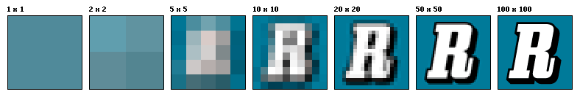

**Gray-scale Images and** **Image Channels**

Channels gives us the number of color for an image. For instance, in RGB image have three channels which are blue, green and red. These channels’ pixels represent the intensities for each color that create that pixels. A grayscale image is one that each pixel has one channel and it represent only an amount of light that it gives us only intensity information. Gray-scale image also may knowns black and white image.

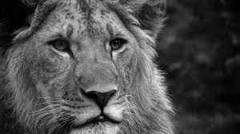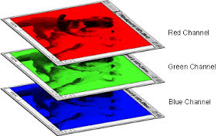

**What is Threshold in an Image and Why do We Use It?**

Thresholding apply on to gray-scale images which have ranging from 0-255 and create binary images. When we threshold an image we classify its pixels into groups that a upper and lower bound to each group. It is important because of some time people who need separation of dark and light region of an image use thresholding. It can separate dark and light side of the color image.

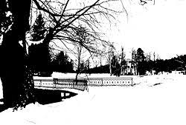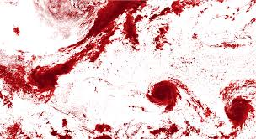

**The Screen Shots of Python Code**

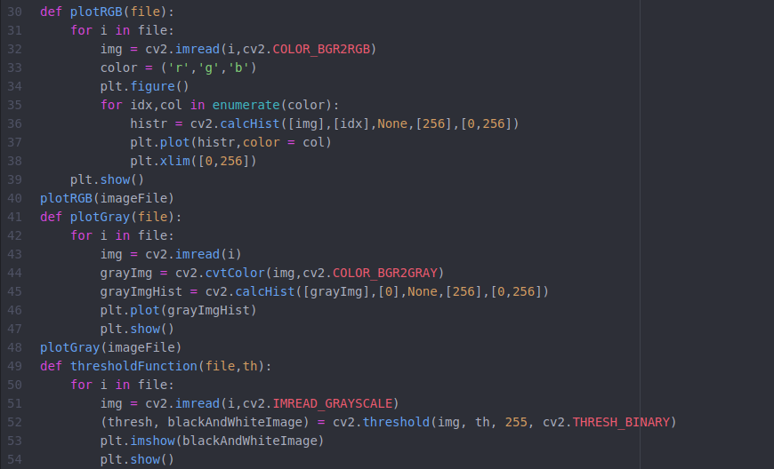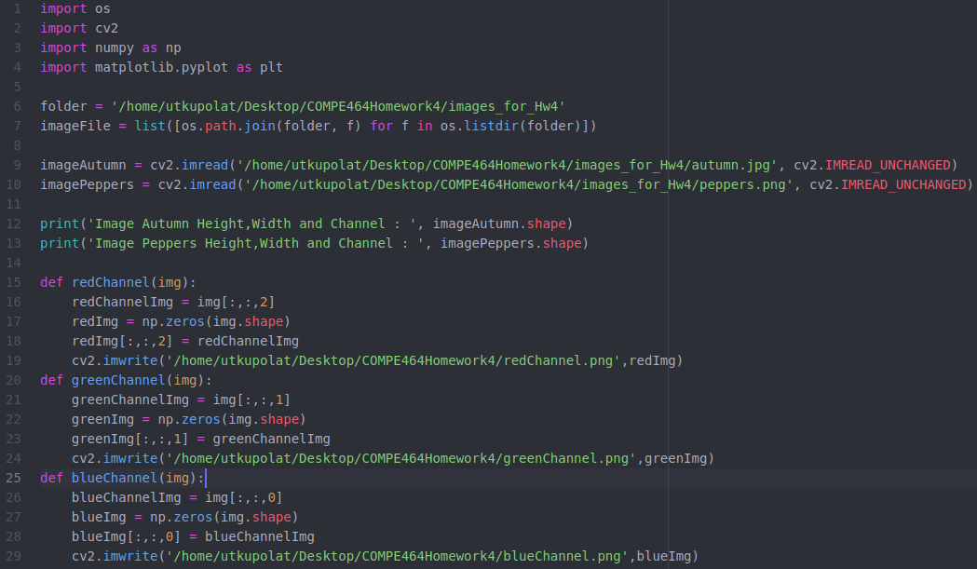

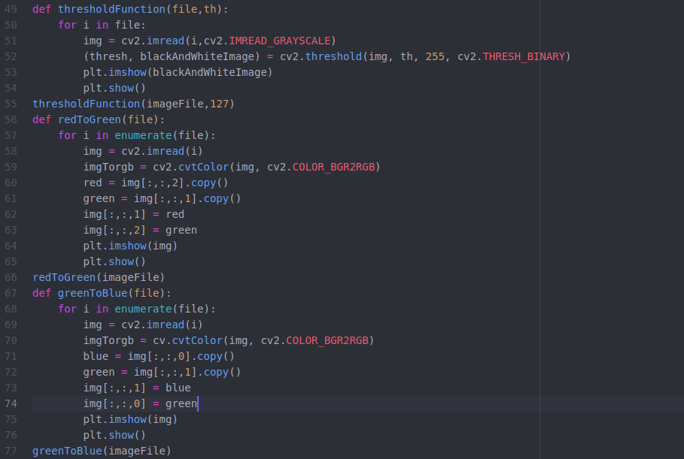

**Comments**

**Line 1-10 =>** I import the necessary libraries and read images. In lines 6 and 7 create a list for function calls and in lines 9 and 10 read images to a variable for resolution calculation.

**Line 12-13 =>** Print the resolutions of images.

**Line 15-29 =>** I wrote three functions that found the red, green and blue channels of an image.

**Line 30-48 =>** I wrote two functions that plot the graphs. In lines from 30 to 40, the function plot the colorful images and the other function in lines from 41 to 48, it plot the gray-scales of autumn and peppers images.

**Line 49-55 =>** I wrote a function that finds the thresholds the images.

**Line 56-77 =>** I wrote two functions and first one changes red band of an image with green band. Second one changes green band of an image with blue band.

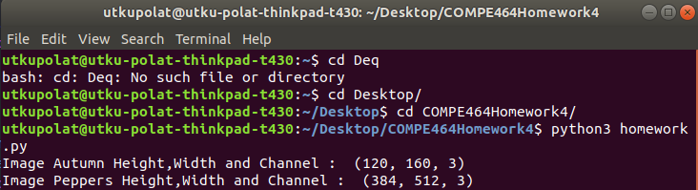**Image Resolutions**

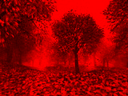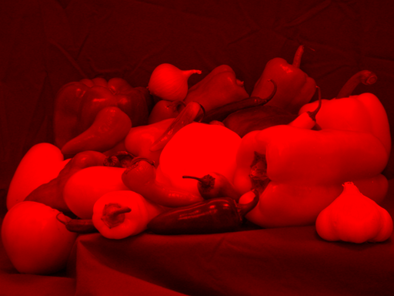

**Red Channel of Autumn Image Red Channel of Peppers Image**

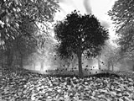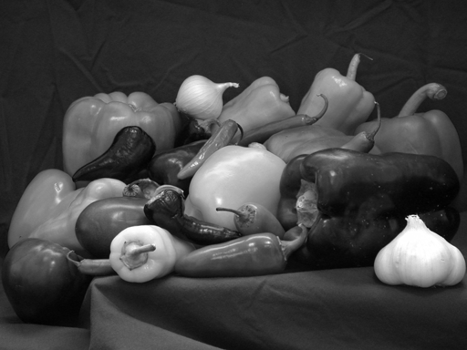

**Green Channel of Autumn Image Green Channel of Peppers Image**

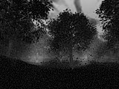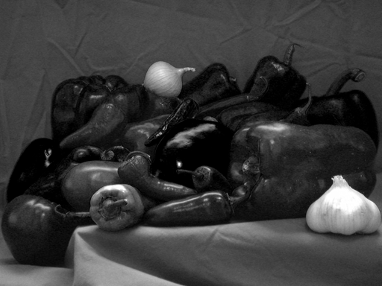

**Blue Channel of Autumn Image Blue Channel of Peppers Image**

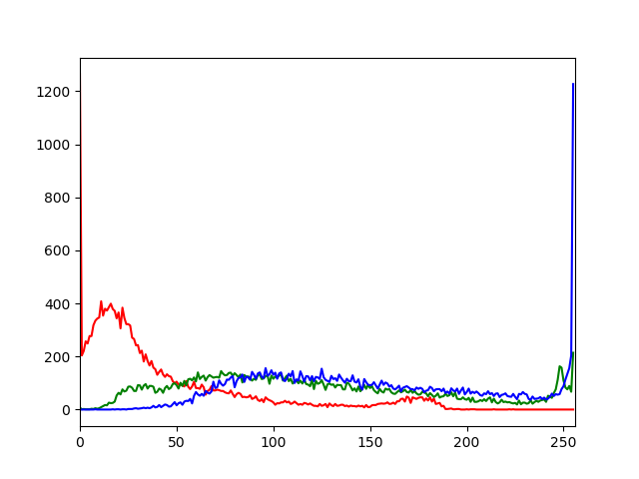

**Autumn Image Plot The Channels**

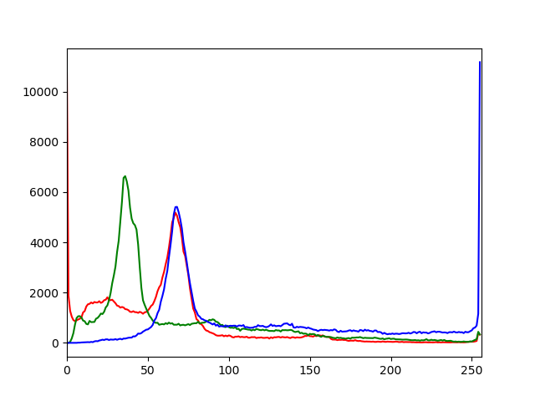

**Peppers Image Plot The Channels**

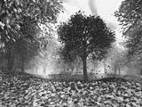

**Gray-Scale of Autumn Image**

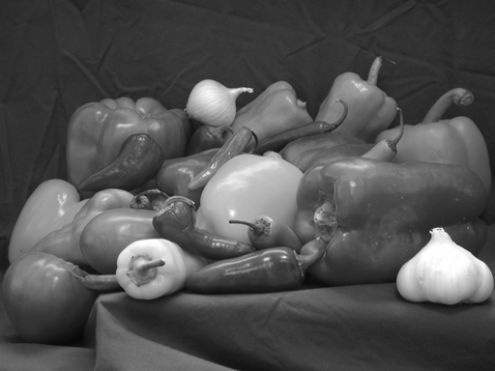

**Gray-Scale of Peppers Image**

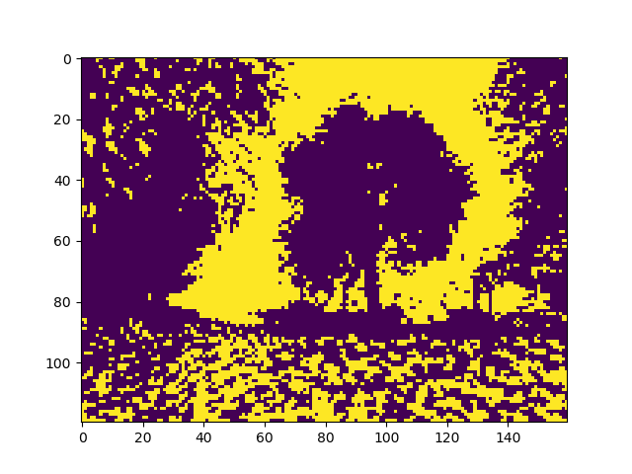

**Threshold In 0-255 => Value 127 For Autumn Image**

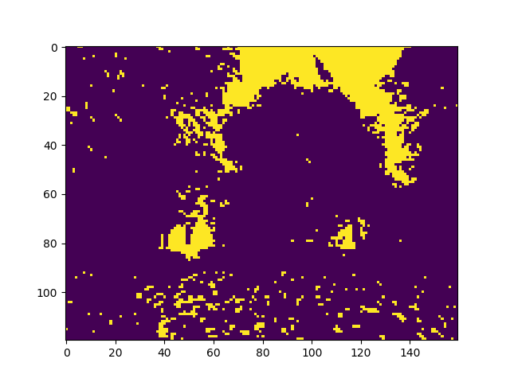

**Threshold In 0-255 => Value 192 For Autumn Image**

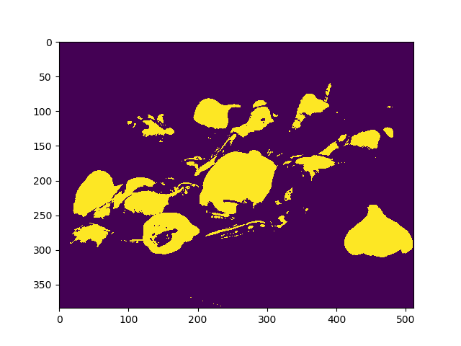

**Threshold In 0-255 => Value 127 For Peppers Image**

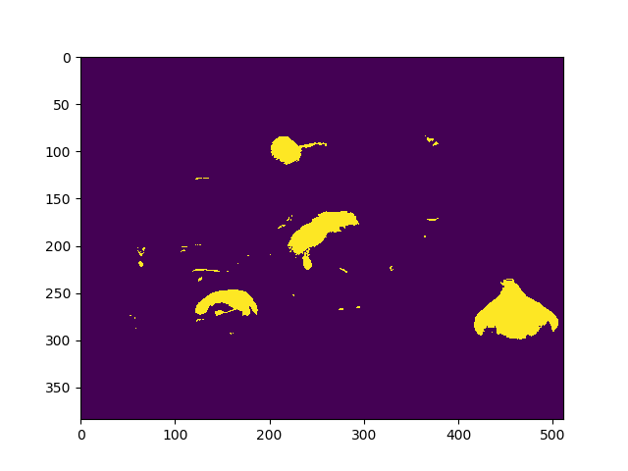

**Threshold In 0-255 => Value 192 For Peppers Image**

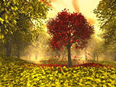

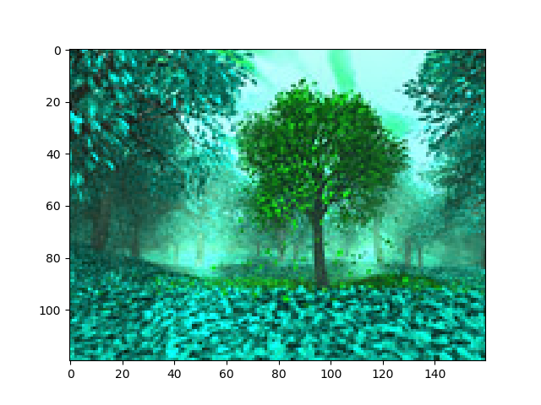**Original Image Autumn**

**Red Band to Green Band Autumn Image**

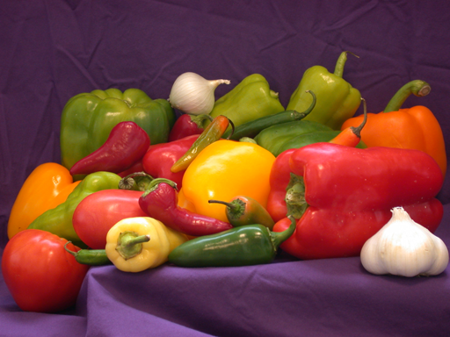

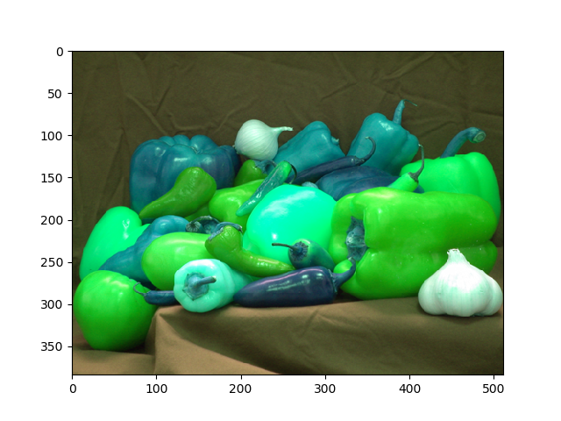**Original Image Peppers Image**

**Red Band to Green Band Peppers Image**



**Original Image Autumn**

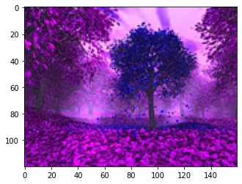

**Green Band to Blue Band Autumn Image**



**Original Image Peppers Image**

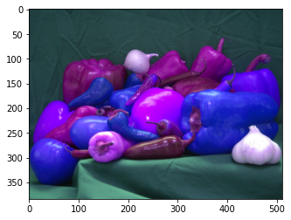

**Green Band to Blue Band Peppers Image**