

**COMPE-464 Image Processing**

**Homework-1**

**Name: Utku**

**Surname: POLAT**

**Student ID: 160302001**

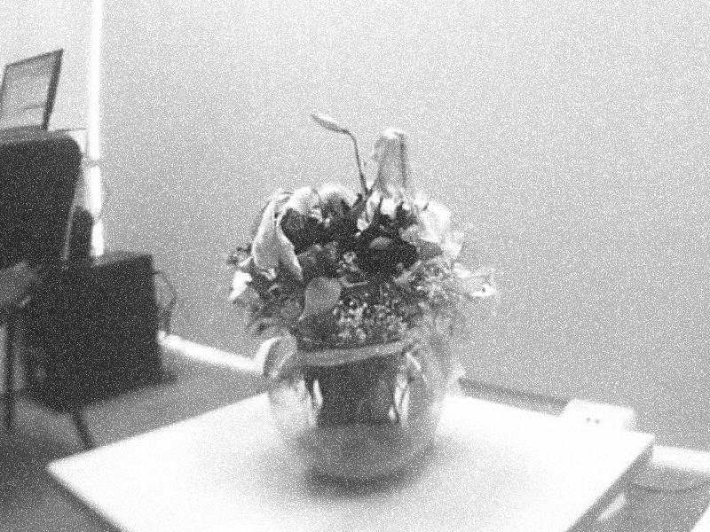

***Original Image***

***What is Gaussian Noise and How can we eliminate it?***

Input image have lots of noises. Gaussian noise in digital images arise during acquisition e.g. sensor noise caused by poor illumination

and/or high temperature, and/or transmission e.g. electronic circuit noise. In digital image processing Gaussian noise can be reduced using a spatial filter. I eliminate those noises by averaging. It takes average of all the pixels under kernel area.

1) **import os**

2) **import cv2**

3) **import numpy as np**

4) **folder = '/home/utkupolat/Desktop/ImageProcessing/flowers'**

5) **imageFile = list([os.path.join(folder, f) for f in os.listdir(folder)])**

6) **def averageImageFunction(numberOfImage):**

7) **averageOfImages = cv2.imread(imageFile[0]).astype(np.float)**

8) **for f in imageFile [1 : (numberOfImage)]:**

9) **image = cv2.imread(f)**

10) **averageOfImages += image**

11) **averageOfImages /= numberOfImage**

12) **cv2.imwrite('Output%d.png' %(numberOfImage), averageOfImages)**

13) **averageImageFunction(80)**

14) **averageImageFunction(50)**

15) **averageImageFunction(20)**

16) **averageImageFunction(10)**

17) **averageImageFunction(5)**

***COMMENTS:***

**Line 1-3 =>** Import necessary libraries for coding.

**Line 4 =>** Images directory path.

**Line 5 =>** Read all images from source folder and add to '**imageFile**' which is a list.

**Line 6-12 =>** Compute the average of all images in function which take only **one parameter(number of images).** In line 7 read first image from folder and convert it to float type after that in line 8-10 adds other readed images from folder on the first image. In line 11 take the average of aggregated images.

**Line 12 =>** Save the results of all calculated pictures in different **'.png'** folders.

**Line 13-17 =>** Call the function for calculating the average of images. For every time different number of images calculated.

**A)Number of Image=5:**

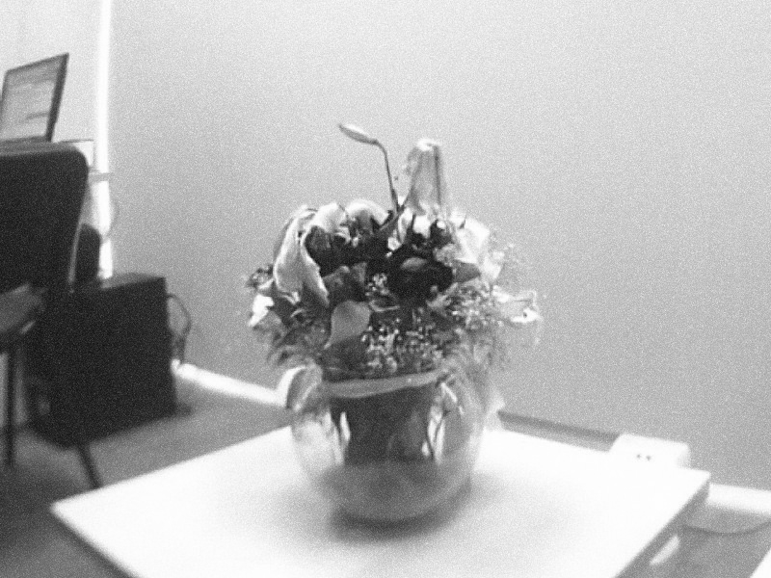

**B)Number of Image=10:**

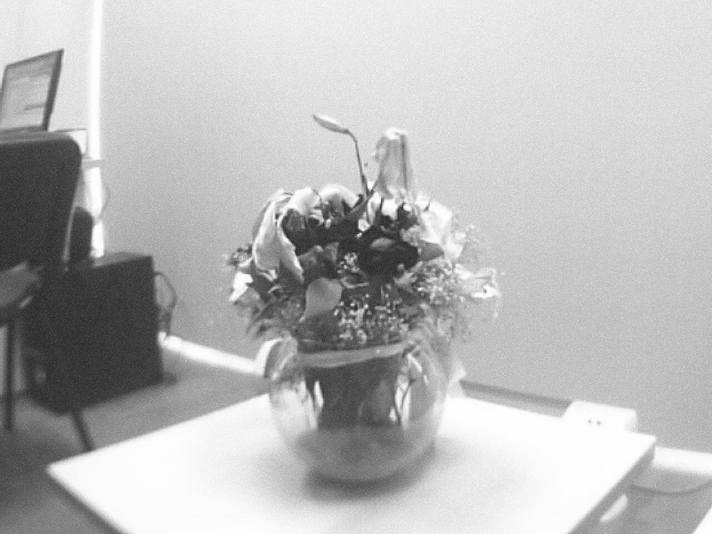

**C)Number of Image=20:**

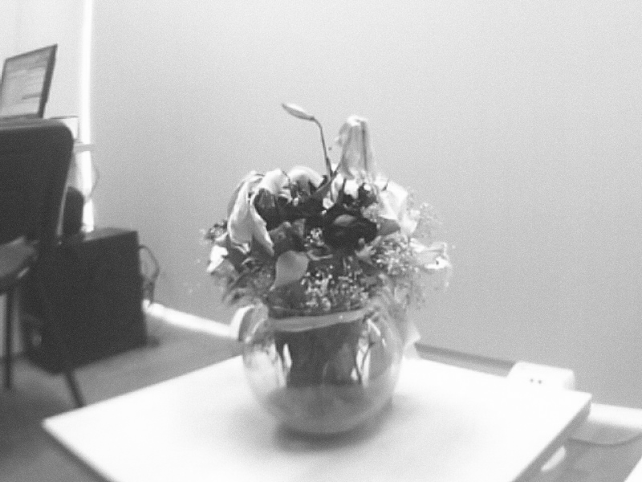

**D)Number of Image=50:**

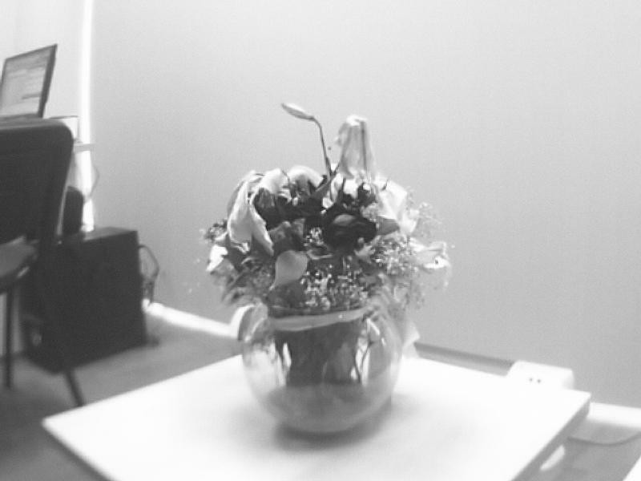

**E)Number of Image=80:**

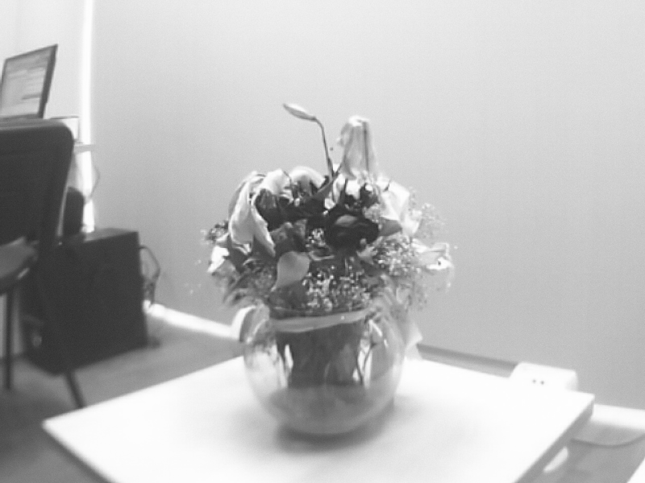

***RESULT***

As a result, as you can see the original image have lots of zero-mean Gaussian additive white noise. There are many ways to eliminate those noises. I try to eliminate those noises by getting average of different number of image. The number of images I used increases, noises in images decrease. However, while taking the average, some problems appear like blurring of fine-scaled image edges and details. I can see blurring increased with increasing the number of pictures.