BOULDER GARDENS
FIELDSTATION WORKBOOK
Observations • systems • photographs • source records
MASTER SOURCE OF TRUTH
Field reports are derived from this workbook.
Original evidence remains attached to the record.
Started July 31, 2026
Version 0.2

How this workbook is used
This workbook is the permanent working record for Boulder Gardens Fieldstation. It keeps observations, equipment details, photographs, instrument readings, calculations, uncertainties, corrections, and later changes together in one place.
Public Field Reports are shorter observational extracts made from these source records. The workbook may contain more technical detail, unfinished questions, and evidence than appears publicly.
CONFIRMED | Visible in a source image, instrument reading, equipment label, or primary record.
RECORDED | Previously supplied by Robert and retained as part of the project record.
CALCULATED | Derived directly from confirmed or recorded numbers.
TO VERIFY | Useful working information that still needs a photograph, label, measurement, or correction.

Archive layers
Workbook: Curated source records and cross-references.
Immich: Original photographs and photograph metadata.
GitHub: Website source, Field Reports, and version history.
Local backup: A copy of the workbook, sources, and published site outside the active working folder.

Record naming
Field Report source records use the form FR001, FR002, and so on. Source files begin with the same identifier so images and notes remain attached to the correct record.

Workbook index
Record | Subject | Status | Date
FR001 | Command Center solar system | Source record opened | 2026-07-31

Planned workbook divisions
- 01 — Field Report source records
- 02 — Solar and energy
- 03 — Water systems
- 04 — Communications and Meshtastic
- 05 — Sensors, ESPHome, and Home Assistant
- 06 — Network and PoE infrastructure
- 07 — Buildings, land, and access
- 08 — People, history, and community
- 09 — Maps, diagrams, and equipment records
- 10 — Revision log and unresolved questions
The divisions will grow as evidence is collected. A record may be indexed in more than one division without duplicating its source material.

FIELD REPORT SOURCE RECORD 001
Command Center Solar System
Record ID | FR001 | Record status | Open
Observation date | July 31, 2026 | Instrument time | 4:10 PM
Location | Command Center | Observer | Robert Redecker
Subjects | Solar • battery • infrastructure | Public report | Not yet published

Record scope
This first source record begins with the working photovoltaic and battery system serving the Command Center. It is intentionally limited to what has already been observed or recorded. PoE, Meshtastic, remote sensors, Home Assistant, and related infrastructure will be linked later as separate observations.

Core observations
- [RECORDED] The present working photovoltaic array consists of six 295-watt modules.
- [CALCULATED] Present photovoltaic nameplate capacity is 1,770 watts, or 1.77 kW.
- [RECORDED] The battery bank consists of sixteen LiFePO₄ cells connected in series.
- [RECORDED] Cell rating is 3.2 V and 280 Ah.
- [CALCULATED] Nominal pack voltage is 51.2 V.
- [CALCULATED] Nominal stored energy is approximately 14.3 kWh.
- [RECORDED] The inverter is a Schneider XW Pro 6848.
- [RECORDED] Solar charging is handled by an OutBack charge controller; exact model remains to be confirmed in this record.
- [CONFIRMED] The JK-BMS application displayed a configured capacity of 270.0 Ah at the time of observation.

Instrument observation: JK-BMS
The following values were transcribed directly from the Android JK-BMS display supplied for this record.
Observed field | Reading | Record status
State of charge | 79% | CONFIRMED
Pack voltage | 53.48 V | CONFIRMED
Current | −1.73 A | CONFIRMED
Power | 92.5 W | CONFIRMED
Operating state | Discharging | CONFIRMED
Estimated time remaining | 123 h 26 min 33 sec | CONFIRMED
Configured capacity | 270.0 Ah | CONFIRMED
Remaining capacity | 213.4 Ah | CONFIRMED
Highest cell | 3.344 V | CONFIRMED
Lowest cell | 3.342 V | CONFIRMED
Displayed voltage difference | 0.004 V | CONFIRMED
Balancing current | 0.000 A | CONFIRMED
Highest reported temperature | 39.0 °C | CONFIRMED
Cell type | LFP | CONFIRMED
Charge control | ON | CONFIRMED
Discharge control | ON | CONFIRMED
Balancing | OFF | CONFIRMED
The application displayed a 0.004 V pack spread while the displayed high and low values differ by 0.002 V. Both values are preserved exactly as shown rather than reconciled.

Source image FR001-S01
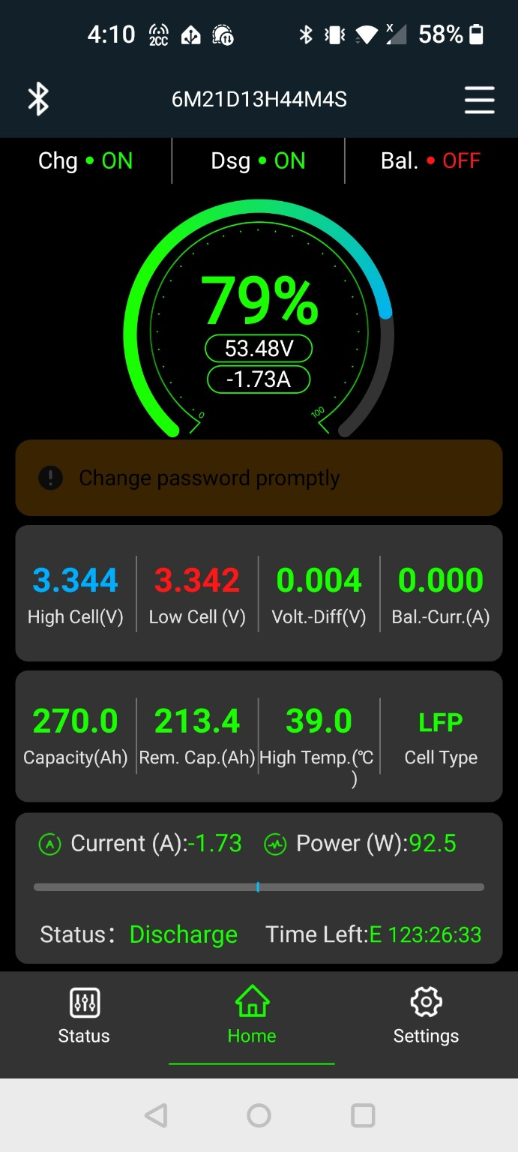
FR001-S01. JK-BMS Android status screen at 4:10 PM on July 31, 2026. Original source file preserved in the companion sources folder.

Calculated values
Quantity | Inputs | Calculation | Result
Present PV nameplate | 6 modules × 295 W | 6 × 295 | 1,770 W / 1.77 kW
Nominal battery voltage | 16 cells × 3.2 V | 16 × 3.2 | 51.2 V
Nominal battery energy | 51.2 V × 280 Ah | 51.2 × 280 | 14,336 Wh / 14.3 kWh
Configured BMS energy | 51.2 V × 270 Ah | 51.2 × 270 | 13,824 Wh / 13.8 kWh

Equipment inventory
Component | Recorded identification | Status | Evidence needed
PV modules | 6 × 295 W | RECORDED | Array photograph and panel label
Inverter | Schneider XW Pro 6848 | RECORDED | Front label and installation photograph
Charge controller | OutBack FlexMax family | TO VERIFY | Exact model label
Battery cells | 16 × LiFePO₄, 3.2 V, 280 Ah | RECORDED | Cell labels and complete bank photograph
Battery management | JK smart BMS, 16S application display | PARTLY CONFIRMED | BMS unit label and wiring photograph
Protection | Disconnects, breakers, and Class-T protection previously recorded | TO VERIFY | Full electrical-wall photograph and ratings

Photographs still to attach
- FR001-S02 — complete six-panel array
- FR001-S03 — Schneider inverter and electrical wall
- FR001-S04 — OutBack charge controller label
- FR001-S05 — complete sixteen-cell battery bank
- FR001-S06 — JK-BMS unit and wiring
- FR001-S07 — disconnects, breakers, and battery protection

Unresolved questions
- What is the exact OutBack charge-controller model installed with the present array?
- How are the six modules presently wired and protected? Earlier notes indicate two strings of three; this needs visual confirmation.
- What loads were active at 4:10 PM when the BMS reported 92.5 W of discharge?
- Which temperature sensor produced the 39.0 °C high-temperature value, and where is it mounted?
- Should the BMS remain configured at 270 Ah or be revised to match the cells’ 280 Ah rating?

Field Report derivation sheet
This section identifies what may safely be extracted for a public Field Report without turning the report into an explanation or tutorial.
Suitable public observation | Source
Six 295-watt modules form the present working array. | Recorded system information
The array’s present nameplate capacity is 1.77 kW. | Direct calculation
The battery bank contains sixteen LiFePO₄ cells. | Recorded system information
At 4:10 PM the pack read 53.48 V and 79% state of charge. | FR001-S01
The system was discharging at 1.73 A / 92.5 W. | FR001-S01
Charging and discharging were enabled; balancing was inactive. | FR001-S01
The BMS displayed 213.4 Ah remaining and a 39.0 °C high temperature. | FR001-S01

Editorial rule for Field Reports
Observe first. Preserve exact readings. Keep interpretation brief. Do not explain general solar theory unless a later report is specifically created for that purpose.

Revision log
Version | Date | Change | Status
0.1 | 2026-07-31 | Workbook created; FR001 opened; JK-BMS screenshot and readings attached. | Current

Next update
Attach the earlier photographs of the array, inverter wall, battery bank, charge controller, BMS unit, and protection equipment. Verify the charge-controller model and present array wiring. Then prepare the short observational Field Report 001 from this record.

FR001 photographic source update
Workbook version 0.2 · August 3, 2026
Five additional photographs were supplied and cataloged for Field Report 001. Original files are preserved in the companion sources/fr001 folder. The public webpage uses optimized copies and concise captions.
Source | Date | Observed content | Public use
FR001-S02 | 2025-09-01 | Robert beside the open Schneider inverter while work is underway. | Report hero
FR001-S03 | 2026-01-31 | Wide view of panels and the surrounding working area. | The setting
FR001-S04 | 2026-07-25 | Ground-mounted modules leading toward the equipment enclosure. | Array and shelter
FR001-S05 | 2026-07-25 | Open wooden equipment shelter beside the array. | Equipment shelter
FR001-S06 | 2026-07-26 | Several fixed panel mounts below the boulder formations. | Panels among the boulders
The photographs document the setting and visible arrangement. They do not by themselves confirm electrical ratings, wiring topology, or equipment model numbers.

FR001-S02
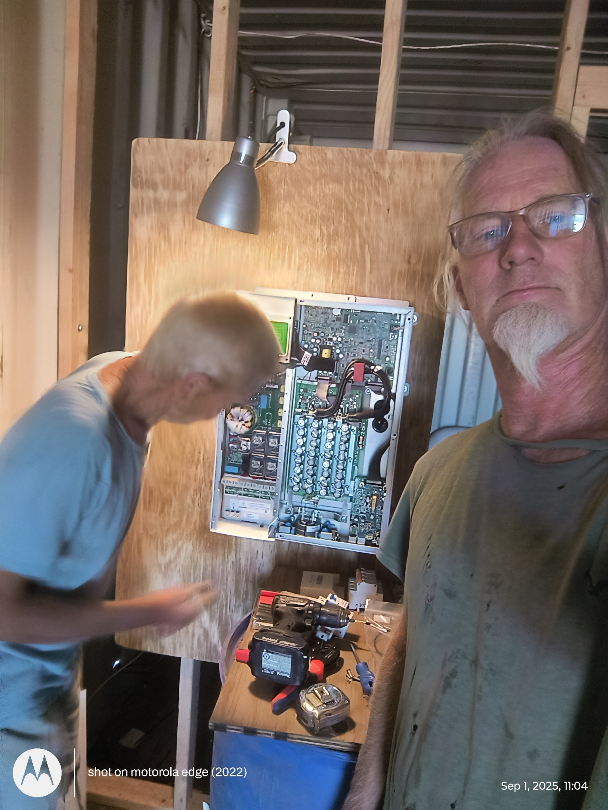
FR001-S02. Robert beside the open Schneider inverter while work is underway.

FR001-S03
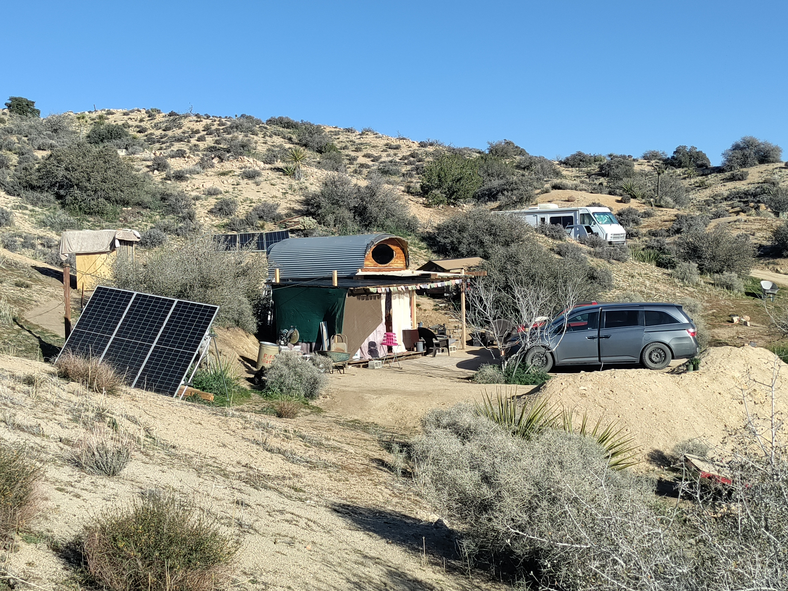
FR001-S03. Wide view of ground-mounted panels and the surrounding working area.

FR001-S04
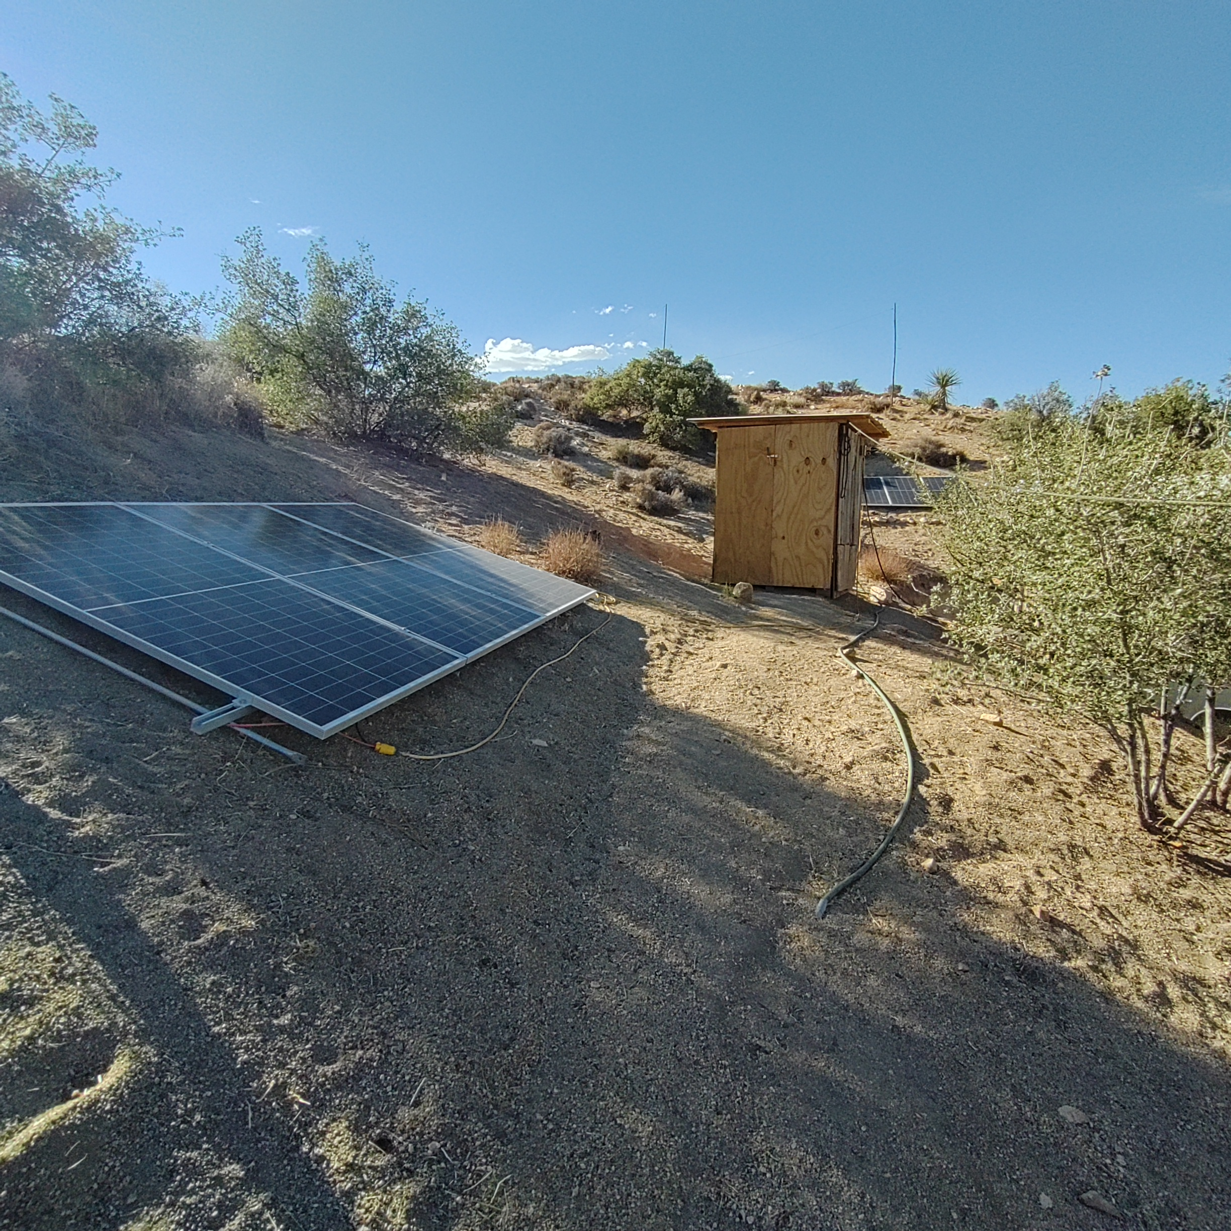
FR001-S04. Ground-mounted modules leading toward the compact equipment enclosure.

FR001-S05
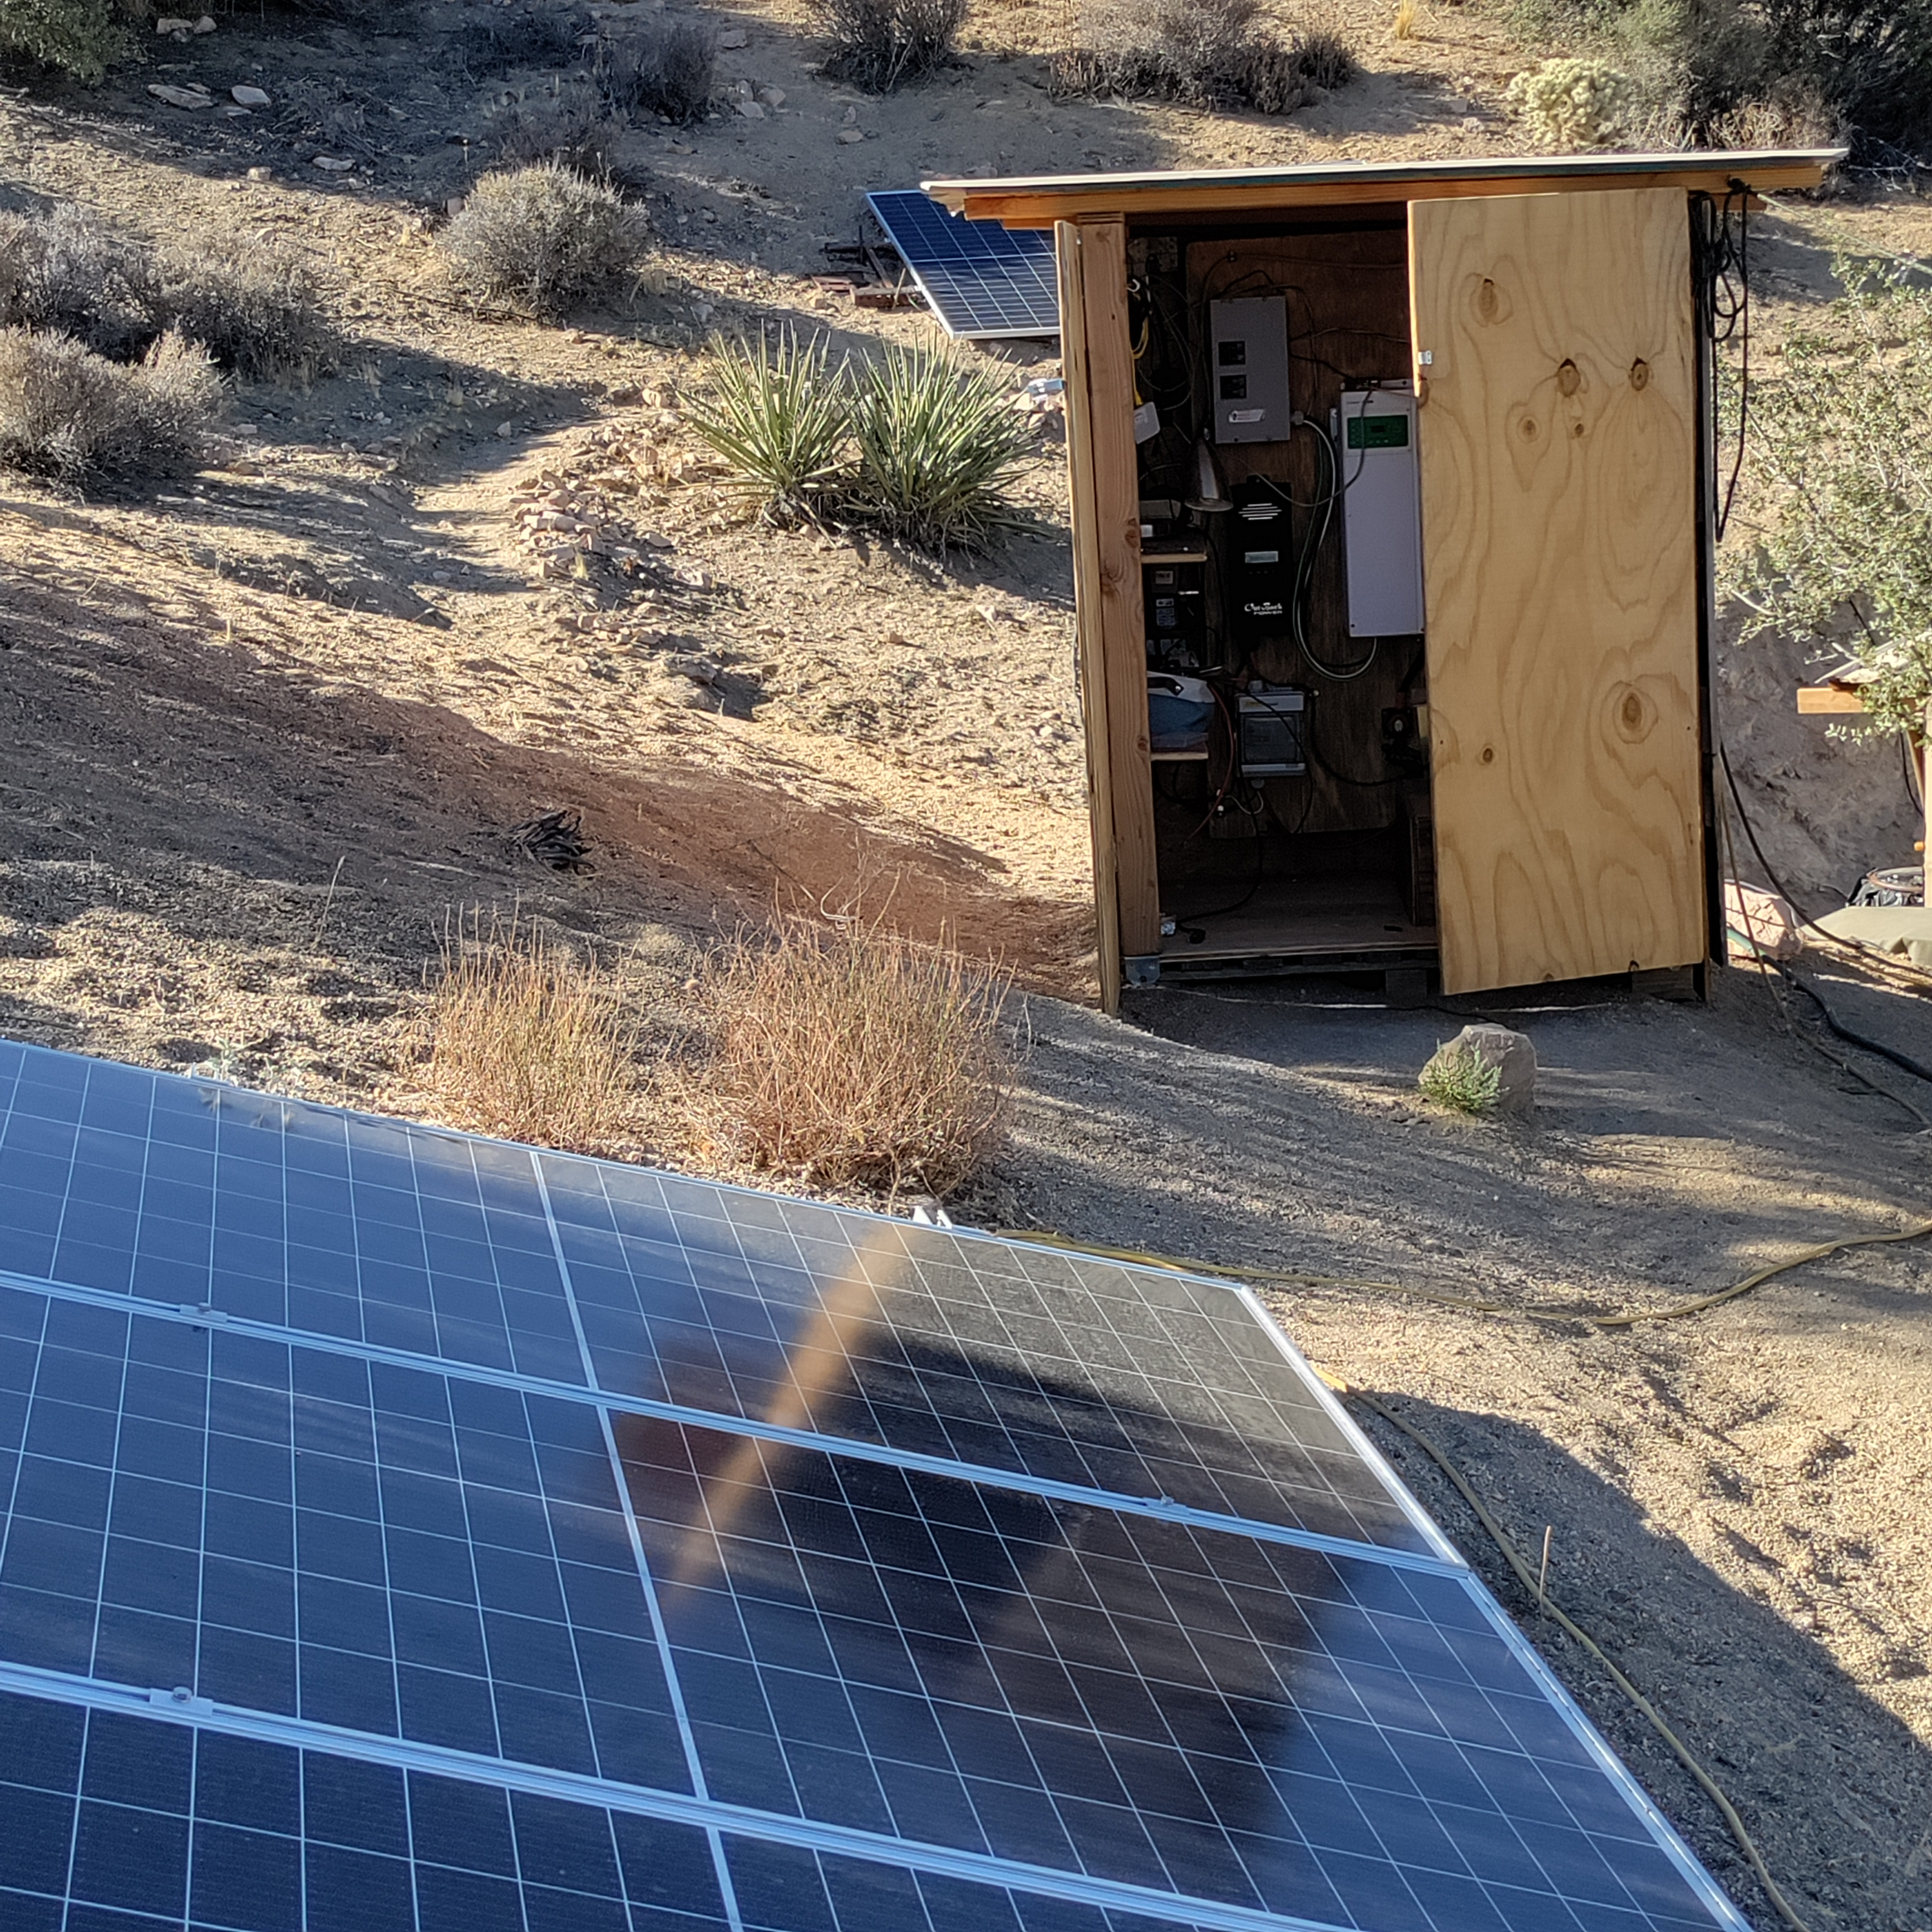
FR001-S05. Open wooden equipment shelter beside the array.

FR001-S06
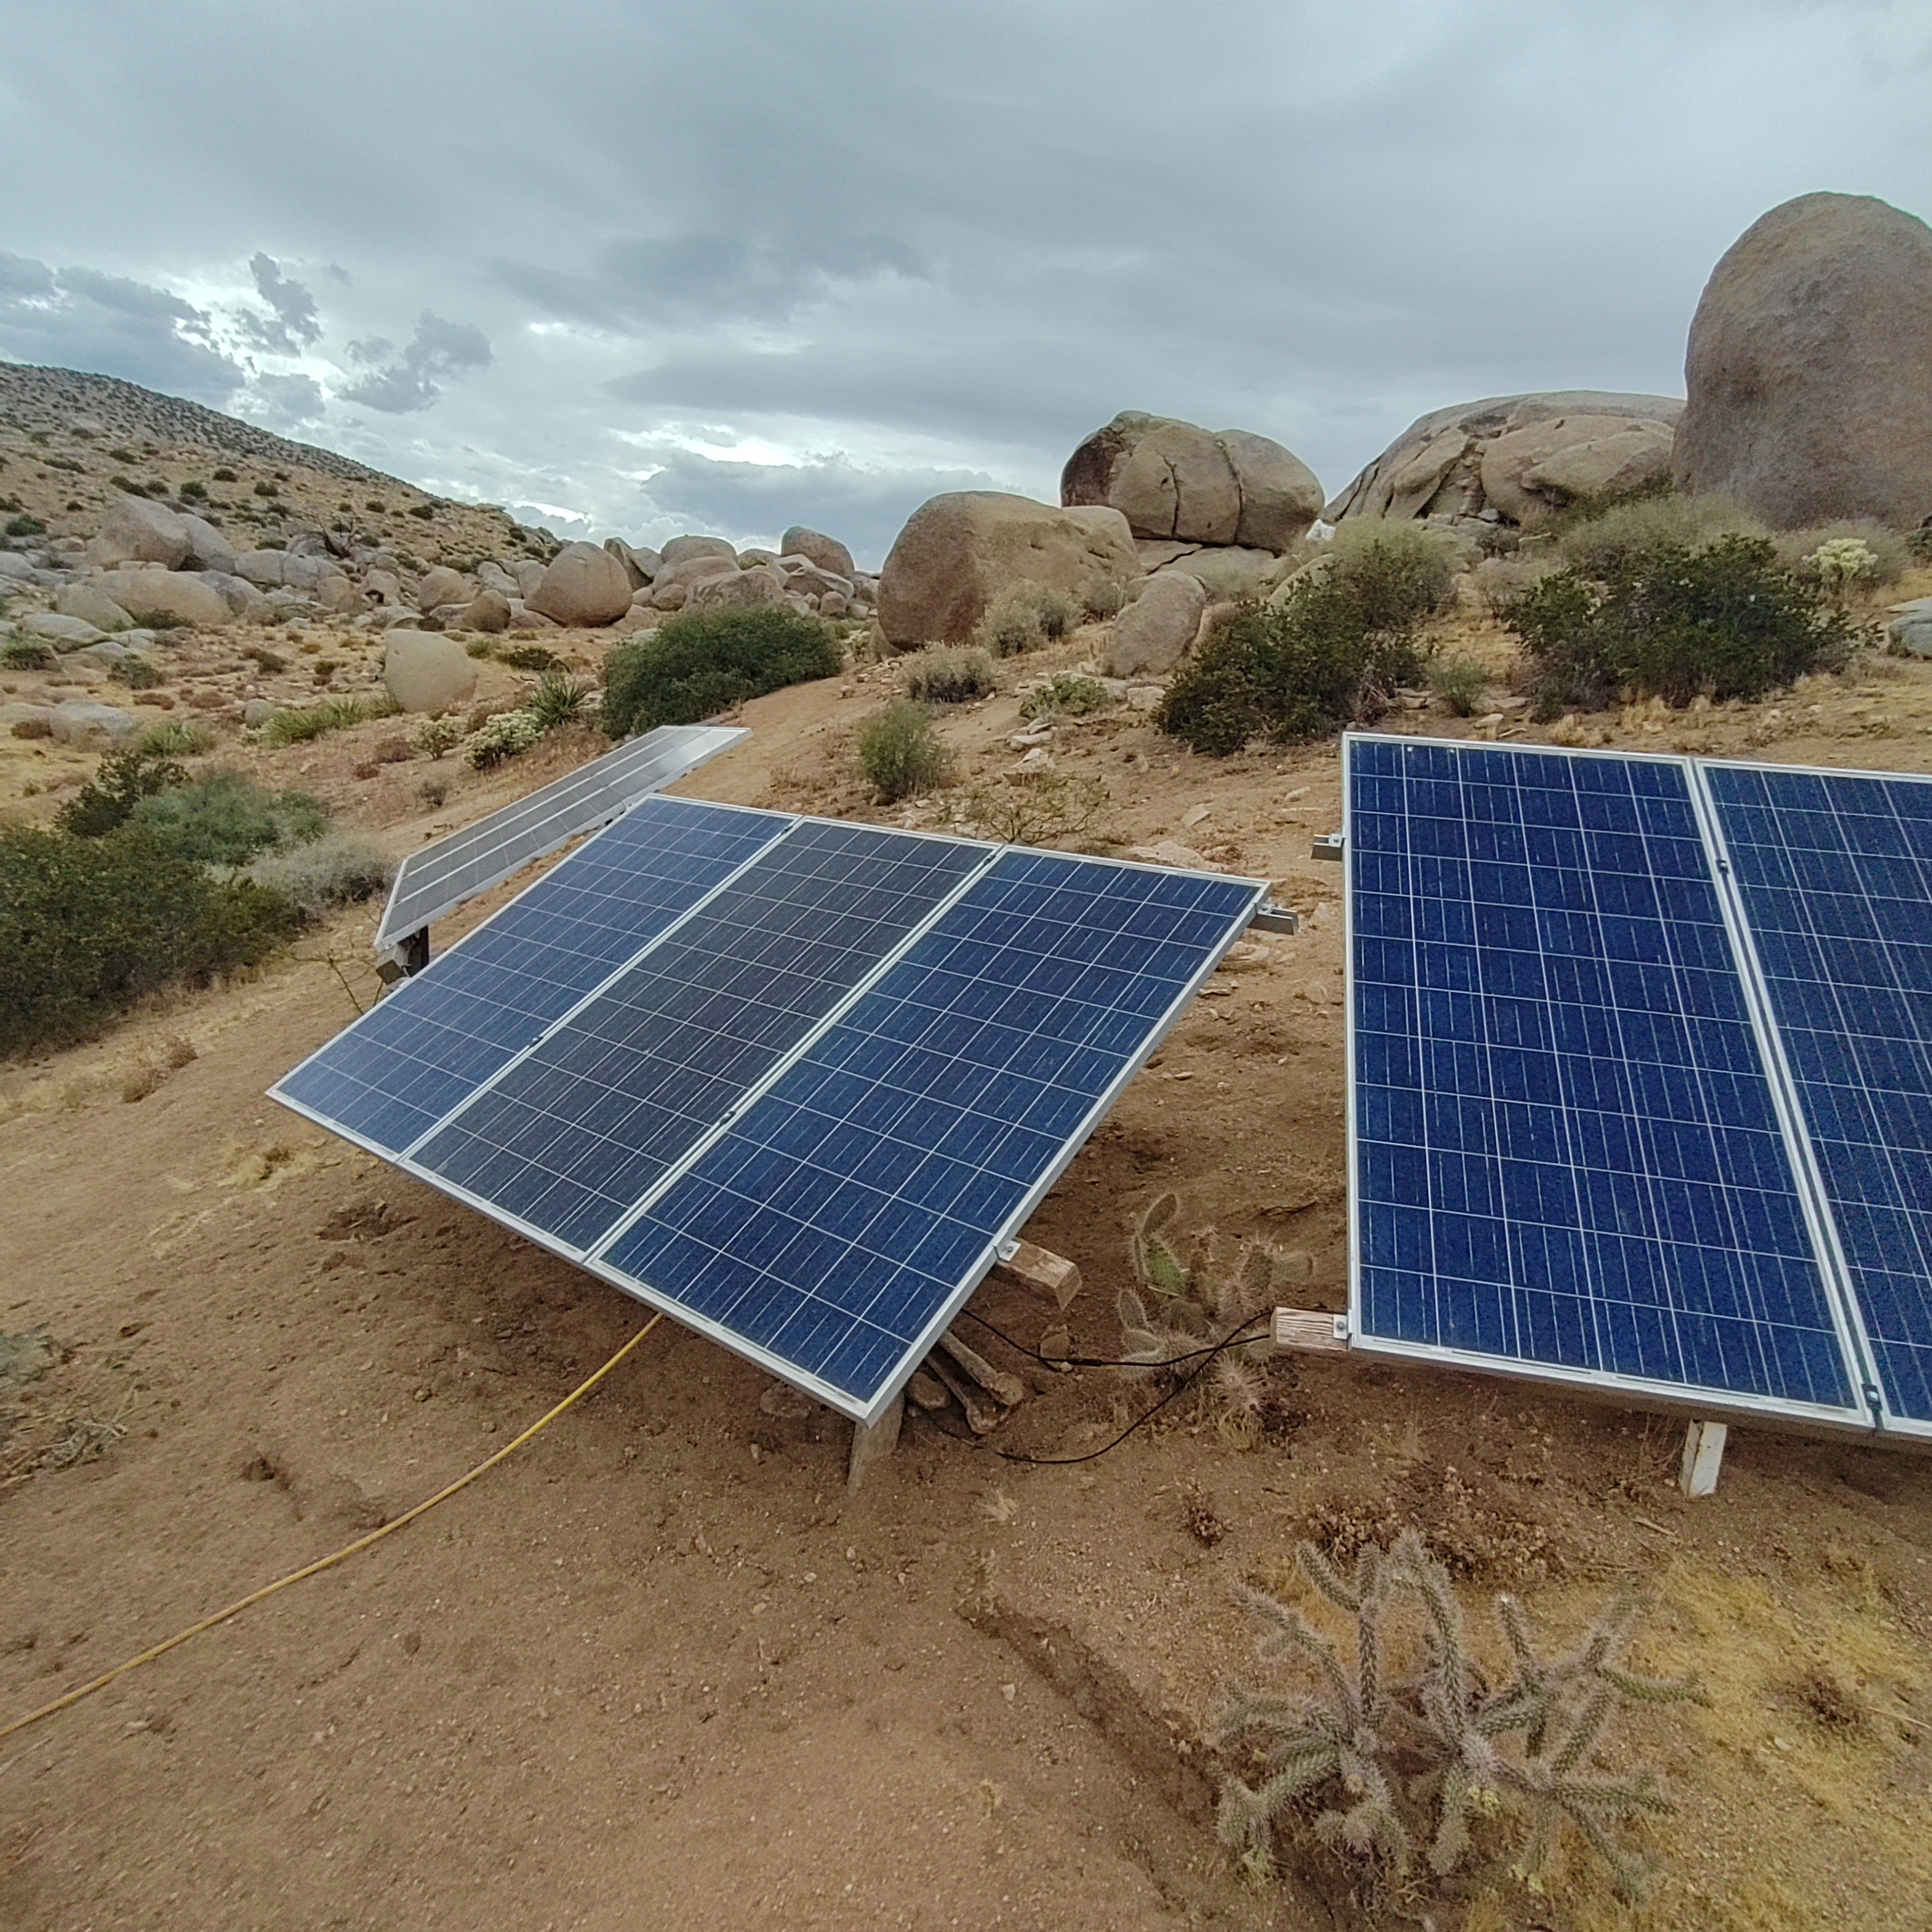
FR001-S06. Several fixed panel mounts below the surrounding boulder formations.

Remaining photographic needs
- Complete battery bank
- JK-BMS hardware and sensing leads
- Clear equipment-label photographs
- Full electrical protection and disconnect arrangement

