BOULDER GARDENS
FIELDSTATION WORKBOOK
Observations • systems • photographs • source records
MASTER SOURCE OF TRUTH
Field reports are derived from this workbook.
Original evidence remains attached to the record.
Started July 31, 2026
Version 0.4

How this workbook is used
This workbook is the permanent working record for Boulder Gardens Fieldstation. It keeps observations, equipment details, photographs, instrument readings, calculations, uncertainties, corrections, and later changes together in one place.
Public Field Reports are shorter observational extracts made from these source records. The workbook may contain more technical detail, unfinished questions, and evidence than appears publicly.
CONFIRMED | Visible in a source image, instrument reading, equipment label, or primary record.
RECORDED | Previously supplied by Robert and retained as part of the project record.
CALCULATED | Derived directly from confirmed or recorded numbers.
TO VERIFY | Useful working information that still needs a photograph, label, measurement, or correction.

Archive layers
Workbook: Curated source records and cross-references.
Immich: Original photographs and photograph metadata.
GitHub: Website source, Field Reports, and version history.
Local backup: A copy of the workbook, sources, and published site outside the active working folder.

Record naming
Field Report source records use the form FR001, FR002, and so on. Source files begin with the same identifier so images and notes remain attached to the correct record.

Workbook index
Record | Subject | Status | Date
FR001 | Fieldstation Solar System | Source record opened | 2026-07-31

Planned workbook divisions
- 01 — Field Report source records
- 02 — Solar and energy
- 03 — Water systems
- 04 — Communications and Meshtastic
- 05 — Sensors, ESPHome, and Home Assistant
- 06 — Network and PoE infrastructure
- 07 — Buildings, land, and access
- 08 — People, history, and community
- 09 — Maps, diagrams, and equipment records
- 10 — Revision log and unresolved questions
The divisions will grow as evidence is collected. A record may be indexed in more than one division without duplicating its source material.

FIELD REPORT SOURCE RECORD 001
Fieldstation Solar System
Record ID | FR001 | Record status | Open
Observation date | July 31, 2026 | Instrument time | 4:10 PM
Location | Command Center | Observer | Robert Redecker
Subjects | Solar • battery • infrastructure | Public report | Published as Field Report 001

Record scope
This first source record begins with the working photovoltaic and battery system serving the Command Center. It is intentionally limited to what has already been observed or recorded. PoE, Meshtastic, remote sensors, Home Assistant, and related infrastructure will be linked later as separate observations.

Core observations
- [CONFIRMED] The present working photovoltaic array consists of six Talesun TP6F72M(H)-395 modules rated 395 watts each.
- [CALCULATED] Present photovoltaic nameplate capacity is 2,370 watts, or 2.37 kW.
- [CONFIRMED] Talesun module label values: Voc 48.9 V; Isc 10.35 A; Vmpp 40.3 V; Impp 9.81 A; maximum series fuse 20 A; maximum system voltage 1500 VDC.
- [RECORDED] The battery bank consists of sixteen LiFePO₄ cells connected in series.
- [CONFIRMED] Cell rating is 3.2 V and 280 Ah; the cell label was photographed on August 8, 2026.
- [CALCULATED] Nominal pack voltage is 51.2 V.
- [CALCULATED] Nominal stored energy is approximately 14.3 kWh.
- [CONFIRMED] Inverter/charger: Schneider Electric Conext XW Pro 6848 NA, part 865-6848-21. The equipment label shows 48.0 V nominal DC output, 6.8 kVA maximum continuous inverter output at 120/240 V, and manufacture date 26 Sep 2022.
- [CONFIRMED] Solar charge controller: OutBack FLEXmax 60, model FM60-150VDC. Equipment-label limits include 150 VDC maximum PV open-circuit voltage and a 15–145 VDC nominal operating PV range.
- [CONFIRMED / CAUTION] The six-module array is wired 3S2P: two parallel strings of three modules in series, with one complete 3-panel string on each side of the hill. Each 3-module string is 146.7 V open-circuit at STC (3 × 48.9 V). This is already above the FLEXmax 60’s 145 V nominal operating range and only 3.3 V below its 150 V absolute PV open-circuit limit. Cold panels raise Voc, so cold-weather overvoltage remains a known system issue requiring mitigation or reconfiguration.
- [HISTORICAL / CORRECTED] The JK-BMS application displayed a configured capacity of 270.0 Ah before the correction. On August 8, 2026, the battery-capacity parameter was changed to 280 Ah to match the confirmed cell labels. The JK settings and home screens subsequently displayed 280 Ah.

Instrument observation: JK-BMS
The following values were transcribed directly from the Android JK-BMS display supplied for this record.
Observed field | Reading | Record status
State of charge | 79% | CONFIRMED
Pack voltage | 53.48 V | CONFIRMED
Current | −1.73 A | CONFIRMED
Power | 92.5 W | CONFIRMED
Operating state | Discharging | CONFIRMED
Estimated time remaining | 123 h 26 min 33 sec | CONFIRMED
Configured capacity | 270.0 Ah | CONFIRMED
Remaining capacity | 213.4 Ah | CONFIRMED
Highest cell | 3.344 V | CONFIRMED
Lowest cell | 3.342 V | CONFIRMED
Displayed voltage difference | 0.004 V | CONFIRMED
Balancing current | 0.000 A | CONFIRMED
Highest reported temperature | 39.0 °C | CONFIRMED
Cell type | LFP | CONFIRMED
Charge control | ON | CONFIRMED
Discharge control | ON | CONFIRMED
Balancing | OFF | CONFIRMED
The application displayed a 0.004 V pack spread while the displayed high and low values differ by 0.002 V. Both values are preserved exactly as shown rather than reconciled.

Source image FR001-S01
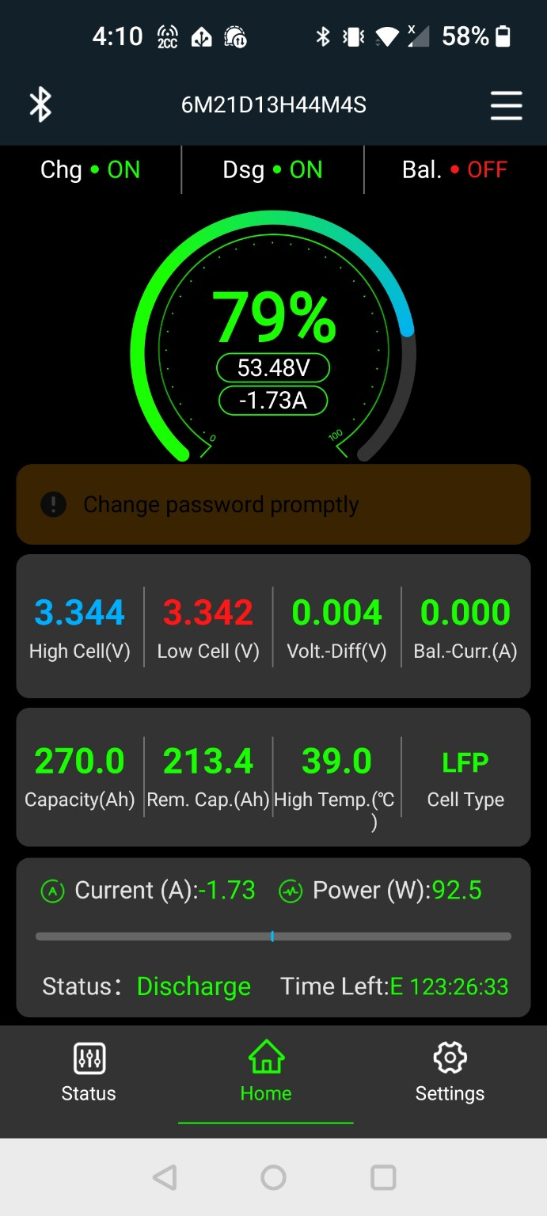
FR001-S01. JK-BMS Android status screen at 4:10 PM on July 31, 2026. Original source file preserved in the companion sources folder.

Calculated values
Quantity | Inputs | Calculation | Result
Present PV nameplate | 6 modules × 395 W | 6 × 395 | 2,370 W / 2.37 kW
Nominal battery voltage | 16 cells × 3.2 V | 16 × 3.2 | 51.2 V
Nominal battery energy | 51.2 V × 280 Ah | 51.2 × 280 | 14,336 Wh / 14.3 kWh
Historical BMS configured energy (before Aug 8 correction) | 51.2 V × 270 Ah | 51.2 × 270 | 13,824 Wh / 13.8 kWh
Current BMS configured energy | 51.2 V × 280 Ah | 51.2 × 280 | 14,336 Wh / 14.3 kWh

Equipment inventory
Component | Recorded identification | Status | Evidence needed
PV modules | 6 × Talesun TP6F72M(H)-395, 395 W each | CONFIRMED | FR001-S08 panel label; 3S2P topology confirmed by owner; combiner/protection photo still useful
Inverter | Schneider Electric Conext XW Pro 6848 NA, part 865-6848-21 | CONFIRMED | FR001-S11 equipment label
Charge controller | OutBack FLEXmax 60, FM60-150VDC | CONFIRMED | FR001-S10 equipment label; confirmed 3S2P string Voc is 146.7 V at STC; cold-weather margin requires mitigation
Battery cells | 16 × LiFePO₄, 3.2 V, 280 Ah | CONFIRMED | FR001-S09 cell label; complete bank photograph still useful
Battery management | JK smart BMS, 16S application display; capacity setting corrected to 280 Ah on Aug 8, 2026 | PARTLY CONFIRMED | FR001-S12–S20 app settings snapshot; BMS hardware label/wiring photograph still useful
Protection | Disconnects, breakers, and Class-T protection previously recorded | TO VERIFY | Full electrical-wall photograph and ratings

Photographs still needed
- Complete sixteen-cell battery bank
- PV combiner/string wiring and protection labels
- JK-BMS unit, sensing leads, and connector labels
- FR001-S07 — disconnects, breakers, and battery protection

Questions, resolved checks, and remaining work
- How should the confirmed 3S2P array be reconfigured or otherwise mitigated so cold-weather open-circuit voltage remains safely within the FLEXmax 60 input limit?
- [RESOLVED August 8, 2026] Array topology is confirmed as 3S2P: two strings of three modules in series, paralleled at the controller side. One 3-panel string is physically located on each side of the hill. The combiner, disconnect, fuse/breaker arrangement, and conductor routing still need photographic documentation.
- What loads were active at 4:10 PM when the BMS reported 92.5 W of discharge?
- Which temperature sensor produced the 39.0 °C high-temperature value, and where is it mounted?
- [RESOLVED August 8, 2026] JK-BMS capacity was changed from 270 Ah to 280 Ah. Before the change, the home screen showed 270.0 Ah capacity / 182.1 Ah remaining / 67% SOC at 53.04 V. After the change, it showed 280.0 Ah capacity / 200.1 Ah remaining / 71% SOC at 53.04 V. The protection settings were left unchanged.

Field Report derivation sheet
This section identifies what may safely be extracted for a public Field Report without turning the report into an explanation or tutorial.
Suitable public observation | Source
Six 395-watt Talesun modules form the present working array. | Confirmed equipment label
The array’s present nameplate capacity is 2.37 kW. | Direct calculation
The battery bank contains sixteen LiFePO₄ cells. | Recorded system information
At 4:10 PM the pack read 53.48 V and 79% state of charge. | FR001-S01
The system was discharging at 1.73 A / 92.5 W. | FR001-S01
Charging and discharging were enabled; balancing was inactive. | FR001-S01
The BMS displayed 213.4 Ah remaining and a 39.0 °C high temperature. | FR001-S01

Editorial rule for Field Reports
Observe first. Preserve exact readings. Keep interpretation brief. Do not explain general solar theory unless a later report is specifically created for that purpose.

Revision log
Version | Date | Change | Status
0.1 | 2026-07-31 | Workbook created; FR001 opened; JK-BMS screenshot and readings attached. | Superseded
0.2 | 2026-08-03 | Five additional photographs cataloged; FR001 website captions and image sequence recorded. | Superseded
0.3 | 2026-08-08 | Corrected PV modules to confirmed Talesun 395 W labels; array total corrected to 2.37 kW; 280 Ah cell rating confirmed; system name updated. | Superseded
0.4 | 2026-08-08 | Added OutBack FLEXmax 60 and Schneider Conext XW Pro equipment-label evidence; confirmed controller PV limits; documented 3-module-string cold-weather overvoltage risk; recommended BMS capacity setting correction from 270 Ah to 280 Ah. | Superseded
0.5 | 2026-08-08 | Confirmed 3S2P topology (one 3-panel series string on each side of hill); corrected JK-BMS capacity 270→280 Ah; archived before/after and settings screenshots; retained cold-weather PV overvoltage issue as active. | Current

Next update
Add the remaining PV combiner/protection photographs, document the exact string combining and disconnect arrangement, and choose a safe mitigation for the confirmed cold-weather PV-voltage margin. Preserve the August 8 JK-BMS configuration snapshot and verify the low-temperature charging threshold against the actual cell manufacturer specification before changing it.

FR001 photographic source update
Photographic source record · updated through August 8, 2026
Additional photographs have been supplied and cataloged for Field Report 001, including equipment-label evidence. Original files are preserved in the companion sources/fr001 folder. The public webpage uses optimized copies and concise captions.
Source | Date | Observed content | Public use
FR001-S02 | 2025-09-01 | Robert beside the open Schneider inverter while work is underway. | Report hero
FR001-S03 | 2026-01-31 | Wide view of panels and the surrounding working area. | The setting
FR001-S04 | 2026-07-25 | Ground-mounted modules leading toward the equipment enclosure. | Array and shelter
FR001-S05 | 2026-07-25 | Open wooden equipment shelter beside the array. | Equipment shelter
FR001-S06 | 2026-07-26 | Several fixed panel mounts below the boulder formations. | Panels among the boulders
FR001-S08 | 2026-08-08 | Talesun TP6F72M(H)-395 module label confirming 395 W rating and electrical specifications. | Technical source record
FR001-S09 | 2026-08-08 | LiFePO₄ cell label confirming 3.2 V, 280 Ah rating. | Technical source record
FR001-S10 | 2026-08-08 | OutBack FLEXmax 60 FM60-150VDC label confirming 150 VDC maximum PV Voc and 15–145 VDC nominal operating range. | Technical source record
FR001-S11 | 2026-08-08 | Schneider Electric Conext XW Pro 6848 NA inverter/charger label, part 865-6848-21, manufactured 26 Sep 2022. | Technical source record
FR001-S12 | 2026-08-08 | JK-BMS home screen before capacity correction: 270.0 Ah, 182.1 Ah remaining, 67% SOC, 53.04 V. | Technical source record
FR001-S13 | 2026-08-08 | JK-BMS Core Parameters after edit: Cell Count 16; Capacity 280 Ah; balancer enabled. | Technical source record
FR001-S14 | 2026-08-08 | JK-BMS active-balancer and upper-voltage settings: 0.010 V delta, 3.00 V start, 2.0 A max balance, 3.600 V cell OVP, 3.560 V SOC-100%, 3.550 V OVPR. | Technical source record
FR001-S15 | 2026-08-08 | JK-BMS lower-voltage and current-protection settings including 2.620 V SOC-0%, 2.600 V UVP, 2.50 V power-off, 40 A charge current and 200 A discharge current settings. | Technical source record
FR001-S16 | 2026-08-08 | JK-BMS temperature-protection settings snapshot. | Technical source record
FR001-S17 | 2026-08-08 | JK-BMS short-circuit, buzzer, and Smart Sleep settings snapshot. | Technical source record
FR001-S18 | 2026-08-08 | JK-BMS Smart Sleep and communication settings snapshot. | Technical source record
FR001-S19 | 2026-08-08 | JK-BMS communication and calibration screen: voltage calibration 53.035 V; current calibration −6.727 A; time calibration 2026-08-08 15:55:55. | Technical source record
FR001-S20 | 2026-08-08 | JK-BMS home screen after capacity correction: 280.0 Ah, 200.1 Ah remaining, 71% SOC, 53.04 V; app reports battery functioning properly. | Technical source record
The setting photographs document visible arrangement. Equipment-label photographs FR001-S08 through FR001-S11 confirm the PV module, battery-cell, charge-controller, and inverter/charger identifications. The 3S2P topology is now confirmed by direct owner observation: one three-panel series string is installed on each side of the hill. Photographs of the combining/protection point are still desirable. FR001-S12 through FR001-S20 preserve the August 8 JK-BMS before/after capacity correction and settings snapshot.

FR001-S02
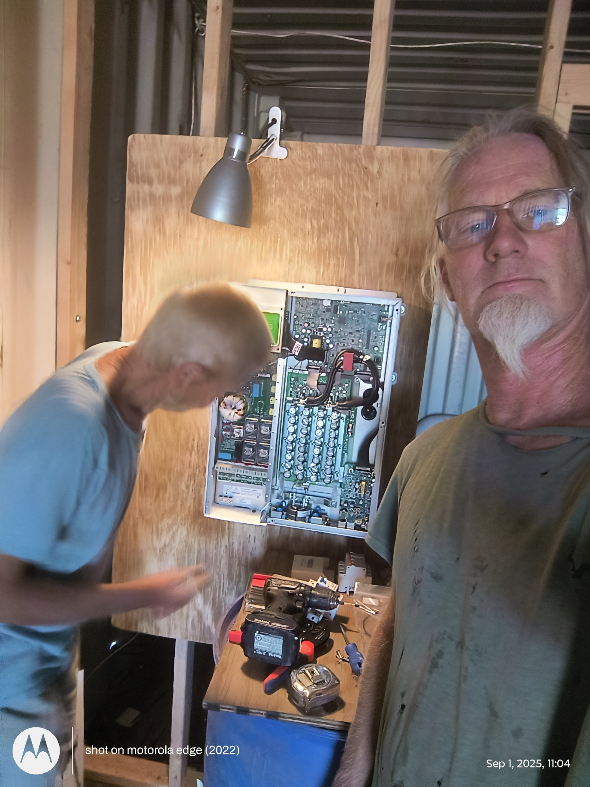
FR001-S02. Robert beside the open Schneider inverter while work is underway.

FR001-S03
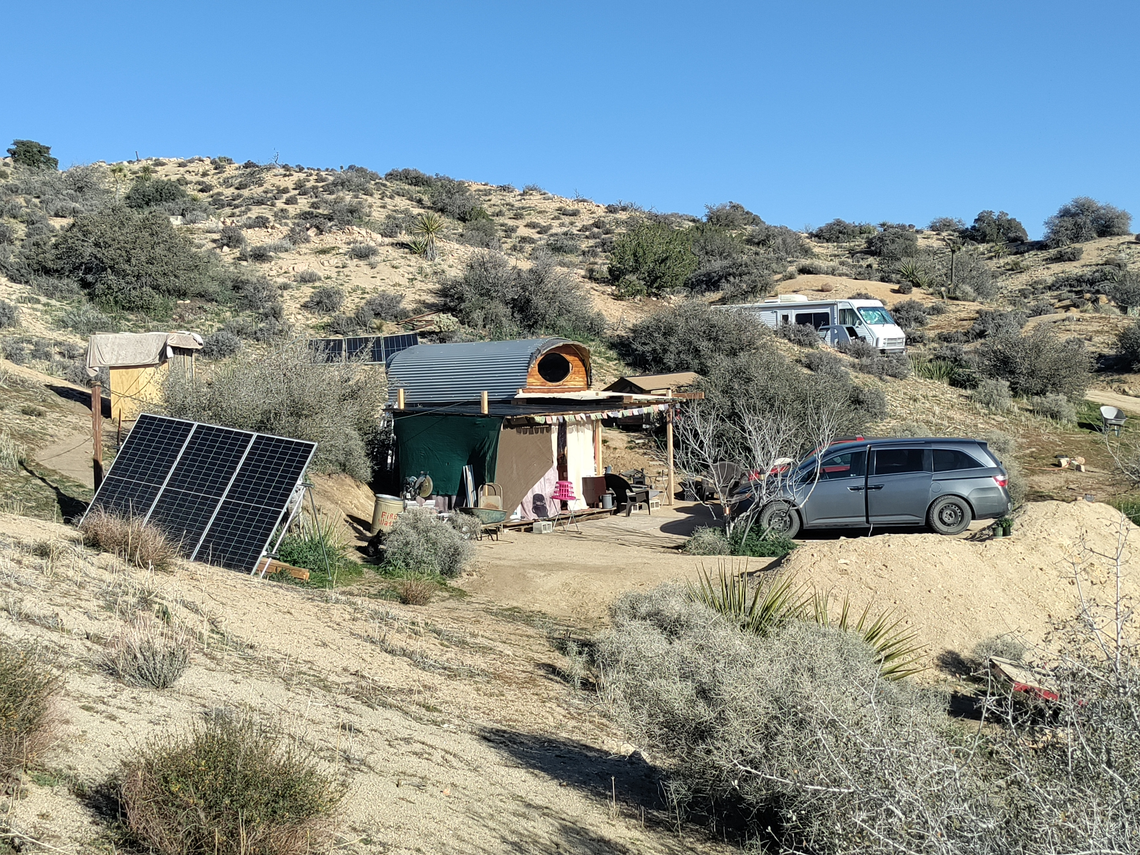
FR001-S03. Wide view of ground-mounted panels and the surrounding working area.

FR001-S04
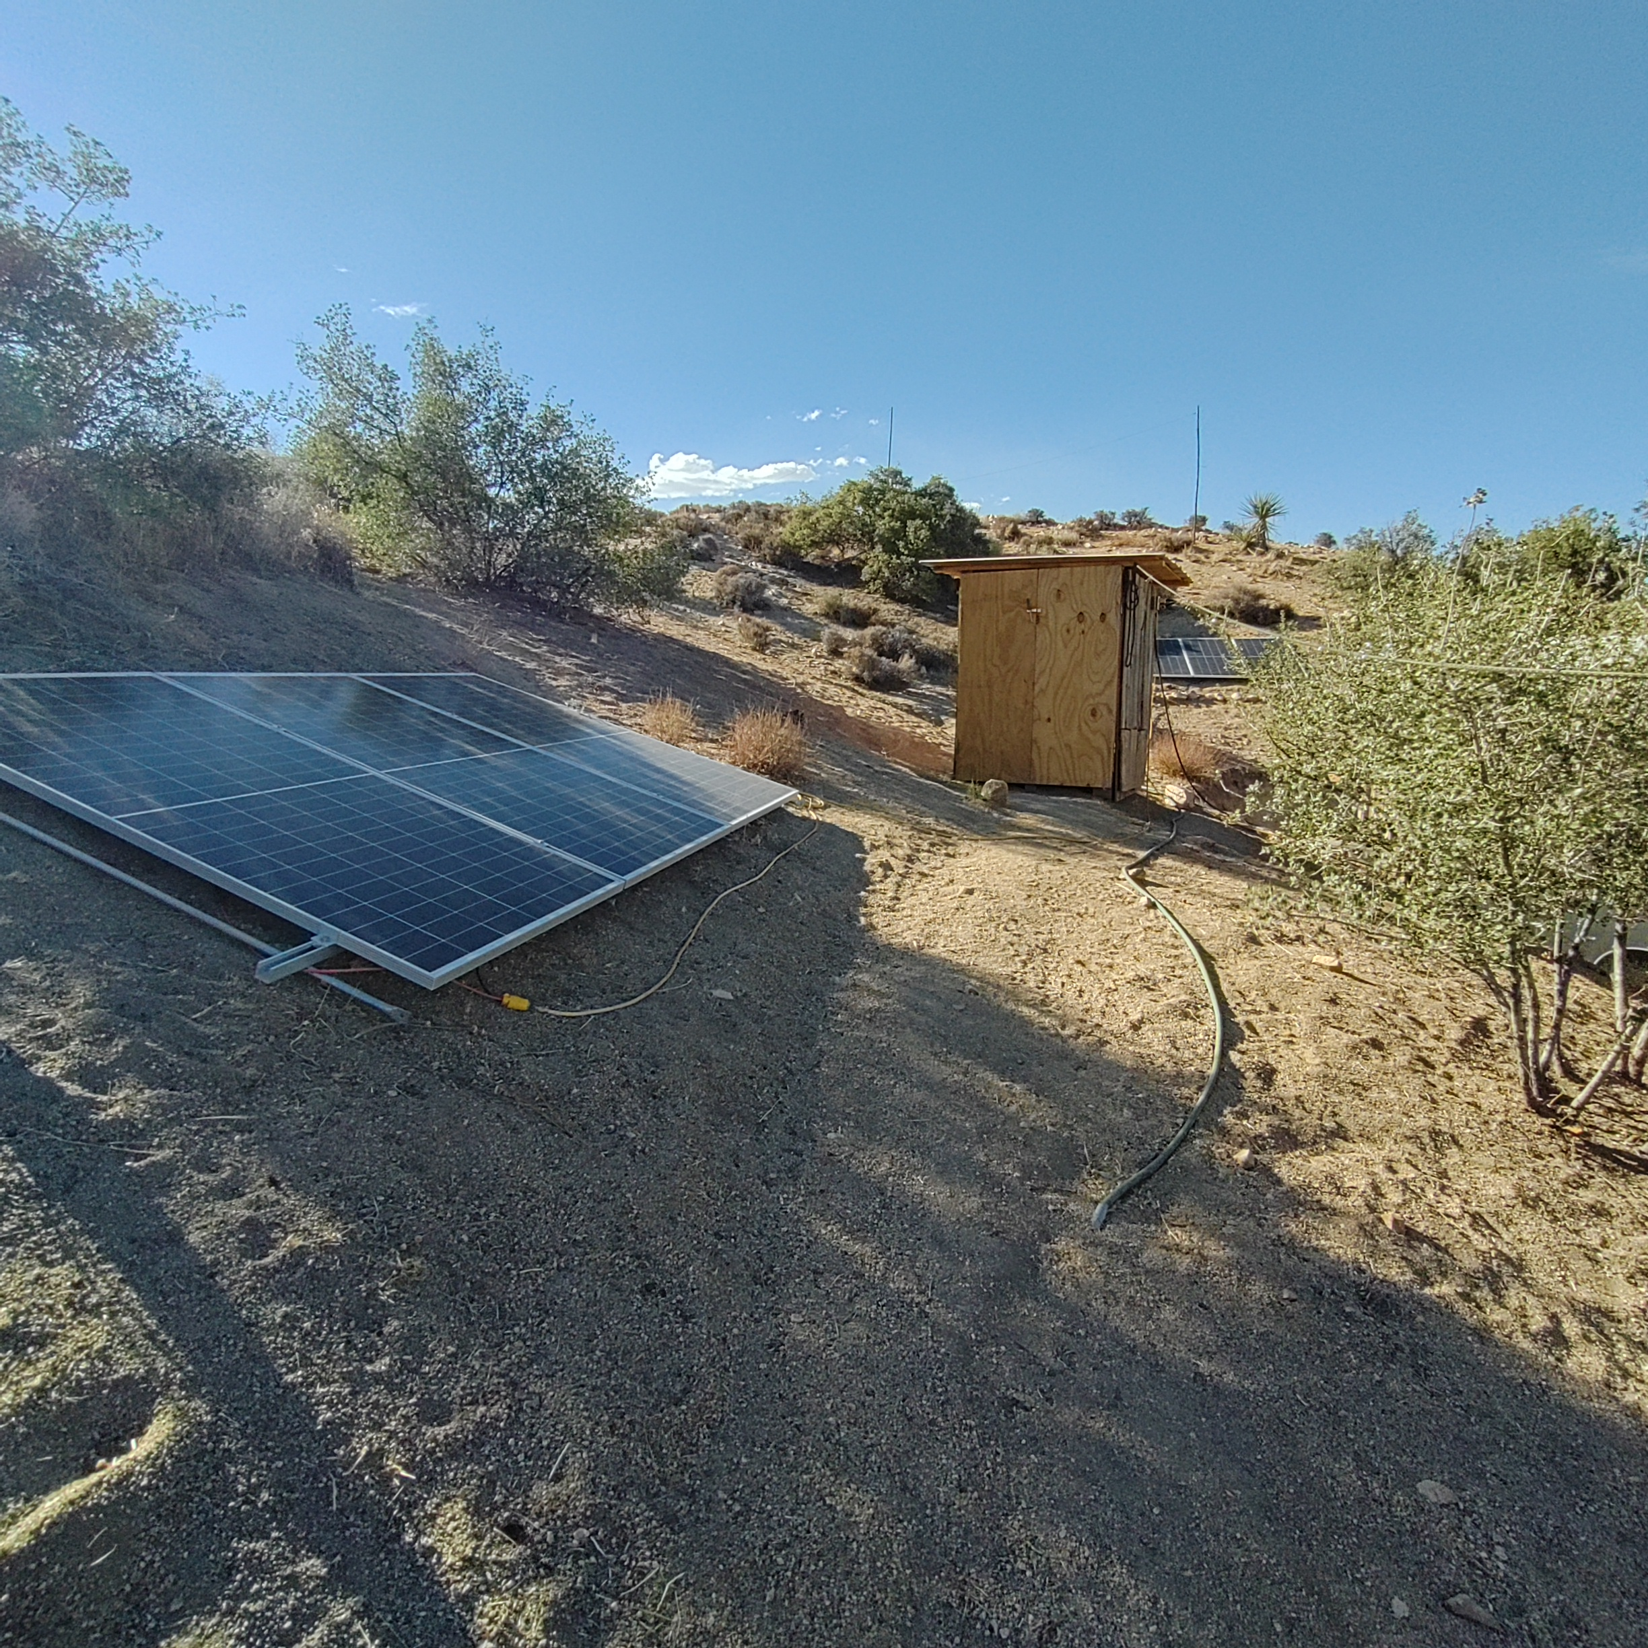
FR001-S04. Ground-mounted modules leading toward the compact equipment enclosure.

FR001-S05
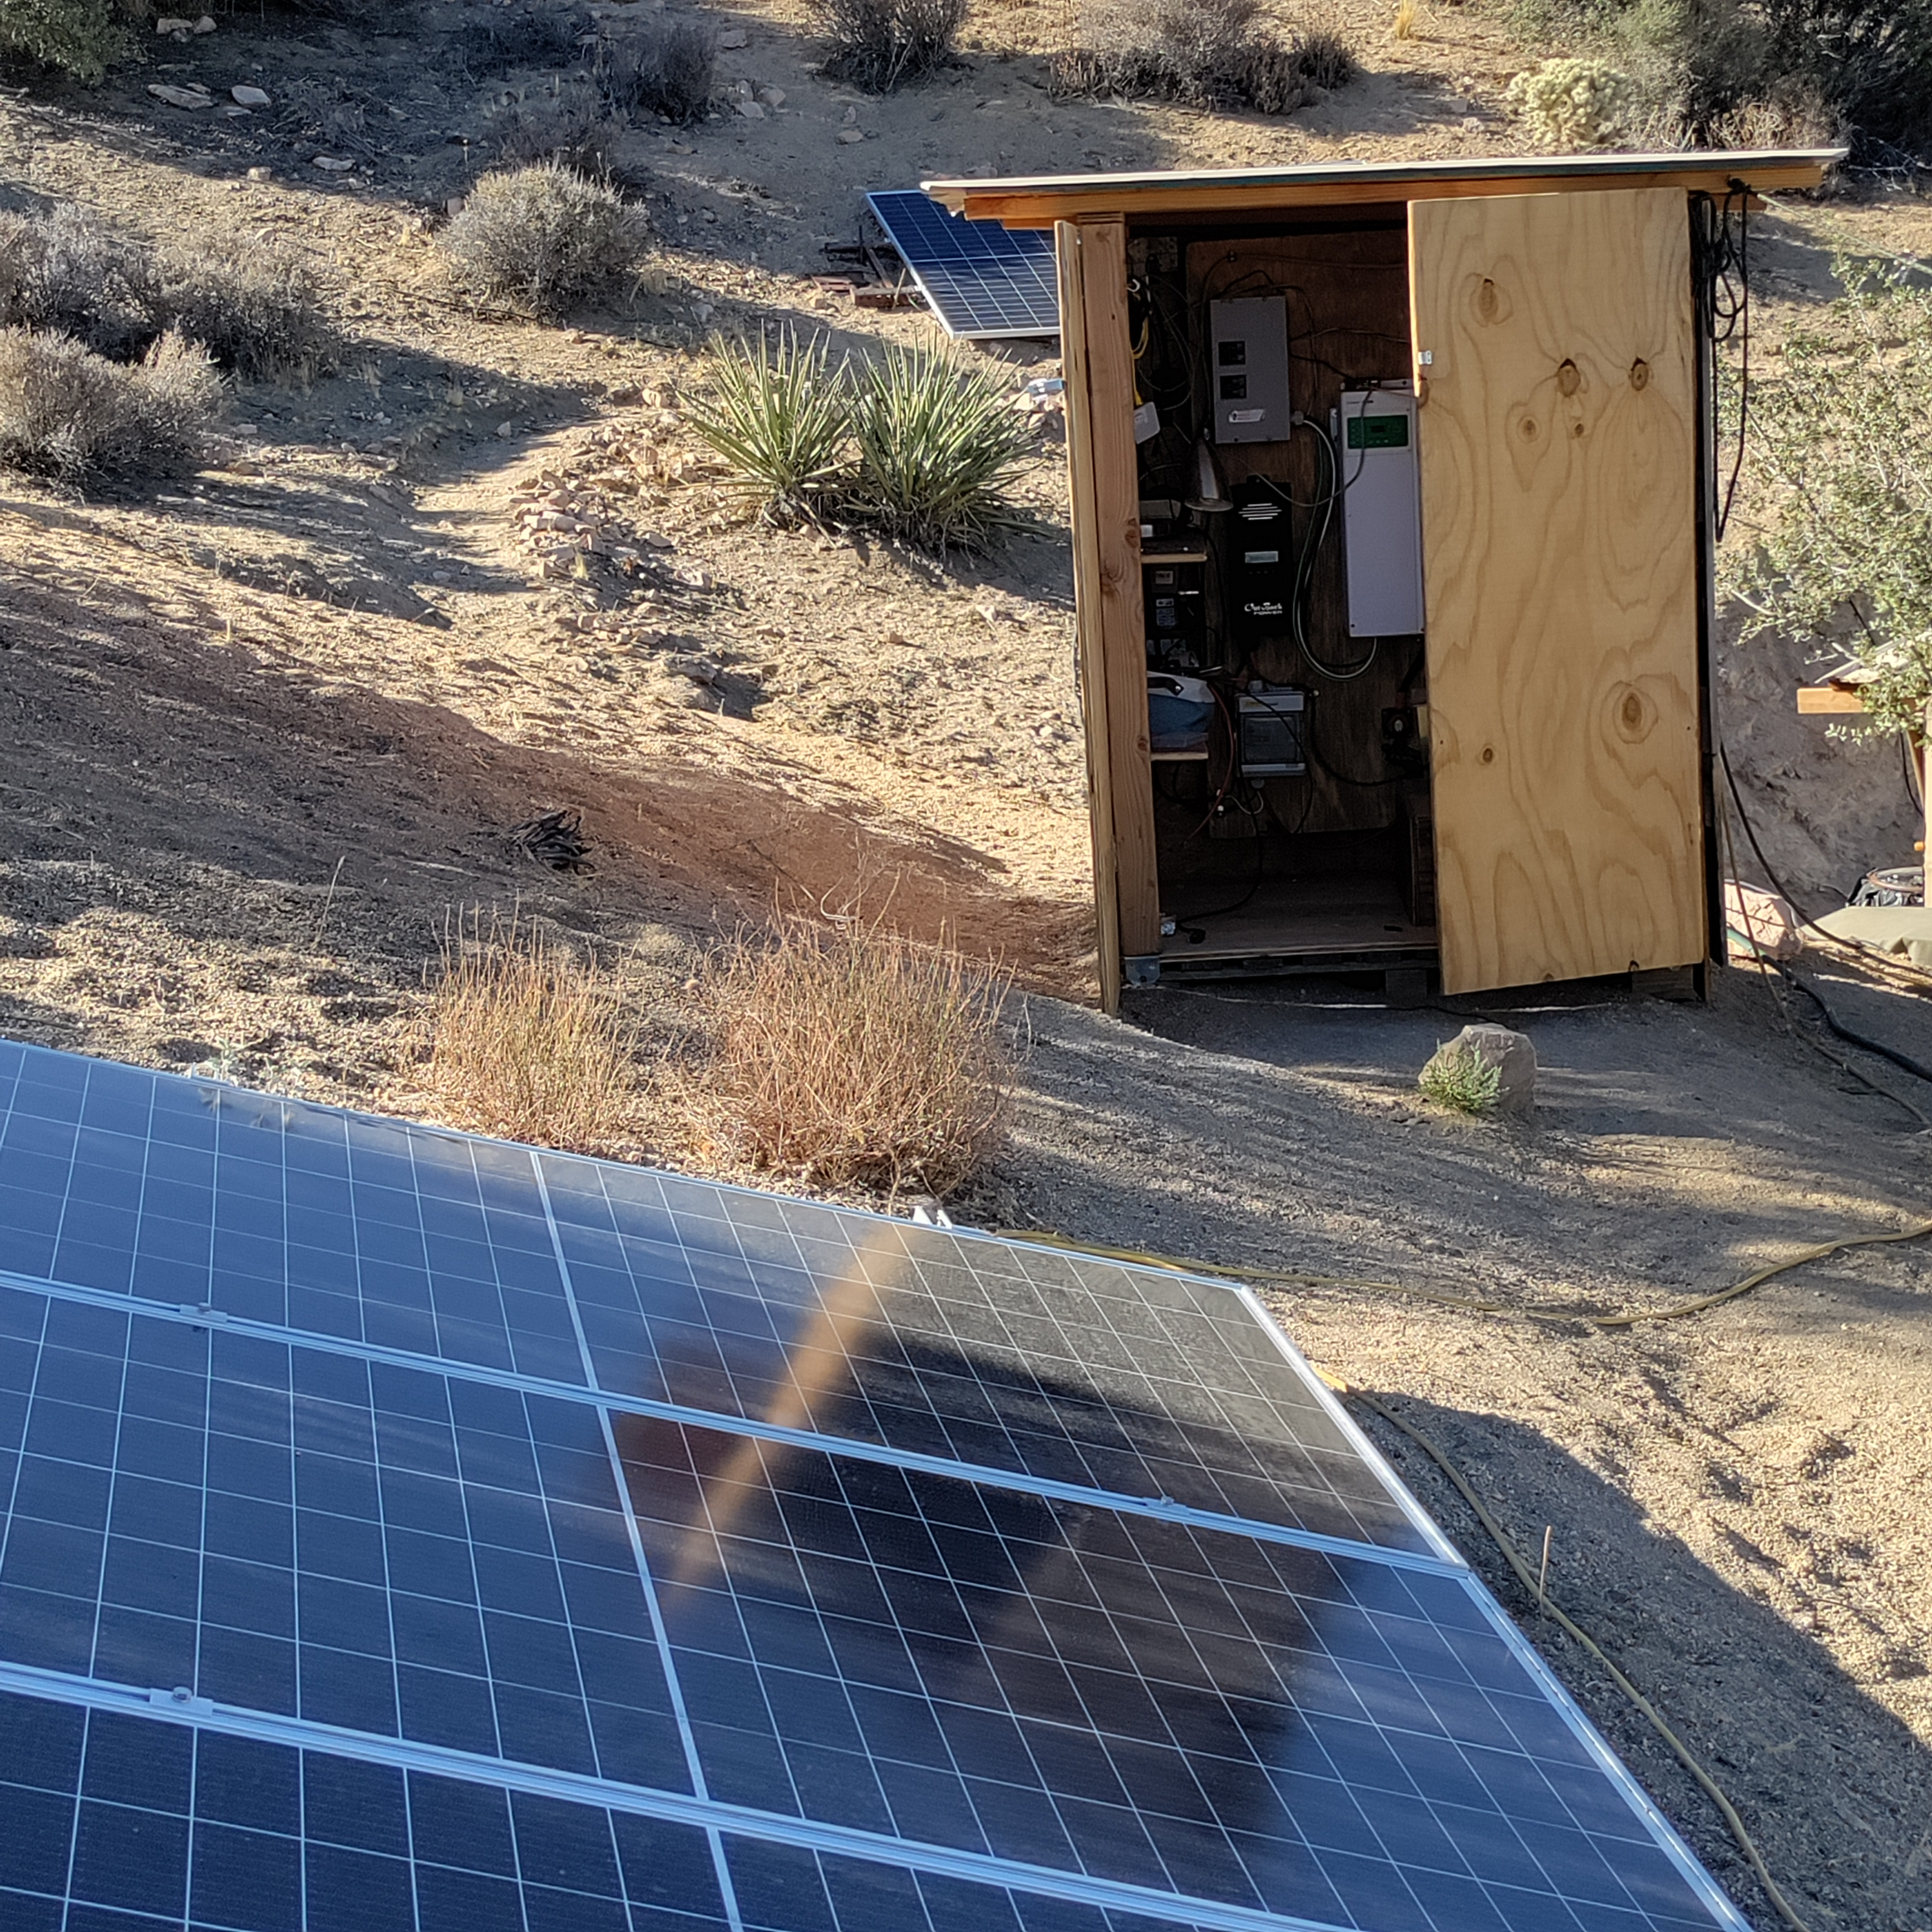
FR001-S05. Open wooden equipment shelter beside the array.

FR001-S06
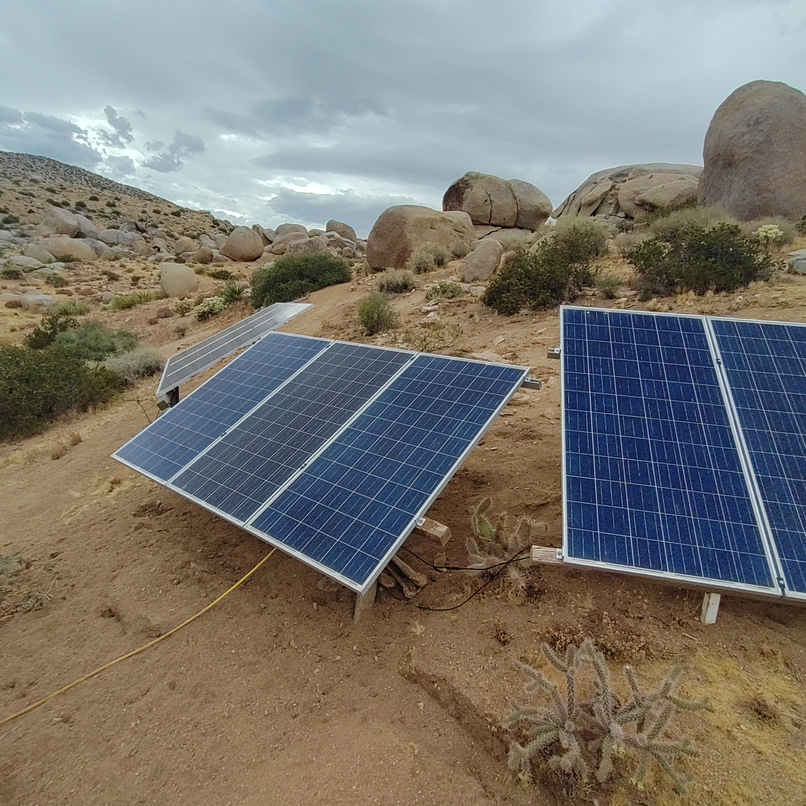
FR001-S06. Several fixed panel mounts below the surrounding boulder formations.

Remaining photographic needs
- Complete battery bank
- JK-BMS hardware and sensing leads
- PV combiner/string wiring and protection labels
- Full electrical protection and disconnect arrangement

FR001-S10
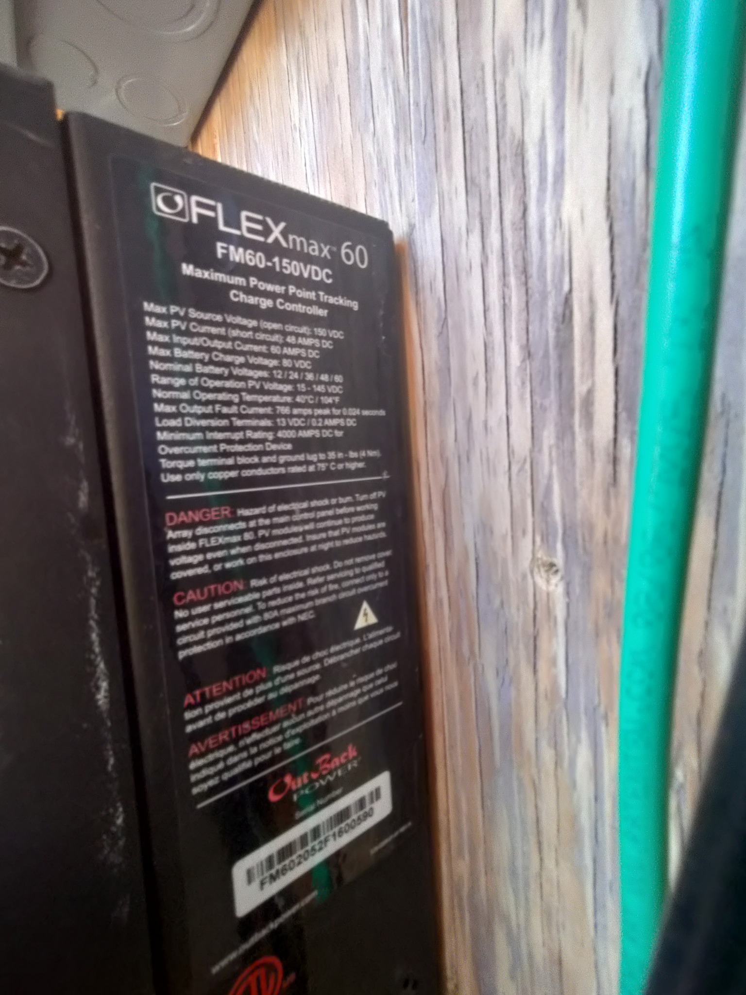
FR001-S10. OutBack FLEXmax 60 charge-controller equipment label. Model FM60-150VDC; maximum PV open-circuit voltage 150 VDC; nominal operating PV range 15–145 VDC. Photograph supplied August 8, 2026.

FR001-S11
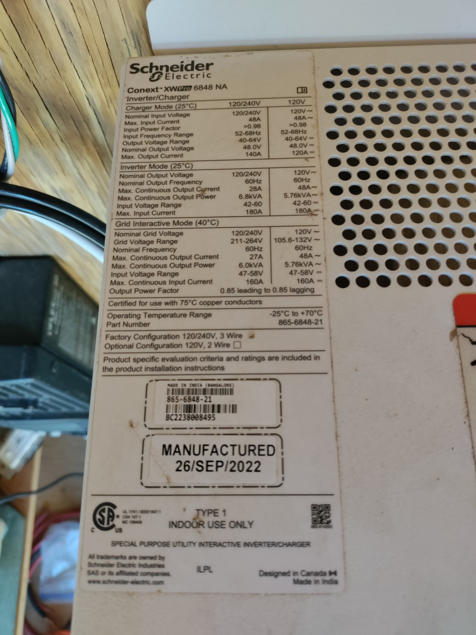
FR001-S11. Schneider Electric Conext XW Pro 6848 NA inverter/charger equipment label, part 865-6848-21, manufactured 26 Sep 2022. Photograph supplied August 8, 2026.

Version 0.5 correction note
August 8, 2026 — The six-panel array topology was confirmed as 3S2P, with one three-panel series string on each side of the hill. The JK-BMS configured capacity was corrected from 270 Ah to 280 Ah and verified on the app. A nine-screen BMS settings snapshot was archived. The 146.7 V STC string Voc versus the FLEXmax 60 150 V absolute limit remains an active cold-weather design concern.

FR001 — JK-BMS Configuration Snapshot
  - Capacity correction and settings record · August 8, 2026
The cell labels confirm 280 Ah nominal capacity. The JK-BMS had been configured at 270 Ah. Only the Capacity (Ah) parameter was changed; the protection settings shown in the accompanying screenshots were left unchanged. The before/after status screens are preserved below, and the complete settings-screen series is cataloged as FR001-S12 through FR001-S20.
Before — 270 Ah | After — 280 Ah
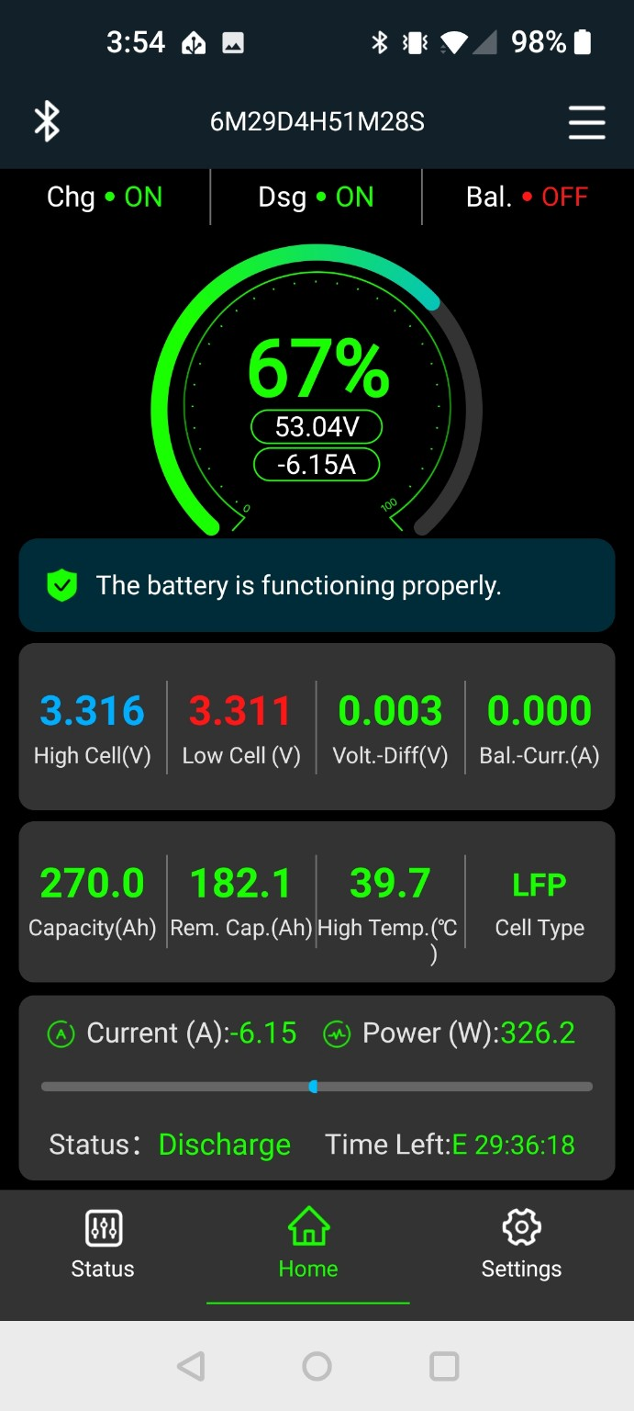 | 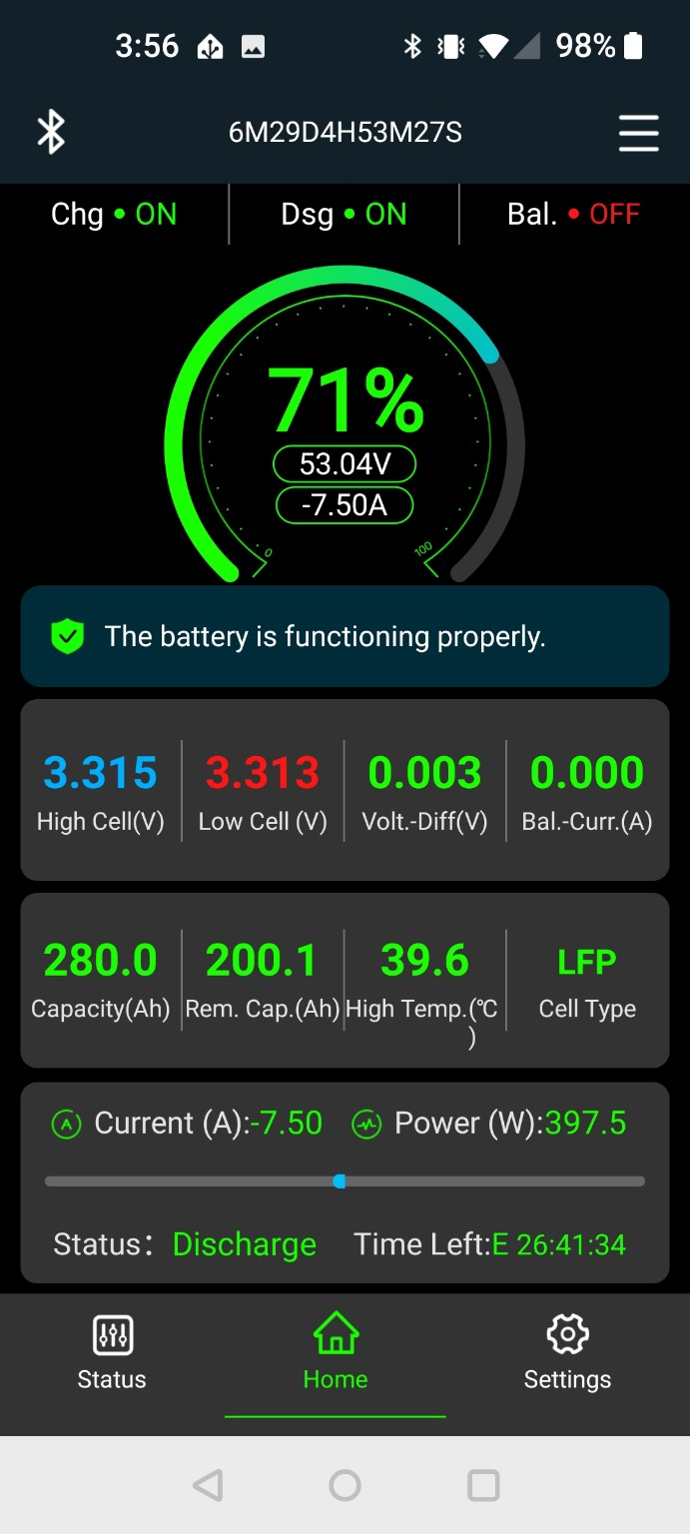

Observed change
Field | Before | After | Note
Configured capacity | 270.0 Ah | 280.0 Ah | Corrected to physical cell rating
Displayed SOC | 67% | 71% | BMS recalculated after parameter change
Remaining capacity | 182.1 Ah | 200.1 Ah | Displayed app value
Pack voltage | 53.04 V | 53.04 V | Essentially unchanged
Current | −6.15 A | −7.50 A | Load changed during the interval
Displayed cell spread | 0.003 V | 0.003 V | Cells remained closely matched

Settings snapshot notes
- Cell count remained 16; cell type remained LFP; charge and discharge remained enabled.
- Active balancer was enabled; displayed balance delta was 0.010 V, start voltage 3.00 V, and maximum balance current 2.0 A.
- Displayed cell over-voltage protection was 3.600 V; SOC-100% voltage 3.560 V; over-voltage release 3.550 V.
- Displayed SOC-0% voltage was 2.620 V; cell under-voltage protection 2.600 V; power-off voltage 2.50 V.
- Displayed continued charge current was 40.0 A and continued discharge current 200.0 A.
- Temperature, short-circuit, Smart Sleep, communication, and calibration screens were preserved as source images without changing those settings.
- TO VERIFY: the displayed low-temperature charge cut-off/release settings should be compared with the actual cell manufacturer specification before any change is made.

