INTERNATIONAL STANDARD

ISO 26262-1

Second edition

2018-12

**Road vehicles — Functional safety —**

Part 1:

**Vocabulary**

*Véhicules routiers — Sécurité fonctionnelle —*

*Partie 1: Vocabulaire*

**iTeh STANDARD PREVIEW**

**(standards.iteh.ai)**

#### ISO 26262-1:2018

##### https://standards.iteh.ai/catalog/standards/sist/c1a72b85-fd93-4952-bc1e- 38aedd5d0742/iso-26262-1-2018

Reference number ISO 26262-1:2018(E)



**iTeh STANDARD PREVIEW**

**(standards.iteh.ai)**

#### ISO 26262-1:2018

##### https://standards.iteh.ai/catalog/standards/sist/c1a72b85-fd93-4952-bc1e- 38aedd5d0742/iso-26262-1-2018

© ISO 2018

### COPYRIGHT PROTECTED DOCUMENT

All rights reserved. Unless otherwise specified, or required in the context of its implementation, no part of this publication may be reproduced or utilized otherwise in any form or by any means, electronic or mechanical, including photocopying, or posting on the internet or an intranet, without prior written permission. Permission can be requested from either ISO at the address below or ISO’s member body in the country of the requester.

ISO copyright office

CP 401 • Ch. de Blandonnet 8 CH-1214 Vernier, Geneva Phone: +41 22 749 01 11

Fax: +41 22 749 09 47

Email: [copyright@iso.org](mailto:copyright@iso.org)

Website: [www.iso.org](http://www.iso.org/) Published in Switzerland

**Contents** Page

Foreword iv

Introduction vi

1. Scope 1
2. Normative references 1
3. Terms and definitions 1
4. Abbreviated terms 28

Bibliography 33

**iTeh STANDARD PREVIEW**

**(standards.iteh.ai)**

#### ISO 26262-1:2018

##### https://standards.iteh.ai/catalog/standards/sist/c1a72b85-fd93-4952-bc1e- 38aedd5d0742/iso-26262-1-2018

# Foreword

ISO (the International Organization for Standardization) is a worldwide federation of national standards bodies (ISO member bodies). The work of preparing International Standards is normally carried out through ISO technical committees. Each member body interested in a subject for which a technical committee has been established has the right to be represented on that committee. International organizations, governmental and non-governmental, in liaison with ISO, also take part in the work. ISO collaborates closely with the International Electrotechnical Commission (IEC) on all matters of electrotechnical standardization.

The procedures used to develop this document and those intended for its further maintenance are described in the ISO/IEC Directives, Part 1. In particular, the different approval criteria needed for the different types of ISO documents should be noted. This document was drafted in accordance with the editorial rules of the ISO/IEC Directives, Part 2 (see [www.iso.org/directives).](http://www.iso.org/directives))

Attention is drawn to the possibility that some of the elements of this document may be the subject of patent rights. ISO shall not be held responsible for identifying any or all such patent rights. Details of any patent rights identified during the development of the document will be in the Introduction and/or on the ISO list of patent declarations received (see [www.iso.org/patents).](http://www.iso.org/patents))

Any trade name used in this document is information given for the convenience of users and does not

constitute an endorsement.

For an explanation on the voluntary nature of standards, the meaning of ISO specific terms and expressions related to conformity assessment, as well as information about ISO's adherence to the World Trade Organization (WTO) principles in the Technical Barriers to Trade (TBT) see the following

**iTeh STANDARD PREVIEW**

URL: [www.iso.org/iso/foreword.html.](http://www.iso.org/iso/foreword.html) **(standards.iteh.ai)**

This document was prepared by Technical Committee ISO/TC 22, *Road vehicles Subcommittee*, SC 32,

*Electrical and electronic components and general*IS*s*O*ys*2*te*6*m*262*a*-*s*1*p*:2*e*0*c*1*t*8*s*.

##### https://standards.iteh.ai/catalog/standards/sist/c1a72b85-fd93-4952-bc1e-

This edition of ISO 26262 series of standa3r8dasedcda5ndc0e74ls2/aisno-d26r2e6p2l-a1c-e2s01t8he edition ISO 26262:2011 series of

standards, which has been technically revised and includes the following main changes:

* requirements for trucks, buses, trailers and semi-trailers;
* extension of the vocabulary;
* more detailed objectives;
* objective oriented confirmation measures;
* management of safety anomalies;
* references to cyber security;
* updated target values for hardware architecture metrics;
* guidance on model based development and software safety analysis;
* evaluation of hardware elements;
* additional guidance on dependent failure analysis;
* guidance on fault tolerance, safety-related special characteristics and software tools;
* guidance for semiconductors;
* requirements for motorcycles; and
* general restructuring of all parts for improved clarity.

Any feedback or questions on this document should be directed to the user’s national standards body. A

complete listing of these bodies can be found at [www.iso.org/members.html.](http://www.iso.org/members.html) A list of all parts in the ISO 26262 series can be found on the ISO website.

**iTeh STANDARD PREVIEW**

**(standards.iteh.ai)**

#### ISO 26262-1:2018

##### https://standards.iteh.ai/catalog/standards/sist/c1a72b85-fd93-4952-bc1e- 38aedd5d0742/iso-26262-1-2018

# Introduction

The ISO 26262 series of standards is the adaptation of IEC 61508 series of standards to address the

sector specific needs of electrical and/or electronic (E/E) systems within road vehicles.

This adaptation applies to all activities during the safety lifecycle of safety-related systems comprised of electrical, electronic and software components.

Safety is one of the key issues in the development of road vehicles. Development and integration of automotive functionalities strengthen the need for functional safety and the need to provide evidence that functional safety objectives are satisfied.

With the trend of increasing technological complexity, software content and mechatronic implementation, there are increasing risks from systematic failures and random hardware failures, these being considered within the scope of functional safety. ISO 26262 series of standards includes guidance to mitigate these risks by providing appropriate requirements and processes.

To achieve functional safety, the ISO 26262 series of standards:

1. provides a reference for the automotive safety lifecycle and supports the tailoring of the activities to be performed during the lifecycle phases, i.e., development, production, operation, service and decommissioning;
2. provides an automotive-specific risk-based approach to determine integrity levels [Automotive

Safety Integrity Levels (A**i**S**T**ILs**e**)]**h**;

**STANDARD PREVIEW**

1. uses ASILs to specify which of the requirements of ISO 26262 are applicable to avoid unreasonable

residual risk;

**(standards.iteh.ai)**

1. provides requirements for functional safeItSyO m26a2n62a-g1e:2m01e8nt, design, implementation, verification, validation and confirmhatttpiso://nstamndeaarsdus.irteehs.;aia/cnatdalog/standards/sist/c1a72b85-fd93-4952-bc1e-
2. provides requirements for relations b3e8tawedede5nd0c7u4s2t/iosom-2e6r2s6a2-n1d-2s0u1p8pliers.

The ISO 26262 series of standards is concerned with functional safety of E/E systems that is achieved through safety measures including safety mechanisms. It also provides a framework within which safety-related systems based on other technologies (e.g. mechanical, hydraulic and pneumatic) can be considered.

The achievement of functional safety is influenced by the development process (including such activities as requirements specification, design, implementation, integration, verification, validation and configuration), the production and service processes and the management processes.

Safety is intertwined with common function-oriented and quality-oriented activities and work products. The ISO 26262 series of standards addresses the safety-related aspects of these activities and work products.

Figure 1 shows the overall structure of the ISO 26262 series of standards. The ISO 26262 series of standards is based upon a V-model as a reference process model for the different phases of product development. Within the figure:

* the shaded “V”s represent the interconnection among ISO 26262-3, ISO 26262-4, ISO 26262-5, ISO 26262-6 and ISO 26262-7;
* for motorcycles:

— ISO 26262-12:2018, Clause 8 supports ISO 26262-3;

— ISO 26262-12:2018, Clauses 9 and 10 support ISO 26262-4;

* the specific clauses are indicated in the following manner: “m-n”, where “m” represents the number

of the particular part and “n” indicates the number of the clause within that part.



EXAMPLE “2-6” represents ISO 26262-2:2018, Clause 6.

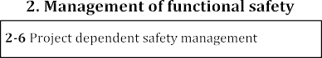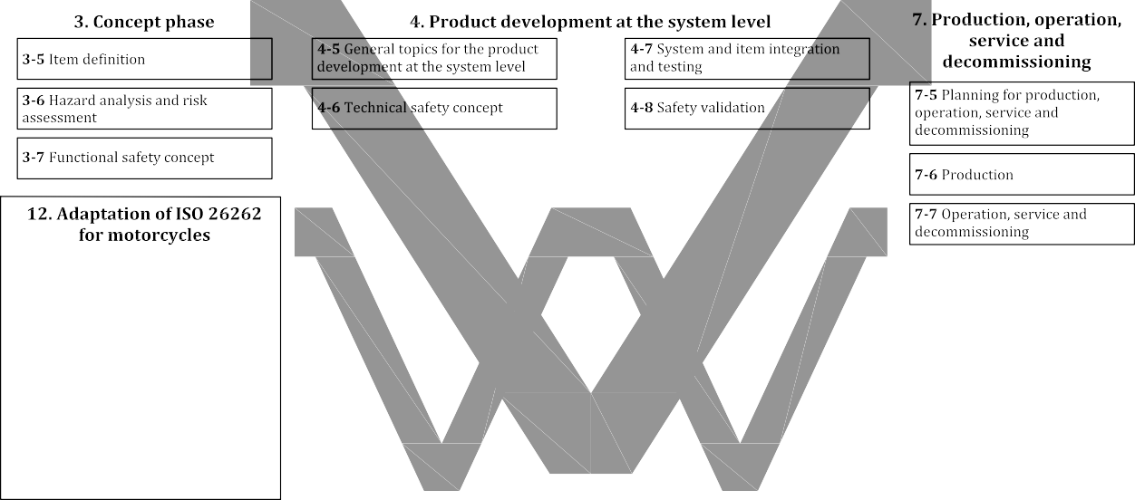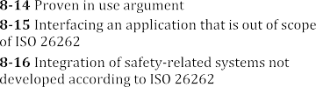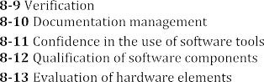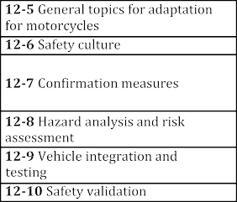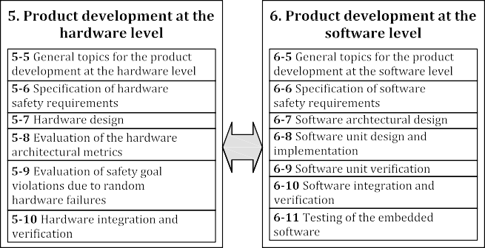

**iTeh STANDARD PREVIEW**

**(standards.iteh.ai)**

ISO 26262-1:2018

38aedd5d0742/iso-26262-1-2018

|  |
| --- |
|  |
|  |
|  |
|  |

|  |  |  |
| --- | --- | --- |
|  | /sist/c |  |
| https://standards.iteh.ai/catalog/standards | 1a72b85-fd93-4952-bc1e- |

###### Figure 1 — Overview of the ISO 26262 series of standards

**iTeh STANDARD PREVIEW**

**(standards.iteh.ai)**

#### ISO 26262-1:2018

##### https://standards.iteh.ai/catalog/standards/sist/c1a72b85-fd93-4952-bc1e- 38aedd5d0742/iso-26262-1-2018

**Road vehicles — Functional safety —**

Part 1:

**Vocabulary**

## Scope

This document is intended to be applied to safety-related systems that include one or more electrical and/or electronic (E/E) systems and that are installed in series production road vehicles, excluding mopeds. This document does not address unique E/E systems in special vehicles such as E/E systems designed for drivers with disabilities.

NOTE Other dedicated application-specific safety standards exist and can complement the ISO 26262 series

of standards or vice versa.

Systems and their components released for production, or systems and their components already under development prior to the publication date of this document, are exempted from the scope of this edition. This document addresses alterations to existing systems and their components released for production prior to the publication of this document by tailoring the safety lifecycle depending on the alteration. This document addresses integration of existing systems not developed according to this document and systems developed according to this document by tailoring the safety lifecycle.

**iTeh STANDARD PREVIEW**

This document addresses possib**(**l**s**e**t**h**a**az**n**ar**d**ds**a**c**r**au**d**se**s**d**.i**b**t**y**e**m**h**a**.**lf**a**un**i**c**)**tioning behaviour of safety-related E/E

systems, including interaction of these systems. It does not address hazards related to electric shock, fire, smoke, heat, radiation, toxicity, flamISmO a2b62il6i2t-y1, :2r0e1a8ctivity, corrosion, release of energy and similar hazards, unless direhtctptlsy://sctaanudsaerdds.biteyh.mai/aclaftaulongc/sttiaonndainrdgs/bsiesth/ca1va7io2bu8r5o-ffds9a3-f4e9t5y2-r-becl1aet-ed E/E systems.

##### 38aedd5d0742/iso-26262-1-2018

This document describes a framework for functional safety to assist the development of safety- related E/E systems. This framework is intended to be used to integrate functional safety activities into a company-specific development framework. Some requirements have a clear technical focus to implement functional safety into a product; others address the development process and can therefore be seen as process requirements in order to demonstrate the capability of an organization with respect to functional safety.

This document defines the vocabulary of terms used in the ISO 26262 series of standards.

## Normative references

The following documents are referred to in the text in such a way that some or all of their content constitutes requirements of this document. For dated references, only the edition cited applies. For undated references, the latest edition of the referenced document (including any amendments) applies.

ISO 26262 (all parts), *Road vehicles — Functional safety*

## Terms and definitions

For the purposes of this document, the terms and definitions given in ISO 26262 (all parts) and the following apply.

ISO and IEC maintain terminological databases for use in standardization at the following addresses:

* ISO Online browsing platform: available at https://[www.iso.org/obp](http://www.iso.org/obp)
* IEC Electropedia: available at <http://www.electropedia.org/>

###### 3.1

###### architecture

representation of the structure of the *item* (3.84) or *element* (3.41) that allows identification of building blocks, their boundaries and interfaces, and includes the allocation of requirements to these building blocks

###### 3.2

###### ASIL capability

capability of the *item* (3.84) or *element* (3.41) to meet assumed *safety* (3.132) requirements assigned

with a given *ASIL* (3.6)

Note 1 to entry: As a part of hardware safety requirements, achievement of the corresponding random hardware target values for fault metrics (see ISO 26262-5:2018, Clauses 8 and 9) allocated to the *element* (3.41) is included, if needed.

###### 3.3

###### ASIL decomposition

apportioning of redundant *safety* (3.132) requirements to *elements* (3.41), with sufficient *independence* (3.78), conducing to the same *safety goal* (3.139), with the objective of reducing the *ASIL* (3.6) of the redundant *safety* (3.132) requirements that are allocated to the corresponding *elements* (3.41)

Note 1 to entry: ASIL decomposition is a basis for methods of *ASIL* (3.6) tailoring during the design process

(defined as requirements decomposition with respect to *ASIL* (3.6) tailoring in ISO 26262-9).

Note 2 to entry: ASIL decomposition does not apply to random hardware failure requirements per ISO 26262-9. Note 3 to entry: Reducing the *A***i***S***T***IL* (**e**3.**h**6) o**S**f t**T**he**A**red**N**un**D**dan**A**t *s***R***afet***D***y* (3**P**.13**R**2) **E**req**V**uir**I**em**E**e**W**nts has some exclusions, e.g. *confirmation measures* (3.23) remain at the**(**le**s**v**t**e**a**l o**n**f th**d**e **a***sa***r***fet***d***y g***s***o***.***a***i***l***t**(3**e**.1**h**39**.**)**a**. **i)**

###### 3.4

###### assessment

#### ISO 26262-1:2018

examination of whether ahtctphsa://rsatacntdearrdiss.titiech.oaif/caatnalo*i*g*t*/*e*s*m*tand(a3r.d8s/4s)ist/ocr1a*e*7*l*2*e*b*m*85*e*-*n*fd*t*9(33-4.49152)-bacc1hei-eves the ISO 26262

objectives

###### 3.5

###### audit

##### 38aedd5d0742/iso-26262-1-2018

examination of an implemented process with regard to the process objectives

###### 3.6

###### automotive safety integrity level ASIL

one of four levels to specify the *item's* (3.84) or *element's* (3.41) necessary ISO 26262 requirements and *safety measures* (3.141) to apply for avoiding an *unreasonable risk* (3.176), with D representing the most stringent and A the least stringent level

Note 1 to entry: *QM* (3.117) is not an ASIL.

###### 3.7

###### availability

capability of a product to provide a stated function if demanded, under given conditions over its defined

lifetime

###### 3.8

###### base failure rate BFR

*failure rate* (3.53) of a hardware *element* (3.41) in a given application use case used as an input to *safety*

(3.132) analyses

###### 3.9

###### base vehicle

Original Equipment Manufacturer (OEM) *T&B vehicle configuration* (3.175) prior to installation of *body builder equipment* (3.12)

Note 1 to entry: *Body builder equipment* (3.12) may be installed on a base vehicle that consists of all driving

relevant *systems* (3.163) (engine, driveline, chassis, steering, brakes, cabin and driver information).

EXAMPLE *Truck* (3.174) chassis with powertrain and cabin, rolling chassis with powertrain.

###### 3.10

###### baseline

version of the approved set of one or more *work products* (3.185), *items* (3.84) or *elements* (3.41) that serves as a basis for change

Note 1 to entry: See ISO 26262-8:2018, Clause 8.

Note 2 to entry: A baseline is typically placed under configuration management.

Note 3 to entry: A baseline is used as a basis for further development through the change management process

during the *lifecycle* (3.86).

###### 3.11

###### body builder BB

organization that adds *trucks* (3.174), *buses* (3.14), *trailers* (3.171) and *semi-trailers* (3.151) (T&B)

bodies, cargo carriers,**i**o**T**r e**e**q**h**uip**S**me**T**nt**A**to**N**a *b***D***ase***A***ve***R***hic***D***le* (3**P**.9)**REVIEW**

Note 1 to entry: T&B bodies include**(***t***s***ru***t***c***a***k* **n**(3.**d**17**a**4)**r**ca**d**bs**s**, *b***.***u***i***s***t**(**e**3**h**.14**.**)**a**bo**i**d**)**ies, walk-in vans, etc.

Note 2 to entry: Cargo carriers include cargo boxes, flat beds, car transport racks, etc.

#### ISO 26262-1:2018

Note 3 to entry: Equiphtmtpes:n//tstianncdlaurddse.sitevho.aci/actaitoanloagl/sdtaenvdiacredss/asinstd/c1maa7c2hb8in5e-frdy9,3s-u4c9h52a-sbcc1eem-ent mixers, dump beds, snow

blades, lifts, etc.

###### 3.12

###### body builder equipment

##### 38aedd5d0742/iso-26262-1-2018

machine, body, or cargo carrier installed on the T&B *base vehicle* (3.9)

###### 3.13

###### branch coverage

percentage of branches of the control flow of a computer program executed during a test

Note 1 to entry: 100 % branch coverage implies 100 % *statement coverage* (3.160).

Note 2 to entry: An if-statement always has two branches - condition true and condition false - independent of the existence of an else-clause.

###### 3.14

###### bus

motor vehicle which, because of its design and appointments, is intended for carrying persons and luggage, and which has more than nine seating places, including the driving seat

Note 1 to entry: A bus may have one or two decks and may also tow a *trailer* (3.171).

###### 3.15

###### calibration data

data that will be applied as software parameter values after the software build in the development process

EXAMPLE Parameters (e.g. value for low idle speed, engine characteristic diagrams); vehicle specific parameters (adaptation values, e.g., limit stop for throttle valve); variant coding (e.g. country code, left-hand/ right-hand steering).

Note 1 to entry: Calibration data does not contain executable or interpretable code.

###### 3.16

###### candidate

*item* (3.84) or *element* (3.41) whose definition and conditions of use are identical to, or have a very high degree of commonality with, an *item* (3.84) or *element* (3.41) that is already released and in operation

Note 1 to entry: This definition applies where candidate is used in the context of a *proven in use argument* (3.115).

###### 3.17

###### cascading failure

*failure* (3.50) of an *element* (3.41) of an *item* (3.84) resulting from a root cause [inside or outside of the *element* (3.41)] and then causing a *failure* (3.50) of another *element* (3.41) or *elements* (3.41) of the same or different *item* (3.84)

Note 1 to entry: Cascading failures are *dependent failures* (3.29) that could be one of the possible root causes of a

*common cause failure* (3.18). See Figure 2.

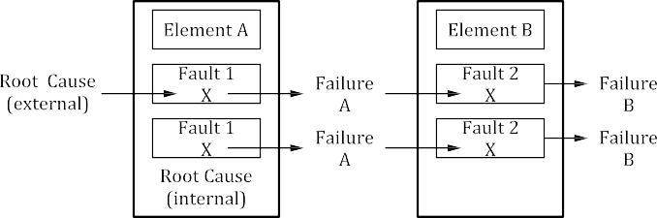

###### 3.18

###### common cause failure CCF

**iTehFigSuTreA2 —NCDasAcadRinDg faPiluRreEVIEW (standards.iteh.ai)**

#### ISO 26262-1:2018

##### https://standards.iteh.ai/catalog/standards/sist/c1a72b85-fd93-4952-bc1e-

*failure* (3.50) of two or more *elements* (3.3481a)edodf5adn07*i*4*t*2*e*/*m*iso-(236.28642)-1r-e2s0u18lting directly from a single specific

event or root cause which is either internal or external to all of these *elements* (3.41)

Note 1 to entry: Common cause failures are *dependent failures* (3.29) that are not *cascading failures* (3.17). See

Figure 3.

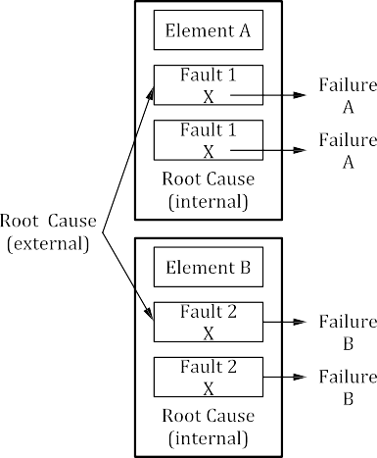

###### Figure 3 — Common cause failure

###### 3.19

###### common mode failure CMF

case of *CCF* (3.18) in which multiple *elements* (3.41) fail in the same manner

Note 1 to entry: *Failure* (3.50) in the same manner does not necessarily mean that they need to fail exactly the same. How close the *failure modes* (3.51) need to be in order to be classified as common mode failure depends on the context.

EXAMPLE 1 A *system* (3.163) has two temperature sensors which are compared with each other. If the difference between the two temperature sensors is larger than or equal to 5 °C it is handled as a *fault* (3.54) and the *system* (3.163) is switched into a *safe state* (3.131). A common mode failure lets both temperature sensors fail in such a way that the difference between the two sensors is smaller than 5 °C and therefore is not detected.

EXAMPLE 2 In a CPU lockstep *architecture* (3.1) where the outputs of both CPUs are compared cycle by cycle, both CPUs need to fail exactly the same way in order for the *failure* (3.50) to go undetected. In this context, a common mode failure lets both CPUs fail exactly the same way.

EXAMPLE 3 An over voltage *failure* (3.50) due to lots of parts not meeting their specification for over voltage

is a common mode failure.

###### 3.20

###### complete vehicle

fully assembled T&B *base vehicle* (3.9) with its *body builder equipment* (3.12)

EXAMPLE Refuse collector, dump *truck* (3.174).

###### 3.21

###### component

**iTeh STANDARD PREVIEW**

**(standards.iteh.ai)**

non-system level *element* (3.41) that is logically or technically separable and is comprised of more than

one *hardware part* (3.71) or one or more *software units* (3.159)

EXAMPLE A microcontroller.

#### ISO 26262-1:2018

##### https://standards.iteh.ai/catalog/standards/sist/c1a72b85-fd93-4952-bc1e-

Note 1 to entry: A component is a part38oaf ead*s*d*y*5*s*d*t*0*e*7*m*42(/3is.o1-6236)2.62-1-2018

###### 3.22

###### configuration data

data that is assigned during element build and that controls the element build process

EXAMPLE 1 Pre-processor variable settings which are used to derive compile time variants from the source code.

EXAMPLE 2 XML files to control the build tools or toolchain.

Note 1 to entry: Configuration data controls the software build. Configuration data is used to select code from existing code variants already defined in the code base. The functionality of selected code variant will be included in the executable code.

Note 2 to entry: Since configuration data is only used to select code variants, configuration data does not include code that is executed or interpreted during the use of the *item* (3.84).

###### 3.23

###### confirmation measure

*confirmation review* (3.24), *audit* (3.5) or *assessment* (3.4) concerning *functional safety* (3.67)

###### 3.24

###### confirmation review

confirmation that a *work product* (3.185) provides sufficient and convincing evidence of their contribution to the achievement of *functional safety* (3.67) considering the corresponding objectives and requirements of ISO 26262

Note 1 to entry: A complete list of confirmation reviews is given in ISO 26262-2.