RESULT and CONCLUSION

To enrapture the deeper insights on the approach opted and models build, it is paramount to encapsulate the outcomes. Thus, for the presented PK model designed and built using the Ordinary Differential Equations for the Oral Administration, different time interval is framed in order to analyse the results and interpreted.

EXISTING RESULTS

Figure 1: A piecewise linear regression model on BCR-ABL% values for the patient 0001 00002 RH with time in days.

Figure 1 explains a piecewise linearly fitted regression model between BCR-ABL% with time. Here, BCR-ABL% value represents the % of mutation that is observed for a cancer patient when the BCR gene and the ABL gene combine over time. The scale is taken to be logarithmic as the Ordinary Differential Equations for the model forms an exponential decay. To comprehend the optimal point of intersection between the two linearly fitted lines for a cancer patient, the Pharmacodynamic (PD) model takes the responsibility to analyse the influence of the drug on the cancer cells.

Below figures shows the standard and the optimized drug dose administration obtained for the patient 0001 00002 RH based on the PK model and the Euclidean Distance Cost Function.

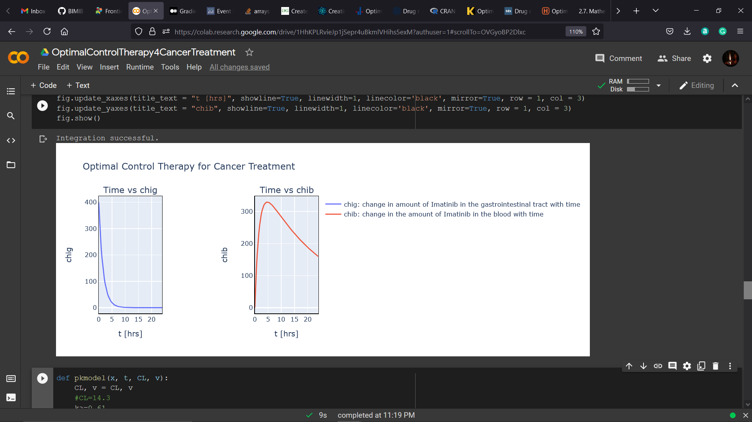

Figure 2: Oral Administration for the patient 0001 00002 RH based on Ordinary Differential Equations from the PK model over a time interval of 24 hours. (Left plot explains the change in the amount of Imatinib in the gastrointestinal track and the right plots showcase the change in the amount of Imatinib in blood)

Figure 3: Standard Drug Administration of 400 mg dosage for the patient 0001 00002 RH based on Ordinary Differential Equations from the PK model and the cost function for over 10 days until a quasi-static state is obtained. (Left plot explains the change in the amount of Imatinib in the gastrointestinal track until a static state is obtained and the right plots represents the change in the optimal target concentration with time).

NEW RESULTS

1. 1-Dose Administration

Figure 4: Standard 1-Dose Administration for different dosage for the patient 0001 00002 RH. (Left plot explains the change in the amount of Imatinib in the gastrointestinal track until a static state is observed over different drug dosage and the right plots represents the variation in the optimal target concentration with time for dosages considered).

Figure 5: Optimized 3-Dose Administration for the patient 0001 00002 RH as observed over 24 hrs (one time dosage) for a single day.

1. 2-Dose Administration

Figure 6: Standard 2-Dose Administration for different dosage for the patient 0001 00002 RH. (Left plot explains the change in the amount of Imatinib in the gastrointestinal track until a static state is observed over different drug dosage and the right plots represents the variation in the optimal target concentration with time for dosages considered).

Figure 7: Optimized 2-Dose Administration for the patient 0001 00002 RH as observed over every 12 hrs (2 times dosage) for a single day.

1. 3-Dose Administration

Figure 8: Standard 3-Dose Administration for different dosage for the patient 0001 00002 RH. (Left plot explains the change in the amount of Imatinib in the gastrointestinal track until a static state is observed over different drug dosage and the right plots represents the variation in the optimal target concentration with time for dosages considered).

Figure 9: Optimized 3-Dose Administration for the patient 0001 00002 RH as observed over every 8 hrs (3 times dosage) for a single day.

1. Optimized 1-Dose, 2-Dose and 3-Dose Administration

Figure 10: Optimized 1-Dose, 2-Dose, and 3-Dose Administration for the patient 0001 00002 RH.

Figure 10 states from the administrations taken into consideration; the 3-Dose is found to be the most optimal one with 160mg as the optimal drug dosage on a single day.