
KARNAVATI UNIVERSITY
UNITEDWORLD INSTITUTE OF TECHNOLOGY (UIT)
MINI PROJECT REPORT
ON
“C-LIKE LANGUAGE LEXICAL ANALYZER
WITH ERROR REPORTING”
Submitted as a part of the course
Compiler Design
Submitted By
Student Name | KU id
Risheek Verma | 23BTAI49
Rudrakumar Chopda | 23BTAI50
Utpal Sakhiya | 23BTAI51

Program: B.Tech CSE-AIML
Semester: VII
Section: __________
Under the Guidance of
Ms Neha Minocha
Assistant Professor
Department of Computer Science & Engineering Technology
Karnavati University, Gandhinagar
TABLE OF CONTENTS
1. Abstract 1
2. Introduction 2
2.1 Background 2
2.2 Tokens, Patterns and Lexemes 2
2.3 Lexical Errors 3
2.4 Problem Statement 4
2.5 Objectives 4
2.6 Scope of the Project 4
2.7 Organisation of the Report 5
3. Overview of Project 6
3.1 System Architecture 6
3.2 Language Specification 7
3.3 Data Structures 8
3.4 Scanning Algorithm 9
3.5 Error Detection and Recovery 10
3.6 Symbol Table 11
3.7 User Interface 11
4. Technology Used 13
4.1 Programming Language: C++17 13
4.2 Standard Library Components 13
4.3 Why a Hand-Written Scanner? 14
4.4 Compiler and Build Tools 14
4.5 Hardware and Software Requirements 14
4.6 Building and Running 15
5. Flow Chart of the Project 16
5.1 Overall Program Flow 16
5.2 Lexical Analysis Flow 17
5.3 Number Recognition 18
6. Screen Shots of the Project 20
7. Results and Conclusion 29
7.1 Testing Approach 29
7.2 Test Cases 29
7.3 Results on the Sample Programs 30
7.4 Limitations 31
7.5 Future Scope 31
7.6 Conclusion 31
References 33
Appendix A: Sample Input Programs 34
A.1 valid_program.c 34
A.2 program_with_errors.c 35
Appendix B: Lexer Interface (lexer.h) 36

1. Abstract
Lexical analysis is the first phase of a compiler. It reads the source program as a stream of characters and groups them into meaningful units called tokens, which are then passed to the parser. This project, titled “C-Like Language Lexical Analyzer with Error Reporting”, implements a hand-written lexical analyzer (scanner) for a C-like language using C++17.
The analyzer recognises keywords, identifiers, integer constants in decimal, octal and hexadecimal form, floating-point constants with fractions and exponents, character constants, string literals, operators, punctuators and preprocessor directives. It skips single-line and block comments, and records every identifier in a symbol table together with its first position, the number of times it is used and the lines on which it appears.
The main focus of the project is error reporting. The analyzer detects eleven kinds of lexical errors (codes E101 to E111) and three kinds of warnings (W201 to W203). These include invalid characters, unterminated strings and comments, malformed numbers, invalid escape sequences, over-long identifiers and integer constants that are too large. Each problem is reported in the style used by modern compilers such as GCC and Clang: the message gives the line and column, reprints the offending source line, underlines the faulty lexeme with a caret (^~~~) and gives a hint on how to fix it. Panic-mode error recovery lets the scanner continue after an error, so every error in a file is reported in a single run instead of one at a time.
The program provides an interactive menu with views for the token stream, the symbol table, the error list, token statistics and an annotated source listing, and it can export a plain-text report. A command-line mode returns a non-zero exit code when errors are found, so the analyzer can also be used from scripts. On a valid sample program the analyzer produced 179 tokens and reported no errors; on a sample program seeded with mistakes it reported all 15 errors and 2 warnings at their exact positions. All 20 additional test cases produced the expected result.
Keywords: lexical analysis, scanner, tokens, symbol table, error detection, error recovery, compiler design, C++17.

2. Introduction

2.1 Background
A compiler translates a program written in a high-level language into an equivalent program in a lower-level language, such as assembly or machine code. Because this task is complex, a compiler is organised as a sequence of phases. Each phase takes the program in one representation and produces another, as shown in Table 2.1. Two components, the symbol table manager and the error handler, are used by all phases [1].
Table 2.1: Phases of a compiler
Phase | Input | Output
Lexical analysis | Stream of characters | Stream of tokens
Syntax analysis | Stream of tokens | Parse tree / syntax tree
Semantic analysis | Syntax tree | Annotated syntax tree (types checked)
Intermediate code generation | Annotated syntax tree | Three-address code or similar
Code optimisation | Intermediate code | Improved intermediate code
Code generation | Intermediate code | Target (assembly / machine) code

Lexical analysis is the only phase that looks at the raw characters of the source program. Besides producing tokens, the lexical analyzer removes whitespace and comments, keeps track of line and column numbers so that later phases can report errors at the right position, and enters identifiers into the symbol table. Keeping lexical analysis separate from parsing makes both phases simpler to design. It also makes the compiler faster, because specialised techniques can be used to read characters, and more portable, because details of the input are confined to one module [1].

2.2 Tokens, Patterns and Lexemes
Three terms are used throughout this report:
- A token is a pair made of a token name (its category, such as IDENTIFIER or OPERATOR) and an optional attribute value.
- A pattern is a description of the form that the lexemes of a token may take. For a keyword the pattern is the fixed sequence of characters; for an identifier it is a rule such as “a letter followed by letters or digits”. Patterns are usually written as regular expressions.
- A lexeme is the actual sequence of characters in the source program that matches the pattern of a token.
Table 2.2 lists the token categories recognised in this project, with example lexemes taken from the sample programs.
Table 2.2: Token categories recognised by the analyzer
Token category | Informal pattern | Example lexemes
KEYWORD | One of 37 reserved words | int, while, return, typedef
IDENTIFIER | Letter or _ followed by letters, digits or _ | count, factorial, _tmp
INTEGER_CONST | Decimal, octal or hex digits with optional U/L suffix | 10, 0755, 0x1F, 0UL
FLOAT_CONST | Digits with a decimal point and/or exponent, optional F/L | 3.0, 2.5e-1, 1.0f
CHAR_CONST | One character or escape between single quotes | 'A', '\n'
STRING_LITERAL | Characters and escapes between double quotes | "5! = %d\n"
OPERATOR | Arithmetic, relational, logical, bitwise, assignment | +, <=, &&, <<=, ->
PUNCTUATOR | Brackets and separators | ( ) { } [ ] ; , ...
PREPROCESSOR | Line starting with # and a known directive | #include <stdio.h>
INVALID | A lexeme that contains a lexical error | 0789, 'abc', @

2.3 Lexical Errors
A lexical error occurs when a sequence of characters cannot be matched to the pattern of any token. Typical examples are characters that do not belong to the language (such as @ or $ in C), a string literal that is not closed before the end of the line, a number such as 3.14.15 that contains two decimal points, or an escape sequence such as \q that has no meaning.
The lexical analyzer has only a local view of the program, so many mistakes cannot be detected at this stage. For example, if the keyword if is misspelt as fi, the scanner correctly returns an identifier, and the mistake is only found by the parser. A good lexical analyzer should therefore concentrate on the errors it can detect and handle them well: it should report the exact location of the error, explain what is wrong, and recover so that it can continue scanning the rest of the program.

2.4 Problem Statement
Lexical analyzers written as coursework often stop at the first error, or print only a short message such as “invalid token at line 6”. Messages like these force the programmer to fix one error, run the tool again and repeat, and they do not explain what the problem is or how to fix it.
The problem addressed by this project is to design and implement a lexical analyzer for a C-like language that produces the correct token stream and symbol table for valid programs, and that also detects a wide range of lexical errors, reports each one precisely and helpfully, and continues scanning so that all errors are found in a single pass.

2.5 Objectives
- To implement a hand-written, single-pass lexical analyzer for a C-like language in C++17, without generator tools such as Lex or Flex.
- To recognise all common C token classes, including integer constants in three bases, floating-point constants with exponents and suffixes, escape sequences and multi-character operators using the longest-match rule.
- To build a symbol table that records each identifier's first occurrence, number of uses and line numbers.
- To detect at least ten distinct classes of lexical errors and report each with its line, column, a caret under the faulty text, and a hint.
- To use panic-mode error recovery so that all errors in a program are reported in one run.
- To provide an easy-to-use interactive interface and a command-line mode suitable for scripting.

2.6 Scope of the Project
The project covers the lexical analysis phase only. It does not parse the token stream or check types. The language accepted is a large subset of C: the 32 keywords of C89, the C99 keywords inline and restrict, and the words bool, true and false. Source files may be plain ASCII or UTF-8; non-ASCII characters are allowed inside comments and string literals. The program runs in a text console on Windows, Linux and macOS.

2.7 Organisation of the Report
Chapter 3 gives an overview of the project: its architecture, the language it accepts, its data structures, the scanning algorithm and the error-handling strategy. Chapter 4 describes the technology used. Chapter 5 presents flow charts of the program and of the scanning algorithm. Chapter 6 contains screenshots of the working program, and Chapter 7 presents the test results and conclusions. The sample input programs and the main header file are listed in the appendices.

3. Overview of Project
The project is a console application named lexer (lexer.exe on Windows). The user gives it the source code of a C-like program, either as a file, by typing the code, or by choosing one of two built-in demo programs. The analyzer breaks the code into tokens, builds a symbol table, collects every error and warning, and then lets the user view the results in several ways.

3.1 System Architecture
The program is divided into three modules with separate responsibilities, as shown in Figure 3.1. The user interface in main.cpp obtains the source code and passes it to the Lexer class. The lexer scans the code once and returns everything it found in a single LexResult object. The report module then formats that result for the screen or for a text file. Because the lexer does not print anything itself, it can be reused unchanged, for example as the front end of a parser.
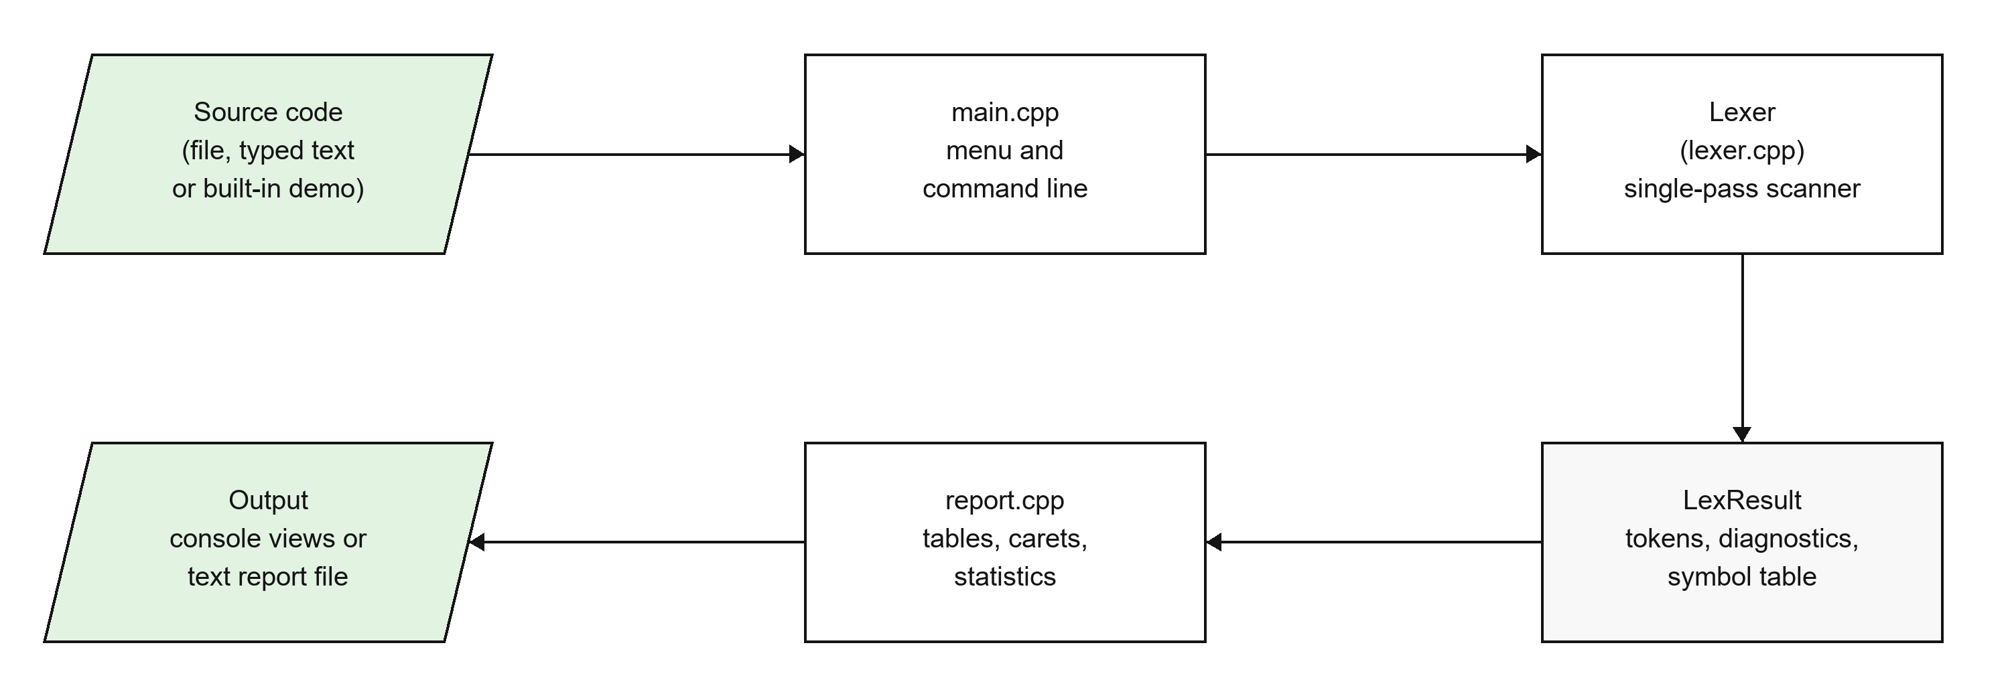
Figure 3.1: System architecture of the lexical analyzer
Table 3.1: Source files and their responsibilities
File | Responsibility
src/lexer.h | Token types, Token, Diagnostic, SymbolEntry and LexResult structures; declaration of the Lexer class
src/lexer.cpp | Scanning logic: one scanner function per token class, error detection, symbol table and bracket tracking
src/report.h, src/report.cpp | Output formatting: summary, token table, symbol table, error messages with caret, statistics bar chart, source listing, language reference
src/main.cpp | Interactive menus, command-line options, file reading, colour handling and report export
src/samples.h | The two demo programs built into the executable
samples/*.c | valid_program.c and program_with_errors.c test inputs
Makefile, build.bat | Build scripts for Linux/macOS (make) and Windows (MinGW g++)

3.2 Language Specification

3.2.1 Keywords
The analyzer reserves 37 keywords. A word that matches the identifier pattern is first looked up in a hash set of keywords; if it is found, a KEYWORD token is produced, otherwise an IDENTIFIER token.
auto break case char const continue default do double else
enum extern float for goto if inline int long register
restrict return short signed sizeof static struct switch
typedef union unsigned void volatile while bool true false

3.2.2 Regular Definitions
The patterns of the main token classes can be written as the following regular definitions. The scanner functions in lexer.cpp implement these patterns directly, character by character.
letter -> [A-Za-z_]
digit -> [0-9]
octdigit -> [0-7]
hexdigit -> [0-9A-Fa-f]
id -> letter ( letter | digit )*
intsuffix -> u | l | ul | lu | ll | ull | llu (any case)
decimal -> [1-9] digit* | 0
octal -> 0 octdigit+
hex -> 0 [xX] hexdigit+
integer -> ( decimal | octal | hex ) intsuffix?
exponent -> [eE] [+-]? digit+
float -> ( digit+ . digit* | . digit+ ) exponent? [fFlL]?
| digit+ exponent [fFlL]?
escape -> \ ( [ntrabfv\'"?] | octdigit{1,3} | x hexdigit+ )
char -> ' ( [^'\\newline] | escape ) '
string -> " ( [^"\\newline] | escape )* "

3.2.3 Operators and Punctuators
Operators are matched using the longest-match (maximal munch) rule: the scanner first tries the three-character operators, then the two-character ones, and only then a single character. This is why <<= is returned as one operator and not as << followed by =.
Table 3.2: Operators and punctuators
Group | Lexemes
3-character operators | <<= >>=
2-character operators | ++ -- -> += -= *= /= %= &= |= ^= == != <= >= && || << >>
1-character operators | + - * / % = < > ! & | ^ ~ ? : .
Punctuators | ( ) { } [ ] ; , ...

3.2.4 Preprocessor Directives
A # that is the first non-blank character on a line starts a preprocessor directive. The whole line (including lines joined with a trailing backslash) becomes one PREPROCESSOR token. The directive name must be one of include, define, undef, if, ifdef, ifndef, elif, else, endif, error, warning, pragma or line; any other name, such as #defne, is reported as error E111.

3.3 Data Structures
The main data structures are declared in lexer.h. Each token stores its category, its lexeme and its position. Each diagnostic stores everything needed to print a helpful message, including how many characters to underline.
struct Token {
TokenType type; // KEYWORD, IDENTIFIER, ... INVALID
std::string lexeme;
int line, column;
};

struct Diagnostic {
Severity severity; // ERROR or WARNING
std::string code; // e.g. "E102"
std::string message; // what went wrong
std::string hint; // how to fix it
int line, column, length; // length = characters to underline
};

struct SymbolEntry {
std::string name;
int firstLine, firstColumn, occurrences;
std::vector<int> lines; // distinct lines where it appears
};
Two further structures are kept inside the Lexer object while scanning:
- symbolIndex, an unordered_map from identifier name to its position in the symbol table. It gives average O(1) lookup, so each identifier occurrence is recorded in constant time.
- bracketStack, a stack of the opening brackets (, [ and { that have not yet been closed, each with its line and column. It is used to detect mismatched and unclosed brackets.

3.4 Scanning Algorithm
The Lexer::analyze() function reads the input exactly once, from left to right. It keeps a current position together with the current line and column. Two helper functions do all the reading: peek(n) looks ahead n characters without consuming them, and advance() consumes one character and updates the line and column. The column counter is UTF-8 aware, so a multi-byte character counts as one column and carets line up correctly.
At each step, the first one or two characters decide which scanner function handles the next lexeme:
- Whitespace and a backslash at the end of a line (line splice) are skipped.
- // and /* start comments, which are skipped and counted.
- # at the start of a line starts a preprocessor directive.
- A letter or underscore starts an identifier or keyword.
- A digit, or a full stop followed by a digit, starts a number.
- A double quote starts a string literal, and a single quote starts a character constant.
- Otherwise the scanner tries to match an operator or punctuator using the longest-match rule.
- If nothing matches, the character is reported as invalid (E101) and skipped.
The order of these tests matters. For example, a full stop followed by a digit must be tested as a number before it is tested as the member-access operator, so that .5 is read as a floating-point constant.
Numbers are the most complex token class. The number scanner first reads the longest possible numeric lexeme: digits, at most one decimal point, an exponent and then any letters or digits that follow. It then checks the lexeme. Reading the whole lexeme first is what allows a mistake such as 2ndValue to be reported as one error covering the whole word, rather than as the number 2 followed by an identifier. Integer constants are also checked for range using strtoull: a value larger than 18446744073709551615 is reported as error E110.

3.5 Error Detection and Recovery
Table 3.3 lists every error and warning that the analyzer can report. Errors are lexical mistakes that make the token invalid. Warnings are problems that the scanner notices but that are not strictly lexical, such as unbalanced brackets.
Table 3.3: Error and warning codes
Code | Meaning | Example
E101 | Invalid character in source | int price = 100$;
E102 | Unterminated string literal | printf("Hello);
E103 | Unterminated character constant | char c = 'a;
E104 | Unterminated block comment | /* never closed
E105 | Malformed number | 2ndValue, 3.14.15, 0789, 0x, 1.5e
E106 | Invalid escape sequence | "Hello\q", "\x"
E107 | Empty character constant | char c = '';
E108 | Identifier longer than 31 characters | thisIdentifierNameIsWayTooLong...
E109 | Multi-character constant | char c = 'abc';
E110 | Integer constant too large | 99999999999999999999999
E111 | Unknown preprocessor directive | #defne LIMIT 100
W201 | Unmatched or mismatched closing bracket | if (a > b)) {
W202 | Opening bracket never closed | int main() { (no closing brace)
W203 | /* inside a block comment | /* outer /* inner */

3.5.1 Error Message Format
Every diagnostic is printed in the same four-part format, modelled on the messages of GCC and Clang [6]: a header with the code, line and column; the source line; a caret and tildes under the faulty text; and a hint. For example:
error[E105] line 7, col 19: Too many decimal points in number '3.14.15'
7 | float ratio = 3.14.15; // too many decimal points
| ^~~~~~~
hint: A numeric literal can contain at most one decimal point.

3.5.2 Panic-Mode Recovery
When the scanner finds an error, it records a diagnostic, emits an INVALID token for the bad lexeme and continues with the next character. For an invalid character it skips just that character; for a malformed number or a bad character constant it skips the whole lexeme it has read; and for an unterminated string it stops at the end of the line. This is a form of panic-mode recovery [1]: the scanner discards input up to a point from which it can safely continue. Because the rest of the program is still scanned normally, one run reports every error. At the end of the scan the diagnostics are sorted by line and column so that they are printed in source order.

3.6 Symbol Table
Every identifier is entered in the symbol table the first time it is seen. Later occurrences increase its use count and add the line number to its list of lines, if that line is not already present. Keywords are not entered. The table therefore shows, for each name, where it is first used and every line on which it appears, which is useful for cross-referencing. For example, in the valid sample program the loop variable i is first seen at line 24, column 14, and is used 5 times on lines 24, 25 and 26.

3.7 User Interface
When the program is started without arguments it shows the main menu in Table 3.4. After every analysis, a results menu offers seven views: the token stream, the symbol table, errors and warnings, token statistics, an annotated source listing, the full report, and export of the report to a text file. Colours are used for errors (red), warnings (yellow), hints (cyan) and success messages (green); they are switched off automatically when the output is redirected to a file.
Table 3.4: Main menu options
Option | Action
[1] | Analyse a source file given by its path
[2] | Type or paste code; finish with a line containing only END
[3] | Demo: analyse the built-in valid C program
[4] | Demo: analyse the built-in program with lexical errors
[5] | Re-open the results of the last analysis
[6] | Show the language reference and all error codes
[7] | Turn coloured output on or off
[0] | Exit

The program also has a command-line mode. When a file name is given, it prints the full report and exits with code 1 if any errors were found and 0 otherwise. Warnings do not change the exit code. The option -o file also saves the report to a text file, and --no-color disables colours.
lexer samples/program_with_errors.c (full report on screen)
lexer myprog.c -o report.txt (also save a text report)
lexer myprog.c --no-color (plain output)

4. Technology Used

4.1 Programming Language: C++17
The analyzer is written in standard C++17. C++ was chosen because it is fast, gives fine control over how characters are read, and is the language most commonly used to build real compilers such as GCC and Clang. The following C++ features are used in the project:
- enum class for the token types and the severity levels, so that the names are type-safe and do not clash with other identifiers.
- std::string and std::vector for lexemes, source lines and the lists of tokens, diagnostics and symbols, so that no manual memory management is needed.
- std::unordered_set for constant-time lookup of keywords and directive names, and std::unordered_map for the symbol table index.
- Lambda expressions with std::count_if and std::stable_sort to count errors and to sort diagnostics by position.
- Namespaces to group the report functions and to hide helper functions inside lexer.cpp.

4.2 Standard Library Components
Table 4.1: Header files used and their purpose
Header | Used for
<string>, <vector> | Lexemes, source lines, token and diagnostic lists
<unordered_map>, <unordered_set> | Symbol table index; keyword and directive sets
<algorithm> | remove (line endings), count_if (error count), stable_sort (diagnostics)
<cctype> | isalpha, isalnum, isxdigit for character classification
<cstdlib>, <cerrno> | strtoull with ERANGE to detect integer overflow (E110)
<iostream>, <fstream>, <sstream> | Console input/output, reading source files, writing reports
<ctime> | Time stamp in exported reports
<windows.h>, <io.h> / <unistd.h> | Enabling colour in the Windows console; detecting whether output is a terminal

4.3 Why a Hand-Written Scanner?
Lexical analyzers can be generated automatically by tools such as Lex or Flex from a list of regular expressions [4]. This project uses a hand-written scanner instead, for three reasons. First, writing the scanner by hand shows clearly how the theory of tokens, patterns and finite automata turns into working code, which is the purpose of the course. Second, a hand-written scanner gives full control over error handling: it can look at the whole faulty lexeme, choose a specific message and hint, and decide exactly where to resume. Third, it needs no extra tools, so the project can be built with any C++ compiler. Hand-written scanners are also what production compilers such as GCC and Clang use.

4.4 Compiler and Build Tools
- GCC (g++). On Windows the project was built and tested with g++ 16.1.0 from the MSYS2 UCRT64 (MinGW-w64) toolchain. Any compiler with C++17 support, including Clang and Microsoft Visual C++, can be used.
- Make. The Makefile provides the targets all, run, demo and clean on Linux and macOS.
- build.bat. A Windows batch script that finds g++ (also in the default MSYS2 folders), builds a statically linked lexer.exe that runs on any Windows PC, and starts it.
- Visual Studio Code was used as the editor.
The compiler flags used are -std=c++17 (language standard), -Wall -Wextra (all common warnings; the project compiles without any) and -O2 (optimisation).

4.5 Hardware and Software Requirements
Table 4.2: System requirements
Item | Requirement
Processor | Any x86-64 or ARM processor
Memory | Minimal; the whole program and its input are held in memory
Disk space | A few megabytes for the source code and executable
Operating system | Windows 10/11, Linux or macOS
Compiler | Any C++17 compiler: g++, Clang or Microsoft Visual C++
Terminal | Any console; ANSI colours are used when supported

4.6 Building and Running
On Windows, double-click build.bat, or run it from a terminal. To build manually with g++ and start the program:
g++ -std=c++17 -Wall -O2 -static -o lexer.exe src\main.cpp src\lexer.cpp src\report.cpp
lexer.exe (interactive menu)
lexer.exe samples\program_with_errors.c (command-line mode)
On Linux or macOS:
make # builds ./lexer
./lexer # interactive menu
make demo # analyses samples/program_with_errors.c

5. Flow Chart of the Project

5.1 Overall Program Flow
Figure 5.1 shows how the program runs as a whole. When it starts, it checks whether a source file was given on the command line. If so, it runs in command-line mode: it reads the file, runs the lexer, prints the full report, optionally writes the report to a file, and exits with a status that tells the caller whether errors were found. Otherwise it shows the main menu. Options 1 to 4 obtain source code and run the lexer, after which the summary and all diagnostics are shown and the results menu lets the user explore the output or export it. Option 0 ends the program.
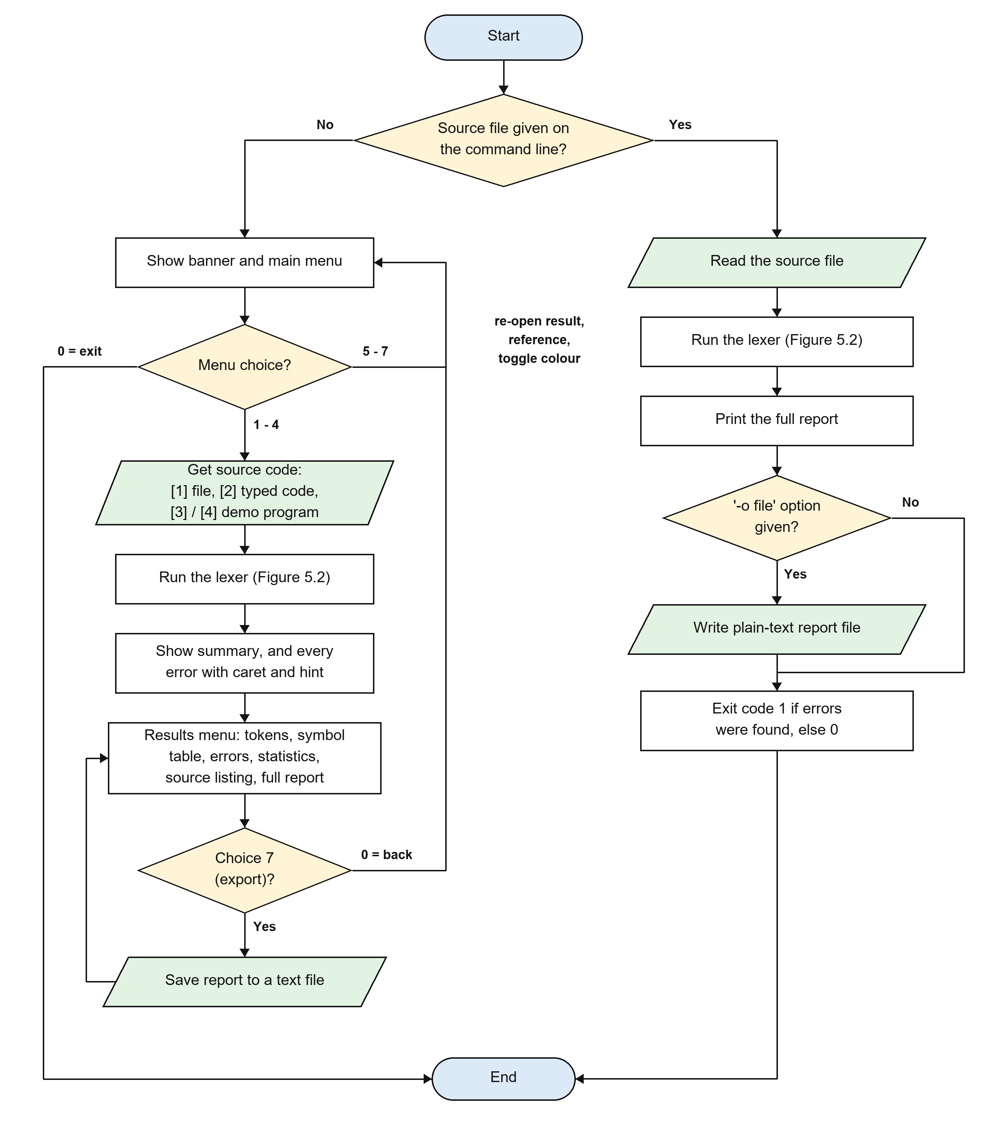
Figure 5.1: Overall flow of the program

5.2 Lexical Analysis Flow
Figure 5.2 shows the main loop of Lexer::analyze(). After normalising line endings, the lexer repeatedly looks at the next character and asks a series of questions to decide which kind of lexeme starts there. The matching scanner function reads the whole lexeme, emits a token, and records any error it finds. If no rule matches, the character is reported as invalid and skipped, which is the panic-mode recovery described in Section 3.5.2. When the input ends, any brackets that are still open are reported, an end-of-file token is added, and the diagnostics are sorted by position.
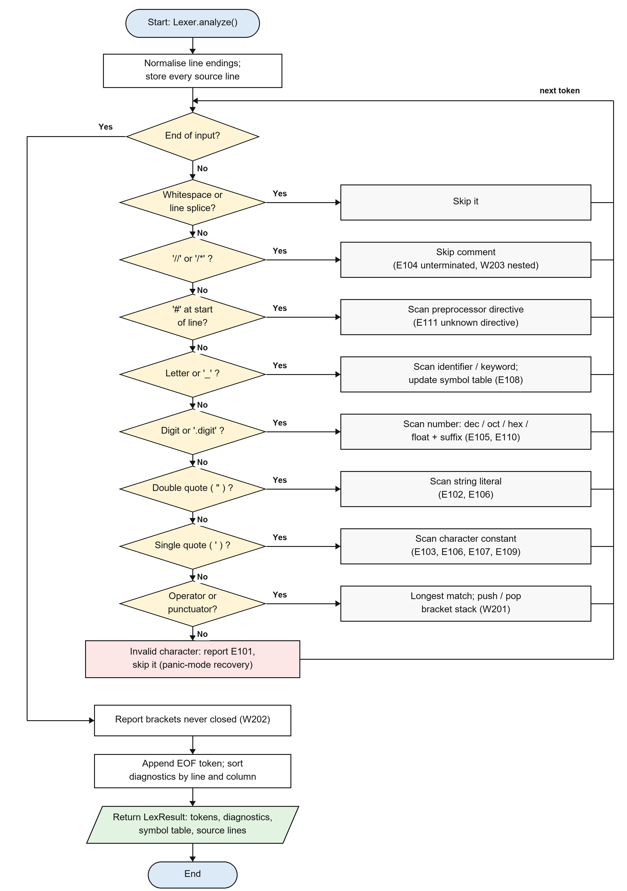
Figure 5.2: Flow chart of the lexical analysis loop

5.3 Number Recognition
Numeric constants are recognised by a small finite automaton, summarised in Table 5.1. Each row shows what the scanner does in a given state when it sees a given input. A number that ends in an error state is reported with code E105 and returned as an INVALID token.
Table 5.1: Transitions of the number scanner
State | Input | Action / next state
Start | 0 followed by x or X | Read “0x”, go to HEX
Start | digit, or . followed by digit | Go to INT (or FRAC)
HEX | hex digit | Stay in HEX
HEX | anything else, no digits read | Error: hexadecimal literal has no digits
INT | digit | Stay in INT
INT | . | Go to FRAC (floating-point)
INT / FRAC | e or E | Go to EXP (floating-point)
FRAC | digit | Stay in FRAC
FRAC | . followed by digit | Error: too many decimal points
EXP | optional + or -, then digit | Read exponent digits
EXP | no digit | Error: exponent has no digits
Any | letter, digit or _ | Read as suffix; must be U/L forms (integer) or F/L (float), else error
INT, leading 0 | digit 8 or 9 present | Error: invalid digit in octal literal
INT accepted | value > 2^64 - 1 | Error E110: integer constant too large

6. Screen Shots of the Project
This chapter shows the program running on Windows. Figures 6.1 to 6.5 use the valid demo program (main menu option 3), Figures 6.6 to 6.9 use the demo program with errors (option 4), and Figures 6.10 and 6.11 show live input and report export.
When started without arguments, the analyzer shows a banner and the main menu. The user selects an option by typing its number.
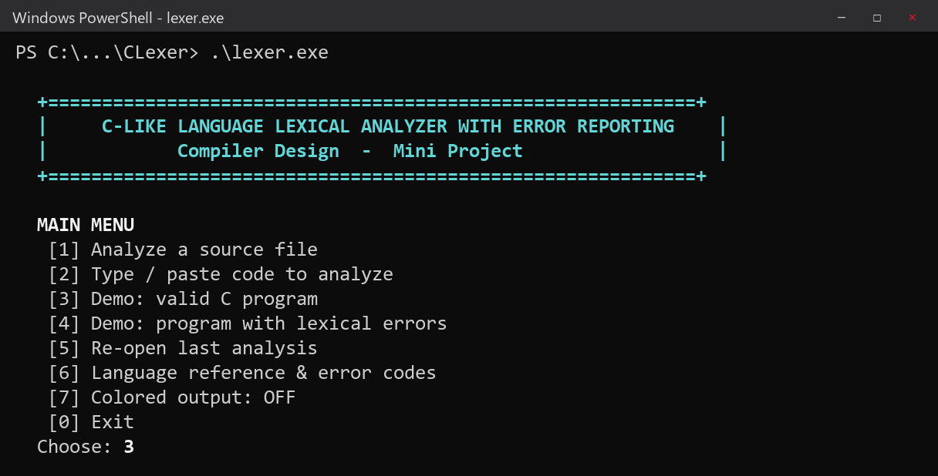
Figure 6.1: Start-up banner and main menu
After analysing the valid program, the summary shows 33 lines, 179 tokens, 17 unique identifiers and 2 comments, with no errors or warnings. The result is shown as PASSED, and the results menu appears.
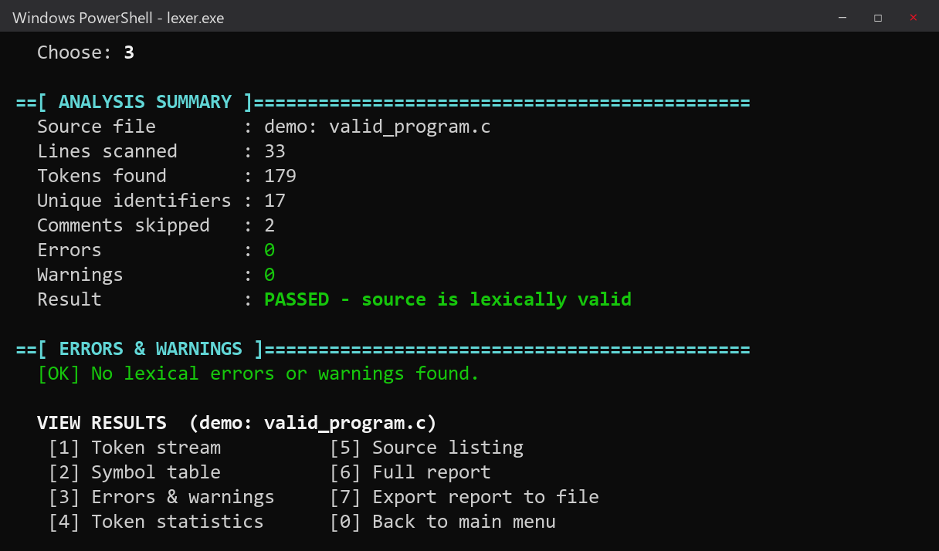
Figure 6.2: Analysis summary for the valid program
The token stream lists every token with its position and category. Categories are coloured so they are easy to tell apart. Note that the whole #include line is a single PREPROCESSOR token.
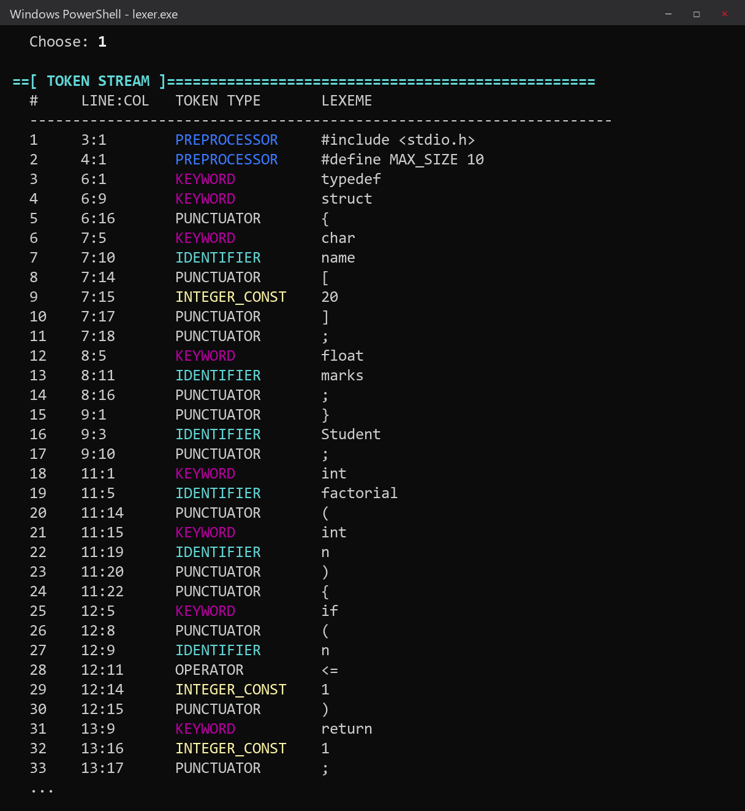
Figure 6.3: Token stream (first 34 tokens)
The symbol table lists the 17 distinct identifiers with their first position, number of uses and the lines on which they appear.
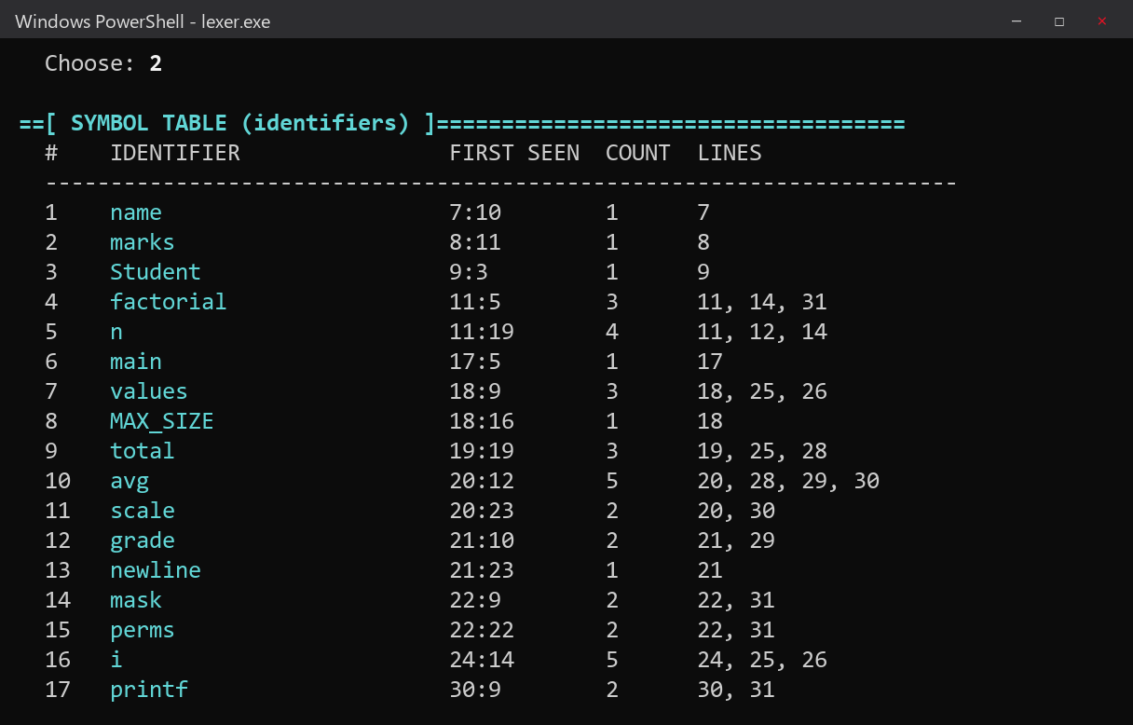
Figure 6.4: Symbol table
The statistics view shows how many tokens of each category were found, with a bar chart. Punctuators are the most common token class in C programs.
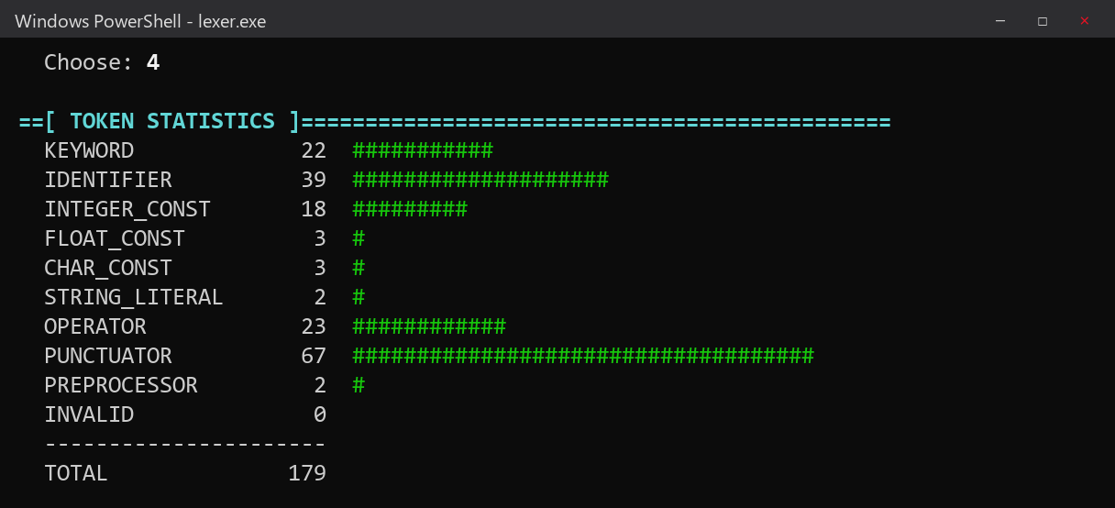
Figure 6.5: Token statistics
For the program with errors the summary shows 15 errors and 2 warnings. Each diagnostic gives the code, line and column, reprints the line, underlines the faulty lexeme and gives a hint.
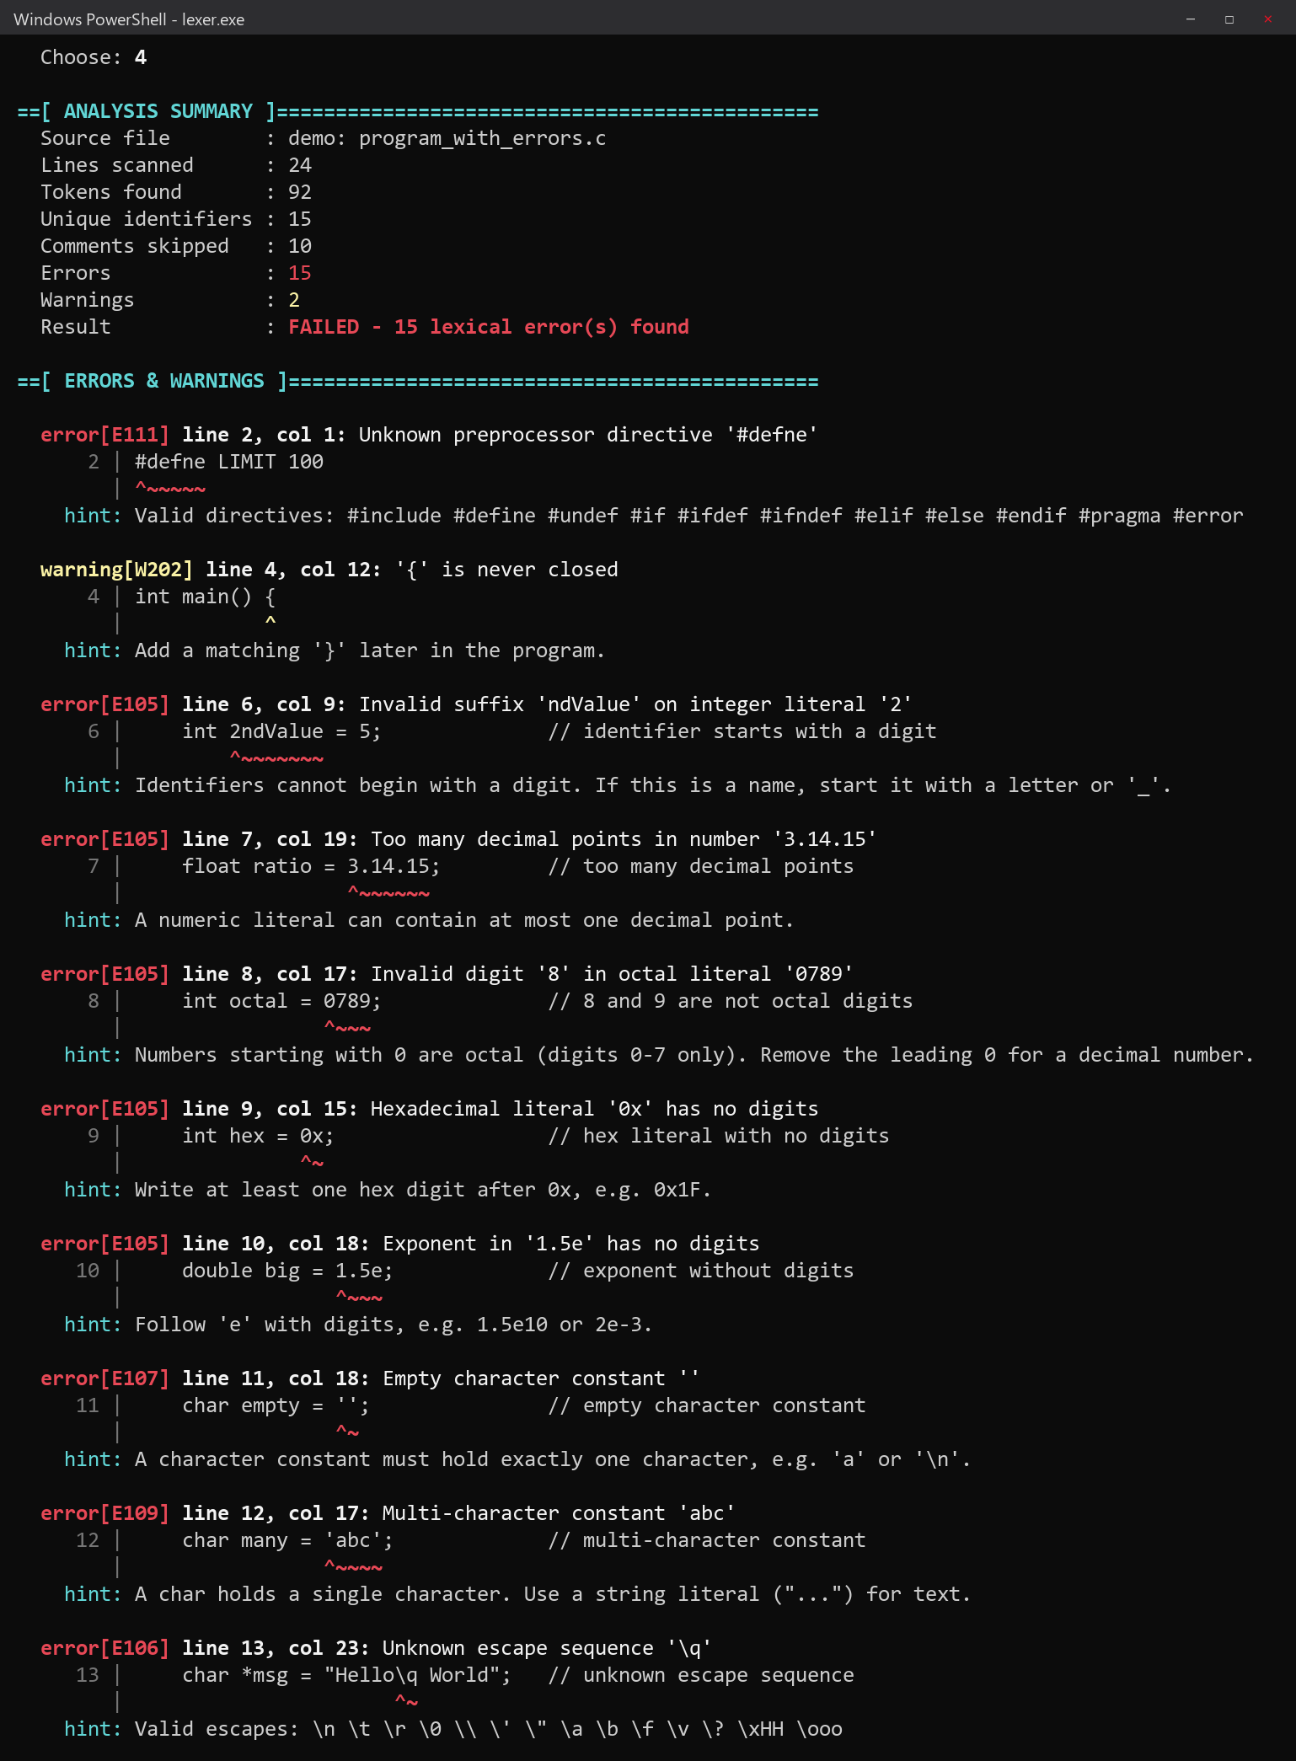
Figure 6.6: Errors and warnings for the faulty program (part 1)
The remaining diagnostics include invalid characters, an over-long identifier, an integer that is too large, an unterminated string, a mismatched bracket and an unterminated comment. The scanner continued after each error, so all of them are reported in one run.
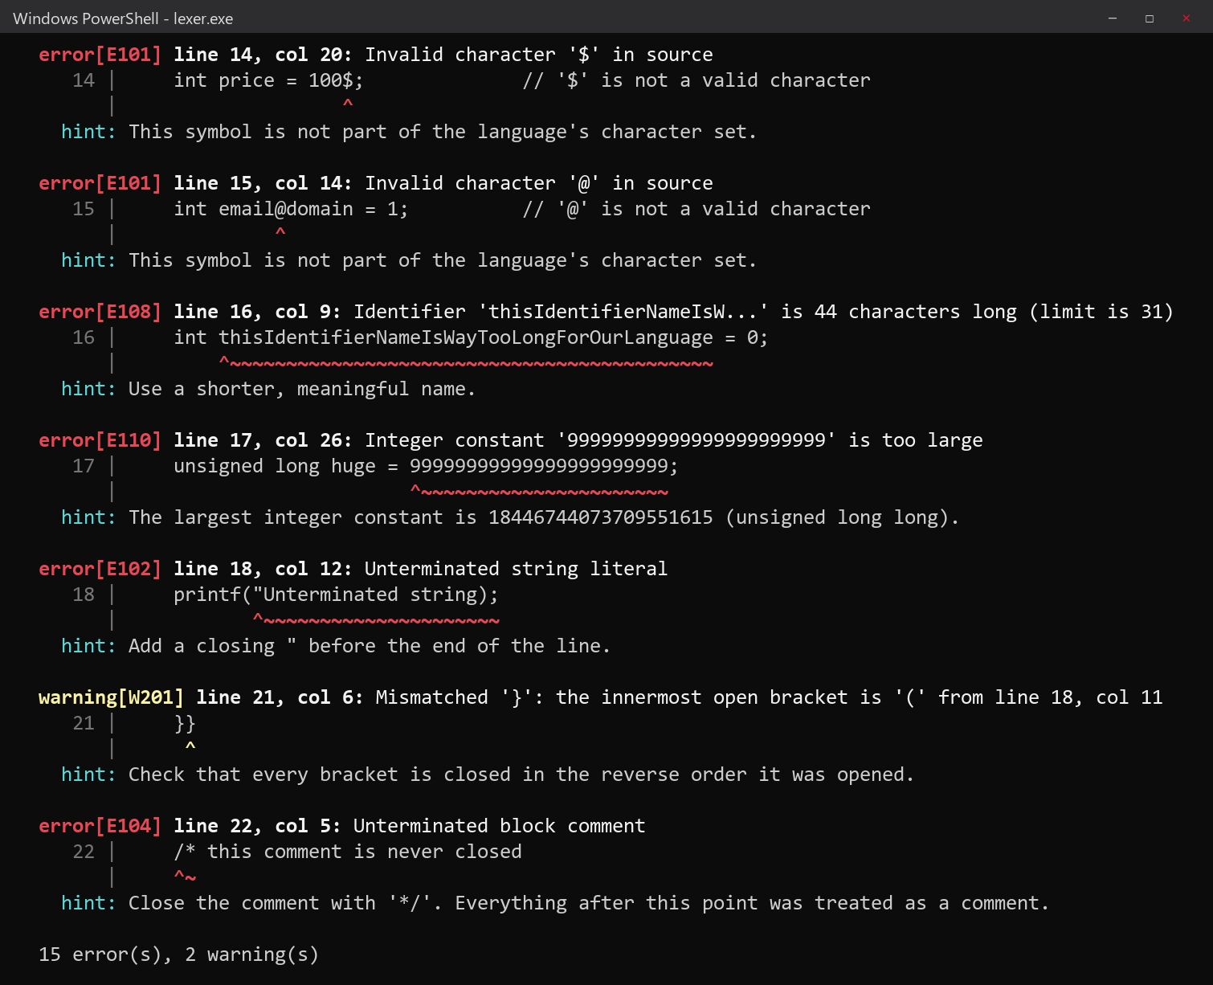
Figure 6.7: Errors and warnings for the faulty program (part 2)
The source listing marks every line that contains an error or warning with a “>” sign, giving a quick overview of where the problems are.
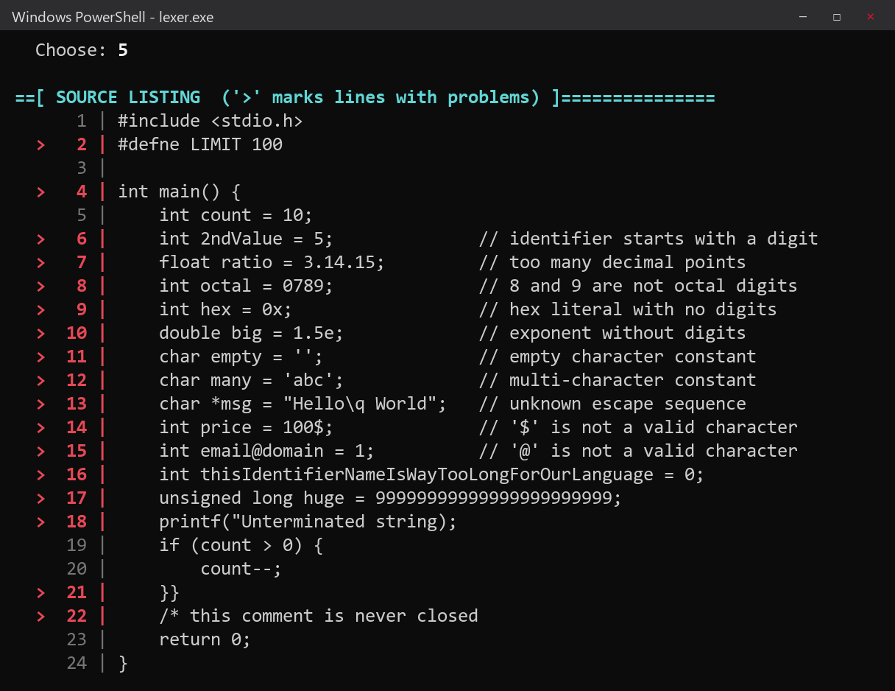
Figure 6.8: Annotated source listing
Main menu option 6 shows a built-in reference of the token classes and all error and warning codes.
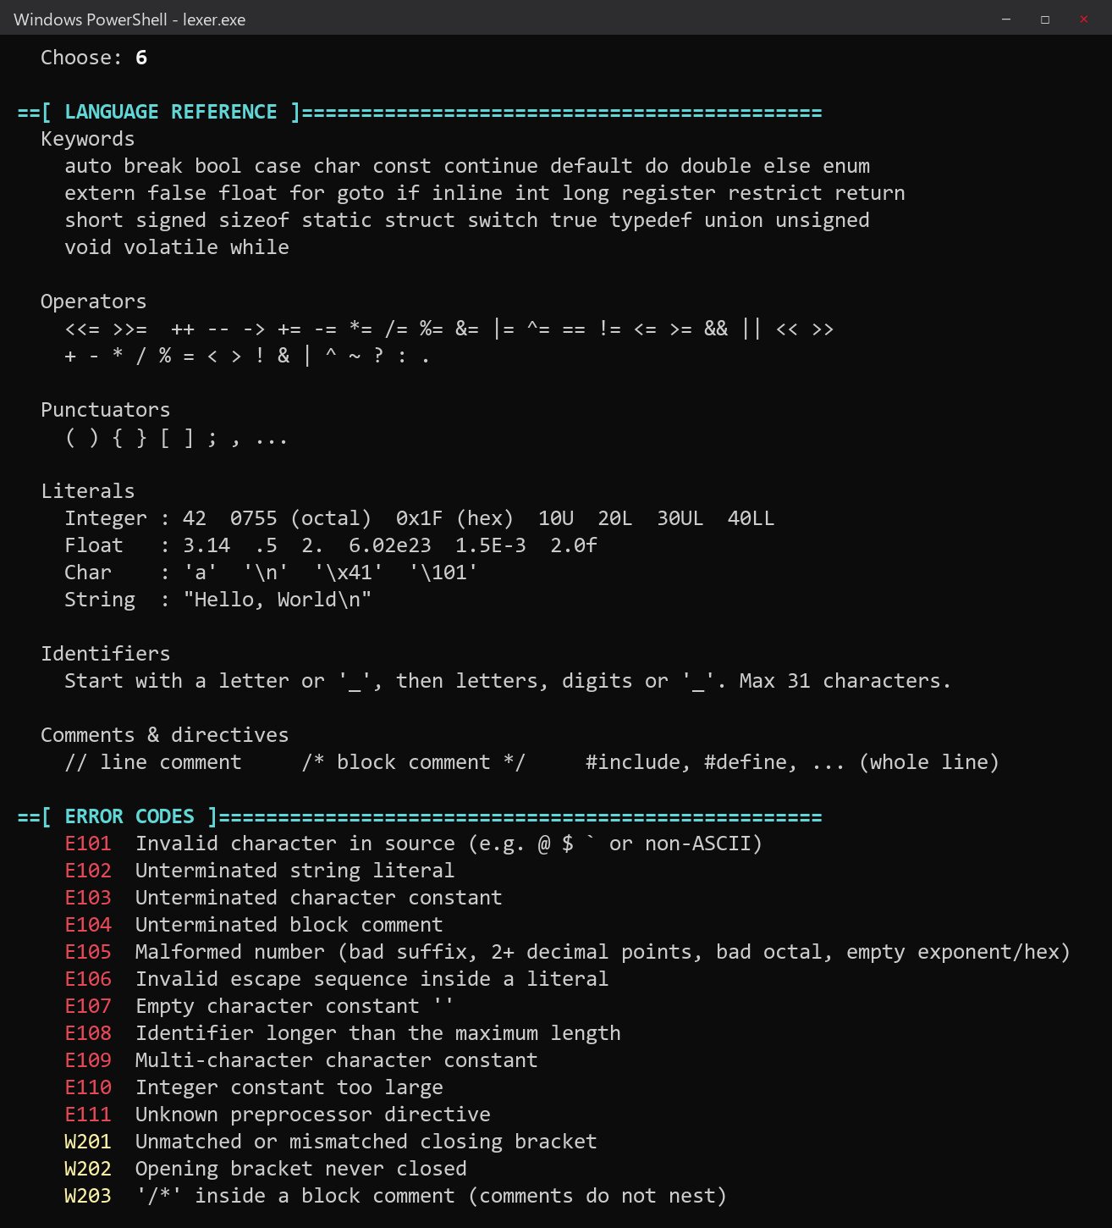
Figure 6.9: Language reference and error codes
With option 2 the user can type code directly. Here two lines containing an invalid character and a multi-character constant are analysed, and both errors are reported immediately.
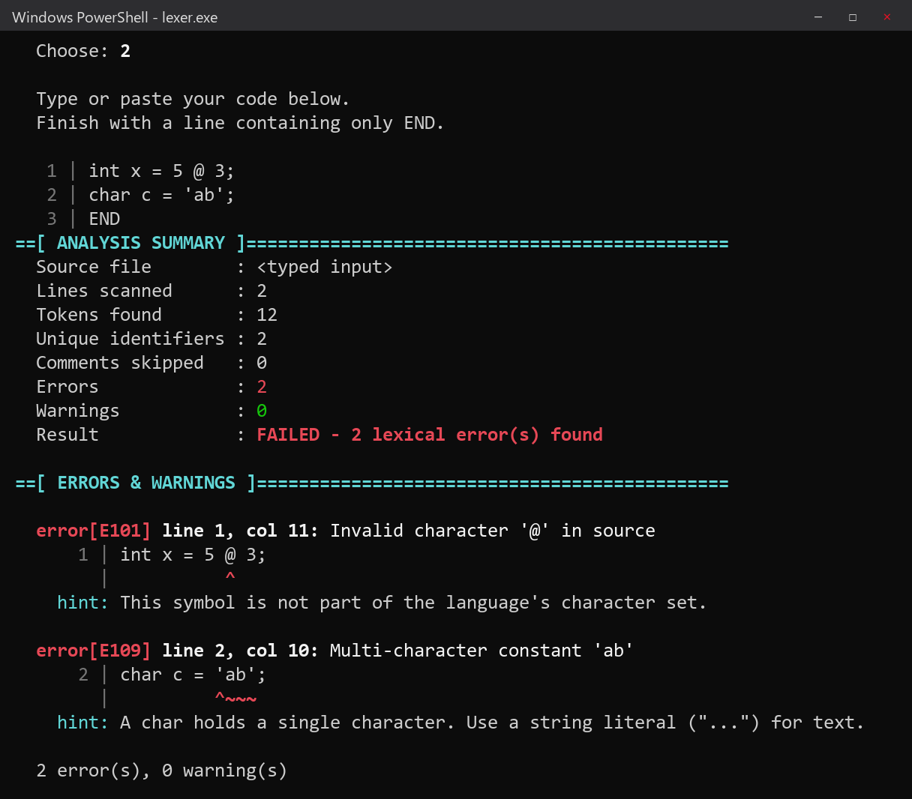
Figure 6.10: Analysing code typed by the user
Option 7 of the results menu saves the full report as a plain-text file, which can be attached to documentation or submitted with an assignment.
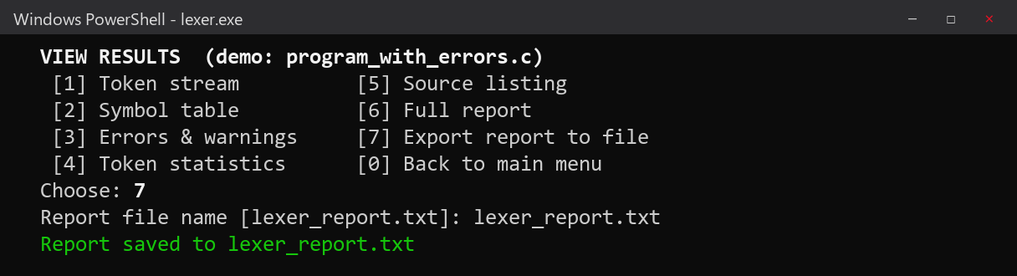
Figure 6.11: Exporting the report to a text file

7. Results and Conclusion

7.1 Testing Approach
The analyzer was tested in two ways. First, it was run on the two sample programs supplied with the project: a valid program that uses most token classes, and a program deliberately seeded with one example of each kind of error. Second, 20 small test inputs were written, each targeting one feature or one error, and run through the command-line mode. For each test the number of tokens, the reported codes and the exit status were compared with the expected result.

7.2 Test Cases
Table 7.1: Test cases and results
# | Input | Expected | Observed | Status
1 | int count = 10; | 5 tokens, no errors | 5 tokens, exit 0 | Pass
2 | x <<= 2; | <<= as one operator | 4 tokens, exit 0 | Pass
3 | float f = 1.5e-3f; | Valid float with exponent and suffix | 5 tokens, exit 0 | Pass
4 | unsigned long h = 0xFFUL; | Valid hex constant with suffix | 6 tokens, exit 0 | Pass
5 | int b = 09; | E105 (bad octal digit) | E105, exit 1 | Pass
6 | char c = '\n'; | Valid escape sequence | 5 tokens, exit 0 | Pass
7 | char *s = "abc; | E102 | E102, exit 1 | Pass
8 | int a@b = 1; | E101 | E101, exit 1 | Pass
9 | #inclde <stdio.h> | E111 | E111, exit 1 | Pass
10 | /* comment never closed | E104 | E104, exit 1 | Pass
11 | int x = 12abc; | E105 (invalid suffix) | E105, exit 1 | Pass
12 | if (a > b)) { | W201 and W202, no errors | W201, W202, exit 0 | Pass
13 | char m = 'ab'; | E109 | E109, exit 1 | Pass
14 | long big = 18446744073709551616; | E110 (one more than the maximum) | E110, exit 1 | Pass
15 | char *e = "bad \x"; | E106 | E106, exit 1 | Pass
16 | int abcdefghijklmnopqrstuvwxyz_123456 = 1; | E108 (33 characters) | E108, exit 1 | Pass
17 | a = b ... c; | ... as one punctuator | 6 tokens, exit 0 | Pass
18 | x = 3.14.15; | E105 (two decimal points) | E105, exit 1 | Pass
19 | char c = 'a; | E103 | E103, exit 1 | Pass
20 | /* outer /* inner */ | W203 only | W203, exit 0 | Pass

All 20 test cases produced the expected result. Test 12 confirms that bracket problems are reported as warnings and do not cause a non-zero exit status, and test 14 confirms that the range check is exact: 18446744073709551615 is the largest accepted value, and one more than that is rejected.

7.3 Results on the Sample Programs
Table 7.2: Results on the sample programs
Measure | valid_program.c | program_with_errors.c
Lines scanned | 33 | 24
Tokens found | 179 | 92
Unique identifiers | 17 | 15
Comments skipped | 2 | 10
Errors | 0 | 15
Warnings | 0 | 2
Result | PASSED | FAILED

Table 7.3: Token distribution in valid_program.c
Token category | Count | Token category | Count
KEYWORD | 22 | STRING_LITERAL | 2
IDENTIFIER | 39 | OPERATOR | 23
INTEGER_CONST | 18 | PUNCTUATOR | 67
FLOAT_CONST | 3 | PREPROCESSOR | 2
CHAR_CONST | 3 | Total | 179

The program with errors contains 15 errors and 2 warnings, and every one of them was found and reported at the correct line and column (Figures 6.6 and 6.7). These cover ten of the eleven error codes and two of the three warning codes; the remaining two, E103 and W203, are covered by test cases 19 and 20 in Table 7.1, so every code has been exercised at least once. Because of panic-mode recovery, the valid tokens around each error were still recognised: for example, on line 14 (int price = 100$;) the tokens int, price, =, 100 and ; were all produced, and only the $ was reported.

7.4 Limitations
- The project covers the lexical phase only. Mistakes that need knowledge of the grammar, such as a misspelt keyword used as a name, are not detected.
- Some less common C features are not supported: wide and Unicode string prefixes (L"..." and u8"..."), hexadecimal floating-point constants, binary literals, digraphs and trigraphs.
- Preprocessor directives are recognised and validated as single tokens, but macros are not expanded and included files are not read.
- Bracket matching is reported only as a warning, because balancing brackets is really the job of the parser.

7.5 Future Scope
- Adding a recursive-descent parser that uses this lexer as its front end, to build a complete front end for the C subset.
- Suggesting corrections, for example “did you mean #define?” for #defne, using the edit distance between the faulty word and the valid names.
- Supporting the remaining C token forms listed in Section 7.4.
- Providing a graphical or web interface, or integrating the analyzer with a code editor so that errors are underlined while the user types.

7.6 Conclusion
This project designed and implemented a lexical analyzer for a C-like language in C++17. The analyzer correctly breaks source code into nine categories of tokens, skips comments, builds a symbol table with cross-references, and detects fourteen kinds of lexical errors and warnings. Its main strength is the quality of its error reporting: each problem is shown with its exact position, the source line, a caret under the faulty text and a hint on how to fix it, and panic-mode recovery allows all errors to be reported in a single run.
All objectives set out in Section 2.5 were met. The analyzer produced the correct output for both sample programs and for all 20 test cases. Building it by hand gave practical insight into the concepts studied in the Compiler Design course, including tokens and patterns, regular definitions, finite automata, the longest-match rule, symbol tables and error recovery, and into how these ideas are applied in real compilers.

References
[1] A. V. Aho, M. S. Lam, R. Sethi and J. D. Ullman, Compilers: Principles, Techniques, and Tools, 2nd ed. Boston, MA, USA: Pearson / Addison-Wesley, 2006.
[2] ISO/IEC 9899:2018, Information technology – Programming languages – C. Geneva, Switzerland: International Organization for Standardization, 2018.
[3] B. W. Kernighan and D. M. Ritchie, The C Programming Language, 2nd ed. Englewood Cliffs, NJ, USA: Prentice Hall, 1988.
[4] J. R. Levine, flex & bison. Sebastopol, CA, USA: O'Reilly Media, 2009.
[5] K. D. Cooper and L. Torczon, Engineering a Compiler, 2nd ed. Burlington, MA, USA: Morgan Kaufmann, 2011.
[6] Free Software Foundation, “Options to Control Diagnostic Messages Formatting,” in Using the GNU Compiler Collection (GCC). [Online]. Available: https://gcc.gnu.org/onlinedocs/
[7] cppreference.com, “C++ reference.” [Online]. Available: https://en.cppreference.com/

Appendix A: Sample Input Programs

A.1 valid_program.c
/* Sample program: student marks and factorial
Demonstrates keywords, literals, operators and comments */
#include <stdio.h>
#define MAX_SIZE 10

typedef struct {
char name[20];
float marks;
} Student;

int factorial(int n) {
if (n <= 1)
return 1;
return n * factorial(n - 1); // recursive call
}

int main(void) {
int values[MAX_SIZE] = {1, 2, 3, 4, 5};
unsigned long total = 0UL;
double avg = 0.0, scale = 2.5e-1;
char grade = 'A', newline = '\n';
int mask = 0x1F, perms = 0755;

for (int i = 0; i < 5; i++) {
total += values[i];
values[i] <<= 1;
}
avg = (double) total / 5;
if (avg >= 3.0 && grade != 'F')
printf("Average: %.2f\tScaled: %f\n", avg, avg * scale);
printf("5! = %d, mask & perms = %d\n", factorial(5), mask & perms);
return 0;
}

A.2 program_with_errors.c
#include <stdio.h>
#defne LIMIT 100

int main() {
int count = 10;
int 2ndValue = 5; // identifier starts with a digit
float ratio = 3.14.15; // too many decimal points
int octal = 0789; // 8 and 9 are not octal digits
int hex = 0x; // hex literal with no digits
double big = 1.5e; // exponent without digits
char empty = ''; // empty character constant
char many = 'abc'; // multi-character constant
char *msg = "Hello\q World"; // unknown escape sequence
int price = 100$; // '$' is not a valid character
int email@domain = 1; // '@' is not a valid character
int thisIdentifierNameIsWayTooLongForOurLanguage = 0;
unsigned long huge = 99999999999999999999999;
printf("Unterminated string);
if (count > 0) {
count--;
}}
/* this comment is never closed
return 0;
}

Appendix B: Lexer Interface (lexer.h)
// =====================================================================
// lexer.h - C-Like Language Lexical Analyzer with Error Reporting
// Compiler Design Mini Project
// =====================================================================
#ifndef LEXER_H
#define LEXER_H

#include <string>
#include <unordered_map>
#include <vector>

// ---------------------------------------------------------------------
// Token categories recognised by the analyzer
// ---------------------------------------------------------------------
enum class TokenType {
KEYWORD,
IDENTIFIER,
INTEGER_LITERAL,
FLOAT_LITERAL,
CHAR_LITERAL,
STRING_LITERAL,
OPERATOR,
PUNCTUATOR,
PREPROCESSOR,
INVALID, // a lexeme that contains a lexical error
END_OF_FILE
};

const char* tokenTypeName(TokenType type);

struct Token {
TokenType type;
std::string lexeme;
int line;
int column;
};

// ---------------------------------------------------------------------
// Diagnostics (errors and warnings)
// ---------------------------------------------------------------------
enum class Severity { ERROR, WARNING };

struct Diagnostic {
Severity severity;
std::string code; // e.g. "E102"
std::string message; // what went wrong
std::string hint; // how to fix it
int line;
int column;
int length; // number of characters to underline
};

// ---------------------------------------------------------------------
// Symbol table entry (one per distinct identifier)
// ---------------------------------------------------------------------
struct SymbolEntry {
std::string name;
int firstLine;
int firstColumn;
int occurrences;
std::vector<int> lines; // distinct lines where it appears
};

// ---------------------------------------------------------------------
// Everything produced by one run of the lexer
// ---------------------------------------------------------------------
struct LexResult {
std::vector<Token> tokens;
std::vector<Diagnostic> diagnostics;
std::vector<SymbolEntry> symbols;
std::vector<std::string> sourceLines;
int commentCount = 0;

int errorCount() const;
int warningCount() const;
};

// ---------------------------------------------------------------------
// The lexical analyzer (hand-written, single pass, panic-mode recovery)
// ---------------------------------------------------------------------
class Lexer {
public:
static constexpr int MAX_IDENTIFIER_LENGTH = 31;

explicit Lexer(std::string source);
LexResult analyze();

private:
struct OpenBracket { char ch; int line; int column; };

std::string src;
size_t pos = 0;
int line = 1;
int col = 1;

LexResult result;
std::unordered_map<std::string, size_t> symbolIndex;
std::vector<OpenBracket> bracketStack;

// character helpers
bool atEnd() const;
char peek(size_t ahead = 0) const;
char advance();
bool onlyWhitespaceBeforeOnLine() const;

// bookkeeping
void addToken(TokenType type, const std::string& lexeme, int l, int c);
void diag(Severity sev, const std::string& code, const std::string& msg,
const std::string& hint, int l, int c, int len);
void recordSymbol(const std::string& name, int l, int c);
void trackBracket(char ch, int l, int c);

// scanners (one per token class)
void skipLineComment();
void skipBlockComment();
void scanPreprocessor();
void scanIdentifierOrKeyword();
void scanNumber();
void scanString();
void scanChar();
bool scanEscape(std::string& lexeme);
bool scanOperatorOrPunctuator();
void scanInvalid();
};

#endif // LEXER_H

