
KARNAVATI UNIVERSITY
UNITEDWORLD INSTITUTE OF TECHNOLOGY (UIT)
MINI PROJECT REPORT
ON
“C-LIKE LANGUAGE LEXICAL ANALYZER
WITH ERROR REPORTING”
Submitted as a part of the course
Compiler Design
Submitted By
Student Name | Enrollment No.
Risheek Verma | 23BTAI49
Rudrakumar Chopda | 23BTAI50
Utpal Sakhiya | 23BTAI51

Program: B.Tech CSE-AIML
Semester: VII

Under the Guidance of
Ms Neha Minocha
Assistant Professor
Department of Computer Science & Engineering Technology
Karnavati University, Gandhinagar
TABLE OF CONTENTS
1. Abstract 1
2. Introduction 1
2.1 Problem Statement and Objectives 1
3. Overview of Project 2
3.1 Architecture 2
3.2 Tokens Recognised 2
3.3 How the Scanner Works 3
3.4 Error Detection and Reporting 3
4. Technology Used 4
5. Flow Chart of the Project 5
6. Screen Shots of the Project 6
7. Results and Conclusion 7
References 7

1. Abstract
Lexical analysis is the first phase of a compiler: it reads the source program character by character and groups the characters into tokens such as keywords, identifiers, constants and operators. This project, "C-Like Language Lexical Analyzer with Error Reporting", is a hand-written lexical analyzer for a C-like language, implemented in C++17 and presented through a local browser-based user interface.
The analyzer recognises nine categories of tokens, skips comments and builds a symbol table of identifiers. Its main contribution is error reporting: it detects eleven kinds of lexical errors and three kinds of warnings, reports each one with its line and column, the source line, a highlighted diagnostic location and a hint on how to fix it, and uses panic-mode recovery so that all errors in a program are reported in a single run. The browser UI presents the editor, status metrics, problems, token stream, symbol table, statistics and reference panels in one workspace, with responsive light and dark themes. On the sample programs it produced 179 tokens with no errors for a valid program and found all 15 errors and 2 warnings in a faulty one; all 20 test cases passed.

2. Introduction
A compiler works in phases: lexical analysis, syntax analysis, semantic analysis, intermediate code generation, optimisation and code generation [1]. The lexical analyzer (scanner) is the only phase that reads the raw source text. It converts the text into a stream of tokens, removes whitespace and comments, records line numbers for later error messages and enters identifiers into the symbol table. Each token has a pattern, usually a regular expression, and the actual text that matches it is called a lexeme.
A lexical error is a sequence of characters that matches no token pattern, for example an illegal character such as @, a string that is not closed, or a number such as 3.14.15. Many simple scanners stop at the first such error or print a short message like “invalid token at line 6”, so the programmer has to fix errors one at a time without being told what is wrong.

2.1 Problem Statement and Objectives
The aim of this project is to build a lexical analyzer that produces the correct tokens and symbol table for valid programs, and that also finds every lexical error in a single pass and explains each one clearly. The objectives were:
- Implement a single-pass, hand-written scanner for a C-like language in C++17.
- Recognise all common C token classes, including integer constants in three bases, floating-point constants, escape sequences and multi-character operators.
- Build a symbol table recording each identifier's first position, number of uses and lines.
- Detect at least ten classes of lexical errors and report each with position, caret and hint.
- Recover from errors so that the whole program is checked in one run.

3. Overview of Project

3.1 Architecture
The project has four cooperating parts (Figure 1). main.cpp provides the command-line and interactive console modes. The Lexer class in lexer.cpp scans the code once and returns a LexResult holding the tokens, diagnostics (errors and warnings) and symbol table. report.cpp formats this result for the screen, a text file or JSON. The local Python server in ui/server.py forwards source code to lexer.exe and serves the browser client in ui/index.html. The lexer itself prints nothing, so it can be reused as the front end of a parser while the UI remains a separate presentation layer.
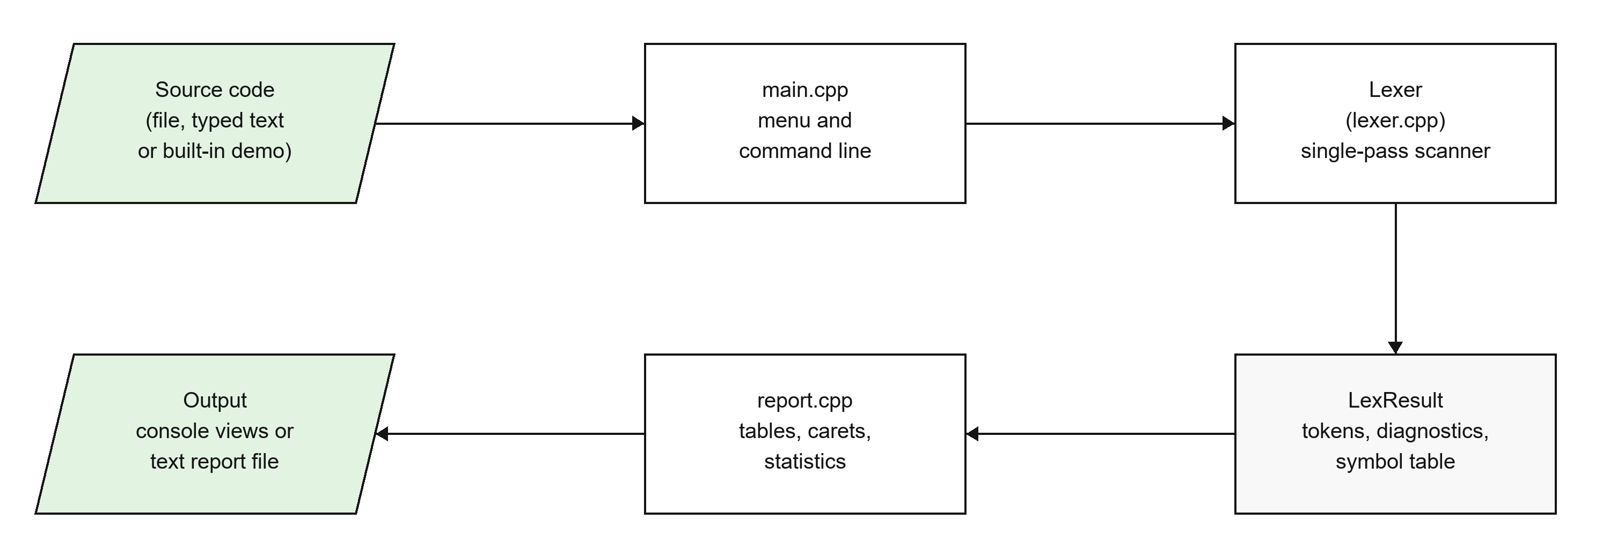
Figure 1: System architecture

3.2 Tokens Recognised
Table 1: Token categories
Category | Examples
KEYWORD (37 reserved words) | int, while, return, typedef, bool
IDENTIFIER | count, factorial, _tmp
INTEGER_CONST (decimal, octal, hex, U/L suffixes) | 10, 0755, 0x1F, 0UL
FLOAT_CONST (fraction, exponent, F/L suffix) | 3.0, 2.5e-1, 1.0f
CHAR_CONST and STRING_LITERAL (with escapes) | 'A', '\n', "Total: %d\n"
OPERATOR (longest match) | +, <=, &&, <<=, ->
PUNCTUATOR | ( ) { } [ ] ; , ...
PREPROCESSOR (whole line) | #include <stdio.h>

3.3 How the Scanner Works
The scanner reads the input once from left to right, using peek() to look ahead and advance() to consume a character while updating the line and column. The first one or two characters of each lexeme decide which scanner function runs: a letter or underscore starts an identifier or keyword, a digit starts a number, a quote starts a string or character constant, and so on (see Figure 2). Operators use the longest-match rule, so <<= is one token rather than << and =. Identifiers are entered into a hash-map-based symbol table, and a stack of open brackets is kept to detect unbalanced brackets.
Numbers are read in full before they are checked, so a mistake such as 2ndValue is reported once for the whole word instead of being split into the number 2 and an identifier. Integer constants are also range-checked: anything above 18446744073709551615 is rejected.

3.4 Error Detection and Reporting
Table 2: Errors and warnings detected
Code | Problem | Example
E101 | Invalid character | int price = 100$;
E102 / E103 | Unterminated string / character constant | "Hello 'a
E104 | Unterminated block comment | /* never closed
E105 | Malformed number | 2ndValue, 3.14.15, 0789, 0x, 1.5e
E106 | Invalid escape sequence | "\q"
E107 / E109 | Empty / multi-character constant | '' 'abc'
E108 | Identifier longer than 31 characters | thisIdentifierNameIsWayTooLong...
E110 | Integer constant too large | 99999999999999999999999
E111 | Unknown preprocessor directive | #defne
W201 / W202 | Mismatched / unclosed bracket | if (a > b)) {
W203 | /* inside a block comment | /* a /* b */

Every problem is reported in the same format, modelled on GCC and Clang:
error[E105] line 7, col 19: Too many decimal points in number '3.14.15'
7 | float ratio = 3.14.15;
| ^~~~~~~
hint: A numeric literal can contain at most one decimal point.
After an error the scanner records the diagnostic, marks the lexeme as an INVALID token, skips the faulty text and carries on. This panic-mode recovery means the rest of the program is still scanned normally, so all errors are found in one run. Warnings do not count as failures: in command-line mode the program exits with code 1 only if there are errors.

4. Technology Used
- C++17 with the standard library only: std::string, std::vector, std::unordered_set (keywords), std::unordered_map (symbol table), std::stable_sort (ordering diagnostics) and strtoull (range check).
- g++ (tested with g++ 16.1 from MSYS2/MinGW-w64 on Windows 11), with -std=c++17 -Wall -Wextra -O2; it compiles with no warnings. The Windows build is statically linked, so lexer.exe runs on any PC without installing anything.
- build.bat (Windows) and a Makefile (Linux/macOS) for building. The browser UI uses Python standard-library HTTP components in ui/server.py, so no web framework or external frontend dependency is required; Visual Studio Code was used as the editor.
- A hand-written scanner was chosen instead of a generator such as Flex because it gives full control over error messages and recovery and shows clearly how the theory becomes code. The UI was kept dependency-free and connected to the real executable through a small local JSON API, making the demonstration easy to run with run_ui.bat.

5. Flow Chart of the Project
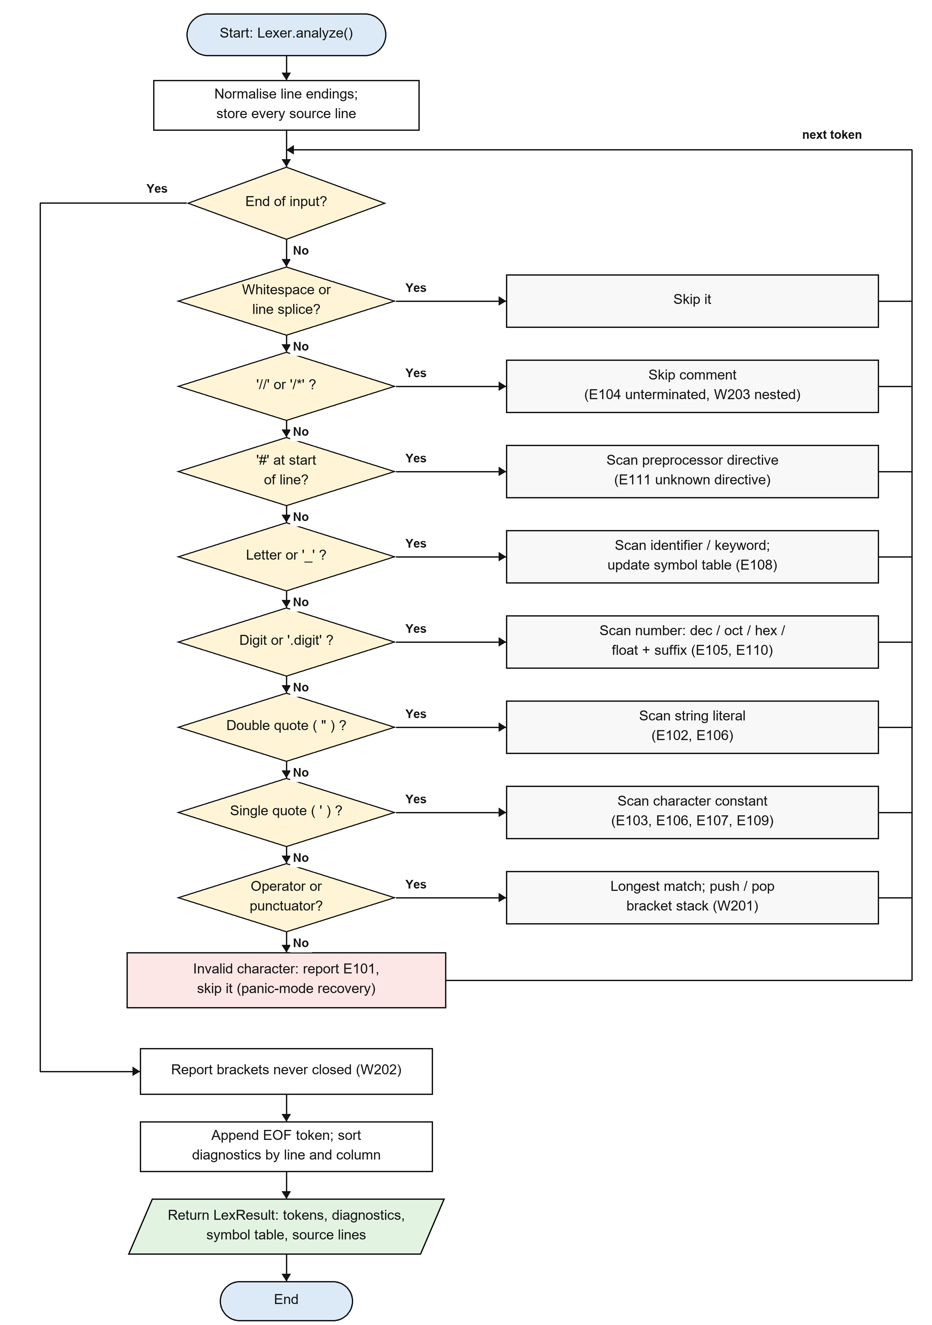
Figure 2: Flow chart of the lexical analysis loop

6. User Interface Screenshots
Figure 3 shows the browser-based analyzer workspace with source code, line diagnostics, summary metrics and the Problems panel. The same workspace provides Token stream, Symbol table, Statistics and Reference tabs; source files can be loaded from samples, opened from disk or dropped into the editor. Figure 4 shows the symbol table produced for the valid demo program. The interface supports both light and dark themes, with explicit dark-theme colors for the editor, cards, tabs, status indicators and diagnostic states.
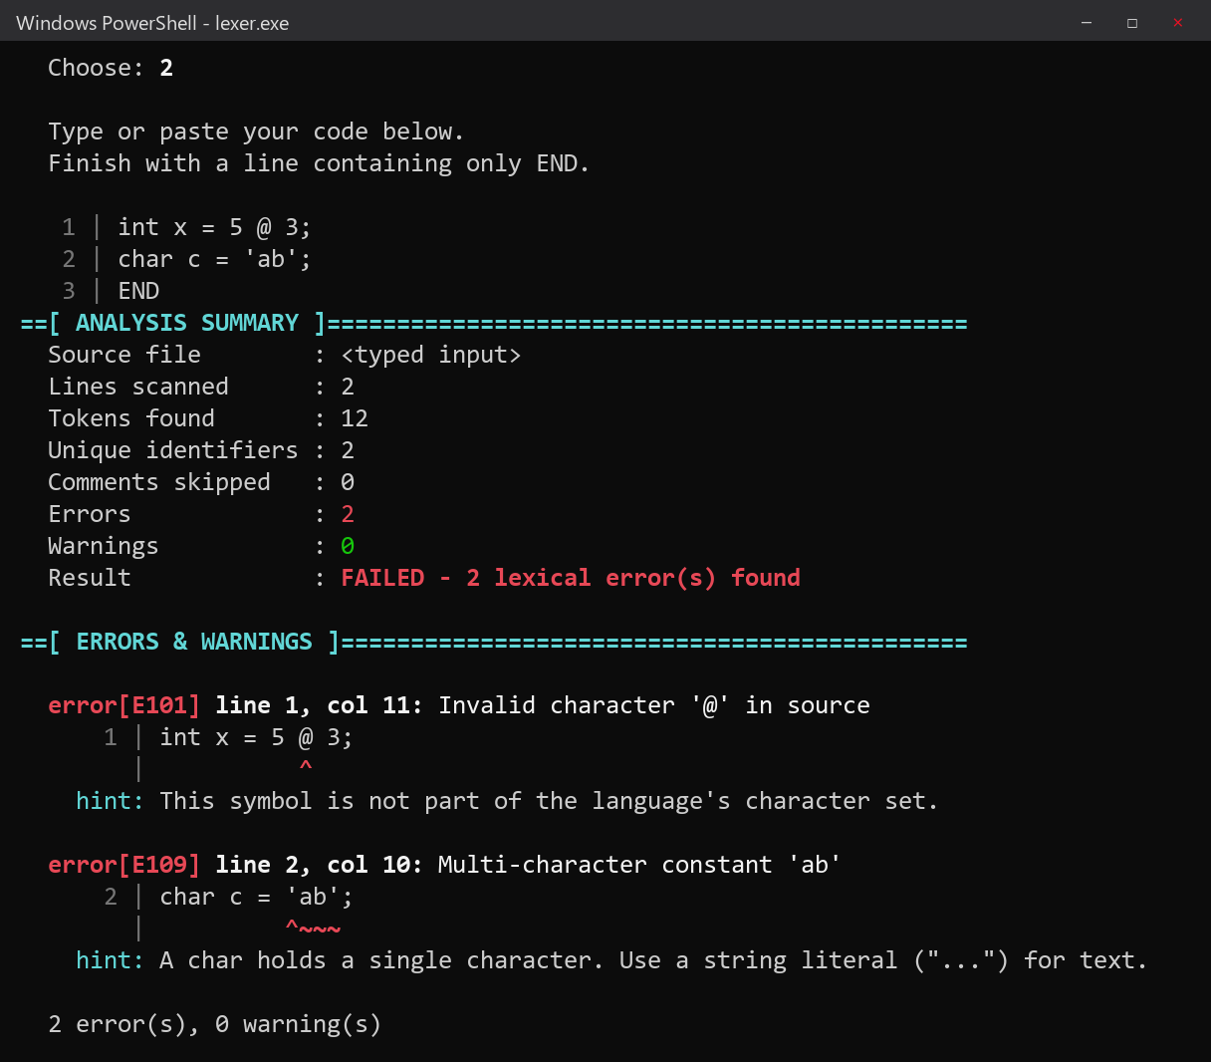
Figure 3: Browser UI showing errors, summary metrics and the Problems panel
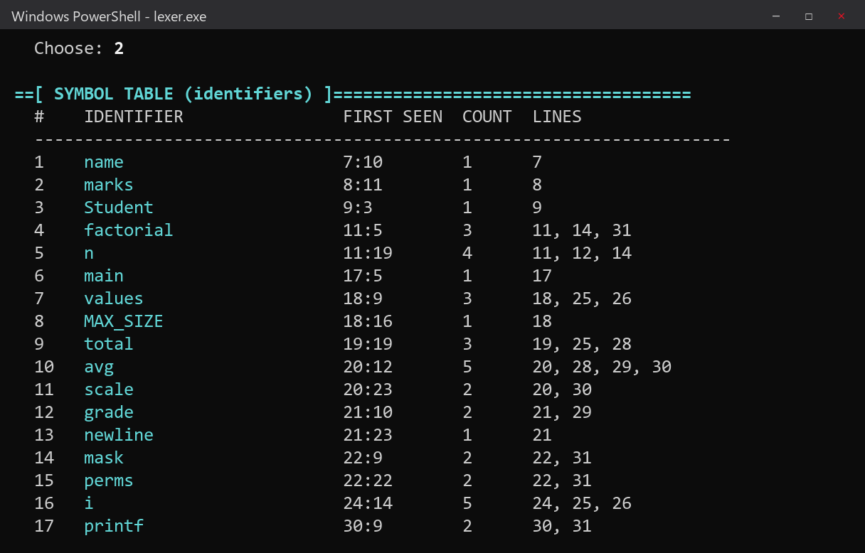
Figure 4: Browser UI showing the symbol table for the valid demo program
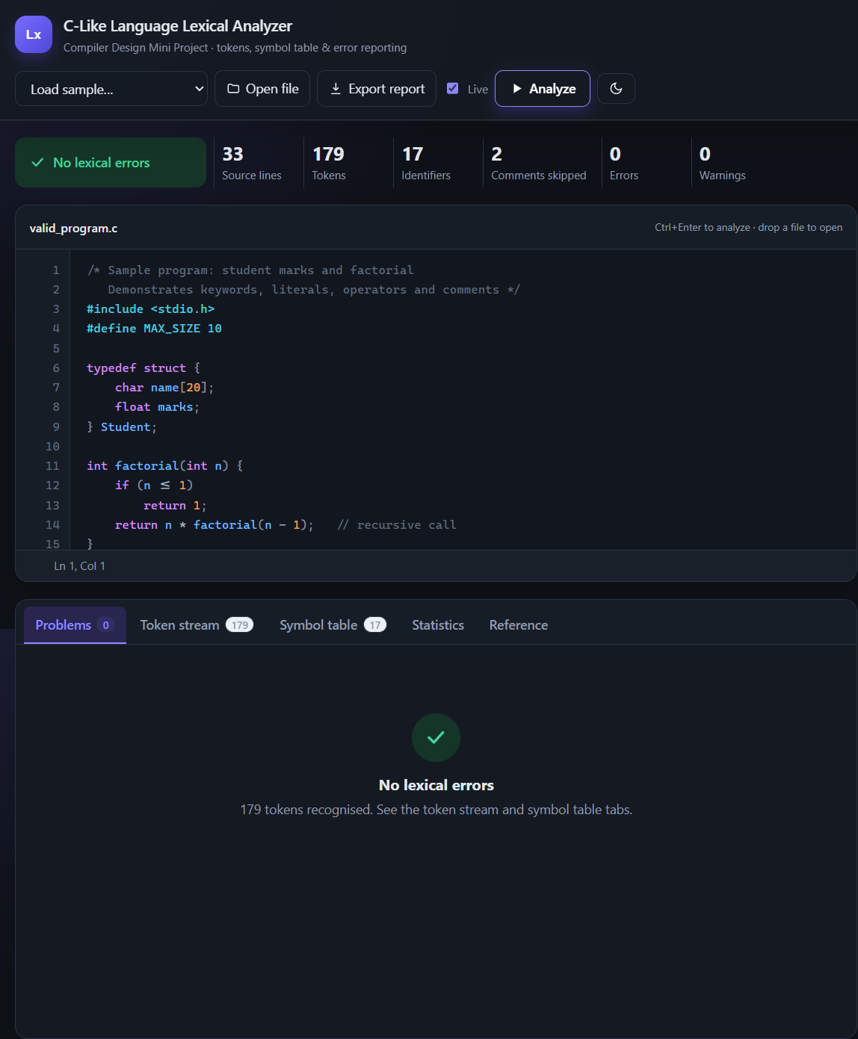
Figure 5: Light-theme workspace showing the valid program analysis
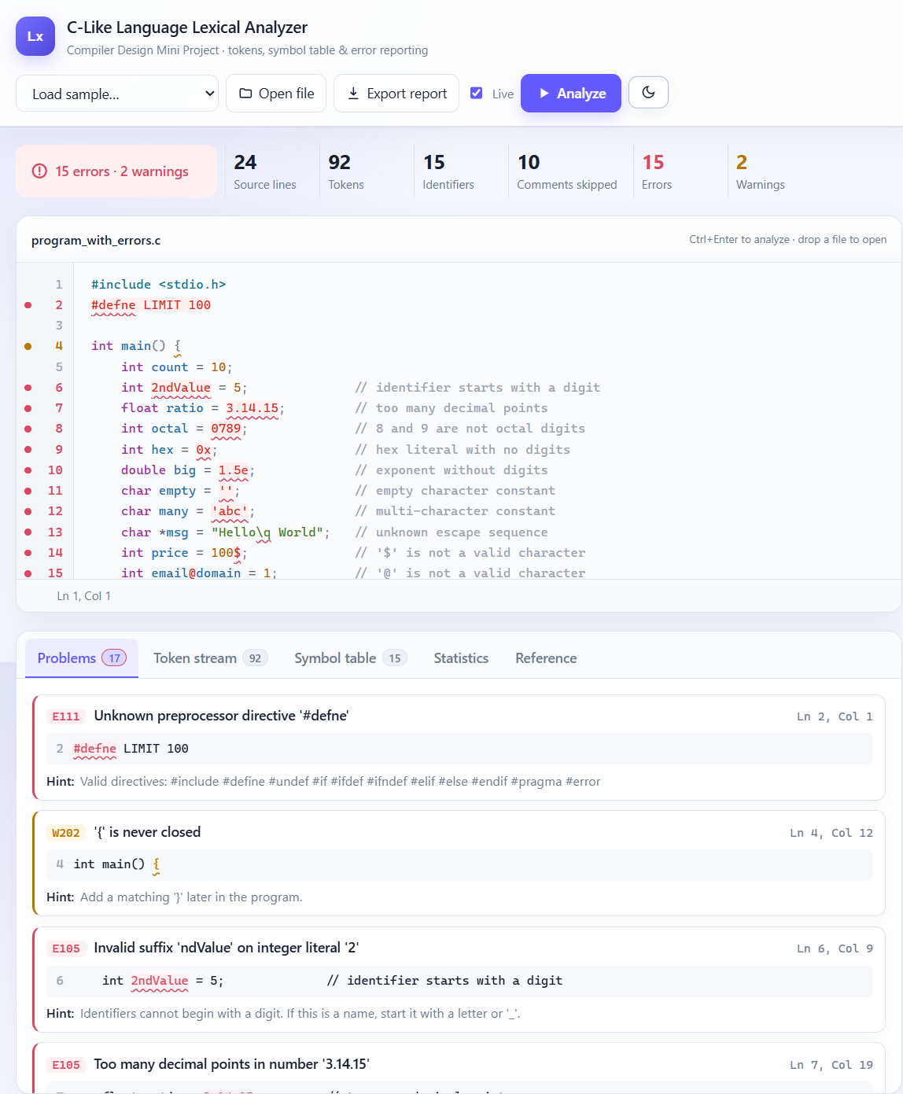
Figure 6: Dark-theme workspace showing lexical errors and diagnostics

7. Results and Conclusion
Table 3: Results on the sample programs
Measure | valid_program.c | program_with_errors.c
Lines / tokens | 33 / 179 | 24 / 92
Unique identifiers / comments | 17 / 2 | 15 / 10
Errors / warnings | 0 / 0 | 15 / 2
Result | PASSED | FAILED (all problems found at the correct position)

In addition, 20 small test cases were run through the command-line mode, each targeting one feature or one error code (for example x <<= 2;, int b = 09;, char c = 'a; and an integer one larger than the maximum). All 20 gave the expected tokens, error codes and exit status, so every error and warning code was exercised at least once. The browser UI was also smoke-tested with both sample programs: the valid sample displayed "No lexical errors", while the faulty sample displayed 15 errors and 2 warnings with clickable navigation to the source locations. The light/dark theme toggle was checked after the visual redesign to ensure that panels, editor text, syntax colors and diagnostics remain readable in dark mode.
Limitations. The project covers the lexical phase only, so mistakes that need the grammar (such as a misspelt keyword used as a name) are not detected. Some rare C forms (wide-string prefixes, hexadecimal floats, trigraphs) are not supported, and macros are not expanded.
Conclusion. The project delivers a working lexical analyzer for a C-like language that tokenises programs correctly, builds a symbol table and, above all, reports lexical errors precisely and helpfully, finding all of them in one run. The accompanying local browser UI makes the results easier to inspect through a responsive editor, summary dashboard, diagnostic list, token stream, symbol table and statistics view. Both light and dark themes are supported without changing the analyzer behavior. All objectives were met. Building it by hand put into practice the course concepts of tokens, patterns, regular definitions, finite automata, the longest-match rule, symbol tables and error recovery. A natural next step is to add a parser that uses this lexer as its front end.

References
[1] A. V. Aho, M. S. Lam, R. Sethi and J. D. Ullman, Compilers: Principles, Techniques, and Tools, 2nd ed. Pearson / Addison-Wesley, 2006.
[2] ISO/IEC 9899:2018, Information technology – Programming languages – C. ISO, 2018.

