The pie chart is titled **"Employee Turnover Rate"** and depicts the proportion of employees who left the organization versus those who stayed. It shows that **57.2%** of employees left (labeled "Yes" in orange), while **42.8%** stayed (labeled "No" in gray). This visualization highlights a turnover rate higher than retention within the organization.

**3.**

**Turnover Rate**

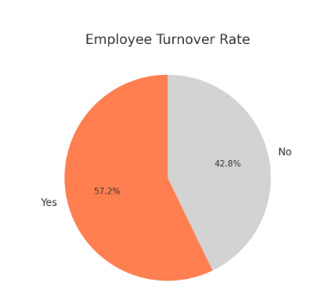

**GOALS**

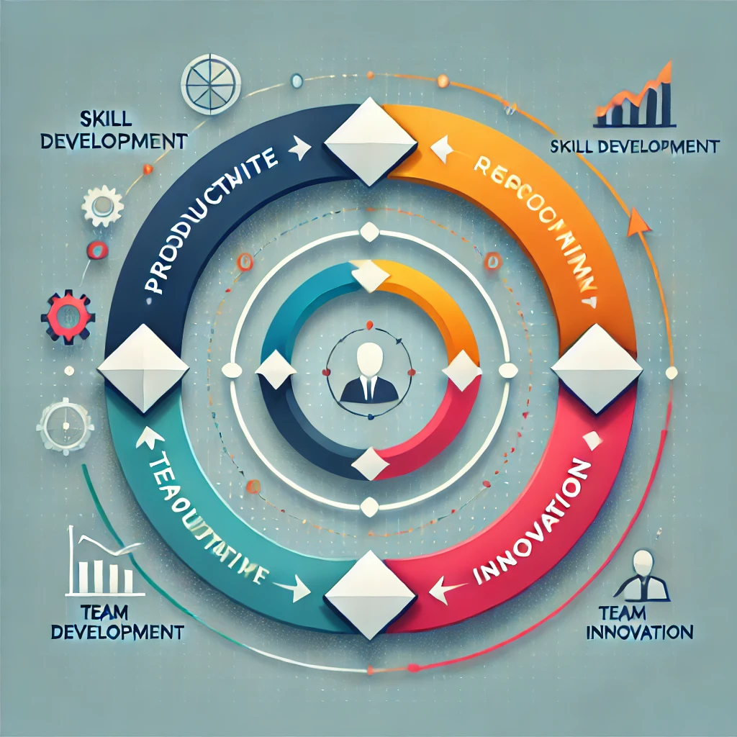

Result

* **Average Performance Rating**: 3.0
* **Average Annual Training Hours**: 56.4 hours
* **Average Monthly Sales**: $5,758.49
* **Turnover Rate**: 57.17%

The bar chart titled **"Average Annual Training Hours by Gender"**. It compares the average number of training hours received annually by employees of different genders: Female, Male, and Non-Binary. The bars indicate that all genders receive similar training hours, with values close to 60 hours on average. The chart highlights the equality in training hours distribution across genders.

**2.**

**Training Hours by Gender**

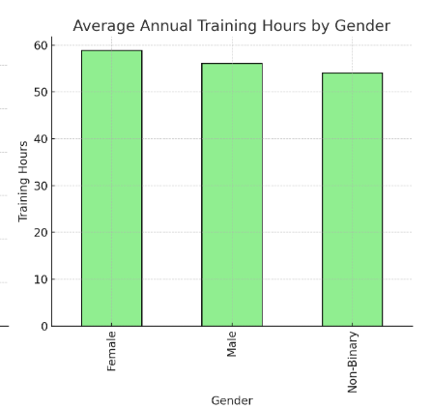

From Dataset Coloumns Describe:

1. **Employee Name**: Identifier for employees.
2. **Age**: Employee age.
3. **Gender**: Employee gender.
4. **Department**: Department of work.
5. **Years of Experience**: Total years of experience.
6. **Education Level**: Highest education level attained.
7. **Job Role**: Employee's job title.
8. **Performance Rating**: Performance on a scale (1-5).
9. **Annual Training Hours**: Total hours of training in a year.

10**.Monthly Sales**: Monthly sales achieved.

11**.Turnover Status**: Whether the employee left the organization.

The bar chart titled **"Average Performance Rating by Department"**. It shows the average performance ratings of employees across various departments, such as Finance, HR, IT, Marketing, Operations, and Sales. Each department's bar indicates the average performance rating, with most values clustered around 3.0. The chart provides a clear comparison of performance ratings by department.

**1.**

**Performance Rating by Department**

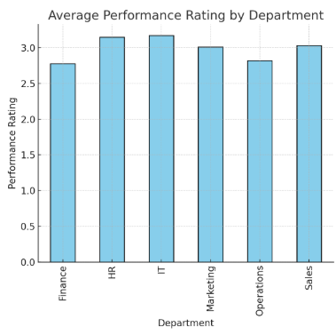

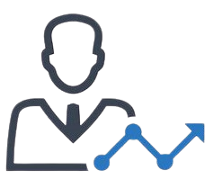



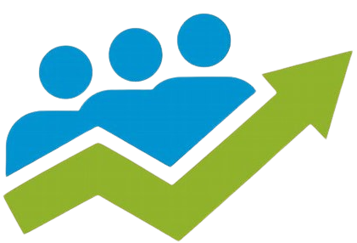

**EMPLOYEE PERFORMANCE**

ABC Limited Company