**ER-Diagram, Schema diagram and different Normalization form of the project “Travel Application”**

**ER - Diagram**

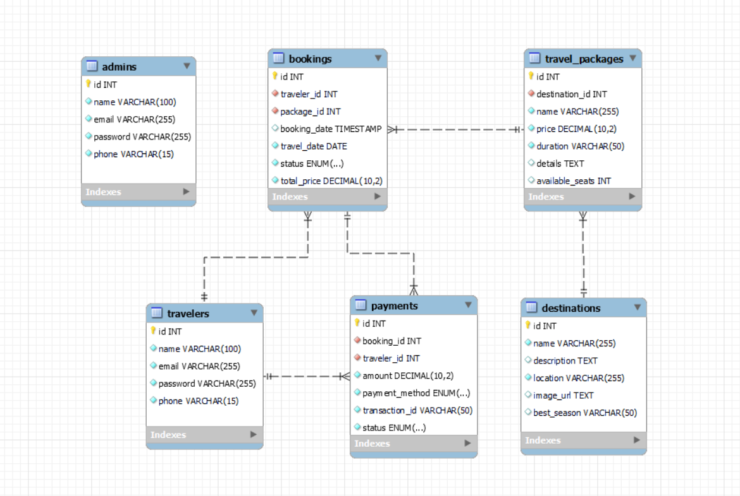

**1st Normal Form (1NF) - Eliminate Repeating Groups**

**Rule:** Ensure each column has atomic (indivisible) values and eliminate repeating groups.

**Example (Before 1NF - Unnormalized Table)**  
A simple **Bookings** table:

|  |  |  |  |
| --- | --- | --- | --- |
| BookingID | CustomerName | Destinations | ContactNumber |
| 1 | John Doe | Paris,London | 1234567890 |
| 2 | Alice Smith | New York,Tokyo | 9876543210 |

**Problems:**

* **Multiple destinations in a single field** (not atomic).
* **Hard to query specific destinations**.

**Solution (After 1NF - Atomic Values, No Repeating Groups)**  
We split destinations into separate rows:

|  |  |  |  |  |  |
| --- | --- | --- | --- | --- | --- |
| | **BookingID** |  | | --- | --- | | **CustomerName** | **Destination** | **ContactNumber** |
| 1 | John Doe | Paris | 1234567890 |
| 1 | John Doe | London | 1234567890 |
| 2 | Alice Smith | New York | 9876543210 |
| 2 | Alice Smith | Tokyo | 9876543210 |

**2nd Normal Form (2NF) - Eliminate Partial Dependency**

**Rule:** Ensure the table is in **1NF** and that **every non-key column is fully dependent on the primary key**.

**Example (Before 2NF - Partial Dependency Exists)**

|  |  |  |  |  |  |  |
| --- | --- | --- | --- | --- | --- | --- |
| | **BookingID** |  | | --- | --- | | **CustomerID** | **CustomerName** | **Destination** | **ContactNumber** |
| 1 | 101 | John Doe | Paris | 1234567890 |
| 1 | 101 | John Doe | London | 1234567890 |

**Problem:**

* **CustomerName and ContactNumber depend only on CustomerID, not BookingID.**
* **Repeating customer details for each booking leads to redundancy.**

**Solution (After 2NF - Separate Customers and Bookings)**

**Customers Table:**

|  |  |  |  |  |  |  |
| --- | --- | --- | --- | --- | --- | --- |
| | **CustomerID** |  | | --- | --- |  |  |  | | --- | --- | |  |  | | **CustomerName** | **ContactNumber** |
| 101 | John Doe | 1234567890 |
| 102 | Alice Smith | 9876543210 |

Bookings Table:

|  |  |  |  |  |  |
| --- | --- | --- | --- | --- | --- |
| | **BookingID** | | --- |  |  |  | | --- | --- | |  |  | | **CustomerID** | **Destination** |
| 1 | 101 | Paris |
| |  |  |  | | --- | --- | --- | | 1 |  |  | | 101 | London |

Now, **CustomerName and ContactNumber are stored separately** and only referenced by CustomerID.

**3rd Normal Form (3NF) - Eliminate Transitive Dependency**

**Rule:** Ensure the table is in **2NF** and that **no non-key column depends on another non-key column**.

**Example (Before 3NF - Transitive Dependency Exists)**

|  |  |  |  |  |  |  |  |  |  |
| --- | --- | --- | --- | --- | --- | --- | --- | --- | --- |
| | **BookingID** |  | | --- | --- |  |  |  | | --- | --- | |  |  |  |  |  | | --- | --- | |  |  | | **CustomerID** | **Destination** | **CityInfo (Country, Population, etc.)** |
| 1 | 101 | Paris | France, 2.1M people |
| 1 | 101 | London | UK, 9M people |

**Problem:**

* **CityInfo depends on Destination, not BookingID.**
* **Repeating city details multiple times leads to redundancy.**

**Solution (After 3NF - Separate Destinations Table)**

**Destinations Table:**

|  |  |  |  |  |  |  |  |  |  |  |  |
| --- | --- | --- | --- | --- | --- | --- | --- | --- | --- | --- | --- |
| | **DestinationID** |  |  | | --- | --- | --- |  |  |  |  | | --- | --- | --- | |  |  |  |  |  |  | | --- | --- | |  |  | | **City** | **Country** | **Population** |
| 201 | London | UK | 9M |
| 202 | Paris | France | 2.1M |

Bookings Table:

|  |  |  |  |  |  |  |  |  |
| --- | --- | --- | --- | --- | --- | --- | --- | --- |
| | **BookingID** | | --- |  |  |  |  | | --- | --- | --- | |  |  |  |  |  |  | | --- | --- | |  |  | | **CustomerID** | **DestinationID** |
| 1 | 101 | 201 |
| 1 | 101 | 202 |

Now, **CityInfo is stored separately in the Destinations table**.