**Login Page Design**

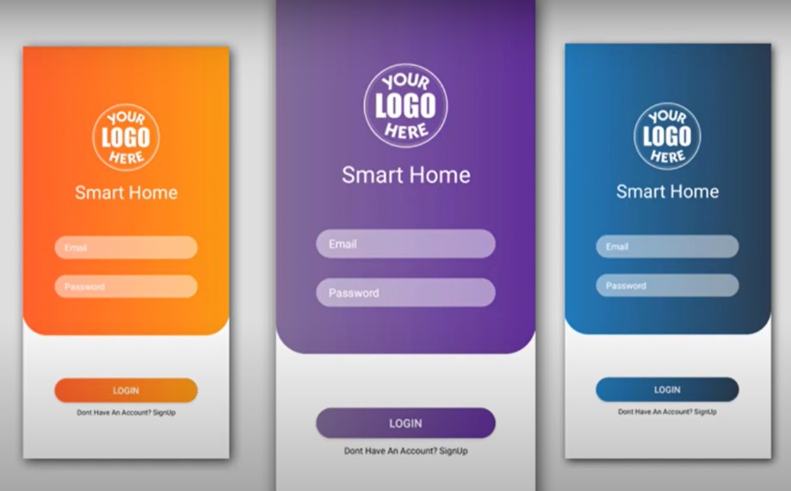

**Intro Design, Home Design, Detail’s Design**

