**Enterprise Data Governance - Charter**

|  |  |
| --- | --- |
| **Version:** | 1. 0 |
| **Version Date:** | 6/7/2022 |
| **Prepared By:** |  |

**Table of** **Contents**

1. Executive Summary 3

2. Data Governance – Vision, Mission and Capabilities 3

2. 01. Vision 3

2. 02. Mission 3

2. 03. Capabilities 4

3. Data Governance Goals 5

4. Data Governance Organization 6

5. Data Governance Implementation 9

6. Scope of Cloud Data Governance 11

7. Stakeholders/Approvers 12

8. Document Revision History 12

Appendix A – Design Decision Details 13

General 13

Security 13

Appendix B 13

Glossary 13

# Executive Summary

Data is the new currency; it is the basic building block that leads to information and analytics. With the migration of applications and data to the cloud, there is a need to govern all data assets in the cloud. Data Governance encompasses the people, processes, and information technology required to create consistent and proper handling of data and understanding of information across the organization, both for operational requirements and needs and the analytical requirements and needs. Data Governance ignores the boundaries created by organizational structures and governs data from its creation thru the end of life.

This Charter sets out the broad expectations for implementing a Enterprise Data Governance function. Enterprise Data Governance is a key driver of an Enterprise approach to Information Management.

This Charter forms part of the overall Enterprise Data Governance framework. Further strategic papers, supporting the implementation and ongoing management of Data Governance, will be developed in support of this Charter.

The Enterprise Data Governance Charter provides:

* **Vision**encapsulating the aspirational view of what Enterprise Data Governance will mean for the organization.
* **Mission Statement**highlighting the main purpose of Enterprise Data Governance.
* **Capabilities**that are required to develop Enterprise Data Governance and Information Management competencies across the organization
* **Goals** of implementing and managing Enterprise Data Governance
* **Organization Structure** supporting Enterprise Data Governance

# Data Governance – Vision, Mission and Capabilities

# Vision

With the move to the cloud and the use of cloud based technologies, it is the perfect time to implement the management of information as an enterprise-wide asset. Therefore, Enterprise Data Governance will provide the organization, processes, and tools that deliver corporate data, as an accurate, trustworthy sets of data; giving the organization a solid, reliable foundation for making business decisions.

# Mission

The mission for Enterprise Data Governance is:

* To undertake a leadership role in the creation, implementation and oversight of the cloud based enterprise-wide information and data management goals, standards, practices and processes aligned with the business goals and objectives of BCBSRI.
* To provide expert advice and support in relation to all aspects of Information and Data Governance including Data Ownership, Data Protection, Data Privacy, Information Usage, Classification and Retention
* To promote Data Governance at an executive and senior management level.

# Capabilities

Organizational capabilities required to deliver the vision and mission statement for Data Governance include:

**Policies**

* Appropriate protocols for Enterprise Data Governance and Information Management are established in the form of best-practices, policies, guidelines, procedures and standards.

**Processes**

* Enterprise Data Governance and Information Management processes are explicitly defined and documented.

**People**

* All staff understands and has an awareness of Information Management language and principles.
* Relevant staff has the necessary Information and Data Management skills to fulfill their role and to maximize value of information to the organization.
* Users are skilled in using available information in the context of doing their job, based on risk intelligence and informed action.

**Information Asset Management**

* An organizational approach that puts rigor and structure around deriving maximum value from the collections of related information.
* Identifying the organization’s information assets is an entry point to understanding the business context(s) for that information, enabling drill-through to multiple business processes which are all supported by same information asset.

**Metadata Management**

* Business metadata is a coordinated approach for data and information definitions, business rules, expected formats, security classifications etc. Also, operational metadata is important to capture and understand. Operational metadata includes where data is stored, when it moves, on what mechanism it moves, access rights etc.

**Data Quality Management**

* A coordinated approach for defining, measuring and improving the quality of data, ensuring its fitness-for-purpose and alignment with the business needs that it serves.

**Information Management Systems and Infrastructure**

* Implementation of necessary Information and Communication Technology infrastructure to support the end-to-end information lifecycle, business information needs and Enterprise Data Governance processes.

# Data Governance Goals

In support of achieving the Enterprise Data Governance Vision and Mission Statement, the Data Governance Function is tasked with the following acheiving the following goals:

* Drive organizational and behavioral change as it relates to the use of data. Drive initiatives to improve and assure the business value of information assets in terms of quality, efficiency, usability and interpretation.
* Define, develop and support the operation of an Information Asset Management plan and associated information Management processes, which align data and information with the key business processes that use each asset.
* Define, establish and operate a robust Information Management program that will deliver sustainable enterprise-wide Information Service capabilities across the organization in collaboration with Business Domain Owners, enabling information to be exploited as a strategic asset for evidence-based decision making.
* Direct, manage and facilitate BCBSRI to optimize the exploitation of data and compliance to corporate and regulatory requirements in consultation with Senior Management, business unit representatives and other stakeholders. Establish and operate the Information Requirements Catalogue and Plan, and set priorities for associated data governance activities
* Develop organizational policy describing how information should be treated and how ownership responsibilities and accountabilities can be established and monitored. Identify data owners and stewards and implement ownership responsibilities as corporate policy. In time, policy is to cover all data and information that is shared or of significant value (both “structured” and “unstructured”, including requirements for document and records management). Provide data consumers and data owners with guidance, standards and consultation to enable owners to develop common and accepted data definitions for all shared data,
* Together with IT, develop an Information Management Strategy and Roadmap that defines the management, policies and processes for the entire lifecycle of all of the organization’s information assets, from capture at the source through to ultimate disposal. Include processes for data security, access, storage, classification and retention.
* Establish a Data Quality Framework of policies, processes, quality measures, information standards and requirements. Work with Data Managers, Data Stewards and technical staff to implement data cleansing plans and participate in the root cause analyses of data quality issues.
* Establish and operate Information Management Benefits Matrix for tracking identification and realization of business benefit opportunities arising from the provision and use of better quality information
* Identify and establish an effective cross divisional Data Governance Council to drive the organization’s Data Governance practices. Recognize areas where existing practices require change or where new ones need to be developed to ensure Data Governance objectives are met. Craft Service Level Agreements with relevant staff members to underpin governance practices and expectations and ensure data are collected, stored, shared and reported accurately and according to the needs of the organization.
* Define, agree and communicate the roles and responsibilities of Business Data Owners, Data Quality Managers, and Data Steward. Define responsibilities at each level and identify appropriate Business Domain Owners, Business Data Owners, Data Quality Managers and Data Stewards in each area and at each level to incorporate into the Data Governance Team.
* Together with IT function, develop an Enterprise Information Model that incorporates common practices for the consistent definition of data terms, business rules and taxonomies, with a common method for storage and retrieval of common data definitions. Define, establish and support the operation of metadata management, business glossary which drives shared communication and understanding of information meaning and improved trust and integrity for information.
* Provide a program of training and support for staff members who interact with data and information (including entry and review, business usage, analysis and insight and technical stewardship).
* Establish effective communication channels with all consumers of data, data owners and stewards to facilitate exchange of ideas that build continuous improvement in data governance and management practices across the organization. Ensure that relevant stakeholders are kept fully informed of the changes introduced by the Data Governance function and encourage them to champion the changes in their areas of influence
* Seek out program, process and technological improvements/innovations that will:
  + Foster improved data quality and reporting
  + Balance access to information with the need for security of data
  + Eliminate redundancies and create consistency
  + Improve the reliability, accuracy, and confidence in information
  + Drive explicit understanding of the value to be derived from the organization’s information holdings.
  + Ensure the consistent implementation of best practice for Information Management and data quality through benchmarking, business process improvement, and customer feedback.

# Data Governance Organization

The organization structure in the lists below describes the people, forums, and groups, and the coordination involved in directing and operating the Data Governance function towards completion of its mission and goals. Separate documents will be created to describe in detail each part of the organization structure. This charter captures a high level bulleted list about each part of the organization

**Strategic – Executive Sponsor**

* Sets initial direction and goals for the program.
* Allocates funding and approves data quality initiatives.
* Approves information policy and tracks the progress of quality initiatives compared to target plan.
* Provide business drivers
* Potential issue escalation path
* Monitor Business & IT alignment
* Champion External Data Disclosure
* Removes roadblocks
* Sets priorities

**Tactical - Data Governance Council**

* Providing subject matter expertise on the application’s data
* Providing architecture support for data storage/transformation/usage
* Providing the data analytics requirements
* Helping in data classification and data security requirements for sharing data amongst internal applications and external vendors
* Develops and monitors an overall strategic plan for enterprise-wide data quality improvement.
* Prioritize and champion for data quality initiatives for all systems, LOBs and functions.
* Ensures scheduling and resource allocation.
* Provide data quality feedback and progress.
* Communicates with business segments. Ensure resolution of escalated issues.
* Defines and manages communication model on data assets.
* Acts on priorities
* Makes decisions on exception requests
* Defines and implements policies and rules
* Continuously monitor progress of current data initiatives.
* Provide high-level integration between technology and the business/organization.
* Facilitate cross-functional data initiatives.

**Operational - Data Owners/Data Stewards**

* Managing and maintenance of the enterprise data catalog for cloud data stores (Viz. , Data Lake, Storage accounts, Cloud application DBs and Enterprise DBs like EDR, SSDS etc. )
* Maintenance of the meta data repository
* Maintenance of cloud data classification
* Review the data lineage
* Review the access requests for both application and end users. Approve read-only or read-write grants to objects stored in a cloud data store using Azure RBAC or other methods
* Define, Produce and Use data on an ongoing basis.
* Ensures adherence to data quality and policies through effective governance and change management.
* Produces regular data quality metrices and KPIs.
* Provides ongoing feedback on IT tools and processes.
* Design standards and rules regarding their own domains.
* Manage data quality for data domain
* Understand end to end requirements and impacts of external data disclosure
* Regular communication with consumers of their data.
* Assist in creating data policies, standards, and procedures.

**Other Stakeholders - External Entities and Business Owners**

* Understand customer requirements
* Understand and advocate adherence to external data disclosure initiatives
* Source of data requirements
* Identifies data quality issues
* Champions data assets to their functions

# Data Governance Implementation

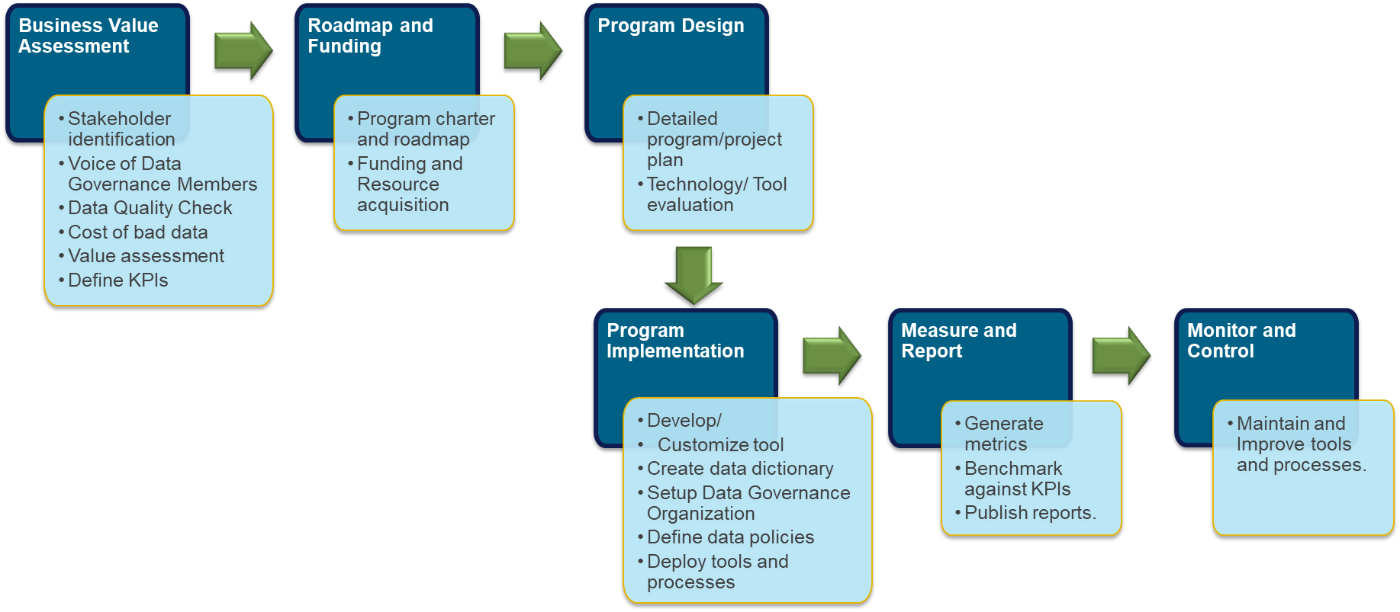

The highlevel tasks of Data Governance Organizations are below:

* Data Access Policies and Processes
* Standard Development Viz. , Database Naming
* Data Catalog Maintenance - Information Asset Management
* Metadata Management
* Data Quality Management
* Information Management Systems and Infrastructure

# Scope of Cloud Data Governance

The scope of cloud data governance include governing the following data assets:

1. Enterprise Data Warehouse
2. Enterprise Data Lake
3. Blob Storage
4. Relational Databases of all Cloud applications
5. EMR data repository
6. FHIR repository
7. Reporting data assets (SAS/Universe etc. )

# Stakeholders/Approvers

|  |  |  |
| --- | --- | --- |
| **Name** | **Role** | **Context in Architecture** |
|  |  | Overall Design |
|  |  | Overall Design |
|  |  | Overall Design |
|  |  | Overall Design |
|  |  | Overall Design |
|  |  | Overall Design |

# Document Revision History

|  |  |  |  |
| --- | --- | --- | --- |
| **Date** | **Version** | **Modifications** | **Author** |
| 6/7/2022 | 1. 0 | Document Creation |  |

# Appendix A – Design Decision Details

This section catalogs the design decisions for this design. Security decisions are called out into a specific section.

## General

## Security

# Appendix B

## Glossary