Evaluation of the probability of causation approach for lung cancer: Scoping review

Count of included studies

Javier Mancilla Galindo

2025-08-20

Table of contents

# Probability of Causation (PoC) ASReview screened and included records

The initial deduplicated dataset included n = 1127 records, out of which n = 184 were screened with ASReview, resulting in n = 133 irrelevant and n = 51 relevant records.

After full-text review, reclassification of studies resulted in n = 161 irrelevant and n = 23 relevant records. Therefore, a total of n = 28 irrelevant records were excluded due to the following reasons:

| poc | quantitative | lung_cancer | n |
| --- | --- | --- | --- |
| 0 | 0 | 1 | 6 |
| 0 | 1 | 1 | 1 |
| 1 | 0 | 0 | 4 |
| 1 | 0 | 1 | 14 |
| 1 | 1 | 0 | 3 |
| NA | NA | NA | 133 |

To summarize these reasons for exclusion, the following hierarchy was applied: poc > lung_cancer > quantitative.

* Not PoC, n = 7
* Not lung cancer, n = 7
* Not quantitative exposure-response, n = 14

# PoC snowball citation ASReview screened and included records

The updated dataset with the citations of the originally identified studies included n = 1714 records, out of which n = 42 were screened with ASReview, resulting in n = 34 irrelevant and n = 8 relevant records.

After full-text review, reclassification of studies resulted in n = 39 irrelevant and n = 3 relevant records. Therefore, a total of n = 5 irrelevant records were excluded due to the following reasons:

| poc | quantitative | lung_cancer | n |
| --- | --- | --- | --- |
| 1 | 0 | 0 | 2 |
| 1 | 1 | 0 | 3 |

* Not PoC, n = 0
* Not lung cancer, n = 5

# PRISMA diagram

The PRISMA2020 R package1 was used to present the flow of studies in this review.

source("scripts/PRISMA.R")

Since the produced diagram little flexibility to report screening of citations, the PRISMA_flowdiagram function was modified to allow for additional reporting.

source("scripts/PRISMA_flowdiagram_modified.R")  
  
source("scripts/PRISMA_enhanced.R")

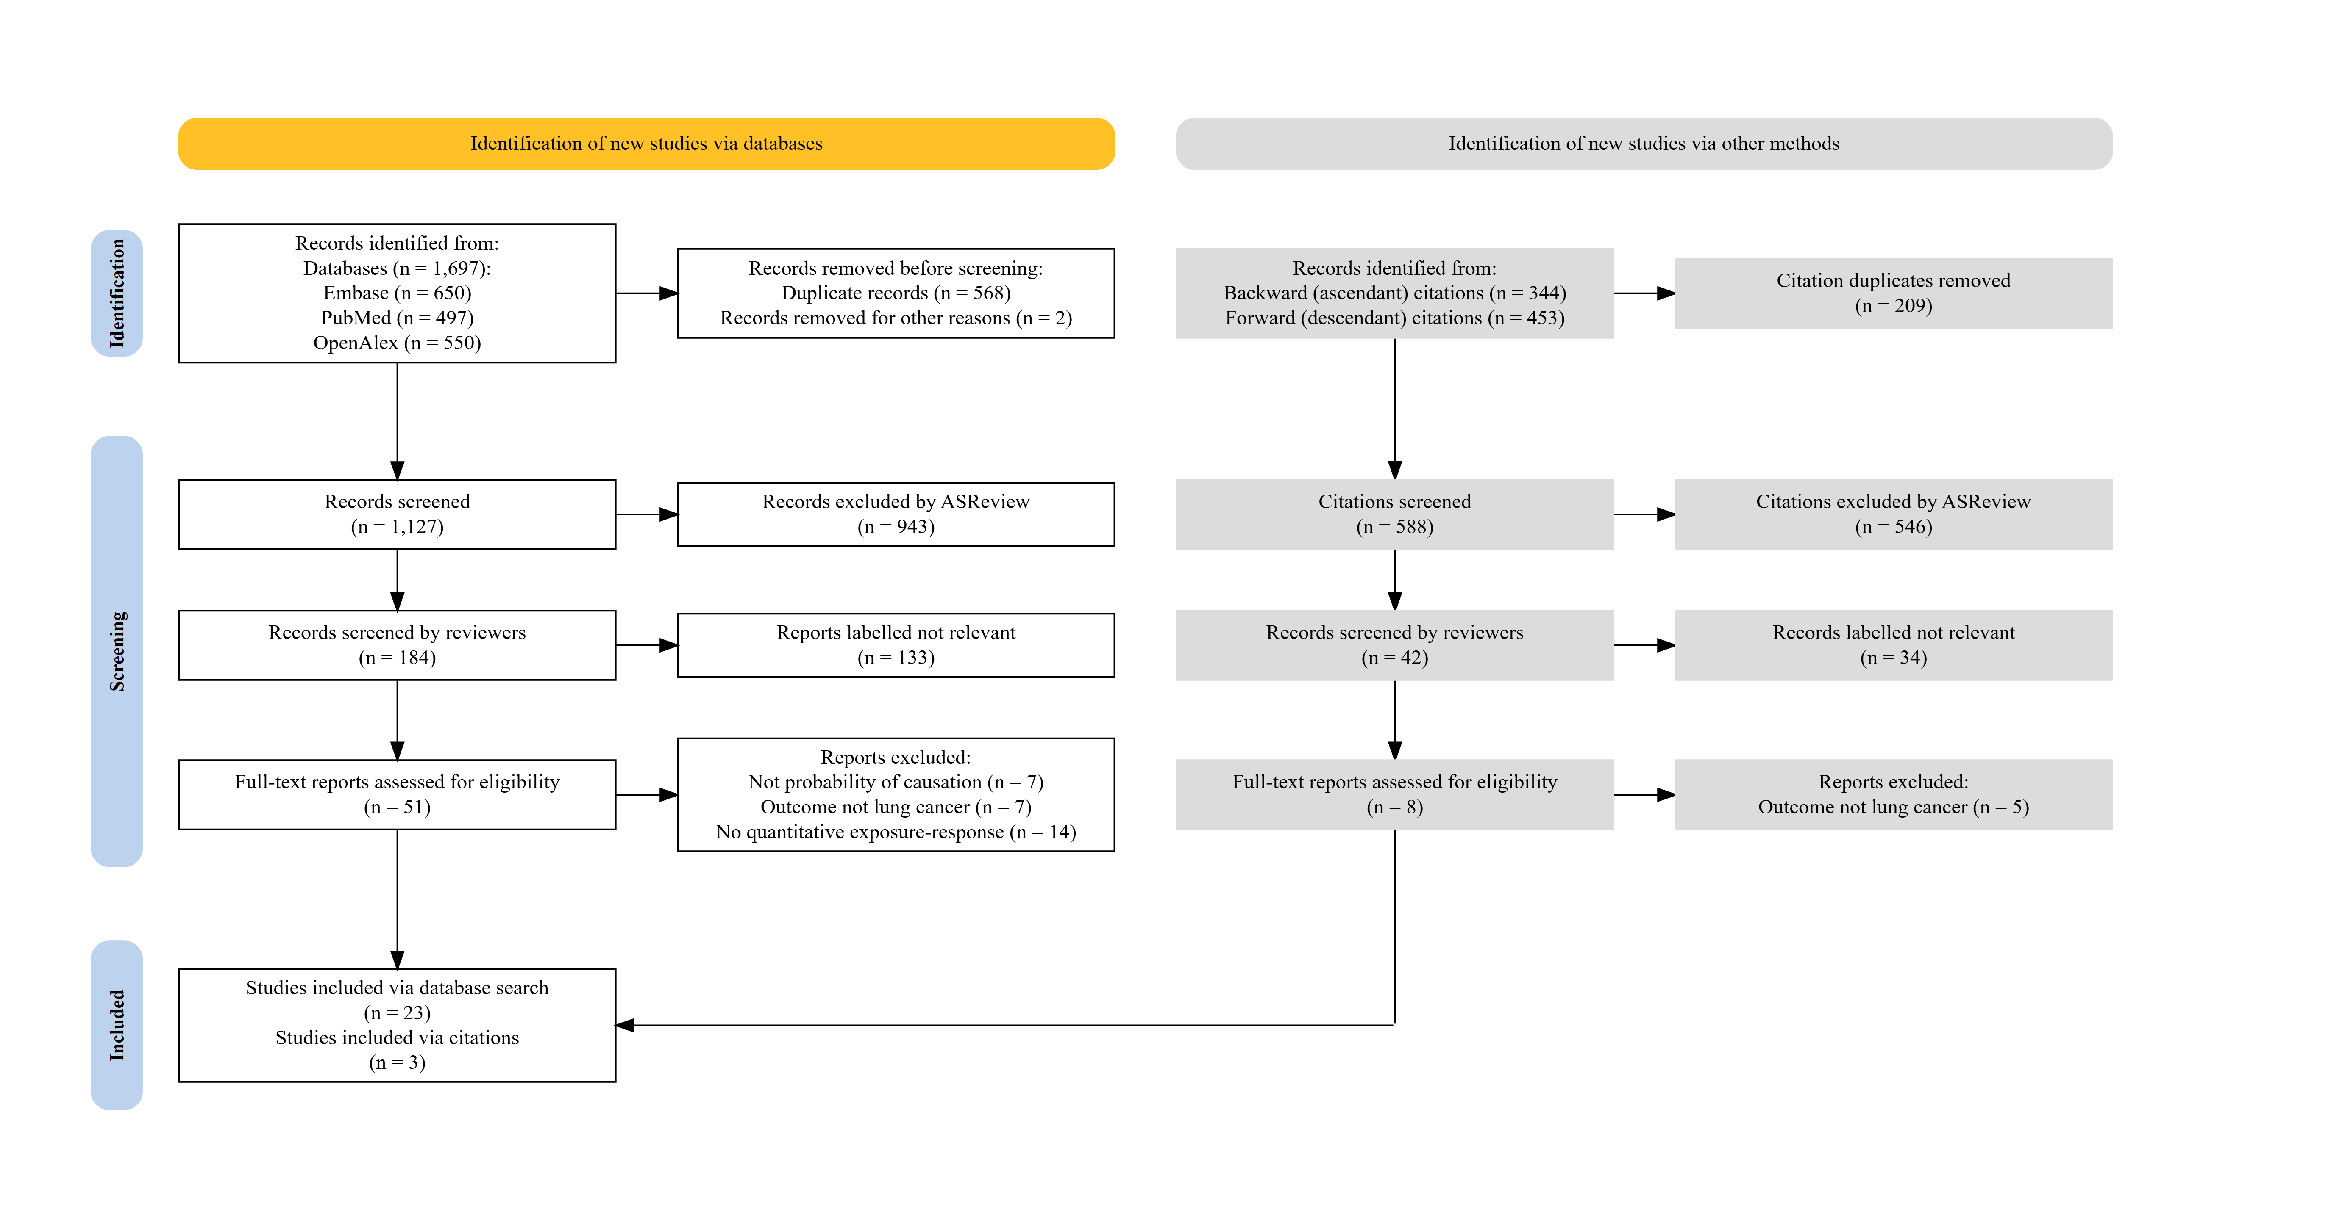

# References

1. Haddaway NR, Page MJ, Pritchard CC, McGuinness LA. *PRISMA2020* : An R package and Shiny app for producing PRISMA 2020-compliant flow diagrams, with interactivity for optimised digital transparency and Open Synthesis. *Campbell Systematic Reviews*. 2022;18(2):e1230. doi:[10.1002/cl2.1230](https://doi.org/10.1002/cl2.1230)

# Package References

* Aden-Buie G, Chang W, Schloerke B (2025). *chromote: Headless Chrome Web Browser Interface*. doi:10.32614/CRAN.package.chromote <https://doi.org/10.32614/CRAN.package.chromote>, R package version 0.5.1, <https://CRAN.R-project.org/package=chromote>.
* Chang W (2025). *webshot2: Take Screenshots of Web Pages*. doi:10.32614/CRAN.package.webshot2 <https://doi.org/10.32614/CRAN.package.webshot2>, R package version 0.1.2, <https://CRAN.R-project.org/package=webshot2>.
* Cheng J, Sievert C, Schloerke B, Chang W, Xie Y, Allen J (2024). *htmltools: Tools for HTML*. doi:10.32614/CRAN.package.htmltools <https://doi.org/10.32614/CRAN.package.htmltools>, R package version 0.5.8.1, <https://CRAN.R-project.org/package=htmltools>.
* Grolemund G, Wickham H (2011). “Dates and Times Made Easy with lubridate.” *Journal of Statistical Software*, *40*(3), 1-25. <https://www.jstatsoft.org/v40/i03/>.
* Haddaway NR, Page MJ, Pritchard CC, McGuinness LA (2022). “PRISMA2020: An R package and Shiny app for producing PRISMA 2020-compliant flow diagrams, with interactivity for optimised digital transparency and Open Synthesis.” *Campbell Systematic Reviews*, *18*(2), e1230. doi:10.1002/cl2.1230 <https://doi.org/10.1002/cl2.1230>.
* Iannone R, Cheng J, Schloerke B, Hughes E, Lauer A, Seo J, Brevoort K, Roy O (2025). *gt: Easily Create Presentation-Ready Display Tables*. doi:10.32614/CRAN.package.gt <https://doi.org/10.32614/CRAN.package.gt>, R package version 1.0.0, <https://CRAN.R-project.org/package=gt>.
* Makowski D, Lüdecke D, Patil I, Thériault R, Ben-Shachar M, Wiernik B (2023). “Automated Results Reporting as a Practical Tool to Improve Reproducibility and Methodological Best Practices Adoption.” *CRAN*. <https://easystats.github.io/report/>.
* Müller K, Wickham H (2025). *tibble: Simple Data Frames*. doi:10.32614/CRAN.package.tibble <https://doi.org/10.32614/CRAN.package.tibble>, R package version 3.3.0, <https://CRAN.R-project.org/package=tibble>.
* R Core Team (2025). *R: A Language and Environment for Statistical Computing*. R Foundation for Statistical Computing, Vienna, Austria. <https://www.R-project.org/>.
* Rinker TW, Kurkiewicz D (2018). *pacman: Package Management for R*. version 0.5.0, <http://github.com/trinker/pacman>.
* Vaidyanathan R, Xie Y, Allaire J, Cheng J, Sievert C, Russell K (2023). *htmlwidgets: HTML Widgets for R*. doi:10.32614/CRAN.package.htmlwidgets <https://doi.org/10.32614/CRAN.package.htmlwidgets>, R package version 1.6.4, <https://CRAN.R-project.org/package=htmlwidgets>.
* Wickham H (2016). *ggplot2: Elegant Graphics for Data Analysis*. Springer-Verlag New York. ISBN 978-3-319-24277-4, <https://ggplot2.tidyverse.org>.
* Wickham H (2023). *forcats: Tools for Working with Categorical Variables (Factors)*. doi:10.32614/CRAN.package.forcats <https://doi.org/10.32614/CRAN.package.forcats>, R package version 1.0.0, <https://CRAN.R-project.org/package=forcats>.
* Wickham H (2023). *stringr: Simple, Consistent Wrappers for Common String Operations*. doi:10.32614/CRAN.package.stringr <https://doi.org/10.32614/CRAN.package.stringr>, R package version 1.5.1, <https://CRAN.R-project.org/package=stringr>.
* Wickham H, Averick M, Bryan J, Chang W, McGowan LD, François R, Grolemund G, Hayes A, Henry L, Hester J, Kuhn M, Pedersen TL, Miller E, Bache SM, Müller K, Ooms J, Robinson D, Seidel DP, Spinu V, Takahashi K, Vaughan D, Wilke C, Woo K, Yutani H (2019). “Welcome to the tidyverse.” *Journal of Open Source Software*, *4*(43), 1686. doi:10.21105/joss.01686 <https://doi.org/10.21105/joss.01686>.
* Wickham H, Bryan J (2025). *readxl: Read Excel Files*. doi:10.32614/CRAN.package.readxl <https://doi.org/10.32614/CRAN.package.readxl>, R package version 1.4.5, <https://CRAN.R-project.org/package=readxl>.
* Wickham H, François R, Henry L, Müller K, Vaughan D (2023). *dplyr: A Grammar of Data Manipulation*. doi:10.32614/CRAN.package.dplyr <https://doi.org/10.32614/CRAN.package.dplyr>, R package version 1.1.4, <https://CRAN.R-project.org/package=dplyr>.
* Wickham H, Henry L (2025). *purrr: Functional Programming Tools*. doi:10.32614/CRAN.package.purrr <https://doi.org/10.32614/CRAN.package.purrr>, R package version 1.1.0, <https://CRAN.R-project.org/package=purrr>.
* Wickham H, Hester J, Bryan J (2024). *readr: Read Rectangular Text Data*. doi:10.32614/CRAN.package.readr <https://doi.org/10.32614/CRAN.package.readr>, R package version 2.1.5, <https://CRAN.R-project.org/package=readr>.
* Wickham H, Vaughan D, Girlich M (2024). *tidyr: Tidy Messy Data*. doi:10.32614/CRAN.package.tidyr <https://doi.org/10.32614/CRAN.package.tidyr>, R package version 1.3.1, <https://CRAN.R-project.org/package=tidyr>.
* Xie Y, Lesur R, Thorne B, Tan X (2025). *pagedown: Paginate the HTML Output of R Markdown with CSS for Print*. doi:10.32614/CRAN.package.pagedown <https://doi.org/10.32614/CRAN.package.pagedown>, R package version 0.22, <https://CRAN.R-project.org/package=pagedown>.

For specific information on the operating system, R version, and R package versions used, please refer to the R/session folder in the GitHub repository.