Pure Press Clipping Processor
This guide covers installation, Pure report exports, Nexis Newsdesk newsletters, and importing clippings into Pure. Run commands from the repository root. The root README is the technical reference for this checkout. The screenshots illustrate the existing newsletter workflow; interface labels may differ in your Nexis Newsdesk or Outlook version.

Installation

Step 1
Clone <https://github.com/UtrechtUniversity/press_pure> and open its root directory. Use Python 3.12 on Linux:
python3 -m venv .venv
source .venv/bin/activate
python -m pip install -r requirements.txt
mkdir -p files knipsel output logs
python -c 'import locale; print(locale.setlocale(locale.LC_TIME, "nl_NL.UTF-8"))'
If the locale check fails, install/enable the Dutch UTF-8 system locale using your distribution's locale tools. The importer downloads NLTK punkt and stopwords resources at startup. Optional PDF archiving requires WeasyPrint system libraries; see the root README for setup details.

Step 2
Copy configdummy.cfg to config.cfg for a new installation. For an existing installation, merge settings into the existing config to preserve credentials. Set APIKEY, APIKEY_CRUD, BASEURL, and BASEURL_CRUD for your own Pure installation; both URLs need trailing slashes. Review [NAME], [FILTERS], [SOURCE_MAP], and [WORKFLOW STATUS] for your institution.
Under [AI], set AI = false to disable AI. Otherwise configure PROVIDER, MODEL, and the matching OPENAI_API or MISTRAL_API credential. The template enables AI by default. Google URL search uses optional GOOGLE_API / GOOGLE_CX.
Configure [PURE_CLIPPING] and at least one [PURE_ROLE:<key>] even when AI is disabled. Set each role's exact URI, LABEL, and COVERAGE_TYPE, and make DEFAULT_RESEARCHER_ROLE reference a configured key. The imported keyword marker defaults to disabled; enable it only with a supported group and classification. Follow the role and keyword setup in README.md under Installation-specific Pure roles and keywords to discover the values allowed by your Pure installation. Upload preflight checks the configured roles and used keyword groups before any batch writes.

Step 3
Edit files/Filter_media.xlsx. The first column of Media name contains exact source names to exclude; the first column of Media title contains title substrings to exclude. Matching is case-sensitive. A missing workbook produces a warning and disables these exclusions.

Step 4
Use files/UU leerstoel report Persons CURRENT (1).json as the basis for a Pure person report. Adjust the Academic, Type, and Media Type filters as appropriate for your report, then apply and save. Run the report and export the results into files/query.csv, files/query.xlsx, or files/query.xls.
For CSV use UTF-8 (with or without a BOM), with commas or semicolons as delimiters. Excel input uses the first worksheet. Supported name columns are Name variant > Known as name-1, Known as name, or Name. Organisation columns are Organisations > Organisational unit-0, Organisational unit name, or Alle organisational units. Names such as van Dijk, Jan are converted automatically; manual name rearrangement is unnecessary.

Step 5
Run from the repository root:
python scripts/build_nexus_query.py
The script selects CSV, then XLSX, then XLS if multiple default files exist, and warns about the ambiguity. To choose explicitly:
python scripts/build_nexus_query.py --input files/query.xlsx --output output/query_subset.txt
The default output is output/queries_per_faculty.txt. Review any Unmatched organisations group before creating searches. Configure [QUERY] FACULTY_TERMS, FACULTY_PREFIXES, and [FACULTY_ALIASES] for your institution. Hierarchies split on //; matching is case-insensitive.

Step 6
Open Nexis Newsdesk
Use the queries from output/queries_per_faculty.txt to create searches:
Set the content types and dates according to the preferences of your institution
Click the magnifying glass to search
Click Save changes to save the search
Repeat this for all your institutes, for example as follows:
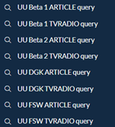
Set the filters on the left according to your preferences
Choose Additional filters at the bottom to get to Source category
The settings used at Utrecht University are shown below:
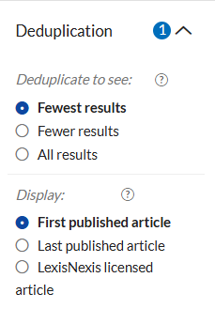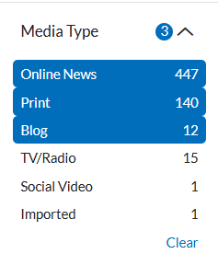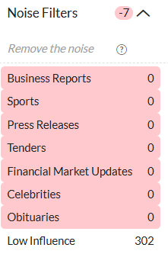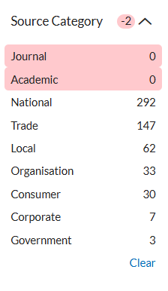

Step 7
After creating all queries, create the newsletters via the Share button and New newsletter:
Add the different searches and create a separate newsletter for each faculty or institute:
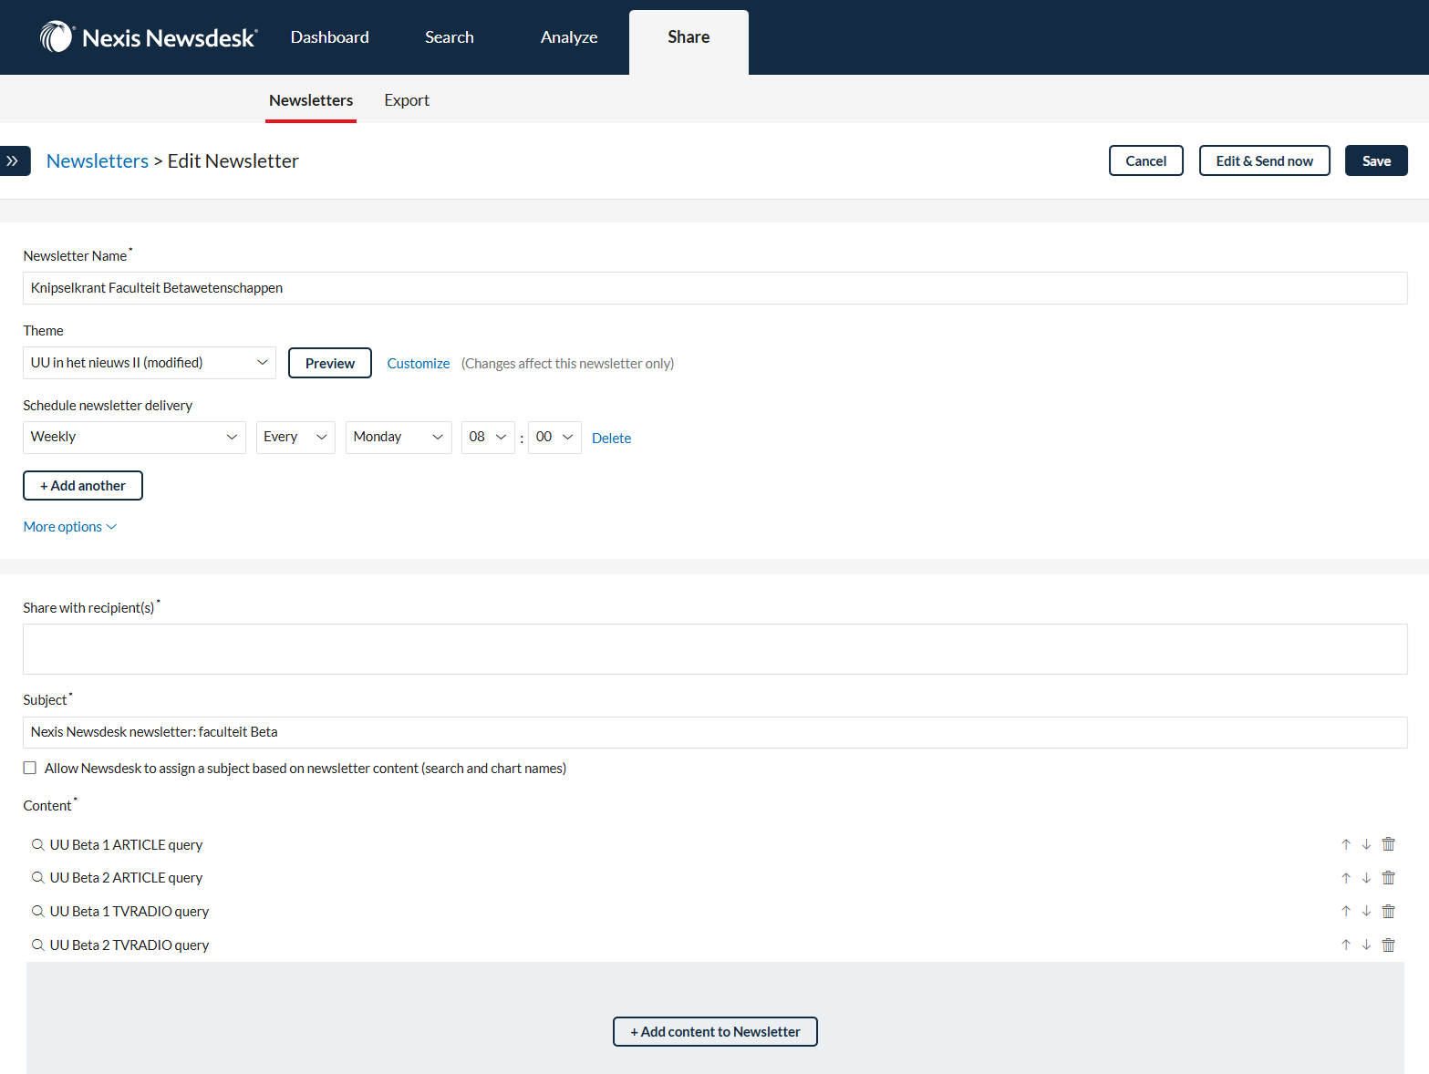
Set the layout by clicking Customize, choose the colour green under Highlight keywords and keep the other settings as shown below:
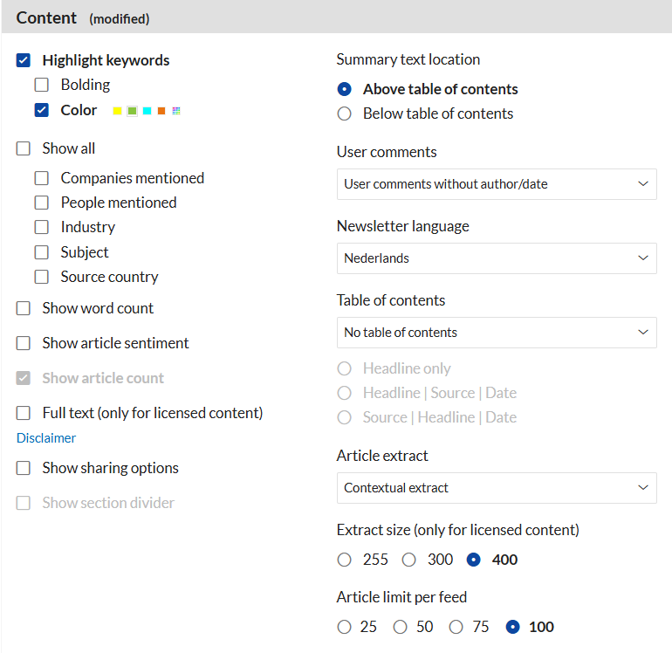
To test: click Edit & send now and then Send test
Set a schedule and add yourself as a recipient
You will now automatically receive these newsletters in your mailbox at the specified time

Step 8
Export all sent newsletters from Outlook 365 with the extension .eml:
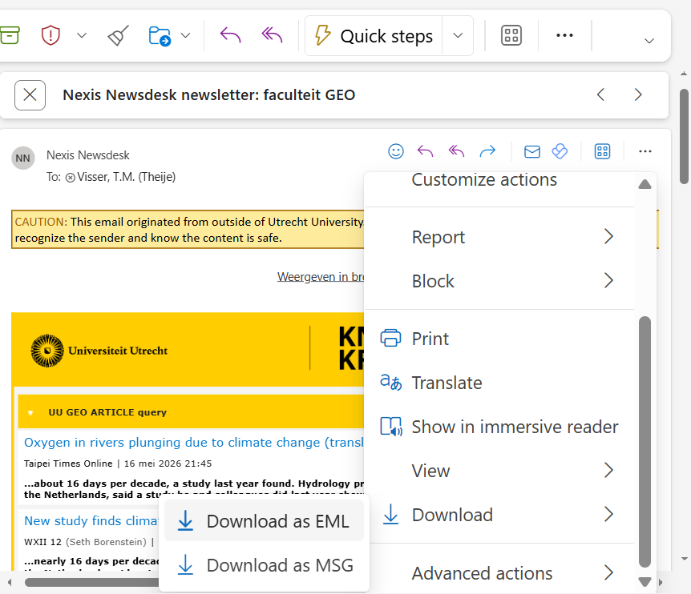
Place all .eml files in knipsel/. The importer also accepts .html files.
All subdirectories are scanned, including an archive subfolder. Move files outside knipsel/ when they should no longer be scanned.

Step 9
Check the configured Pure target first: this command uploads eligible clippings to Pure and has no command-line dry-run mode. For an initial live check, use staging credentials and keep only a small input sample under knipsel/.
Run from the repository root:
python scripts/knipselkrant.py
The importer parses clippings, matches persons, checks duplicates, writes output/press_clippings_*.xml, and uploads eligible records through the Pure API. Review logs/press_import_*.log for the actual upload results. XML generation alone does not confirm upload success. logs/processed_articles.xlsx is overwritten each run. Optional PDFs go under output/pdf/.
For an offline code check, run:
python -m unittest discover -s tests -v

