OpenMP

OpenMP Lab

Setting compiler flag in Devc++

Go to Tools> Compiler Options> Add the following commands when calling the linker
Add -fopenmp
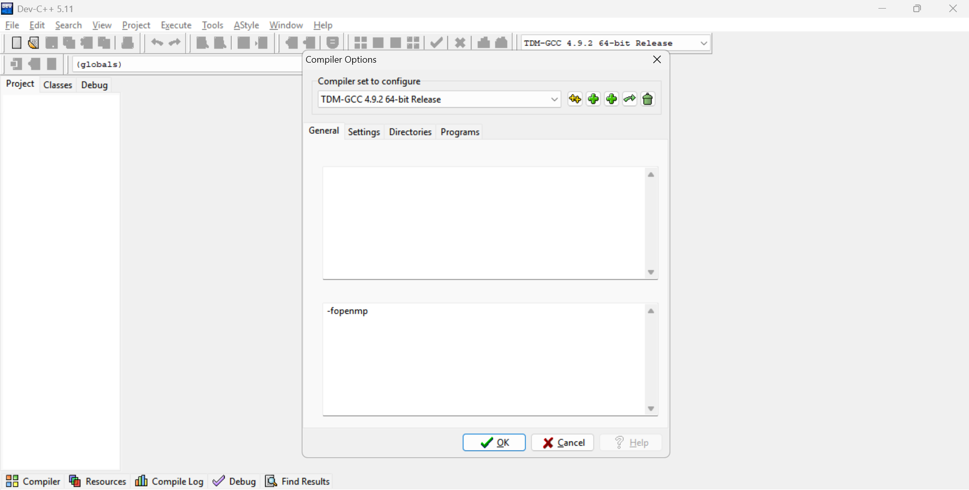

Setting compiler flag in CodeBlocks

Go to Settings> Compiler Settings> Other compiler option
Add -fopenmp
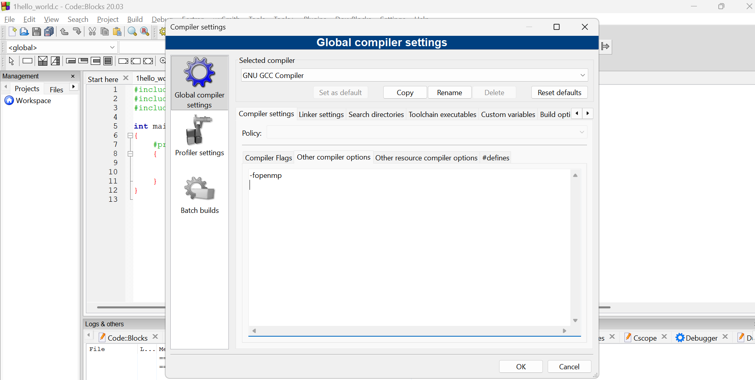
For Linux-based systems compile using:
gcc -fopenmp code.c

