IT HOME LAB
Documentation & Setup Guide
Executive Summary
This document details the end-to-end construction of a professional IT home lab built to simulate enterprise-level IT infrastructure. The lab was designed to develop and demonstrate practical skills directly aligned with Level 1 and Level 2 IT Support roles.

The environment was built entirely on VirtualBox using Windows Server 2022 as the domain controller and Windows 11 Pro as the client machine. All configurations were performed hands-on, including Active Directory management, DNS and DHCP services, Group Policy enforcement, VPN access, and security hardening.

Skills demonstrated include user and group administration, network troubleshooting, remote access configuration, security event monitoring, and real-world helpdesk ticket resolution — all of which directly reflect the responsibilities listed in the target IT Support role.

Platform | Domain | Client OS | Duration
VirtualBox + Win Server 2022 | lab.local | Windows 11 Pro | May 2026

Prepared by: Utsarga Dhakali
GitHub Portfolio | IT Support Specialist
May 2026

Table of Contents
Table of Contents 1
1. Lab Overview & Objectives 1
1.1 Purpose & Objectives 1
1.2 Lab Architecture 1
1.3 Infrastructure Summary 1
1.4 Technologies Demonstrated 1
2.1 Overview 1
2.2 DNS Manager Configuration 1
DNS Forwarder Configuration 1
2.3 Windows 11 Pro Installation 1
3.1 Overview 1
3.2 Organisational Structure 1
3.3 Active Directory Administration Tasks 1
4.1 Overview 1
4.2 Group Policy Management Console 1
4.3 GPO 1 — IT Department Wallpaper Policy 1
4.4 GPO 2 — HR Control Panel Restriction 1
4.5 GPO Inheritance & Scope Verification 1
5.1 Overview 1
5.2 DHCP Server Installation & Scope Configuration 1
DHCP Scope Configuration Details 1
5.3 Network Diagnostic Commands 1
5.4 DNS A Record Creation 1
6.1 Overview 1
7.1 Overview 1
7.2 VPN Server Configuration — DC01 1
7.3 VPN Client Configuration — Windows 11 VM 1
Registry Fix — L2TP Behind NAT 1
7.4 Successful VPN Connection 1
7.5 Troubleshooting Log 1
8.1 Overview 1
8.2 Security Event Log — Event ID Reference 1
8.3 Windows Defender 1
8.4 Windows Firewall — Custom Rule Creation 1
ICMP Block Rule — Configuration Steps 1
8.5 Common Security Threats — Reference Guide 1
9.1 Overview 1
9.2 Microsoft 365 — Next Steps 1
10. Summary & Competency Mapping 1
10.1 Skills Demonstrated vs Job Description Requirements 1
10.2 Certifications Pathway 1
10.3 Planned Next Phases 1

1. Lab Overview & Objectives

1.1 Purpose & Objectives
This home lab was constructed to develop and validate practical IT support competencies in a controlled, virtualized environment. The primary objective was to replicate the infrastructure commonly found in small-to-medium enterprise environments, enabling hands-on experience with the tools and technologies encountered in Level 1 and Level 2 IT support roles.

The lab directly addresses the following job description requirements:

- Deliver Level 1 & Level 2 IT support via remote tools
- Troubleshoot Windows 10/11, desktop applications, hardware issues, and basic networking
- Log, track, and resolve incidents using ticketing systems while meeting SLA targets
- Create, manage, and support user accounts in Active Directory and Azure AD
- Support Microsoft 365 services and hybrid infrastructure operations
- Configure and maintain VPN connections for secure remote access
- Monitor and manage backup solutions and Hyper-V virtual machines

1.2 Lab Architecture
The lab runs entirely within VirtualBox on a single host machine, using a NAT network to provide internet access while maintaining an isolated private network. The following diagram illustrates the complete network topology:

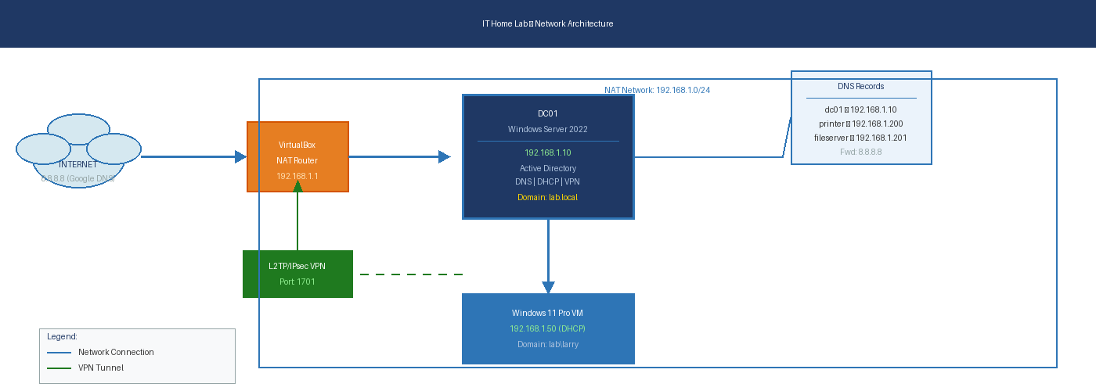
Figure 1.1: IT Home Lab Network Topology — showing all components and their relationships

1.3 Infrastructure Summary
Component | OS / Role | IP Address | Services Running
DC01 — Domain Controller | Windows Server 2022 | 192.168.1.10 (Static) | AD DS, DNS, DHCP, VPN (RRAS)
WIN11-CLIENT | Windows 11 Pro | 192.168.1.50 (DHCP) | Domain member, VPN client
VirtualBox NAT | Virtual Router | 192.168.1.1 | Internet gateway, NAT
Google DNS (Forwarder) | External DNS | 8.8.8.8 / 8.8.4.4 | External DNS resolution

1.4 Technologies Demonstrated
Infrastructure | Security | Administration
Active Directory Domain Services | Windows Defender | Group Policy Management
DNS Server (Forward & Reverse) | Windows Firewall (Custom Rules) | User & Group Administration
DHCP Server (Scopes & Options) | IPsec / L2TP VPN Encryption | OU & Permission Management
VPN Server (RRAS / L2TP) | Security Event Log Analysis | Helpdesk Ticket Resolution
Azure for Students | UAC Configuration | DNS Record Management

PHASE 1 | Domain Controller & DNS Configuration

2.1 Overview
The first phase established the foundational infrastructure of the lab. Windows Server 2022 was installed on DC01 with a static IP address of 192.168.1.10. Active Directory Domain Services was promoted, creating the lab.local domain. DNS was configured to support both internal name resolution and external internet access via forwarding.

2.2 DNS Manager Configuration
DNS Manager was accessed via Server Manager → Tools → DNS. DC01 was confirmed as the authoritative DNS server for the lab.local zone.

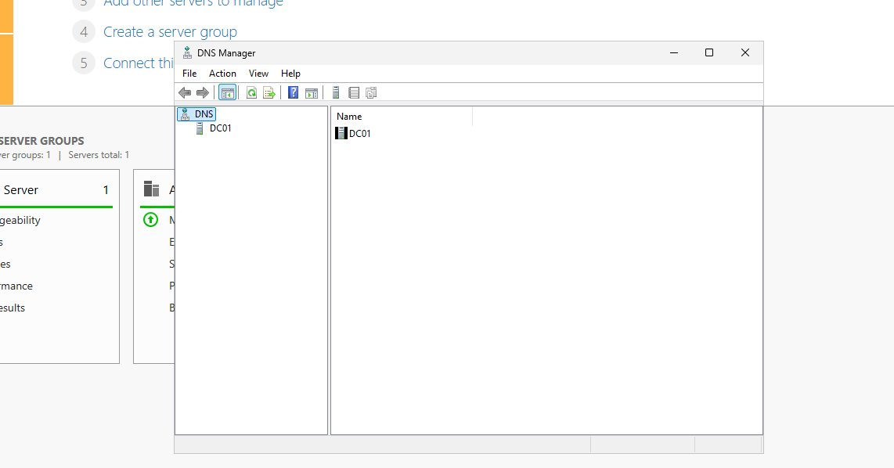
Figure 2.1: DNS Manager showing DC01 as the primary DNS server for lab.local

DNS Forwarder Configuration
A DNS forwarder was configured to redirect all external DNS queries (i.e. queries for domains not within lab.local) to Google's public DNS infrastructure. This enables internet access on all domain-joined machines without compromising internal domain resolution.

Configuration path: DNS Manager → Right-click DC01 → Properties → Forwarders tab → Edit → Add 8.8.8.8

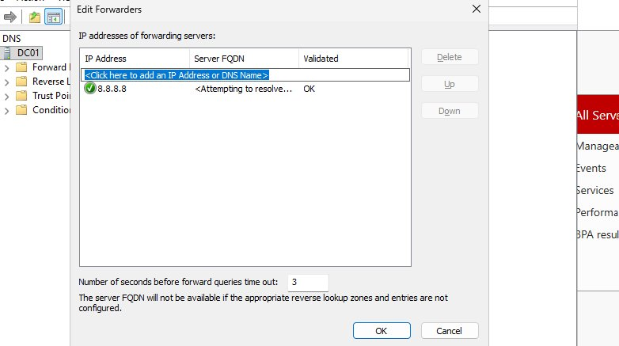
Figure 2.2: DNS Forwarder configured with 8.8.8.8 (Google DNS) — validated and active

Key Concept: Without DNS forwarders, domain-joined machines can resolve internal names (e.g. DC01.lab.local) but cannot resolve external internet addresses (e.g. google.com). The forwarder tells the DNS server to ask Google when it cannot answer the query itself — maintaining both internal domain functionality and internet access simultaneously.

2.3 Windows 11 Pro Installation
During initial setup, Windows 11 Home was identified on the client VM. Home edition does not support domain joining (System Properties shows the option greyed out with a restriction message). The VM was reinstalled with Windows 11 Pro using the same ISO — selecting "I don't have a product key" and choosing the Pro edition at the edition selection screen.

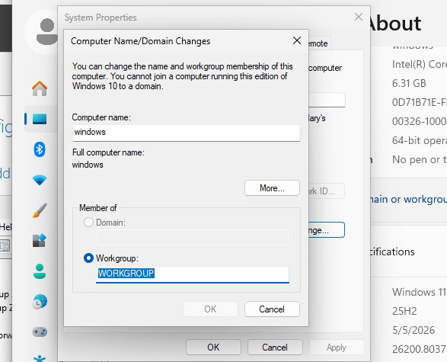
Figure 2.3: Windows 11 Home restriction — domain join unavailable, Pro edition required

PHASE 2 | Active Directory Management

3.1 Overview
Active Directory Users and Computers (ADUC) was used to build out the organisational structure of the lab.local domain. This phase replicates the day-to-day AD administration tasks performed by IT Support staff, including user account management, security group assignment, and OU organisation.

3.2 Organisational Structure
The following structure was created within the lab.local → Company container:

Organisational Unit | Security Group | User Account | Purpose
IT | IT ADMIN | utsarga Dhakali (utsarga) | IT department users — elevated access
HR | HR ADMIN | Larry Wheels (larry) | HR department — restricted access

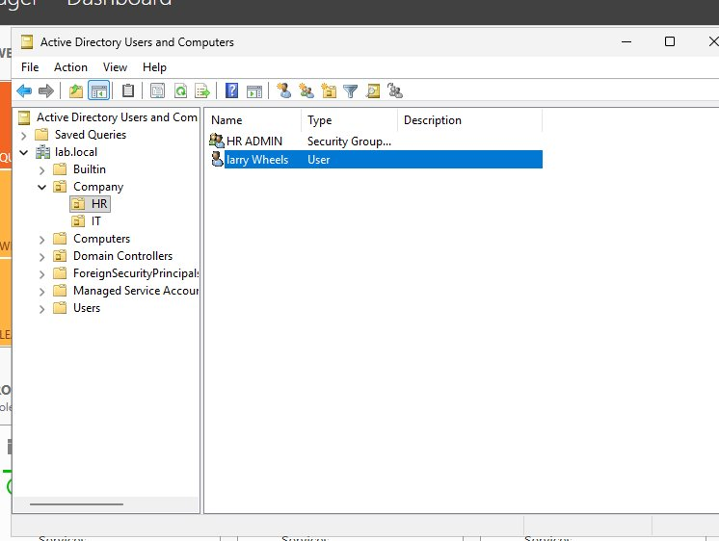
Figure 3.1: HR Organisational Unit containing HR ADMIN security group and Larry Wheels user account
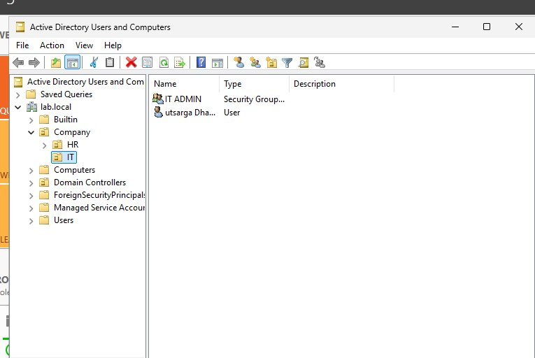
Figure 3.2: IT Organisational Unit containing IT ADMIN security group and utsarga Dhakali user account

3.3 Active Directory Administration Tasks
The following AD administration tasks were performed to simulate real-world IT support scenarios:

Task | Procedure
Create User Account | Right-click OU → New → User → Enter first name, last name, logon name → Set password → Configure account options
Reset User Password | Right-click user → Reset Password → Enter temporary password → Enable "User must change password at next logon"
Unlock Account | Right-click user → Properties → Account tab → Tick "Unlock account" → Apply
Disable / Enable Account | Right-click user → Disable Account (or Enable Account) — icon displays down arrow when disabled
Add User to Security Group | Double-click security group → Members tab → Add → Enter username → Check Names → OK
Move User Between OUs | Right-click user → Move → Select destination OU — GPO settings update automatically
Check Account Lockout | Right-click user → Properties → Account tab → "Unlock account" checkbox visible if locked
Set VPN Dial-in Permission | Right-click user → Properties → Dial-in tab → Network Access Permission → Allow access

Security Best Practice: When resetting a user password, always enable "User must change password at next logon." This ensures IT staff never know the user's actual password, maintaining the principle of least privilege and protecting user data privacy.

PHASE 3 | Group Policy Object (GPO) Management

4.1 Overview
Group Policy Objects were created and linked to specific Organisational Units to enforce configuration settings across domain users and computers. GPOs are a fundamental tool for IT administrators to standardise desktop environments, enforce security policies, and restrict access to system functions.

4.2 Group Policy Management Console
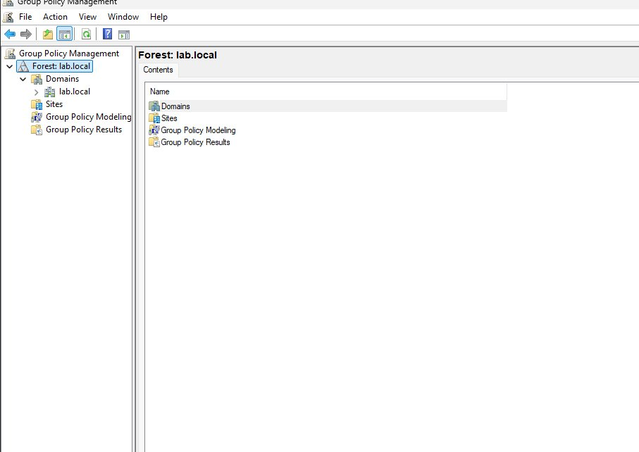
Figure 4.1: Group Policy Management Console showing the lab.local domain structure with linked GPOs

4.3 GPO 1 — IT Department Wallpaper Policy
A Group Policy Object was created and linked to the IT Organisational Unit to enforce a standard corporate desktop wallpaper. This prevents users from modifying the desktop background and ensures a consistent, professional appearance on all IT department workstations.

Configuration path: User Configuration → Policies → Administrative Templates → Desktop → Desktop → Desktop Wallpaper

Setting | Value
GPO Name | IT Wallpaper Policy
Linked To | IT Organisational Unit
Status | Enabled
Wallpaper Path | C:\Windows\Web\Wallpaper\Windows\img0.jpg
Wallpaper Style | Fill
Effect | Users cannot change desktop background — setting is greyed out

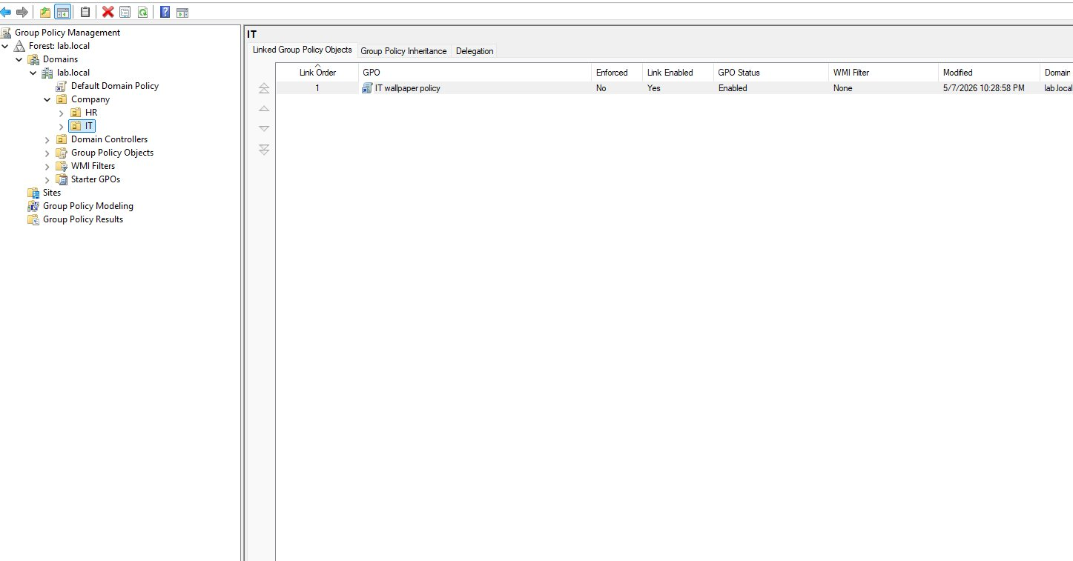
Figure 4.2: IT Wallpaper Policy linked to IT OU — Link Enabled: Yes, GPO Status: Enabled
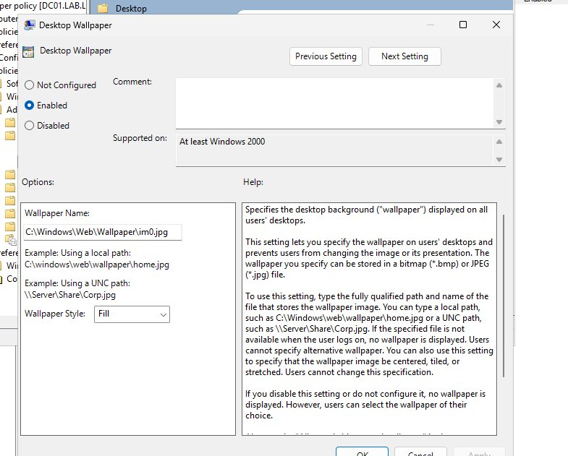
Figure 4.3: Desktop Wallpaper policy setting configured — Enabled with fill style

4.4 GPO 2 — HR Control Panel Restriction
A second GPO was created and linked to the HR Organisational Unit to prevent HR department users from accessing Control Panel and PC Settings. This is a standard enterprise security control that prevents non-technical staff from modifying system settings, installing software, or changing network configurations.

Configuration path: User Configuration → Policies → Administrative Templates → Control Panel → Prohibit access to Control Panel and PC settings

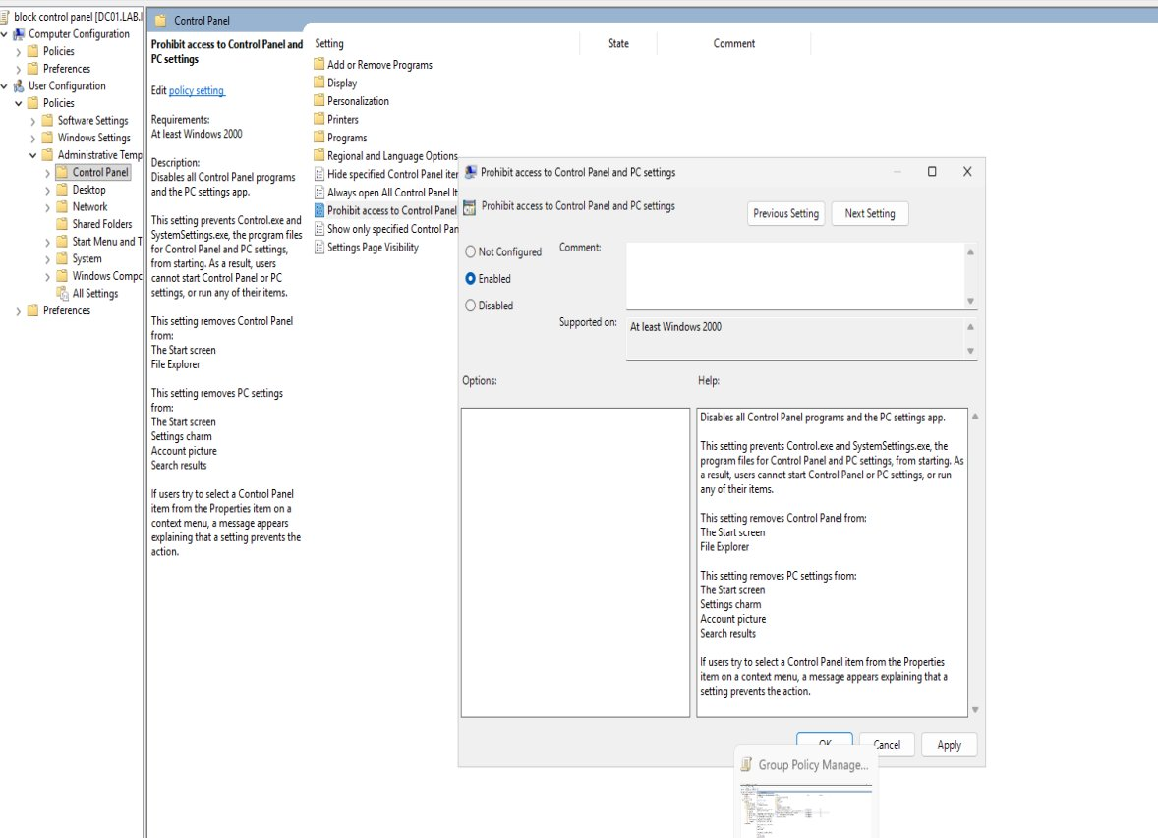
Figure 4.4: Block Control Panel GPO — Prohibit access to Control Panel and PC Settings enabled for HR OU

4.5 GPO Inheritance & Scope Verification
Group Policy inheritance was reviewed to confirm policies apply correctly. The Scope tab on each GPO displays all linked Organisational Units, Sites, and Security Groups. The Group Policy Inheritance tab on each OU shows all policies that apply, including those inherited from parent OUs.

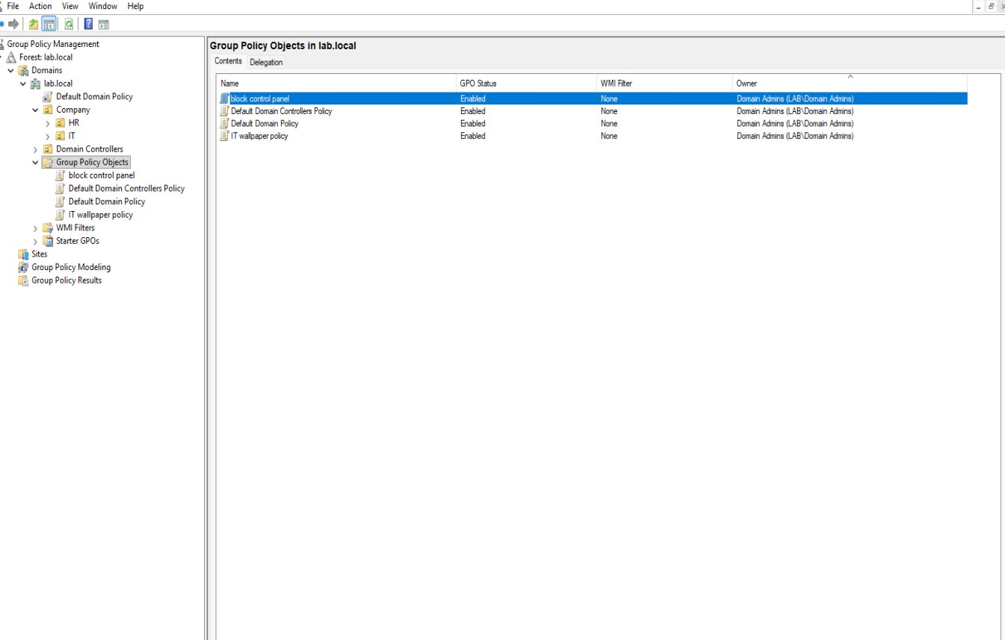
Figure 4.5: Group Policy Objects overview — all GPOs visible with status and domain

Key Command: Run gpupdate /force in an elevated Command Prompt to immediately apply Group Policy changes without waiting for the default 90-minute refresh interval. This is essential when testing GPO configurations during lab work or in a real support scenario.

PHASE 4 | Networking — DHCP, DNS Records & Diagnostics

5.1 Overview
This phase covers the installation and configuration of DHCP on DC01, the creation of manual DNS records, and the practice of essential network diagnostic commands. These skills are used in daily IT support to troubleshoot connectivity issues, manage IP address assignment, and verify network service functionality.

5.2 DHCP Server Installation & Scope Configuration
The DHCP Server role was added to DC01 via Server Manager → Add Roles and Features. Following installation, the service was authorised in Active Directory and a DHCP scope was created to automatically assign network configuration to client machines.

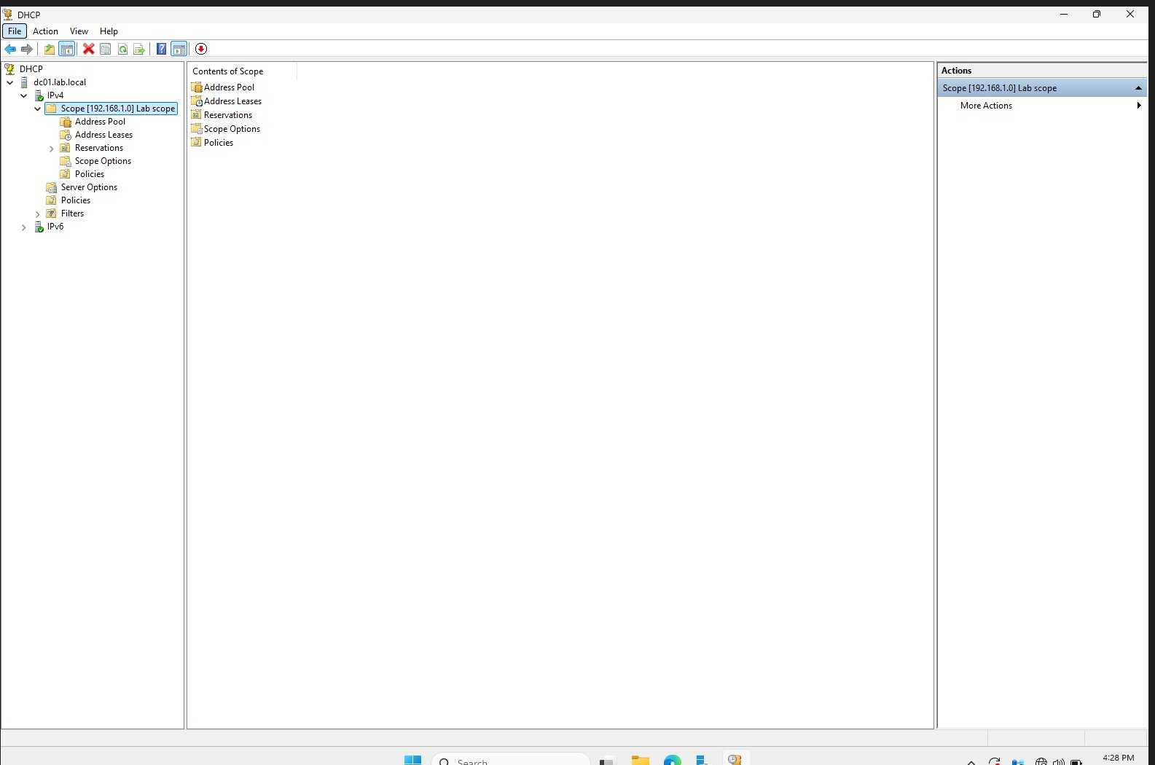
Figure 5.1: DHCP Manager showing Lab Scope created and active under IPv4

DHCP Scope Configuration Details
DHCP Option | Value | Purpose
Scope Name | Lab Scope | Identifies this DHCP scope in the management console
IP Range Start | 192.168.1.50 | First address available for dynamic assignment
IP Range End | 192.168.1.100 | Last address available for dynamic assignment
Subnet Mask | 255.255.255.0 | Defines the network boundary (/24)
003 — Default Gateway | 192.168.1.1 | VirtualBox NAT router — provides internet routing
006 — DNS Server | 192.168.1.10 | Points clients to DC01 for domain name resolution
015 — DNS Domain Name | lab.local | Appended to unqualified hostnames for DNS searches
Lease Duration | 8 days | Period before client must renew the IP lease

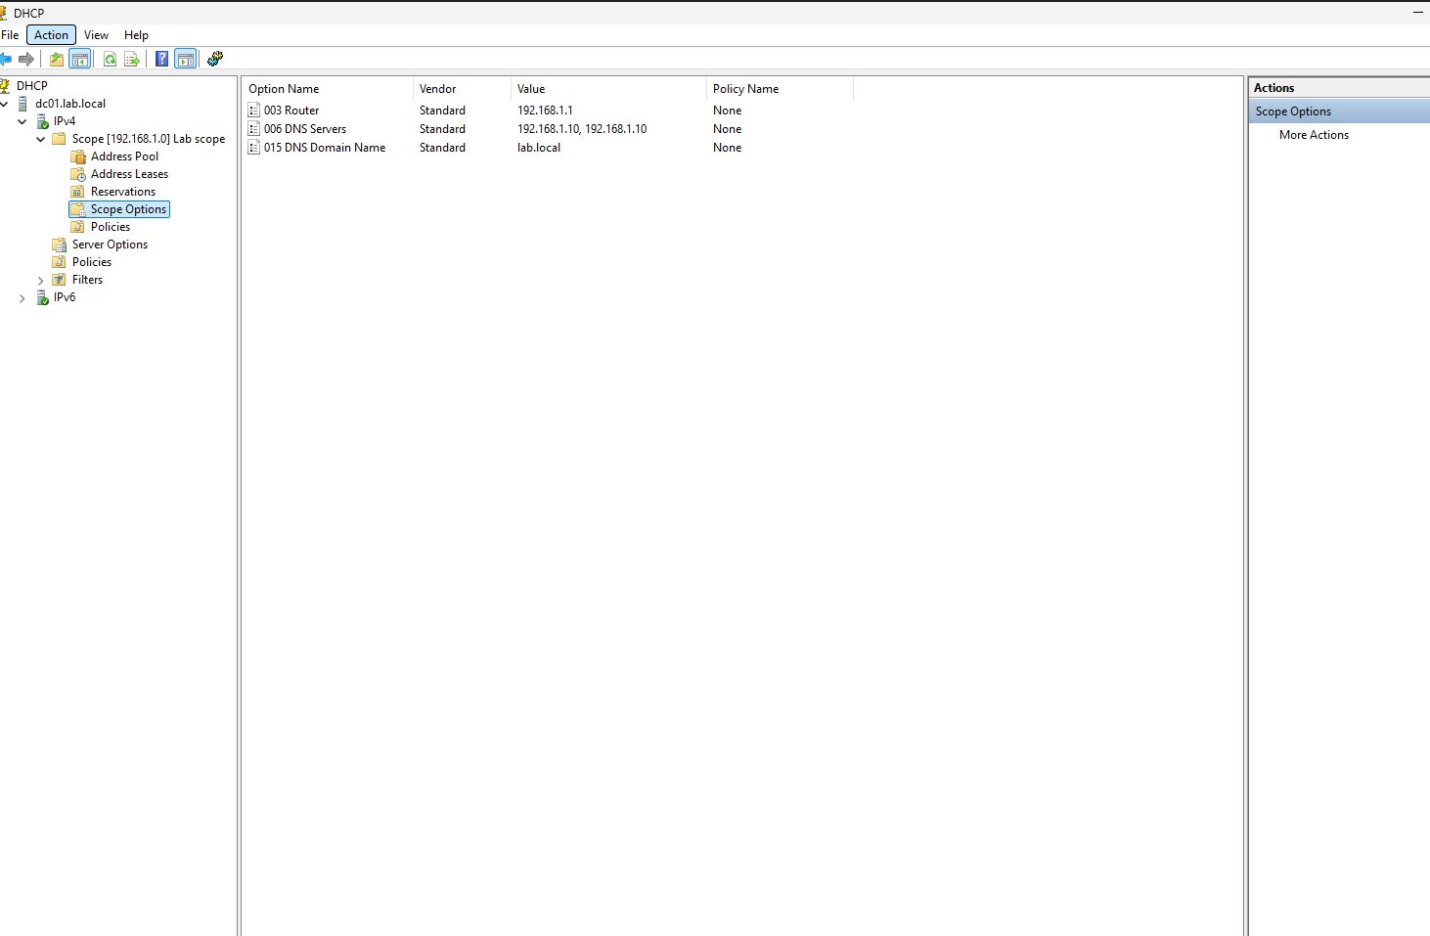
Figure 5.2: Scope Options — Router (003), DNS Server (006) and Domain Name (015) all configured

Real-World Note: In production environments, static IP addresses are reserved for servers, printers, and network infrastructure. Client workstations use DHCP. DHCP reservations (binding a MAC address to a specific IP) can be used for devices that need a consistent address — such as printers — without manually configuring a static IP on the device itself.

5.3 Network Diagnostic Commands
The following commands were executed on the Windows 11 client VM to validate network configuration and practice diagnostic techniques used in IT support:

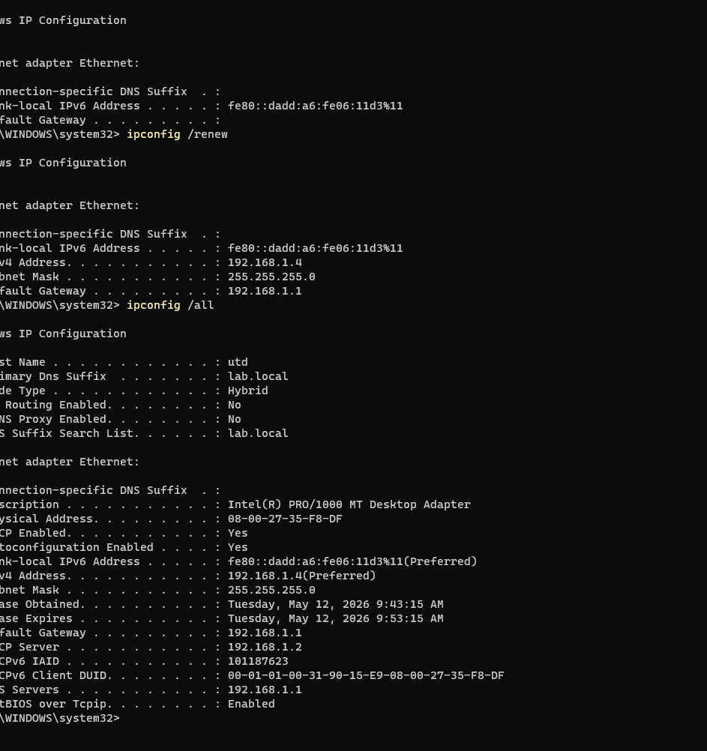
Figure 5.3: ipconfig /all output — confirms DHCP-assigned IP (192.168.1.50), DNS pointing to DC01 (192.168.1.10), and domain suffix lab.local
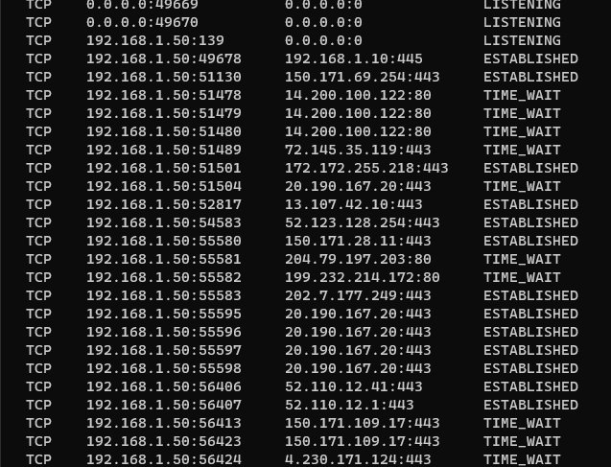
Figure 5.4: netstat -an output — shows ESTABLISHED connections to Microsoft servers from 192.168.1.50, confirming network connectivity

Command | Function | Common Use Case
ipconfig /all | Displays full network adapter configuration | Verify IP, DNS, gateway, MAC address, DHCP status
ipconfig /release | Releases DHCP-assigned IP address | Force return of IP lease before requesting new one
ipconfig /renew | Requests new IP from DHCP server | Refresh IP configuration after network changes
ipconfig /flushdns | Clears local DNS resolver cache | Fix stale DNS entries causing wrong resolution
ping <IP or hostname> | Tests connectivity to a host | Ping IP first, then hostname to isolate DNS vs network
nslookup <name> | Queries DNS for name resolution | Verify DNS records resolve correctly
tracert <host> | Traces route packets take to destination | Identify where network connectivity breaks
netstat -an | Lists all active network connections | Identify active connections, listening ports, suspicious traffic

5.4 DNS A Record Creation
Manual DNS A records were created in the lab.local Forward Lookup Zone to simulate the real-world process of registering network devices such as printers and file servers in DNS. This allows users to access devices by name rather than memorising IP addresses.

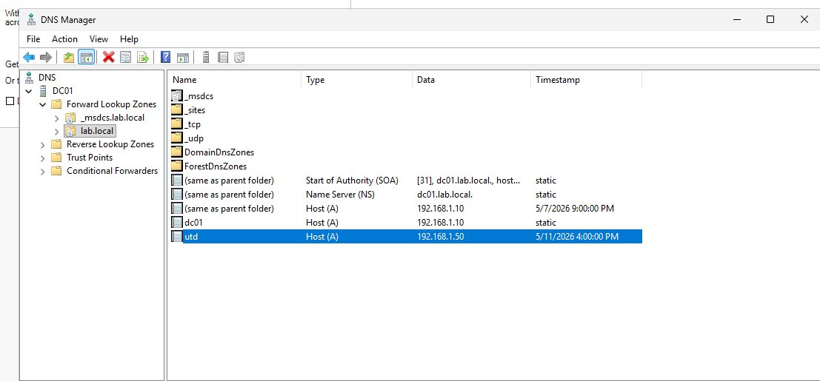
Figure 5.5: lab.local DNS zone showing A records — dc01 (192.168.1.10), utd/client (192.168.1.50), printer (192.168.1.200), fileserver (192.168.1.201)
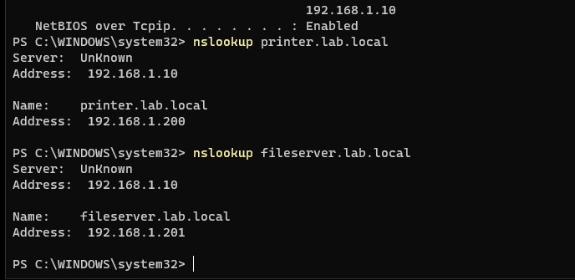
Figure 5.6: nslookup confirming printer.lab.local resolves to 192.168.1.200 and fileserver.lab.local to 192.168.1.201

PHASE 5 | Helpdesk Ticket Simulation

6.1 Overview
Five real-world IT support scenarios were simulated to practise the structured troubleshooting and communication skills required for Level 1 and Level 2 helpdesk roles. Each ticket was worked through from initial user report through to documented resolution, following the standard ITIL-aligned support process.

Standard Helpdesk Process: (1) Verify user identity → (2) Gather information and reproduce the issue → (3) Troubleshoot systematically from simplest to most complex → (4) Resolve and confirm with user → (5) Document the ticket with cause and resolution.

Ticket #01 Password Reset Request
User Report:
"Hi IT, this is Sarah from HR. I cannot log into my computer this morning. It says my password is incorrect but I am certain I am typing it correctly. I have not changed anything. Can you help?"
Troubleshooting Steps:
- Verified user identity — requested full name and employee ID before making any changes
- Opened Active Directory Users and Computers (ADUC) → navigated to HR OU → located Sarah Smith
- Opened user Properties → Account tab — checked for account lockout ("Unlock account" checkbox) and password expiry
- Right-clicked user → Reset Password → set temporary password → enabled "User must change password at next logon"
- Communicated temporary password to user via secure channel (not email in plaintext)
- Followed up to confirm successful login and password change
Resolution: Password reset in Active Directory. User prompted to set new personal password on next login. Ticket closed after user confirmed successful access.

Ticket #02 Cannot Access Shared Drive
User Report:
"Hi IT, this is John from IT. My internet is working fine but I cannot access the shared drive. It was working yesterday and I have not changed anything."
Troubleshooting Steps:
- Asked clarifying questions: when did it start, any error message displayed, is anyone else affected
- Ran ipconfig /all on John's machine — confirmed correct IP, DNS pointing to 192.168.1.10
- Ran ping fileserver.lab.local — succeeded, confirming DNS resolution is working
- Ran ping 192.168.1.201 — succeeded, confirming basic network connectivity to server
- Checked John's user account in ADUC → Member Of tab — confirmed he had been removed from the file server access security group
- Added John back to the correct security group → confirmed access restored
Resolution: User was inadvertently removed from the security group controlling shared drive access. Re-added to group in ADUC. Shared drive access immediately restored. Ticket closed.

Ticket #03 New Employee Cannot Log In
User Report:
"Hi IT, I am Emma Johnson and I am starting today. My manager said my account should be ready but I cannot log in at all. The screen just says my username or password is incorrect."
Troubleshooting Steps:
- Searched ADUC for "Emma Johnson" — confirmed account existed in the correct OU
- Checked Account tab → confirmed account was disabled (overlooked during onboarding)
- Enabled the account → checked it was not locked and had not expired
- Verified Emma was a member of the correct security groups for her department
- Reset password and enabled "User must change password at next logon"
- Communicated username (ejohnson@lab.local) and temporary password to Emma and her manager
Resolution: New user account was disabled. Account enabled in ADUC, placed in correct OU and security groups, password set. Emma successfully logged in. Onboarding process flagged for improvement to prevent recurrence.

Ticket #04 No Internet Access — DNS Issue
User Report:
"Hi IT, my laptop is connected to the company WiFi but I cannot open any websites at all. My colleague sitting next to me has full internet access. Everything was working this morning."
Troubleshooting Steps:
- Clarified: how long, any error message, any recent changes to the device
- Ran ping 8.8.8.8 — succeeded, confirming physical network connectivity and routing are intact
- This immediately isolated the issue as a DNS problem, not a connectivity problem
- Ran ipconfig /all — DNS server field showed incorrect address (not 192.168.1.10)
- Ran ipconfig /release then ipconfig /renew — DHCP reassigned correct DNS server
- Ran ipconfig /flushdns to clear any stale cached DNS entries
- Ran nslookup google.com — confirmed correct resolution, internet access restored
Resolution: DHCP lease had assigned incorrect DNS configuration. DHCP renewal corrected the settings. Internet access restored. Underlying DHCP issue investigated and resolved on DC01.

Ticket #05 Account Locked After Extended Leave
User Report:
"Hi IT, I just came back from three weeks holiday and my computer will not let me log in. The screen says my account has been locked."
Troubleshooting Steps:
- Verified user identity before touching the account
- Opened ADUC → located user → Account tab → ticked "Unlock account" → Applied
- Opened Event Viewer on DC01 → Windows Logs → Security → filtered for Event ID 4740 (account lockout)
- Event log identified the lockout source: user's mobile phone attempting to sync email with old cached credentials
- Confirmed account was also approaching password expiry — proactively reset password
- Advised user to update saved credentials on all devices (phone, tablet) to prevent recurrence
Resolution: Account unlocked in ADUC. Password proactively reset. Root cause identified as mobile device using cached credentials post-holiday. User educated on updating credentials across all devices. Ticket closed.

PHASE 7 | VPN Setup — L2TP/IPsec Remote Access

7.1 Overview
A VPN server was configured on DC01 using the Routing and Remote Access Service (RRAS) role. This enables domain users to securely connect to the lab.local network from outside the office environment, replicating the remote access infrastructure used in real-world enterprise environments.

The L2TP/IPsec protocol was selected for its balance of compatibility and security. L2TP (Layer 2 Tunneling Protocol) creates the tunnel, while IPsec (Internet Protocol Security) provides encryption and authentication using a pre-shared key.

7.2 VPN Server Configuration — DC01
The following steps were performed on DC01 to establish the VPN server:

# | Step | Detail
1 | Install RRAS Role | Server Manager → Add Roles and Features → Remote Access → DirectAccess and VPN (RAS)
2 | Launch RRAS Console | Server Manager → Tools → Routing and Remote Access
3 | Configure VPN | Right-click DC01 → Configure and Enable Routing and Remote Access → Deploy VPN only → Custom Configuration → VPN Access
4 | Enable L2TP Ports | Ports → Properties → WAN Miniport (L2TP) → Configure → Enable Remote access connections (inbound only) → 5 ports
5 | Set Pre-shared Key | Right-click DC01 → Properties → Security tab → Allow custom IPsec policy for L2TP/IKEv2 → Enter pre-shared key: VPNlab123
6 | Grant User Access | ADUC → larry Wheels → Properties → Dial-in tab → Network Access Permission → Allow access
7 | Restart Service | Right-click DC01 (local) → All Tasks → Restart

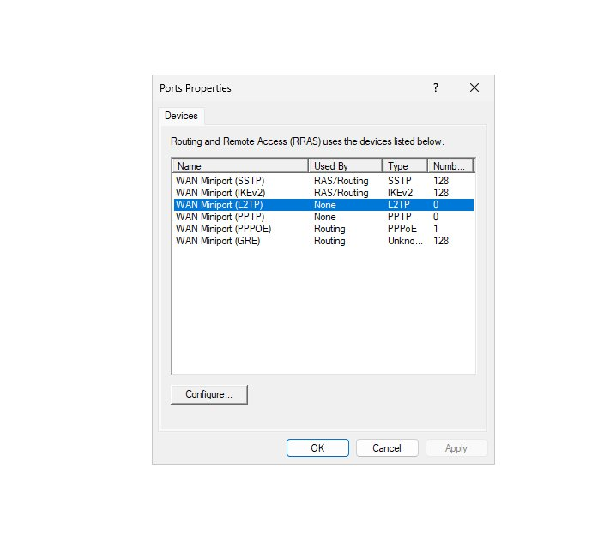
Figure 7.1: Ports Properties showing L2TP configured with 5 ports for RAS — Used By: RAS, Number: 5

7.3 VPN Client Configuration — Windows 11 VM
The Windows built-in VPN client was configured on the Windows 11 VM to connect to the VPN server on DC01:

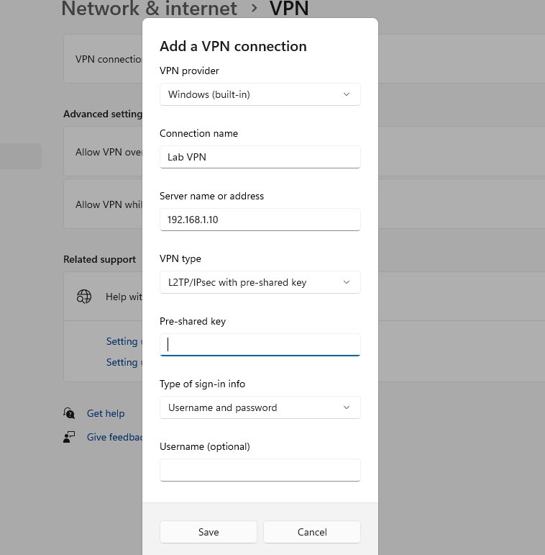
Figure 7.2: VPN connection configured — L2TP/IPsec with pre-shared key, credentials stored

Registry Fix — L2TP Behind NAT
Windows 11 blocks L2TP VPN connections when operating behind a NAT device (such as the VirtualBox NAT network) by default. The following registry modification was required to enable the connection:

reg add "HKEY_LOCAL_MACHINE\SYSTEM\CurrentControlSet\Services\PolicyAgent" /v AssumeUDPEncapsulationContextOnSendRule /t REG_DWORD /d 2 /f

The value /d 2 instructs Windows to allow L2TP encapsulation even when the client is behind a NAT device. A full system restart was required for the change to take effect. The registry value was verified with:
reg query "HKEY_LOCAL_MACHINE\SYSTEM\CurrentControlSet\Services\PolicyAgent" /v AssumeUDPEncapsulationContextOnSendRule

7.4 Successful VPN Connection
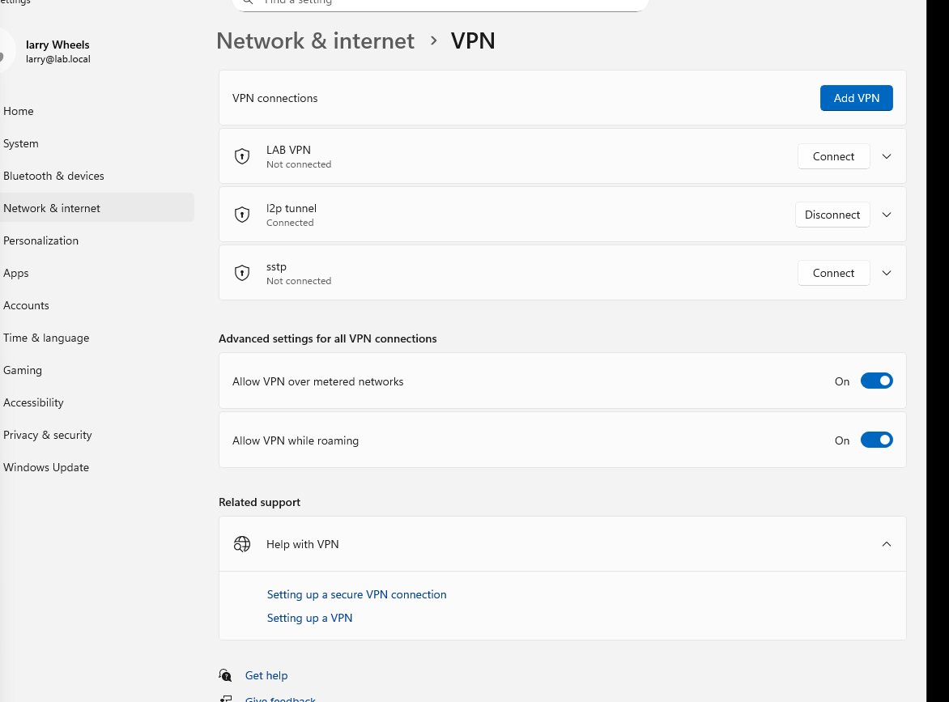
Figure 7.3: L2TP tunnel successfully connected — larry@lab.local authenticated and active

7.5 Troubleshooting Log
The VPN configuration required several troubleshooting cycles, providing valuable real-world diagnostic experience:

Issue Encountered | Root Cause | Resolution
L2TP security layer error | Registry not applied / VM not restarted | Applied registry fix, restarted VM
IKE authentication credentials unacceptable | IKEv2 requires certificates, not pre-shared key | Reverted to L2TP/IPsec protocol
No L2TP ports available | L2TP WAN Miniport had 0 ports configured | Enabled Remote access connections on L2TP miniport, set 5 ports
User Dial-in access denied | Larry's Dial-in permission was set to Deny | Changed to Allow access in ADUC → Dial-in tab
Connection succeeded | All issues resolved systematically | L2TP tunnel active, authenticated via AD

Outcome: A fully functional L2TP/IPsec VPN server was successfully configured on DC01. Domain users with Dial-in permission can authenticate through Active Directory and access lab.local resources remotely. This directly demonstrates the job requirement: "Configure and maintain VPN connections to support secure remote access for users."

PHASE 10 | Security Fundamentals

8.1 Overview
This phase covers the core security tools and concepts used in enterprise IT support environments. Effective security management requires both the technical ability to configure protection tools and the knowledge to recognise, respond to, and document security incidents.

8.2 Security Event Log — Event ID Reference
Windows Security Event Logs were reviewed in Event Viewer (Server Manager → Tools → Event Viewer → Windows Logs → Security) on DC01. The VPN authentication events from the successful L2TP connection in Phase 7 were identifiable as Event ID 4624 entries.

Event ID | Meaning | IT Support Action Required
4624 | Successful account login | Normal — monitor for logins at unusual hours or from unexpected locations
4625 | Failed login attempt | Investigate if repeated — may indicate brute force attack or forgotten password
4740 | User account locked out | Unlock account in ADUC → investigate source computer → check for cached credentials
4720 | New user account created | Verify was authorised — alert if unexpected during off-hours
4726 | User account deleted | Verify authorised offboarding — investigate immediately if unexpected
4728 | User added to security group | Verify authorised — privilege escalation risk if unexpected
4648 | Logon with explicit credentials | May indicate credential reuse — investigate if repeated or unexpected
4634 | Account logoff | Normal — useful for audit trails and session duration tracking

8.3 Windows Defender
Windows Security was reviewed on the Windows 11 client VM. A Quick Scan was performed confirming zero threats. Security intelligence (virus definitions) was confirmed as current.

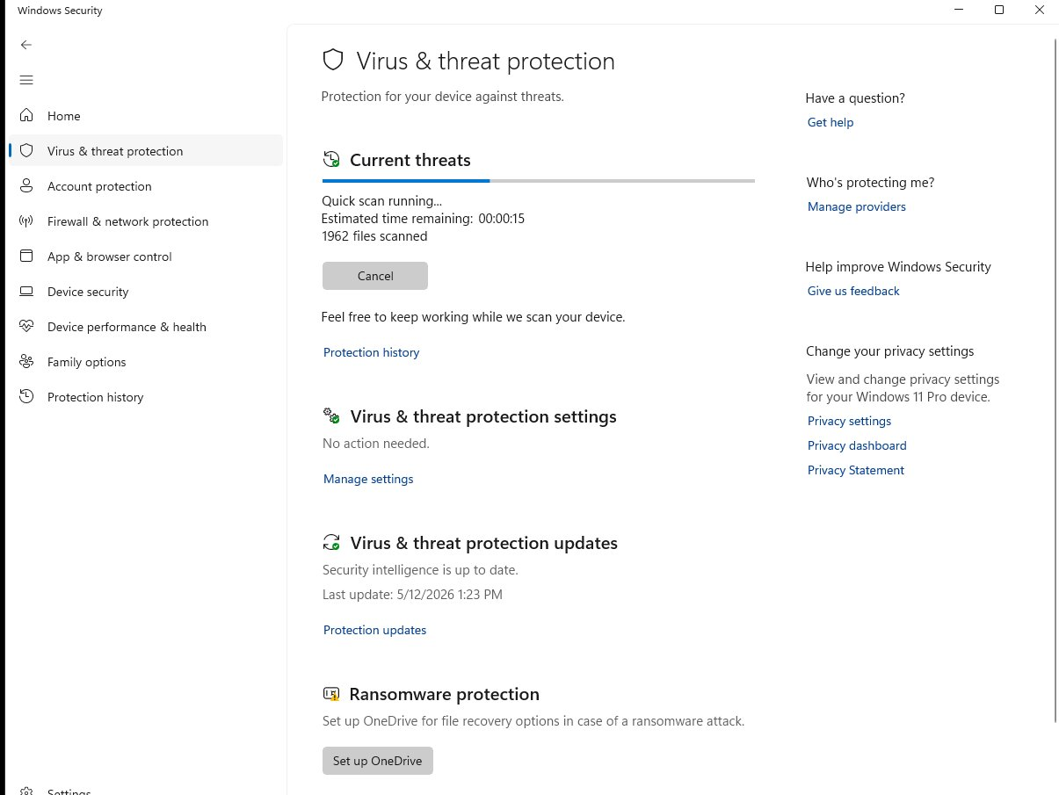
Figure 8.1: Windows Defender — Quick Scan running, 1,962 files scanned, security intelligence up to date (5/12/2026)

Defender Component | Purpose & IT Responsibility
Virus & Threat Protection | Scans for malware — ensure real-time protection is always ON, definitions updated
Firewall & Network Protection | Controls network access per profile — configure rules for allowed/blocked traffic
App & Browser Control | Blocks malicious apps and SmartScreen warnings — maintain default settings
Ransomware Protection | Controlled folder access — protect documents, enable OneDrive integration for recovery
Device Security | Core isolation, Secure Boot — verify enabled on managed endpoints

8.4 Windows Firewall — Custom Rule Creation
The Windows Defender Firewall with Advanced Security console was used to create a custom inbound rule blocking ICMP (ping) traffic. Blocking ping is a common security hardening practice that prevents attackers from using network discovery tools to identify active hosts.

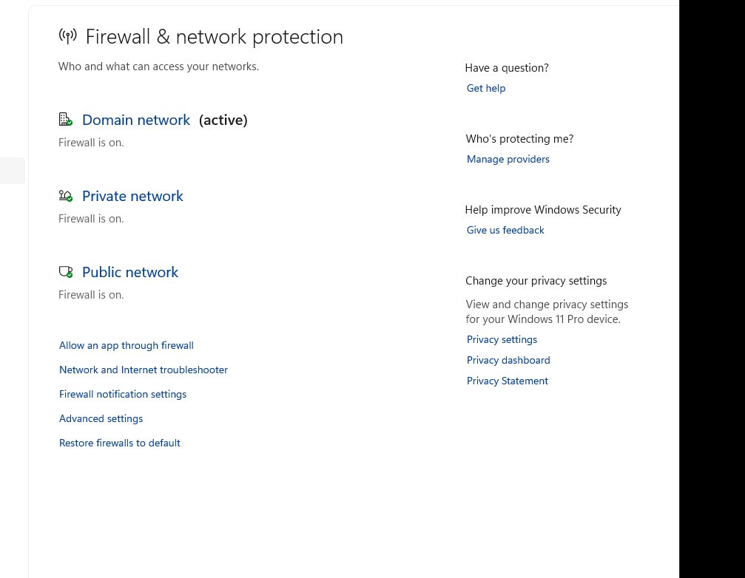
Figure 8.2: Windows Firewall showing all three profiles active — Domain (active), Private, and Public

ICMP Block Rule — Configuration Steps
- Opened Windows Defender Firewall with Advanced Security (wf.msc)
- Selected Inbound Rules → New Rule in the Actions pane
- Rule type: Custom → All programs → Protocol: ICMPv4
- Scope: Any IP address (source and destination)
- Action: Block the connection
- Profiles: Domain, Private, and Public — all selected
- Name: Block ICMP → Finish

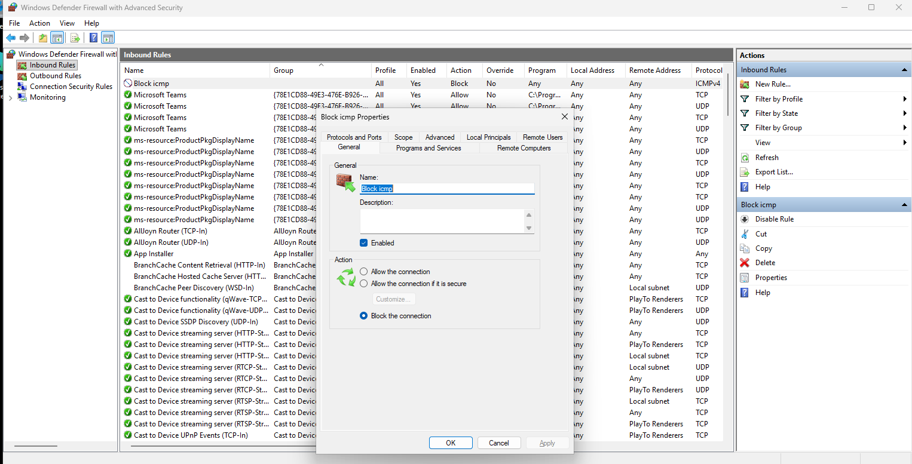
Figure 8.3: Block ICMP inbound rule — Enabled: Yes, Action: Block, Profile: All
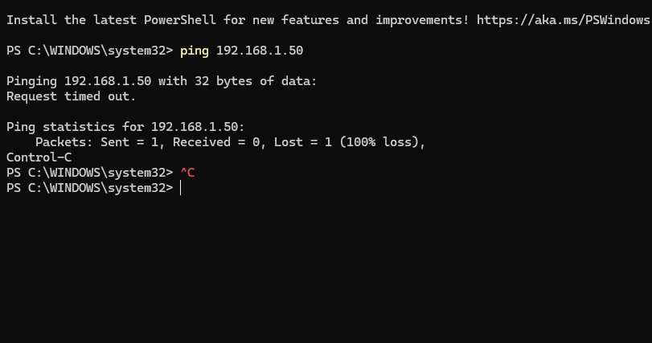
Figure 8.4: ping 192.168.1.50 returns "Request timed out" — firewall rule successfully blocking ICMP

8.5 Common Security Threats — Reference Guide
Threat Type | Description | IT Response & Prevention
Phishing | Fraudulent emails impersonating legitimate organisations to steal credentials or deploy malware | User security awareness training, email filtering, report suspicious emails, never click unverified links
Brute Force | Automated tool repeatedly attempts password combinations until successful | Account lockout policy (3-5 attempts), MFA enforcement, strong password complexity requirements
Ransomware | Malware encrypts user files and demands payment for decryption key | Regular verified backups, Defender real-time protection, restrict macro execution, patch promptly
Social Engineering | Manipulating users into revealing information or performing actions through psychological deception | IT staff never ask for passwords — train users to verify caller identity, escalate suspicious requests
Insider Threat | Malicious or negligent action by a current or former employee causing data loss or system damage | Principle of least privilege, audit logging, immediate account disabling on departure, access reviews
Man-in-the-Middle | Attacker intercepts communication between two parties to eavesdrop or modify data | Enforce HTTPS, require VPN on public networks, verify certificate authenticity, disable HTTP

