**PROJECT REPORT**

**MSMEKart ENTERPRISE APPLICATION**

**Submitted By**: -

|  |  |  |
| --- | --- | --- |
| **NAME** | **ROLL-NO** | **SAP-ID** |
| Utsav Bhardwaj | R163217011 | 500063056 |
| Bhavesh Joshi | R163217001 | 500062435 |
| Sehajpreet Boparai | R163217007 | 500062448 |

**Under the guidance of**

**Dr. Durgansh Sharma**

**School of Computer Science and Engineering**  


**SCHOOL OF COMPUTER SCIENCE**

UNIVERSITY OF PETROLEUM & ENERGY STUDIES

Bidholi Campus, Energy Acres, Dehradun – 248007.

**Project Title**: MSMEKart

**GitHub**: https://github.com/Utsav-99/MSMEKart

**Abstract**

Our customized apps increase the turnaround and capacity of merchandise. They manage activities like transportation management, inventory management, order management and fleet management. It also facilitates the MSMEs of every single area of the app user where he / she can find the every useful thing, regarding the fact of COVID-19, safely.

TABLE OF CONTENTS

S.no. Contents Page nos.

|  |  |  |
| --- | --- | --- |
| **1** | **Introduction**   * **Objective** | **5** |
| **2** | **Wireframe of the project**   * **Screen-wise Decription** | **6-7** |
| **3** | **Methodology** | **8** |
| **4** | **Push Notifications** | **8-11** |
| **5** | **Working with adapters** | **12-15** |
| **6** | **Administering and Testing for Credentials Validation towards User authentication.** | **16** |
| **7** | **SQLite Database** | **17-18** |
| **8** | **Snapshots of the project** | **19-27** |
| **9** | **Enterprise Architecture** | **28** |
| **10** | **Limitations** | **29** |
| **11** | **Future Scope** | **29** |

**TABLE OF FIGURES**

**S.no. Content page no**

|  |  |  |
| --- | --- | --- |
| **1** | **Wireframe** | **6** |
| **2** | **Enterprise Architecture** | **28** |

**Introduction**

**OBJECTIVE**

The Enterprise Application suggested is a Business to Business Application, named MSMEKart.  
It’ll be a native Android Application.

* It is basically an E-commerce application at an enterprise level.
* It is a Business to Business application.
* Users can find the particular commodities at MSMEs of the particular area through this app.
* The Company staff will be notified via push notifications at various steps, such as shipment.
* **We tend to implement to increase reach of local retailers to customers**
* **We will implement various support mechanism like authentication customer care.**

Some of the basic features, to be used in the application itself, are:

* Authentication
* Location Tracker
* Push Notifications
* Complaint service
* Database storage and retrieval

**Wireframe of the project: -**

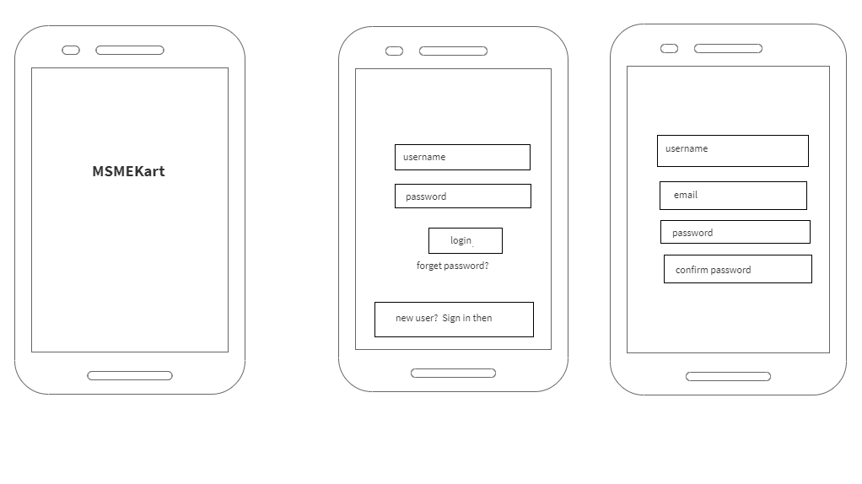

Screen 1 Screen 2 Screen3

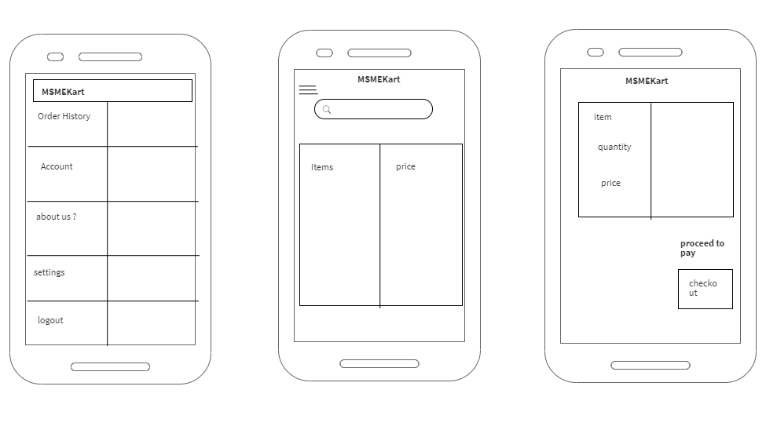

Screen4 Screen5 Screen6

Above are the wireframes of the project proposed.

**Screen-wise Description**

**Screen1**It is a splash screen with the logo of the Application, which will be displayed for a few seconds.

**Screen2**The next screen will be taking some input from the user i.e. his/her phone number for authentication. It is an OTP based authentication; the user will receive an OTP to log into his/her account. Here, the user enters his/her phone number and clicks proceed to jump to the next screen.

**Screen3**Now, the next screen is for those who are using it for the first time and they are here for the signup.

**Screen4**

This the screen where user will find out about his account, settings and about the developers of the MSMEKart. He or she can logout through the account with this.

**Screen5**Home screen of the app where user will search for accessories exposure through the local MSMEs of his area through our app and user can have his/her order history regarding to the past transactions.

**Screen6**this is the screen where user will actually selects his/her certain items with certain quantity and will be ready to checkout with it.

A confirmation mail will be sent to the user about the order he or she has been placed.

**METHODOLOGY**

The methodology which we are using is Agile Development. This method is an iterative and incremental method in this complete development of the app will be dived into sub modules and those modules will be considered as small project in itself

**Push Notifications: -**

A push notification is a message that pops up on a mobile device. App publishers can send them at any time; users don't have to be in the app or using their devices to receive them. ... Push notifications look like SMS text messages and mobile alerts, but they only reach users who have installed your app.  
In our app we have used Push notification to notify user that whether their account has been registered or not, we have also implemented payment Invoice which will be received when user has successfully ordered.

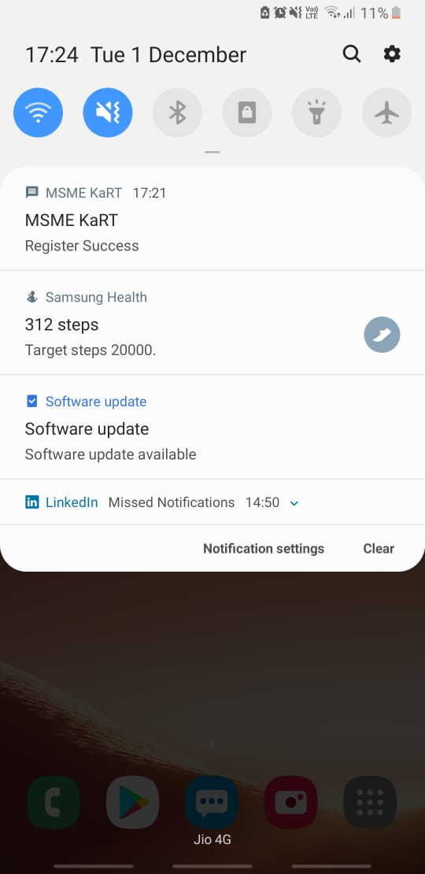

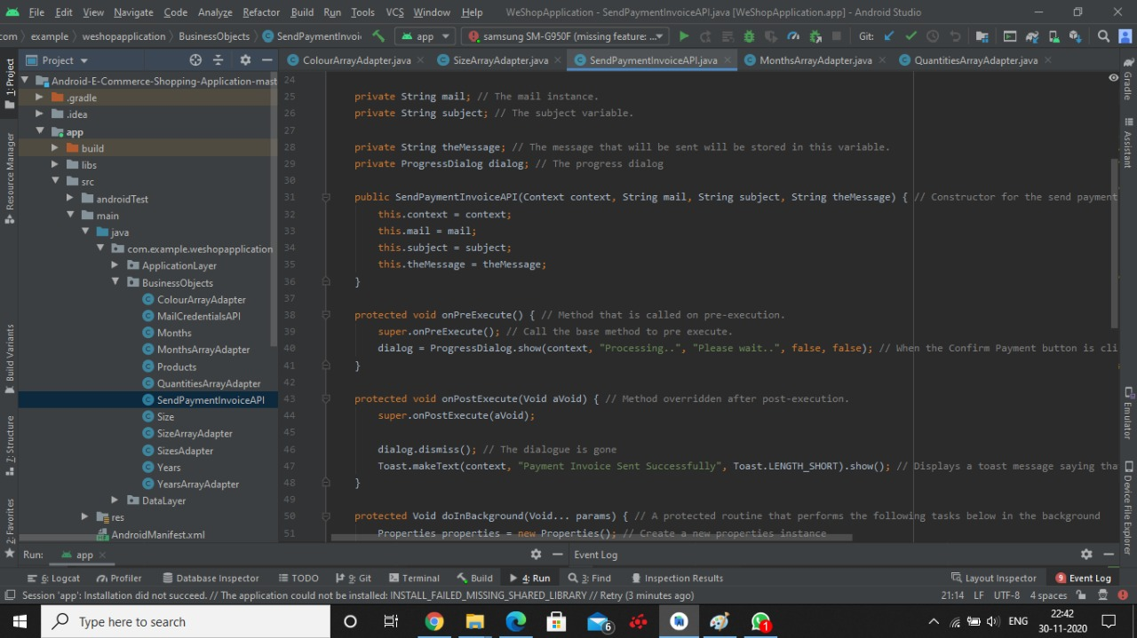

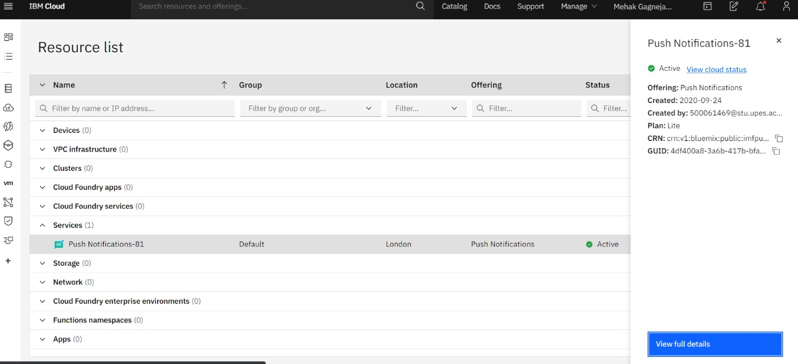

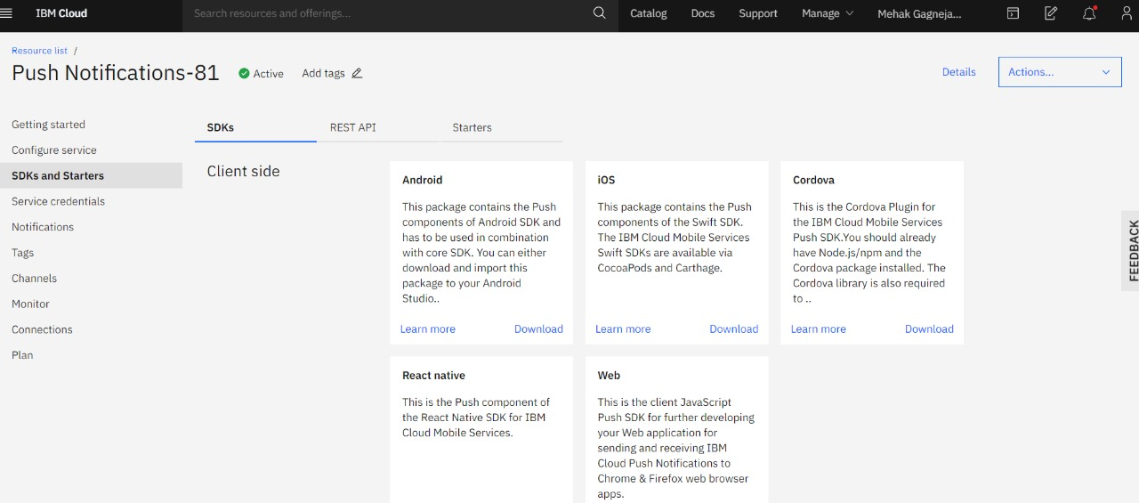

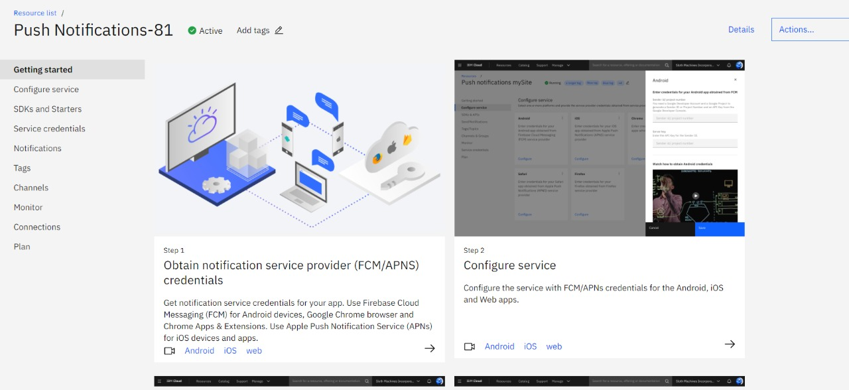

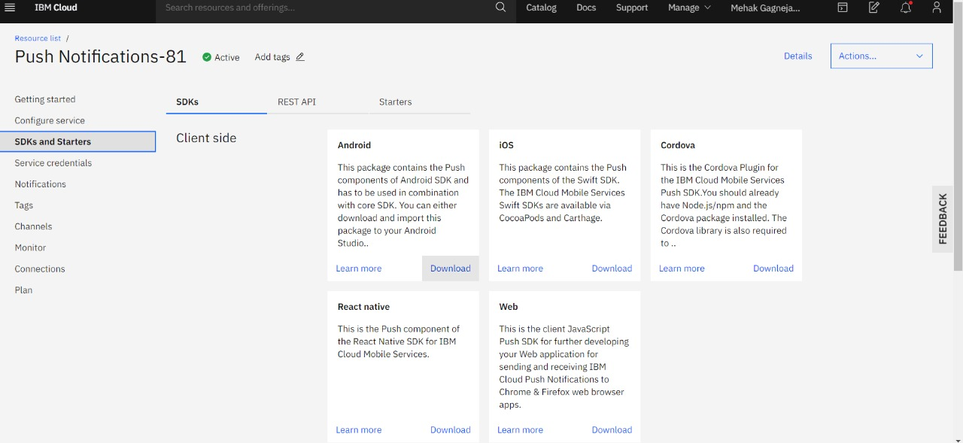

**Working with adapters: -**

In Android, Adapter is a bridge between UI component and data source that helps us to fill data in UI component. It holds the data and send the data to an Adapter view then view can takes the data from the adapter view and shows the data on different views like as QuantitiesArrayAdapter, MonthsArrayAdapter, ColourArrayAdapter etc.

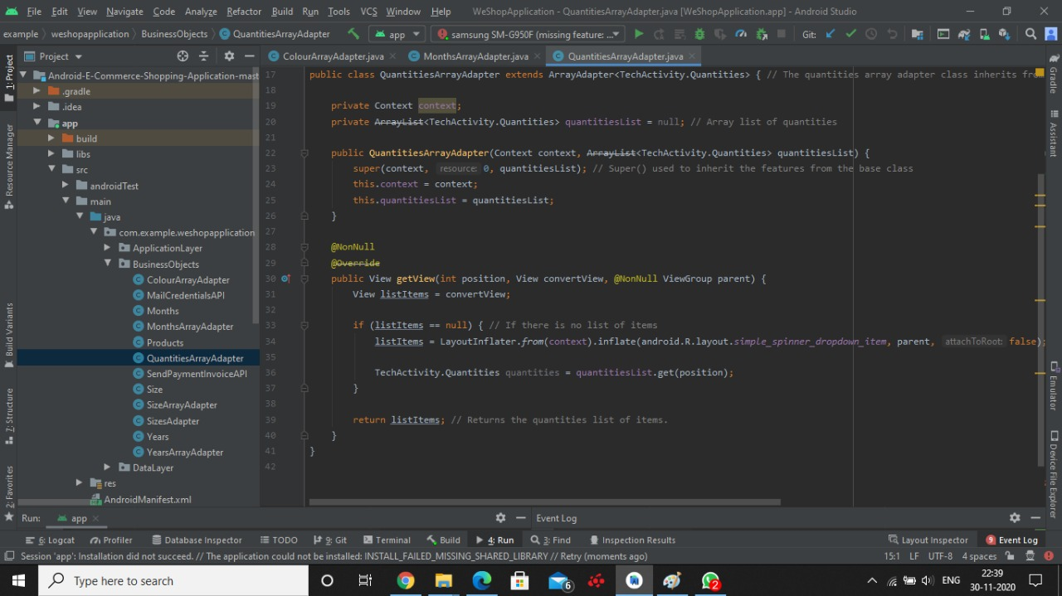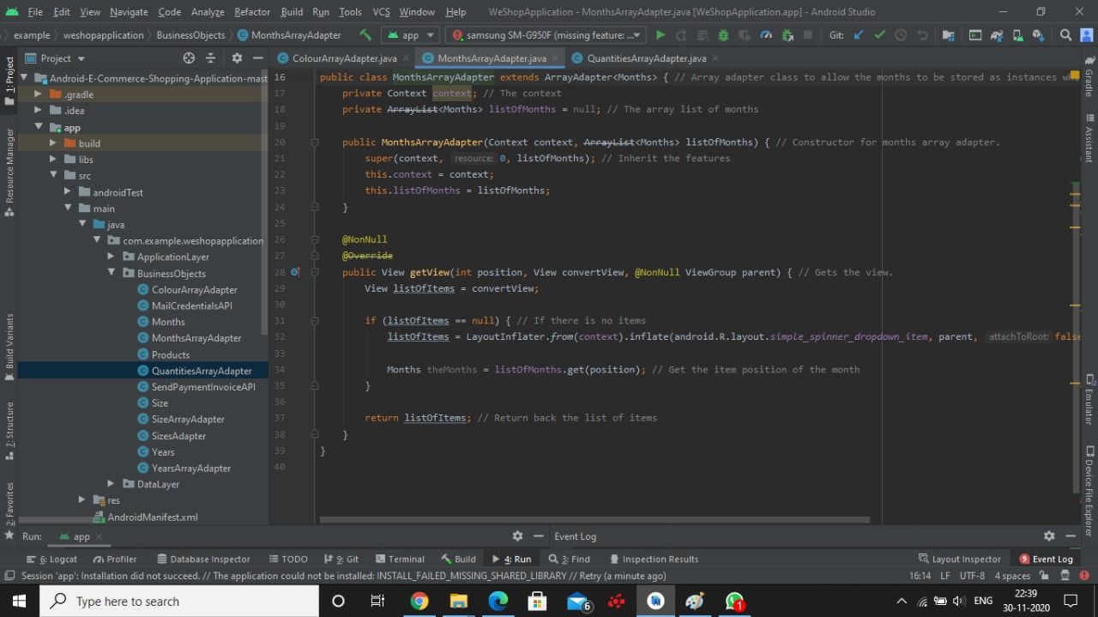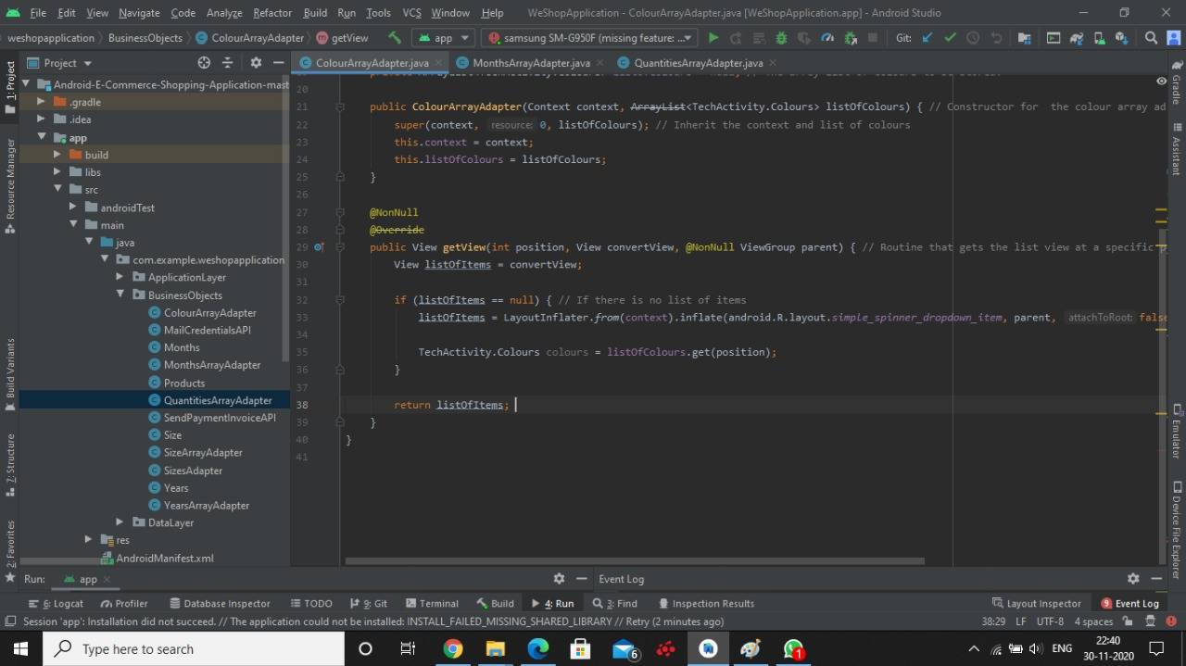

**Administering and Testing for Credentials Validation towards User authentication.**

In our project MSMEKart. We have used Oath 2.0 based authentication. In which a Unique token is given to user when they register their email id and then the user can use that email to login.  
Steps:  
Implement the Firebase AUTH API  
Go to cloud console in Firebase and enable authentication through Email/password.  
Write code for Authentication in your Android Studio.  
Authentication completed

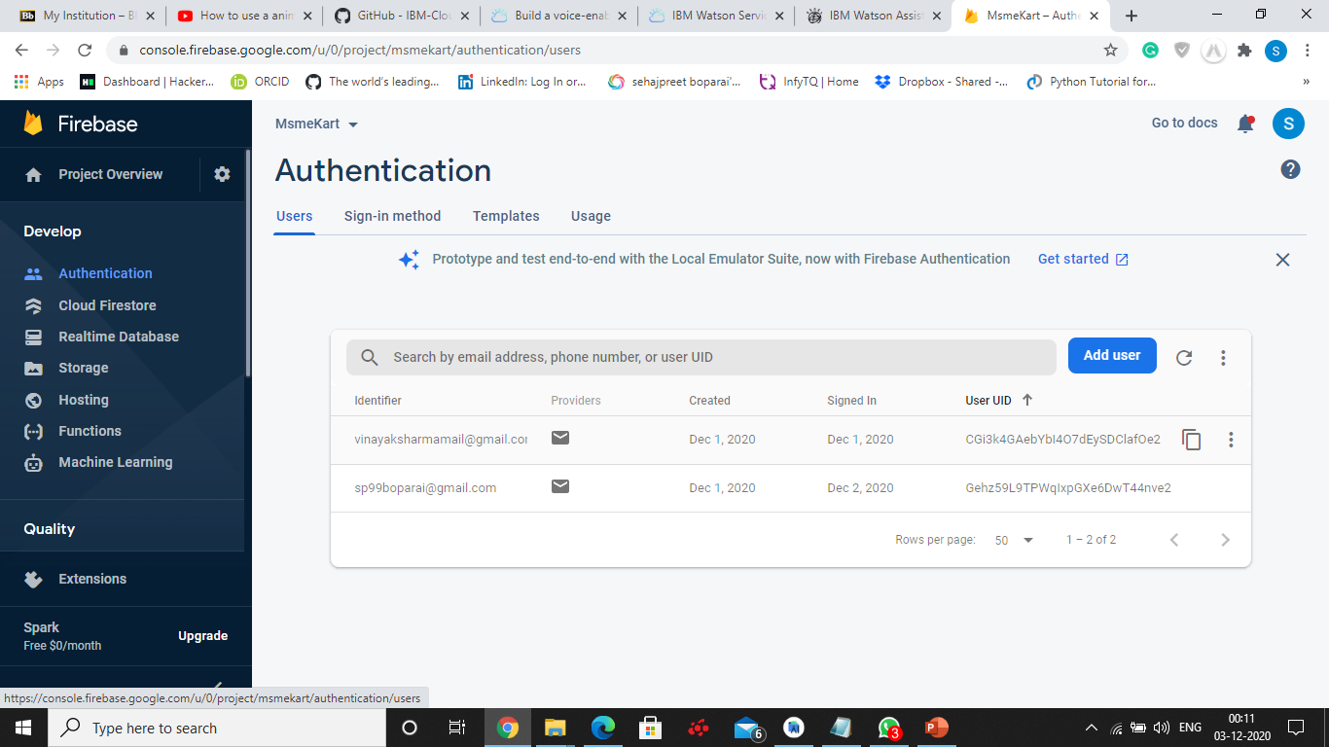

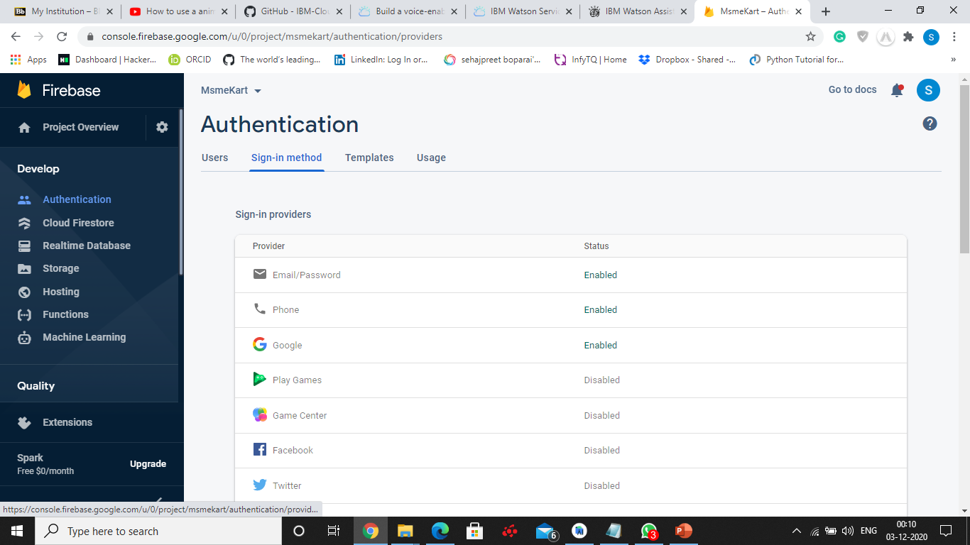

**SQL Lite Database**

In our app we have implemented the SQL LITE database for payment and Customer complaint. So basically what happens is that when a customer is making a payment the information like card number and transaction details are stores in the sql lite database so if user what's to review their order it can be done easily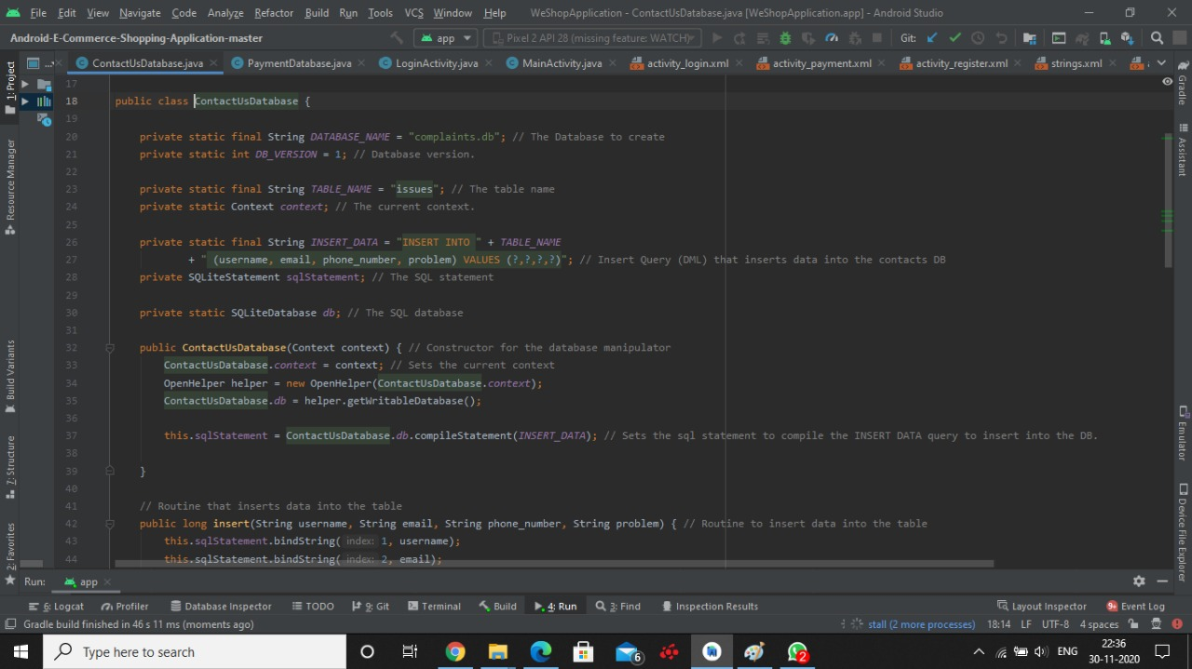

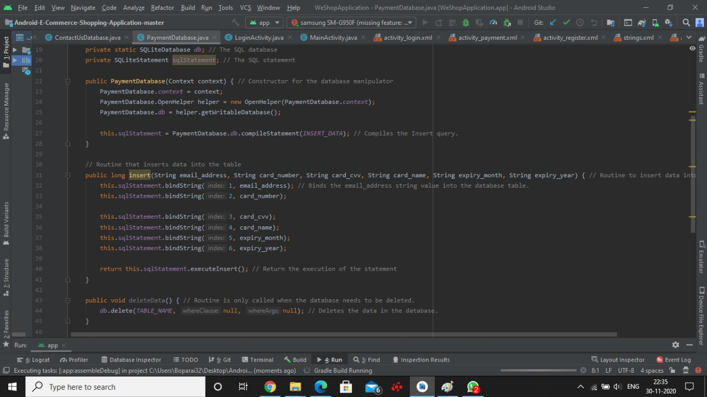

**SNAPSHOTS OF THE APP**

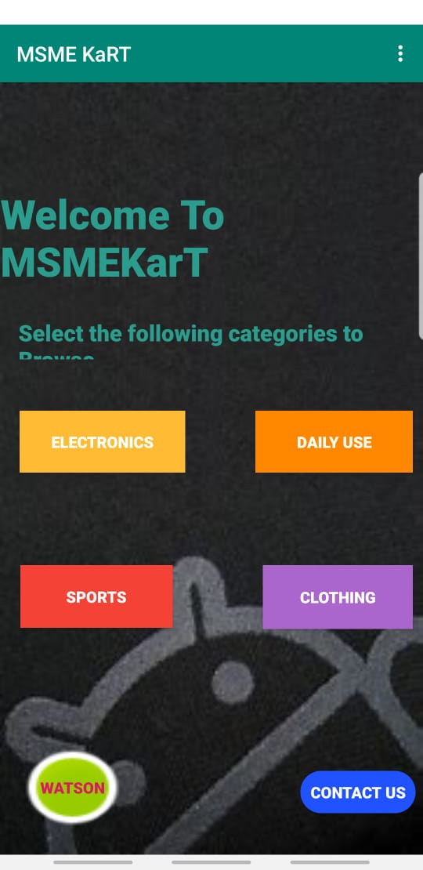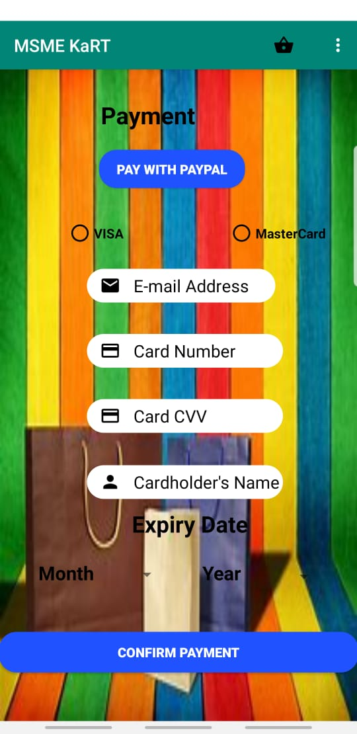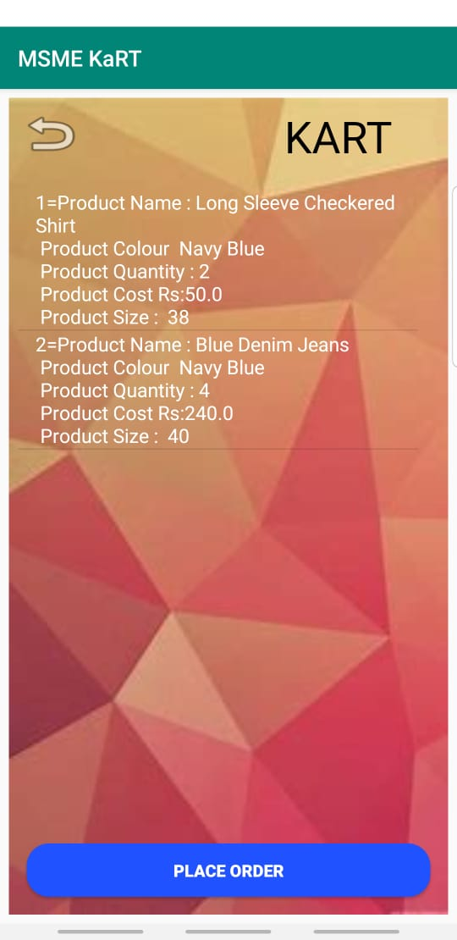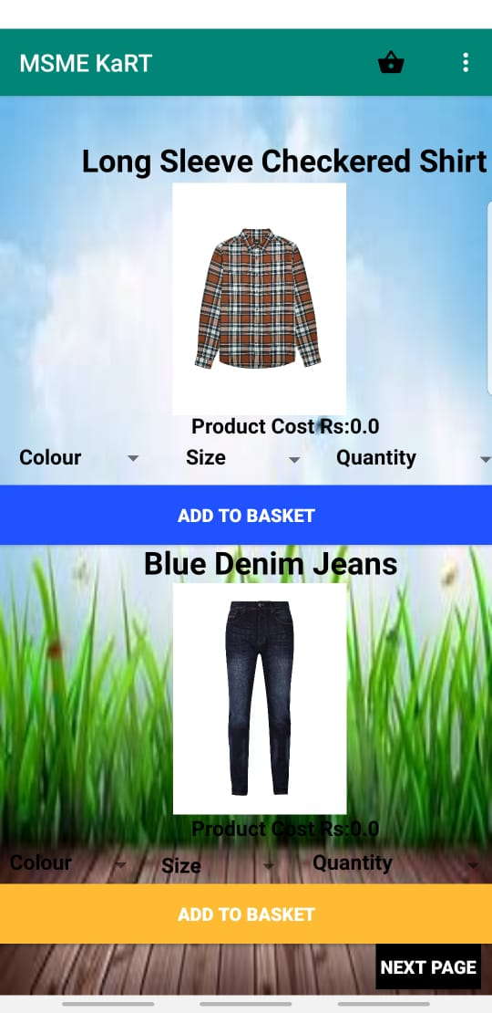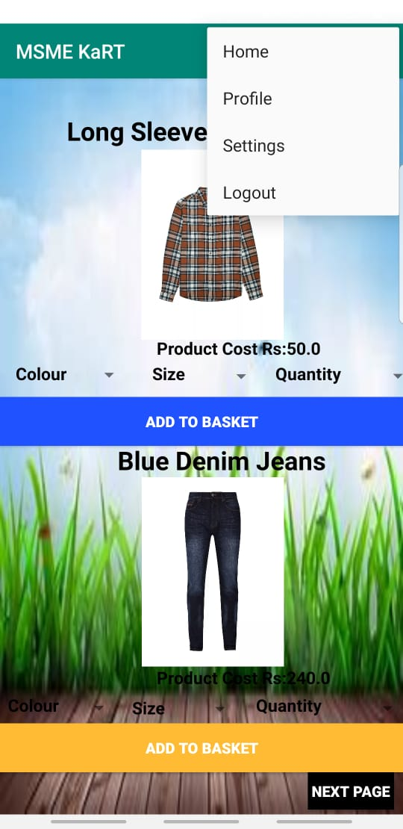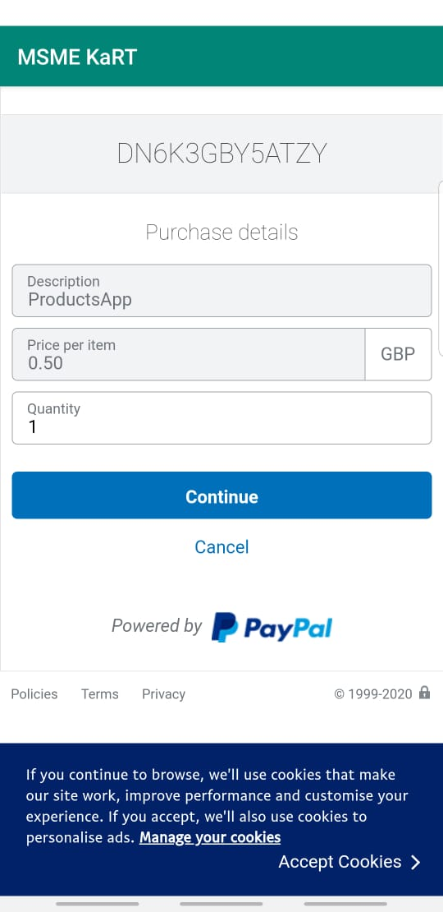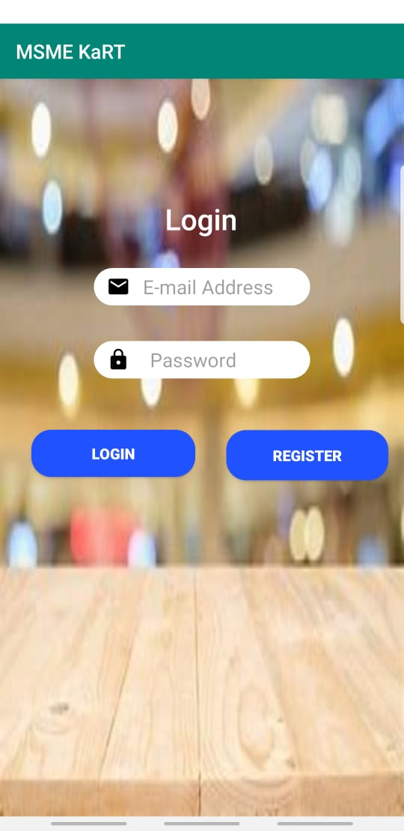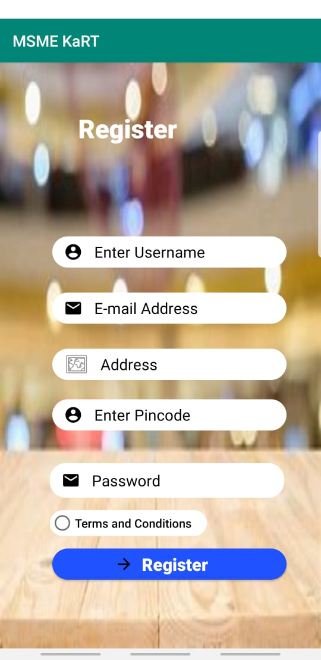

**Enterprise Architecture**

Using JSON store in a n application, Deploying Mobile First server and managing the data transfer over cloud.

JSON relationship with mobile first server.

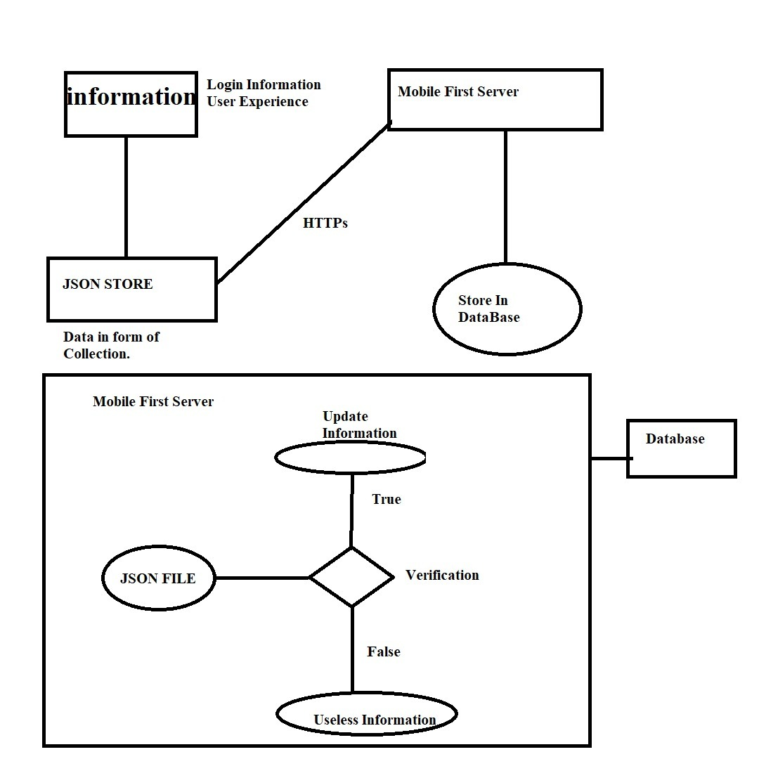

**Limitations**

* Always require Internet connectivity.
* Limited to certain categories

**Future Scope**

* Improving the assistant
* Tracking the order
* Improving Kart Functionalities