CAPSTONE PROJECT
TRAFFIC-LIGHT CONTROLLER + MOD-N COUNTER
AIM
To design and simulate a synchronous traffic-light controller using a finite-state machine (FSM) and a reusable Mod-N counter in Verilog HDL, and to verify the phase sequence and timing behavior using the Vivado Design Suite.
SOFTWARE USED
Xilinx Vivado Design Suite
THEORY
A traffic-light controller is a sequential digital system that changes its outputs according to a defined sequence of states. In this project, the North-South (NS) and East-West (EW) directions are controlled so that only one direction can have a green light at a time. Each green phase is followed by a yellow phase, after which the other direction receives green.
A finite-state machine (FSM) stores the current phase in a state register. A timer counts clock cycles in that phase and causes a transition when the selected phase duration is reached. The design uses synchronous state updates and non-blocking assignments in clocked always blocks.
A Mod-N counter counts from 0 to N−1 and then returns to 0. It is useful for generating periodic timing intervals. For a clock frequency f_clk and a required interval T, the approximate number of ticks is N = T × f_clk.
DESIGN SPECIFICATIONS
The design has four traffic phases: NS Green, NS Yellow, EW Green, and EW Yellow. The sequence repeats continuously after reset is released. Green and yellow durations are configurable through parameters.
- Use a single rising-edge clock and an active-high synchronous reset.
- Reset the FSM to NS Green, with EW Red active.
- Follow the sequence NS Green → NS Yellow → EW Green → EW Yellow → NS Green.
- Never assert NS Green and EW Green simultaneously.
- Provide a parameterized Mod-N counter with enable and terminal-count output.
- Verify behavior in simulation and inspect the waveform before attempting hardware implementation.
INPUTS AND OUTPUTS
Traffic-light controller inputs: clk, rst. Outputs: ns_red, ns_yellow, ns_green, ew_red, ew_yellow, ew_green. All light outputs are active-high.
Mod-N counter inputs: clk, rst, enable. Outputs: count and terminal.

TRUTH TABLE / STATE TABLE
The following table shows the expected light outputs in each FSM state. A value of 1 means that lamp is ON.
State | NS Red | NS Yellow | NS Green | EW Red | EW Yellow | EW Green
NS Green | 0 | 0 | 1 | 1 | 0 | 0
NS Yellow | 0 | 1 | 0 | 1 | 0 | 0
EW Green | 1 | 0 | 0 | 0 | 0 | 1
EW Yellow | 1 | 0 | 0 | 0 | 1 | 0
TIMING AND STATE TRANSITIONS
The FSM transitions after the configured duration of each phase. In the included testbench, GREEN_TICKS is set to 5 and YELLOW_TICKS is set to 2 to make the transitions easy to observe in simulation. These are demonstration values, not real-road timing recommendations.
- NS Green → NS Yellow when the green timer expires.
- NS Yellow → EW Green when the yellow timer expires.
- EW Green → EW Yellow when the green timer expires.
- EW Yellow → NS Green when the yellow timer expires.
VERILOG HDL SOURCE CODE — MOD-N COUNTER
`timescale 1ns/1ps
module mod_n_counter #(
parameter integer N = 10,
parameter integer WIDTH = (N <= 2) ? 1 : $clog2(N)
) (
input wire clk,
input wire rst,
input wire enable,
output reg [WIDTH-1:0] count,
output wire terminal
);
assign terminal = (count == N-1);
always @(posedge clk) begin
if (rst)
count <= {WIDTH{1'b0}};
else if (enable) begin
if (terminal)
count <= {WIDTH{1'b0}};
else
count <= count + 1'b1;
end
end
endmodule

VERILOG HDL SOURCE CODE — TRAFFIC-LIGHT CONTROLLER
`timescale 1ns/1ps
module traffic_light_controller #(
parameter integer GREEN_TICKS = 10,
parameter integer YELLOW_TICKS = 3,
parameter integer COUNT_WIDTH = 16
) (
input wire clk,
input wire rst,
output reg ns_red,
output reg ns_yellow,
output reg ns_green,
output reg ew_red,
output reg ew_yellow,
output reg ew_green
);
localparam [1:0] NS_GREEN = 2'd0;
localparam [1:0] NS_YELLOW = 2'd1;
localparam [1:0] EW_GREEN = 2'd2;
localparam [1:0] EW_YELLOW = 2'd3;
reg [1:0] state;
reg [COUNT_WIDTH-1:0] timer;
reg [COUNT_WIDTH-1:0] phase_limit;
always @* begin
case (state)
NS_GREEN: phase_limit = GREEN_TICKS - 1;
NS_YELLOW: phase_limit = YELLOW_TICKS - 1;
EW_GREEN: phase_limit = GREEN_TICKS - 1;
EW_YELLOW: phase_limit = YELLOW_TICKS - 1;
default: phase_limit = GREEN_TICKS - 1;
endcase
end
always @(posedge clk) begin
if (rst) begin
state <= NS_GREEN;
timer <= 0;
end else begin
if (timer >= phase_limit) begin
timer <= 0;
case (state)
NS_GREEN: state <= NS_YELLOW;
NS_YELLOW: state <= EW_GREEN;
EW_GREEN: state <= EW_YELLOW;
EW_YELLOW: state <= NS_GREEN;
default: state <= NS_GREEN;
endcase
end else begin
timer <= timer + 1'b1;
end
end
end
always @* begin
ns_red = 0; ns_yellow = 0; ns_green = 0;
ew_red = 0; ew_yellow = 0; ew_green = 0;
case (state)
NS_GREEN: begin ns_green = 1; ew_red = 1; end
NS_YELLOW: begin ns_yellow = 1; ew_red = 1; end
EW_GREEN: begin ew_green = 1; ns_red = 1; end
EW_YELLOW: begin ew_yellow = 1; ns_red = 1; end
default: begin ns_red = 1; ew_red = 1; end
endcase
end
endmodule

TESTBENCH CODE
`timescale 1ns/1ps
module tb_traffic_light_controller;
reg clk = 0;
reg rst = 1;
wire ns_red, ns_yellow, ns_green;
wire ew_red, ew_yellow, ew_green;
traffic_light_controller #(
.GREEN_TICKS(5),
.YELLOW_TICKS(2),
.COUNT_WIDTH(8)
) dut (
.clk(clk), .rst(rst),
.ns_red(ns_red), .ns_yellow(ns_yellow), .ns_green(ns_green),
.ew_red(ew_red), .ew_yellow(ew_yellow), .ew_green(ew_green)
);
always #5 clk = ~clk;
initial begin
$dumpfile("traffic_light.vcd");
$dumpvars(0, tb_traffic_light_controller);
$display("time NS(RYG) EW(RYG)");
$monitor("%4t %b%b%b %b%b%b", $time,
ns_red, ns_yellow, ns_green,
ew_red, ew_yellow, ew_green);
repeat (2) @(posedge clk);
rst = 0;
repeat (30) @(posedge clk);
$finish;
end
endmodule

SIMULATION RESULTS / WAVEFORM
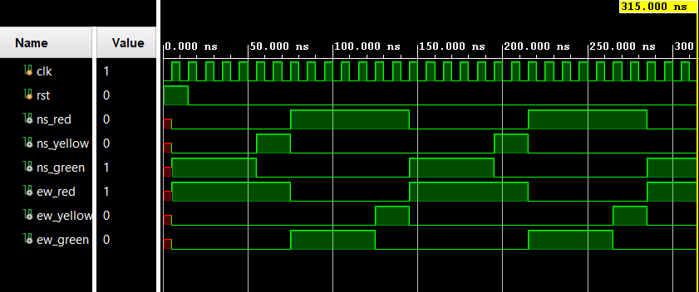
RTL SCHEMATIC
