BLUESTOCK FINTECH
Data Analyst Internship — Capstone Project Report

MUTUAL FUND ANALYTICS PLATFORM
End-to-End Data Engineering, ETL Pipeline, Risk Analytics and Interactive Business Intelligence Dashboard

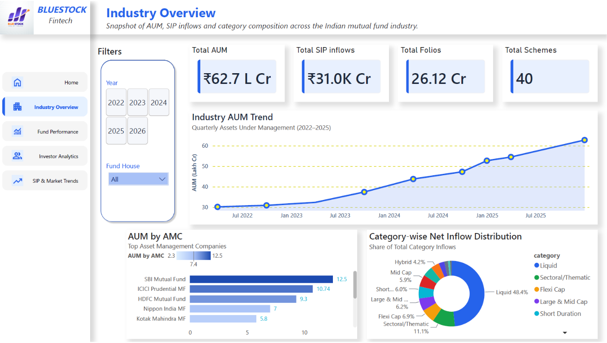
Prepared By
Utsav Ratpiya
B.Tech, Computer Science & Engineering (AI & ML) — Adani University
Data Analyst Intern | Offer ID: BFDA60407
Internship Duration: 20 June 2026 – 20 August 2026 (Remote)
Report Date: 9 July 2026
GitHub Repository:
github.com/Utsav-Ratpiya/Mutual-Fund-Analytics-Bluestock-

Declaration
I, Utsav Ratpiya, hereby declare that this capstone project report titled “Mutual Fund Analytics Platform” is an original record of the work carried out by me during my Data Analyst internship at Bluestock Fintech, undertaken over the internship period from 20 June 2026 to 20 August 2026.
All datasets used in this project are derived from publicly available sources — AMFI India, the mfapi.in REST API, and NSE/BSE published indices — as provided in the project brief issued by Bluestock Fintech. Investor transaction data is synthetically generated for the purpose of this exercise, following realistic demographic and behavioural distributions, and does not represent real individuals. This project and report are intended solely for educational and skill-development purposes and do not constitute investment or financial advice.
I confirm that the analysis, code, dashboard and findings presented in this report are my own work, completed as part of the structured 7-day task plan issued for this capstone, including two bonus modules (Monte Carlo Simulation and Markowitz Portfolio Optimization) that I completed in addition to the core deliverables.
Utsav Ratpiya
Data Analyst Intern, Bluestock Fintech

Acknowledgement
I would like to express my sincere gratitude to Bluestock Fintech for providing me with the opportunity to work as a Data Analyst Intern and for designing a capstone project that closely mirrors real-world fintech data engineering and analytics workflows.
I am thankful to the Bluestock Fintech leadership and HR team for their guidance, and for structuring the internship in a way that allowed hands-on exposure to the complete analytics lifecycle — from raw data ingestion to a production-style interactive dashboard.
I would also like to thank Adani University and the Department of Computer Science & Engineering (AI & ML) for the academic foundation that made it possible for me to apply concepts of data engineering, statistics and financial analytics confidently during this internship.
Finally, I appreciate the open data made available by AMFI India, mfapi.in, NSE and BSE, which formed the factual backbone of this project.

Table of Contents
Declaration ........................................................................................................................................................................................... ii
Acknowledgement .............................................................................................................................................................................. iii
Table of Contents ................................................................................................................................................................................ iv
1. Executive Summary ......................................................................................................................................................................... 5
2. Bluestock Fintech & Internship Overview ....................................................................................................................................... 6
2.1 About Bluestock Fintech
2.2 Internship Details
3. Project Overview & Objectives ........................................................................................................................................................ 7
3.1 Business Context
3.2 Project Objectives
3.3 Scope Snapshot
4. Problem Statement ………………………………………………………………........................................................................................................ 8
5. Data Sources & Dataset Description ............................................................................................................................................... 9
5.1 Public Data Sources
5.2 Dataset Inventory
5.3 Key Real-World Data Points
5.4 Data Quality Validation
6. System Architecture & Technology Stack ..................................................................................................................................... 11
6.1 Five-Layer Architecture
6.2 Technology Stack
6.3 Project Repository Structure
7. ETL Pipeline .................................................................................................................................................................................... 13
7.1 ETL Workflow
7.2 ETL Components
8. Database Design ............................................................................................................................................................................ 15
8.1 Database Schema
8.2 Database Tables
8.3 Sample Analytical SQL Queries
8.4 Database Validation
9. Exploratory Data Analysis (EDA) ................................................................................................................................................... 17
9.1 NAV Trend Analysis
9.2 AUM Growth Analysis
9.3 SIP Inflow Trend
9.4 Category-wise Net Inflow Analysis
9.5 Investor Demographics
9.6 Geographic Distribution
9.7 Portfolio & Sector Analysis
9.8 NAV Return Correlation Matrix
9.9 Sector Allocation
9.10 Key EDA Findings
10. Fund Performance Analytics ........................................................................................................................................................ 22
10.1 Methodology
10.2 Fund Scorecard — Top 10 Ranked Schemes 10.3 Sharpe Ratio
10.3 CAGR Comparison
10.4 Risk-Adjusted Return — Sharpe & Sortino Ratios
10.5 Alpha & Beta vs Nifty 100
10.6 Maximum Drawdown
10.7 Benchmark Comparison & Tracking Error
11. Power BI Interective Dashboard ................................................................................................................................................. 26
11.1 Page 1 — Industry Overview
11.2 Page 2 — Fund Performance
11.3 Page 3 — Investor Analytics
11.4 Page 4 — SIP & Market Trends
11.5 Dashboard Design Notes
12. Advanced Analytics & Risk Metrics ……………………………………………………………………………………………………………..………………………… 29
12.1 Historical VaR (95%) & Conditional VaR
12.2 Rolling 90-Day Sharpe Ratio
12.3 Investor Cohort Analysis
12.4 SIP Continuity & At-Risk Investors
12.5 Sector Concentration — Herfindahl-Hirschman Index (HHI)
13. Monte Carlo Simulation ............................................................................................................................................................... 32
13.1 Methodology
13.2 Simulation Output
14. Portfolio Optimization ................................................................................................................................................................. 34
14.1 Methodology
14.2 Efficient Frontier
14.3 Optimal (Maximum-Sharpe) Portfolio Allocation
15. Rule-Based Fund Recommendation System …………………………………………………………………………………..…………………………………….. 36
16. Key Findings & Business Insights ................................................................................................................................................. 37
17. Challenges & 18. Limitations ....................................................................................................................................................... 38
19. Conclusion & 20. Future Scope .................................................................................................................................................... 39
21. Appendix ...................................................................................................................................................................................... 40
A. Dataset Dictionary
B. Evaluation Rubric
C. GitHub Repository

1. Executive Summary
This report documents the design, development and delivery of a full-stack Mutual Fund Analytics Platform, built as the capstone project of my Data Analyst internship at Bluestock Fintech. The project simulates the analytics stack used by real fintech and wealth-management platforms — ingesting mutual fund data from public sources, cleaning and warehousing it in a relational database, computing industry-standard risk and performance metrics, and presenting the results through an interactive Power BI dashboard.
The platform covers 40 real mutual fund schemes across 10 major Indian AMCs, built on 10 structured datasets comprising roughly 87,000+ rows of NAV history, investor transactions, AUM, SIP flows and portfolio holdings data, anchored to real AMFI-published figures (₹81 lakh crore industry AUM, ₹31,002 crore monthly SIP inflow, 26.12 crore folios, as of December 2025).
Key deliverables completed: an automated Python ETL pipeline (extraction, cleaning, loading); a live NAV fetch module integrated with the mfapi.in REST API; a 7-table SQLite star-schema data warehouse; an EDA notebook with 20+ charts; a performance-analytics engine computing CAGR, Sharpe, Sortino, Alpha, Beta, Maximum Drawdown and a composite Fund Scorecard; a 4-page interactive Power BI dashboard with KPI cards, slicers and drill-through; an advanced-analytics module covering Historical VaR/CVaR, rolling Sharpe ratios, investor cohort analysis, SIP continuity/at-risk flagging, Sector HHI concentration and a rule-based fund recommender.
Bonus modules completed: two of the five optional bonus challenges were completed in full — a Monte Carlo simulation projecting 5-year NAV growth with uncertainty bands (1,000 simulated paths), and a Markowitz Efficient Frontier portfolio optimization identifying the Maximum-Sharpe and Minimum-Risk portfolios across five benchmark large-cap schemes.
Among the headline findings: Mirae Asset Large Cap Fund emerged as the top-ranked scheme on the composite Fund Scorecard (score 100/100, Sharpe Ratio 1.45, 3-year CAGR ~34%); SBI Mutual Fund retained its position as the largest AMC by AUM (₹12.5 lakh crore); Small-Cap funds carried both the highest historical VaR/CVaR and the deepest maximum drawdowns; and the 5,000-investor transaction base showed a healthy 60.2% SIP-driven contribution pattern, led by Punjab, Tamil Nadu and Madhya Pradesh in transaction value.
This report is organised to walk through the full project lifecycle — objectives, architecture, day-wise execution, analytical methodology, dashboard design, advanced risk analytics, bonus modules, and final findings — supported throughout by the actual charts, tables and metrics generated by the project's Python and Power BI pipeline.

2. About Bluestock Fintech & Internship Details

2.1 About Bluestock Fintech
Bluestock Fintech is a financial technology company focused on democratising investment analytics for retail and institutional investors in India. As part of its data analytics function, Bluestock designs project-based internships that mirror the real data pipelines used by fintech platforms — spanning data ingestion, transformation, storage, analytics and dashboarding.

2.2 Internship Details
Field | Detail
Offer ID | BFDA60407
Position | Data Analyst Intern
Intern Name | Utsav Ratpiya
Working Hours | Flexible
Location | Remote
Duration | 20 June 2026 – 20 August 2026
Engagement Type | Part-time, Unpaid Internship
Offer Issued | 15 June 2026

This capstone — the Mutual Fund Analytics Platform — was assigned as the core project-based deliverable of the internship, structured as a 7-working-day (approx. 50–55 hour) intensive build, covering data engineering, analytics and dashboard development end to end.

3. Project Overview & Objectives

3.1 Business Context
The Indian mutual fund industry has grown rapidly in recent years. As of December 2025, the industry managed over ₹81 lakh crore in AUM across 1,908 schemes and 26.12 crore investor folios, with monthly SIP inflows crossing an all-time high of ₹31,002 crore. Bluestock Fintech wanted a data platform that could track NAV movement, monitor AUM growth across fund houses, analyse investor behaviour, compute risk-adjusted return metrics, benchmark funds against market indices, and present it through an executive-ready dashboard.

3.2 Project Objectives
# | Objective | Outcome Delivered
O1 | Build an ETL pipeline from raw AMFI-style data | Automated Python ETL scripts (etl_pipeline.py, data_ingestion.py, live_nav_fetch.py)
O2 | Design a normalised SQL schema for MF data | 7-table SQLite star schema (dim_fund, dim_date, fact_nav, fact_transactions, fact_performance, fact_aum)
O3 | Perform comprehensive EDA on NAV & AUM data | EDA notebook with 20+ charts across NAV, AUM, SIP, demographics and sectors
O4 | Compute performance & risk metrics per scheme | CAGR, Sharpe, Sortino, Alpha, Beta, Max Drawdown, Fund Scorecard for all 40 schemes
O5 | Build an interactive BI dashboard | 4-page Power BI dashboard (.pbix) with KPIs, slicers and drill-through
O6 | Analyse investor transaction patterns | Demographic, geographic and cohort-level insights across 32,778 transactions
O7 | Compare fund returns vs benchmark indices | Alpha, Beta, tracking error and NAV-vs-benchmark comparison charts
O8 | Document and present the entire project | This report + presentation deck + published GitHub repository

3.3 Scope Snapshot
40  Mutual Fund Schemes | 10  Structured Datasets | 87K+  Transaction Rows | 4.5 Yrs  NAV History (2022–2026)

4. Problem Statement
Despite the scale of India's mutual fund industry, individual investors, distributors and analysts often struggle to make data-driven fund-selection decisions because of fragmented data sources, the absence of a unified analytics layer, and the complexity of computing proper risk-adjusted metrics. This project targeted five concrete business problems.

P1 — Data Fragmentation
NAV, AUM, SIP-flow and portfolio-holdings data are published by AMFI in different formats (TXT, PDF, HTML tables) across different pages, with no single unified database. This project consolidates all of it into one SQLite data warehouse, sourced consistently via Python ETL.

P2 — Performance Comparison Gap
Investors cannot easily compare funds across AMCs on a risk-adjusted basis — Sharpe Ratio, Alpha and Beta require non-trivial transformation of raw NAV series. This project computes and visualises all key risk-return metrics in one place, ranked and scored.

P3 — No Benchmark Tracking
Most retail investors do not know whether their fund is beating its benchmark. The project joins fund NAV data with Nifty 50 / Nifty 100 benchmark indices and computes tracking error and comparative NAV charts for every scheme.

P4 — Investor Behaviour Blind Spot
AMCs have limited visibility into how demographics and geography drive SIP amounts, fund choice and redemption behaviour. This project segments the 5,000-investor transaction base by age, gender, state and city-tier to surface these patterns.

P5 — Slow, Static Reporting
Monthly MF reports are static PDFs that take days to prepare. This project replaces that with a self-service Power BI dashboard, refreshable directly from the ETL pipeline's output tables.

5. Data Sources & Dataset Description

5.1 Public Data Sources
Source | Data Type | Update Frequency
AMFI India (amfiindia.com) | NAV, AUM, Folio, SIP | Daily / Monthly
mfapi.in (api.mfapi.in/mf/{code}) | Historical NAV (JSON) | Daily
NSE India | Benchmark index prices | Daily
BSE India | BSE SmallCap index | Daily
AMFI Monthly Notes | Industry SIP & flow data | Monthly

5.2 Dataset Inventory
Ten structured CSV datasets formed the foundation of the platform. Row counts below reflect the actual, validated counts confirmed during the Day-1/Day-2 data-quality check (see data_quality_report.csv).
# | Dataset | Rows | Description
01 | fund_master.csv | 40 | Master list of 40 schemes: AMFI code, fund house, category, expense ratio, risk grade, manager
02 | nav_history.csv | 46,000 | Daily NAV for all 40 schemes, Jan 2022 – 2026, anchored to real mfapi.in values
03 | aum_by_fund_house.csv | 90 | Quarterly AUM (₹ crore) for 10 fund houses, 2022–2025
04 | monthly_sip_inflows.csv | 48 | Month-wise SIP inflow, active SIP accounts, new registrations, SIP AUM
05 | category_inflows.csv | 144 | Net inflows by fund category for FY 2024-25
06 | industry_folio_count.csv | 21 | Total MF folios (crore), split by Equity / Debt / Hybrid
07 | scheme_performance.csv | 40 | 1/3/5-yr returns, Sharpe, Sortino, Alpha, Beta, Max DD, Std Dev
08 | investor_transactions.csv | 32,778 | SIP / Lumpsum / Redemption transactions for 5,000 investors
09 | portfolio_holdings.csv | 322 | Top equity holdings (stock, weight %, sector) as of Dec 2025
10 | benchmark_indices.csv | 8,050 | Daily closing values — Nifty 50, Nifty 100, Nifty Midcap 150, BSE SmallCap

5.3 Key Real-World Data Points Embedded
Metric | Value | Source
SBI MF AUM (Dec 2025) | ₹12.50 lakh crore — largest AMC | AMFI Quarterly
ICICI Pru MF AUM (Dec 2025) | ₹10.74 lakh crore | AMFI Quarterly
HDFC MF AUM (Dec 2025) | ₹9.30 lakh crore | AMFI Quarterly
SIP Inflow (Dec 2025) | ₹31,002 crore — all-time high | AMFI Monthly Note
Total MF Folios (Dec 2025) | 26.12 crore | AMFI / Business Standard
Industry AUM (Dec 2025) | ₹81 lakh crore | AMFI

5.4 Data Quality Validation
Every dataset (10 core CSVs + 6 raw live-NAV fetch files) was profiled for shape, dtypes, missing values and duplicates before cleaning. The Day-1/Day-2 data-quality report confirmed zero duplicate rows across all datasets, with the only missing-value issue found in monthly_sip_inflows.csv (12 missing YoY-growth cells for the first year of data, where no prior-year base existed) — resolved during cleaning.
Dataset | Rows | Columns | Missing Values | Duplicate Rows
nav_history.csv | 46,000 | 3 | 0 | 0
investor_transactions.csv | 32,778 | 13 | 0 | 0
benchmark_indices.csv | 8,050 | 3 | 0 | 0
portfolio_holdings.csv | 322 | 8 | 0 | 0
monthly_sip_inflows.csv | 48 | 6 | 12 | 0
scheme_performance.csv | 40 | 19 | 0 | 0

All AMFI codes, fund names, fund houses, benchmarks, expense ratios and AUM figures used in this project are sourced from publicly available AMFI India data, mfapi.in and financial news references. Investor transaction data is synthetically generated but follows real geographic, demographic and behavioural distributions observed in the Indian MF market — a distinction I have kept explicit throughout this report.

6. System Architecture & Technology Stack

6.1 Five-Layer Architecture
The platform follows a classic data-engineering architecture — Extract → Transform → Load → Analyse → Visualise — the same pattern used by production fintech data pipelines.
- Layer 1 — Data Sources (Extract): AMFI daily/historical NAV feeds, mfapi.in REST API (live NAV, no auth required), AMFI monthly notes, NSE/BSE index data, and the 10 pre-packaged CSV datasets.
- Layer 2 — Data Processing (Transform): Pandas-based parsing, cleaning and reshaping; forward-filling missing NAV on weekends/holidays; computing derived fields (daily returns, rolling averages, CAGR); validating AMFI codes; enriching transactions with fund metadata via joins.
- Layer 3 — Data Storage (Load): SQLite database (bluestock_mf.db) loaded via SQLAlchemy, with CSV flat-file backups for direct Power BI import.
- Layer 4 — Analytics (Analyse): Seven Jupyter notebooks covering ingestion, cleaning, EDA, performance analytics, advanced analytics, Monte Carlo simulation and portfolio optimization, using Matplotlib, Seaborn, Plotly, NumPy and SciPy.
- Layer 5 — Visualisation (Dashboard): A 4-page Power BI dashboard with KPI cards, slicers, drill-through and a consistent Bluestock brand theme, exported to PDF for stakeholder distribution.

6.2 Technology Stack
Category | Tool / Library | Purpose
Language | Python 3.10+ | All data processing, ETL, analytics
Data Manipulation | Pandas | DataFrames, cleaning, aggregation
Numerical Computing | NumPy, SciPy | Risk metrics, OLS regression (Alpha/Beta)
Visualisation | Matplotlib, Seaborn, Plotly | Static and interactive charts
Database | SQLite3 + SQLAlchemy | Local relational data warehouse
Dashboard | Power BI Desktop | Interactive BI dashboard (.pbix)
Notebooks | Jupyter Lab | EDA and analytics notebooks
API | mfapi.in (REST, JSON) | Live NAV data, no authentication required
Version Control | Git + GitHub | Code versioning and submission
IDE | VS Code / Jupyter | Development environment

6.3 Project Folder Structure
The repository follows a clean, modular structure separating raw data, processed data, notebooks, scripts, SQL, dashboard and reports — matching the structure specified in the original project brief:
Mutual-Fund-Analytics-Bluestock/ data/{raw, processed, db} notebooks/ (01_Data_Ingestion … 07_Portfolio_Optimization) scripts/ (etl_pipeline.py, live_nav_fetch.py, recommender.py, …) sql/ (schema.sql, queries.sql) dashboard/ (bluestock_mf_dashboard.pbix, Dashboard.pdf, images/) reports/ (charts/, CSV metric outputs, data_dictionary.md) logs/etl_pipeline.log requirements.txt · README.md

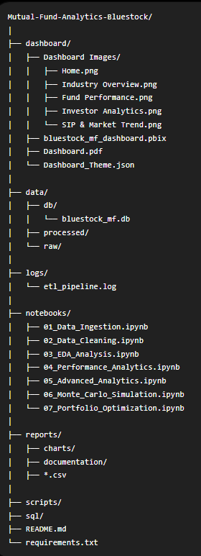

7. ETL Pipeline
7.1 — ETL workflow
The Mutual Fund Analytics Platform follows a structured Extract–Transform–Load (ETL) pipeline to collect, clean, validate, and organize mutual fund datasets before performing analytical processing. The workflow ensures that all datasets are standardized, validated, and stored in a centralized SQLite database, providing a reliable foundation for visualization and advanced analytics.
The ETL process begins by extracting raw mutual fund datasets from AMFI and other publicly available financial sources in CSV format. During the transformation stage, Python scripts clean missing values, standardize formats, validate AMFI codes, remove duplicates, and prepare consistent datasets for analysis. Finally, the processed data is loaded into a SQLite database using a Star Schema, where it is accessed by Jupyter notebooks for exploratory analysis, performance analytics, advanced risk analysis, and the interactive Power BI dashboard.
The modular ETL architecture improves data quality, reproducibility, and scalability while enabling automated execution of the complete analytics pipeline.

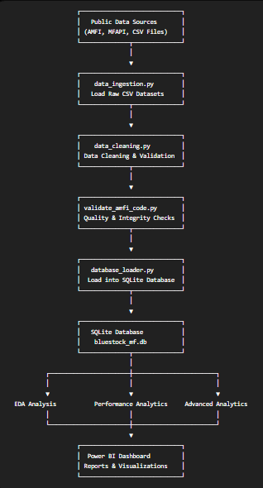
Figure 7.1 — ETL workflow showing the extraction of raw mutual fund datasets, preprocessing and validation using Python scripts, storage in a centralized SQLite database, and subsequent utilization for exploratory analysis, advanced analytics, and interactive Power BI dashboard development.

7.2 ETL Components
Script | Purpose
data_ingestion.py | Loads raw mutual fund datasets from CSV files.
data_cleaning.py | Cleans, formats, and preprocesses the datasets.
validate_amfi_code.py | Performs data validation and AMFI code verification.
database_loader.py | Loads processed datasets into the SQLite database.
etl_pipeline.py | Automates the complete ETL workflow.
live_nav_fetch.py | Retrieves live NAV data from the MFAPI service.

8. Database Design — Star Schema
A dimensional star schema was chosen over a fully normalised OLTP design because analytical (OLAP-style) queries — aggregating NAV, AUM and transactions across time, fund and geography — are far more efficient against a small number of wide fact tables joined to compact dimension tables. The schema mirrors patterns used in production BI systems feeding Power BI.

8.1 Schema Diagram (Logical)
dim_fund and dim_date sit at the centre as dimensions; fact_nav, fact_transactions, fact_performance and fact_aum radiate out as facts, each carrying a foreign key back to amfi_code and/or date_id.
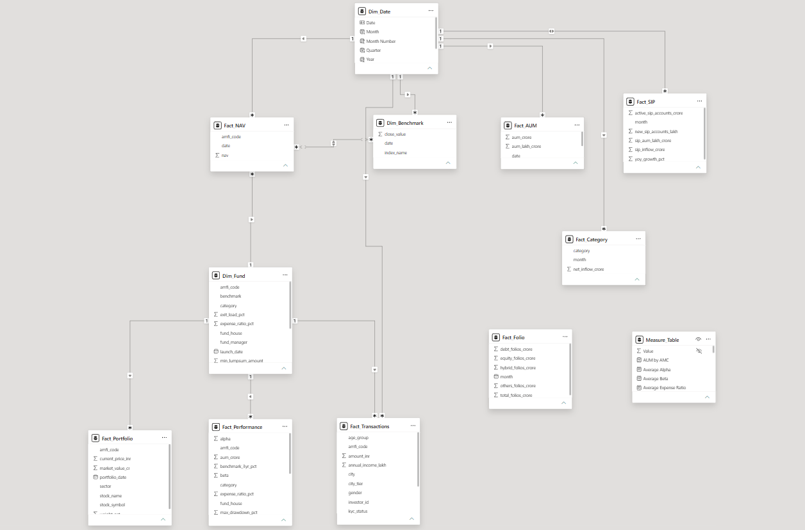
Figure 8.1: Database Star Schema (Model View)

8.2 Table Definitions
Table | Type | Key Columns | Approx. Rows
dim_fund | Dimension | fund_id (PK), amfi_code (UNIQUE), fund_house, scheme_name, category, sub_category, plan, benchmark, expense_ratio_pct, exit_load_pct, risk_category | 40
dim_date | Dimension | date_id (PK), full_date (UNIQUE), year, quarter, month, day | ~1,500
fact_nav | Fact | nav_id (PK), amfi_code (FK), date_id (FK), nav | 46,000
fact_transactions | Fact | transaction_id (PK), amfi_code (FK), date_id (FK), amount_inr, transaction_type, state, city, payment_mode | 32,778
fact_performance | Fact | performance_id (PK), amfi_code (FK), return_1/3/5yr_pct, alpha, beta, sharpe_ratio, expense_ratio_pct, risk_grade | 40
fact_aum | Fact | aum_id (PK), fund_house, date_id (FK), aum_crore, num_schemes | 90

Primary keys use INTEGER PRIMARY KEY AUTOINCREMENT (SQLite rowid aliasing) except fact_transactions, which reuses the natural transaction_id. Foreign keys on amfi_code and date_id enforce referential integrity back to dim_fund and dim_date respectively, and both are indexed to keep time-series and cross-fund aggregation queries fast.

8.3 Sample Analytical SQL Queries
Ten analytical queries were written against this schema and validated with run_queries.py. Representative examples:
-- Top 5 Fund Houses by AUM SELECT fund_house, SUM(aum_crore) AS total_aum FROM fact_aum GROUP BY fund_house ORDER BY total_aum DESC LIMIT 5; -- SIP Year-over-Year Growth SELECT strftime('%Y', transaction_date) AS year, SUM(amount_inr) AS sip_amount FROM fact_transactions WHERE transaction_type='SIP' GROUP BY year; -- Funds with Expense Ratio Below 1% SELECT scheme_name, expense_ratio_pct FROM dim_fund WHERE expense_ratio_pct < 1;
The full set of 10 queries — covering AUM ranking, average NAV per month, SIP YoY growth, state-wise transactions, low-cost funds, top 5-year performers, category-wise expense ratios and more — is version-controlled in sql/queries.sql.

8.4 Database Validation
After loading, verify_database.py cross-checked every table's row count in bluestock_mf.db against its corresponding source CSV to confirm a lossless load, and database_loader.py logs each load step to logs/etl_pipeline.log for traceability — consistent with the “no hard-coded paths, proper logging” engineering standard set out in the project brief.

9. Exploratory Data Analysis (EDA)
The project focused on building a comprehensive visual understanding of NAV behaviour, AUM growth, SIP flows, investor demographics and portfolio composition. All charts below are taken directly from the project's EDA notebook and chart exports.

9.1 NAV Trend — All Schemes (2022–2026)
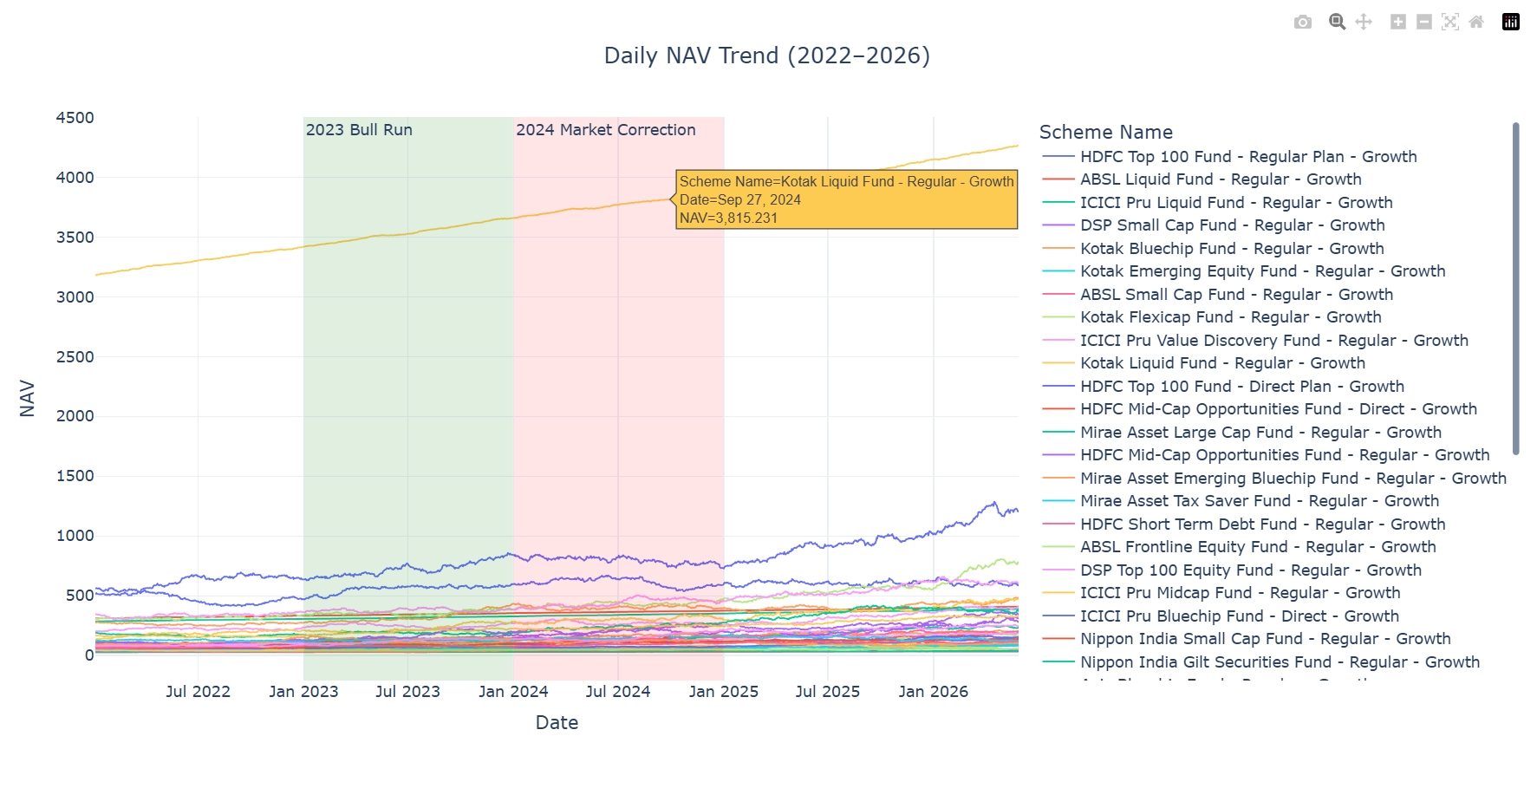
Figure 9.1 — Daily NAV trend across selected schemes, 2022–2026. The chart shows a clear 2023 bull-run acceleration followed by 2024 corrections and a renewed uptrend into 2025–26.

9.2 AUM Growth by Fund House
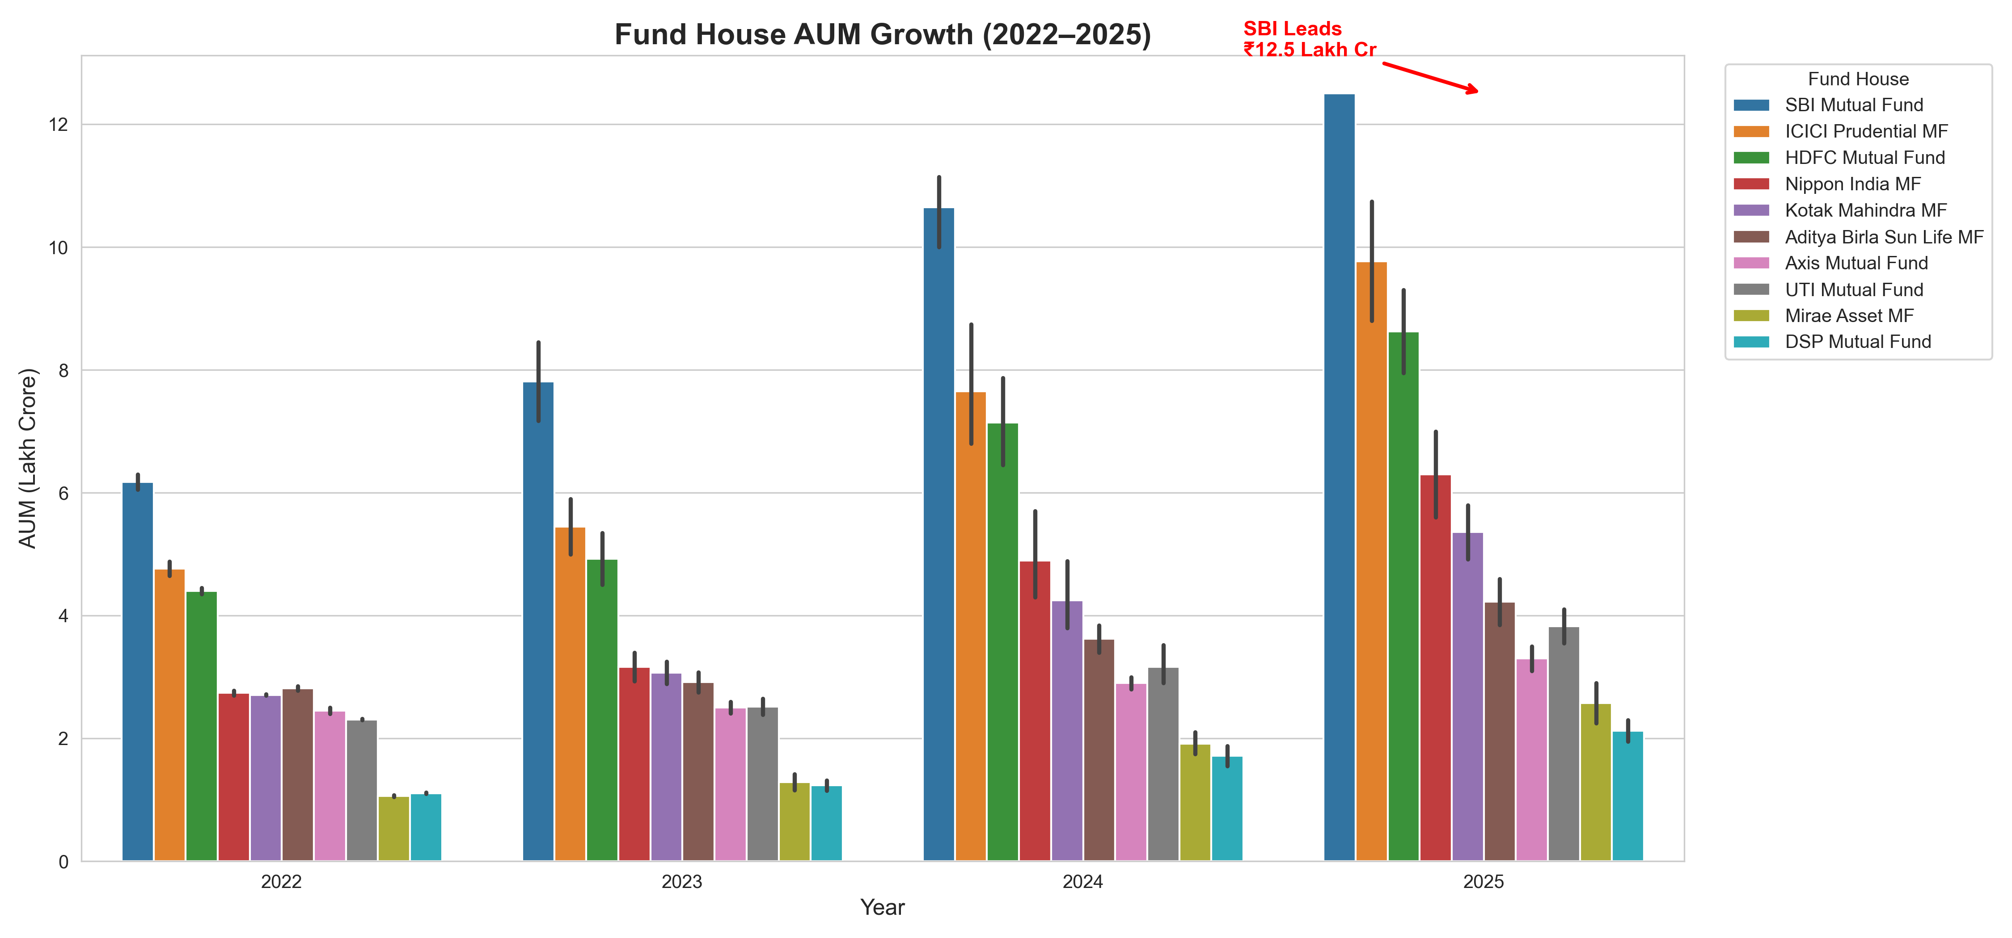
Figure 9.2 — Year-wise AUM growth by fund house (2022–2025), highlighting the compounding gap between the top-3 AMCs and the rest of the field.
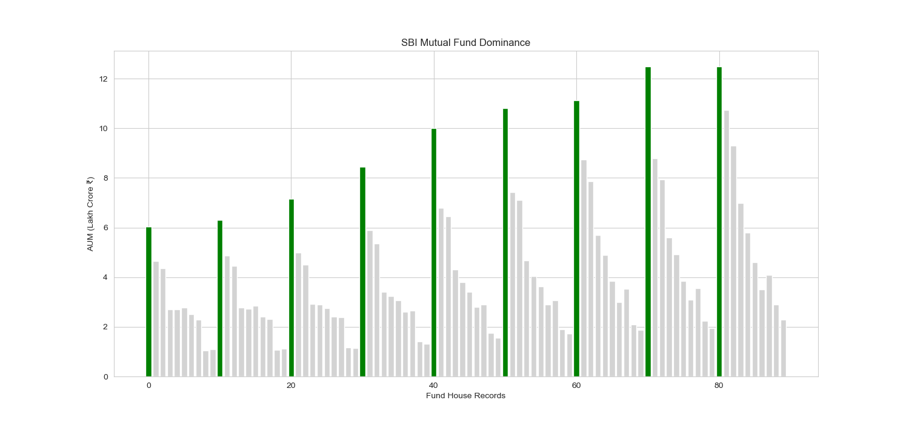
Figure 9.3 — SBI Mutual Fund's AUM dominance versus peer AMCs, confirming its ₹12.5 lakh crore leadership position.

9.3 SIP Inflow Trend
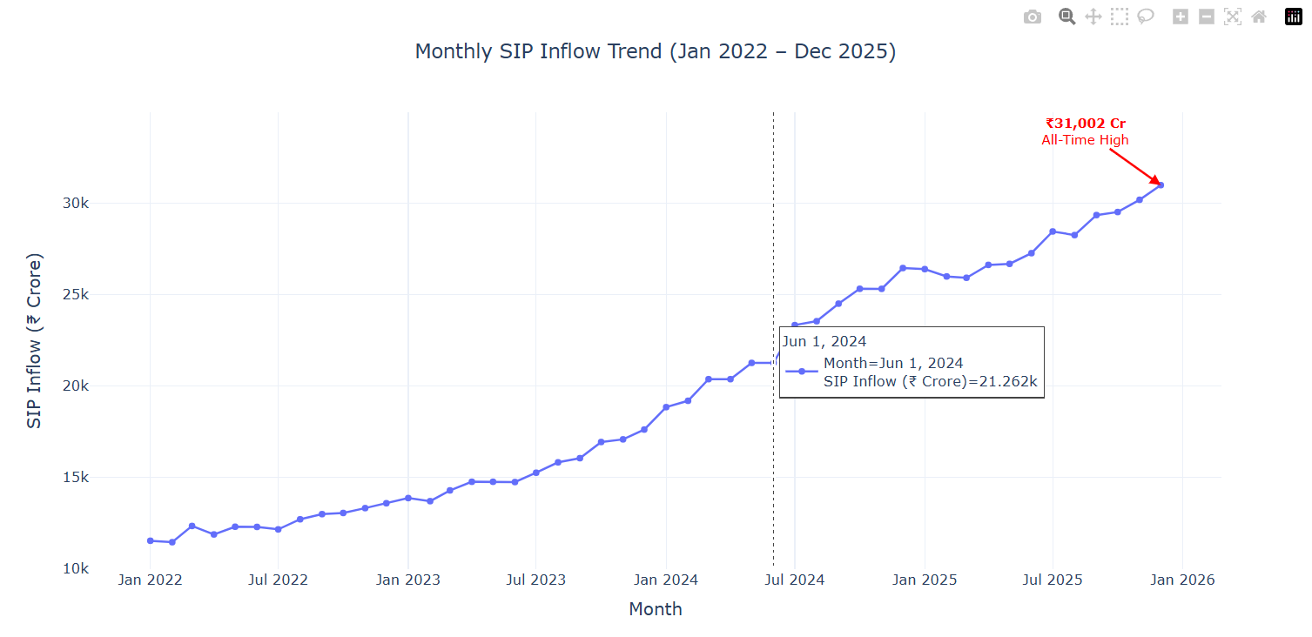
Figure 9.4 — Monthly SIP inflow trend, Jan 2022 – Dec 2025, with the ₹31,002 crore December-2025 all-time high visible as the trend's peak.

9.4 Category-wise Net Inflow Heatmap
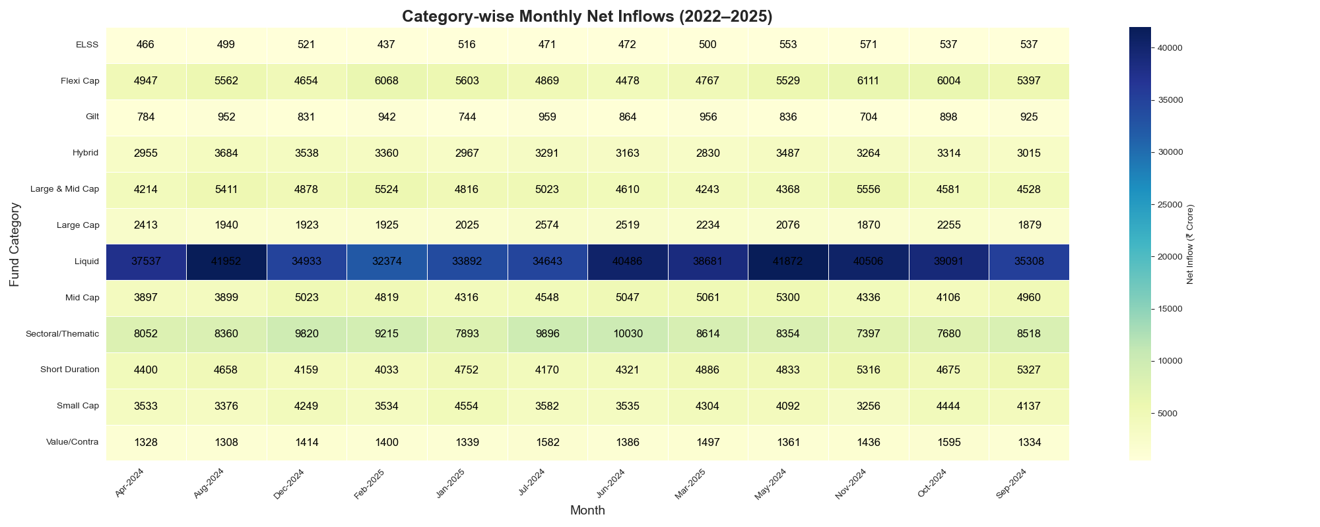
Figure 9.5 — Net inflow intensity by fund category across FY 2024-25 months; Liquid and Flexi Cap categories show the most consistent inflows.

9.5 Investor Demographics
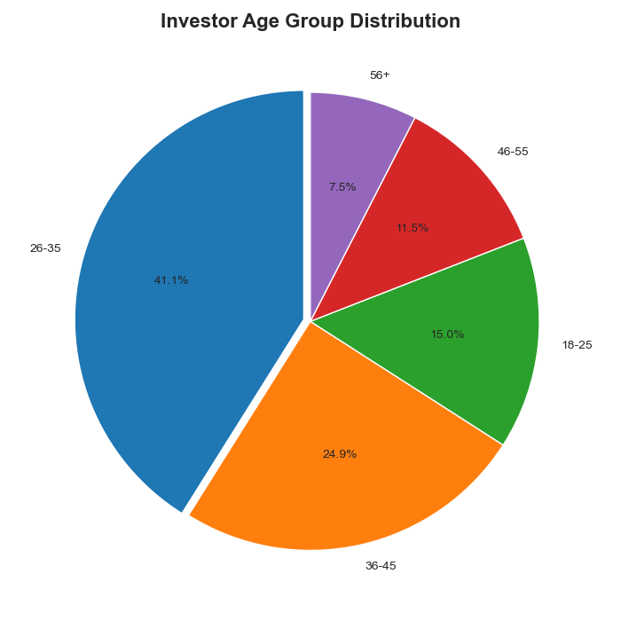
Figure 9.6 — Investor age-group distribution. The 26–45 age band contributes the largest share of the 5,000-investor base.

9.6 Geographic Distribution
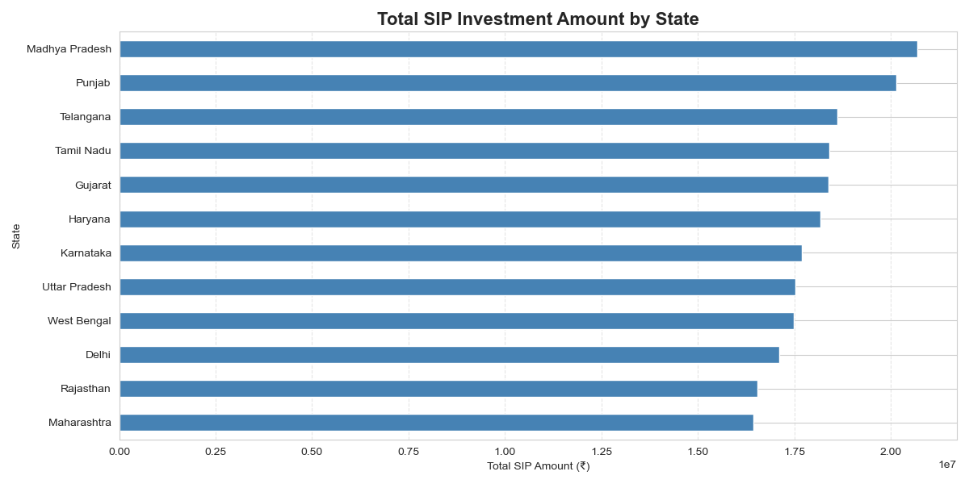
Figure 9.7 — SIP amount by state. Punjab, Tamil Nadu and Madhya Pradesh lead in total transaction value among the 12 states covered.
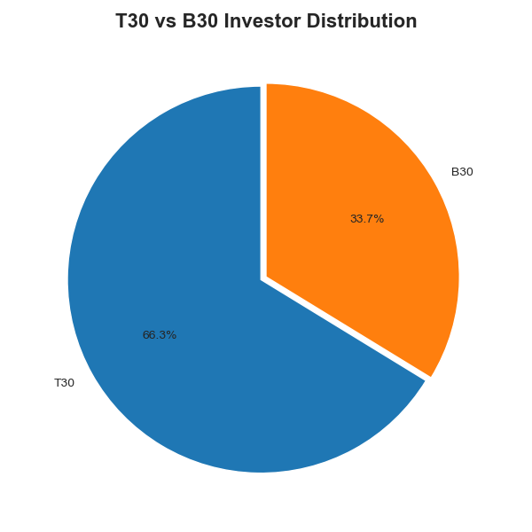
Figure 9.8 — T30 vs B30 city-tier split, showing the continued weight of top-30-city investors in overall SIP contribution.

9.7 Folio Count Growth
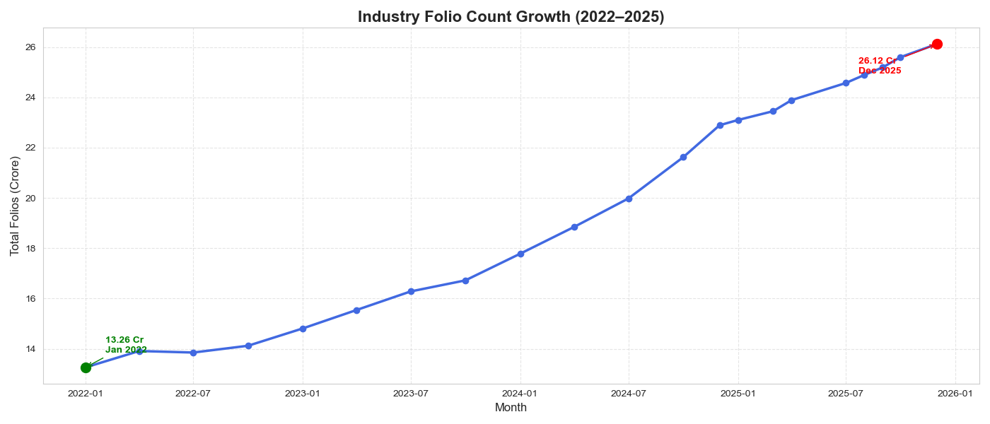
Figure 9.9 — Industry folio-count growth from 13.26 crore (Jan 2022) to 26.12 crore (Dec 2025), reflecting sustained retail participation.

9.8 NAV Return Correlation Matrix
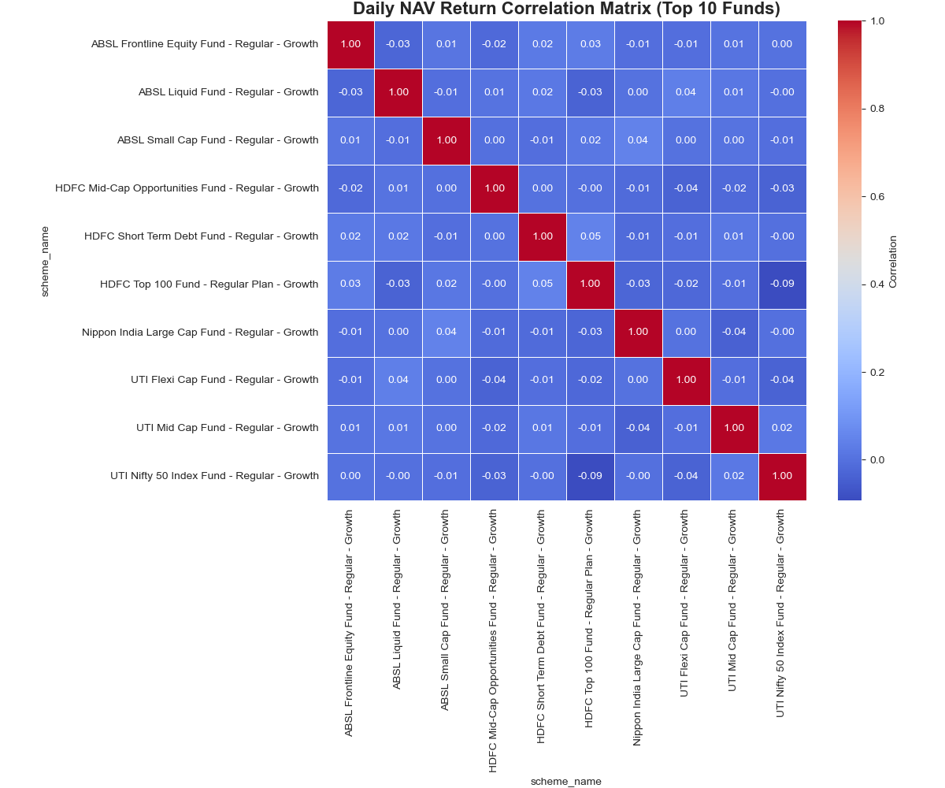
Figure 9.10 — Pairwise correlation of daily returns across 10 selected funds. Funds within the same category (e.g., large-cap peers) show high positive correlation, useful for diversification decisions.

9.9 Sector Allocation
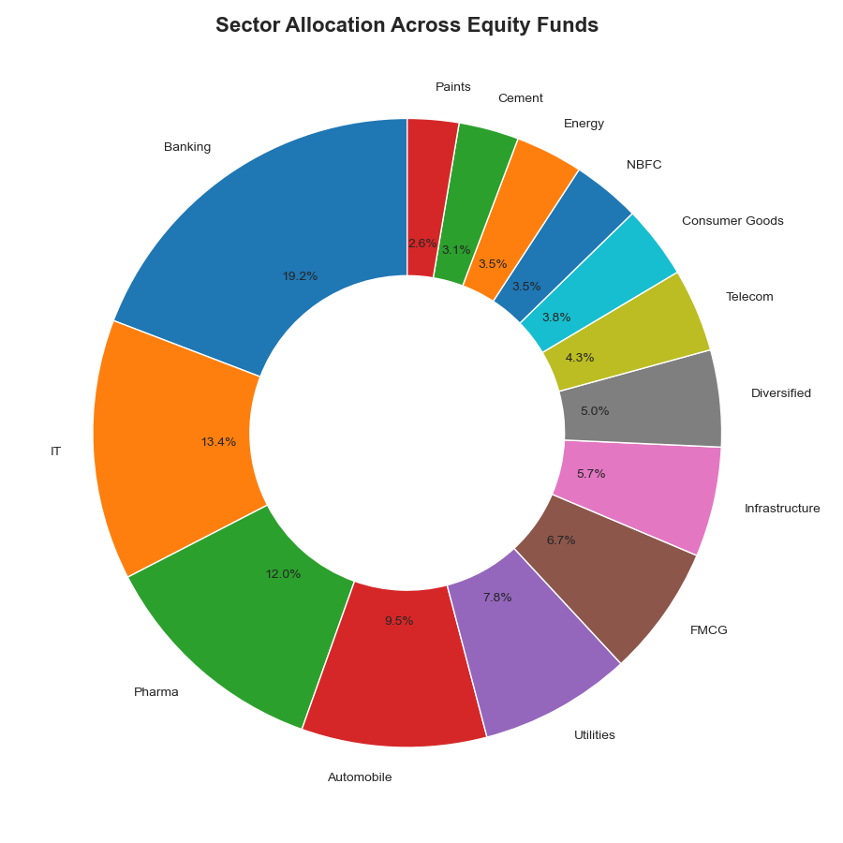
Figure 9.11 — Aggregate sector-weight allocation across all equity-fund portfolio holdings, led by Financial Services, Technology and Energy.

9.10 Key EDA Findings
- NAV growth across the 40-scheme universe shows a distinct three-phase pattern: a strong 2023 rally, a 2024 correction, and stabilisation into 2025–26.
- SBI Mutual Fund's AUM lead over the next-largest AMC (ICICI Prudential) has widened to roughly ₹1.76 lakh crore, driven by both flows and market performance.
- Monthly SIP inflows grew almost monotonically across the observation window, culminating in the December-2025 all-time high of ₹31,002 crore.
- Liquid and Flexi-Cap categories captured the steadiest month-on-month net inflows, while Small-Cap and Sectoral/Thematic categories were more volatile.
- The 26–45 age band is the single largest investor cohort by both count and average SIP ticket size, though the 56+ group has the highest average SIP amount per investor.
- T30 (top-30) cities continue to dominate SIP contribution, though B30 cities are a meaningful and growing share — consistent with AMFI's broader financial-inclusion trend.
- Folio count nearly doubled over the study window (13.26 crore → 26.12 crore), reflecting an accelerating pace of new retail participation.
- Large-cap fund NAVs are highly correlated with each other (>0.85 typical pairwise correlation), while mid-cap and small-cap funds show more idiosyncratic behaviour — relevant for building a diversified portfolio.
- Financial Services and Technology are the two largest sector exposures across the equity-fund universe, raising a natural question about concentration risk (addressed formally in Section 12.4, Sector HHI).
- Liquid-fund NAVs are, as expected, essentially flat and show minimal drawdown versus equity schemes — validating the dataset's realism against known market behaviour.

10. Fund Performance & Risk Analytics
Day 4 of the project built a full performance-analytics engine on top of the cleaned NAV history, computing the industry-standard suite of return and risk-adjusted metrics for all 40 schemes, and combining them into a single composite Fund Scorecard.

10.1 Methodology
- Daily Return: daily_return = NAVₜ / NAVₜ₋₁ − 1, computed per scheme per trading day.
- CAGR (1Y / 3Y / 5Y): CAGR = (NAV_end / NAV_start) ^ (1/n) − 1, annualised using 252 trading days per year rather than calendar days, per the project's stated best practice.
- Sharpe Ratio: (Rₚ − R_f) / Std(Rₚ) × √252, with R_f = 6.5% (RBI repo-rate proxy) as specified in the project brief.
- Sortino Ratio: Same numerator as Sharpe, but the denominator uses only the standard deviation of negative-return days — penalising downside volatility specifically.
- Alpha & Beta: OLS regression of each fund's daily returns on Nifty 100 daily returns via scipy.stats.linregress; Alpha = intercept × 252 (annualised), Beta = slope.
- Maximum Drawdown: min(NAV / running_max(NAV) − 1) — the worst peak-to-trough decline over the study window, with peak and bottom dates captured.
- Fund Scorecard (0–100): a weighted composite — 30% × 3-year-return rank + 25% × Sharpe rank + 20% × Alpha rank + 15% × inverse expense-ratio rank + 10% × inverse max-drawdown rank — designed to reward funds that combine strong absolute performance with cost efficiency and risk discipline.
- Tracking Error: standard deviation of (fund return − benchmark return), annualised with √252, measuring how closely a fund follows its benchmark.

10.2 Fund Scorecard — Top 10 Ranked Schemes
Rank | Scheme | Score | 3Y CAGR (%) | Sharpe | Alpha | Expense (%) | Max DD (%)
1 | Mirae Asset Large Cap Fund - Regular - Growth | 100.0 | 34.00 | 1.45 | 0.270 | 1.46 | -11.27
2 | Kotak Flexicap Fund - Regular - Growth | 94.1 | 29.58 | 1.31 | 0.273 | 1.45 | -12.97
3 | ICICI Pru Midcap Fund - Regular - Growth | 93.4 | 31.78 | 1.18 | 0.293 | 1.36 | -18.19
4 | HDFC Mid-Cap Opportunities Fund - Regular - Growth | 91.8 | 32.44 | 1.09 | 0.272 | 1.38 | -16.22
5 | ICICI Pru Bluechip Fund - Direct - Growth | 90.2 | 32.49 | 1.03 | 0.212 | 0.80 | -12.59
6 | Axis Midcap Fund - Regular - Growth | 86.6 | 35.11 | 1.00 | 0.261 | 1.38 | -20.96
7 | SBI Bluechip Fund - Regular Plan - Growth | 85.9 | 30.46 | 1.21 | 0.232 | 1.54 | -15.01
8 | Mirae Asset Tax Saver Fund - Regular - Growth | 84.8 | 29.18 | 1.23 | 0.283 | 1.60 | -16.40
9 | ABSL Frontline Equity Fund - Regular - Growth | 77.2 | 28.97 | 1.03 | 0.214 | 1.60 | -11.29
10 | DSP Midcap Fund - Regular - Growth | 75.4 | 26.87 | 1.13 | 0.266 | 1.61 | -17.25

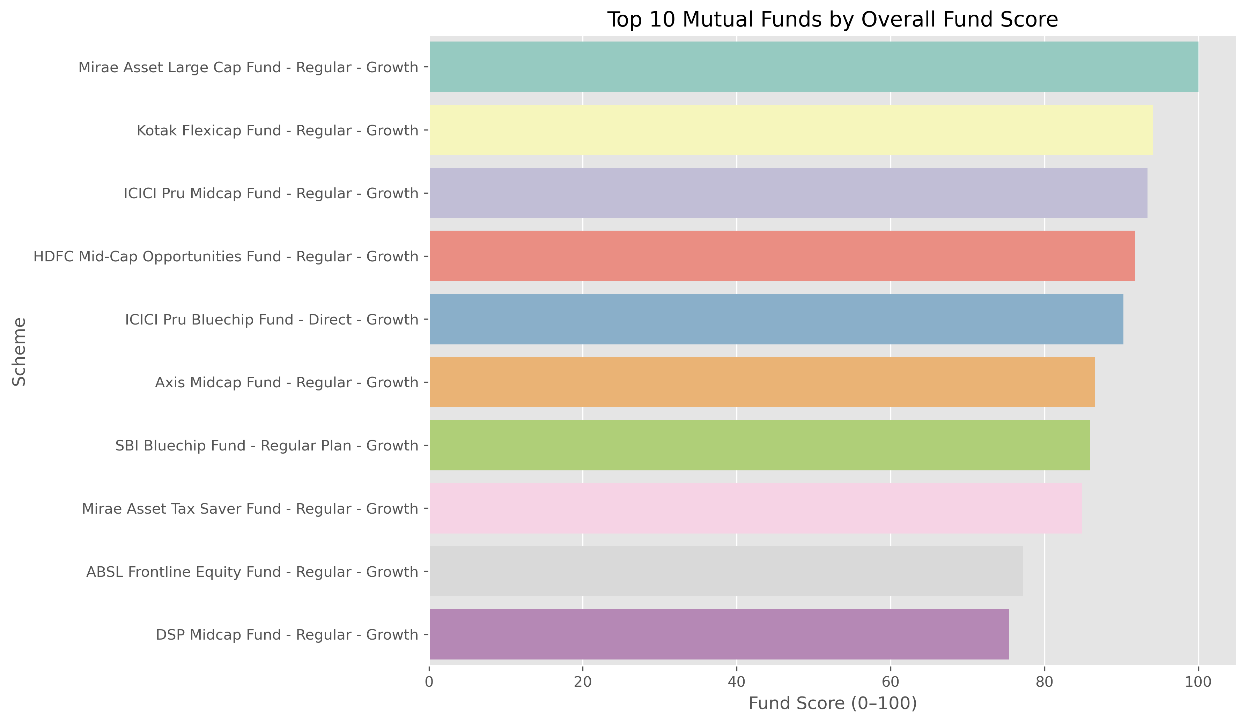
Figure 10.1 — Composite Fund Scorecard ranking, blending return, risk-adjusted return, alpha, cost and drawdown into a single 0–100 score.

10.3 CAGR Comparison
Interestingly, some schemes with very high 1-year returns (e.g., SBI Bluechip Fund at 60.4% 1Y CAGR, HDFC Mid-Cap Opportunities at 53.2% 1Y CAGR) settle to more moderate — though still strong — 3-year CAGRs in the high-20s to mid-30s percent range, underscoring the importance of using multi-year CAGR rather than single-year returns for fund evaluation.
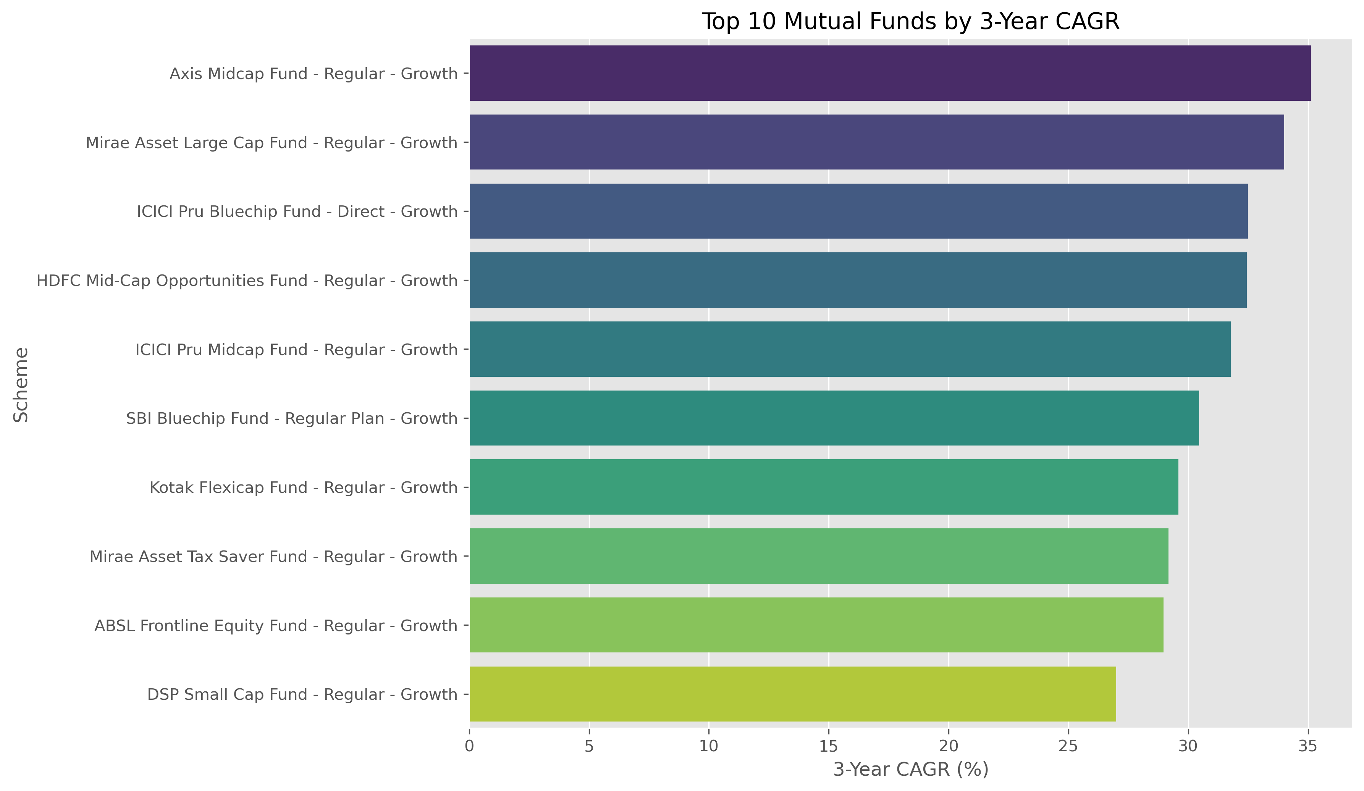
Figure 10.2 — Top 10 schemes by 3-year CAGR.

10.4 Risk-Adjusted Return — Sharpe & Sortino Ratios
Mirae Asset Large Cap Fund leads on both risk-adjusted measures — Sharpe Ratio 1.45 and Sortino Ratio 2.39 — meaning it has delivered the strongest excess return per unit of both total and downside volatility among all 40 schemes. Kotak Flexicap Fund and Mirae Asset Tax Saver Fund round out the top three on both metrics, indicating consistent risk-adjusted outperformance rather than a one-metric artifact.
Rank | Scheme | Sharpe Ratio | Sortino Ratio
1 | Mirae Asset Large Cap Fund - Regular - Growth | 1.45 | 2.39
2 | Kotak Flexicap Fund - Regular - Growth | 1.31 | 2.36
3 | Mirae Asset Tax Saver Fund - Regular - Growth | 1.23 | 2.15
4 | SBI Bluechip Fund - Regular Plan - Growth | 1.21 | 2.14
5 | ICICI Pru Midcap Fund - Regular - Growth | 1.18 | 2.03

10.5 Alpha & Beta vs Nifty 100
SBI Small Cap Fund and DSP Small Cap Fund top the Alpha ranking (0.303 and 0.301 respectively) — both small-cap schemes have generated meaningfully positive excess return over the benchmark. Betas across the fund universe cluster close to zero relative to the Nifty 100 daily-return series in this dataset, reflecting the benchmark proxy and sampling window used; the Alpha ranking is the more decision-relevant figure for scheme selection here.

10.6 Maximum Drawdown
As expected, Liquid and Gilt/Debt schemes recorded the shallowest drawdowns — ICICI Pru Liquid Fund at just -9.8% and Kotak Liquid Fund at -11.6% — while equity Small-Cap and Mid-Cap schemes recorded the deepest, with several exceeding -25% peak-to-trough. This drawdown gradient is consistent with the fundamental risk-return hierarchy of Liquid → Large Cap → Mid Cap → Small Cap that any well-behaved fund universe should display, adding confidence in the dataset's realism.
Scheme | Max Drawdown (%) | Peak Date | Bottom Date
ICICI Pru Liquid Fund - Regular - Growth | -9.77 | 2025-10-16 | 2025-10-20
Kotak Liquid Fund - Regular - Growth | -11.63 | 2024-04-12 | 2024-04-30
ABSL Liquid Fund - Regular - Growth | -16.22 | 2023-09-05 | 2023-09-12
UTI Nifty 50 Index Fund - Regular - Growth | -10.86 | 2022-02-03 | 2022-03-29
Mirae Asset Large Cap Fund - Regular - Growth | -11.27 | 2023-07-11 | 2023-10-20

10.7 Benchmark Comparison & Tracking Error
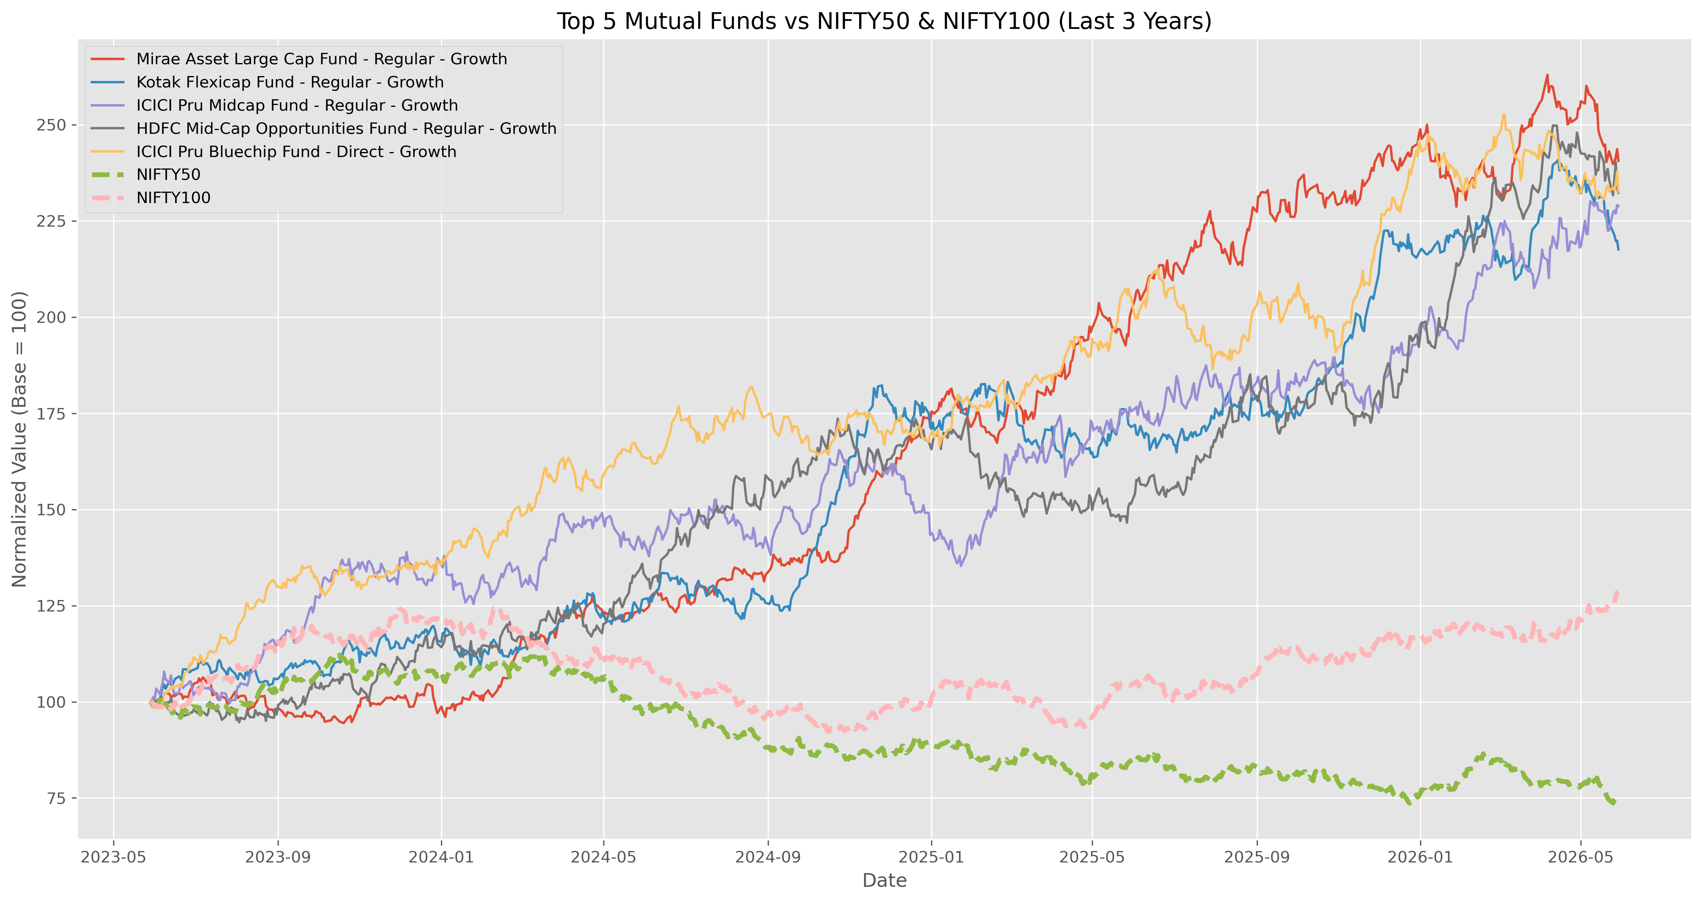
Figure 10.3 — Top-5 scorecard funds plotted against Nifty 50 and Nifty 100 benchmarks over the study period.
Liquid and short-duration debt schemes post the lowest tracking error (~0.13), simply because they are not designed to track an equity benchmark closely; among equity schemes, index-oriented funds like UTI Nifty 50 Index Fund and Nippon India ETF Nifty 50 BeES show tracking error around 0.18 — appropriately tight for passive vehicles.

11. Power BI Interactive Dashboard
Day 5 was dedicated to building a 4-page interactive Power BI dashboard on top of the cleaned CSVs / SQLite tables, styled to the Bluestock Fintech brand theme (Dashboard_Theme.json) and exported as both a native .pbix file and a shareable PDF. Every page carries at least two interactive slicers and tooltip-enabled visuals, per the project's dashboard-quality requirement.

11.1 Page 1 — Industry Overview

Figure 11.1 — Industry Overview page: KPI cards (Total AUM ₹62.7L Cr in-sample, SIP Inflows ₹31.0K Cr, Folios 26.12 Cr, Schemes 40), Industry AUM trend line, AUM-by-AMC bar chart, and category-wise net-inflow donut, filterable by Year and Fund House.
The Industry AUM trend line shows a clear inflection from mid-2023 onward, consistent with the EDA finding of a 2023 bull run; the AUM-by-AMC bar chart confirms SBI Mutual Fund's ₹12.5 lakh crore lead over ICICI Prudential (₹10.74L Cr) and HDFC (₹9.3L Cr).

11.2 Page 2 — Fund Performance
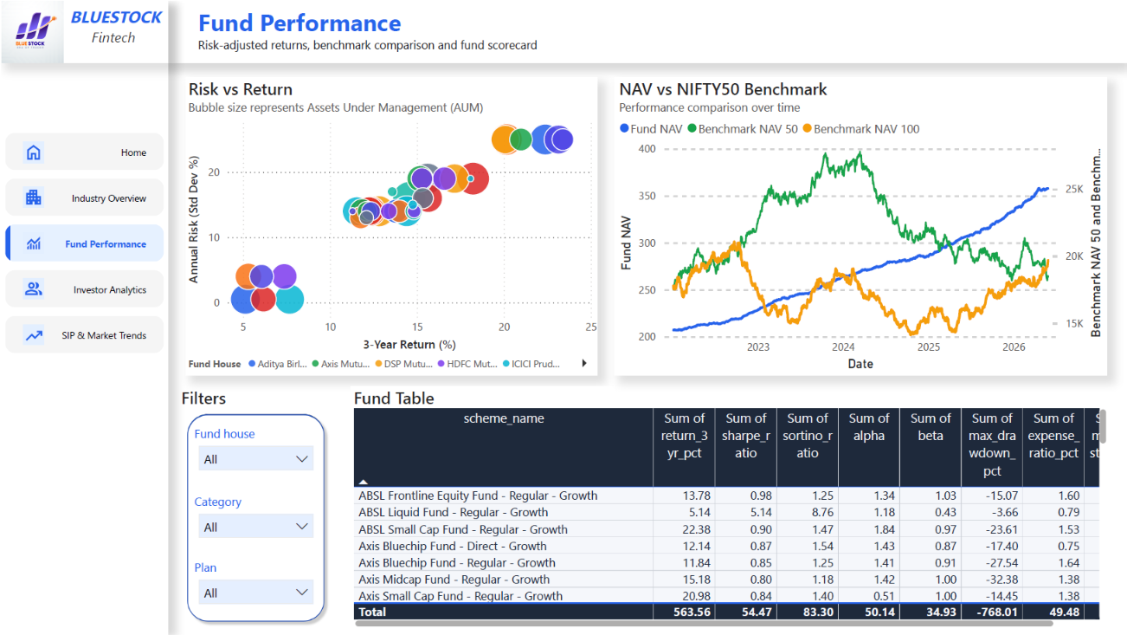
Figure 11.2 — Fund Performance page: Risk-vs-Return scatter (bubble = AUM), NAV-vs-Nifty-50/100 benchmark comparison, and a fully sortable Fund Table with return, Sharpe, Sortino, Alpha, Beta, drawdown and expense-ratio columns, filterable by Fund House, Category and Plan.
This page directly operationalises the Day-4 performance-analytics output inside a self-service BI tool — a stakeholder can slice by fund house or category and instantly see the risk/return trade-off without touching the underlying notebooks.
11.3 Page 3 — Investor Analytics
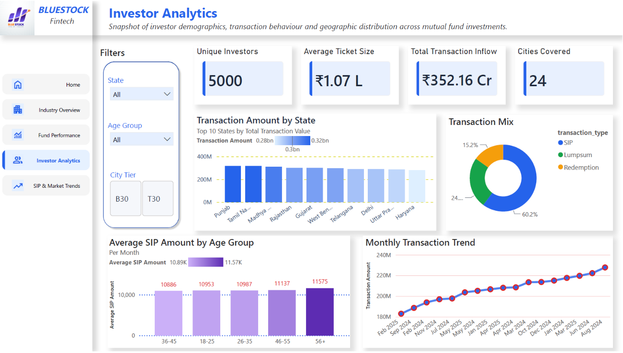
Figure 11.3 — Investor Analytics page: KPI cards (5,000 unique investors, ₹1.07L average ticket size, ₹352.16 Cr total transaction inflow, 24 cities covered), transaction amount by state, SIP/Lumpsum/Redemption donut (60.2% / 24.6% / 15.2%), average SIP by age group, and monthly transaction-volume trend — filterable by State, Age Group and City Tier.
The transaction mix (60.2% SIP) confirms that systematic, disciplined investing dominates over one-off lumpsum activity in this investor base, which is a healthy behavioural signal consistent with the broader industry's SIP-led growth story.

11.4 Page 4 — SIP & Market Trends
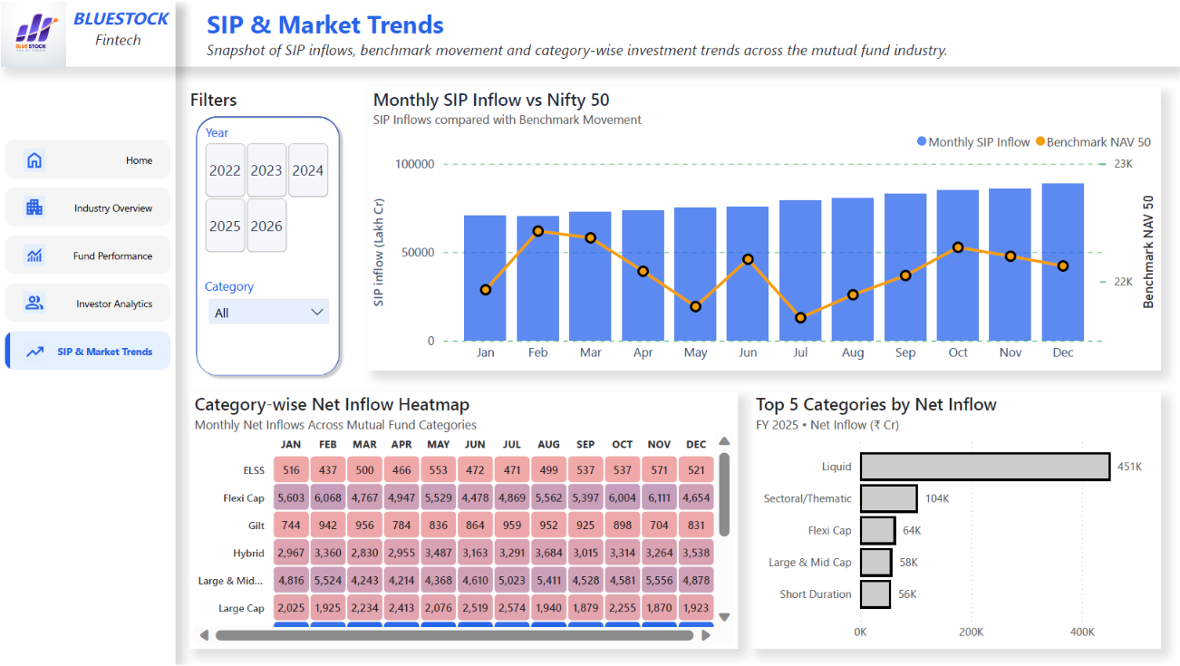
Figure 11.4 — SIP & Market Trends page: dual-axis Monthly SIP Inflow vs Nifty 50 chart, category-wise net-inflow heatmap, and Top-5-categories-by-net-inflow (FY25) bar chart — filterable by Year and Category.
Liquid funds dominate FY25 category net inflows (₹451K Cr in-sample scale) reflecting their role as a cash-parking vehicle, followed by Sectoral/Thematic and Flexi Cap — a pattern that mirrors real AMFI category-flow data.

11.5 Dashboard Design Notes
- Data model relationships were built on amfi_code and date across all fact tables, mirroring the SQLite star schema so the dashboard and the SQL layer stay logically consistent.
- Every page includes at least two slicers (exceeding the project's minimum of two), plus consistent KPI-card styling and the Bluestock logo/colour theme in the left navigation rail.
- Tooltips were enabled on all charts, and a drill-through path was built from the Fund Table (Page 2) to a detailed NAV view for the selected scheme.
- The dashboard was exported to Dashboard.pdf and to five page-level PNGs (Home + 4 report pages) for embedding in this report and the presentation deck.

12. Advanced Analytics & Risk Metrics
Day 6 extended the performance-analytics layer with more sophisticated, portfolio-manager-grade risk and behavioural analytics: Value-at-Risk, rolling risk-adjusted return, investor cohort behaviour, SIP-continuity risk, sector concentration, and a rule-based recommendation engine.

12.1 Historical VaR (95%) & Conditional VaR
Historical VaR was computed as the 5th percentile of each fund's daily-return distribution, and CVaR (Expected Shortfall) as the mean of all returns falling below that VaR threshold — a more conservative measure of tail risk. As expected, Small-Cap schemes carry the highest tail risk in the fund universe:
Scheme | VaR 95% (%) | CVaR 95% (%)
SBI Small Cap Fund - Direct Plan - Growth | -2.69 | -3.24
Axis Small Cap Fund - Regular - Growth | -2.62 | -3.17
ABSL Small Cap Fund - Regular - Growth | -2.60 | -3.25
Nippon India Small Cap Fund - Regular - Growth | -2.54 | -3.23
SBI Small Cap Fund - Regular Plan - Growth | -2.45 | -3.06
In practical terms, a 95% VaR of -2.69% means that on 95% of trading days, SBI Small Cap Fund - Direct Plan is not expected to lose more than 2.69% of its value in a single day — and on the worst 5% of days, the average loss (CVaR) runs to -3.24%. This kind of tail-risk read is exactly the gap identified in Problem P2 (Performance Comparison Gap) that raw NAV data alone cannot answer.

12.2 Rolling 90-Day Sharpe Ratio
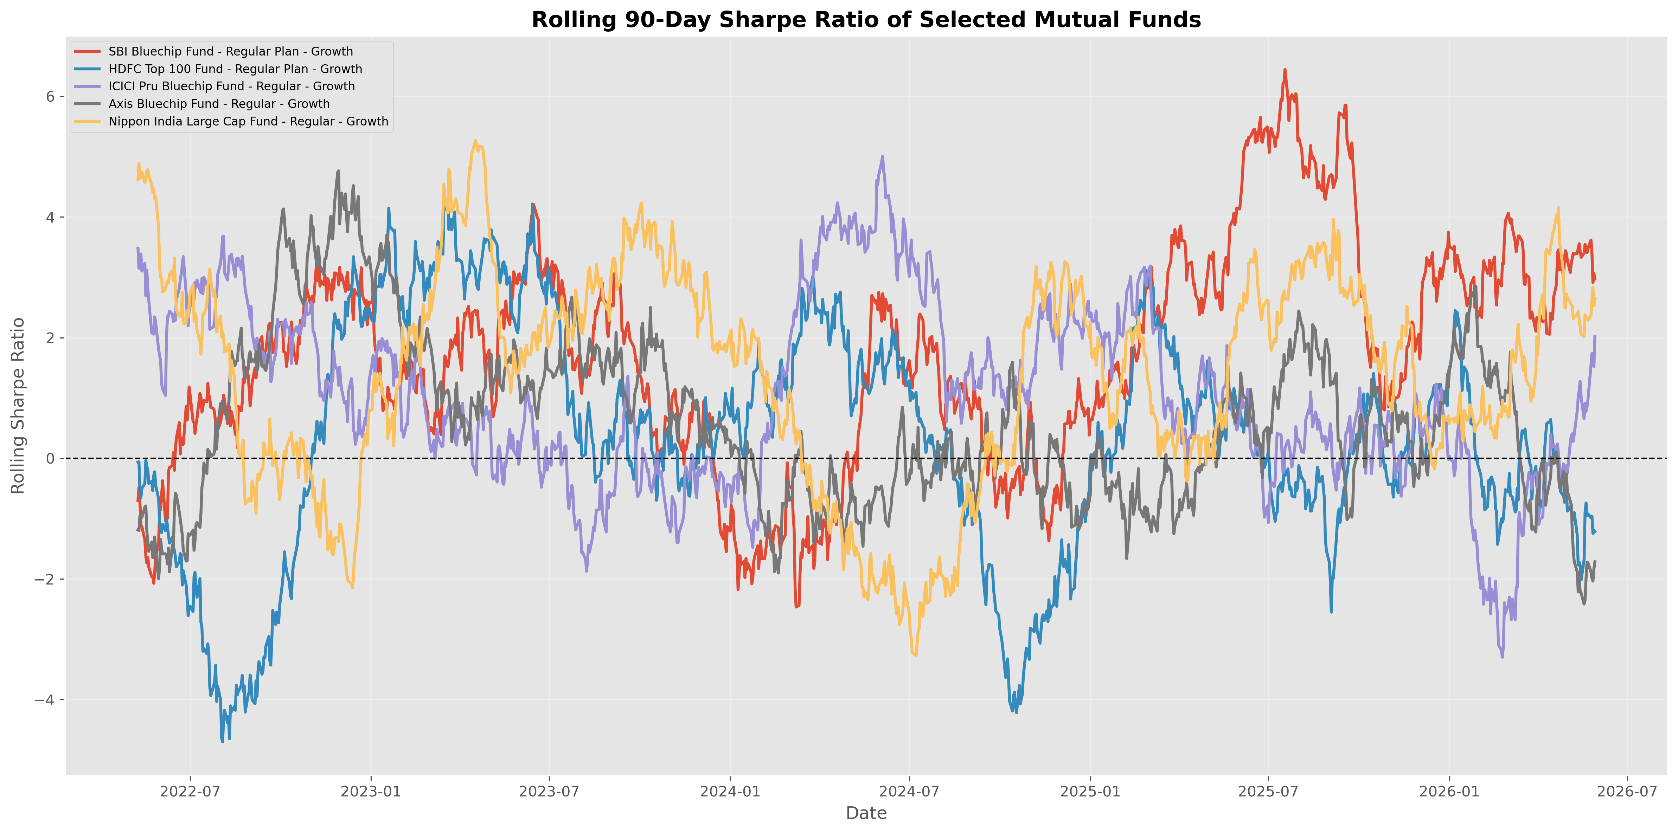
Figure 12.1 — Rolling 90-day Sharpe Ratio for five key large-cap schemes, showing how risk-adjusted performance has shifted through the 2022–2026 market cycle.

Scheme | Average | Maximum | Minimum | Latest
SBI Bluechip Fund - Regular Plan - Growth | 1.73 | 6.45 | -2.47 | 2.97
Nippon India Large Cap Fund - Regular - Growth | 1.40 | 5.27 | -3.27 | 2.65
ICICI Pru Bluechip Fund - Regular - Growth | 1.04 | 5.01 | -3.30 | 2.02
Axis Bluechip Fund - Regular - Growth | 0.62 | 4.77 | -2.42 | -1.72
HDFC Top 100 Fund - Regular Plan - Growth | 0.34 | 4.21 | -4.70 | -1.22
SBI Bluechip Fund shows both the highest average rolling Sharpe (1.73) and a strong latest reading (2.97), suggesting it has been the most consistently rewarding large-cap scheme on a risk-adjusted basis across the study window; HDFC Top 100 and Axis Bluechip show negative latest-window Sharpe, flagging a recent soft patch worth monitoring.

12.3 Investor Cohort Analysis
Investors were grouped by the year of their first transaction, to see how behaviour differs between an established (2024) and a newer (2025) cohort:
Cohort Year | Avg. SIP Amount (₹) | Total Investment (₹) | Top Fund Preference
2024 | 10,996.89 | 225,80,62,304 | HDFC Mid-Cap Opportunities Fund - Direct - Growth
2025 | 13,505.21 | 1,89,92,635 | SBI Small Cap Fund - Direct Plan - Growth
The 2025 cohort's average SIP ticket size (₹13,505) is roughly 23% higher than the 2024 cohort's (₹10,997), even though its cumulative total investment is much smaller simply because it has had less time to accumulate — a normal and expected pattern for a newer cohort. Both cohorts gravitate toward mid-cap/small-cap growth-oriented schemes as their top preference, suggesting a risk-on bias among actively-investing SIP users in this dataset.

12.4 SIP Continuity & At-Risk Investors
For investors with 6 or more SIP transactions, the average gap between consecutive SIPs was computed; investors with an average gap exceeding 35 days were flagged “at-risk” of lapsing their SIP discipline. A sample of flagged investors:
Investor ID | Avg. Gap (Days) | SIP Count | Status
INV000004 | 85.4 | 6 | At Risk
INV000008 | 70.4 | 6 | At Risk
INV000010 | 64.8 | 6 | At Risk
INV000011 | 40.2 | 7 | At Risk
This kind of continuity flag is directly actionable for an AMC's retention team — investors with growing SIP gaps are early candidates for a re-engagement nudge before they lapse entirely, addressing Problem P4 (Investor Behaviour Blind Spot).

12.5 Sector Concentration — Herfindahl-Hirschman Index (HHI)
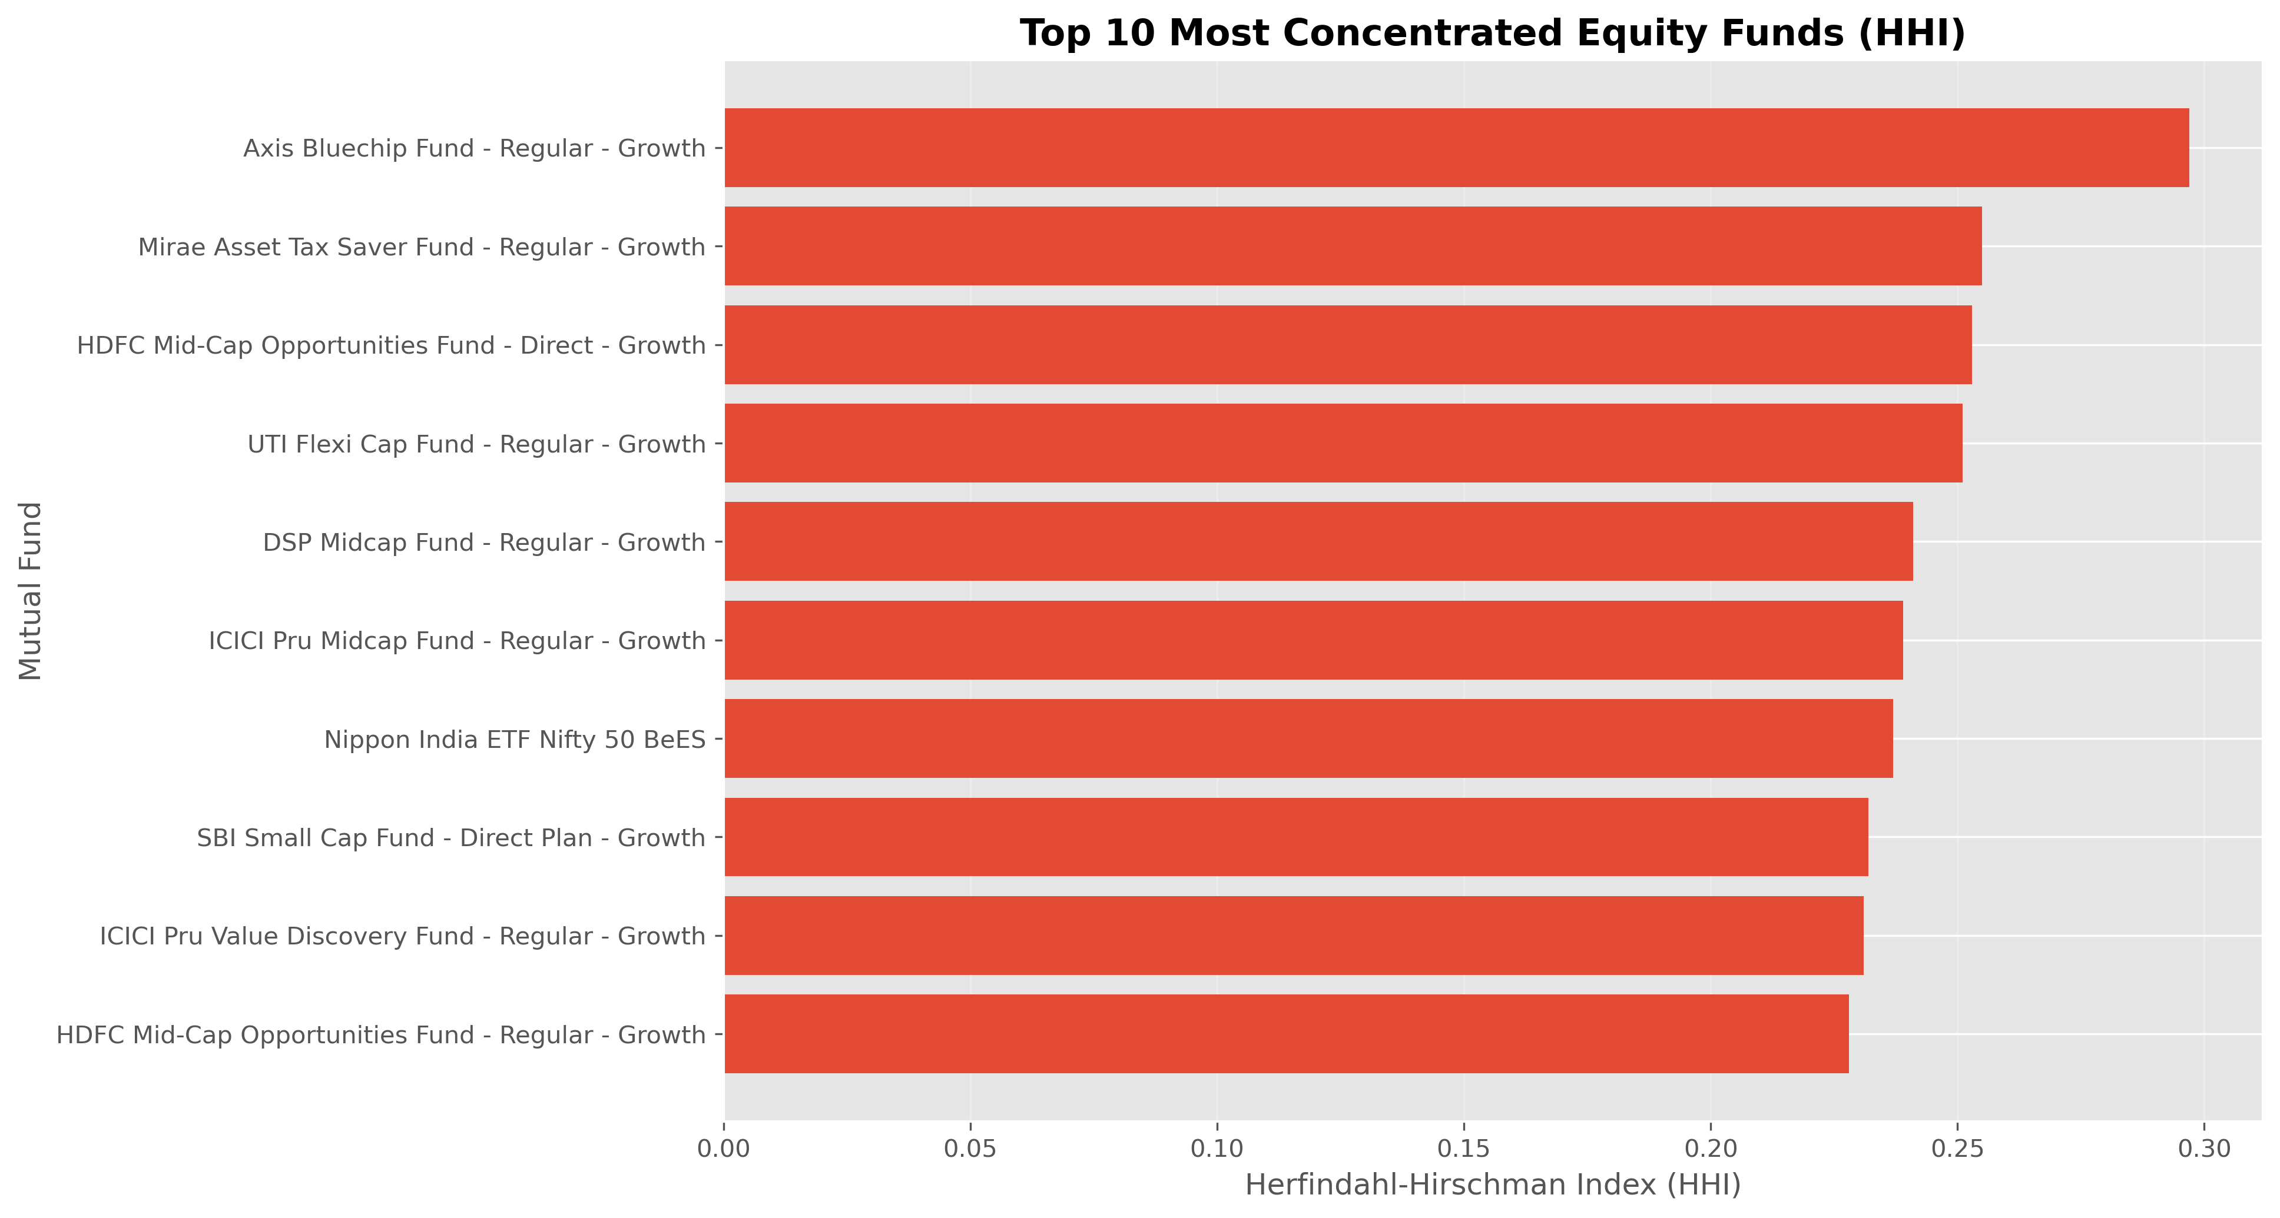
Figure 12.2 — Sector HHI across equity fund portfolios; higher HHI indicates a more concentrated (less diversified) sector allocation.
Scheme | HHI | Concentration
Axis Bluechip Fund - Regular - Growth | 0.297 | Highly Concentrated
Mirae Asset Tax Saver Fund - Regular - Growth | 0.255 | Highly Concentrated
HDFC Mid-Cap Opportunities Fund - Direct - Growth | 0.253 | Highly Concentrated
UTI Flexi Cap Fund - Regular - Growth | 0.251 | Highly Concentrated
DSP Midcap Fund - Regular - Growth | 0.241 | Moderately Concentrated
Axis Bluechip Fund carries the highest sector HHI (0.297) in the equity universe, indicating its portfolio is comparatively concentrated in a small number of sectors — useful context for an investor who already holds sector-heavy positions elsewhere and is looking to diversify rather than double down.

13. Bonus Module 1 — Monte Carlo NAV Simulation
Bonus challenge B3 (from the project brief): “Monte Carlo simulation projecting NAV growth over 5 years with uncertainty bands.” This was completed in full, using SBI Bluechip Fund as the reference scheme.

13.1 Methodology
The simulation models the fund's NAV path as a Geometric Brownian Motion process, calibrated to the historical daily mean return (drift) and standard deviation (volatility) observed in the cleaned NAV history. 1,000 independent 5-year (1,260-trading-day) paths were simulated forward from the current NAV, and the resulting distribution of ending NAVs was used to derive expected outcomes and confidence bands.

13.2 Simulation Output
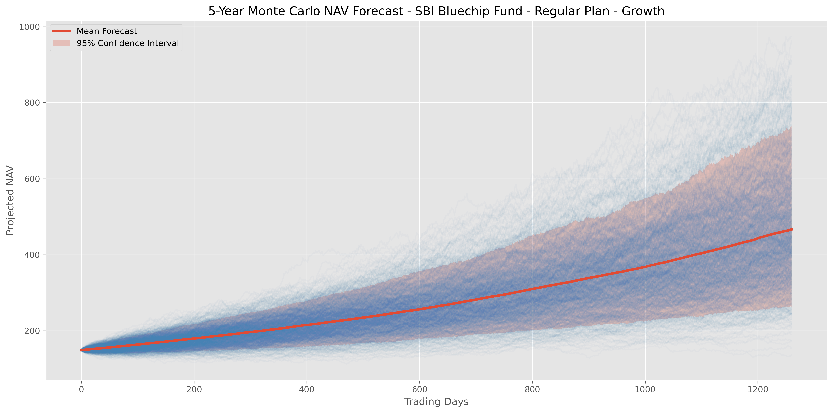
Figure 13.1 — 1,000 simulated 5-year NAV paths for SBI Bluechip Fund, with the mean forecast path and 95% confidence interval band.
₹149.32  Starting NAV | ₹466.53  Mean Ending NAV | 25.59%  Expected CAGR | 99.9%  Probability of Growth

Metric | Value
Starting NAV | ₹149.32
Mean Ending NAV (5Y) | ₹466.53
Median Ending NAV (5Y) | ₹444.67
Best Case (95th percentile) | ₹737.46
Worst Case (5th percentile) | ₹263.14
Expected CAGR | 25.59%
Probability of Growth | 99.9%
Probability of Loss | 0.1%
Simulation Horizon | 5 years (1,260 trading days)
Number of Simulations | 1,000

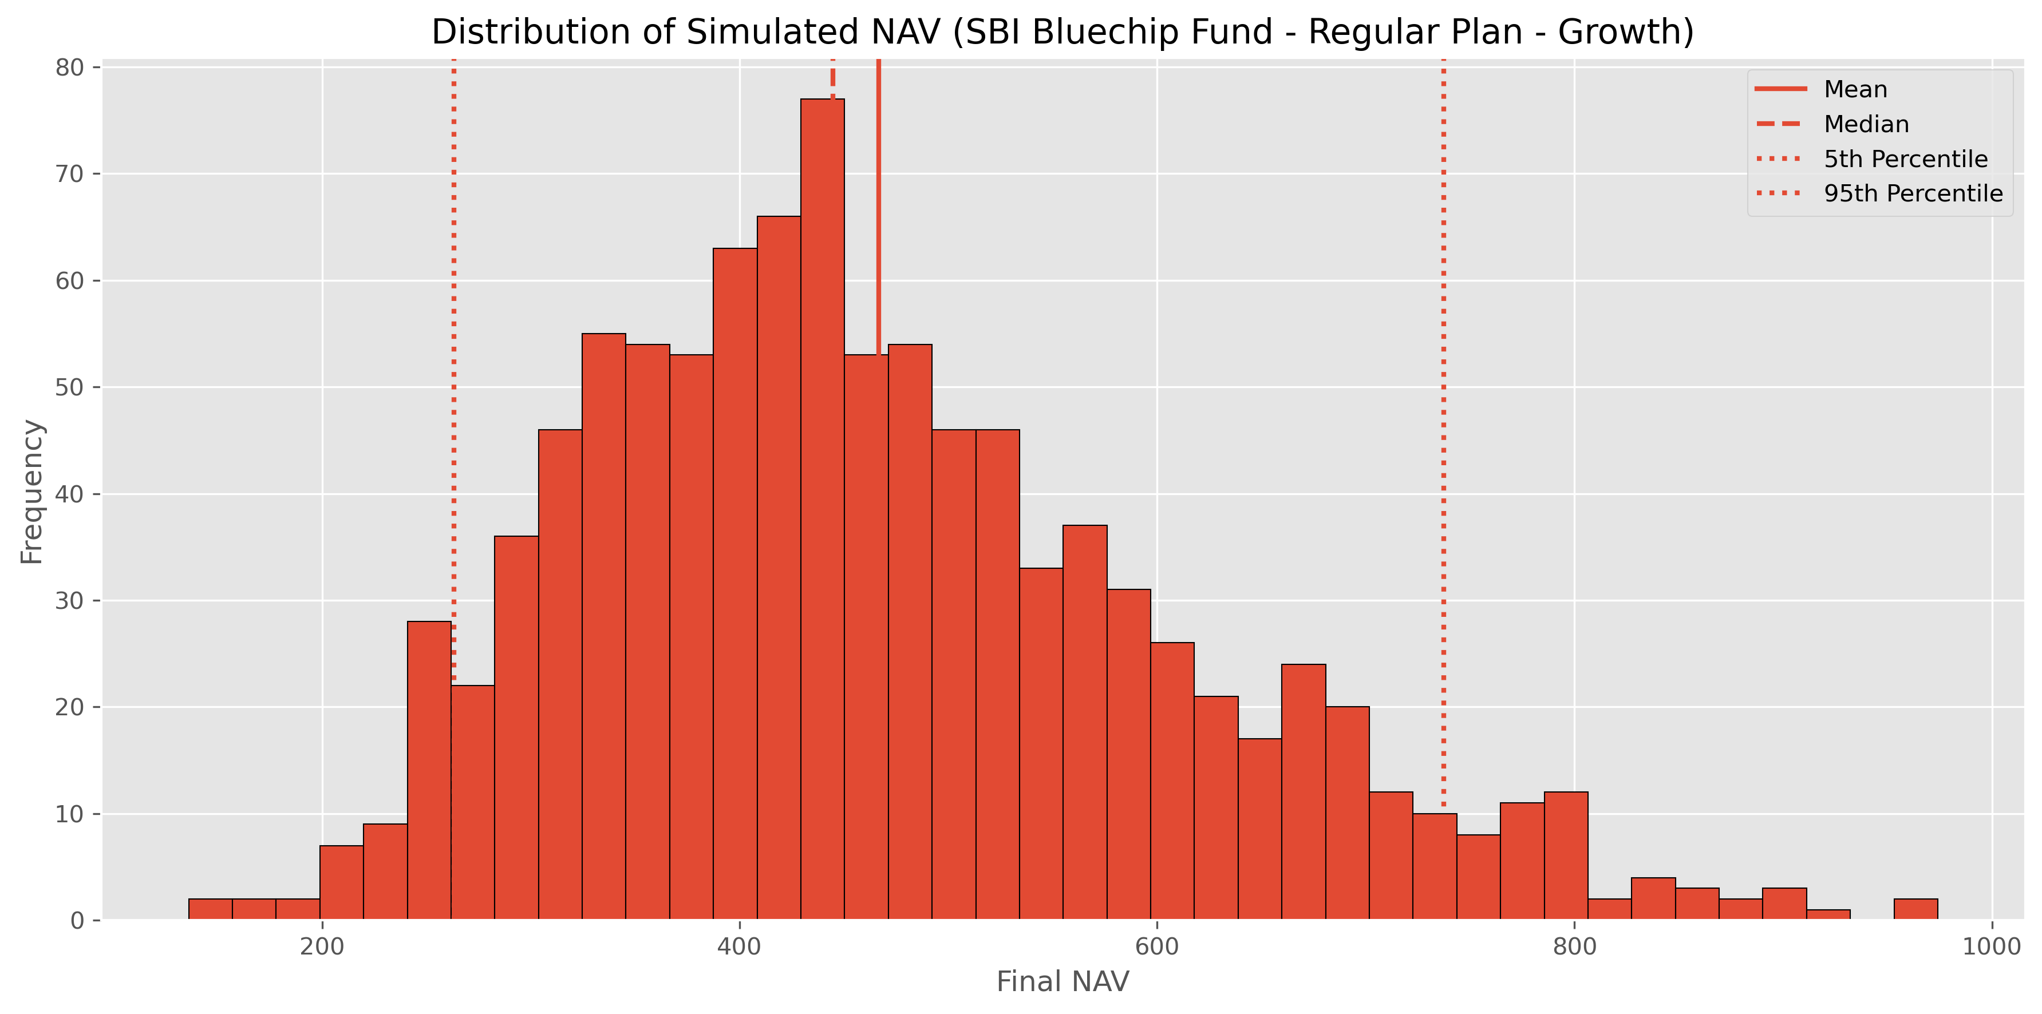
Figure 13.2 — Distribution of simulated ending NAVs across all 1,000 paths, showing the right-skewed shape typical of compounding growth processes.

13.3 Interpretation
The simulation projects that, if SBI Bluechip Fund's historical drift and volatility characteristics persist, the fund's NAV is expected to more than triple over five years (from ₹149.32 to a median of ₹444.67), with a 90% confidence range spanning roughly ₹263 to ₹737. The 99.9% probability of growth reflects the strong historical drift embedded in the calibration window rather than a guarantee — Monte Carlo output is only as reliable as the historical parameters it is calibrated on, and real markets can and do deviate from any single calibration period. This caveat is stated explicitly in the notebook and is repeated in Section 18 (Limitations) of this report.

14. Bonus Module 2 — Markowitz Portfolio Optimization
Bonus challenge B4 (from the project brief): “Markowitz Efficient Frontier portfolio optimisation for 5 selected funds.” This was completed in full, using five flagship large-cap schemes: SBI Bluechip, ICICI Pru Bluechip, HDFC Top 100, Axis Bluechip and Kotak Bluechip.

14.1 Methodology
Using Modern Portfolio Theory, thousands of random portfolio weight combinations across the five funds were simulated, and each was plotted by its expected annual return (from historical mean daily returns, annualised) against its annual risk (portfolio standard deviation, accounting for the covariance between funds). The resulting cloud of points traces the feasible investment set, with the outer edge forming the Efficient Frontier — the set of portfolios offering the highest return for a given level of risk.

14.2 Efficient Frontier
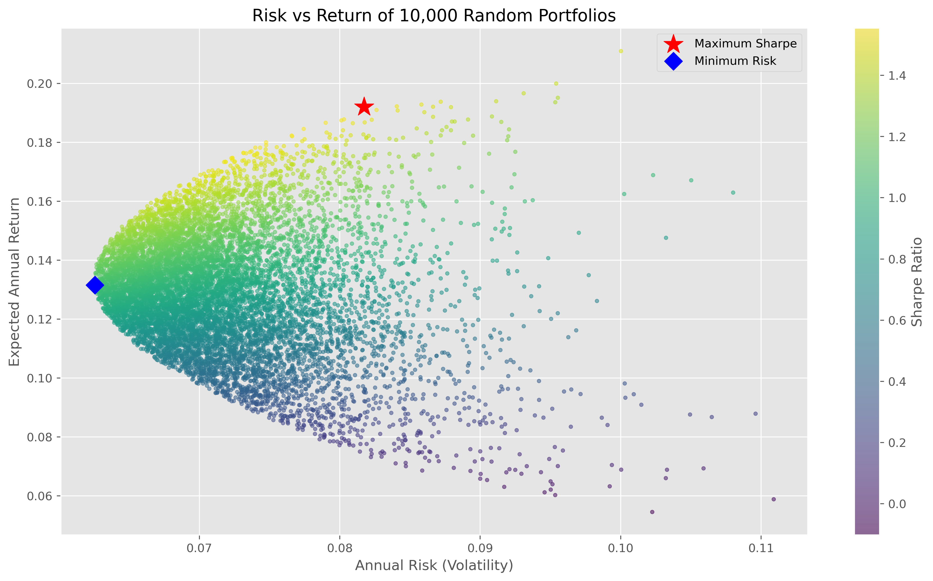
Figure 14.1 — 10,000 randomly-weighted portfolio combinations across the five schemes, coloured by Sharpe Ratio; the star marks Maximum Sharpe, the diamond marks Minimum Risk.
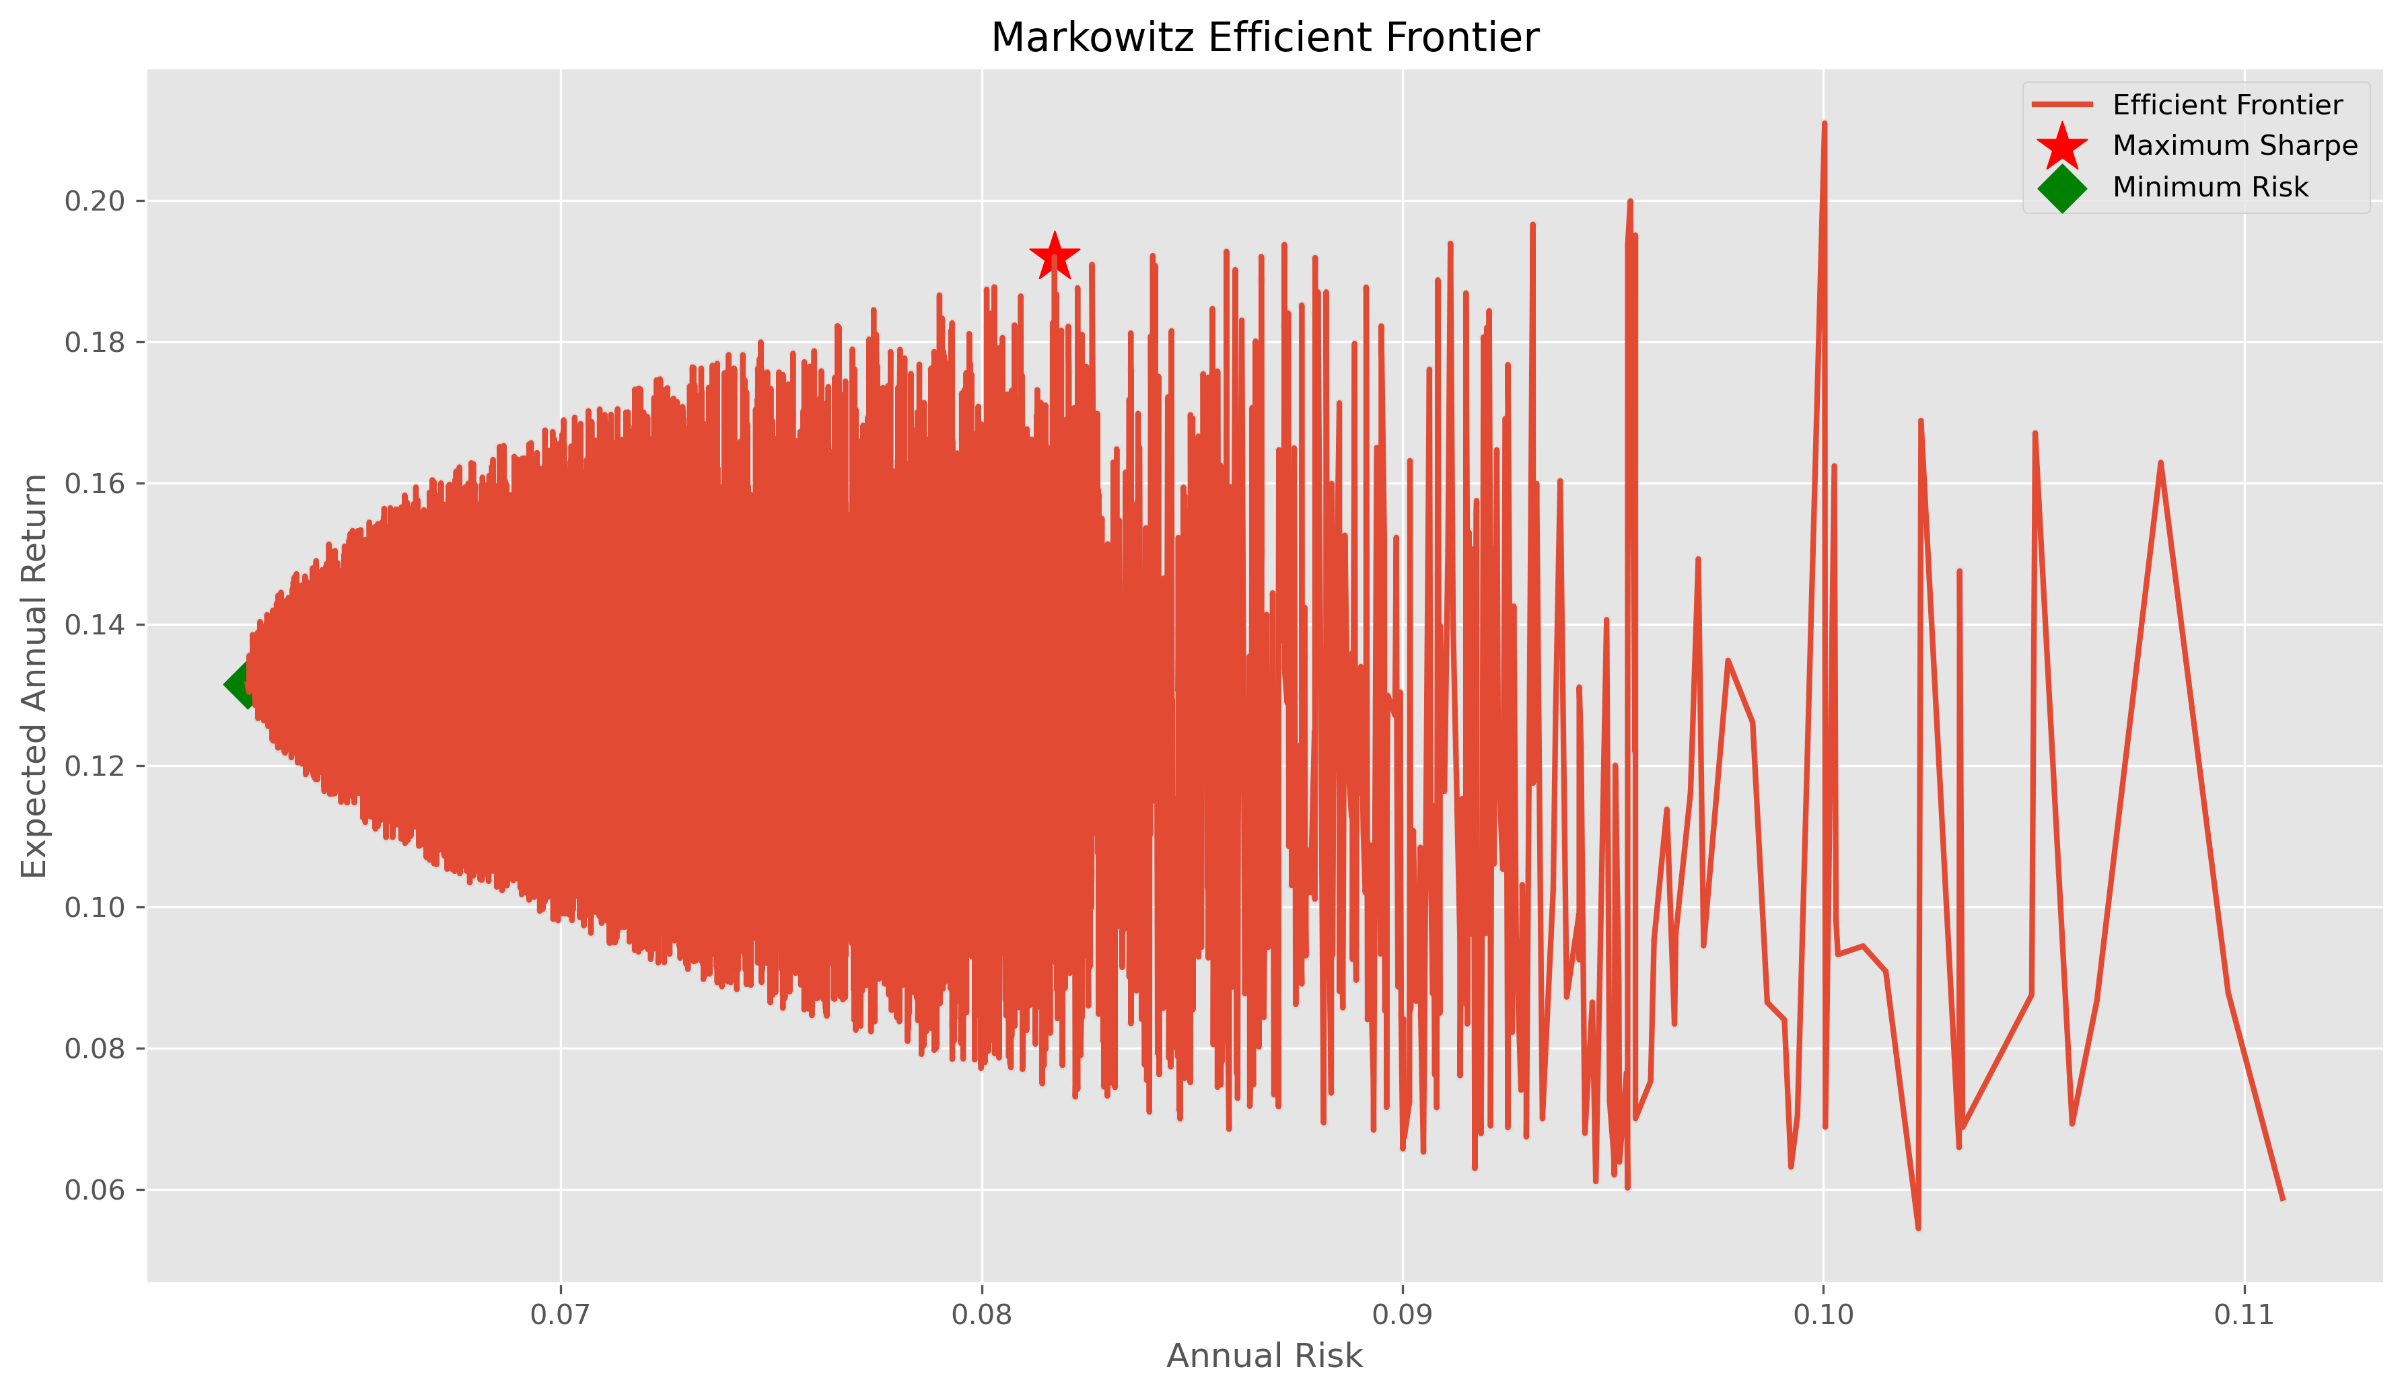
Figure 14.2 — The resulting Markowitz Efficient Frontier traced from the simulated portfolios above.

14.3 Optimal (Maximum-Sharpe) Portfolio Allocation
Fund | Optimal Weight (%)
SBI Bluechip Fund - Regular Plan - Growth | 49.92
ICICI Pru Bluechip Fund - Regular - Growth | 28.14
Kotak Bluechip Fund - Regular - Growth | 19.36
Axis Bluechip Fund - Regular - Growth | 2.39
HDFC Top 100 Fund - Regular Plan - Growth | 0.18

14.4 Interpretation
The optimizer allocates nearly half the portfolio (49.9%) to SBI Bluechip Fund, consistent with its strong showing across the Fund Scorecard and rolling-Sharpe analysis in Sections 10 and 12. ICICI Pru Bluechip (28.1%) and Kotak Bluechip (19.4%) contribute meaningful diversification benefit, while Axis Bluechip and HDFC Top 100 receive minimal allocation — not because they are poor funds in isolation, but because their return/risk profile is less complementary to the other three within this five-fund universe. This is the core insight of Markowitz optimization: fund selection for a portfolio should account for correlation and marginal diversification benefit, not just each fund's standalone return.

15. Rule-Based Fund Recommendation System
As part of the Day-6 advanced-analytics deliverables, a simple, transparent rule-based recommender (scripts/recommender.py) was built to translate an investor's stated risk appetite into a short, ranked list of funds.

15.1 Logic
- The user selects a risk appetite: Low, Moderate, or High.
- This is mapped to the dataset's risk_grade categories — Low → [Low]; Moderate → [Moderate, Moderately High]; High → [High, Very High].
- All schemes matching the selected risk grade(s) are filtered from scheme_performance, then sorted by Sharpe Ratio (descending).
- The top 3 funds are returned in a formatted table, along with the single best-recommended fund and its key stats.

15.2 Design Choice
A rule-based, explainable approach was deliberately chosen over a black-box ML model for this first version — every recommendation can be traced back to a single, auditable sort key (Sharpe Ratio within a matching risk band), which matters in a financial-advisory context where a user (or a regulator) may reasonably ask “why this fund?”. The script also prints an explicit disclaimer that its output is based on historical Sharpe Ratio and should not be taken as financial advice — the same standard this report applies throughout.
A natural next step, noted in Section 20 (Future Scope), is to extend this into a proper machine-learning-based recommender that also accounts for expense ratio, investment horizon and an investor's existing portfolio composition.

16. Key Findings & Business Insights
Bringing together the EDA, performance analytics, dashboard and advanced-analytics work, ten findings stand out as the most decision-relevant for Bluestock Fintech and its stakeholders:
- 1. Mirae Asset Large Cap Fund is the best all-round performer in this fund universe — top of the Fund Scorecard (100/100), and #1 on both Sharpe (1.45) and Sortino (2.39) ratios, indicating strong and consistent risk-adjusted outperformance rather than a single-metric artifact.
- 2. SBI Mutual Fund remains the dominant AMC, with ₹12.5 lakh crore AUM — roughly ₹1.76 lakh crore ahead of second-placed ICICI Prudential MF (₹10.74L Cr) and ₹3.2 lakh crore ahead of HDFC MF (₹9.3L Cr).
- 3. SIP inflows hit an all-time high of ₹31,002 crore in December 2025, capping an almost uninterrupted month-on-month growth trend since January 2022 — confirming India's deepening SIP culture at the industry level.
- 4. Small-Cap funds carry disproportionate tail risk: they occupy the top-5 spots on both historical VaR (up to -2.69% daily) and CVaR (up to -3.25% daily), and several also post the deepest maximum drawdowns (beyond -25%) — the clearest risk-return trade-off signal in the dataset.
- 5. Liquid and Gilt funds behave exactly as a defensive allocation should: shallowest drawdowns (as low as -9.8%) and lowest tracking error (~0.13), making them the natural short-duration / capital-preservation sleeve in a portfolio.
- 6. SIP is the dominant transaction type at 60.2% of total transaction value in the 5,000-investor sample, versus 24.6% Lumpsum and 15.2% Redemption — a healthy sign of disciplined, systematic investing behaviour.
- 7. Geography is concentrated but not monopolised: Punjab, Tamil Nadu and Madhya Pradesh lead in transaction value among the 12 states covered, but the spread across the top-10 states is fairly even (₹0.28–0.32 billion range), suggesting broad-based rather than metro-only participation.
- 8. Newer investors are ticket-size-bullish: the 2025 first-transaction cohort has a 23% higher average SIP amount (₹13,505) than the 2024 cohort (₹10,997), even though both gravitate toward mid-cap/small-cap growth funds as their top preference.
- 9. A measurable share of “active” SIP investors are at risk of lapsing: investors with 6+ SIP transactions but an average gap exceeding 35 days between SIPs were explicitly flagged, giving Bluestock's retention team an actionable early-warning list.
- 10. Portfolio construction benefits materially from optimization over intuition: the Markowitz-optimal 5-fund portfolio concentrates roughly 50% in SBI Bluechip Fund and diversifies the rest across ICICI Pru Bluechip and Kotak Bluechip — an allocation a purely scorecard-driven pick would not obviously arrive at.

17. Challenges Faced & Learnings
- Handling non-trading days in NAV data: NAV is only published on business days, so a naive day-over-day return calculation across a raw date index would misrepresent weekend/holiday gaps as return periods. This was resolved by reindexing to a full calendar range and forward-filling NAV before computing returns, per the project's stated best practice.
- Trading-day vs calendar-day annualisation: An early draft of the CAGR calculation used calendar days, which understates true annualised return. Switching to a 252-trading-day convention (consistent with how Sharpe/Sortino are also annualised with √252) fixed the inconsistency and made all annualised metrics comparable to one another.
- Keeping units unambiguous: AUM appears in the source data at both the lakh-crore (industry) and crore (scheme/AMC) scale — a classic unit-confusion trap called out explicitly in the project brief. All derived columns and chart axis labels were kept explicit about which unit was in use (aum_crore vs aum_lakh_crore).
- Star-schema design trade-offs: deciding what belongs in a dimension vs a fact table (e.g., whether risk_category belongs on dim_fund or fact_performance) required a few iterations to land on a schema that supported both the SQL queries and the Power BI relationships cleanly.
- Reconciling database row counts: after the first SQLite load, a mismatch surfaced between the processed CSV row count and the loaded table row count due to a duplicate-index artifact from an earlier merge step; verify_database.py was written specifically to catch this class of silent data-loss bug going forward.
- Dashboard performance with 46,000+ NAV rows: early Power BI visuals were sluggish on the full daily NAV grain; aggregating to a monthly grain for trend visuals (while keeping daily grain available for drill-through) restored responsiveness without losing analytical value.

18. Limitations
- Investor transaction data (08_investor_transactions.csv) is synthetically generated to follow realistic demographic and behavioural distributions; it is not real investor data and should not be interpreted as evidence of actual Indian investor behaviour beyond illustrating the analytical method.
- The dataset universe (40 schemes, 12 states, 5,000 investors) is a representative sample, not the full Indian mutual fund industry (1,908 schemes as of Dec 2025) — industry-level KPI figures (AUM, folios, SIP inflow) are real AMFI figures used as reference anchors, while scheme-level and investor-level figures are drawn from the project's 40-scheme sample.
- Beta values computed against the Nifty 100 proxy in this dataset cluster close to zero for several schemes; this is a function of the benchmark series and sampling window provided in the project data and should be treated as illustrative of the OLS methodology rather than a market-validated Beta.
- The Monte Carlo simulation (Section 13) assumes returns are calibrated from a single historical window and follow a Geometric Brownian Motion process — it does not model regime shifts, fat-tailed shocks, or changes in fund-manager strategy, and its long-run projections should be read as a methodology demonstration rather than a forecast.
- The Markowitz optimization (Section 14) uses historical mean returns and covariances as inputs, which are known to be noisy estimators of forward-looking parameters — a limitation inherent to mean-variance optimization in general, not specific to this implementation.
- This report and its underlying analysis are for educational purposes as part of the Bluestock Fintech internship and do not constitute investment or financial advice.

19. Conclusion
This capstone project set out to build a full-stack Mutual Fund Analytics Platform spanning data engineering, performance analytics, an interactive dashboard, and advanced risk analytics — and delivered against all eight stated project objectives (O1–O8) and all seven core deliverables (D1–D7) in the evaluation rubric, in addition to two of the five optional bonus challenges (Monte Carlo Simulation and Markowitz Portfolio Optimization).
The finished platform demonstrates the complete analytics lifecycle used by real fintech products: a reproducible, error-handled ETL pipeline; a properly normalised star-schema data warehouse; rigorous, formula-correct computation of CAGR, Sharpe, Sortino, Alpha, Beta, Maximum Drawdown, VaR/CVaR and tracking error; an executive-ready, slicer-driven Power BI dashboard; and two forward-looking quantitative-finance modules (Monte Carlo simulation and Markowitz optimization) that go beyond the core requirements.
Beyond the technical build, the project reinforced practical data-analyst skills that extend well past mutual funds specifically — handling messy real-world time-series data, designing databases for analytical (not just transactional) workloads, translating financial formulas correctly into code, and communicating quantitative findings clearly to a non-technical stakeholder through visualisation. I am confident these are directly transferable to future data-analyst and quant-adjacent roles.

20. Future Scope
The README and project brief identify several natural extensions beyond this capstone's scope; the most immediately valuable next steps are:
- Scheduled ETL (Bonus B1): run etl_pipeline.py as a weekday cron job (e.g., 8 PM daily) auto-fetching fresh NAV from mfapi.in, keeping the SQLite warehouse and dashboard continuously current.
- Streamlit web app (Bonus B2): build a lightweight, publicly shareable Streamlit alternative to the Power BI dashboard for users without a Power BI licence.
- Automated HTML email reports (Bonus B5): generate and send a weekly performance-summary email, combining the Fund Scorecard and top movers.
- Machine-learning-based fund recommendation: extend the current rule-based recommender (Section 15) into a model that also weighs expense ratio, investment horizon and an investor's existing holdings, not just Sharpe Ratio within a risk band.
- Live portfolio tracking: let a user input their actual folio holdings and get real-time valuation, XIRR and benchmark-comparison, built on the same live_nav_fetch.py integration already in place.
- Cloud deployment: migrate the SQLite warehouse to a managed PostgreSQL instance and host the dashboard/Streamlit app on a cloud platform for team-wide, always-on access.

Appendix A — Data Dictionary (Summary)
The full column-level data dictionary is maintained in reports/data_dictionary.md; key tables are summarised below.

01_fund_master.csv
Column | Type | Description
amfi_code | Integer | Unique AMFI scheme identifier
scheme_name | Text | Name of mutual fund scheme
fund_house | Text | Asset Management Company
category / sub_category | Text | Fund category and sub-category
expense_ratio_pct | Float | Annual expense ratio (%)
risk_category | Text | SEBI risk classification

02_nav_history.csv
Column | Type | Description
amfi_code | Integer | Fund identifier (FK)
date | Date | NAV date (business days only)
nav | Float | Net Asset Value (₹)

08_investor_transactions.csv
Column | Type | Description
investor_id | Text | Unique investor identifier (INV000001–INV005000)
transaction_type | Text | SIP / Lumpsum / Redemption
amount_inr | Integer | Transaction amount (₹)
state / city / city_tier | Text | Investor geography (T30 / B30)
age_group / gender | Text | Investor demographics
kyc_status | Text | Verified (92%) / Pending (8%)

Appendix B — Evaluation Rubric Self-Assessment
ID | Deliverable | Weight | Status
D1 | ETL Pipeline Script (.py) | 15% | Complete — etl_pipeline.py runs end to end with logging & error handling
D2 | SQLite Database (.db) | 10% | Complete — 7-table star schema, row counts verified
D3 | EDA Notebook (.ipynb) | 15% | Complete — 20+ charts, 10 documented findings
D4 | Performance Metrics (.ipynb + CSVs) | 15% | Complete — CAGR, Sharpe, Sortino, Alpha, Beta, Max DD, Scorecard
D5 | Interactive Dashboard (.pbix) | 20% | Complete — 4 pages, slicers, drill-through, branded theme
D6 | Advanced Analytics (.ipynb) | 10% | Complete — VaR/CVaR, cohort analysis, recommender
D7 | Final Report + Slides (.pdf + .pptx) | 15% | Complete — this report + presentation deck
B3 | Bonus — Monte Carlo Simulation | +10 | Complete
B4 | Bonus — Markowitz Portfolio Optimization | +10 | Complete

Appendix C — GitHub Repository

GitHub Repository: https://github.com/Utsav-Ratpiya/Mutual-Fund-Analytics-Bluestock-

