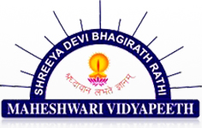

**PROJECT NAME: ABSTERGO**

**SUBJECT: INFORMATICS PRACTICES**

**Session (2018 – 19)**

**Submitted to Submitted by**

**NASEEM KHAN UTSAV MORADIYA**

**CERTIFICATE**

This is to certify that UTSAV MORADIYAof XII Science has worked under my supervision by showing a great interest and completed his project to my total satisfaction.

The work and conduct of UTSAV MORADIYA during the completion of his / her project was excellent.

__________________ ____________________ ___________________

Teacher’s Signature Principal’s Signature Examiner’s Signature

____________________

School Stamp

**ACKNOWLEDGEMENT**

I, Utsav Moradiyaof class XII –Science would sincerely like to thank Mrs. Naseem Khan , my Informatics Practices teacher who has been a constant source of inspiration and guidance throughout the project work, acting as a guiding spirit behind the completion of this project. I am thankful to her for providing me the valuable suggestions and motivation for the completion of this project.

My sincere thanks also to our Principal Mr. Tushar Kulkarni who has encouraged in general the science students to be more analytical in solving the problems.