**Author - Utsav Saxena Superset ID - 6361856**

**React Hands-On Exercises Solutions**

**Lab 1**

**LAB 1 Code -**

**/App.js**

import React from 'react';

function App() {

  return (

    <div className='full'>

      <h1>Welcome to the first session of React</h1>

      <h3>Utsav Saxena - 6361856</h3>

    </div>

  );

}

export default App;

**LAB 1 Output -**

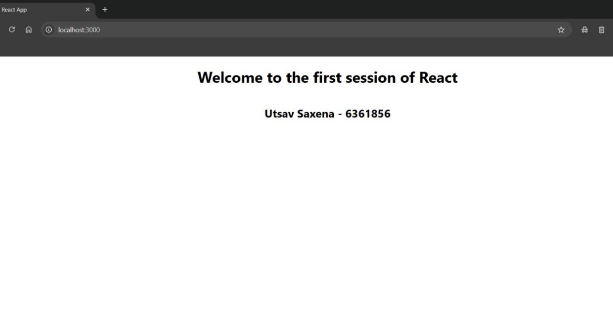

**Lab 2**

**LAB 2 Code -**

**/App.js**

import React, { Component } from 'react';

import './App.css';

import Home from './Components/Home';

import About from './Components/About';

import Contact from './Components/Contact';

class App extends Component {

  render() {

    return (

      <div className="container">

        <Home />

        <About />

        <Contact />

        <h3>Utsav Saxena - 6361856</h3>

      </div>

    );

  }

}

export default App;

**/Components/Home.js**

import React, { Component } from 'react';

class Home extends Component {

  render() {

    return (

      <div>

        <h3>Welcome to the Home page of Student Management Portal</h3>

      </div>

    );

  }

}

export default Home;

**/Components/About.js**

import React, { Component } from 'react';

class About extends Component {

  render() {

    return (

      <div>

        <h3>Welcome to the About page of the Student Management Portal</h3>

      </div>

    );

  }

}

export default About;

**/Components/Contact.js**

import React, { Component } from 'react';

class Contact extends Component {

  render() {

    return (

      <div>

        <h3>Welcome to the Contact page of the Student Management Portal</h3>

      </div>

    );

  }

}

export default Contact;

**LAB 2 Output -**

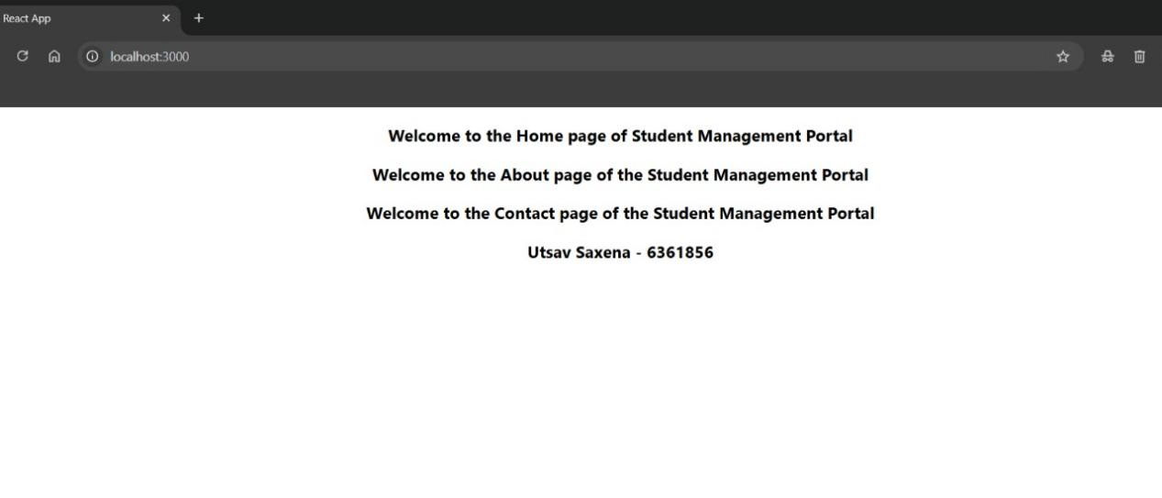

**Lab 3**

**LAB 3 Code -**

**/CalculateScore.js**

import React from 'react';

const percentToDecimal = (decimal) => {

  return (decimal * 100).toFixed(2) + '%';

};

const calcScore = (total, goal) => {

  return percentToDecimal(total / goal);

};

export const CalculateScore = ({ Name, School, total, goal }) => (

  <div className="formatstyle">

    <h1><font color="Brown">Student Details:</font></h1>

    <div className="Name">

      <b><span>Name: </span></b> <span>{Name}</span>

    </div>

    <div className="School">

      <b><span>School: </span></b> <span>{School}</span>

    </div>

    <div className="Total">

      <b><span>Total: </span></b> <span>{total}</span> <span>Marks</span>

    </div>

    <div className="Score">

      <b>Score: </b> <span>{calcScore(total, goal)}</span>

    </div>

  </div>

);

**/App.css**

.Name {

  font-weight: 300;

  color: blue;

}

.School {

  color: crimson;

}

.Total {

  color: darkmagenta;

}

.formatstyle {

  text-align: center;

  font-size: large;

}

.Score {

  color: forestgreen;

}

**/App.js**

import React from 'react';

import { CalculateScore } from './Components/CalculateScore';

import './App.css';

function App() {

  return (

    <div>

      <CalculateScore

        Name="Utsav Saxena"

        School="KIIT University"

        total={450}

        goal={500}

      />

    </div>

  );

}

export default App;

**LAB 3 Output -**

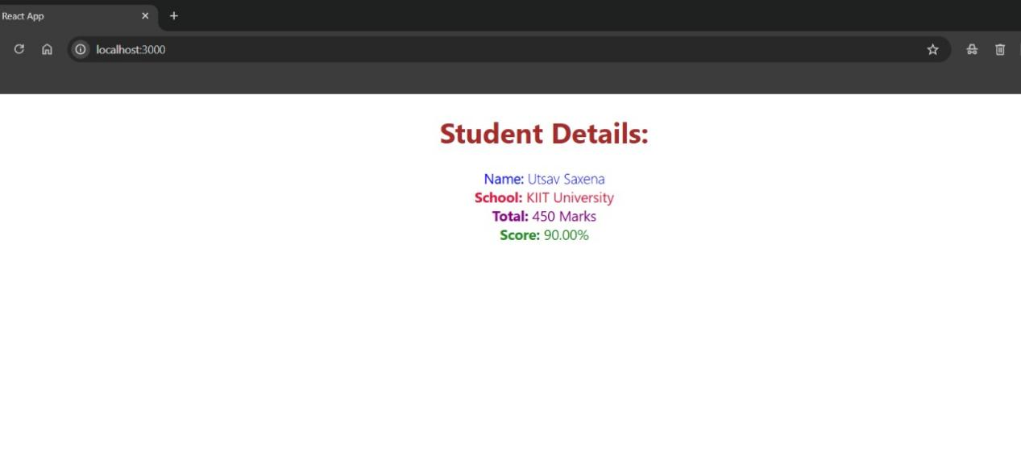

**Lab 4**

**LAB 4 Code -**

**/App.js**

import React from 'react';

import { Posts } from './Post';

function App() {

  return (

    <div>

      <Posts />

    </div>

  );

}

export default App;

**/Post.js**

import React from 'react';

class Posts extends React.Component {

  constructor(props) {

    super(props);

    this.state = {

      posts: []

    };

  }

  loadPosts() {

    fetch('https://jsonplaceholder.typicode.com/posts')

      .then(response => response.json())

      .then(data => {

        this.setState({ posts: data });

      });

  }

  componentDidMount() {

    this.loadPosts();

  }

  componentDidCatch(error, info) {

    alert('An error occurred: ' + error.toString());

  }

  render() {

    return (

      <div>

        <h1>Blog Posts</h1>

        {this.state.posts.map(post => (

          <div key={post.id} style={{ marginBottom: '20px' }}>

            <h3>{post.title}</h3>

            <p>{post.body}</p>

          </div>

        ))}

      </div>

    );

  }

}

class Post {

  constructor(id, title, body) {

    this.id = id;

    this.title = title;

    this.body = body;

  }

}

export default Post;

export { Posts };

**LAB 4 Output-**



**Lab 5**

**LAB 5 Code -**

**/CohortDetails.js**

import React from 'react';

import styles from './CohortDetails.module.css';

function CohortDetails(props) {

  const status = props.cohort.currentStatus.toLowerCase();

  const titleStyle = {

    color: status === 'ongoing' ? 'green' : 'blue'

  };

  return (

    <div className={styles.box}>

      <h3 style={titleStyle}>

        {props.cohort.cohortCode} - <span>{props.cohort.technology}</span>

      </h3>

      <dl>

        <dt>Started On</dt>

        <dd>{props.cohort.startDate}</dd>

        <dt>Current Status</dt>

        <dd>{props.cohort.currentStatus}</dd>

        <dt>Coach</dt>

        <dd>{props.cohort.coachName}</dd>

        <dt>Trainer</dt>

        <dd>{props.cohort.trainerName}</dd>

      </dl>

    </div>

  );}

export default CohortDetails;

**/CohortDetails.module.css**

.box {

  width: 300px;

  display: inline-block;

  margin: 10px;

  padding: 10px 20px;

  border: 1px solid black;

  border-radius: 10px;

}

dt {

  font-weight: 500;

}

‘**LAB 5 Output-**

