**Author - Utsav Saxena Superset ID - 6361856**

**GIT Hands-On Exercises Solutions**

**Module - 1.Git HandsOn**

**Step 1: Setup your machine with Git Configuration**

**BASH**

**To check if Git client is installed properly**

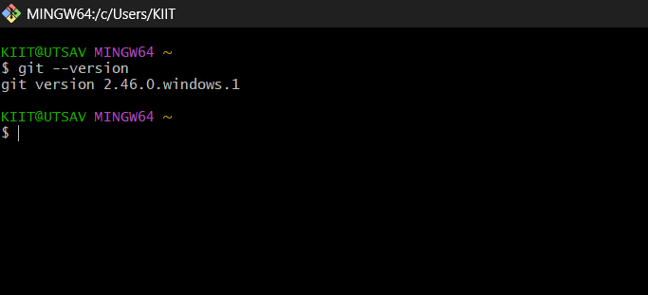

**To configure and Check user level configuration of user ID and email ID execute**

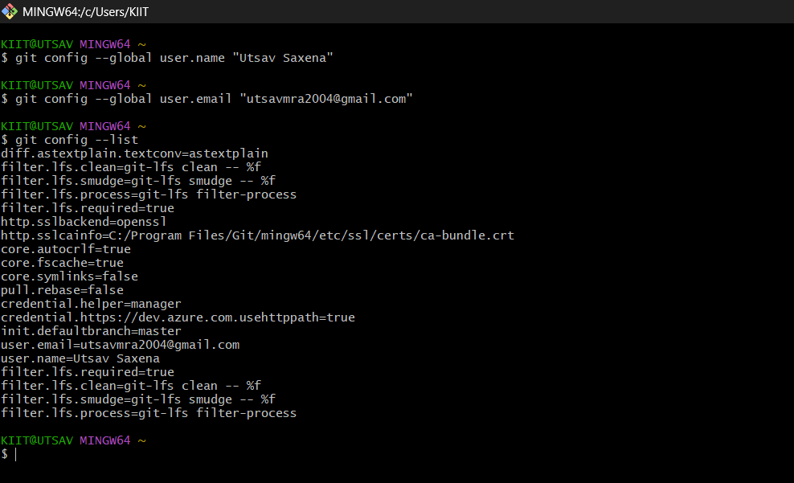

**Step 2: Integrate notepad++.exe to Git and make it a default editor**

**BASH**

**To check, if notepad++.exe execute from Git bash**

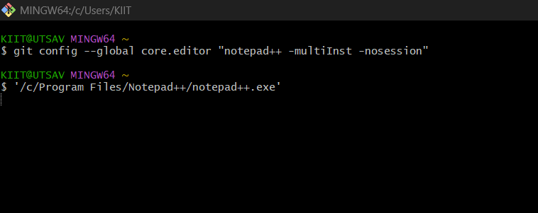

**To create an alias command for notepad++.exe, execute**

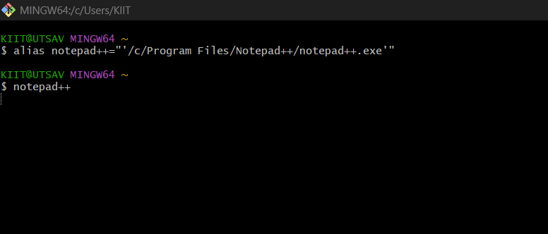

**To verify if notepad++ is the default editor, execute the command**

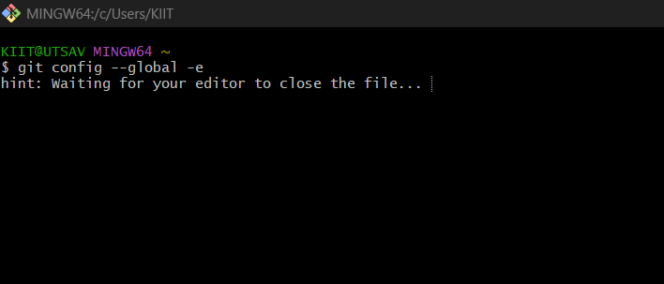

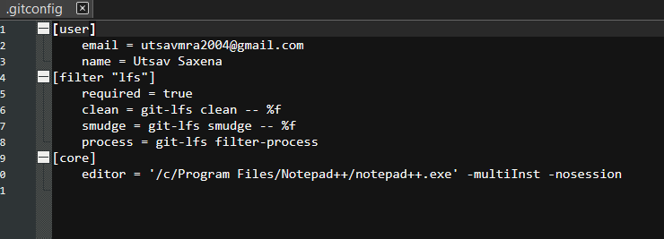

**Step 3: Add a file to source code repository**

**BASH**

**Open Git bash shell and create a new project “GitDemo” by executing the command**

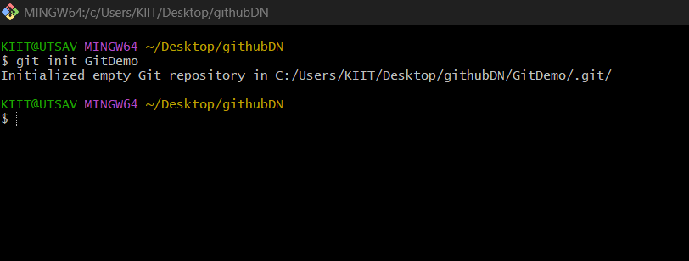

**To create and check a file “welcome.txt” and add content to the file, execute the command**

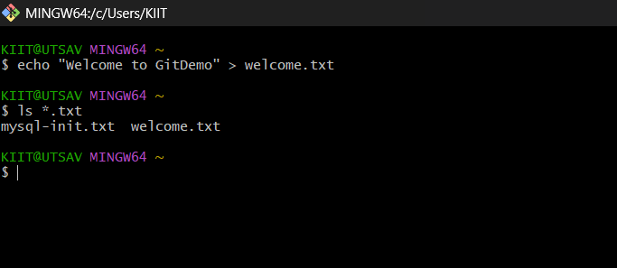

**To verify the content, execute the command**

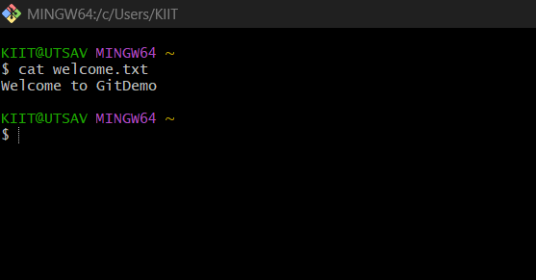

**Check the status by executing**

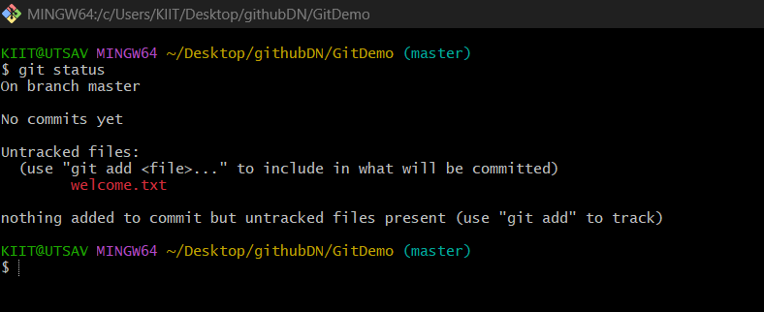

**To make the file to be tracked by Git repository, execute the command**

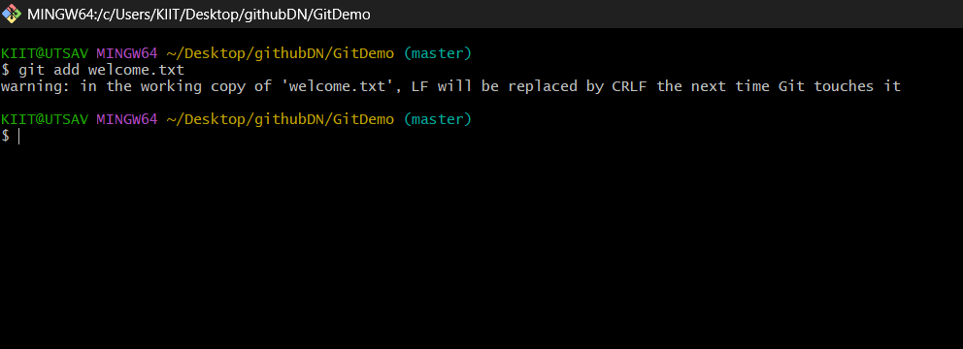

**To add multi line comments, we are opening default editor to comment. Execute the command**

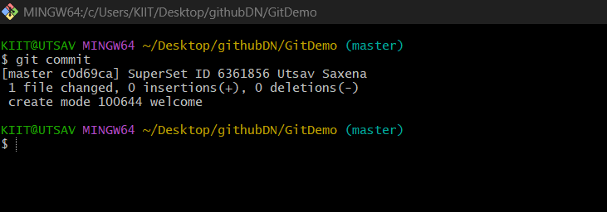

**To push the local to remote repository, execute**

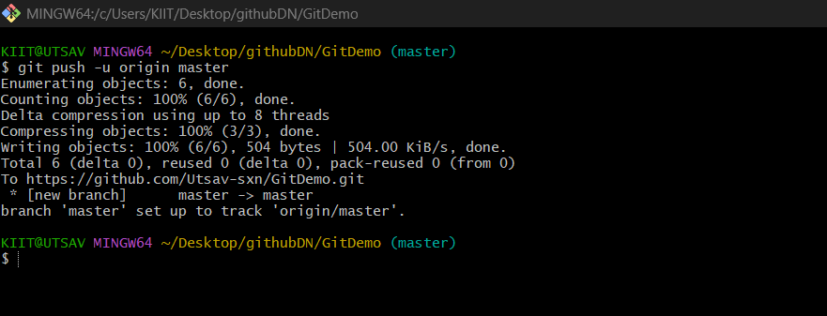

**Module - 2.Git HandsOn**

**BASH**

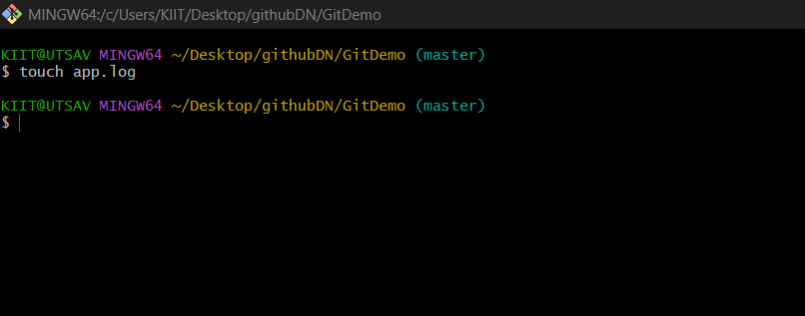

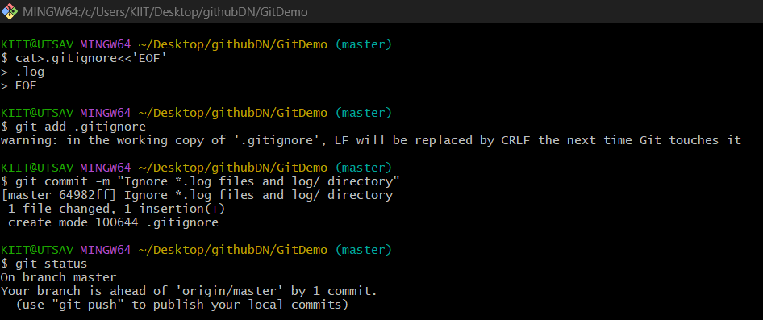

**Module - 3.Git HandsOn**

**BASH**

**Create a new branch “GitNewBranch”.**

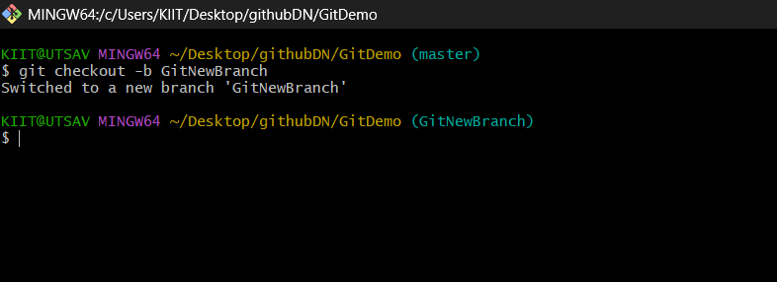

**List all the local and remote branches available in the current trunk. Observe the “*” mark which denote the current pointing branch**

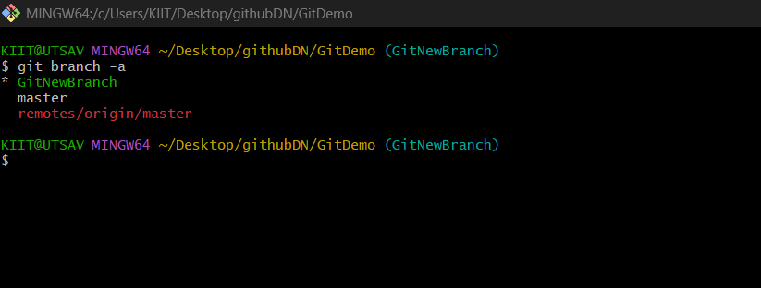

**Switch to the newly created branch. Add some files to it with some contents**

**Commit the changes to the branch.**

**Check the status with “git status” command.**

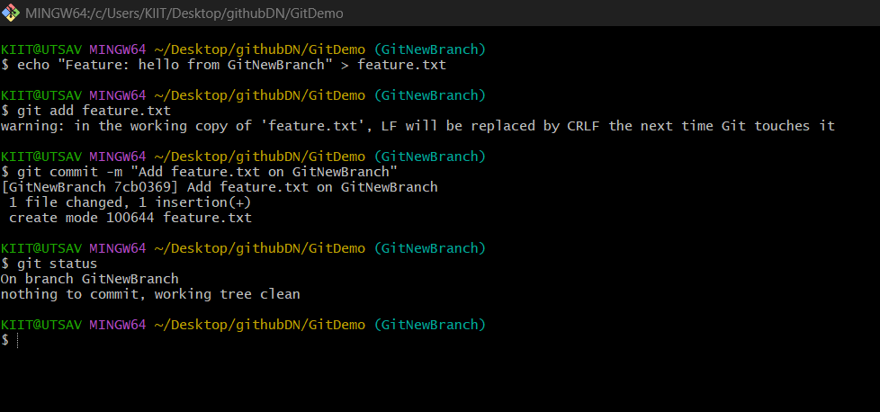

**List out all the visual differences between master and branch using P4Merge tool.**

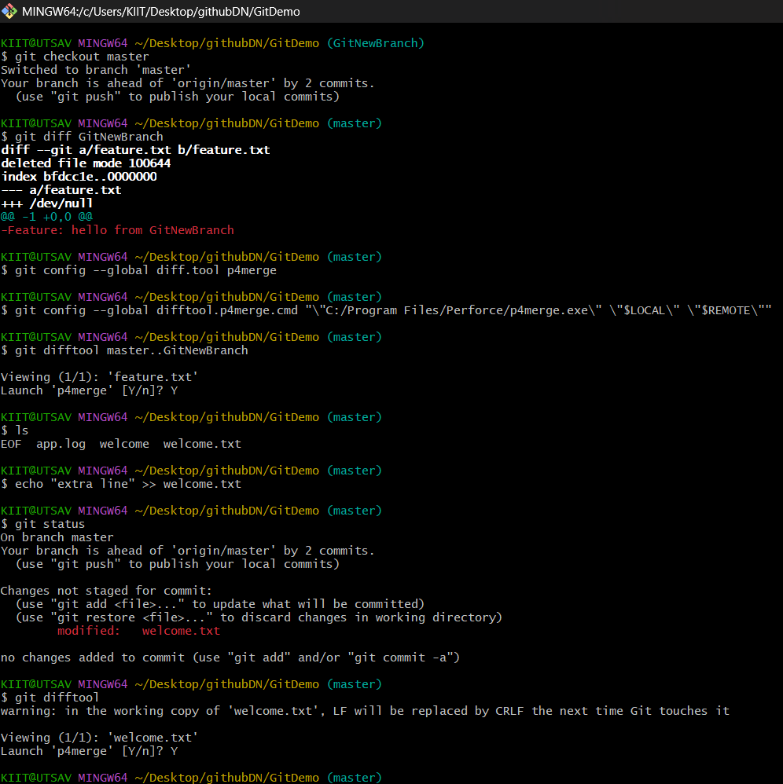

**Merge the source branch to the trunk.**

**Observe the logging after merging using “git log –oneline –graph –decorate”**

**Delete the branch after merging with the trunk and observe the git status.**

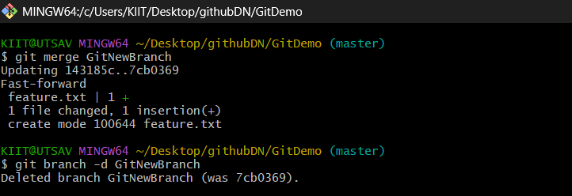

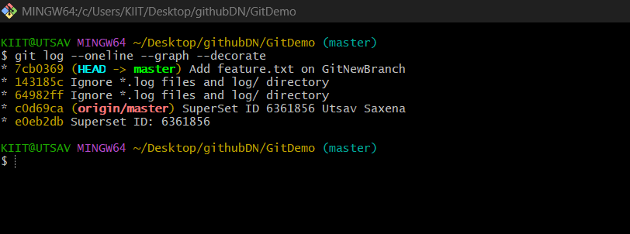

**Module - 4.Git HandsOn**

**BASH**

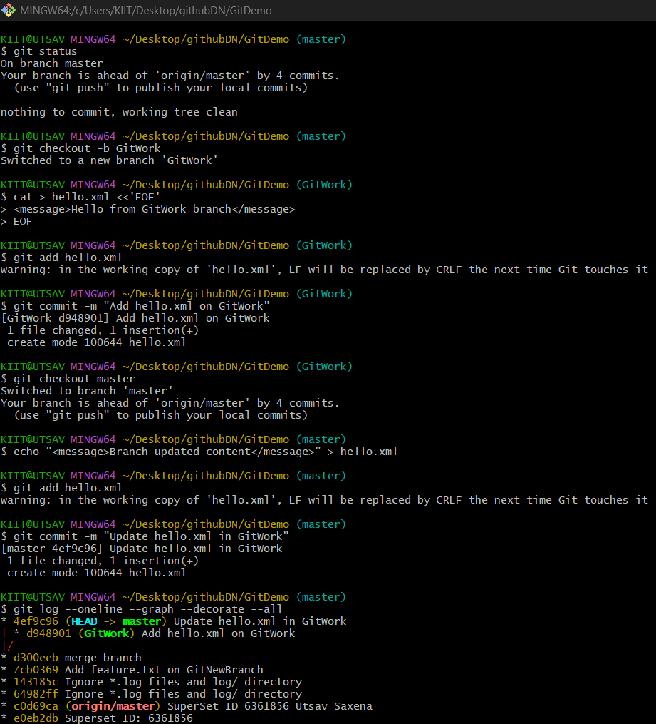

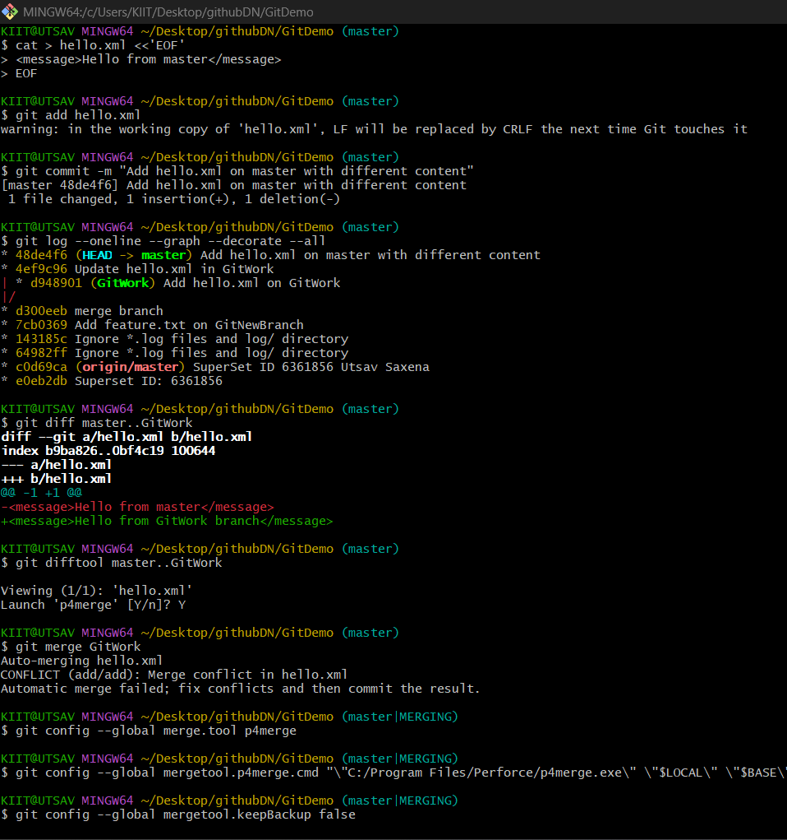

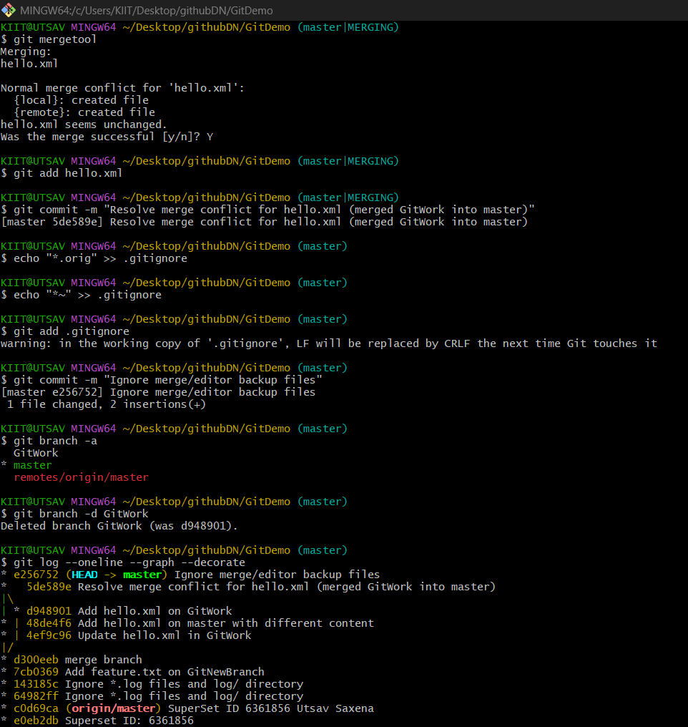

**Module - 5.Git HandsOn**

**BASH**

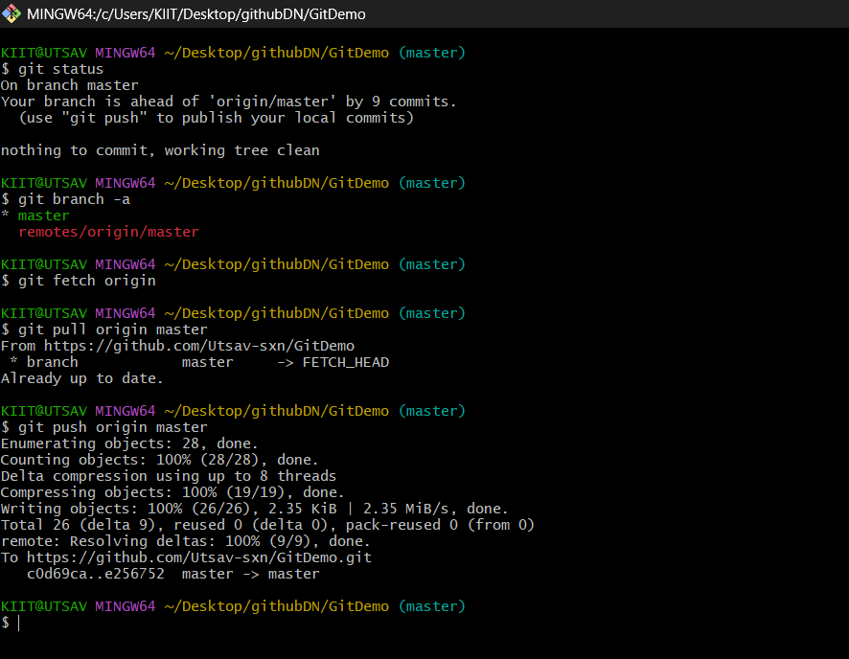

**Changes reflected in GitHub**

