**Assessment: Use Case Oriented Project**

Use Case Scenario:

Your company is developing a new e-commerce application consisting of several

microservices: a front-end service, a product catalog service, and an order processing

service. The goal is to automate the deployment and configuration of these services across

development, testing, and production environments using Ansible, Docker, Kubernetes, and

Jenkins.

Front-end:

Docker File

Index.html

frontend-kube.yml

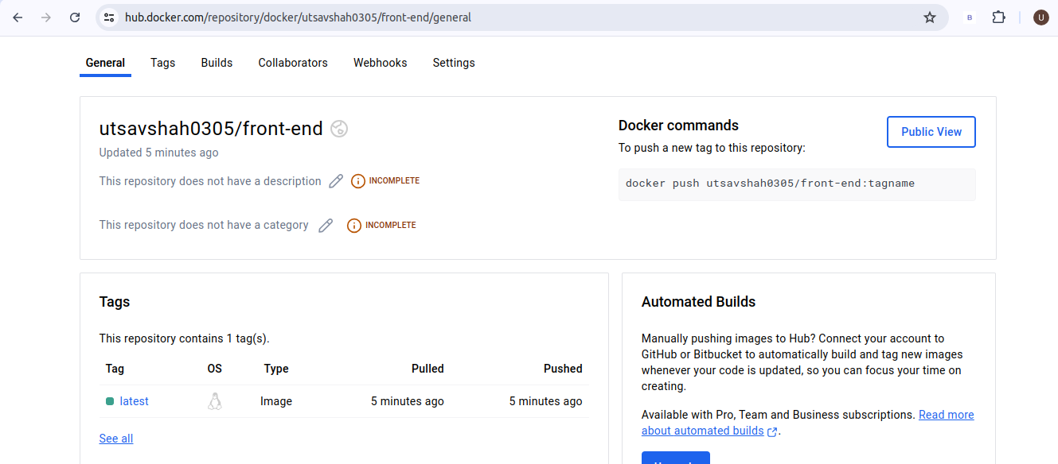.

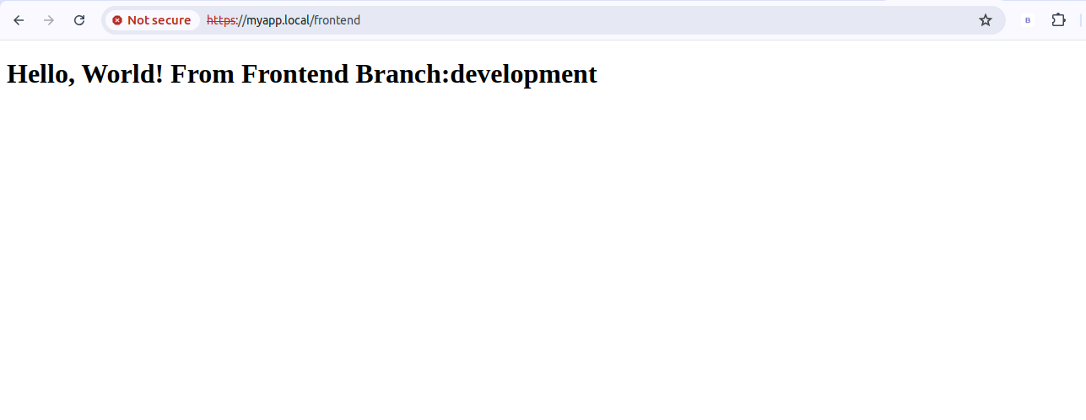.

Backend:

Docker File

Index.html

backend-kube.yml

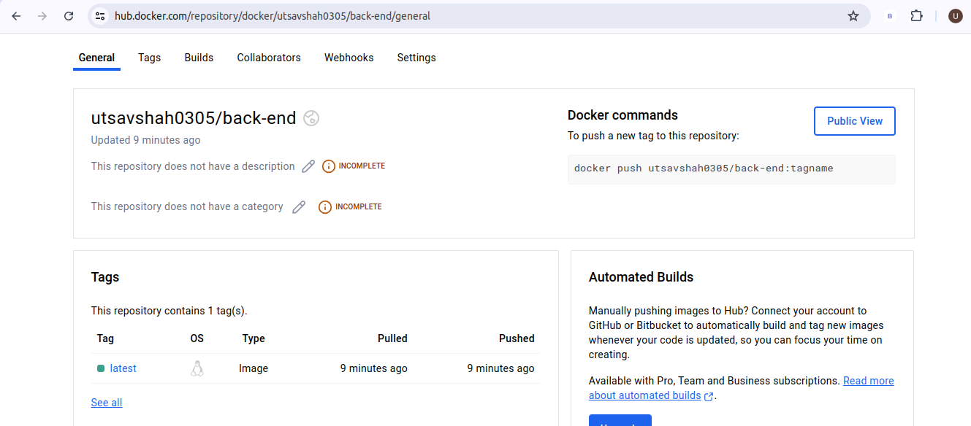.

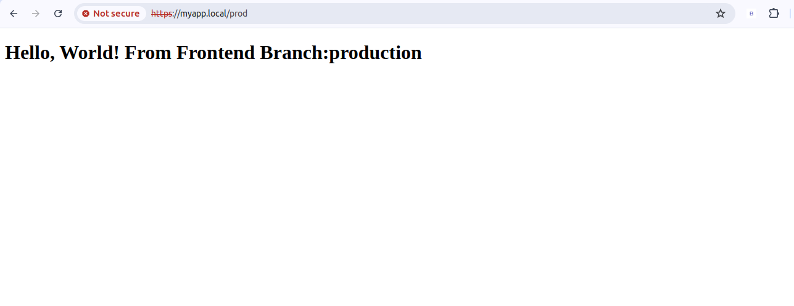.

Testing:

Docker File

Index.html

testing-kube.yml



