**Project Documentation**

**Project Title:** Travel (Contact Us)

**Technologies Used-** HTML, CSS, JS, REACT, Bootstrap (Standard & Mdb)

**Github Link:-** https://github.com/Utsav1510/Travel-Contact-Us-.git

**Project Description:**

This project is just testing project in the scope of the “Travel Safari” Project. The main work done in the project was for the Contact Us part. The contact us part just takes the input and stores it in the back-end which can only be accessed by the admin.

**How to Install and Run the Project:**

This is a React application and hence needs to be forked and cloned in your system and then Run it with the code **npm start** in the console with pre- requisite of nodejs installed in your system and the directory should be the one in which **package.json** file is present.

To access the admin portal just add **“/admin”** after the domain name. For Eg: **“http://localhost:3000/admin“.**

Password and Username: admin.

**Screenshots:**

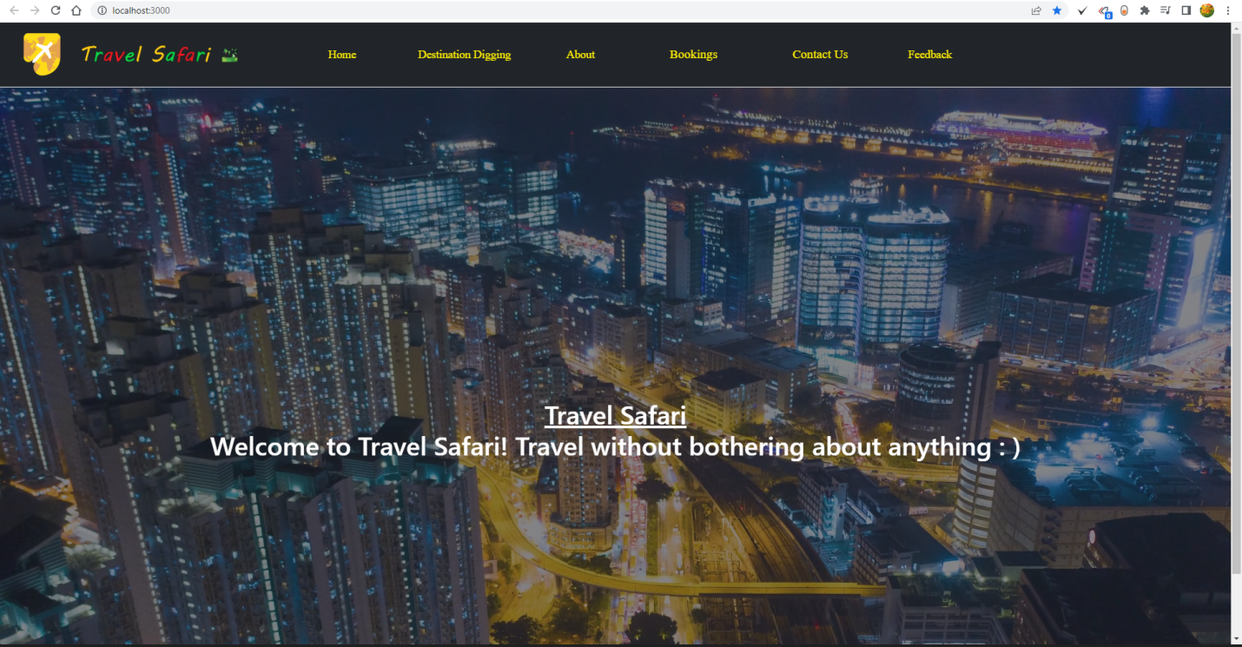

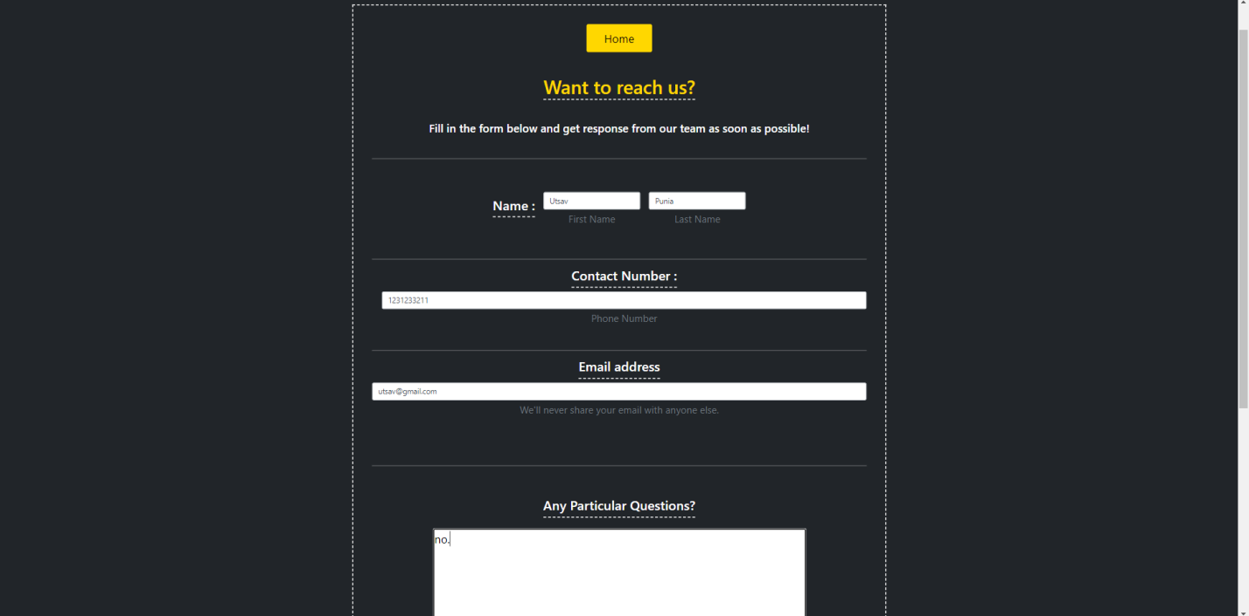

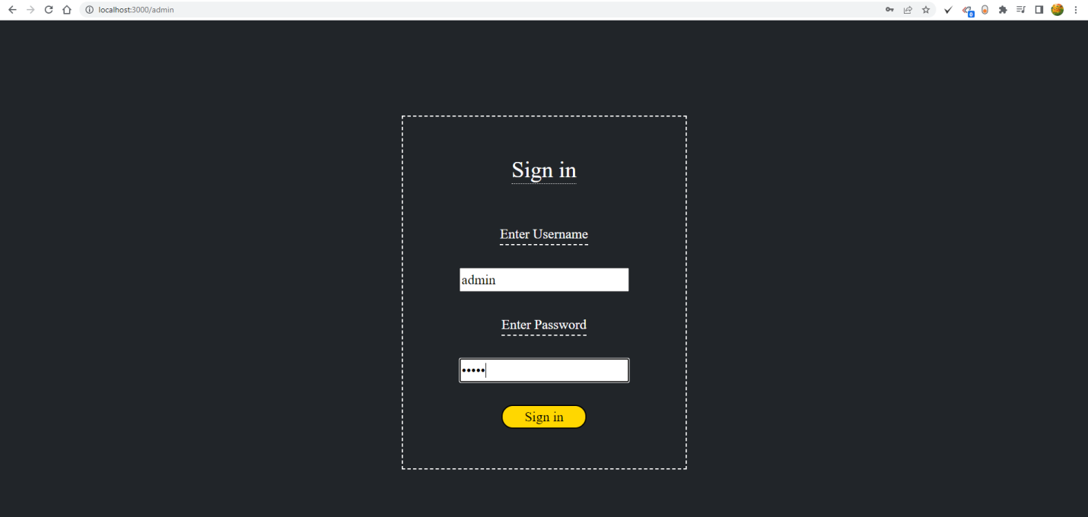

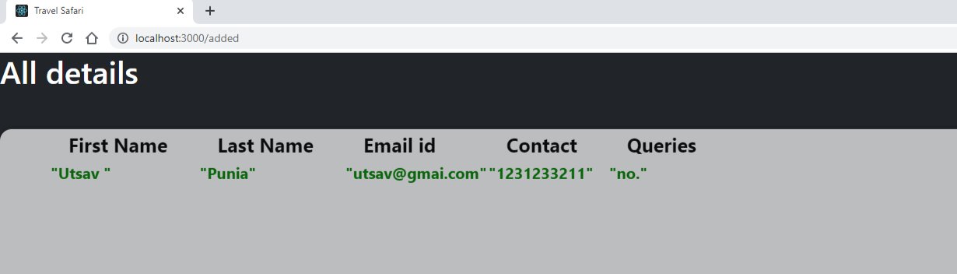

**Conclusion & Scope of Improvement:**

This project serves the purpose of information gathering at the backend and with only admin access. This project is to be combined with the “Travel Safari” project which would lead to its purpose fulfillment.