**Principles of Wireless Communications**

Lab 3(a): *OFDM*

# Overview

Orthogonal Frequency Division Multiplexing (OFDM) is the modulation scheme of choice for modern wireless data communications systems such as WiFi and LTE. This scheme offers simple and accurate methods for channel equalization by splitting a wide bandwidth into a set of narrow sub-channels, which have flat fading. In this assignment, you will implement an OFDM system on an SDR platform.

Since this is a challenging project and will take a lot of time, we will work on it step by step. The following are the steps that we will take.

* Lab 3(a) – Simulated system with synchronized clocks (individual/teams)
  + Due: A report with working code
    - The report should include a few scatter plots of your received, processed data
    - A clear writeup of the fundamentals behind OFDM (including a clear and thorough explanation of the DFT and IDFT - would a high school student understand your description? Write with the clarity that they could!)
    - Please review the Report Checklist on the second page of this document. A point will be removed for each item.
* Lab 3(b) – Simulated system with unsynchronized clocks (teams)
  + Due 2.5 weeks after 3(a): Working code and a few scatter plots of your received, processed data.
* Lab 3(c) – USRP-based system (teams)
  + Due 1 week after 3(b)

In this exercise, you will implement a rudimentary, simulated OFDM system. Your task is to generate a vector of OFDM modulated data samples (including any training samples you may need), and transmit it through a simulated channel, by calling the function nonflat_channel(x).

You need to then decode the received signal and check if you can recover your transmitted bits.

Some hints:

1. A 64 point FFT, with 16 sample cyclic prefix is suggested. These are the parameters used in 802.11g WiFi systems. Therefore, every 64 +-1 values is represented using 64+16 = 80 samples.
2. You can estimate the IDFT of the channel impulse response by transmitting a training signal (i.e. a known set of several blocks of $X_{k}$, e.g. 100. When properly aligned and after the cyclic prefix has been discarded, you can take the FFT of blocks of 64 received samples, divide by the corresponding transmitted samples and average to get $H_{k}$ which is the 64-point DFT of the channel impulse response.
3. You can then equalize your received signal using this estimated $H_{k}$.
4. An overall structure for the encoding/transmission/decoding is shown in the following figure

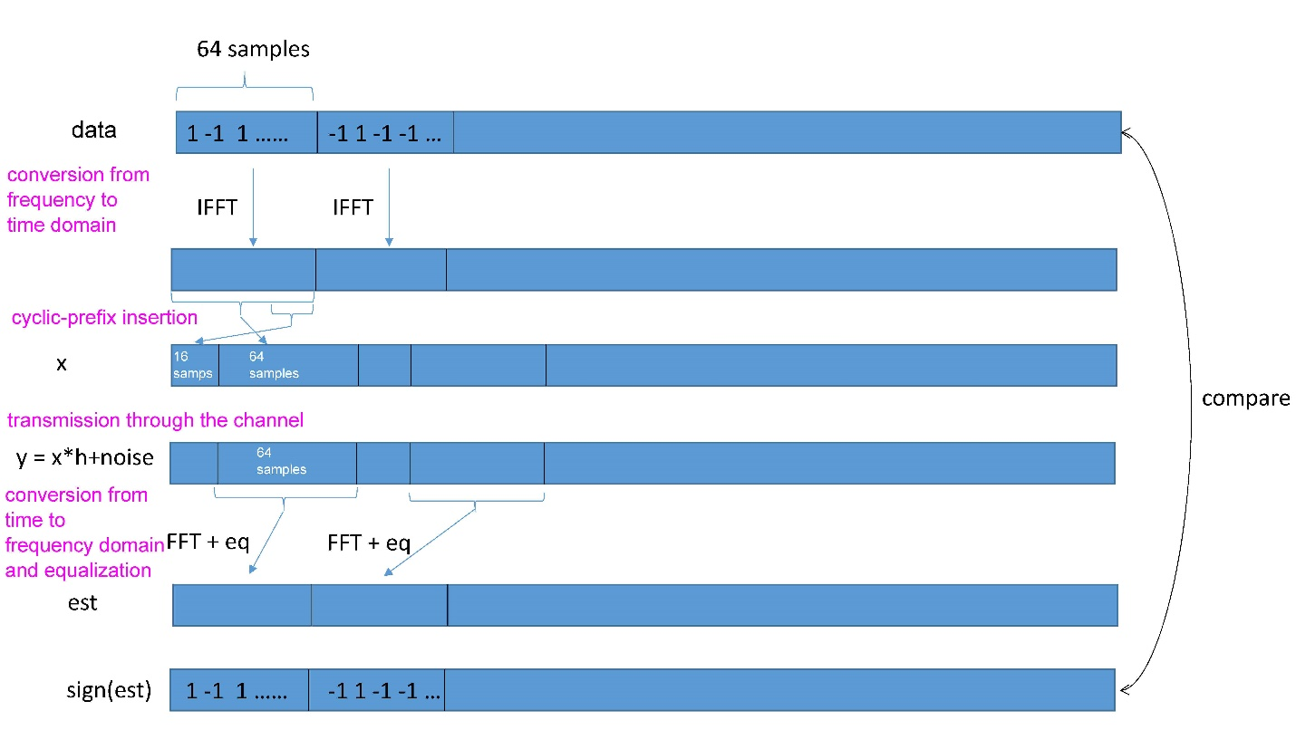

**Report Checklist**

* Figures: Are all of the axes labelled with units? Are all of the figures mentioned in text before they are presented as well as described after they are presented? Are all of the figures given titles, “Figure X. Figure Title”, that appear below the figure?
* Titles: Are all of the tables mentioned in text before they are presented and are takeaways summarized after they are presented? Are all tables titled “Table X. Table Name” with titles on top of each table?
* Does your report include any of the following words: “I”, “we”, “get”, “very”, “simply” – if so please remove. Aim to use objective language when possible.
* Does your report use proper grammar? Are there missing or duplicated words in the text?