Assignment 1 Report: Statistical Interpretation and Exploratory Data Analysis
Name: Utsav Rijal
ID: 2501481

Table of Contents

1. Overview 1
2. Problem 1A – HDI Analysis for a Single Year (2022) 2
3. Problem 1B – Examination of HDI Trends (2020–2022) 2
4. Problem 2 – In-Depth HDI Analysis (South Asia) 3
5. Problem 3 – Regional Comparison of HDI Performance 4
6. Overall Summary 6
7. References 6

Git hub link: https://github.com/Utsav313/2501481_UtsavRijal

Overview

The HDI for a country represents the three important elements in human development .The standard of living, education and health .The dataset for the development of humanIndex, HDI, runs from 1990 to 2022.The dataset shall be analyzed in this report.

2. Problem 1A – HDI Analysis for a Single Year (2022)
Techniques /Procedures
• Strained data for
• Changed numeric columns and checked for missing values.

• Data was cleaned and duplicates removed.
The descriptive statistics were calculated for HDI.
• ranked by GNI per capita after excluding the countries with an HDI above 0.800.
• The classification of countries to HDI categories was done using UNDP thresholds.
Key Results:
- Max HDI: [Switzerland, 0.967]
- Min HDI: [Somalia, 0.38]
- Mean HDI: [0.7228872549019609], Median HDI: [0.7395], Standard Deviation: [0.15302880386427825]
- Ten leading nations with HDI > 0.800 listed.
Interpretation:
The importance of health and education can be gauged from the fact that even when the GNI levels of different nations are similar, their HDI can differ.

3. Problem 1B – Examination of HDI Trends (2020–2022)
Methods Employed:
- Cleaned and strained value for 2020–2022
- Visualizations produced:
- Line graph: Five chosen countries' HDI trends.
- Box plot: Distribution of HDI by year.
- Scatter plot: HDI vs. GNI per capita scatter plot.
Key Results:
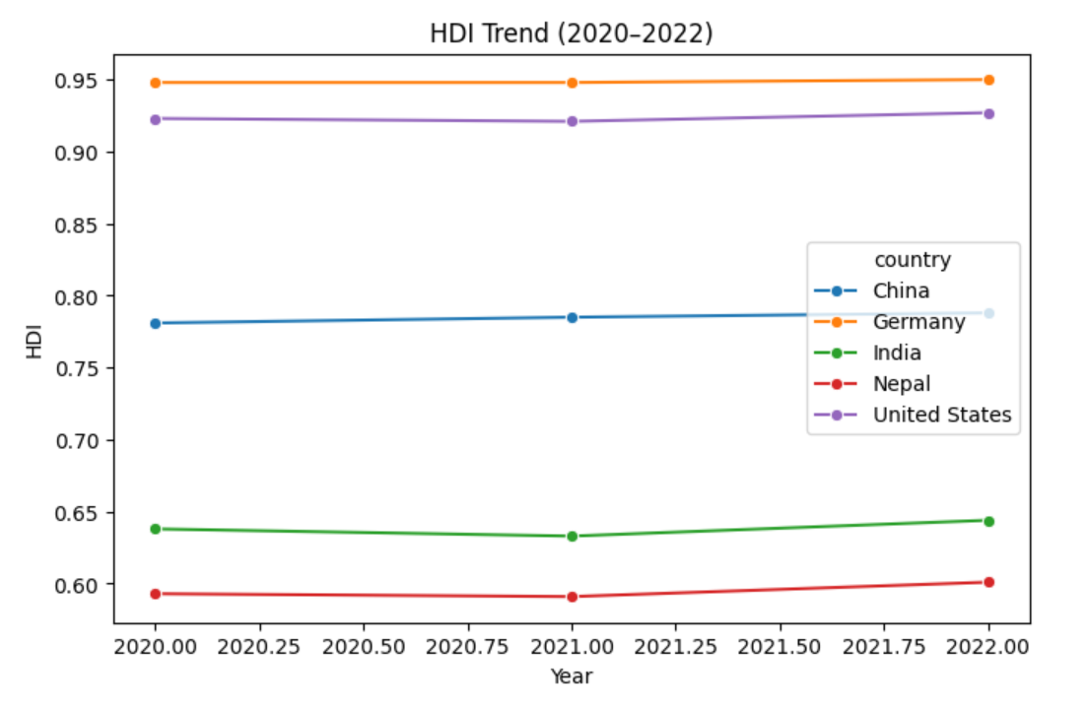
• For the majority of countries, a gradual improvement in the HDI was noted.
• Box plots show that the median HDI has slightly increased.
• There are some outliers in the GNI per capita increases, HDI also increases.
Interpretation:
• Countries that have gotten better the most: [examples]
• No big drops were seen.
• Global events such as COVID-19 pandemic is likely to have influenced patterns in human development indicators.

Note: Average HDI by region could not be computed due to missing region variable in the dataset.

4. Problem 2 – In-Depth HDI Analysis (South Asia)
Techniques / Procedures
Strained valueset for South Asian countries.
• Computed Composite Score = 0.30 × Life Expectancy + 0.30 × GNI per Capita.
• Nations and visualized top 5.
• Detected outliers using 1.5 × IQR rule.
• Examined correlations between HDI and Life Expectancy / Gender Development.
• Calculated GNI–HDI gaps
Key Results:
- Top 5 countries by Composite Score:
- 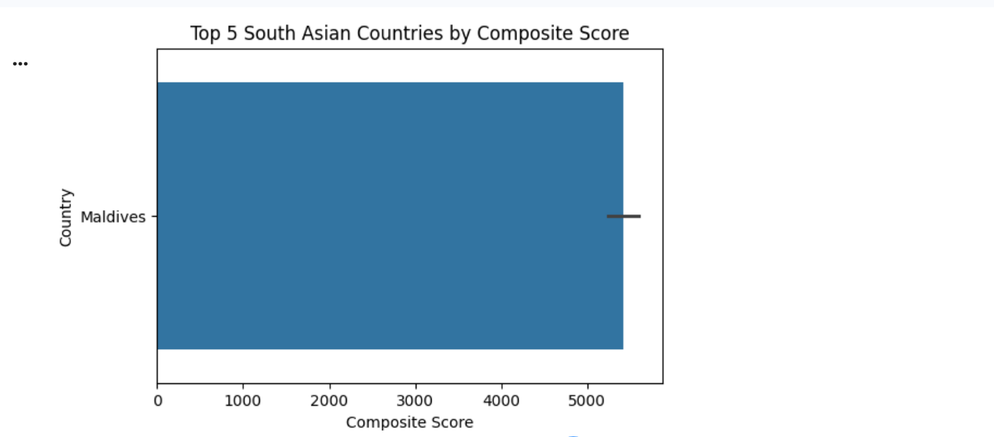
- Outliers
- Metric correlations: Life Expectancy strongest, Gender Development weaker.
- GNI–HDI gaps: positive and negative gaps identified.
Interpretation:
Analysis highlights development disparities in South Asia and identifies countries where GNI does not fully explain how humans grow and develop.

5. Problem 3 – Regional Comparison of HDI Performance
Techniques and Procedures
- Created South Asia and Middle East subsets (2020–2022).
- Evaluated central tendencies and variability while identifying regional leaders and laggards.
- Compared metrics: Life Expectancy, GNI per Capita, Gender Development.
- Calculated HDI disparity (range and CV).
- Correlation analysis and outlier detection conducted.
Key Results:
• Av. HDI (South Asia): [0.639583333333], Std: [0.09827331747496995]
• Average HDI (Middle East): [0.7889090909090909], Std: [0.14129476362297624]

• Top 3 HDI countries (South Asia)
• Top 3 HDI Countries (Middle East)
• ”Life Expectancy” displays the largest inequality in
• HDI range: High variance exists in Middle Eastern HDIs
• Correlations: HDI was more strongly correlated with Life Expectancy.
• Scatter plots used to identify outliers.
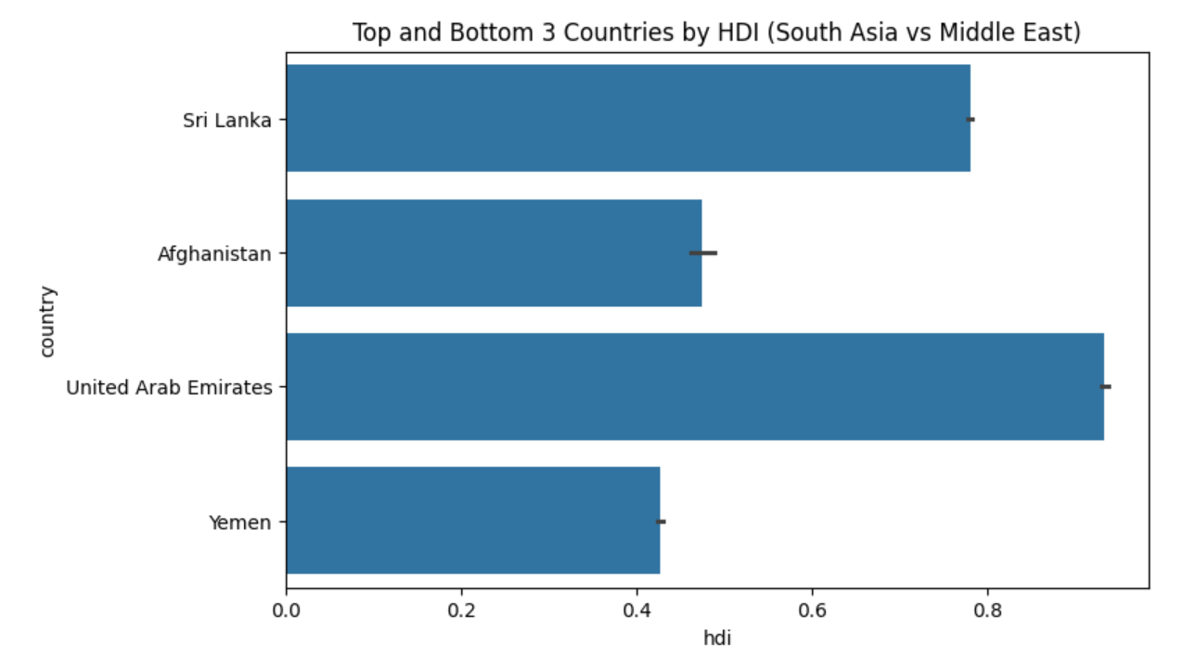
Interpretation:
The South Asia region trails the Middle East in these areas and has large discrepancies with regard to equality in health care, economic development, and gender equality

6. Overall Summary
• Worldwide trend for HDI is enhancing.
• South Asia has a higher level of inequality and lower values for its HDI.
• Life Expectancy has the biggest influence on HDI.
• Outlier and Gap Analysis helps identify unexpected patterns of HDI.
• Dataset limitations: missing region variable

7. References
- Pandas Documentation
- Matplotlib & Seaborn Documentation

