Problem 1 - Data Read, Write and Inspect: Complete all following Task:
• Dataset for the Task: "bank.csv" 1. Load the provided dataset and import in pandas DataFrame.
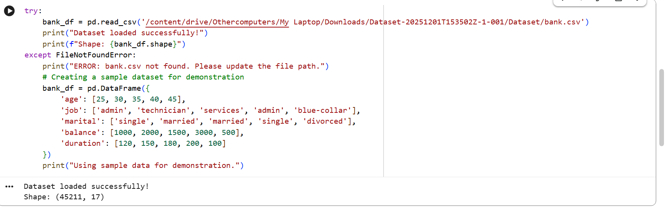
2. Check info of the DataFrame and identify following:
(a) columns with dtypes=object
(b) unique values of those columns.
(c) check for the total number of null values in each column.
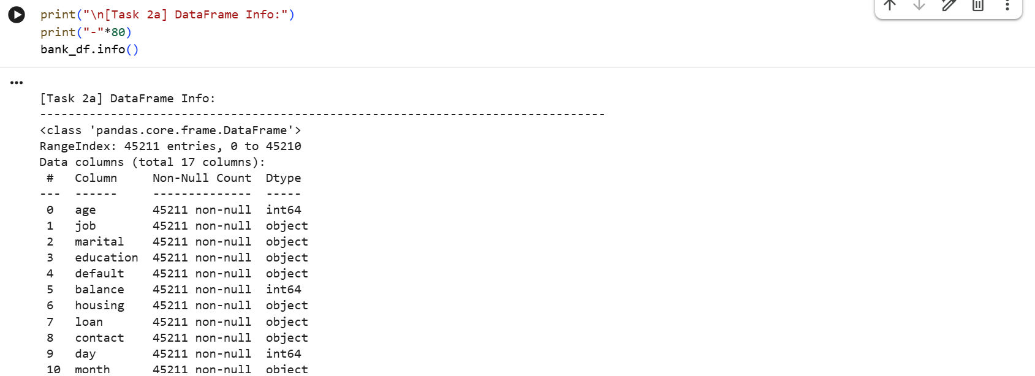
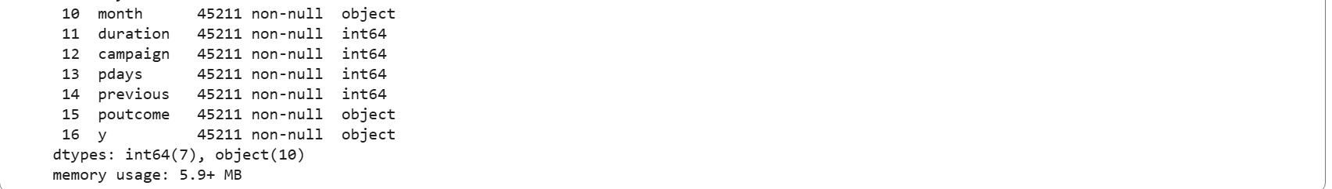
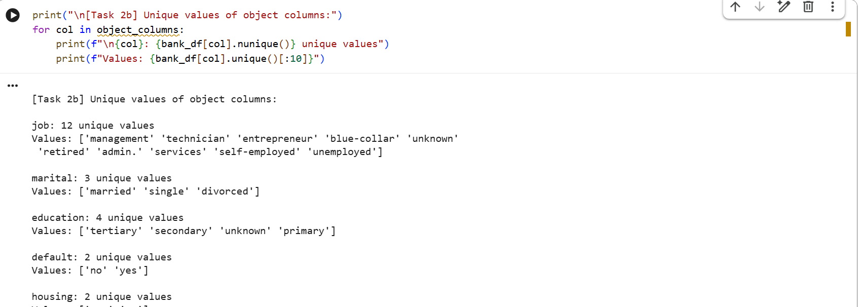
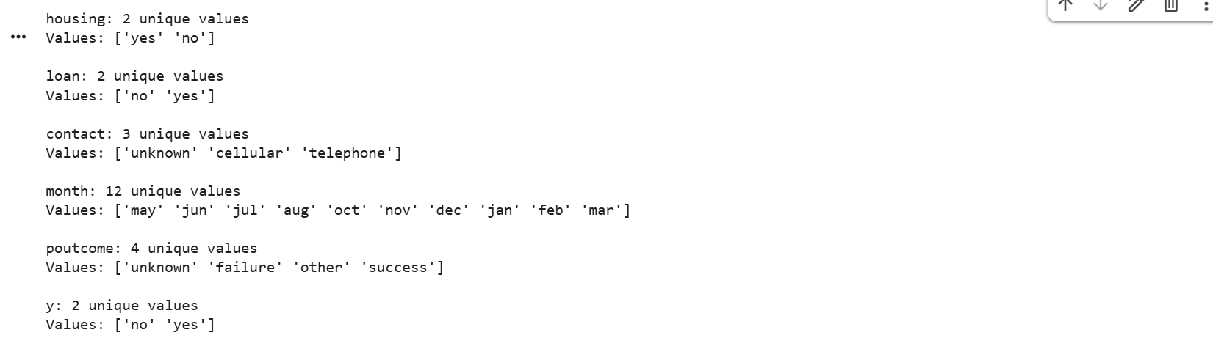

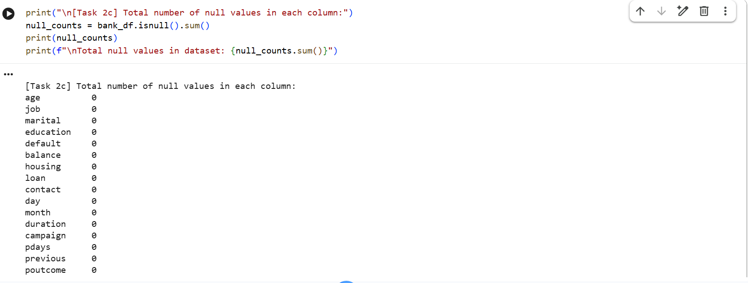

3. Drop all the columns with dtypes object and store in new DataFrame, also write the DataFrame in ”.csv” with name ”banknumericdata.csv”
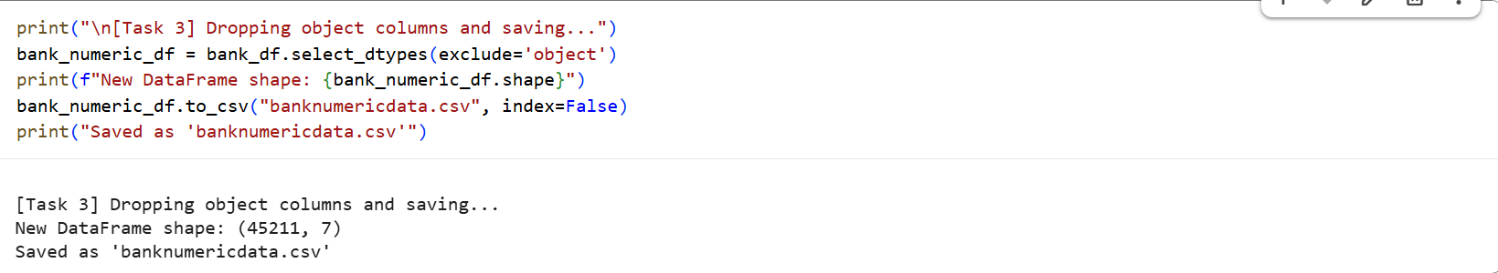

4. Read ”banknumericdata.csv” and Find the summary statistics.
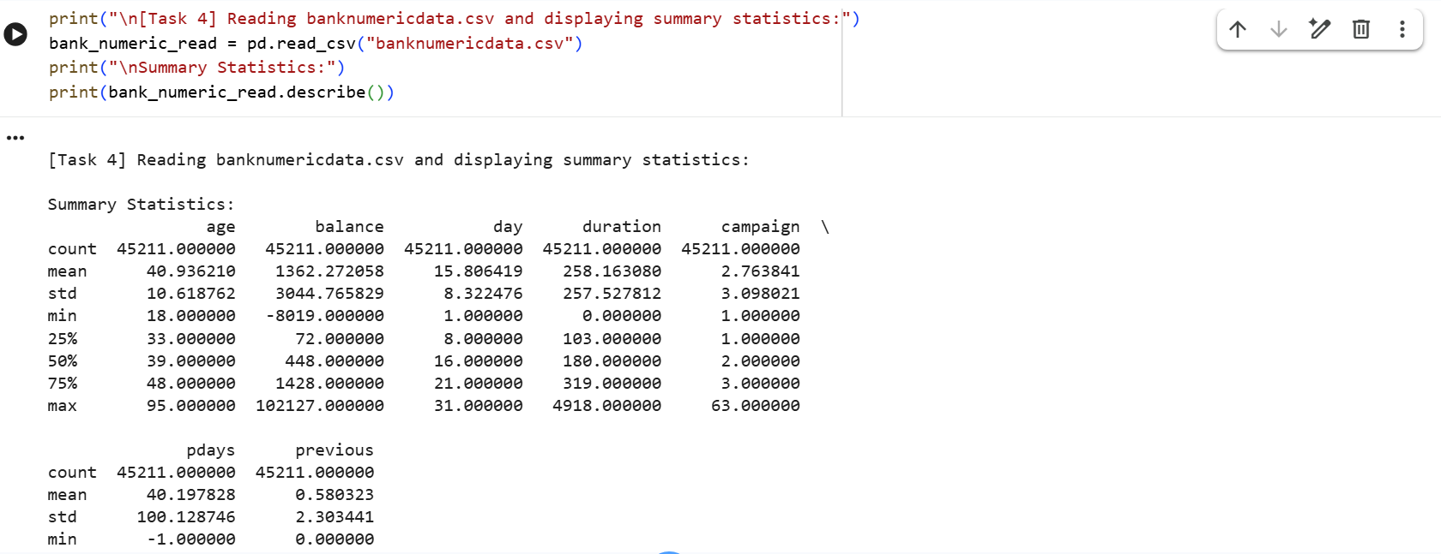
Problem 2 - Data Imputations: Complete all the following Task:
• Dataset for the Task: "medical_student.csv"
- Load the provided dataset and import in pandas DataFrame.
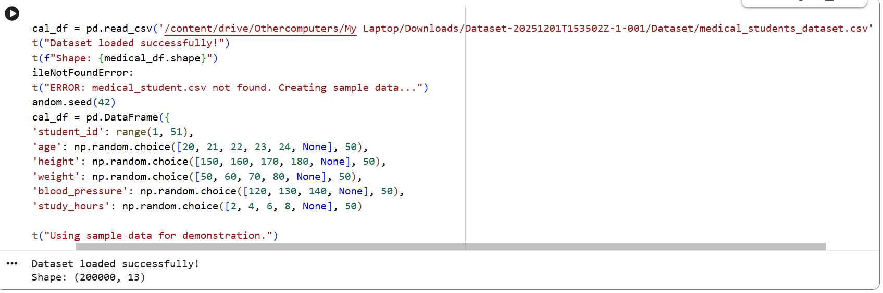
- Check info of the DataFrame and identify column with missing (null) values.
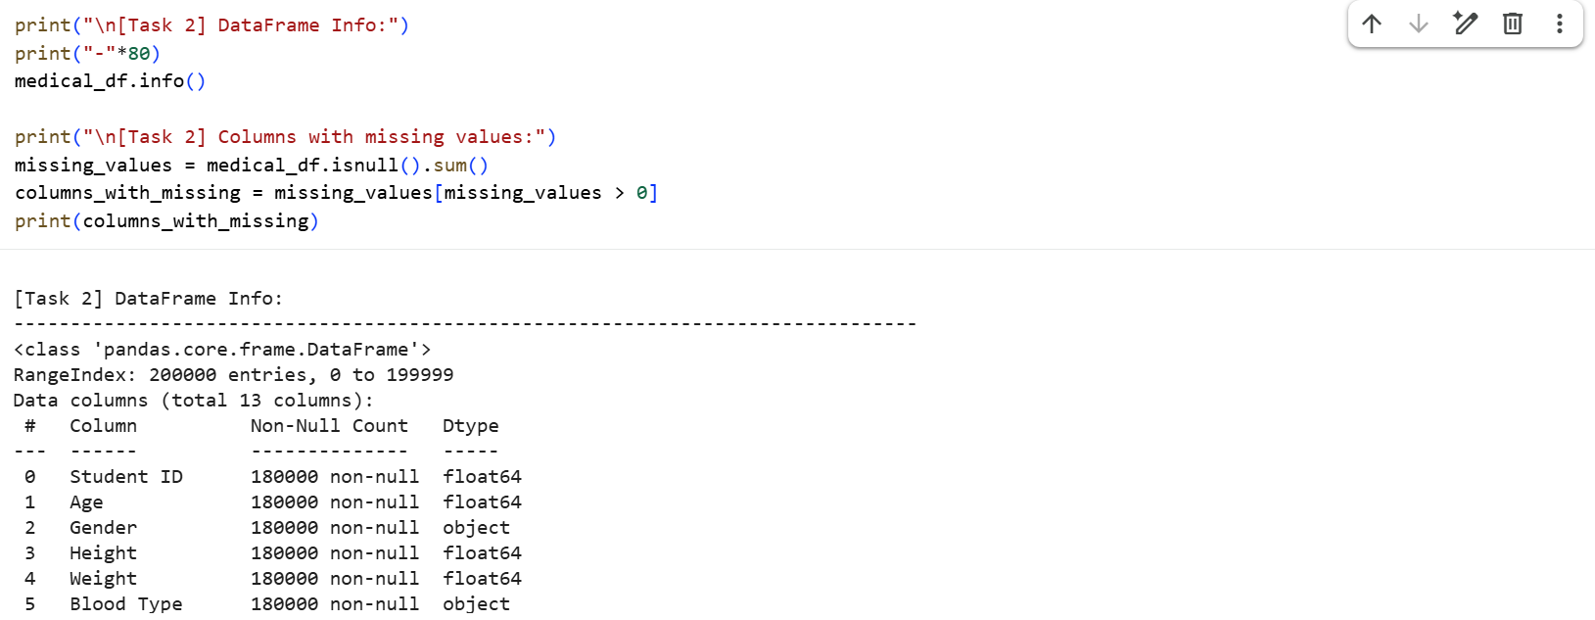
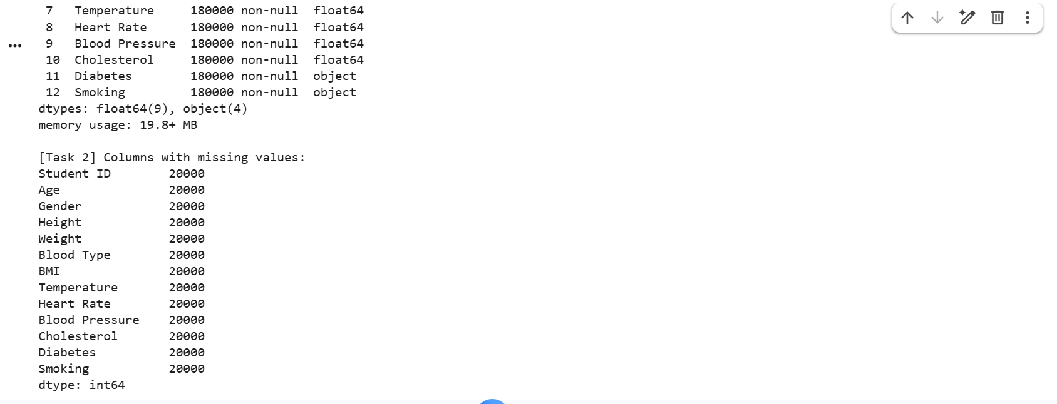
- For the column with missing values fill the values using various techniques we discussed above. Try to explain why did you select the particular methods for particular column.
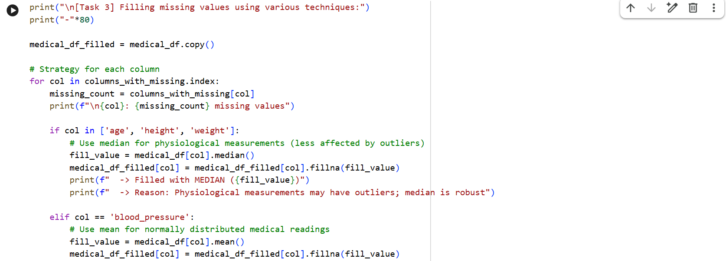
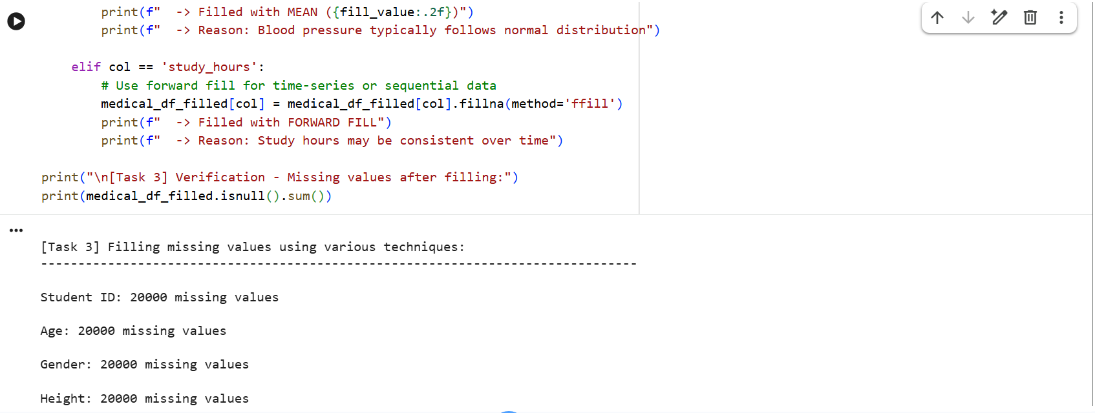
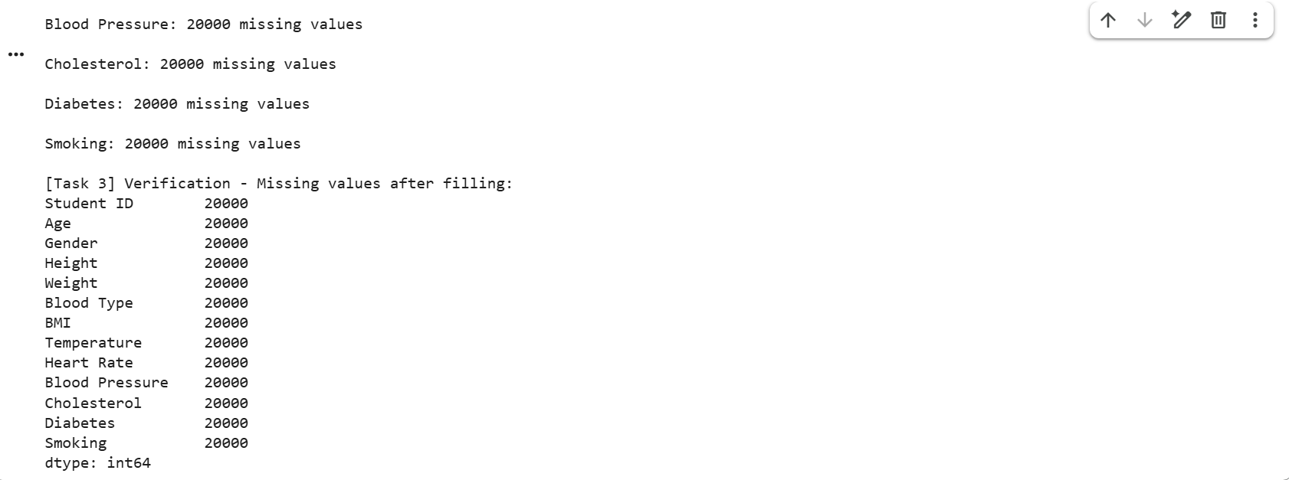
- Check for any duplicate values present in Dataset and do necessary to manage the duplicate items. {Hint: dataset.duplicated.sum()}
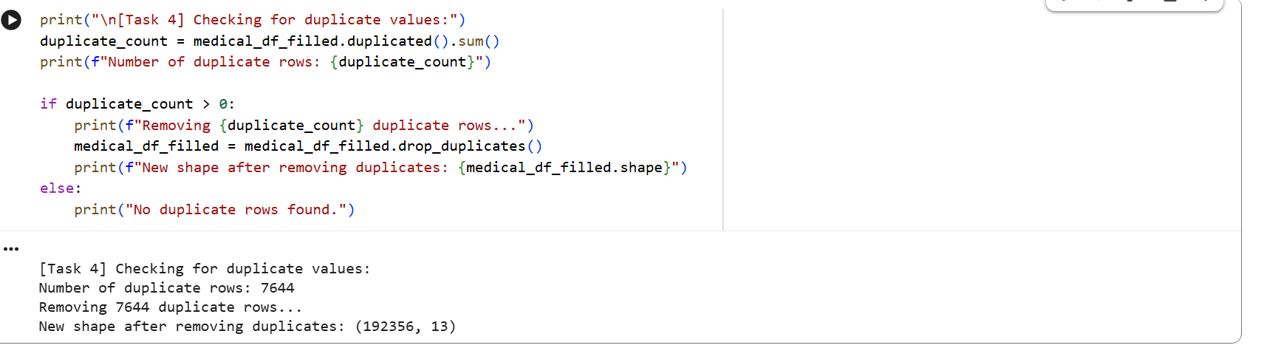

3.2 Exercises - Data Cleaning and Transformations with ”Titanic Dataset”:
Dataset Used: "titanic.csv"
Problem - 1:
Create a DataFrame that is subsetted for the columns ’Name’, ’Pclass’, ’Sex’, ’Age’, ’Fare’, and ’Survived’. Retain only those rows where ’Pclass’ is equal to 1, representing first-class passengers. What is the mean, median, maximum value, and minimum value of the ’Fare’ column?
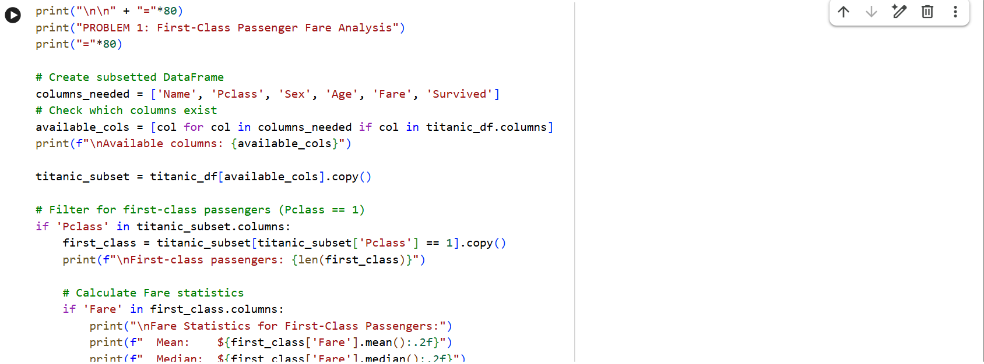
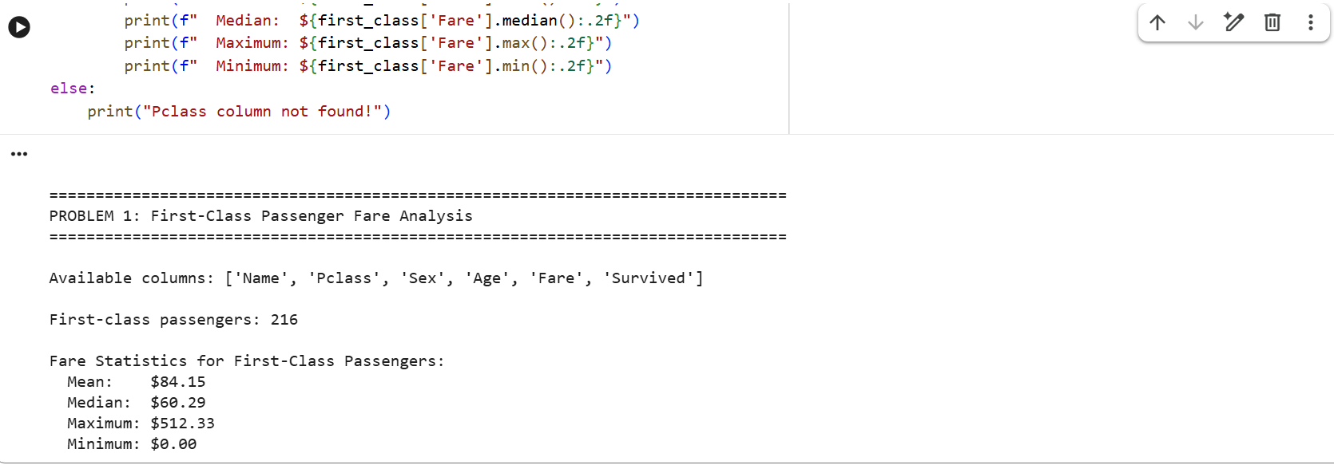
Problem - 2:
How many null values are contained in the ’Age’ column in your subsetted DataFrame? Once you’ve found this out, drop them from your DataFrame.
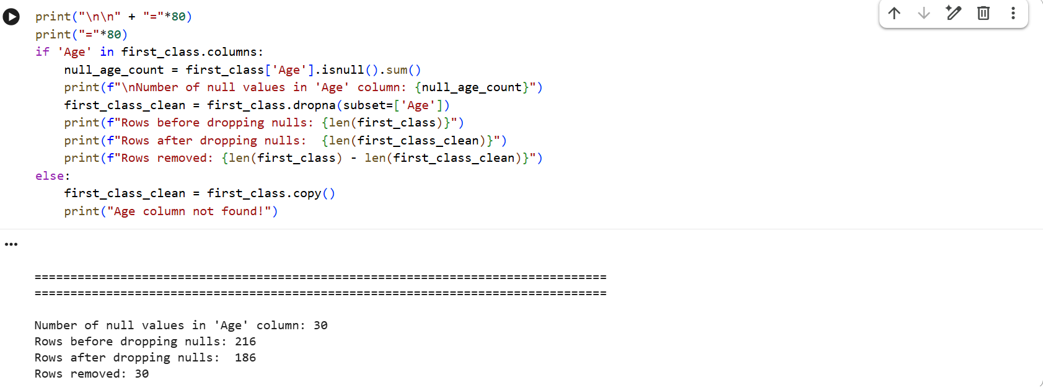

Problem - 3:
The ’Embarked’ column in the Titanic dataset contains categorical data representing the ports of embarkation: • ’C’ for Cherbourg • ’Q’ for Queenstown • ’S’ for Southampton

Task: 1
. Use one-hot encoding to convert the ’Embarked’ column into separate binary columns (’Embarked C’, ’Embarked Q’, ’Embarked S’).
2. Add these new columns to the original DataFrame.
3. Drop the original ’Embarked’ column.
4. Print the first few rows of the modified DataFrame to verify the changes.
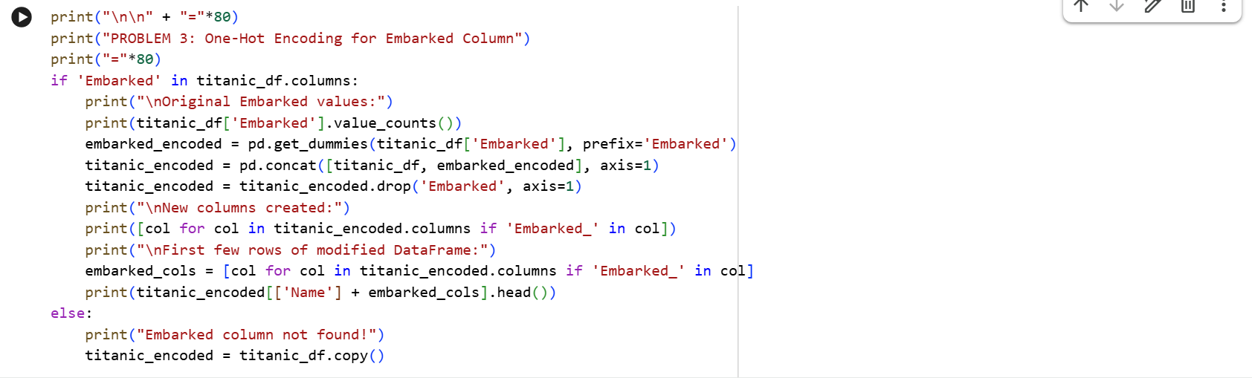
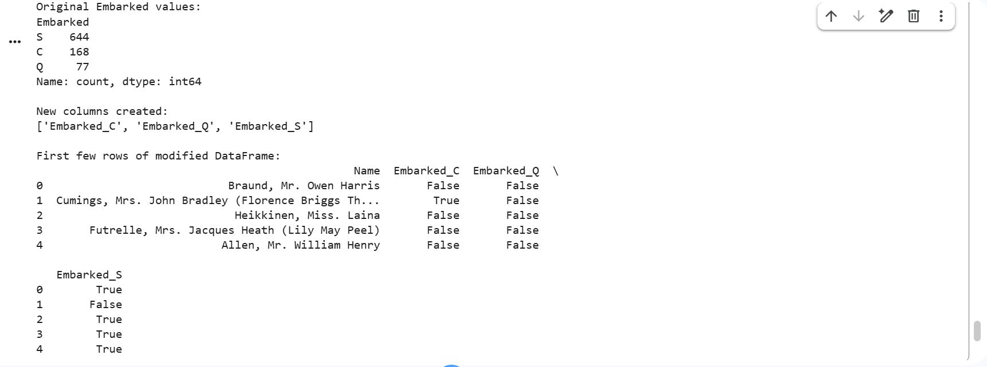

Problem - 4:
Compare the mean survival rates (’Survived’) for the different groups in the ’Sex’ column. Draw a visualization to show how the survival distributions vary by gender.
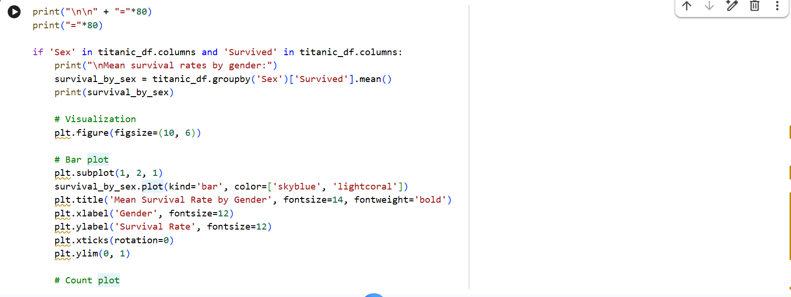
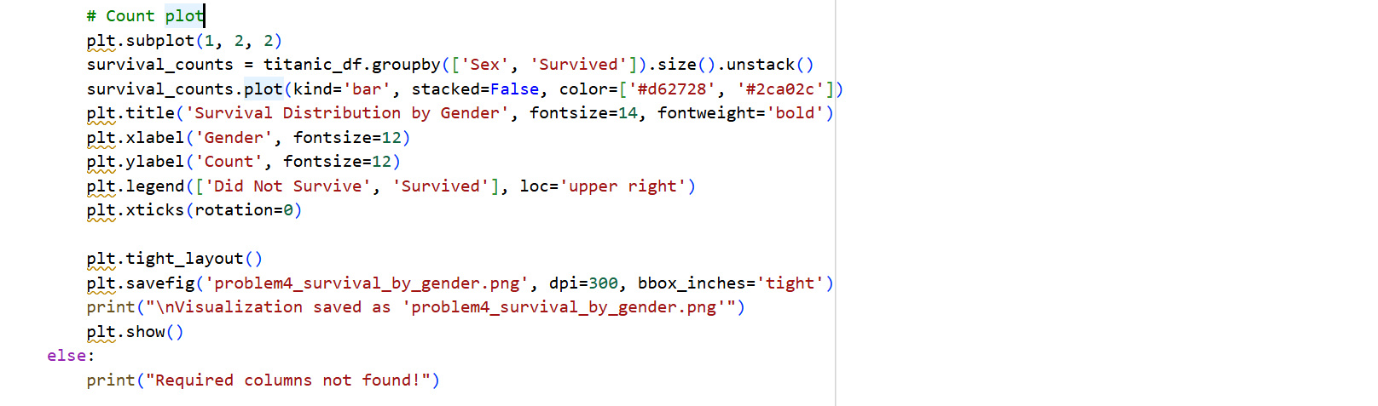
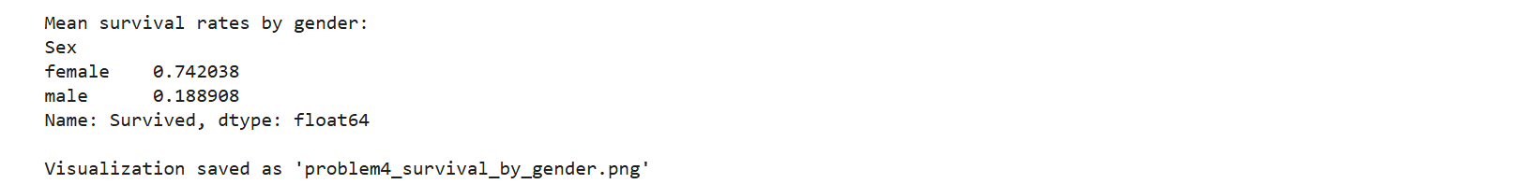
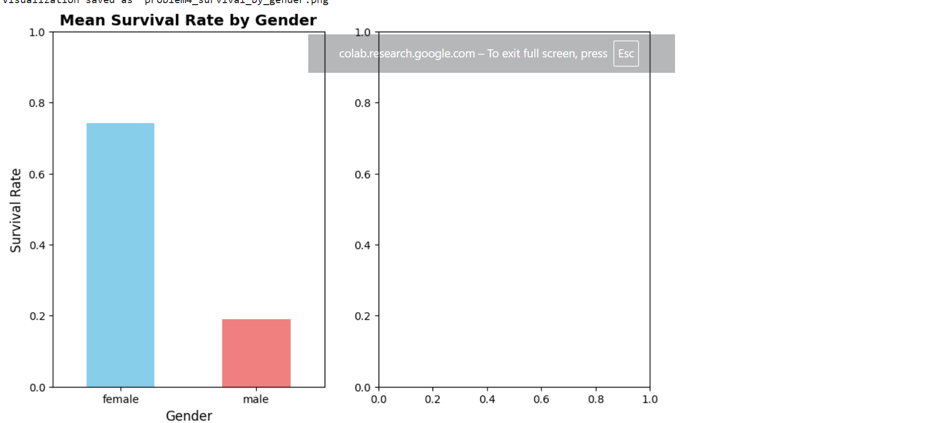
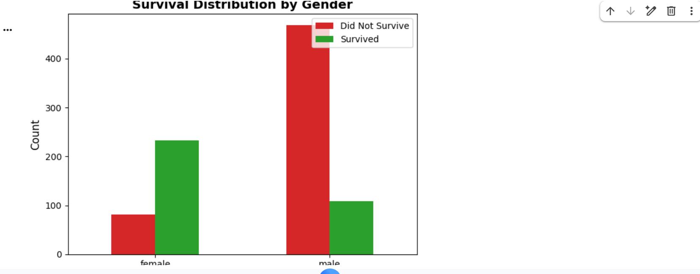
Problem - 5:
Draw a visualization that breaks your visualization from Exercise 3 down by the port of embarkation (’Embarked’). In this instance, compare the ports ’C’ (Cherbourg), ’Q’ (Queenstown), and ’S’ (Southampton).
