7.1 Warming Up Exercise:
Task 1. Classify Study Time:
- Create empty lists for study time classifications: (a) Low: less than 3 hours. (b) Moderate: between 3 and 5 hours. (c) High: more than 5 hours.
- Iterate over the time_data list and add each study hour to the appropriate category.
- Print the lists to verify the classifications.
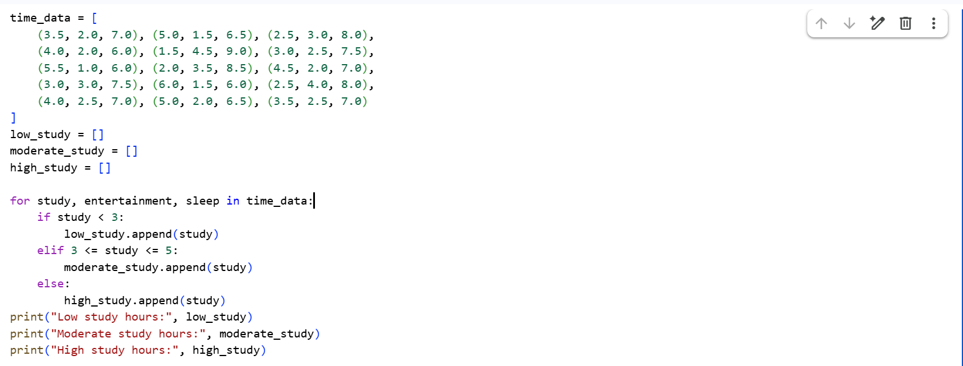
Task 2. Based on Data – Answer all the Questions:
- How many days had low study time? (a) Hint: Count the number of items in the low study list and print the result.
- How many days had moderate study time?
- How many days had high study time?
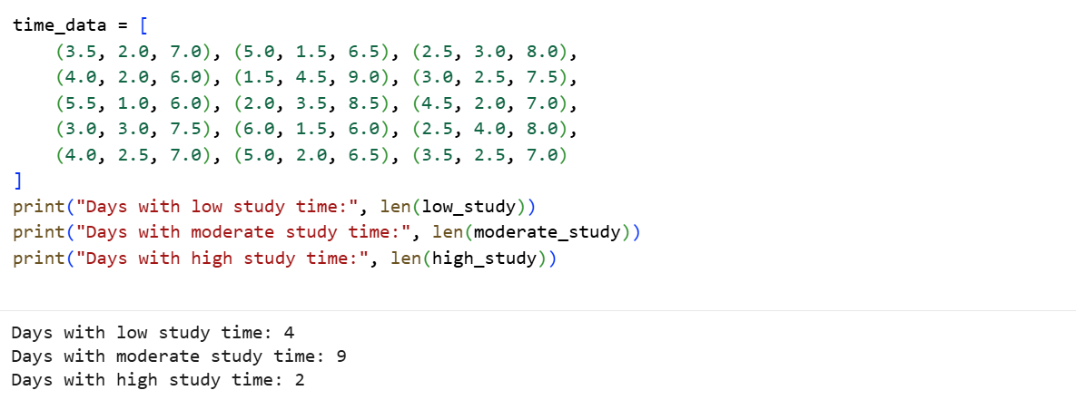
Task 3. Convert Study Hours to Minutes: Convert each study hour value into minutes and store it in a new list called study_minutes.
Formula: Minutes = Hours × 60
- Iterate over the time_data list and apply the formula to the study hours.
- Store the results in the new list.
- Print the converted values.
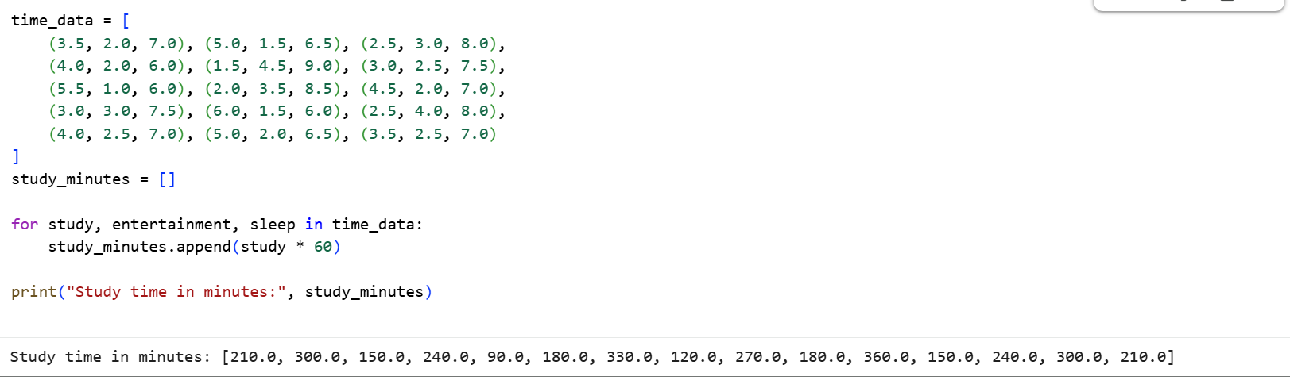
Task 4. Analyze Average Time Use: Scenario: Each record contains daily hours of study, entertainment, and sleep.
- Create empty lists for study_hours, entertainment_hours, and sleep_hours.
- Iterate over time_data and extract values into each list.
- Calculate and print: (a) Average hours spent studying. (b) Average hours spent on entertainment. (c) Average hours spent sleeping.
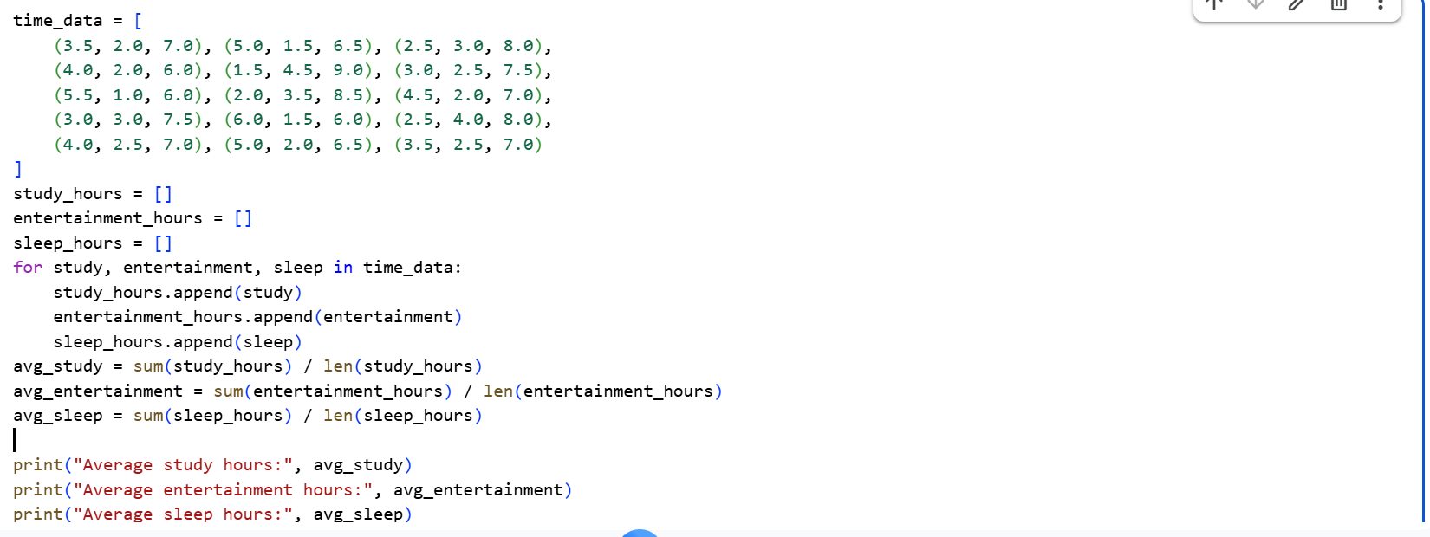
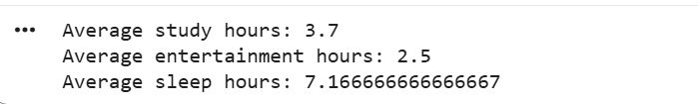
Task 5. Visualization - Study vs Sleep Pattern:
- Import matplotlib.pyplot as plt.
- Plot a scatter plot with: • x-axis: Study hours • y-axis: Sleep hours
- Add labels, title, and color.
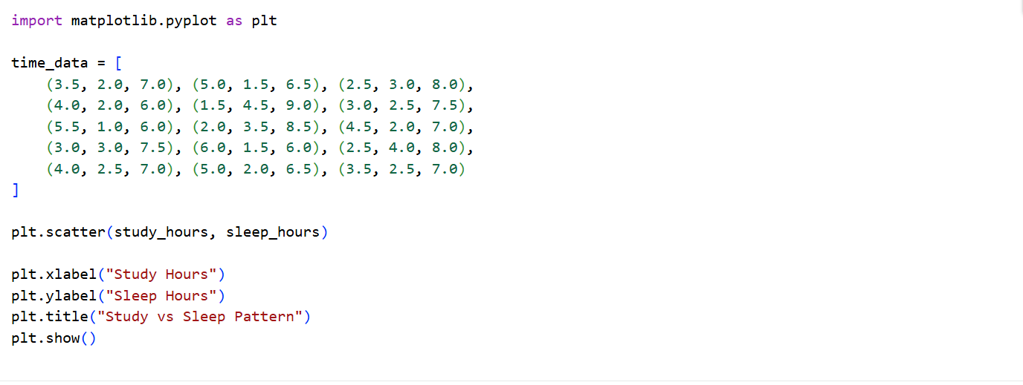
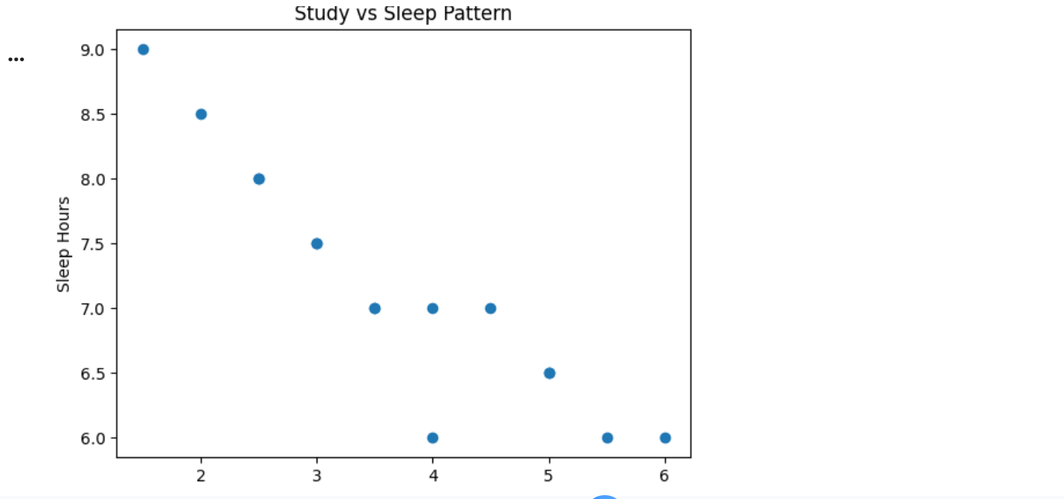
8.1.1 Exercise - Recursion:
Task 1 - Sum of Nested Lists: Scenario: You have a list that contains numbers and other lists of numbers (nested lists). You want to find the total sum of all the numbers in this structure. Task: • Write a recursive function sum_nested_list(nested_list) that:
- Takes a nested list (a list that can contain numbers or other lists of numbers) as input.
- Sums all numbers at every depth level of the list, regardless of how deeply nested the numbers are. • Test the function with a sample nested list, such as nested_list = [1, [2, [3, 4], 5], 6, [7, 8]]. The result should be the total sum of all the numbers.
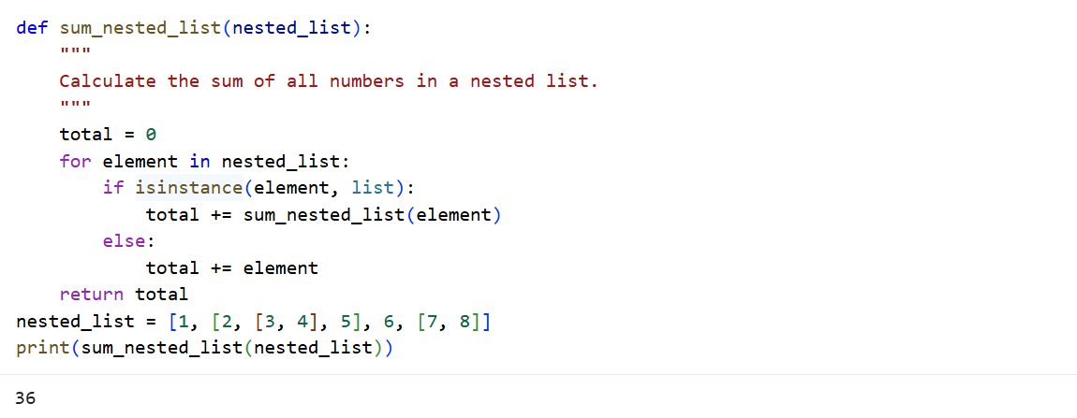
Task 2 - Generate All Permutations of a String: Scenario: Given a string, generate all possible permutations of its characters. This is useful for understanding backtracking and recursive depth-first search. Task: • Write a recursive function generate_permutations(s) that: – Takes a string s as input and returns a list of all unique permutations. • Test with strings like ”abc” and ”aab”.
print(generate_permutations("abc"))

Should return [’abc’, ’acb’, ’bac’, ’bca’, ’cab’, ’cba’]

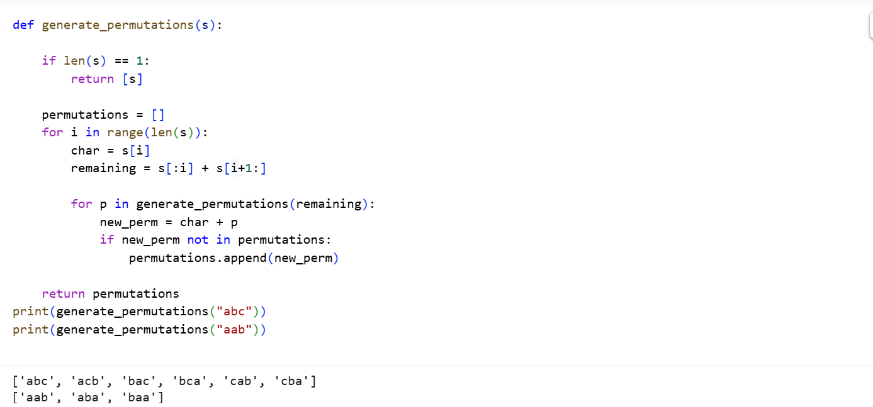
Task 3 - Directory Size Calculation: Directory Size Calculation Scenario: Imagine a file system where directories can contain files (with sizes in KB) and other directories. You want to calculate the total size of a directory, including all nested files and subdirectories.
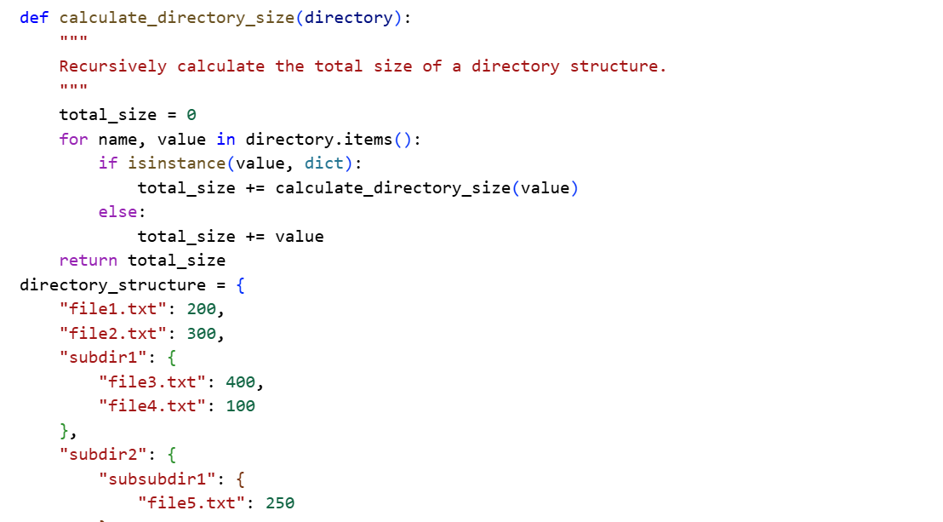
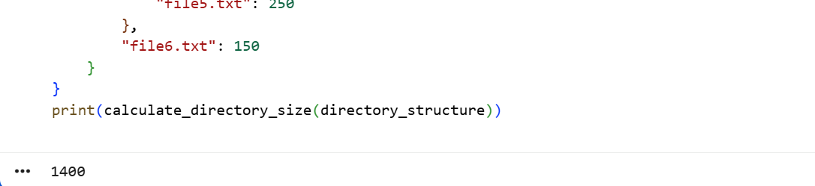
Task:4
- Write a recursive function calculate_directory_size(directory) where: • directory is a dictionary where keys represent file names (with values as sizes in
KB) or directory names (with values as another dictionary representing a subdi- rectory).
• The function should return the total size of the directory, including all nested subdirectories. 2. Test the function with a sample directory structure.
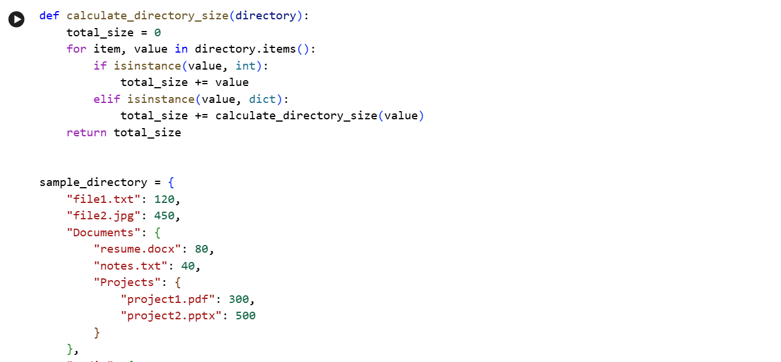
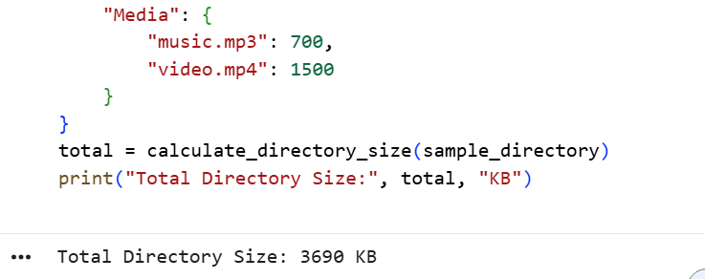
8.2.1 Exercises - Dynamic Programming:
Task 1 - Coin Change Problem: Scenario: Given a set of coin denominations and a target amount, find the minimum number of coins needed to make the amount. If it’s not possible, return - 1. Task:
- Write a function min_coins(coins, amount) that: • Uses DP to calculate the minimum number of coins needed to make up the amount.
- Test with coins = [1, 2, 5] and amount = 11. The result should be 3 (using coins [5, 5, 1]).
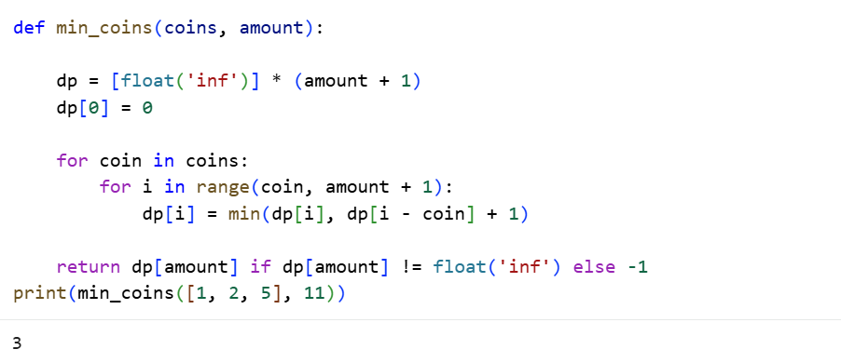
Task 2 - Longest Common Subsequence (LCS): Scenario: Given two strings, find the length of their longest common subsequence (LCS). This is useful in text comparison. Task:
- Write a function longest_common_subsequence(s1, s2) that: • Uses DP to find the length of the LCS of two strings s1 and s2.
- Test with strings like "abcde" and "ace"; the LCS length should be 3 ("ace").
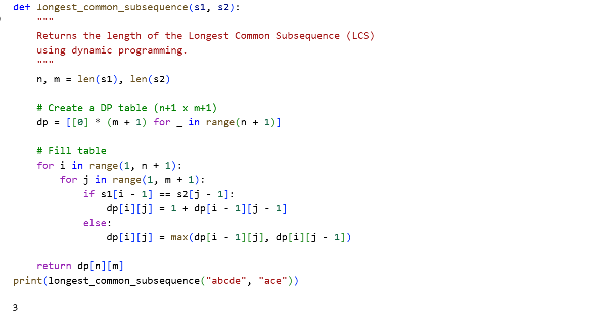

Task 3 - 0/1 Knapsack Problem: Scenario: You have a list of items, each with a weight and a value. Given a weight capacity, maximize the total value of items you can carry without exceeding the weight capacity. Task:
- Write a function knapsack(weights, values, capacity) that: • Uses DP to determine the maximum value that can be achieved within the given weight capacity.
- Test with weights [1, 3, 4, 5], values [1, 4, 5, 7], and capacity 7. The re- sult should be 9.
