|  |  |
| --- | --- |
| logo | **CHHOTUBHAI GOPALBHAI PATEL INSTITUTE OF TECHNOLOGY**  **Computer Engineering**  **Web Development** |

**List of Experiments**

|  |  |  |  |
| --- | --- | --- | --- |
| **No.** | **Practical** | **Date** | **Signature** |
| 1. | Write a JavaScript program to apply validation on various fields of student registration form and validate it on validator.w3.org. |  |  |
|  | a. Write a PHP program to display today’s date in dd-mm-yyyy format.  b. Write a PHP program for swapping of two numbers.  c. Write a PHP program to print following pattern.  1  01  101  0101  10101  d. Implement for-each loop to print username and password as key-value pair in PHP. |  |  |
|  | Write a PHP program to apply following string functions on data of file and save the result in the same file.  strtolower(), strtoupper(), strlen(), ltrim(), rtrim(), trim(), substr(),  strcmp(), strcasecmp(), strpos(), str_replace(), strrev(). |  |  |
| **CIE - 1** | | | |
|  | Write a PHP program for storing and retrieving user information from MySQL table.  a. Design a HTML registration and login page which takes name, password, email and mobile number from user.  b. Store this data in MySQL database.  c. On next page display all user in HTML table using PHP.  d. Update/Delete details of user. |  |  |
|  | Implement session and cookie to maintain session during login and implement visitor counter. |  |  |
|  | Host your website on server. |  |  |
|  | a. Write a program to verify new user via email and OTP.  b. Write a program to reset a password in case of forgetting login credentials. |  |  |
| **CIE - 2** | | | |
|  | Write a program to check the strength of password using jQuery. |  |  |
|  | Integrate google reCAPTCHA with PHP. |  |  |
|  | Write a program using AJAX and PHP to demonstrate how a web page can communicate with the web server while a user type characters in input field. |  |  |
| **CIE - 3** | | | |

**Practical 1**

**AIM:** **Write a JavaScript program to apply validation on various fields of student registration form and validate it on validator.w3.org.**

**Code:**

practical1.html

<!DOCTYPE html>

<html lang="en">

<head>

<meta charset="utf-8" />

<title>Register Form</title>

<script>

function validate() {

var validname = /^[a-zA-Z]+$/;

var fname = document.forms["RegisterForm"]["firstname"].value;

if(fname === "") {

alert("First Name cannot be empty!");

return false;

} else if(!fname.match(validname)) {

alert("Enter Valid First Name!")

return false;

}

var lname = document.forms["RegisterForm"]["lastname"].value;

if(lname === "") {

alert("Last Name cannot be empty!");

return false;

} else if(!lname.match(validname)) {

alert("Enter Valid Last Name")

return false;

}

var fage = document.forms["RegisterForm"]["age"].value;

if(fage === "") {

alert("Age cannot be empty!")

return false;

} else if(fage < 18 && fage > 99) {

alert("Please Enter your correct age");

return false;

}

var em = document.forms["RegisterForm"]["Email"].value;

var atpos = em.indexOf("@gmail");

var dotpos = em.lastIndexOf(".");

if(em === "") {

alert("Email cannot be empty!")

return false;

} else if(atpos < 1 || dotpos - atpos < 2) {

alert("Please enter correct email ID (Use @gmail.com)");

return false;

}

var dobyear = (new Date(document.forms["RegisterForm"]["Date"].value)).getFullYear();

var currentyear = (new Date()).getFullYear();

var validateyear = currentyear - dobyear;

if(fage != validateyear) {

alert("Incorrect Date of Birth (Check your Age)");

return false;

}

var phoneno = /^\+?([6-9]{1})\)?([0-9]{9})$/;

var ph = document.forms["RegisterForm"]["phone"].value;

if(ph === "") {

alert("Phone number cannot be empty!");

return false;

}

if(!phoneno.test(ph)) {

alert("Please Enter a valid phone number");

return false;

}

var addr = document.forms["RegisterForm"]["address"].value;

if(addr === "") {

alert("Address must be filled out");

return false;

}

}

</script>

</head>

<body>

<form name="RegisterForm" onsubmit="return validate()" method="post">

<table>

<tr>

<td>

<label>1. First Name</label>

</td>

<td>

<input type="text" name="firstname" /> </td>

</tr>

<tr>

<td>

<label>2. Last Name</label>

</td>

<td>

<input type="text" name="lastname" /> </td>

</tr>

<tr>

<td>

<label>3. Age</label>

</td>

<td>

<input type="number" name="age" /> </td>

</tr>

<tr>

<td>

<label>4. Email </label>

</td>

<td>

<input type="email" name="Email" /> </td>

</tr>

<tr>

<td>

<label>5. Date of Birth </label>

</td>

<td>

<input type="date" name="Date" /> </td>

</tr>

<tr>

<td>

<label>6. Gender </label>

</td>

<td>

<input type="radio" value="Male" name="gender" checked /> Male

<input type="radio" value="Female" name="gender" /> Female

<input type="radio" value="Other" name="gender" /> Other </td>

</tr>

<tr>

<td>

<label>7. Choose your department </label>

</td>

<td>

<select>

<option value="Course">Course</option>

<option value="BCA">BCA</option>

<option value="BBA">BBA</option>

<option value="B.Tech" selected>B.Tech</option>

<option value="MBA">MBA</option>

<option value="MCA">MCA</option>

<option value="M.Tech">M.Tech</option>

</select>

</td>

</tr>

<tr>

<td>

<label>8. Mobile Number </label>

</td>

<td>

<input type="text" name="phone" /> </td>

</tr>

<tr>

<td>

<label>9. Enter Address </label>

</td>

<td>

<textarea style="background-color:yellow" cols="80" rows="5" name="address"></textarea>

</td>

</tr>

<tr>

<td>

<button type="submit">REGISTRATION</button>

</td>

<td></td>

</tr>

</table>

</form>

</body>

</html>

**Output:**

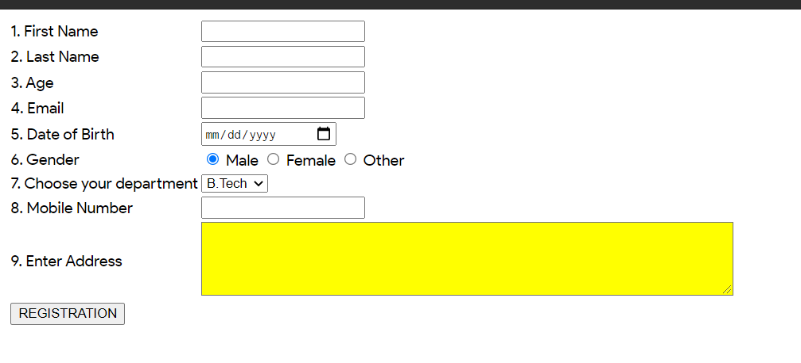

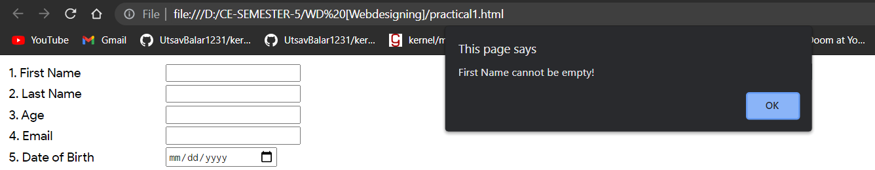

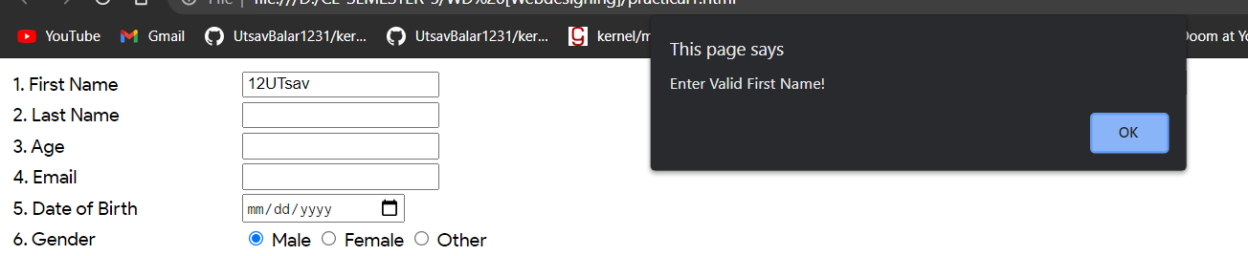

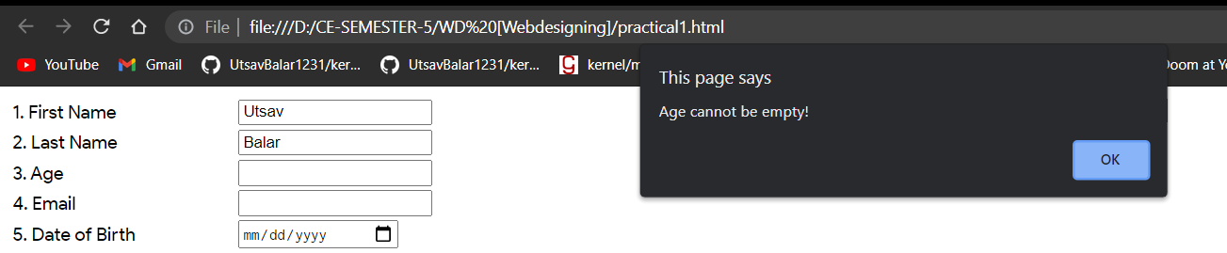

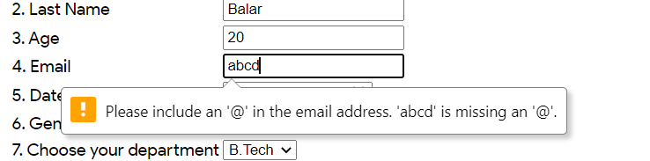

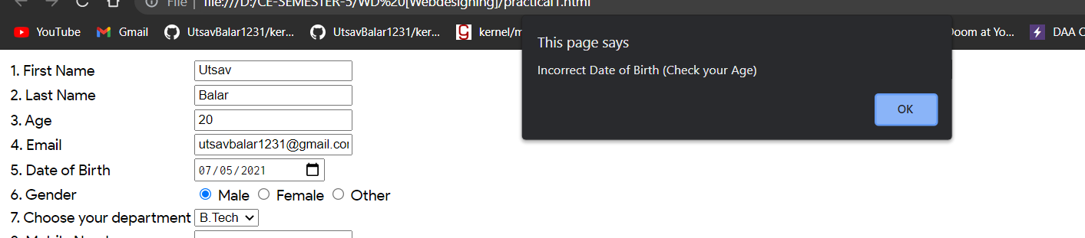

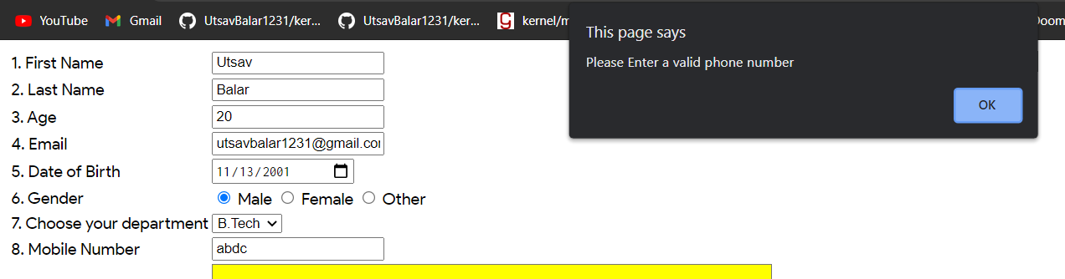

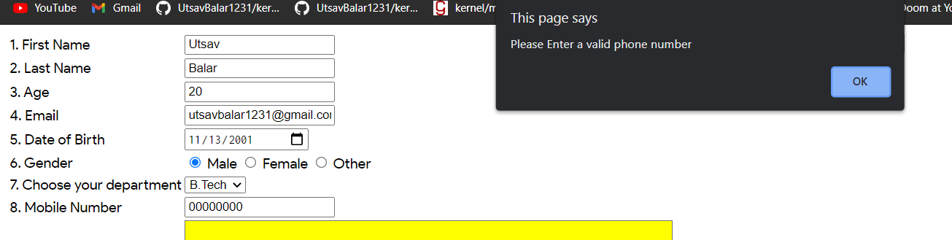

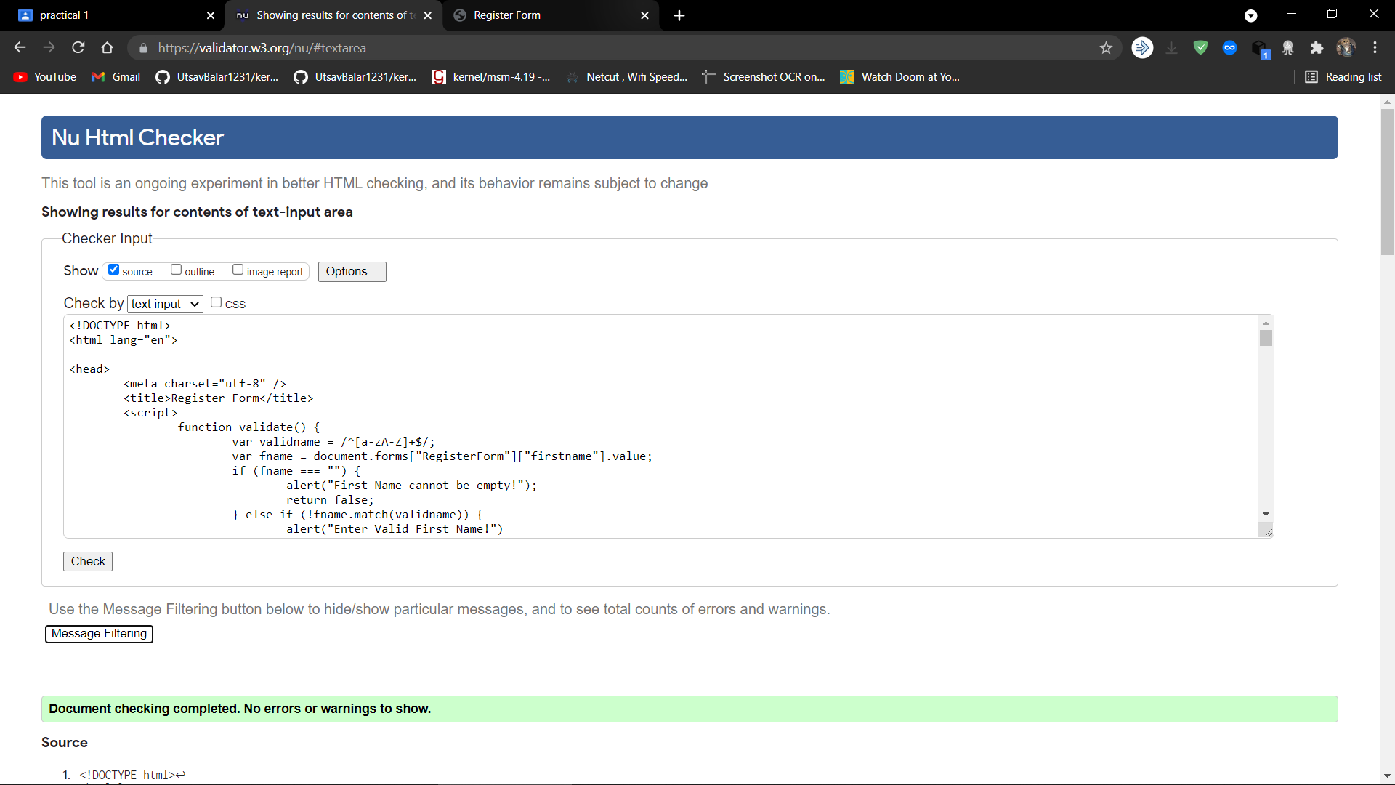

**Practical 2**

**AIM:**

**a. Write a PHP program to display today’s date in dd-mm-yyyy format.**

**b. Write a PHP program for swapping of two numbers.**

**c. Write a PHP program to print following pattern.**

**1**

**01**

**101**

**0101**

**10101**

**Code:**

practical2.php

<?php

**// practical 2a**

print "Date: " . date("m/d/Y") . "<br>";

**// practical 2b**

$x = 20;

$y = 100;

print "Value of a and b before swapping is $x and $y respectively<br>";

$x = $x + $y;

$y = $x - $y;

$x = $x - $y;

print "Value of a and b after swapping is $x and $y respectively<br>";

**// practical 2c**

$n = 5;

for ($i = 0;$i <= $n;$i++)

{

for ($j = 1;$j <= $i;$j++)

{

if (($i + $j) % 2 == 0) print "\t 1";

else print "\t 0";

}

print "<br>";

}

?>

**Output:**

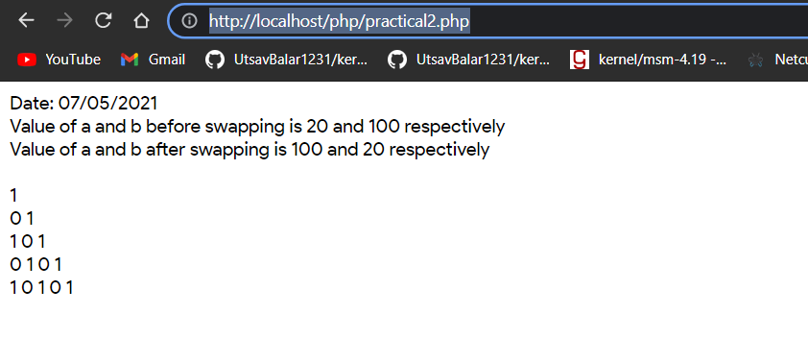

**Practical 3**

**AIM:**

**Write a PHP program to apply following string functions on data of file and save the result in the same file.**

**strtolower(), strtoupper(), strlen(), ltrim(), rtrim(), trim(), substr(),**

**strcmp(), strcasecmp(), strpos(), str_replace(), strrev().**

**Code:**

<?php

$mystr = "Knowing the will of the heavens, The Father is unrivaled!";

print "<b>mystr = </b> $mystr";

print '<br><b>strtolower($mystr):</b> ' . strtolower($mystr);

print '<br><b>strtoupper($mystr):</b> ' . strtoupper($mystr);

print '<br><b>strlen($mystr):</b> ' . strlen($mystr);

print '<br><b>ltrim($mystr, "heavens"):</b> ' . ltrim($mystr, "heavens");

print '<br><b>rtrim($mystr, "heavens"):</b> ' . rtrim($mystr, "heavens");

print '<br><b>trim($mystr, "heavens"):</b> ' . trim($mystr, "heavens");

print '<br><b>substr($mystr, 12, 20):</b> ' . substr($mystr, 12, 20);

print '<br><b>strcmp($mystr, "will of the heavens"):</b> ' . strcmp($mystr, "will

of the heavens");

print '<br><b>strcasecmp($mystr, "heavens, The Father is unrivaled!"):</b> ' .

strcasecmp($mystr, "heavens, The Father is unrivaled!");

print '<br><b>strpos($mystr, "heavens"): </b>' . strpos($mystr, "heavens");

print '<br><b>str_replace("Knowing the will of the heavens, The Father is

unrivaled!", "STOOD ALONE, UNSWAYABLE AND ENLIGHTENED. THE

UNRIVALED FATHER WHO KNOWS THE WILL OF THE HEAVENS...",

$mystr): </b>' . str_replace("Knowing the will of the heavens, The Father is

unrivaled!", "STOOD ALONE, UNSWAYABLE AND ENLIGHTENED. THE

UNRIVALED FATHER WHO KNOWS THE WILL OF THE HEAVENS...",

$mystr);

print '<br><b>strrev($mystr ): </b>' . strrev($mystr);

?>

**Output:**

