**Practical – 1**

**Aim: Installation of android SDK, android studio and creating android AVD.**

Step 1: Head over to the Android Studio install page https://developer.android.com/studio

Step 2: Click on the Download Android Studio Button.

* Agree the terms and conditions and download

Step 3: After the downloading has finished, open the file from downloads and run it. It will prompt the following dialog box.

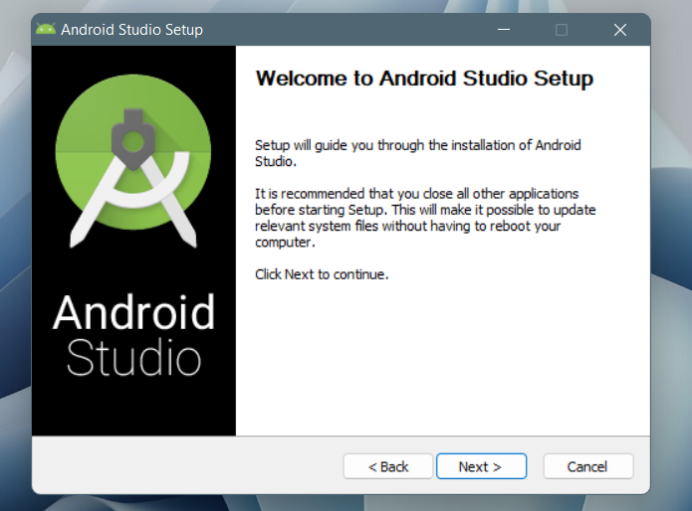

Step 4: It will start the installation, and once it is completed, it will be like the image shown below.

Step 5: Once “Finish” is clicked, it will ask whether the previous settings need to be imported [if the android studio had been installed earlier, or not. It is better to choose the ‘Don’t import Settings option’.

Step 6: This will start the Android Studio.



Meanwhile, it will be finding the available SDK components.

Step 7: After it has found the SDK components, it will redirect to the Welcome dialog box.

Step 8: Now it is time to download the SDK components.

Step 9: Click on Start a new Android Studio project to build a new app.

Step10: Open the Device Manager.

Step11: Click Create Device.

The Select Hardware window appears.

Step12: Select a hardware profile, and then click Next.

If you don't see the hardware profile you want, you can create or import a hardware profile. The System Image page appears.

Select the system image for a particular API level, and then click Next.

Step13: Change AVD properties as needed, and then click Finish.