**Practical -10**

**Aim: To implement multiclass classification with neural network on Iris flower species.**

# Code:

import pandas as pd

import matplotlib.pyplot as plt

from sklearn.model_selection import train_test_split

from sklearn.preprocessing import StandardScaler

from sklearn.neural_network import MLPClassifier

from sklearn.metrics import accuracy_score

from sklearn.metrics import plot_confusion_matrix

from sklearn.metrics import classification_report

from sklearn.model_selection import GridSearchCV

df = pd.read_csv('Iris.csv')

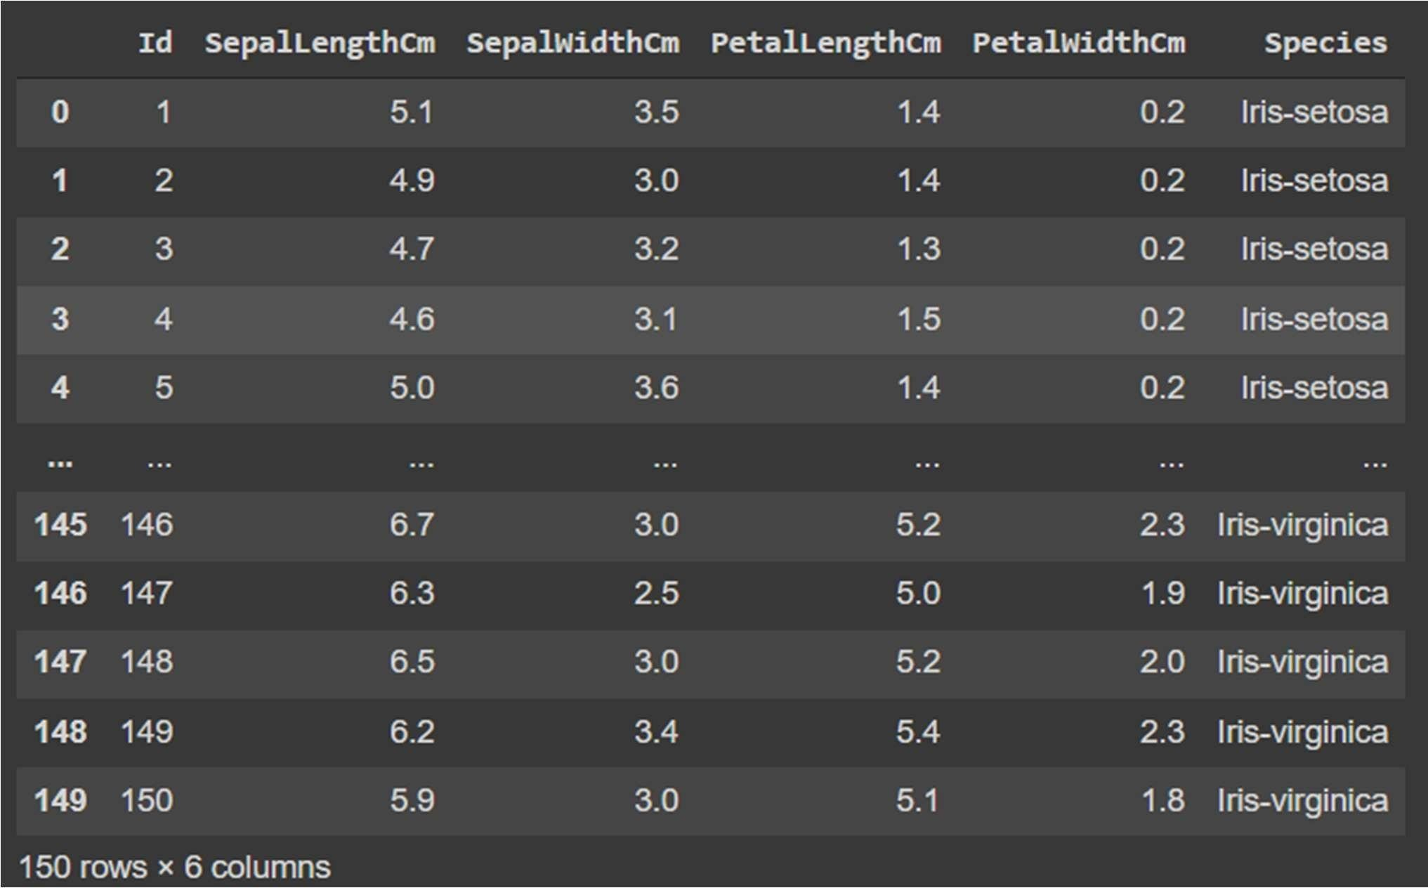

# Code:

df['Species'].value_counts()

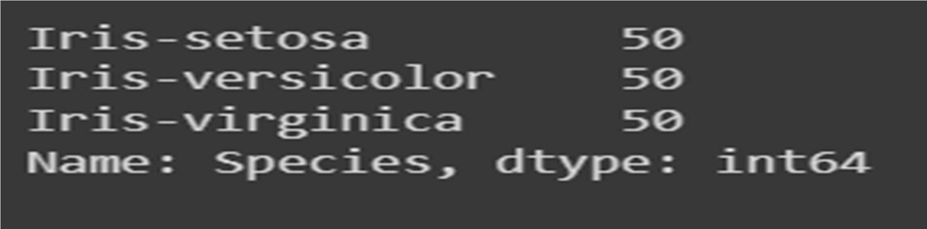

**Code:**

x = df.drop('Species', axis=1) y = df['Species']

trainX, testX, trainY, testY = train_test_split(x, y, test_size = 0.

sc=StandardScaler()

scaler = sc.fit(trainX)

trainX_scaled = scaler.transform(trainX)

testX_scaled = scaler.transform(testX)

mlp_clf = MLPClassifier(hidden_layer_sizes=(15 0,100,50),max_iter = 300,activation = 'relu',solver = 'adam')

mlp_clf.fit(trainX_scaled, trainY)



# Code:

y_pred = mlp_clf.predict(testX_scaled) print('Accuracy:

{:.2f}'.format(accuracy_score(testY, y_pred)))

# Code:

fig = plot_confusion_matrix(mlp_clf, testX_scaled, testY, display_labels=mlp_clf.classes_)

fig.figure_.suptitle("Confusion Matrix”)

# Code:

print(classification_report(testY, y_pred))

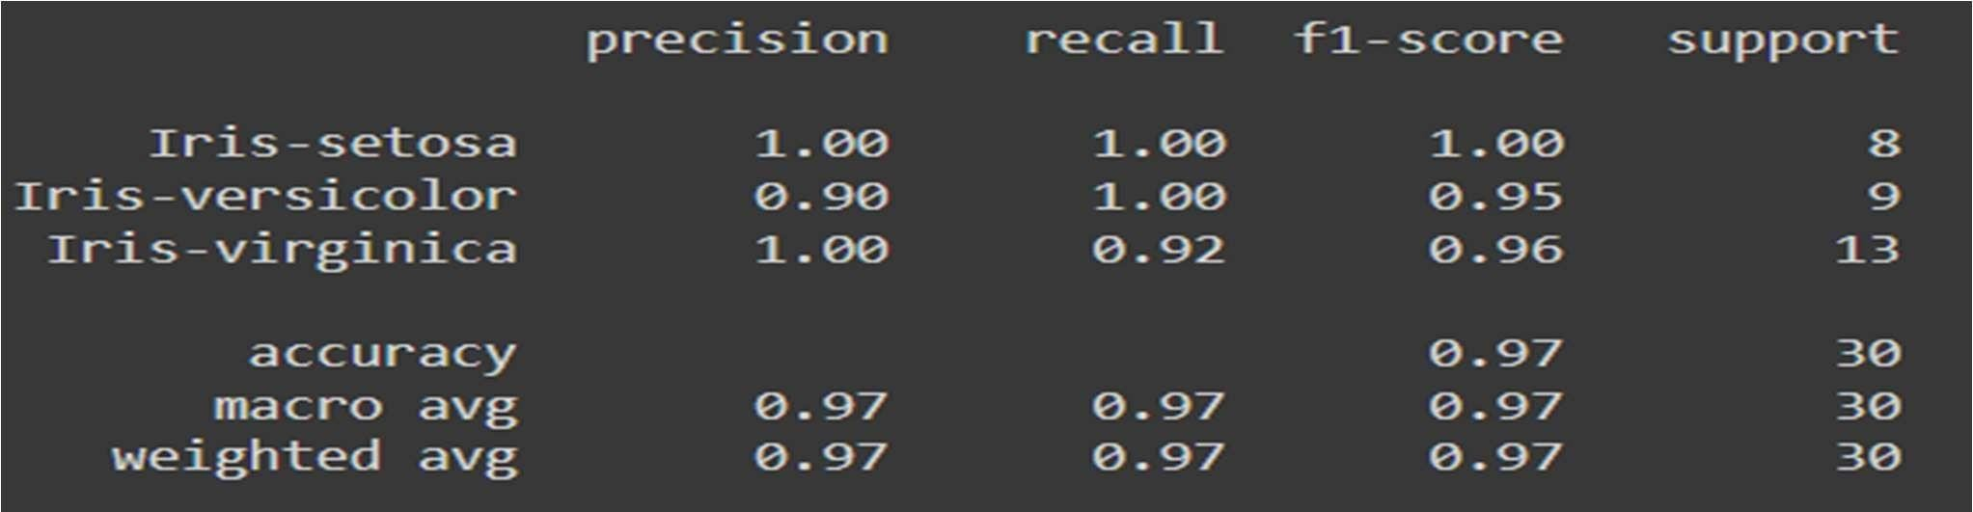

plt.plot(mlp_clf.loss_curve_) plt.title("Loss Curve", fontsize=14) plt.xlabel('Iterations') plt.ylabel('Cost')

plt.show()

# Code:

param_grid = {

'hidden_layer_sizes': [(150,100,50),

(120,80,40), (100,50,30)],

'max_iter': [50, 100, 150],

'activation': ['tanh', 'relu'],

'solver': ['sgd', 'adam'],

'alpha': [0.0001, 0.05],

'learning_rate': ['constant','adaptive'],}

grid = GridSearchCV(mlp_clf, param_grid, n_jobs= -1, cv=5)

grid.fit(trainX_scaled, trainY) print(grid.best_params_)



# Code:

grid_predictions = grid.predict(testX_scaled)

print('Accuracy:

{:.2f}'.format(accuracy_score(testY, grid_predictions)))

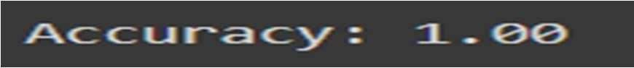

**Practical - 11**

**Aim: To implement a convolutional neural network for object recognition inan image with CIFAR 10 dataset.**

# Code:

from future import print_function import tensorflow as tf

from tensorflow.keras.datasets import cifar10

from tensorflow.keras.preprocessing.image import ImageDataGenerator from tensorflow.keras.models import Sequential

from tensorflow.keras.layers import Dense, Dropout, Activation, Flatten from tensorflow.keras.layers import BatchNormalization

from tensorflow.keras.layers import Conv2D, MaxPooling2D from tensorflow.keras.regularizers import l2

import numpy as npimportos import matplotlib.pyplot as plt

%matplotlib inline

# Defining the parameters batch_size = 16

num_classes = 10

epochs = 10

# Splitting the data between train and test (x_train, y_train), (x_test, y_test) = cifar10.load_data()print('x_train shape:', x_train.shape) print(x_train.shape[0], 'train samples') print(x_test.shape[0], 'test samples')

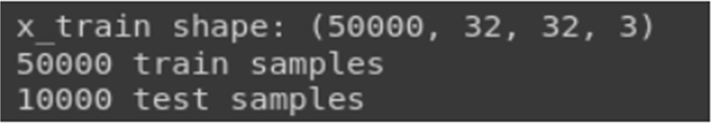

# Code:

# Convert class vectors to binary class matrices. y_train = tf.keras.utils.to_categorical(y_train, num_classes)y_test = tf.keras.utils.to_categorical(y_test, num_classes)

# Printing sample data print(y_train[:10])

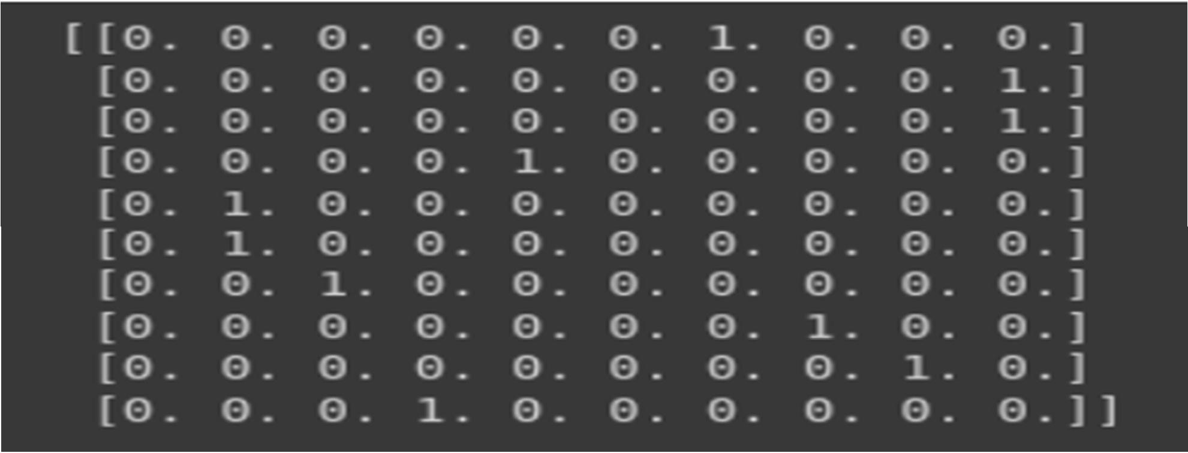

# Code:

model = Sequential() model.add(Conv2D(64, (3, 3), padding='same', input_shape=x_train.shape[1:])) model.add(Activation('relu')) model.add(BatchNormalization()) model.add(Conv2D(64, (3, 3))) model.add(Activation('relu'))

model.add(BatchNormalization()) model.add(MaxPooling2D(pool_size=(2,2)) model.add(Dropout(0.25)) model.add(Conv2D(128, (3, 3), padding='same'))model.add(Activation('relu')) model.add(BatchNormalization()) model.add(Conv2D(128, (3, 3))) model.add(Activation('relu')) model.add(BatchNormalization()) model.add(MaxPooling2D(pool_size=(2, 2))) model.add(Dropout(0.25)) model.add(Flatten()) model.add(Dense(512,kernel_regularizer=l2(0.01)) model.add(Activation('relu')) model.add(Dropout(0.5)) model.add(Dense(num_classes)) model.add(Activation('softmax'))

# compile model.compile(loss='categorical_crossentro’, optimizer='sgd',

metrics=['accuracy']) x_train=x_train.astype('float3') x_test=x_test.astype('float32') # Normalizing the input imagex_train /= 255

x_test /= 255

from keras.callbacksimportModelCheckpoit model_path = 'inceptionv3_face_bg.h5'

checkpoint = ModelCheckpoint(model_path, monitor='val_accuracy', verbose=1,

save_best_only=True, mode='max') callbacks_list=[checkpoint]

# Training the model history = model.fit(x_train,

y_train,batch_size=batch_size, epochs=epochs, validation_data=(x_test, y_test), callbacks=callbacks_list

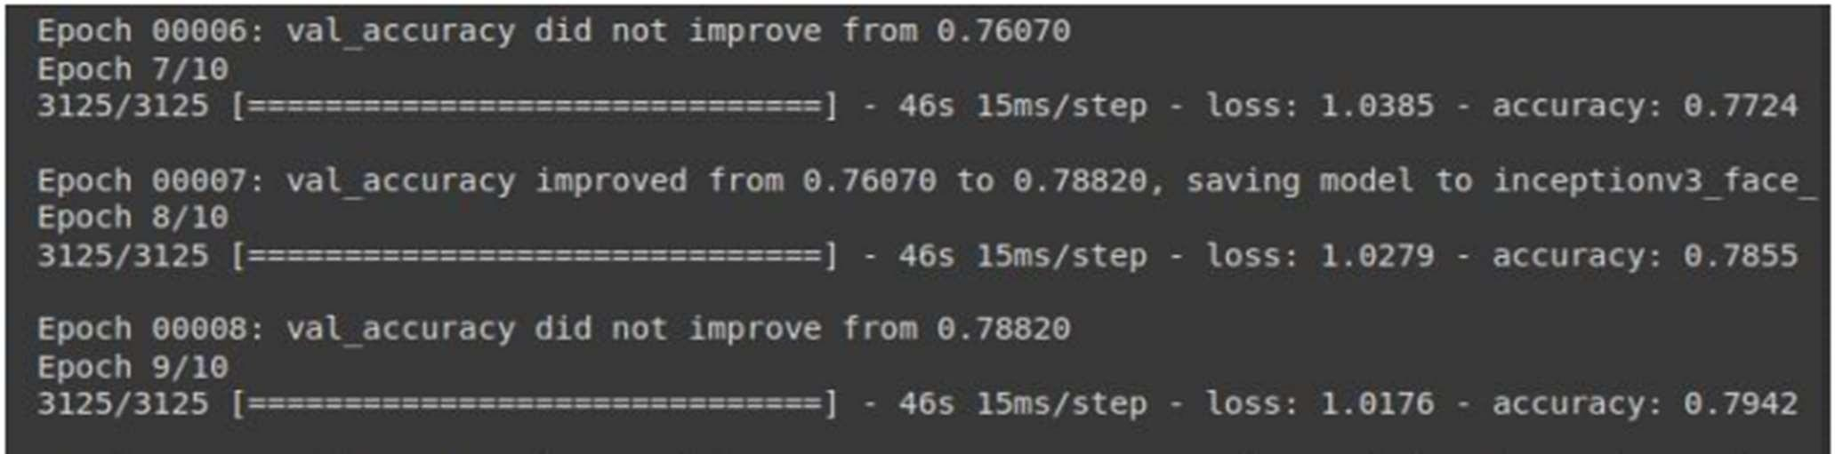

# Code:

# list all data in history print(history.history.keys())

# summarize history for accuracy plt.plot(history.history['accuracy']) plt.plot(history.history['val_accuracy '])plt.title('model accuracy') plt.ylabel('accuracy') plt.xlabel('epoch')

plt.legend(['train', 'test'], loc='upper left')plt.show()

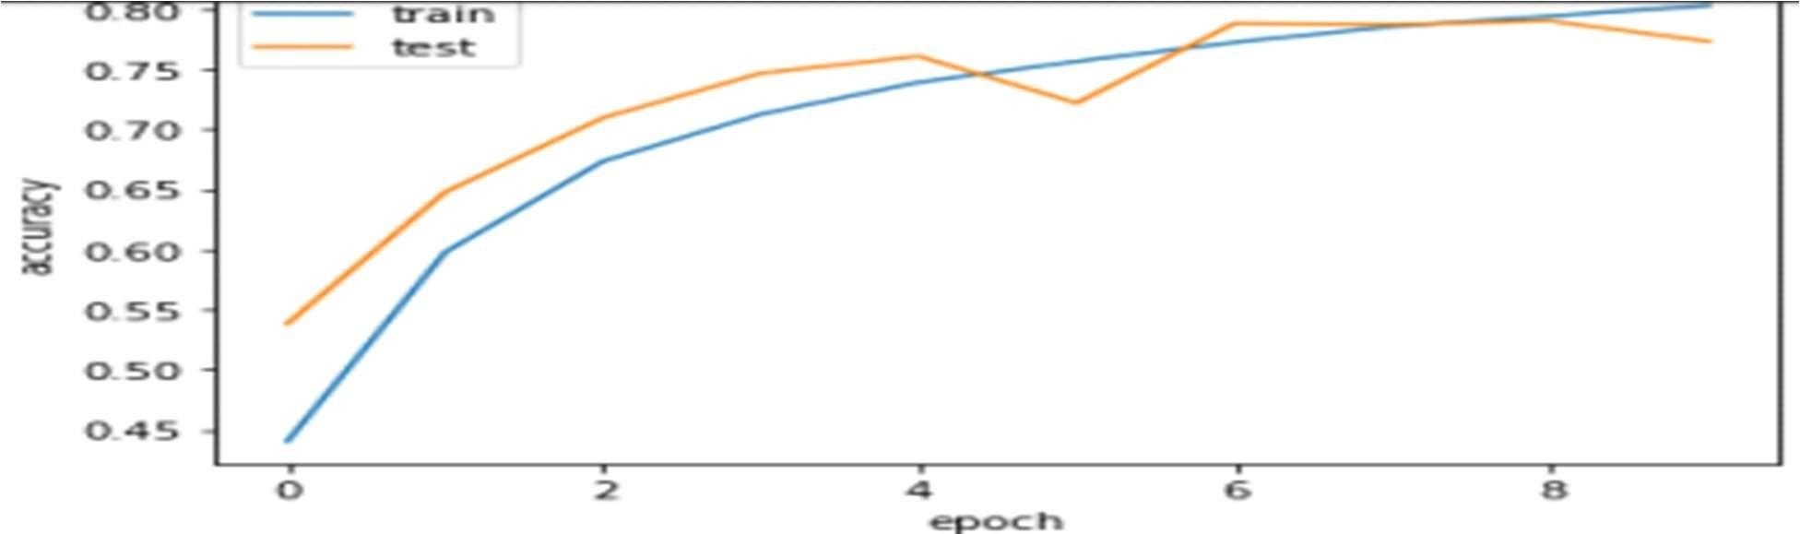

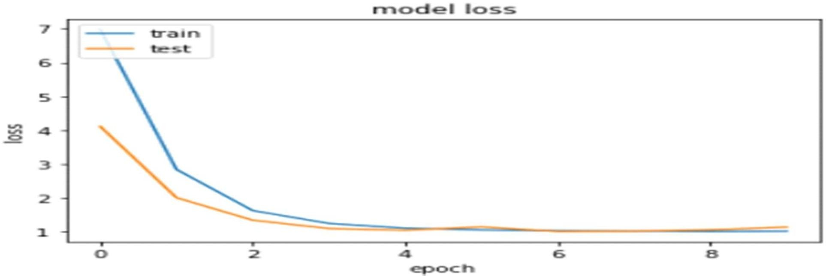

# Code:

import keras

from keras.models import load_model from keras.preprocessing import image import numpy as np

import keras

from tensorflow.keras.models import load_model from tensorflow.keras.preprocessing import image from matplotlib import pyplot as plt

import numpy as np import cv2

import numpy as np import cv2

#img = cv2.imread('/content/index.jpeg')

model = keras.models.load_model('/content/inceptionv3_face_bg.h5') t_img = image.load_img("/content/index.jpeg", target_size = (32,32)) t_img = image.img_to_array(t_img)/255

t_img = np.expand_dims(t_img, axis = 0) result = model.predict(t_img)

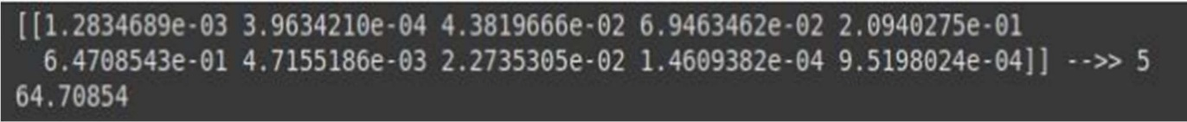pred = np.argmax(result) print(result, "-->>",pred) print(max(result[0]*1003

**Practical-12**

**Aim: To implement sequence classification of Movie reviews with LSTM network.**

# Code:

import numpy

from keras.datasets import imdb from keras.models import Sequential from keras.layers import Dense

from keras.layers import LSTM

from keras.layers.embeddings import Embedding from keras.preprocessing import sequence

# fix random seed for reproducibility numpy.random.seed(7)

# load the dataset but only keep the top n words, zero the rest top_words = 5000

(X_train, y_train), (X_test, y_test) = imdb.load_data(num_words=top_words)

# truncate and pad input sequences max_review_length = 500

X_train = sequence.pad_sequences(X_train, maxlen=max_review_length) X_test = sequence.pad_sequences(X_test, maxlen=max_review_length)

# create the model embedding_vecor_length = 32 model = Sequential()

model.add(Embedding(top_words, embedding_vecor_length, input_length=max_review_length)) model.add(LSTM(100))

model.add(Dense(1, activation='sigmoid')) model.compile(loss='binary_crossentropy', optimizer='adam', metrics=['accuracy']) print(model.summary())

model.fit(X_train, y_train, epochs=3, batch_size=64)

# Final evaluation of the model

scores = model.evaluate(X_test, y_test, verbose=0) print("Accuracy: %.2f%%" % (scores[1]*100))

