**Practical: 6**

**Aim: To Implement principal component analysis**

**Code:**

import pandas as pd

from sklearn.model_selection import train_test_split

from sklearn import metrics, preprocessing

from sklearn.tree import DecisionTreeClassifier

from sklearn.metrics import accuracy_score

import matplotlib.pyplot as plt

import numpy as np

data = pd.read_csv('diabetes.csv')

# Data Preprocessing

preprocessing = False

#preprocessing = True

if preprocessing:

data['Glucose'].fillna(data['Glucose'].mean(), inplace=True)

data['BloodPressure'].fillna(data['BloodPressure'].mean(), inplace=True)

data['SkinThickness'].fillna(data['SkinThickness'].mean(), inplace=True)

data['Insulin'].fillna(data['Insulin'].mean(), inplace=True)

data['BMI'].fillna(data['BMI'].mean(), inplace=True)

# Correlation Matrix for Diabetes Data

corr = data.corr()

# print(corr.values)

plt.figure(figsize=(17, 7))

X = data.drop(['Outcome'], axis=1).values

y = data['Outcome'].values

# Split the data into training and testing sets

X_train, X_test, y_train, y_test = train_test_split(X,

y,

test_size=0.2,

random_state=0)

print('training data : ', X_train.shape, y_train.shape)

print('testing data : ', X_test.shape, y_test.shape)

# Decision Tree Classifier

dtc = DecisionTreeClassifier()

dtc = dtc.fit(X_train, y_train)

y_pred = dtc.predict(X_test)

acc = accuracy_score(y_pred, y_test)

print('Accuracy is: ', acc)

**# Ouput:**

1. Without preprocessing

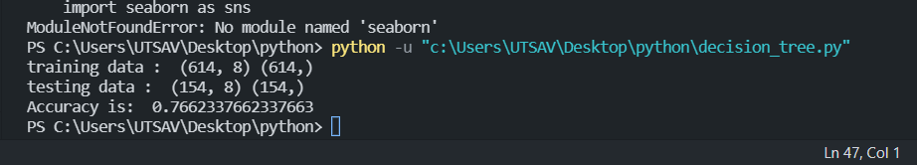

1. With preprocessing

