**Practical – 3**

**Aim: Write a program to queue multiple transactions created by clients in blockchain application**

**Code:**

***main.rs***

use simple_blockchain_rs::client::Client;

use simple_blockchain_rs::transaction::Transaction;

fn main() {

let mut transactions = vec];

let utsav = Client::new();

let bhupendra = Client::new();

let jash = Client::new();

println!("utsav public key: {}", utsav.identify());

println!("bhupendra public key: {}", bhupendra.identify());

println!("jash public key: {}", jash.identify());

println!("");

let mut transaction1 = Transaction::new(utsav.public_key, bhupendra.public_key, 10.0, None);

transaction1.sign_transaction(&utsav);

println!(

"Transaction 1 signature validation: {:#?}",

transaction1.is_valid_transaction()

);

transactions.push(transaction1);

let mut transaction2 = Transaction::new(bhupendra.public_key, jash.public_key, 10.0, None);

transaction2.sign_transaction(&bhupendra);

println!(

"Transaction 2 signature validation: {:#?}",

transaction2.is_valid_transaction()

);

transactions.push(transaction2);

let mut transaction3 = Transaction::new(jash.public_key, utsav.public_key, 10.0, None);

transaction3.sign_transaction(&jash);

println!(

"Transaction 3 signature validation: {:#?}",

transaction3.is_valid_transaction()

);

transactions.push(transaction3);

println!("");

transactions.iter().for_each(|transaction| {

transaction.print_transaction();

});

***client.rs from practical - 1***

***transaction.rs from practical – 2***

***lib.rs from practical – 2***

***Transactions between Utsav, Bhupendra and Jash as three clients***

**Clients public keys**

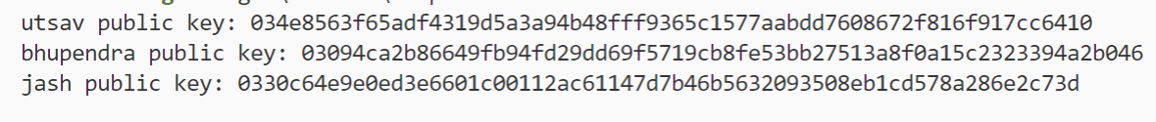

**Transaction between Utsav – Bhupendra**

**Transaction between Bhupendra – Jash**

**Transaction between Jash – Utsav**

**Signature Verification**

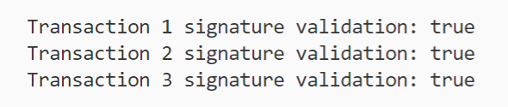

**Complete output on stdout**

