**Practical – 4**

**Aim: Write a program to create a block class which can hold 3 transactions. Also create a genesis block**

**Code:**

***lib.rs***

pub mod client;

pub mod transaction;

pub mod block;

***main.rs***

use simple_blockchain_rs::client::Client;

use simple_blockchain_rs::transaction::Transaction;

use simple_blockchain_rs::block::Block;

fn main() {

let utsav = Client::new();

let bhupendra = Client::new();

let jash = Client::new();

let mut block0 = Block::genesis_block(&utsav);

println!("Genesis Block: {:#?}", block0);

println!("utsav public key: {}", utsav.identify());

println!("bhupendra public key: {}", bhupendra.identify());

println!("jash public key: {}", jash.identify());

println!("");

let mut transaction1 = Transaction::new(utsav.public_key, bhupendra.public_key, 10.0, None);

transaction1.sign_transaction(&utsav);

println!(

"Transaction 1 signature validation: {:#?}",

transaction1.is_valid_transaction()

);

block0.verified_transactions.push(transaction1);

let mut transaction2 = Transaction::new(bhupendra.public_key, jash.public_key, 10.0, None);

transaction2.sign_transaction(&bhupendra);

println!(

"Transaction 2 signature validation: {:#?}",

transaction2.is_valid_transaction()

);

block0.verified_transactions.push(transaction2);

let mut transaction3 = Transaction::new(jash.public_key, utsav.public_key, 10.0, None);

transaction3.sign_transaction(&jash);

println!(

"Transaction 3 signature validation: {:#?}",

transaction3.is_valid_transaction()

);

block0.verified_transactions.push(transaction3);

println!("Block 0: {:#?}", block0);

}

***block.rs***

use super::transaction::*;

use crate::client::*;

/// A block in the blockchain.

///

/// `index` contains the index of the block.

/// `nonce` contains the nonce of the block that is used to find a valid hash.

/// `previous_hash` contains the hash of the previous block.

/// `hash` contains the hash of the block.

/// `verified_transactions` contains the transactions that are verified in the block.

#[derive(Debug)]

pub struct Block {

pub index: u64,

pub nonce: u64,

pub previous_hash: Option<String>,

pub hash: String,

pub verified_transactions: Vec<Transaction>,

}

impl Block {

/// This method creates a new block.

pub fn new(index: u64, previous_hash: Option<String>) -> Self {

Self {

index,

nonce: 0u64,

previous_hash,

hash: String::new(),

verified_transactions: vec],

}

}

/// This method generates genesis block.

pub fn genesis_block(receiver: &Client) -> Self {

let genesis = Client::new();

let initial_transaction =

Transaction::new(genesis.public_key, receiver.public_key, 1000.0, None);

let mut genesis_block = Block::new(0, None);

genesis_block

.verified_transactions

.push(initial_transaction);

genesis_block.hash = genesis_block.calculate_hash();

genesis_block

}

/// This method verifies the transactions in the block.

pub fn has_valid_transactions(&self) -> bool {

for tran in &self.verified_transactions {

if !tran.is_valid_transaction() {

return false;

}

}

return true;

}

/// This method serializes the block into a string.

pub fn serialize(&self) -> String {

let transactions = self

.verified_transactions

.iter()

.fold(String::new(), |acc, x| acc + &x.serialize());

format!(

"{}{}{}{}",

self.index,

self.nonce,

self.previous_hash.as_ref().unwrap_or(&String::new()),

transactions

)

}

/// This method calculates the hash of the block using SHA256.

pub fn calculate_hash(&self) -> String {

crypto_hash::hex_digest(crypto_hash::Algorithm::SHA256, &self.serialize().as_bytes())

}

}

***client.rs from practical - 1***

***transaction.rs from practical – 2***

**Genesis Block**

**Public keys of Utsav, Bhupendra, Jash**



**Transactions between the above three clients inside the block**

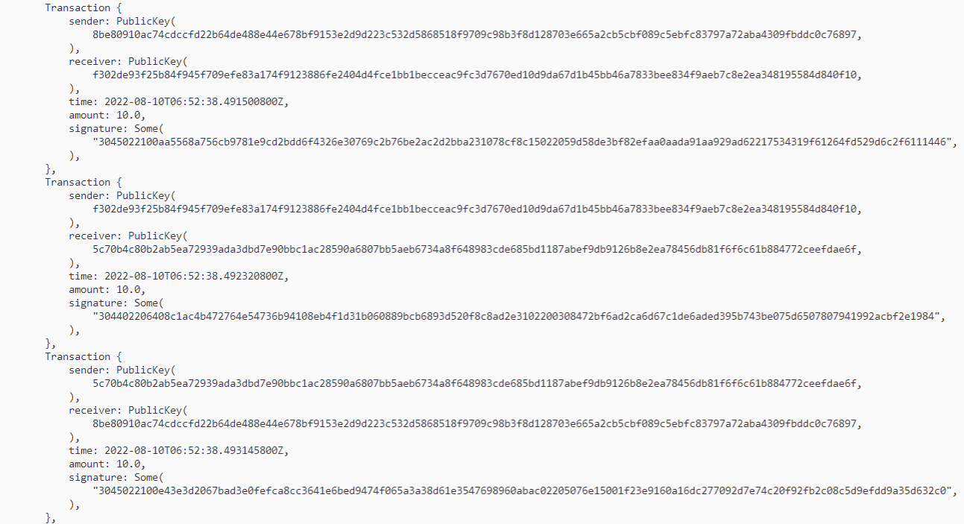

**Verified transactions inside the block**

