**Practical – 5**

**Aim: Write a program that will demonstrates adding blocks to the blockchain**

**Code:**

***tests.rs***

#[allow(dead_code)]

pub fn blockchain_class_print_blockchain() {

let utsav = Client::new();

let bhupendra = Client::new();

let jash = Client::new();

let mut block0 = Block::genesis_block(&utsav);

println!("utsav public key: {}", utsav.identify());

println!("bhupendra public key: {}", bhupendra.identify());

println!("jash public key: {}", jash.identify());

println!("");

let mut transaction1 = Transaction::new(utsav.public_key, bhupendra.public_key, 10.0, None);

transaction1.sign_transaction(&utsav);

println!(

"Transaction 1 signature validation: {:#?}",

transaction1.is_valid_transaction()

);

block0.verified_transactions.push(transaction1);

let mut transaction2 = Transaction::new(bhupendra.public_key, jash.public_key, 10.0, None);

transaction2.sign_transaction(&bhupendra);

println!(

"Transaction 2 signature validation: {:#?}",

transaction2.is_valid_transaction()

);

block0.verified_transactions.push(transaction2);

let mut transaction3 = Transaction::new(jash.public_key, utsav.public_key, 10.0, None);

transaction3.sign_transaction(&jash);

println!(

"Transaction 3 signature validation: {:#?}",

transaction3.is_valid_transaction()

);

block0.verified_transactions.push(transaction3);

let _last_block_hash = block0.calculate_hash();

let mut coin_chain = Blockchain::new();

coin_chain.add_block(block0);

coin_chain.dump_blockchain();

}

**Public keys**

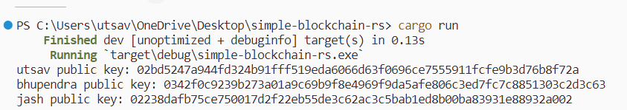

**Transactions validation**

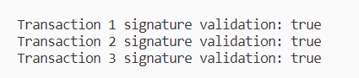

**Print blockchain**

