**Practical - 4**

**Aim:**

**(a) Write a FLEX program to print all html tags from a file.**

**(b) Write a FLEX program to remove single line comment from a file.**

**(c) Write a FLEX program that accepts language of all strings of the form anbn.**

**Code (a):**

%%

^\<[^<|^>]+>$ printf("%s is valid\n", yytext);

.*|\n ;

%%

void main() {

printf("start:\n");

yylex();

}

**Output:**

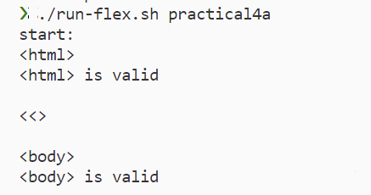

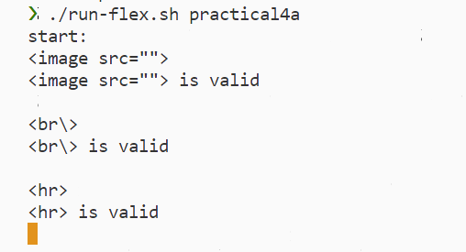

**(4b): Write a FLEX program to remove single line comment from a file.**

**Code (4b):**

%%

^[//].*[\n]? ;

.|\n ECHO;

%%

void main() {

yyin = fopen("test.c", "r");

yylex();

}

***test.c***

**Output:**

