**Practical – 6**

**Aim:**

**(a) Write a FLEX program which adds line numbers to the given file and display the same onto the standard output.**

**(b) Write a FLEX program that demonstrate use of the following**

**functions: yymore(), yyless(), unput(), input(), yyterminate()**

**Code (a):**

%{

int counter = 0;

%}

%x line

%%

<INITIAL>[^\n] {

printf("%d %s", ++counter, yytext);

BEGIN(line);

}

<INITIAL>[\n] printf("%d %s", ++counter, yytext);

<line>\n { ECHO; BEGIN(INITIAL); }

%%

void main() {

yyin = fopen("test.c", "r");

yylex();

fclose(yyin);

}

**test.c**

#include <stdio.h>

int main()

{

return 0;

}

**Output (a):**

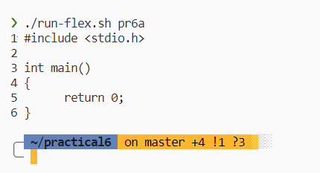

**Code (6b):**

%{

%}

%x COMMENT

%x SINGLE_COMMENT

%%

<INITIAL>"/*" {

BEGIN(COMMENT);

yymore();

}

<INITIAL>"/"+"/" {

BEGIN(SINGLE_COMMENT);

yymore();

}

<COMMENT>[^*]* yymore();

<COMMENT>"*"+[^*/]* yymore();

<COMMENT>"*"+"/" {

int c = input();

if (c == '\n')

printf("--Multiline comment was detected here--\n");

unput(c);

BEGIN(INITIAL);

}

<SINGLE_COMMENT>[^\n] {

int c = input();

if (c == '\n')

printf("--Singleline comment was detected here--\n");

unput(c);

yymore();

}

<SINGLE_COMMENT>[\n] {

yyless(yyleng);

BEGIN(INITIAL);

}

<<EOF>> {

printf("EOF\n");

yyterminate();

}

%%

void main() {

yyin = fopen("test.c", "r");

yylex();

fclose(yyin);

}

**test.c**

#include <stdio.h>

int main()

{

/**

* multiline comment

*

*/

return 0;

// single line comment

}

**Ouput (6b):**

