**Practical - 2**

**Aim: Implement message based IPC**

**Code:**

***sender.c***

#include <stdio.h>

#include <sys/ipc.h>

#include <sys/msg.h>

struct msg_buffer

{

long msg_type;

char mesg_text[100];

} message;

void main()

{

key_t key;

int id;

key = ftok("file", 65);

id = msgget(key, 0666 | IPC_CREAT);

message.msg_type = 1;

printf("data write: ");

fgets(message.mesg_text, 12, stdin);

msgsnd(id, &message, sizeof(message), 0);

printf("sent data: %s \n", message.mesg_text);

}

***receiver.c***

#include <stdio.h>

#include <sys/ipc.h>

#include <sys/msg.h>

struct msg_buffer

{

long msg_type;

char mesg_text[100];

} message;

void main()

{

key_t key;

int id;

key = ftok("file", 65);

id = msgget(key, 0666 | IPC_CREAT);

msgrcv(id, &message, sizeof(message), 1, 0);

printf("received data: %s \n", message.mesg_text);

msgctl(id, IPC_RMID, NULL);

}

**# Sender**

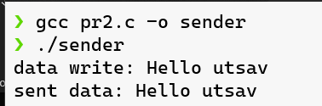

**# Receiver**

