**Practical - 5**

**Aim: implement a TCP based client server program in which client send two number to server, server will return multiplication of two number to client.**

**Code:**

***Client.java***

import java.io.DataInputStream;

import java.io.DataOutputStream;

import java.io.IOException;

import java.net.InetAddress;

import java.net.Socket;

import java.util.Scanner;

public class Client {

public static void main(String[] args) throws IOException {

InetAddress ip = InetAddress.getByName("127.0.0.1");

int port = 4444;

try (Scanner sc = new Scanner(System.in)) {

try (Socket s = new Socket(ip, port)) {

DataInputStream dis = new DataInputStream(s.getInputStream());

DataOutputStream dos = new DataOutputStream(s.getOutputStream());

boolean retry = true;

while (retry) {

System.out.println("Enter equation: ");

String input = sc.nextLine();

dos.writeUTF(input);

String result = dis.readUTF();

System.out.println("Result: " + result);

System.out.println("Do you want to continue? (y/n)");

String answer = sc.nextLine();

if (answer.equals("n")) {

retry = false;

}

}

}

}

}

}

***CalculateServer.java***

import java.io.DataInputStream;

import java.io.DataOutputStream;

import java.io.IOException;

import java.net.ServerSocket;

import java.net.Socket;

import java.util.StringTokenizer;

public class CalculateServer {

public static void main(String args[]) throws IOException {

try (ServerSocket ss = new ServerSocket(4444)) {

Socket s = ss.accept();

DataInputStream dis = new DataInputStream(s.getInputStream());

DataOutputStream dos = new DataOutputStream(s.getOutputStream());

while (true) {

String input = dis.readUTF();

if (input.equals("exit"))

break;

System.out.println("Equation received: " + input);

int result = 0;

StringTokenizer st = new StringTokenizer(input);

int number1 = Integer.parseInt(st.nextToken());

String operation = st.nextToken();

int number2 = Integer.parseInt(st.nextToken());

System.out.println("Sending result!");

if (operation.equals("*")) {

result = number1 * number2;

dos.writeUTF(Integer.toString(result));

} else {

System.out.println("Operation not supported");

}

}

} catch (IOException e) {

e.printStackTrace();

}

}

}

**Server**

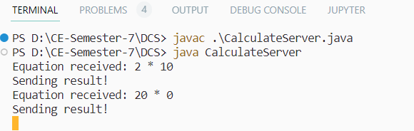

**Client**

