ASSIGNMENT - 3
CS553 - Advanced Database Systems LAB

Name: Utsav Balar
Roll no.: T24CS003

File: t24cs003-assignment-3.py
from tinydb import TinyDB, Query
import os

if os.path.exists("db.json"):
os.remove("db.json")

db = TinyDB("db.json")

# Tables
students_table = db.table("students")
courses_table = db.table("courses")
exam_table = db.table("exams")
faculty_table = db.table("faculty")
enrollment_table = db.table("enrollment")
teaching_table = db.table("teaching")
exam_registration_table = db.table("exam_registration")
exam_results_table = db.table("exam_results")

# Inserting sample data
students_table.insert_multiple(
[
{
"StudentID": 1,
"Name": "abcd",
"Email": "abcd@test.com",
"Phone": "325870489",
"Address": "Surat",
},
{
"StudentID": 2,
"Name": "efgh",
"Email": "efgh@test.com",
"Phone": "408320174",
"Address": "Dehli",
},
{
"StudentID": 3,
"Name": "Utsav Balar",
"Email": "utsav@balar.com",
"Phone": "123456789",
"Address": "Umpling",
},
{
"StudentID": 4,
"Name": "lmno",
"Email": "lmno@test.com",
"Phone": "985973232",
"Address": "Vadodra",
},
{
"StudentID": 5,
"Name": "pqrs",
"Email": "pqrs@test.com",
"Phone": "325870489",
"Address": "Assam",
},
{
"StudentID": 6,
"Name": "tuvw",
"Email": "tuvw@test.com",
"Phone": "483112984",
"Address": "Tamil Nadu",
},
{
"StudentID": 7,
"Name": "xyz",
"Email": "xyz@test.com",
"Phone": "324982309",
"Address": "Punjab",
},
{
"StudentID": 8,
"Name": "ijkl",
"Email": "ijkl@test.com",
"Phone": "918321473",
"Address": "Mumbai",
},
]
)

courses_table.insert_multiple(
[
{
"CourseID": 701,
"CourseName": "Advanced Engineering Mathematics",
"Credits": 4,
},
{
"CourseID": 501,
"CourseName": "Advanced Algorithms and Complexity",
"Credits": 4,
},
{"CourseID": 503, "CourseName": "Advanced Database Systems", "Credits": 4},
{"CourseID": 555, "CourseName": "Advanced Programming Lab", "Credits": 4},
{"CourseID": 553, "CourseName": "Advanced Databases Systems Lab", "Credits": 4},
{"CourseID": 511, "CourseName": "Digital Image processing", "Credits": 4},
{"CourseID": 517, "CourseName": "Soft Computing Mathematics", "Credits": 4},
]
)

exam_table.insert_multiple(
[
{
"ExamID": 1,
"ExamDate": "2024-09-15",
"ExamTime": "10:00",
"Location": "CR12",
},
{
"ExamID": 2,
"ExamDate": "2024-09-05",
"ExamTime": "10:00",
"Location": "CR11",
},
{
"ExamID": 3,
"ExamDate": "2024-09-25",
"ExamTime": "10:00",
"Location": "CR12",
},
{
"ExamID": 4,
"ExamDate": "2024-09-16",
"ExamTime": "10:00",
"Location": "CR11",
},
{
"ExamID": 5,
"ExamDate": "2024-09-15",
"ExamTime": "10:00",
"Location": "CR12",
},
{
"ExamID": 6,
"ExamDate": "2024-09-15",
"ExamTime": "10:00",
"Location": "CR11",
},
]
)

faculty_table.insert_multiple(
[
{
"FacultyID": 101,
"Name": "Rizzvik Sharam",
"Email": "rizz@sharma.com",
"Phone": "987654321",
"Department": "Mathematics",
},
{
"FacultyID": 102,
"Name": "Rohil Khan",
"Email": "rohil@khan.com",
"Phone": "947560821",
"Department": "Computer Vision",
},
{
"FacultyID": 103,
"Name": "Runganko Dosa",
"Email": "dosaruganko@mail.com",
"Phone": "6934738422",
"Department": "Soft Computing",
},
{
"FacultyID": 104,
"Name": "Kumari Ashu",
"Email": "ashukumari@mail.com",
"Phone": "5876094585",
"Department": "Advanced Algorithms and Complexity",
},
{
"FacultyID": 105,
"Name": "Ustav blyat",
"Email": "blyatutsav@mail.com",
"Phone": "9407658934",
"Department": "Advanced Databases Systems",
},
]
)

enrollment_table.insert_multiple(
[
{
"EnrollmentID": 1,
"StudentID": 1,
"CourseID": 701,
"EnrollmentDate": "2024-05-15",
},
{
"EnrollmentID": 2,
"StudentID": 2,
"CourseID": 701,
"EnrollmentDate": "2024-05-15",
},
{
"EnrollmentID": 4,
"StudentID": 3,
"CourseID": 701,
"EnrollmentDate": "2024-05-15",
},
{
"EnrollmentID": 5,
"StudentID": 4,
"CourseID": 701,
"EnrollmentDate": "2024-05-15",
},
{
"EnrollmentID": 6,
"StudentID": 5,
"CourseID": 701,
"EnrollmentDate": "2024-05-15",
},
{
"EnrollmentID": 7,
"StudentID": 6,
"CourseID": 701,
"EnrollmentDate": "2024-05-15",
},
]
)

teaching_table.insert_multiple(
[
{"TeachingID": 1, "FacultyID": 101, "CourseID": 701},
{"TeachingID": 2, "FacultyID": 102, "CourseID": 511},
{"TeachingID": 3, "FacultyID": 103, "CourseID": 517},
{"TeachingID": 4, "FacultyID": 104, "CourseID": 501},
{"TeachingID": 5, "FacultyID": 105, "CourseID": 503},
{"TeachingID": 6, "FacultyID": 104, "CourseID": 555},
{"TeachingID": 7, "FacultyID": 104, "CourseID": 553},
]
)

exam_registration_table.insert_multiple(
[
{ "RegistrationID": 1, "StudentID": 1, "ExamID": 1, "RegistrationDate": "2024-08-25", },
{ "RegistrationID": 2, "StudentID": 2, "ExamID": 1, "RegistrationDate": "2024-08-05", },
{ "RegistrationID": 3, "StudentID": 3, "ExamID": 1, "RegistrationDate": "2024-08-15", },
{ "RegistrationID": 4, "StudentID": 4, "ExamID": 1, "RegistrationDate": "2024-08-25", },
{ "RegistrationID": 5, "StudentID": 5, "ExamID": 1, "RegistrationDate": "2024-08-15", },
{ "RegistrationID": 6, "StudentID": 6, "ExamID": 1, "RegistrationDate": "2024-08-05", },
]
)

exam_results_table.insert_multiple([
{"ResultID": 1, "StudentID": 1, "ExamID": 1, "Score": 88.50},
{"ResultID": 2, "StudentID": 2, "ExamID": 1, "Score": 58.00},
{"ResultID": 3, "StudentID": 3, "ExamID": 1, "Score": 80.00},
{"ResultID": 4, "StudentID": 4, "ExamID": 1, "Score": 98.25},
{"ResultID": 5, "StudentID": 5, "ExamID": 1, "Score": 18.50},
{"ResultID": 6, "StudentID": 6, "ExamID": 1, "Score": 68.75},
])

# Querying data
Student = Query()
students = students_table.all()

# Adjusting column widths for better alignment
print("\n\n\tStudents Table\n")
print(f"{'StudentID':<10} | {'Name':<15} | {'Email':<25} | {'Phone':<12} | {'Address'}")
print("-" * 70)
for student in students:
print(
f"{student['StudentID']:<10} | {student['Name']:<15} | {student['Email']:<25} | {student['Phone']:<12} | {student['Address']}"
)

Course = Query()
courses = courses_table.all()

print("\n\n\tCourses Table")
print(f"\n{'CourseID':<10} | {'CourseName':<35} | {'Credits':<7}")
print("-" * 60)
for course in courses:
print(
f"{course['CourseID']:<10} | {course['CourseName']:<35} | {course['Credits']}"
)

Exam = Query()
exams = exam_table.all()

print("\n\n\tExams Table")
print(f"\n{'ExamID':<10} | {'ExamDate':<15} | {'ExamTime':<10} | {'Location'}")
print("-" * 50)
for exam in exams:
print(
f"{exam['ExamID']:<10} | {exam['ExamDate']:<15} | {exam['ExamTime']:<10} | {exam['Location']}"
)

Faculty = Query()
faculties = faculty_table.all()

print("\n\n\tFaculty Table")
print(
f"\n{'FacultyID':<10} | {'Name':<15} | {'Email':<25} | {'Phone':<12} | {'Department'}"
)
print("-" * 70)
for faculty in faculties:
print(
f"{faculty['FacultyID']:<10} | {faculty['Name']:<15} | {faculty['Email']:<25} | {faculty['Phone']:<12} | {faculty['Department']}"
)

Enrollment = Query()
enrollements = enrollment_table.all()

print("\n\n\tEnrollement Table")
print(
f"\n{'EnrollmentID':<15} | {'StudentID':<10} | {'CourseID':<10} | {'EnrollmentDate'}"
)
print("-" * 60)
for enrollment in enrollements:
print(
f"{enrollment['EnrollmentID']:<15} | {enrollment['StudentID']:<10} | {enrollment['CourseID']:<10} | {enrollment['EnrollmentDate']}"
)

Teaching = Query()
teachers = teaching_table.all()

print("\n\n\tTeachers Table")
print(f"\n{'TeachingID':<10} | {'FacultyID':<10} | {'CourseID'}")
print("-" * 40)
for teacher in teachers:
print(
f"{teacher['TeachingID']:<10} | {teacher['FacultyID']:<10} | {teacher['CourseID']}"
)

Exam_registration = Query()
registrations = exam_registration_table.all()

print("\n\n\tRegistration Table")
print(
f"\n{'RegistrationID':<15} | {'StudentID':<10} | {'ExamID':<10} | {'RegistrationDate'}"
)
print("-" * 60)
for registration in registrations:
print(
f"{registration['RegistrationID']:<15} | {registration['StudentID']:<10} | {registration['ExamID']:<10} | {registration['RegistrationDate']}"
)

Exam_results = Query()
results = exam_results_table.all()

print("\n\n\tResults Table")
print(f"\n{'ResultID':<10} | {'StudentID':<10} | {'ExamID':<10} | {'Score'}")
print("-" * 50)
for result in results:
print(
f"{result['ResultID']:<10} | {result['StudentID']:<10} | {result['ExamID']:<10} | {result['Score']}"
)

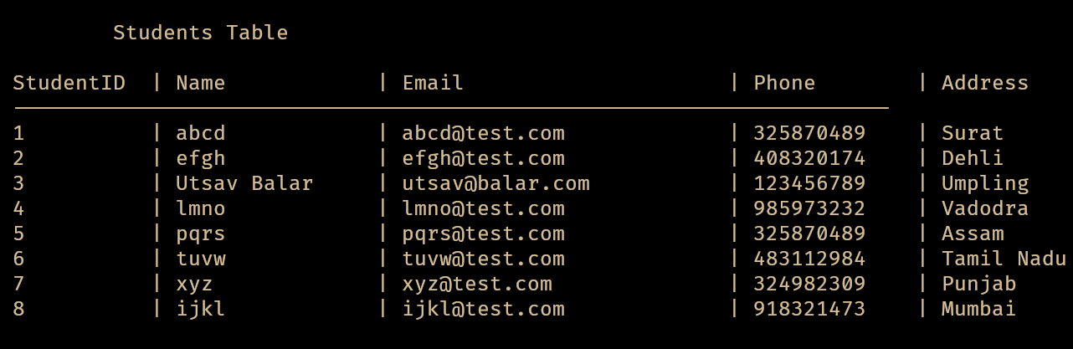
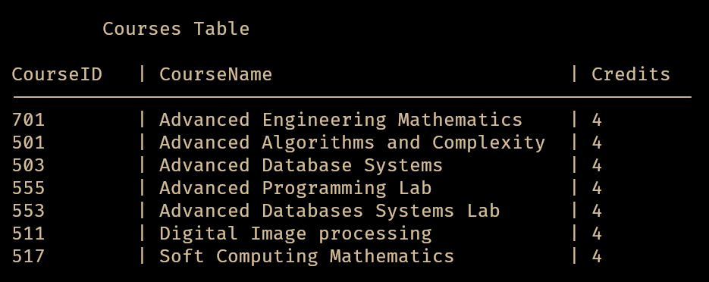
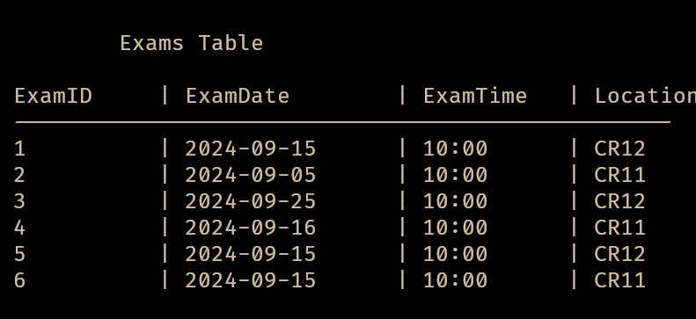
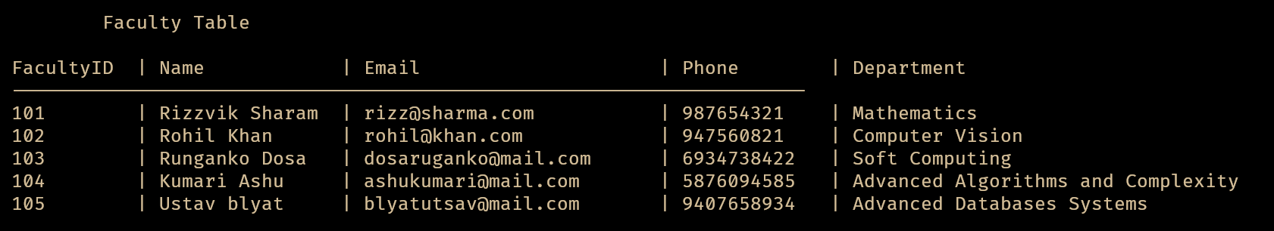
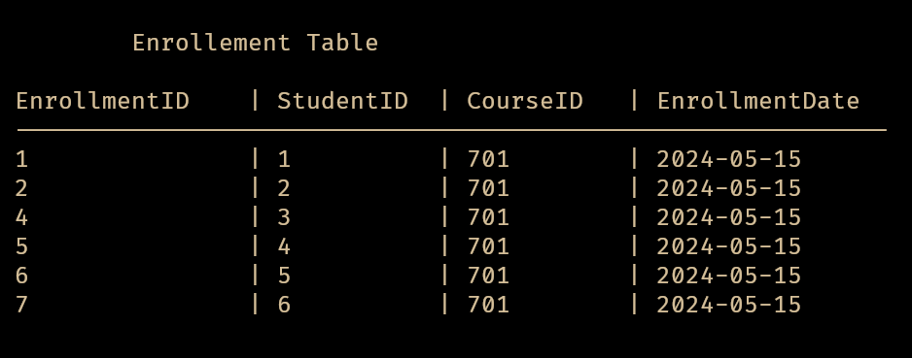
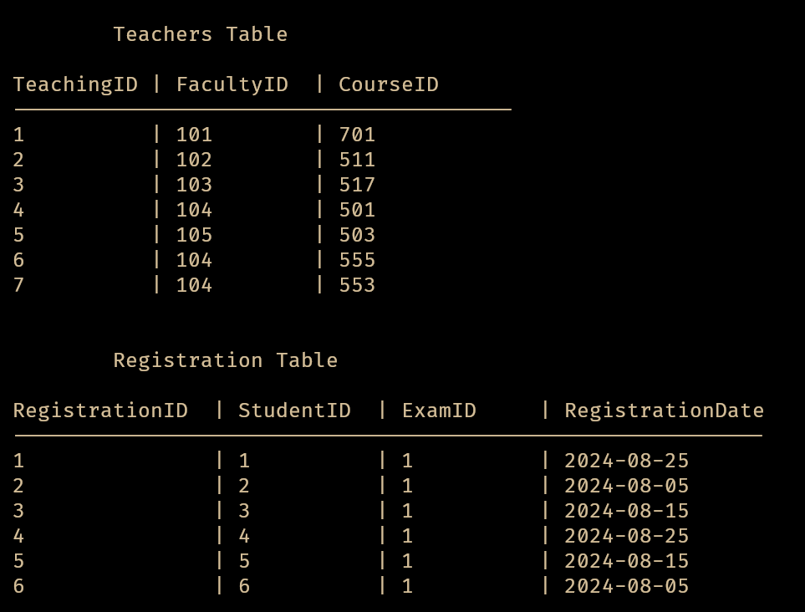
1
