LAB 1:
Assignment on DDL, DML and DCL commands given assignment with specific data type, constraint.

1. Create a table for customer with following attributes:
a. Id
b. First name
c. Last name
d. Address
e. City
f. Country
g. Phone
h. Notes
i. Family Size
j. Customer Size
k. Credit Score

Solution:
create database lab1;

use lab1;

create table customer
(
id INT unsigned NOT NULL AUTO_INCREMENT,
first_name VARCHAR(128) NOT NULL,
last_name VARCHAR(128) NOT NULL,
address VARCHAR(256) NOT NULL,
city VARCHAR(64) NOT NULL,
country VARCHAR(64) NOT NULL,
phone INT unsigned NOT NULL,
family_size INT unsigned NOT NULL,
customer_since DATE NOT NULL,
credit_limit INT NOT NULL,
PRIMARY KEY (id)
);

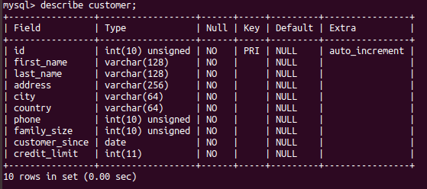

2. Populate your databse with least 10 customers and perform data manipulation using DML statements.

insert into customer (id, first_name, last_name, address, city, country, phone, family_size, customer_since, credit_limit) values
(1, 'a', 'A', "Suite 616 217 Annita Village, Vickyside, AZ 33360-0471", 'azzz', 'USA', 123456789, 4, '1970-01-01', 10000),
(2, 'b', 'B', "77879 Stamm Springs, West Heeberg, NC 36598-4745" , 'nccc', 'USA', 123456789, 2, '1970-01-01', 200000),
(3, 'c', 'C', "Borkumstr. 71c, Klein Rayandorf, NW 80518" , 'hmmm', 'Germany', 123456789, 4, '1970-01-01', 33000),
(4, 'd', 'D', "Jacob-Fröhlen-Str. 58a, Sagonasberg, MV 15696" , 'mmmh', 'Germany', 123456789, 1, '1970-01-01', 40000),
(5, 'e', 'E', "Liebigstr. 741, Oscargrün, SN 81476" , 'smmm', 'Germany', 123456789, 1, '1970-01-01', 55555),
(6, 'f', 'F', "Liebigstr. 741, Oscargrün, SN 81476" , 'smmm', 'Germany', 123456789, 5, '1970-01-01', 60000),
(7, 'g', 'G', "44 E. West Street Ashland, OH 44805" , 'ohhh', 'UK', 123456789, 3, '1970-01-01', 70007),
(8, 'h', 'H', "611 Penn Street Long Branch, NJ 07740" , 'njjj', 'South Africa', 123456789, 2, '1970-01-01', 8880000),
(9, 'i', 'I', "809 North Peg Shop Dr. Ladson, SC 29456" , 'innn', 'India', 123456789, 4, '1970-01-01', 90000),
(10, 'j', 'J', "8551 St Margarets Road Seymour, IN 47274" , 'innn', 'India', 123456789, 2, '1970-01-01', 100000000);

select * from customer;

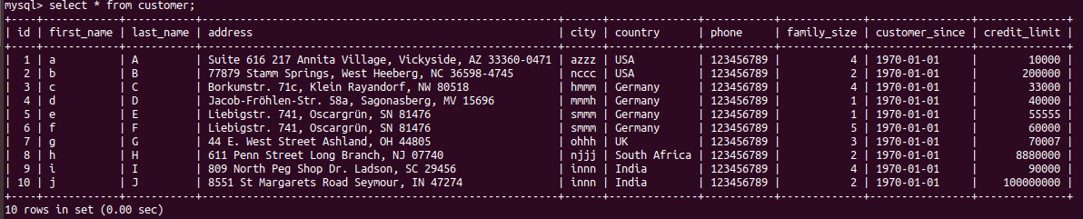

alter table customer drop phone;
alter table customer drop customer_since;

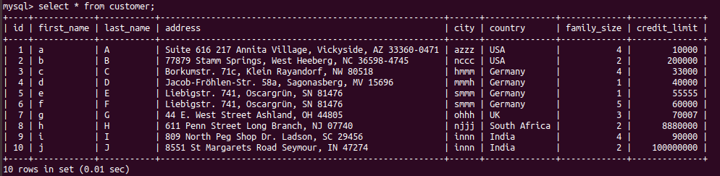

3. Create two different views by considering two different types of groups and display each output data.

select id, first_name, last_name, credit_limit from customer where credit_limit <= 70000;

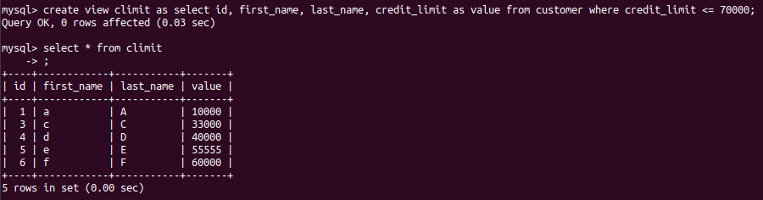

select id, first_name, last_name, family_size, credit_limit from customer where family_size = 4 and country = 'Germany';

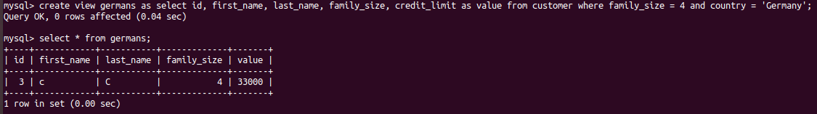

3. use GRANT and REVOKE command to authorize user group to access certain data.

grant all privileges on *.* to 'root'@'localhost';

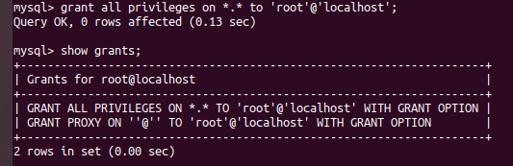

grant all privileges on *.* to 'root'@'localhost';
