ASSIGNMENT – 7
Advanced Database Systems LAB
Name: Utsav Balar
Roll no: T24CS003

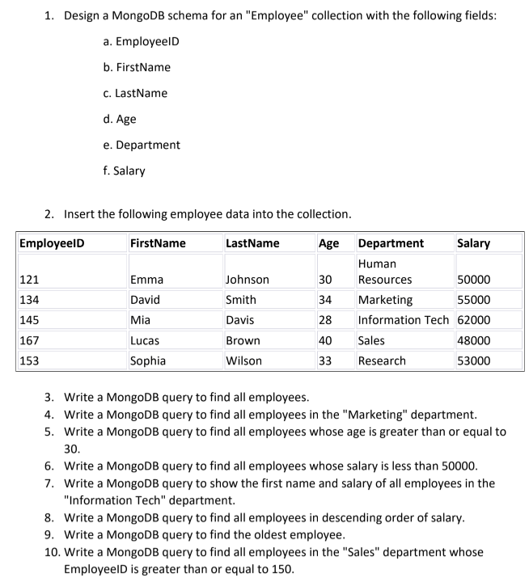

Code:

#![allow(dead_code)]

extern crate mongodb;
use futures_util::TryStreamExt;
use mongodb::bson::{doc, Document};
use mongodb::{options::ClientOptions, Client};use serde::{Deserialize, Serialize};
use termion::terminal_size;

#[derive(Serialize, Deserialize, Debug)]
struct Employee {
employee_id: usize,
first_name: String,
last_name: String,
age: usize,
department: String,
salary: usize,
}

type CollectionType = Employee;

impl CollectionType {
fn new(
employee_id: usize,
first_name: String,
last_name: String,
age: usize,
department: String,
salary: usize,
) -> Self {
Self {
employee_id,
first_name,
last_name,
age,
department,
salary,
}
}
}

fn create_employee_db() -> Vec<CollectionType> {
// EmployeeID FirstName LastName Age Department Salary
// 121 Emma Johnson 30 Human Resources 50000
// 134 David Smith 34 Marketing 55000
// 145 Mia Davis 28 Information Tech 62000
// 167 Lucas Brown 40 Sales 48000
// 153 Sophia Wilson 33 Research 53000
vec![
CollectionType::new(
121,
"Emma".to_string(),
"Johnson".to_string(),
30,
"Human Resources".to_string(),
50000,
),
CollectionType::new(
134,
"David".to_string(),
"Smith".to_string(),
34,
"Marketing".to_string(),
55000,
),
CollectionType::new(
145,
"Mia".to_string(),
"Davis".to_string(),
28,
"Information Tech".to_string(),
62000,
),
CollectionType::new(
167,
"Lucas".to_string(),
"Brown".to_string(),
40,
"Sales".to_string(),
48000,
),
CollectionType::new(
153,
"Sophia".to_string(),
"Wilson".to_string(),
33,
"Research".to_string(),
53000,
),
]
}

async fn insert_employee(client: &Client, db_name: &str, doc: CollectionType, coll_name: &str) {
let db = client.database(db_name);
let coll = db.collection(coll_name);

coll.insert_one(doc).await.unwrap();
}

async fn get_filtered_documents(
client: &Client,
db_name: &str,
coll_name: &str,
filter: Document,
projection: Option<Document>,
) {
let db = client.database(db_name);
let coll: mongodb::Collection<Document> = db.collection(coll_name);

let mut cursor = coll
.find(filter)
.projection({
if let Some(projection) = projection {
projection
} else {
doc! {"_id": 0, "employee_id": 1, "first_name": 1, "last_name": 1, "age": 1, "department": 1, "salary": 1}
}
})
.await
.unwrap();

if let Ok((width, _height)) = terminal_size() {
println!("{}", "-".repeat(width as usize));
}

while let Some(doc) = cursor.try_next().await.unwrap() {
println!("{}", doc);
}

if let Ok((width, _height)) = terminal_size() {
println!("{}", "-".repeat(width as usize));
}
println!("\n");
}

async fn get_aggregated_documents(
client: &Client,
db_name: &str,
coll_name: &str,
filter: Vec<Document>,
) {
let db = client.database(db_name);
let coll: mongodb::Collection<Document> = db.collection(coll_name);

let mut results = coll
.aggregate(filter)
.await
.expect("Failed to aggregate documents");

if let Ok((width, _height)) = terminal_size() {
println!("{}", "-".repeat(width as usize));
}

while let Some(doc) = results
.try_next()
.await
.expect("Failed to get next document")
{
println!("{}", doc);
}

if let Ok((width, _height)) = terminal_size() {
println!("{}", "-".repeat(width as usize));
}
println!("\n");
}

async fn get_aggregated_documents_with_limit(
client: &Client,
db_name: &str,
coll_name: &str,
filter: Vec<Document>,
limit: usize,
) {
let db = client.database(db_name);
let coll: mongodb::Collection<Document> = db.collection(coll_name);

let mut results = coll
.aggregate(filter)
.await
.expect("Failed to aggregate documents");

if let Ok((width, _height)) = terminal_size() {
println!("{}", "-".repeat(width as usize));
}

let mut count = 0;
while let Some(doc) = results
.try_next()
.await
.expect("Failed to get next document")
{
if count == limit {
break;
}
count += 1;
println!("{}", doc);
}

if let Ok((width, _height)) = terminal_size() {
println!("{}", "-".repeat(width as usize));
}
println!("\n");
}

#[tokio::main]
async fn main() {
let client_options = ClientOptions::parse("mongodb://localhost:27017")
.await
.expect("ClientOptions failed to parse");
let client = Client::with_options(client_options).expect("Failed to create client");
let db_name: &str = "t24cs003_lab7";
let db = client.database(db_name);
let collection: &str = "cs553";

db.create_collection(collection)
.await
.expect("Failed to create collection");

let employees: Vec<CollectionType> = create_employee_db();

for employee in employees {
insert_employee(&client, db_name, employee, collection).await;
}

println!("3. Write a MongoDB query to find all employees.");
let filter = doc! {};
get_filtered_documents(&client, db_name, collection, filter, None).await;

println!("4. Write a MongoDB query to find all employees in the \"Marketing\" department.");
let filter = doc! {"department": "Marketing"};
get_filtered_documents(&client, db_name, collection, filter, None).await;

println!(
"5. Write a MongoDB query to find all employees whose age is greater than or equal to 30."
);
let filter = doc! {"age": doc! {"$gte": 30}};
get_filtered_documents(&client, db_name, collection, filter, None).await;

println!("6. Write a MongoDB query to find all employees whose salary is less than 50000.");
let filter = doc! {"salary": doc! {"$lt": 50000}};
get_filtered_documents(&client, db_name, collection, filter, None).await;

println!("7. Write a MongoDB query to show the first name and salary of all employees in the Information Tech department.");
let filter = doc! {"department": "Information Tech"};
let projection = doc! {"first_name": 1, "salary": 1, "_id": 0};
get_filtered_documents(&client, db_name, collection, filter, Some(projection)).await;

println!("8. Write a MongoDB query to find all employees in descending order of salary.");
let filter = vec![
doc! {
"$sort": {
"salary": -1
}},
doc! {
"$project": {
"_id": 0
},
},
];
get_aggregated_documents(&client, db_name, collection, filter).await;

println!("9. Write a MongoDB query to find the oldest employee.");
let filter = vec![
doc! {
"$sort": {
"age": -1
}},
doc! {
"$project": {
"_id": 0
},
},
];
get_aggregated_documents_with_limit(&client, db_name, collection, filter, 1).await;

println!("10. Write a MongoDB query to find all employees in the \"Sales\" department whose EmployeeID is greater than or equal to 150.");
let filter = doc! {"department": "Sales", "employee_id": doc! {"$gte": 150}};
get_filtered_documents(&client, db_name, collection, filter, None).await;

db.drop().await.expect("Failed to drop database");
}

Results:

