ASSIGNMENT – 3
Advanced Programming Lab
Name: Utsav Balar
Roll.no. T24cs003
Objective:
Assignment on sensors and how to interface them with the ECG/EEG Sensors.

Overview of Arduino UNO

Arduino UNO is a versatile microcontroller board based on the ATmega328P chip, designed for a wide range of electronics projects. It features 14 digital I/O pins (6 of which support PWM output), 6 analog inputs, a 16 MHz ceramic resonator, USB connectivity, a power jack, an ICSP header, and a reset button. The board is ready to use right out of the box; simply connect it to a computer via a USB cable or use an AC-to-DC adapter or battery for power. As an open-source microcontroller board, the Arduino UNO is developed by Arduino.cc and first launched in 2010. It is compatible with various shields and circuits through its digital and analog I/O pins and is programmed using the Arduino IDE.
Specifications:
- Microcontroller: Microchip ATmega328P (8-bit AVR core)
- Clock Speed: 16 MHz on the board (up to 20 MHz at 5V)
- Memory: 32 KB Flash (0.5 KB used by bootloader), 2 KB SRAM, 1 KB EEPROM
- Communication Peripherals: 1 USART, 1 SPI, 1 I²C
- Operating Voltage: 5V
- Digital I/O Pins: 14 (6 PWM)
- Analog Input Pins: 6
- Current: 20 mA per I/O pin, 50 mA for 3.3V pin
- Size/Weight: 68.6 mm x 53.4 mm, 25 g
- Power Sources:
- USB Connector: Voltage range of 4.75 to 5.25V
- Barrel Jack Connector: Supports 6 to 20V (recommended 7 to 12V)
- VIN Pin: Can power or be powered by an external source
Applications:
- Home Automation: Manage lights, temperature, and security.
- Robotics: Create autonomous machines.
- Smart Gardening: Build systems for automated plant care.
- IoT Devices: Design connected devices.
- Wearable Technology: Develop interactive wearables.
- Control Systems: For advanced applications like Industry 4.0.
- Miscellaneous: Useful in security systems, digital electronics, and more.

Introduction to EMG Sensors
EMG (Electromyography) Sensors measure and record the electrical activity of muscles during contraction. They are valuable in medical diagnostics, research, rehabilitation, sports science, and wearable technologies, capturing real-time muscle activity data.
How EMG Sensors Work:
- Electrode Placement: Electrodes detect muscle-generated electrical signals.
- Signal Amplification: Weak signals are amplified for analysis.
- Signal Filtering/Processing: Noise is filtered, and data is processed to interpret muscle activation.
- Data Interpretation: The processed signals are displayed as waveforms or numerical data.
Types:
- Surface EMG (SEMG): Non-invasive sensors for superficial muscles.
- Intramuscular EMG: Invasive needle electrodes for deeper muscle analysis.
Applications:
- Medical Diagnostics: Identify nerve or muscle dysfunction.
- Rehabilitation: Track muscle recovery and strength training.
- Human-Computer Interaction: Control devices and prosthetics.
- Sports Science: Optimize performance by monitoring muscle engagement.
- Robotics/Wearables: Enable muscle-movement-based control systems.

Implementation: Reading EMG Sensor Data with Arduino UNO
Arduino Sketch Example:
int sensorPin = A0; // select the input pin for the sensor
int sensorValue = 0;

#define MAX_VAL 1023
#define GET_VAL(val) (MAX_VAL - val)

void setup() {
pinMode(sensorPin, INPUT);
Serial.begin(9600);
}

void loop() {
// read the value from the sensor:
sensorValue = analogRead(sensorPin);
Serial.println(GET_VAL(sensorValue));
delay(100);
}

This sketch captures and outputs the EMG sensor data, making it easy to monitor muscle activity using the Serial Monitor in the Arduino IDE.

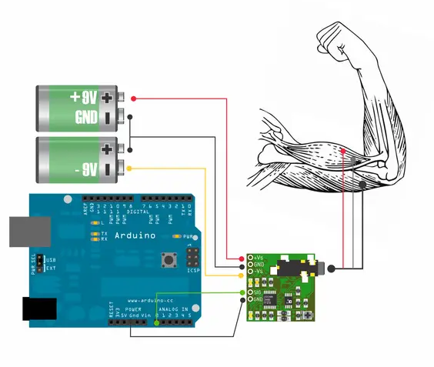

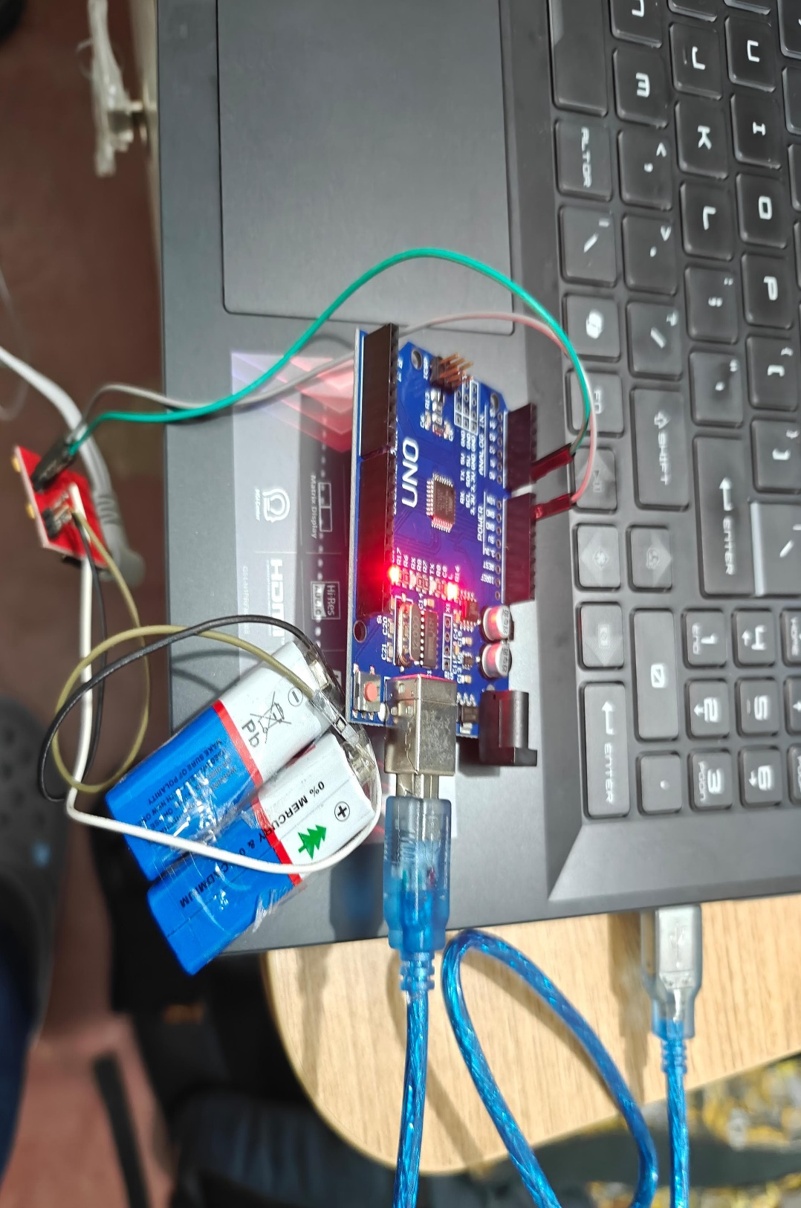

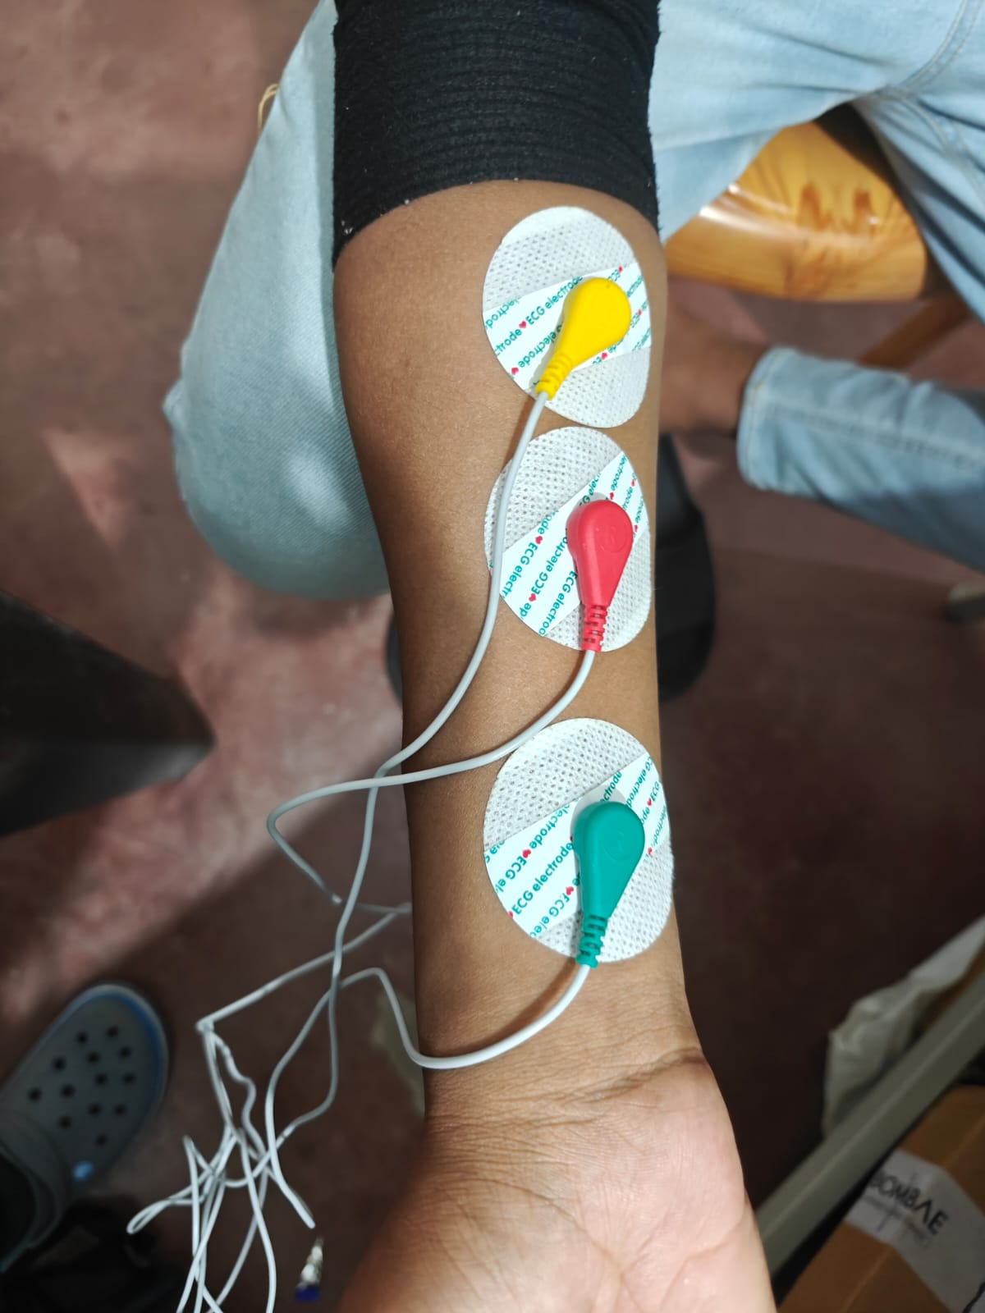

Observations: Almost 1000+ values have been captured from the EMG sensor and the histogram has been plotted.

