ASSIGNMENT – 5
Advanced Database Systems LAB
Name: Utsav Balar
Roll no: T24CS003

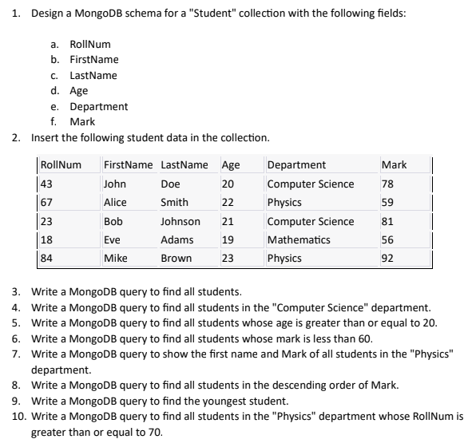

Code:

#![allow(dead_code)]

extern crate mongodb;
use futures_util::TryStreamExt;
use mongodb::bson::{doc, Document};
use mongodb::{options::ClientOptions, Client};
use serde::{Deserialize, Serialize};
use std::fmt::Formatter;
use termion::terminal_size;

#[derive(Serialize, Deserialize)]
struct Student {
roll_num: usize,
first_name: String,
last_name: String,
age: usize,
department: String,
marks: usize,
}

impl std::fmt::Display for Student {
fn fmt(&self, f: &mut Formatter<'_>) -> std::fmt::Result {
write!(
f,
"Roll Number: {}, First Name: {}, Last Name: {}, Age: {}, Department: {}, Marks: {}",
self.roll_num, self.first_name, self.last_name, self.age, self.department, self.marks
)
}
}

impl Student {
fn new(
roll_num: usize,
first_name: String,
last_name: String,
age: usize,
department: String,
marks: usize,
) -> Self {
Self {
roll_num,
first_name,
last_name,
age,
department,
marks,
}
}
}

async fn get_filtered_documents(
client: &Client,
db_name: &str,
coll_name: &str,
filter: Document,
projection: Option<Document>,
) {
let db = client.database(db_name);
let coll: mongodb::Collection<Document> = db.collection(coll_name);

let mut cursor = coll
.find(filter)
.projection({
if let Some(projection) = projection {
projection
} else {
doc! {"_id": 0, "roll_num": 1, "first_name": 1, "last_name": 1, "age": 1, "department": 1, "marks": 1}
}
})
.await
.unwrap();

if let Ok((width, _height)) = terminal_size() {
println!("{}", "-".repeat(width as usize));
}

while let Some(doc) = cursor.try_next().await.unwrap() {
println!("{}", doc);
}

if let Ok((width, _height)) = terminal_size() {
println!("{}", "-".repeat(width as usize));
}
println!("\n");
}

async fn insert_student(client: &Client, db_name: &str, doc: Student, coll_name: &str) {
let db = client.database(db_name);
let coll = db.collection(coll_name);

coll.insert_one(doc).await.unwrap();
}

async fn get_aggregated_documents(
client: &Client,
db_name: &str,
coll_name: &str,
filter: Vec<Document>,
) {
let db = client.database(db_name);
let coll: mongodb::Collection<Document> = db.collection(coll_name);

let mut results = coll
.aggregate(filter)
.await
.expect("Failed to aggregate documents");

if let Ok((width, _height)) = terminal_size() {
println!("{}", "-".repeat(width as usize));
}

while let Some(doc) = results
.try_next()
.await
.expect("Failed to get next document")
{
println!("{}", doc);
}

if let Ok((width, _height)) = terminal_size() {
println!("{}", "-".repeat(width as usize));
}
println!("\n");
}

fn generate_students_data() -> Vec<Student> {
vec![
Student::new(
43,
"John".to_string(),
"Doe".to_string(),
20,
"Computer Science".to_string(),
78,
),
Student::new(
67,
"Alice".to_string(),
"Smith".to_string(),
22,
"Physics".to_string(),
59,
),
Student::new(
23,
"Bob".to_string(),
"Johnson".to_string(),
21,
"Computer Science".to_string(),
81,
),
Student::new(
18,
"Eve".to_string(),
"Adams".to_string(),
19,
"Mathematics".to_string(),
56,
),
Student::new(
84,
"Mike".to_string(),
"Brown".to_string(),
23,
"Physics".to_string(),
92,
),
]
}

#[tokio::main]
async fn main() {
let client_options = ClientOptions::parse("mongodb://localhost:27017")
.await
.expect("ClientOptions failed to parse");
let client = Client::with_options(client_options).expect("Failed to create client");
let db_name: &str = "t24cs004_lab5";
let db = client.database(db_name);
let collection: &str = "cs553";

db.create_collection(collection)
.await
.expect("Failed to create collection");

let students: Vec<Student> = generate_students_data();

for student in students {
insert_student(&client, db_name, student, collection).await;
}

println!("3. Write a MongoDB query to find all students.");
let filter = doc! {"roll_num": doc! {"$exists": true}};
get_filtered_documents(&client, db_name, collection, filter, None).await;

println!(
"4. Write a MongoDB query to find all students in the \"Computer Science\" department."
);
let filter = doc! {"department": "Computer Science"};
get_filtered_documents(&client, db_name, collection, filter, None).await;

println!(
"5. Write a MongoDB query to find all students whose age is greater than or equal to 20."
);
let filter = doc! {"age": doc! {"$gte": 20}};
get_filtered_documents(&client, db_name, collection, filter, None).await;

println!("6. Write a MongoDB query to find all students whose mark is less than 60.");
let filter = doc! {"marks": doc! {"$lt": 60}};
get_filtered_documents(&client, db_name, collection, filter, None).await;

println!("7. Write a MongoDB query to show the first name and Mark of all students in the \"Physics\" department.");
let filter = doc! {"department": "Physics"};
let projection = doc! {"first_name": 1, "marks": 1, "_id": 0};
get_filtered_documents(&client, db_name, collection, filter, Some(projection)).await;

println!("8. Write a MongoDB query to find all students in the descending order of Mark.");
let filter = vec![
doc! {
"$sort": {
"marks": 1
}},
doc! {
"$project": {
"_id": 0
},
},
];
get_aggregated_documents(&client, db_name, collection, filter).await;

println!("9. Write a MongoDB query to find the youngest student.");
let filter = vec![
doc! {
"$sort": {
"age": 1

}},
doc! {
"$project": {
"_id": 0
},

},
];
get_aggregated_documents(&client, db_name, collection, filter).await;

println!("10. Write a MongoDB query to find all students in the \"Physics\" department whose RollNum is greater than or equal to 70.");
let filter = vec![
doc! {
"$match": {
"department": "Physics",
"roll_num": {
"$gte": 70
}
}},
doc! {
"$project": {
"_id": 0
},

},
];
get_aggregated_documents(&client, db_name, collection, filter).await;

db.drop().await.expect("Failed to drop database");
}

Results:

