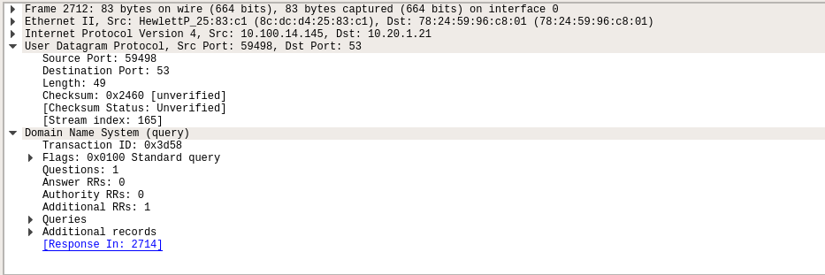
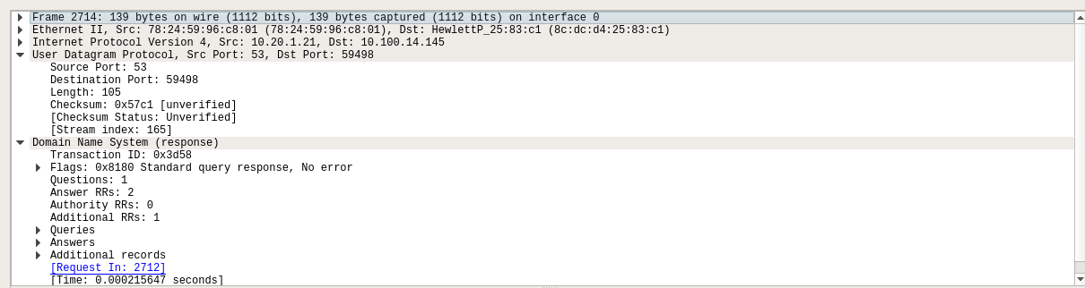

1.The DNS query uses UDP
2. client->server: src is ephimeral and dest is 53
server->client : src port is 53 and dest port is an ephimeral port
3. it is sent to 10.20.1.21
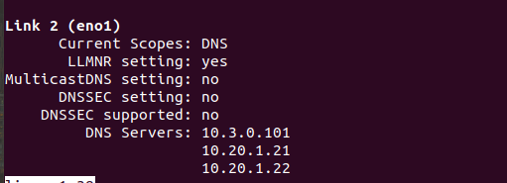

4. It queries for AAAA ip address. The quert message has no answers
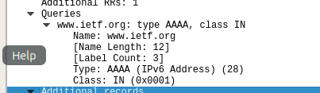

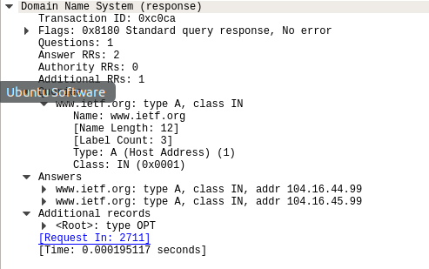
5. Contains 2 answers, both IP mapping
6. No as once we get the IP it is stored in the local HOST FILE to avoid subsequent queries to DNS server

Q2.
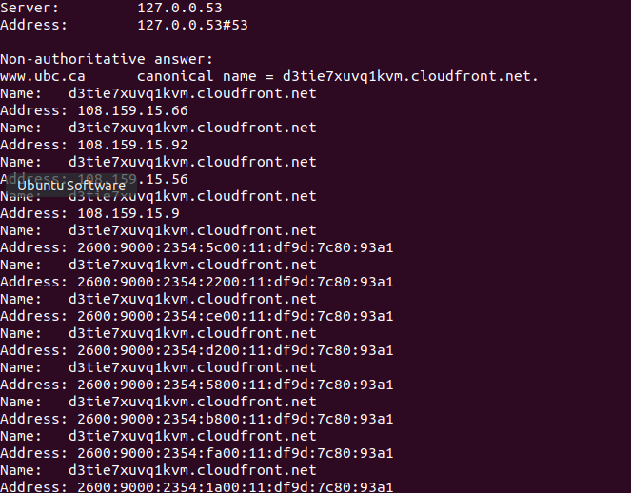

1. destination port is 53 and src port is an ephimeral port
2. it is sent to 10.20.1.21. It is the ip address of my DNS server (not something like 8.8.8.8 which is google’s DNS server)
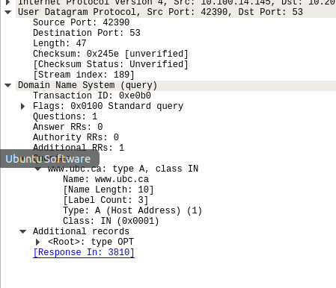
3.

type-A query. Recursion desired query.

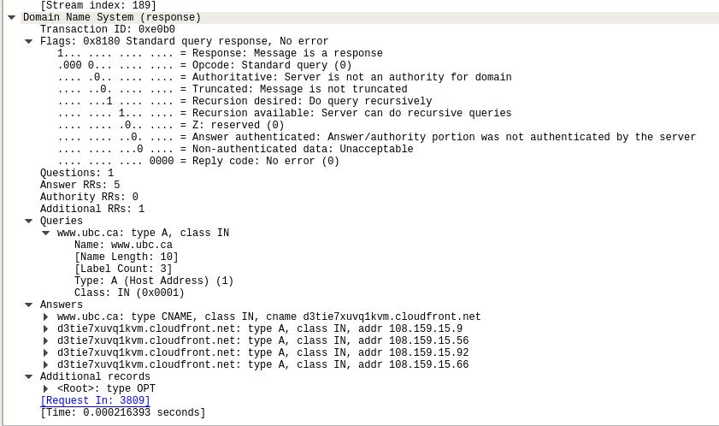
4.

5 answers are provided. Each of them give a IP to the domain. Load balencing in action.

Server
import socket
import threading
import sys
# Server setup
HOST = '127.0.0.1'
PORT = 5000
clients = []
def broadcast(message, sender_socket):
for client in clients:
if client != sender_socket:
try:
client.send(message)
except:
# If a client fails, remove it
client.close()
clients.remove(client)
def handle_client(client_socket, address):
print("New connection from %s:%s" % (address[0], address[1]))
clients.append(client_socket)

while True:
try:
message = client_socket.recv(1024)
if message:
print("Received from client %s:%s: %s" % (address[0], address[1], message.strip()))
broadcast(message, client_socket)
else:
# Client disconnected
client_socket.close()
clients.remove(client_socket)
print("Client %s:%s disconnected." % (address[0], address[1]))
break
except:
client_socket.close()
clients.remove(client_socket)
break
def main():
server = socket.socket(socket.AF_INET, socket.SOCK_STREAM)
server.setsockopt(socket.SOL_SOCKET, socket.SO_REUSEADDR, 1)
server.bind((HOST, PORT))
server.listen(5)
print("Server started on %s:%s" % (HOST, PORT))

while True:
client_socket, address = server.accept()
thread = threading.Thread(target=handle_client, args=(client_socket, address))
thread.daemon = True
thread.start()
if __name__ == "__main__":
main()

Client
import socket
import threading
import sys
# Client setup
HOST = '127.0.0.1'
PORT = 5000
def receive_messages(sock):
while True:
try:
data = sock.recv(1024)
if data:
sys.stdout.write("\n" + data.decode('utf-8') + "\n>> ")
sys.stdout.flush()
else:
break
except:
print("Disconnected from server.")
break
def send_messages(sock):
while True:
# Change this line
message = input(">> ") # Use input() instead of raw_input()
try:
sock.send(message.encode('utf-8'))
except:
print("Failed to send message.")
break
def main():
try:
sock = socket.socket(socket.AF_INET, socket.SOCK_STREAM)
sock.connect((HOST, PORT))
print("Connected to server on %s:%s" % (HOST, PORT))

# Threads for receiving and sending
receive_thread = threading.Thread(target=receive_messages, args=(sock,))
receive_thread.daemon = True
receive_thread.start()

send_thread = threading.Thread(target=send_messages, args=(sock,))
send_thread.daemon = True
send_thread.start()

# Keep the main thread alive
while True:
pass

except Exception as e:
print("Could not connect to server:", e)
sys.exit(1)
if __name__ == "__main__":
main()

