Name: Date: Class:

1. 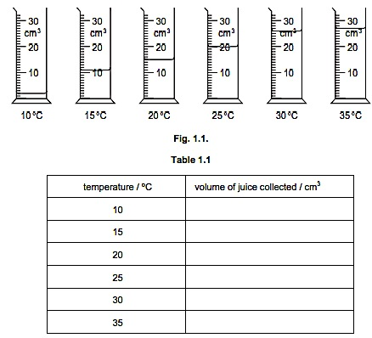Enzymes are used commercially to extract fruit juices. The use of enzymes increases the volume of juice produced. An investigation was carried out to determine the volume of apple juice produced at different temperatures.

Mixtures of apple pulp and enzyme were left for 15 minutes at different temperatures. After 15 minutes, the mixtures were filtered and the juice collected. Fig.1.1 shows the volume of juice collected from each mixture.

(a) (i) Record the volume of juice in each measuring cylinder in Table 1.1. [3]

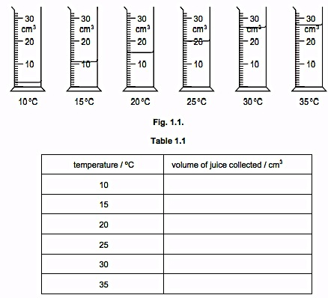

(ii) Present the data in a suitable graphical form, using the grid at the right. [5]

(iii) Describe the results. [2]

(b) Describe an investigation that could be used to show the effect of pH on the activity of the enzyme that is used to extract apple juice. [6]

1. 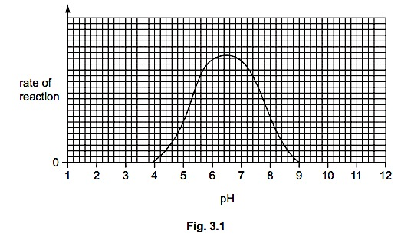The graph at the right shows the effect of pH on the activity of an enzyme.
2. Explain what is meant by the term enzyme.[2]
3. Describe the effect of pH on the activity of this enzyme.[2]
4. (i) A protease enzyme works in the human stomach, where hydrochloric acid is secreted. This enzyme is adapted to work best in these conditions. On the graph above (top right), **sketch a curve** to show how pH affects the activity of this protease enzyme. [1]

(ii) After the food has been in the stomach for a while, it passes into the duodenum. Pancreatic juice, which contains sodium hydrogencarbonate, is mixed with the food in the duodenum. Explain why the protease enzyme stops working when it enters the duodenum.[2]

1. Name the substrate(s) and product(s) of a protease enzyme. [2]

Substrate(s): ____________________________________________ Product(s): ______________________________________________

1. Catalase is an enzyme found in plant and animal cells. It has the function of breaking down hydrogen peroxide, a toxic waste product of metabolic processes. An investigation was carried out to study the effect of pH on catalase, using pieces of potato as a source of the enzyme.

Oxygen is formed when catalase breaks down hydrogen peroxide, as shown in the equation.



The rate of reaction can be found by measuring how long it takes for 10 cm3 oxygen to be collected.

(a) (i) State the independent (input) variable in this investigation.[1] _____________________________________

(ii) Suggest **two** factors that would need to be kept constant in this investigation. [2]

Table 3.1 shows the results of the investigation, but it is incomplete.

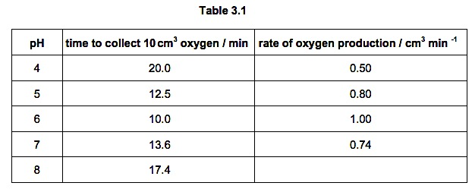

(c) Calculate the rate of oxygen production at pH 8. *HINT: divide the volume of oxygen (10 cm3) by the time listed to collect it.* Write your answer in Table 3.1[2]

(d) Complete the graph by plotting the rate of oxygen production against pH and labeling the axes.

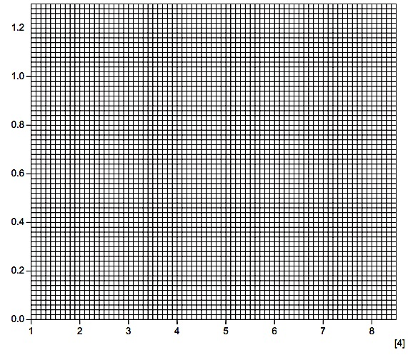

1. (i) Using data from the graph, describe the changes in the reaction rate between pH 4 and pH 8. [2]

(ii) Explain the change in the reaction rate between pH 6 and pH 8. [3]

1. A mixture of vegetable oil, an enzyme and a pH indicator was put into a test-tube. The tube

was incubated at 35 °C and the color of the mixture was recorded at 5 minute intervals. The indicator changes from blue to yellow at pH 5 or less.

The investigation was repeated at other temperatures and the results are shown in Table 6.1.

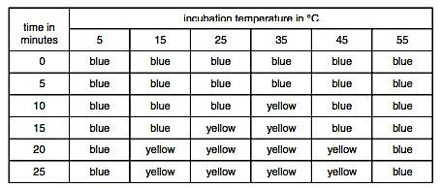

(a) (i) Name the enzyme that digests the vegetable oil. [1]

(ii) State the end products of oil digestion (HINT: what are lipids made of?). [1]

(iii) Suggest how these end products cause the change in color of the indicator. [2]

(b) Explain the difference in results between the tubes incubated at 15 °C and 35 °C. [2]

(c) (i) After 25 minutes, the tubes originally incubated at 5 °C and 55 °C were then incubated at 30 °C for a further 20 minutes. Suggest what the final color would be in each of these tubes by completing Table 6.2. [2]

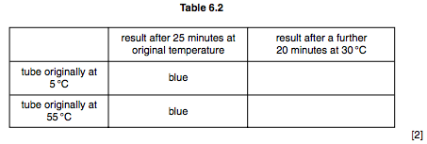

(ii) Explain these likely results. [4]