FINAL YEAR PROJECT
B. TECH 4th YEAR
ADAPTIVE ML STUDIO: A TESTBED AND A BUDGET-AWARE CONTROLLER FOR LEARNING FROM CHANGING DATA STREAMS
Final Year Project Report
Submitted to
Sharda University
In partial fulfilment of the requirements of the award of the
Degree of Bachelor of Technology
in
Computer Science Engineering
by
Utsav Kumar (2023430537)
Under the guidance of
Dr. Neha Kumari
[Designation]
DEPARTMENT OF COMPUTER SCIENCE ENGINEERING
SHARDA UNIVERSITY, GREATER NOIDA
November 2026

DECLARATION
This report is my own account of the implementation work of our final year project. It has not been submitted for credit toward any other degree, certificate or qualification.
I confirm that nothing in it breaks copyright. Every outside source I relied on is listed in the References: the published papers behind the methods and datasets, and the documentation of the software libraries I used. The review paper that this project grows out of was written jointly with my teammates Simran Shikha and Aastha Bansal, under Dr. Neha Kumari. Where this report uses ideas from that review (the pipeline stages, the five decision rules, the cost formula) it says so and cites it. The review’s own wording is not copied here.
Adaptive ML Studio, the software described in this report, was built as the implementation part of that project. The team split the project into three workstreams: the literature review, the implementation, and the experimental study. This report covers the implementation and the experiments I ran on it. I used an AI coding assistant during development, to write and check code and to help draft parts of this report. I ran the system myself, checked the numbers in this report against the saved result files, and I take responsibility for everything stated here.
Where the report says how the system behaves, I checked that behaviour by running it. Where I could not check something, the report says so.

_______________________
Signature of the Student
Utsav Kumar
System ID: 2023430537
Date: _______________

CERTIFICATE
This is to certify that Utsav Kumar, a student of Sharda University, has successfully undertaken and completed the project titled “ADAPTIVE ML STUDIO: A TESTBED AND A BUDGET-AWARE CONTROLLER FOR LEARNING FROM CHANGING DATA STREAMS” as part of the partial fulfilment of the requirements for the Bachelor of Technology Examination 2026–2027 at Sharda University.
The present report is a genuine account of the work carried out by him during the period [start date] to [end date].

Utsav Kumar (2023430537)
Dr. Neha Kumari
[Designation]

ACKNOWLEDGEMENT
Many people helped me finish this project, and I would like to thank them here.
I am grateful to my supervisor, Dr. Neha Kumari, who guided the project from the first literature survey to the final experiments. Her comments on our review paper, in particular her insistence that we show measured results and not only describe a framework, are what turned this work into a system that has to prove itself on real data.
I thank my teammates Simran Shikha and Aastha Bansal, with whom I wrote the review that this project is built on, and with whom I shared the planning of the work.
I thank the faculty of the School of Computer Science and Engineering, Sharda University, for the teaching that prepared me for this work and for the support that let me carry it out.
The software and data this system stands on deserve their own thanks. The River library for streaming machine learning, FastAPI, React, Vite, uPlot, NumPy, SciPy and Matplotlib did most of the heavy lifting, and their documentation was my main technical reference. The CIC-IDS2017 data set was created by the Canadian Institute for Cybersecurity at the University of New Brunswick, and the corrected labels I used were published by the researchers at KU Leuven and their collaborators. Without their careful work on both, none of the real-data results in this report would exist.
Finally, I thank my family and friends for their patience and encouragement through the long stretches of this project.

Utsav Kumar
System ID: 2023430537

ABSTRACT / TECHNICAL SUMMARY
A machine-learning model that is trained once and then left alone slowly goes wrong when the data it sees starts to change. Ways of keeping a model up to date do exist, but they are usually judged on accuracy alone, even though on a small device such as a router, the time and memory a method uses matter just as much. The review paper we wrote earlier in this project pointed at that gap. It proposed five decision rules that adapt to changing data and to a device’s limited resources together, and it left them untested. This report describes Adaptive ML Studio, the system I built to test them, and what the tests showed.
The system has two parts. The first is a web application with a live demonstration, an experiment runner and a results viewer. It shows a model that adapts next to one that does not, and records every number together with the time each pipeline stage took. The second part is a research testbed. It replays 2.1 million real network connections from one week of traffic (the corrected CIC-IDS2017 data set), which contains 22 dated attack periods, on simulated small devices that allow only a fixed amount of time and memory for each connection. It can also delay or withhold the true labels, and it produces tables, figures and statistics from saved runs.
Three findings stand out. First, simply repeating the previous answer is right 98.7 % of the time on this stream, so accuracy cannot tell methods apart; the gain over that copy-the-last-answer baseline, called κ-temporal, can. Second, in every method except the new controller, preparing the data and updating the model take 75 to 85 % of the time per connection, while checking for drift is cheap. Third, the review’s five rules overshoot the time budget of a small device by about 60 %. A new controller I designed, which puts a price on computing time and does less work on easy stretches of the stream, stayed at the budget. On Wednesday’s traffic it made 27 % fewer errors than the rules on the small simulated device. On two further days that were not used while designing it, it made about the same number of errors as the rules on one day and about 18 % fewer on the other (a gap that is only borderline statistically), in half to two-thirds of the time. So the safer claim is “equal or fewer errors, at the budget”. It does not solve the problem of labels that arrive late, where plain continuous learning does better.
The system comes with 162 automated backend tests and 42 frontend tests. The devices are simulated, only one data set was used for the main experiments, and most controller results come from short runs of a single machine. The report states these limits where they apply.

TABLE OF CONTENTS
DECLARATION
CERTIFICATE
ACKNOWLEDGEMENT
ABSTRACT / TECHNICAL SUMMARY
TABLE OF CONTENTS
LIST OF FIGURES
LIST OF TABLES
LIST OF ABBREVIATIONS
CHAPTER 1 INTRODUCTION
1.1 Introduction
1.2 Problem Definition
1.3 Motivation
1.4 Objectives
1.5 Scope of the Work
1.6 Hardware and Software Specification
1.7 Contributions
1.8 Organisation of the Report
CHAPTER 2 LITERATURE SURVEY AND BACKGROUND
2.1 Background
2.2 Existing Systems and Related Work
2.3 Limitations of Existing Approaches
2.4 Need for the Proposed System
2.5 Summary
CHAPTER 3 DESIGN AND IMPLEMENTATION
3.1 System Overview
3.2 System Architecture
3.3 Technology Stack
3.4 System Modules
3.5 Frontend Design
3.6 Backend Design
3.7 Data and Result Storage
3.8 API Design
3.9 Integrity and Reproducibility Controls
3.10 Core Feature Implementation
3.11 Running and Deployment
3.12 Testing, Validation and Error Handling
3.13 Summary
CHAPTER 4 RESULTS AND DISCUSSION
4.1 Implementation Results
4.2 User Interface and Screens
4.3 Functional Results
4.4 Feature-wise Results
4.5 Reliability Observations
4.6 Discussion
4.7 Limitations
4.8 Summary
CHAPTER 5 CONCLUSION AND FUTURE SCOPE
5.1 Conclusion
5.2 Key Learnings
5.3 Limitations of the Present Work
5.4 Future Scope
5.5 Summary
REFERENCES
APPENDIX A — RUNNING THE SYSTEM
A.1 Installing
A.2 Starting from source
A.3 Preparing the data sets
A.4 Running experiments and building reports
A.5 A short demonstration
A.6 Tests

LIST OF FIGURES
Figure 3.1 Overall System Architecture
Figure 3.2 From Data Download to Report
Figure 3.3 The Per-Row Pipeline and the Controller
Figure 3.4 The Budgeted Effort Controller
Figure 4.1 Home Page
Figure 4.2 The Six-Step Walkthrough on the Home Page
Figure 4.3 Testbed Set-up Page with the Demonstration Settings
Figure 4.4 Results Page of a Testbed Run
Figure 4.5 Findings Page
Figure 4.6 Accuracy over the Week with the Dated Attack Periods
Figure 4.7 Methods Compared over the Whole Week
Figure 4.8 Where the Time per Connection Goes
Figure 4.9 Wednesday’s Traffic on the Small and Micro Devices
Figure 4.10 Thursday and Friday: the Days Not Used in the Design
Figure 4.11 What Each Part of the New Controller Is Worth
Figure 4.12 Errors When True Answers Arrive Late

LIST OF TABLES
Table 1.1 Hardware Specification of the Development Environment
Table 1.2 Software Specification
Table 2.1 Comparison of Existing Approaches with Adaptive ML Studio
Table 3.1 Technology Stack
Table 3.2 Principal Modules of the System
Table 3.3 Data and Result Files and Their Purpose
Table 3.4 Representative REST and Streaming API Endpoints
Table 3.5 The Simulated Device Tiers
Table 3.6 Automated Backend Test Suite (by Category)
Table 4.1 Methods Compared over the Whole Week
Table 4.2 Share of Each Kind of Traffic Flagged as an Attack (%)
Table 4.3 Wednesday’s Traffic on the Simulated Devices
Table 4.4 Thursday and Friday: Days Not Used in the Design
Table 4.5 What Removing Each Part of the Effort Controller Costs
Table 4.6 The Memory Rule (R5) on a Memory-Limited Device
Table 4.7 Feature-wise Implementation Outcome
Table 4.8 Defects Identified and Resolved During Development
Table 5.1 Limitations and Corresponding Future Work

LIST OF ABBREVIATIONS
Abbreviation | Expansion
ADWIN | Adaptive Windowing (a drift detector)
API | Application Programming Interface
ARF | Adaptive Random Forest
ASGI | Asynchronous Server Gateway Interface
CIC-IDS2017 | Canadian Institute for Cybersecurity Intrusion Detection data set, 2017
CPU | Central Processing Unit
CSV | Comma-Separated Values
DDoS / DoS | (Distributed) Denial of Service
IoT | Internet of Things
JSON | JavaScript Object Notation
SHA-256 | Secure Hash Algorithm, 256-bit
REST | Representational State Transfer
SPA | Single-Page Application
SRP | Streaming Random Patches
SSE | Server-Sent Events
UI / UX | User Interface / User Experience
YAML | YAML Ain’t Markup Language (a settings file format)
κ-temporal | Kappa-temporal: gain over repeating the previous label
µs | Microsecond (one millionth of a second)

CHAPTER 1
INTRODUCTION

1.1 Introduction
Most machine-learning models are trained once, on data from the past, and then put to work. That is fine as long as the world stays put. It usually does not. Customers change their habits, sensors age, and attackers change their tactics. When the link between the inputs and the right answer shifts like this, it is called concept drift, and a model trained before the shift goes on giving confident answers that are more and more wrong. Nothing in the incoming data looks broken, so the failure is easy to miss.
Good techniques exist for keeping a model up to date while data keeps arriving. Scaling can adapt as the data moves, useful inputs can be picked on the fly, a change can be detected, and a model can learn one example at a time. Our review paper looked at about twenty studies of these techniques. It found that they are mostly studied one at a time and mostly judged by accuracy. For a model that runs on a router or a small sensor gateway, accuracy is not enough. The time spent on each item and the memory used decide whether a method can run on that device at all.
This report covers the implementation side of our final year project, which was registered as “Cross Scale Adaptive ML for Accuracy Stability Under Varying Data Conditions”. I built a platform, Adaptive ML Studio, that runs the pipeline the review described, measures accuracy and cost in the same run, and tests the review’s proposed decision rules for the first time. Along the way the measurements exposed a weakness in those rules, and I designed and tested a controller that handles it better.

1.2 Problem Definition
The problem has two parts. The first is about measurement. A complete adaptive pipeline, with preprocessing, input selection, drift detection, adaptation and prediction, has to be run on a changing stream so that predictive quality and the cost of every stage are recorded together, in a way that someone else can repeat.
The second part is about decisions. When data drift and a limited resource budget both matter, how should the pipeline decide how much work to do on each item? The review proposed five rules for this and said plainly that they were untested. The question is whether they work on a real problem, where they fail, and whether something better can be built.

1.3 Motivation
Three things made this worth doing. The first is that the comparison most papers make, accuracy, hid more than it showed. When I first ran the pipeline on the real network traffic, every method that keeps learning scored between 99.1 and 99.9 %, which looked like a settled question. It was not. Attacks come in long runs, so a method that merely repeats the previous answer is already right 98.7 % of the time. A score that cannot separate a useful method from a useless one is not a good score, and we needed a fairer one.
The second is that cost was invisible. The studies we reviewed rarely report where the time goes, so nobody could say whether preparing the data, selecting inputs or updating the model was the expensive part. The review listed this as an open question. The third is that the review’s decision rules and its question about how to choose a pipeline configuration had never been tried. Running them was the obvious next step.
There is also a practical reason to care. Network attacks arrive in bursts and change from day to day, which makes intrusion detection a natural test for methods that must adapt, and a router has little time and memory to spare. That combination is exactly what the review was about.

1.4 Objectives
- Build one pipeline that covers adaptive preprocessing, online input selection, drift detection, model adaptation, prediction and monitoring.
- Record predictive quality and the time of every pipeline stage in the same run, with fixed seeds and saved settings so that a run can be repeated.
- Provide a web application that explains the idea, demonstrates it live, runs experiments and shows saved results.
- Bring a large real data set with known change points into the platform, without loading all of it into memory.
- Add fairer scoring for streams: a copy-the-last-answer baseline, κ-temporal, and results per attack type and per attack period.
- Turn the review’s five decision rules into a working controller, each rule switchable, and test them under simulated device limits.
- Design a new controller that uses the resource budget more carefully, and test it with ablations and on days not used in its design.
- Support true answers that arrive late or not at all, because that is how labels behave in practice.
- Cover the system with automated tests and a fixed experiment protocol, and generate tables, figures and statistics from saved runs.

1.5 Scope of the Work
The work covers a single-machine platform with a web interface, an experiment runner, a real-data testbed with three data sets, two controllers for the pipeline (the review’s rules and the new one), simulated device limits, late and missing labels, and a report generator with statistics. Five boundaries were drawn on purpose.
- No real edge hardware. Device limits are enforced in software on a laptop, with placeholder values, and no slower processor is imitated.
- No energy measurement. Energy appears in the review’s cost formula, but I had no reliable way to measure it on this machine.
- No new learning algorithm. The learners are standard ones from the River library, such as the Hoeffding tree. What is tested is how to control them under a budget.
- Binary classification only: a connection is either an attack or normal.
- A local research tool. There are no user accounts, and it is not built for public hosting.

1.6 Hardware and Software Specification
Everything was developed and measured on one laptop. No special hardware is needed to build, run or extend the system.
Table 1.1: Hardware Specification of the Development Environment
Component | Specification
Machine | Laptop with an Apple M1 chip (Apple Silicon); all real-data measurements in this report come from it
Memory | 8 GB. A full-week trial peaks at about 150–165 MB, so memory was never the limit
Storage | About 2.5 GB for the intrusion data set (download, unpacked files and the prepared stream); results and reports are a few hundred megabytes
Network | Needed only to download the data sets once; experiments run offline
Special hardware | None. No GPU or accelerator is used anywhere

Table 1.2: Software Specification
Category | Software and version
Language and runtime | Python 3.11.18; Node.js 24
Streaming machine learning | River 0.26.1 (Hoeffding tree, ADWIN, Adaptive Random Forest, Streaming Random Patches, Leveraging Bagging)
Backend | FastAPI 0.141.1 with Uvicorn 0.52.4; Pydantic 2.13.5 for settings and validation
Numbers and statistics | NumPy 2.4.6; SciPy 1.17.1; psutil 7.2.2 (process memory); PyYAML 6.0.3
Charts for reports | Matplotlib 3.11.2
Frontend | React 19; TypeScript 7; Vite 8; uPlot 1.6 for live charts
Testing | pytest 9.1.1 (backend); Vitest 5 (frontend)
Storage | Plain files (JSON, CSV, YAML). No database

1.7 Contributions
- A measurement platform. One pipeline whose every stage is timed, so that quality and the cost terms of the review’s formula come out of the same run.
- A real-data testbed. The corrected CIC-IDS2017 data (2,099,976 connections, 22 dated attack periods) streams through the pipeline in constant memory, with simulated device tiers, late labels and a fixed protocol.
- Fairer scoring. The copy-the-last-answer baseline and κ-temporal, with per-attack results and confidence intervals that respect the order of the stream.
- A first test of the review’s five rules. Measured, including where they fall short and why.
- A budgeted effort controller. Designed from those measurements, tested with ablations and on two days not used in its design, with its failure on late labels reported as it is.

1.8 Organisation of the Report
Chapter 2 reviews the background and the existing work this project rests on, and names the limits that motivate it. Chapter 3 is the main technical chapter. It covers the architecture, the data handling, the pipeline, both controllers, the evaluation measures, and how the system is tested. Chapter 4 reports what the system looks like and what the experiments showed, including the defects found along the way and the limits of the results. Chapter 5 concludes and lists future work. The References and an appendix with the commands for running the system follow.

CHAPTER 2
LITERATURE SURVEY AND BACKGROUND

2.1 Background
A data stream is a sequence of items that arrives over time, too fast and too long to store and revisit. A model that learns from a stream has to update itself one item at a time. The standard way of testing such a model is to let it predict each item first and only then show it the true answer. This test-then-learn scheme, also called prequential evaluation, is the one used throughout this project.
Concept drift is the central difficulty. Gama and colleagues organised the field in a survey that distinguishes sudden, gradual, incremental and recurring changes, and the platform’s drift options follow that classification. A drift detector watches some signal, often the model’s own error rate, and raises an alarm when it changes in a statistically meaningful way. ADWIN, by Bifet and Gavaldà, does this by keeping a window of recent values and shrinking it when two parts of the window disagree. It is the detector used here.
For the learner, the usual choice on streams is the Hoeffding tree of Domingos and Hulten, a decision tree that splits a node only when enough examples have been seen to be statistically sure of the best split. Ensembles of such trees, such as Adaptive Random Forest, Streaming Random Patches and Leveraging Bagging, are more accurate and also much slower, since every member learns from every item. All of these are available in River, the Python library by Montiel and colleagues, which is the base of this project.
A last piece of background concerns how streams should be scored. In many streams the label of one item is likely to equal the label of the previous one. Žliobaitė and colleagues showed that on such streams accuracy flatters any method, and proposed κ-temporal, which compares a method with the one that just repeats the previous label. Their paper is the reason this report scores methods by the gain over that baseline.

2.2 Existing Systems and Related Work
Libraries and frameworks. River and SAMOA give researchers the building blocks for stream learning: learners, detectors and evaluators. They do not decide, while the system runs, how much work the pipeline should do per item, and they do not break the cost of a run into stages. The review lists this as a limit of these frameworks.
Drift-aware methods. Work on drift focuses on detecting a change quickly and recovering from it, for example with adaptive windows, ensembles with background learners, or probabilistic models of recurring concepts. These methods are judged mainly on accuracy and detection delay.
Resource-aware and edge methods. A second line of work takes resources seriously. Petri and colleagues studied resource-aware stream analytics at the edge, Disabato and Roveri showed how to handle concept drift on very small devices, and Lourenço and colleagues proposed DFDT, a decision tree that limits its memory for IoT devices. These studies consider memory or run time, but in most of them the response to drift and the response to resource limits are separate mechanisms.
Updating under a budget. The closest work I found is RCCDA by Piaseczny and colleagues (NeurIPS 2025). It decides when to update a model so that an average resource budget is respected, using a Lyapunov-style rule that needs only past losses. It makes a single yes-or-no choice about updating, with an average budget. It does not deal with per-item deadlines, memory limits or the separate stages of a pipeline. I read the abstract of this paper only, and my description of it goes no further than that.
Intrusion-detection data and evaluation. The CIC-IDS2017 data set, by Sharafaldin and colleagues, records a week of traffic with scripted attacks. Engelen and colleagues, and later Liu and colleagues, found labelling errors in it and published a corrected version, which this project uses. Arp and colleagues listed common pitfalls of machine learning in security, among them weak baselines, which is the pitfall the copy-the-last-answer baseline addresses. For late labels, Grzenda and colleagues described how to evaluate streams when true answers arrive after a delay. For comparing many methods, Demšar’s Friedman and Nemenyi tests are the standard tools.
Table 2.1: Comparison of Existing Approaches with Adaptive ML Studio
Aspect | Typical existing work | Adaptive ML Studio
What adapts | One component, such as the model or the window | The whole pipeline: preparation, input selection, model update and replacement
Resource awareness | Memory or run time, usually a fixed setting | A CPU budget, a per-item deadline and a memory limit, read by a controller while it runs
Cost reporting | Average time or a single memory figure | Every stage timed separately, in the same run as the quality measures
How quality is judged | Accuracy and detection delay | Gain over repeating the last label (κ-temporal), per-attack results, intervals that respect stream order
Data | Often synthetic streams or small snapshots | A real week of traffic with 22 dated attack periods, plus three smaller data sets
Late labels | Usually assumed to arrive at once | Delay and missing labels are settings of the experiment
Repeatability | Settings often not saved with results | Seeds, settings, data checksum and machine details saved with every run

2.3 Limitations of Existing Approaches
Four limits motivate this work. Accuracy is the usual yardstick, and on streams with long runs of one label it cannot separate a good method from a trivial one. Cost is rarely reported by stage, so the choice of which stage to make cheaper is a guess. Drift handling and resource handling are mostly separate, so a system that notices drift does not also check whether it can afford the response. And the rules that the review proposed for combining the two had no measurement behind them.

2.4 Need for the Proposed System
What is needed is a place where an adaptive pipeline can be run on a changing stream with its quality and its stage-by-stage cost recorded together, scored fairly, under limits that imitate a small device, and in a way that another person can repeat. It also has to make the review’s decision rules testable and make it possible to try a better one. Adaptive ML Studio is built for these needs, and Chapter 3 describes how.

2.5 Summary
The parts of an adaptive stream pipeline are well studied, but separately, and mostly with accuracy as the only measure. Work that joins drift and resources is recent and narrow. The review’s proposal for joining them was untested. Table 2.1 sets out the gap this project addresses.

CHAPTER 3
DESIGN AND IMPLEMENTATION

3.1 System Overview
Adaptive ML Studio is one trial engine with several ways of driving it. The engine takes a settings file, replays a stream through one or more methods and writes down what happened. A live demonstration page drives it interactively and shows two models side by side. An experiment runner drives it for many settings, one fresh process per trial. The research testbed drives it on the large intrusion data set, adds simulated device limits, and produces reports. The same pipeline code runs underneath all of these, so a number seen on the demo screen and a number in a report come from the same place.
The central design choice is that measurement is built in, not added afterwards. Each pipeline stage is wrapped in a timer, each prediction is recorded with its true label, and every decision a controller takes is written to an event log with the row where it happened. Anything in this report can therefore be recomputed from the saved files.

3.2 System Architecture
The system has four layers, shown in Figure 3.1. A React application in the browser talks to a FastAPI server. The server does not run the learning itself. When an experiment starts, it hands the settings to a trial worker, a separate process that holds the stream reader, the pipeline and the controller. Keeping the engine in its own process means the web server cannot disturb the timings, and the memory figures belong to the engine alone. Everything the engine produces goes to plain files on disk.
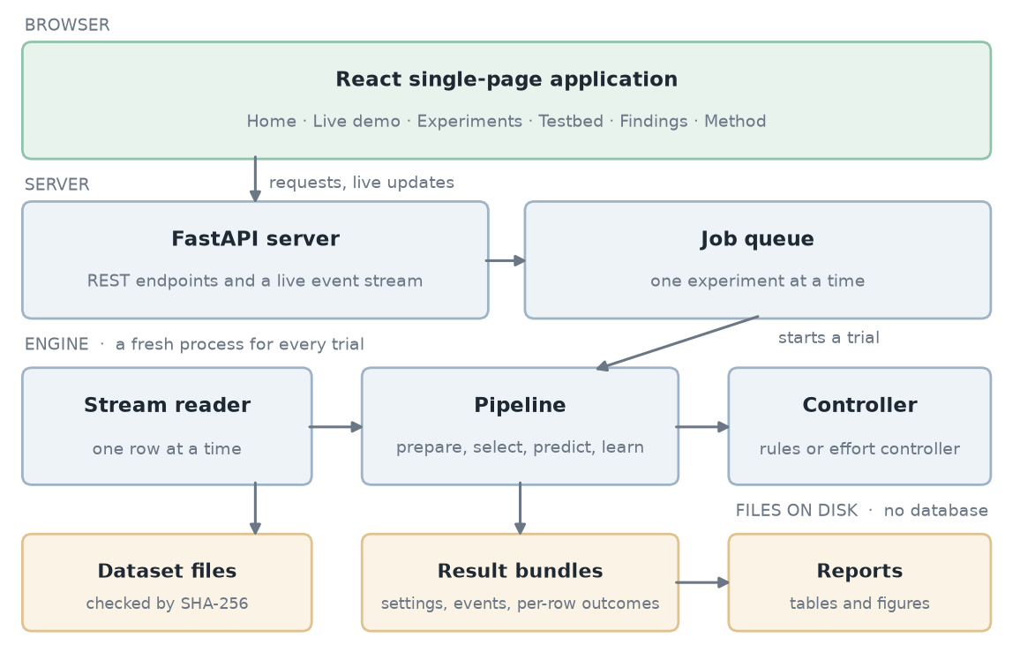
Figure 3.1: Overall System Architecture

3.3 Technology Stack
Table 3.1: Technology Stack
Layer | Technology | Role in this project
Stream learning | River | Hoeffding tree, ADWIN, ensembles; built for learning one item at a time
Server | FastAPI, Uvicorn | REST endpoints, live updates over Server-Sent Events, serving the built frontend
Settings and validation | Pydantic, YAML | One settings schema for the web app, the command line and saved runs; unknown keys are rejected
Numbers and statistics | NumPy, SciPy | Metrics from recorded outcomes; Friedman test; bootstrap resampling
Process measurement | psutil, resource | Process memory and CPU time, read from outside the timed loop
Frontend | React, TypeScript, Vite | Six pages, typed API client, hash-based routing with no router library
Charts | uPlot, Matplotlib | uPlot for live charts in the browser; Matplotlib for report figures
Storage | JSON, CSV, YAML files | Result bundles and reports are plain files that any tool can open
Tests | pytest, Vitest | Backend and frontend automated tests

3.4 System Modules
Table 3.2: Principal Modules of the System
Module | Responsibility | Location
config | Settings schema, device tiers, seeds | backend/adaptiveml/config
stream | Synthetic stream, small data snapshots, and the row-by-row reader for large data | backend/adaptiveml/stream
preprocessing, features | Adaptive scaling with gap filling; online ranking and selection of inputs | backend/adaptiveml/preprocessing, features
models, drift, adaptation | Learners, ADWIN wrapper, and the ladder from detector signal to action | backend/adaptiveml/models, drift, adaptation
pipeline | One complete pipeline per compared method, with stage timers | backend/adaptiveml/pipeline
controllers | The earlier subset controller, the review’s rules (R1–R5), and the effort controller | controller.py, joint_controller.py, effort_controller.py
engine, metrics | Runs one trial; scores, cost terms, per-attack and per-period results | backend/adaptiveml/engine, metrics
results, experiments | Result bundles; runner for many trials, including in parallel | backend/adaptiveml/results, experiments
analysis | Block bootstrap intervals; Friedman and Nemenyi tests | backend/adaptiveml/analysis
api | Web endpoints, live stream, testbed and report endpoints | backend/adaptiveml/api
frontend | Six pages, results views, explanation popovers | frontend/src
research_testbed | Protocol file, scripts, generated reports, research notes | research_testbed/

3.5 Frontend Design
The interface follows the order in which the project is explained, and the top bar is numbered to match: Home, Live demo, Experiments, Testbed, Findings, Method. Every page after Home starts with a one-line strip saying which step of six it is and what it shows, and ends with a button to the next step. I added this for the final presentation, so that a panel can follow the project without anyone steering it.
A few rules shaped the design. Every measured number says whether it is measured or simulated. Every technical term has an information button that answers three questions: what it is, how this project measures it, and why it matters. Charts, tables and explanations use plain words first and technical ones second. A presentation mode makes the type and charts larger for a projector. The Findings page reads its numbers from the saved reports when it loads, so it cannot disagree with them. Screens are shown in Chapter 4.

3.6 Backend Design
The backend is a FastAPI application. It validates a submitted setting, pins the data set by its checksum, queues the job and reports progress. Only one live run or experiment can be active at a time, because two runs on the same processor would spoil each other’s timings, and the server refuses a second one with a clear message. During a run, progress reaches the browser about four times a second over Server-Sent Events, sent between blocks of rows so that it does not enter the timed path.
Each trial runs in a freshly spawned process. When several trials are asked for, they run one after another by default. A worker option runs several at once for speed; the result then records how many ran in parallel, because timings taken that way include contention.

3.7 Data and Result Storage
There is no database. Data sets, results and reports are all plain files, which keeps every number inspectable and every run portable. Data files are kept out of version control; only their catalogue, with checksums, is stored. Figure 3.2 shows how a data set travels from download to report.
Table 3.3: Data and Result Files and Their Purpose
File or folder | Purpose
data/catalog.json | Registers each data set: file, row count, input columns, label mapping, source, licence and SHA-256 checksum
data/cicids2017/prepared/*.csv | The week of network traffic as one stream, ordered by the time each connection ended, with a binary label and the original label
…/prepared/schedule.json | The 22 attack periods and the first row of each day, taken from the data itself
results/experiments/<run>/manifest.json | Run summary: settings hash, machine and library versions, status, number of parallel workers
…/trials/<trial>/summary.json | Scores, cost terms, controller report, per-attack and per-period results of one trial
…/trials/<trial>/events.jsonl | Every drift alarm, model replacement and controller decision, with its row number
…/trials/<trial>/outcomes.csv.gz | The true label and prediction of every row, so any score can be recomputed
research_testbed/reports/<name>/ | Generated report: report.md, CSV tables, figures, and the run IDs it was built from

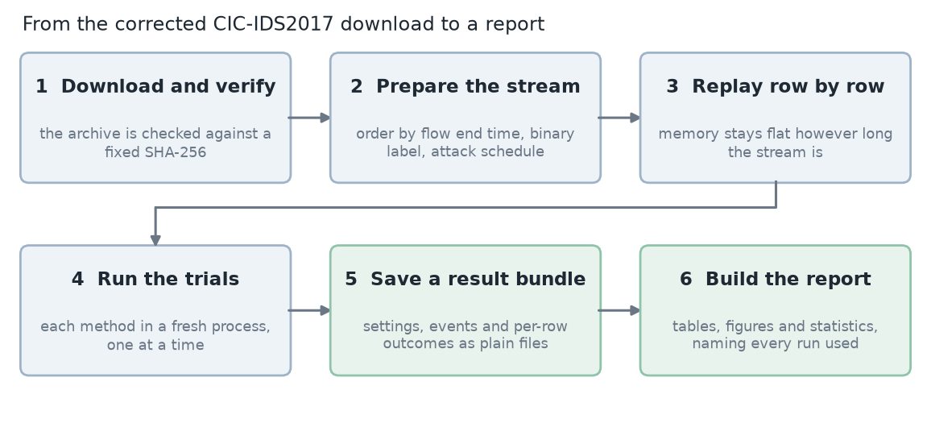
Figure 3.2: From Data Download to Report

3.8 API Design
The API is small and mostly read-only. Settings go in as one JSON document that has the same shape as the YAML files used on the command line.
Table 3.4: Representative REST and Streaming API Endpoints
Method and path | Purpose
GET /api/health | Server, Python and River versions; whether a run is active
GET /api/datasets | Registered data sets with row counts, sources and licences
POST /api/config/validate | Checks a setting and returns it in full, or explains what is wrong
POST /api/live · GET /api/live/stream | Start a live demonstration; follow it over Server-Sent Events
POST /api/experiments | Queue an experiment; GET /api/experiments/job reports its progress
GET /api/experiments/{id} | A saved run with its trials and summaries
GET /api/experiments/{id}/trials/{trial}/series | Per-block series for the charts of one trial
POST /api/experiments/{id}/rerun | Re-run a saved experiment and compare prediction hashes
GET /api/testbed/options | Slices of the stream, device tiers, methods and rule descriptions for the Testbed form
GET /api/testbed/reports · …/{name} | List generated reports; fetch one with its tables and figures

3.9 Integrity and Reproducibility Controls
Adaptive ML Studio is a local research tool and has no user accounts, so this section covers what protects the results and not who may use them. Four controls matter.
- Data integrity. A data file is accepted only if its SHA-256 checksum matches the catalogue. A mismatch stops the run before anything is computed. Row counts and every value are checked while reading, and a bad value is reported with its line number in the file.
- Repeatability. Each run stores its resolved settings, a hash of them, its seed and the versions of the machine and libraries. Model seeds never change the order of the data. A saved experiment can be re-run and the hash of every prediction compared.
- Isolation. One trial per process, one job at a time, and process memory read from outside the timed loop, so that one method’s costs cannot leak into another’s.
- Safe report serving. The report endpoints refuse any path outside the reports folder and any file type other than Markdown, CSV, PNG and SVG; files are sent with a restrictive content-security header. A test tries path traversal and expects it to fail.
The API itself is open. It should be run on a trusted machine and not exposed to a network.

3.10 Core Feature Implementation

3.10.1 The pipeline
Figure 3.3 shows what happens to every row. The pipeline predicts first and learns after, so a model is never scored on something it has already seen the answer to.
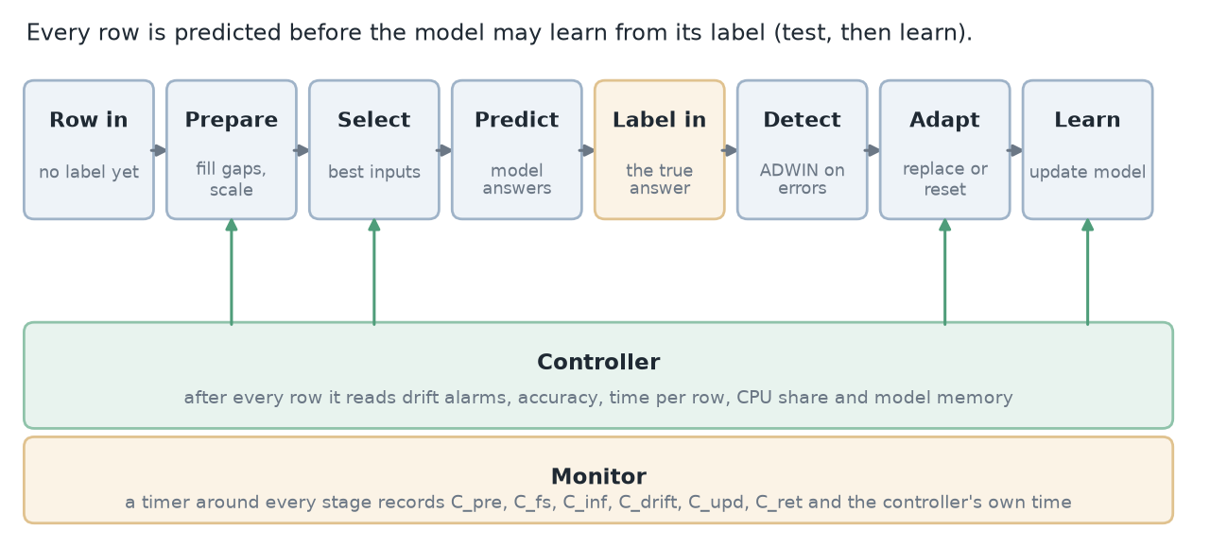
Figure 3.3: The Per-Row Pipeline and the Controller
Preparing the row fills a missing value with the running mean, then standardises it with a mean and variance that fade old rows out (a fading factor of 0.001) and clips values beyond five standard deviations. Input selection keeps the most useful inputs, ranked by the size of the weights of a small online logistic regression, which follows the truncation idea of online feature selection. By default a model keeps two thirds of the inputs. The learner is a Hoeffding tree with a grace period of 200 rows.
Drift detection feeds ADWIN the model’s 0-or-1 error on each row, with a warning level of 0.01 and an alarm level of 0.002. A drift alarm is acted on only when the error rate went up. The adaptation ladder then does one of three things: when a warning has come first it trains a replacement model in the background and swaps it in after 200 rows of learning; if background models are not allowed it resets to a fresh model at once; and it waits 300 rows after any adaptation before acting again.

3.10.2 Data sets and the stream reader
Three real data sets and one synthetic stream are registered. ELEC2 (45,312 half-hourly electricity-market records, 8 inputs) and the room occupancy data (20,560 one-minute sensor records, 5 inputs) are small enough to load whole. The synthetic SEA stream has a known drift position and is used for the live demo.
The main data set is the corrected CIC-IDS2017: 2,099,976 network connections recorded over five working days in July 2017, 505,431 of them attacks (24.1 %), with 83 numeric inputs per connection. The original day files are not in time order, so I wrote a preparation script that merges them into one stream ordered by the time each connection ended, which is the time a device could first score it. The script also marks connections labelled only as attempted attacks as normal, as the data’s authors advise, keeps the original label in a separate column, keeps identifiers (both IP addresses, the sender’s port, the connection id and timestamps) out of the model’s inputs, and writes out the schedule of 22 attack periods. The archive and both prepared files are pinned by checksum.
A new reader streams this file one row at a time, so memory stays flat. Reading all 2.1 million rows takes about 28 seconds and 89 MB. Running a method over the whole week peaks at about 150–165 MB per trial.

3.10.3 How methods are scored
Scores are computed after a warm-up of 1,000 rows. Besides accuracy, the platform reports the confusion counts, macro-F1, attack recall and false-alarm rate. Two further measures make the stream fair. The first is the copy-the-last-answer baseline, a method that ignores every input and repeats the previous label. The second is κ-temporal, which is the accuracy of a method minus the accuracy of that baseline, divided by one minus the baseline’s accuracy. It is 0 when a method is no better than copying, 1 when it is perfect, and negative when it is worse.
Results are also broken down by the original label (for example FTP-Patator or DoS Hulk) and by each of the 22 dated attack periods, with the number of attack connections that pass before the first one is flagged. Because neighbouring rows are not independent, confidence intervals come from resampling whole blocks of 10,000 consecutive rows, 1,000 times, and many methods are compared with the Friedman test followed by the Nemenyi critical difference.

3.10.4 Cost accounting
The review defines the total adaptation cost as a sum of terms: preprocessing, feature selection, drift detection, inference, model update, retraining and communication. Every stage in the pipeline sits between two timer readings, so the stage times add up exactly to the time spent on the row. I split the update stage further, into the part that updates the scaler statistics and the feature ranking, the part that updates the active model, and the part that trains a replacement. The controller’s own time is reported as an extra term, so the cost of deciding is visible. Communication does not apply, since everything runs in one process, and is reported as not applicable and not as zero. Across runs the terms add up to the measured time within a few microseconds per row.

3.10.5 Simulated device tiers
A tier is a set of limits that a controller must respect: a CPU budget per connection, a deadline for a single connection, and a memory limit for the model. They are enforced in software on the laptop. No slower processor is imitated, so a budget of 100 µs is a share of this machine’s time, not a measurement of a real device. The values are placeholders that I chose so that the limits bind for these methods, and the interface and every report say so.
Table 3.5: The Simulated Device Tiers
Tier | CPU per connection | Deadline | Model memory | Other limits
standard | none | none | none | No limits; the reference
small_sim (Raspberry Pi class) | 100 µs | 0.5 ms | 8 MiB | Updates may be thinned to every 4th row; at least 4 features
micro_sim (IoT gateway class) | 50 µs | 0.2 ms | 1 MiB | No background replacement model; updates every 8th row at most; at least 2 features
memory_sim (memory only) | none | none | 256 KiB | Isolates the memory rule

3.10.6 Late and missing labels
In real use the true answer for a connection is not known at once. Two settings imitate this. A label delay holds each row’s label back for a number of rows. A coverage setting lets only a share of rows ever receive a label, and the same rows are chosen for every method. After the warm-up, drift detection, adaptation and learning use only the labels that have arrived, and the controllers judge accuracy only from those. Scores still use every row’s true label, so they show what the late information costs.

3.10.7 The review’s rules as a controller (R1–R5)
The first controller turns the review’s five rules into code, one check per rule, evaluated after every row once the label is known. The review says resource limits come first when rules conflict, and the order here follows that. The memory rule (R5) comes first: when the model, plus any replacement being trained, is over its memory limit, the replacement is dropped, and if there is none the model is reduced. The deadline rule (R3) comes next: when too many rows in the last 200 miss the deadline, the controller halves the number of inputs, narrows preprocessing to the inputs in use, and then thins the updates, and it steps back up after a long calm stretch. The drift rules (R1 and R2) follow: while resources are spare a drift is met with a background replacement, and while they are tight with an immediate reset that needs no second model. The accuracy rule (R4) comes last: when accuracy over the last 500 labelled rows falls below 70 % and resources are spare, a fresh model is trained on the most recent 2,000 labelled rows. Each rule, and the resource checks, can be switched off for an ablation.

3.10.8 The budgeted effort controller
The measurements in Chapter 4 showed where the rules go wrong, and the effort controller is my answer to them. It keeps the same pipeline and the same hard limits for memory and deadline, but replaces the rule “use fewer inputs first” with a choice of how much work to do on each row. Figure 3.4 shows the loop.
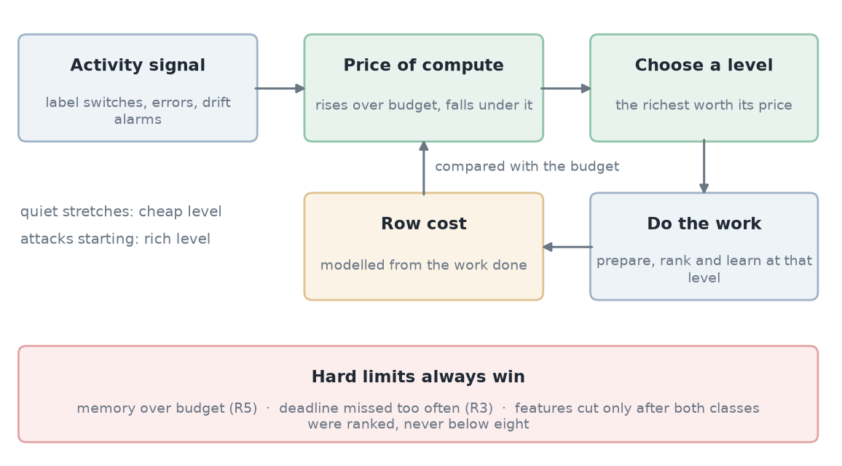
Figure 3.4: The Budgeted Effort Controller
A level is a setting of five levers: preprocess only the inputs the models need; update the scaler statistics on one row in a few; update the feature ranking on one row in a few, over all inputs, so that it stays current even while processing is narrowed; skip the model update on easy rows, meaning rows where the last 100 labels agreed and were all predicted correctly; and change the number of inputs only after the ranking has seen at least 200 rows of each class, never going below eight.
Which level a row gets depends on two things. The first is an activity signal made from the recent rate of label changes, the recent error rate, and a drift alarm, which is close to zero in quiet normal traffic and one when attacks are interleaved. The second is a price of compute, which rises a little whenever a row costs more than its share of the budget and falls whenever it costs less: price ← min(5, max(0, price + 0.002 × (cost ÷ budget − 1))). For each row the controller picks the richest level whose benefit, scaled by the activity, is worth its price, among the levels that meet the deadline. Quiet stretches therefore run cheaply and attack stretches run richly, and the running average stays near the budget. Three repairs address weaknesses found in the rules: a waiting replacement model is promoted as soon as it beats the current one on the last 20 labels, repeated alarms right after an adaptation are ignored while the label mix is unchanged, and with late labels a replacement is warm-started and the detector is muted for a while.
To make decisions repeatable, the controller reads a modelled cost, not a timer. The model adds up the work the pipeline actually did, using coefficients such as 212 ns per input transformed, 321 ns per input for scaler statistics, 148 ns per input for the ranking, and 6,688 ns plus 935 ns per feature for a model update. I calibrated the coefficients on Tuesday’s traffic by regressing the pipeline’s own timers at 8, 28 and 56 features. On Tuesday the modelled mean was within 3 % of the measured one. On Wednesday it under-predicts by about 7–10 %. Measured time is still recorded and reported. Because decisions never read a timer, the same settings give identical predictions on any machine load, which a test checks.

3.10.9 Experiment protocol and statistics
A single protocol file fixes the experiments: the methods, the device tiers, ten seeds, the warm-up, and the block size for intervals. It defines seven groups: the core comparison (which includes the effort controller), the literature ensembles, ablations of the rules controller, ablations of the effort controller, the memory rule, the label settings, and a recorded-arrival-rate group in which rows arrive at the speed of the original timestamps (scaled up), so that the CPU budget per row shrinks during attack bursts. Version 2 of the protocol expands to 333 trials in full and 105 in a short version on Wednesday’s attack traffic. A report script turns saved runs into tables, figures and statistics, and names every run it used. The full protocol would take about two days on this laptop and has not been run end to end; the experiments reported in Chapter 4 are the parts that were run.

3.11 Running and Deployment
There are no containers and no hosted instance. The system runs from source on one machine, and the exact package versions are pinned in a lock file so that the environment can be rebuilt. For presentation, the frontend can be built once and served by the backend. The two commands in Appendix A start everything. I chose this on purpose: the project is a research instrument whose results must be repeatable, and a single local setup does that with the least that can go wrong.

3.12 Testing, Validation and Error Handling
The backend has 162 automated tests, grouped as in Table 3.6, and the frontend has 42. They check the parts where a silent mistake would corrupt a result: the order and labelling rules of the data preparation, the stage timers adding up, every rule of both controllers on a hand-built case, the statistics against SciPy and against a worked example in Demšar’s paper, and the safe serving of reports.
Table 3.6: Automated Backend Test Suite (by Category)
Category | What is checked | Tests
API and result files | Endpoints, the report path guard, result bundle contents and recording | 18
Data and streams | Synthetic and real replay order, labels, checksums, bad values, drift shapes, start offset, arrival rate | 42
Pipeline and engine | Components, per-row stage timing, controlled runs, stress harness inputs | 40
Metrics and baselines | κ-temporal by hand, per-attack and per-period scores, the new methods | 7
Rules controller (R1–R5) | Each rule fires on a crafted case; ablation switches; the memory rule’s steps | 10
Effort controller | Each lever and repair; price rises and falls; hard limits win; identical predictions on repeat | 23
Scale, protocol, statistics | Label delay, tiers, parallel runs, bootstrap, Friedman, Nemenyi, protocol expansion, report building | 13
Stress harness | Corrupted-label and shifted-input checks on the pipeline | 9
Total |  | 162

Errors are meant to be loud. Unknown keys in a settings file are rejected so that a typo cannot fall back to a default quietly. A checksum mismatch, a short file or a bad value stops a run with a message that names the problem. The interface shows an explicit error state and a retry button. One honest caveat: three of the older tests depend on timing and can fail when the laptop is heavily loaded. They passed every time the machine was idle, and the same failure appeared on the committed code before my changes, so I treat it as a property of the tests, not of the new work.

3.13 Summary
The system is one engine with a fixed per-row order, wrapped in timers and driven four ways: a live demo, an experiment runner, a real-data testbed and a report generator. Data is checked by checksum and read in constant memory. Two controllers sit on the same pipeline, the review’s rules and the new effort controller, and both can be switched apart rule by rule. The next chapter shows the system in use and what it measured.

CHAPTER 4
RESULTS AND DISCUSSION

4.1 Implementation Results
The system covers the whole path from a download to a report: a data set is verified and prepared, replayed through the pipeline under a chosen device tier, scored, saved, and turned into tables and figures. The backend is about 7,100 lines of Python, with 2,400 more in tests. The frontend is about 9,300 lines of TypeScript and 1,800 of styling. All 162 backend tests and 42 frontend tests pass.
The first full-week check showed that the data path works at the scale it was built for. Two methods ran over all 2,099,976 connections in about six minutes, and a single trial peaked at 152–164 MB of memory. Reading the file alone takes about 28 seconds and 89 MB, so the stream reader is not what limits a run.

4.2 User Interface and Screens
The Home page (Figure 4.1) explains the problem before showing any instrument. The curve at the top is a drawing, labelled as one, of what the platform exists to study: a model trained once and then frozen, against one that keeps learning. Further down, the page tells the story from the review to the testbed and lists the six steps of the walkthrough (Figure 4.2).
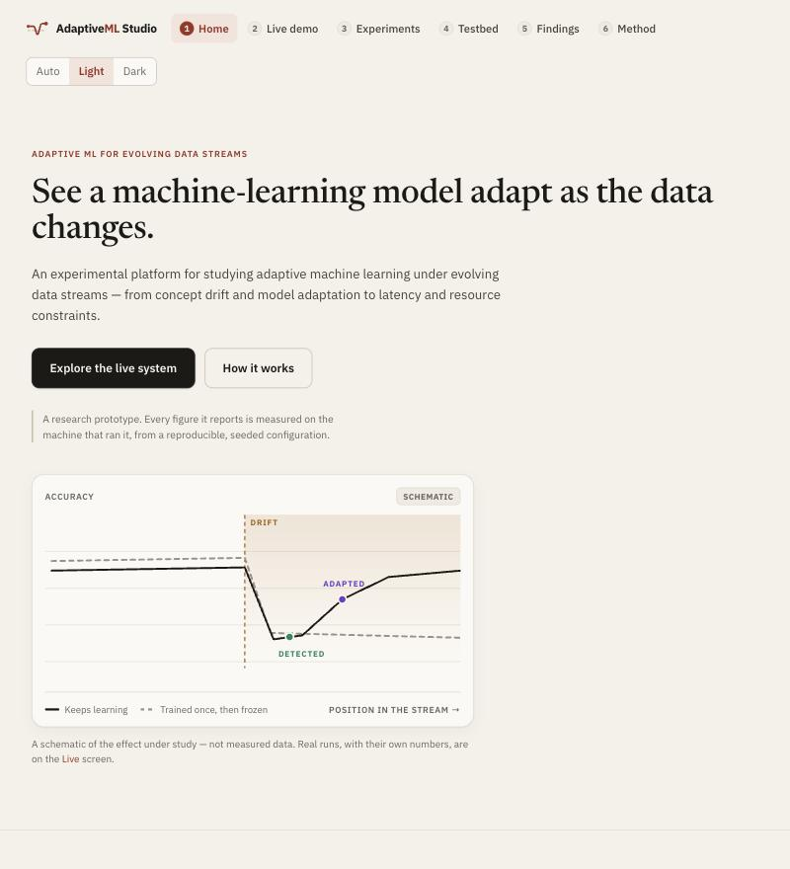
Figure 4.1: Home Page
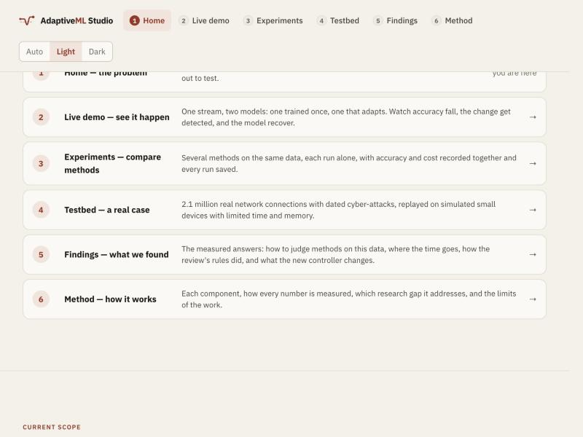
Figure 4.2: The Six-Step Walkthrough on the Home Page
The Testbed page (Figure 4.3) is where a real-data experiment is set up. The slice of the week, the methods, the device tier, the label delay and the controller rules are all chosen here, and a preset button fills in a 40-second demonstration: 40,000 connections that include two real attacks, on the simulated small device, comparing the copy baseline, the review’s rules and the effort controller. Every simulated tier carries a visible label saying that its budgets are placeholders.
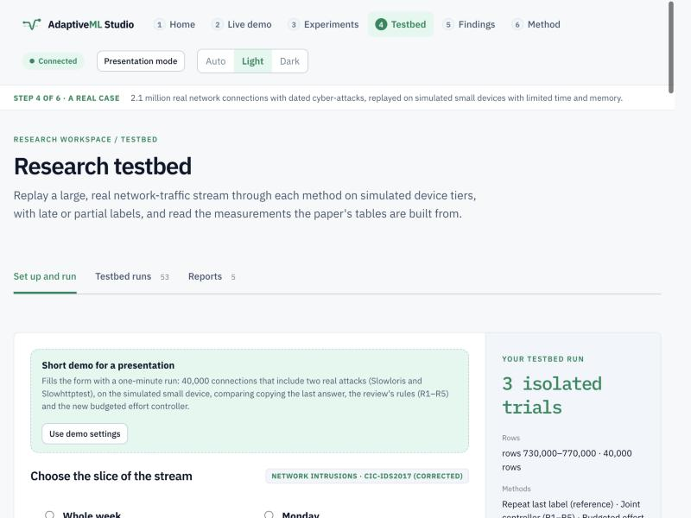
Figure 4.3: Testbed Set-up Page with the Demonstration Settings
When a run finishes, its results page (Figure 4.4) shows a “Testbed measures” view: scores and cost for every method and tier, where the time per row goes, each attack type and attack period, and what the controller decided. I started the demonstration from the page itself and it finished in about 40 seconds. In that short run the effort controller scored a κ-temporal of 0.88 against 0.84 for the rules, at 110 µs against 122 µs per connection. I treat it as a demonstration of the screen, not as evidence.
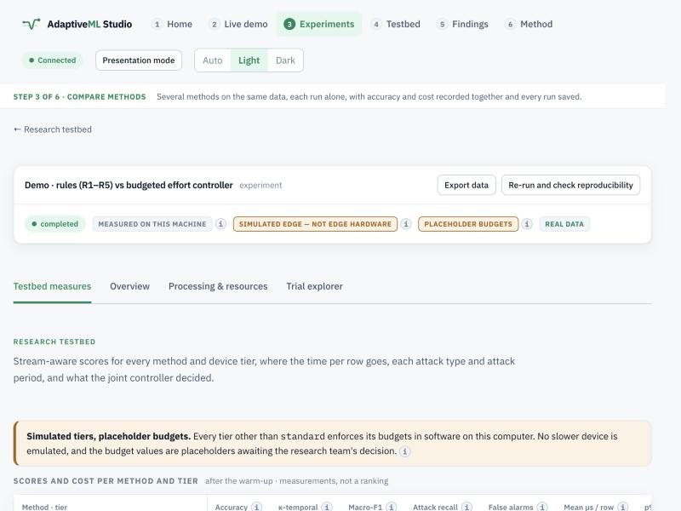
Figure 4.4: Results Page of a Testbed Run
The Findings page (Figure 4.5) states four findings in plain words, with a table or bar chart for each, and a closing section on what the numbers do not show. It reads its numbers from the saved reports when it opens, and each table links to the report it came from.
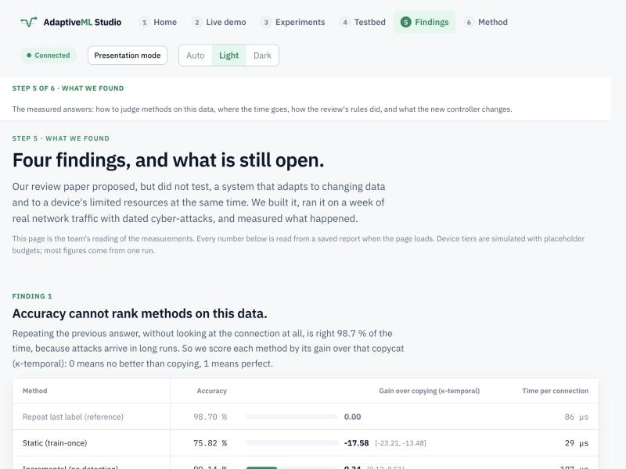
Figure 4.5: Findings Page

4.3 Functional Results

4.3.1 Accuracy cannot rank the methods
Over the whole week, repeating the previous label is right 98.70 % of the time. Every method that keeps learning lands between 99.14 and 99.90 %, so by accuracy they look alike (Table 4.1). Scored by κ-temporal, the gain over the copy baseline, they separate clearly, from 0.34 for plain incremental learning to 0.92 for Streaming Random Patches. The static model, which learned only from the first 1,000 connections (all normal Monday traffic), never flags an attack and scores −17.6.
Table 4.1: Methods Compared over the Whole Week
Method | Accuracy (%) | κ-temporal [95 % interval] | Attack recall (%) | False alarms (%) | µs per connection
Repeat last label | 98.70 | 0.00 | 97.3 | 0.86 | 86
Static (train once) | 75.82 | −17.58 [−23.21, −13.48] | 0.0 | 0.00 | 29
Incremental | 99.14 | 0.34 [0.12, 0.51] | 97.3 | 0.29 | 197
Adaptive pipeline | 99.34 | 0.49 [0.37, 0.60] | 98.7 | 0.45 | 125
Leveraging bagging | 99.76 | 0.82 [0.70, 0.90] | 99.2 | 0.05 | 5,751
ARF | 99.86 | 0.89 [0.86, 0.92] | 99.7 | 0.09 | 657
SRP | 99.89 | 0.92 [0.90, 0.94] | 99.7 | 0.04 | 4,790

Figure 4.6 shows the same story over time. The static model collapses in every attack period, while the others hold near the top of the chart.
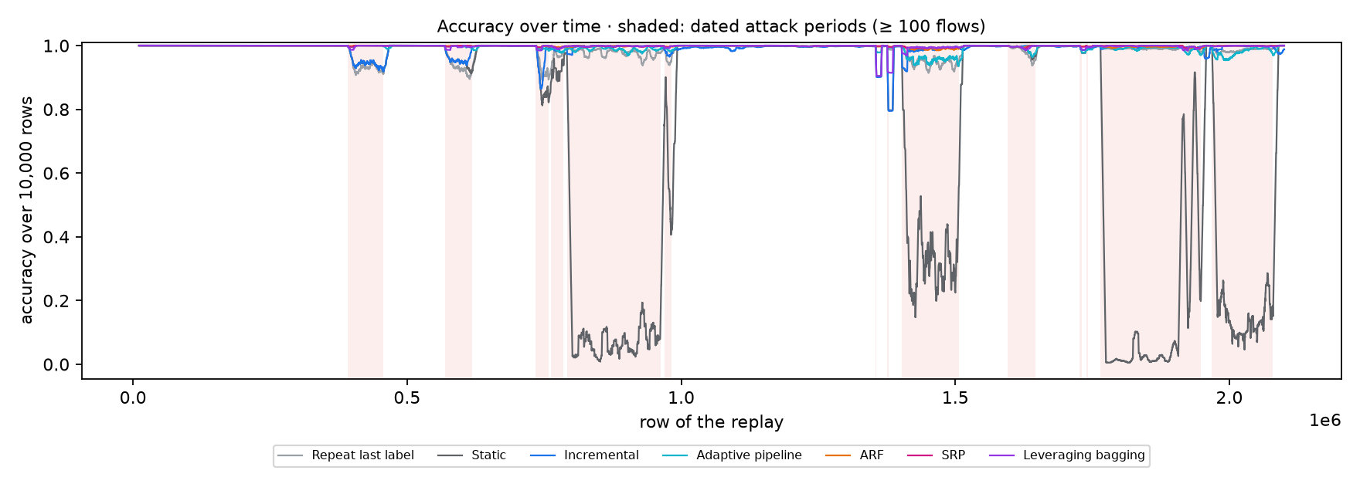
Figure 4.6: Accuracy over the Week with the Dated Attack Periods
The price of the top scores is high. Streaming Random Patches takes about 38 times as long per connection as the adaptive pipeline (4,790 against 125 µs), Leveraging Bagging about 46 times, and Adaptive Random Forest about five times. Figure 4.7 puts the two sides next to each other.
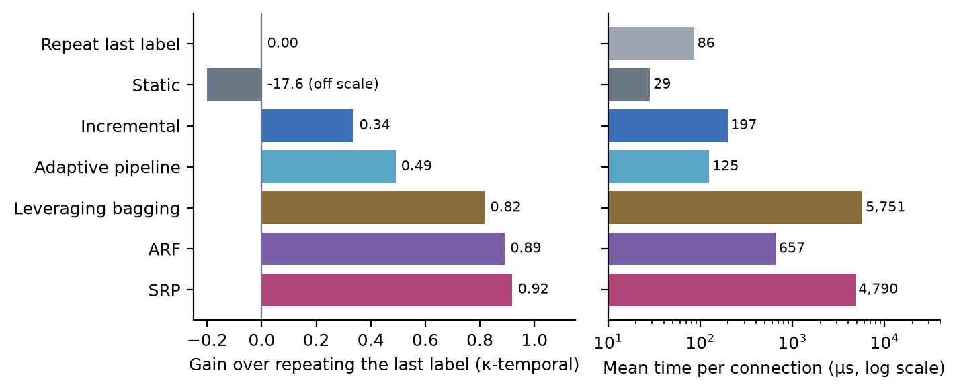
Figure 4.7: Methods Compared over the Whole Week
The averages hide where the differences come from. Table 4.2 shows that the attacks which look like their neighbours are easy for everyone, and the ones that do not are where methods part ways. On the two password-guessing attacks, FTP-Patator and SSH-Patator, copying the previous label catches 41 % and 38 %, and plain incremental learning catches 0.4 % and 27 %. The adaptive pipeline catches 98.5 % and 93.7 %. Botnet is a case where incremental learning, at 97.4 %, beats every method with a drift detector. The very rare types are another matter. Heartbleed (11 connections) and SQL injection (13) are missed by every method, and the other rare ones (cross-site scripting with 18 connections, infiltration with 36, web brute force with 73) are caught poorly and unevenly. A score that averaged them in would hide all this.
Table 4.2: Share of Each Kind of Traffic Flagged as an Attack (%)
Traffic | Flows | Copy | Static | Incr. | Adapt. | ARF | SRP | Lev. bag.
FTP-Patator | 3,972 | 41.2 | 0.0 | 0.4 | 98.5 | 99.4 | 99.5 | 96.8
SSH-Patator | 2,961 | 38.3 | 0.0 | 27.2 | 93.7 | 98.8 | 98.1 | 91.3
DoS Hulk | 158,468 | 98.7 | 0.0 | 99.8 | 99.2 | 99.9 | 100.0 | 100.0
Botnet | 736 | 21.1 | 0.0 | 97.4 | 34.2 | 77.7 | 74.9 | 64.9
Heartbleed | 11 | 0.0 | 0.0 | 0.0 | 0.0 | 0.0 | 0.0 | 0.0
Normal traffic (false alarms) | 1,581,566 | 0.8 | 0.0 | 0.3 | 0.4 | 0.1 | 0.0 | 0.0

4.3.2 Where the time goes
The review called it an open question which pipeline stage costs the most, and Figure 4.8 and the shares below answer it for this stack. In every method except the new controller, preparing the data and updating the model take between 75 and 85 % of the time per connection. Checking for drift takes about 1–2 %. On the simulated small device, plain incremental learning spends 33 % on preparing and 52 % on updating, and the rules controller 34 % and 42 %. In an early test with all 83 inputs prepared on every row, preparing alone took 107 of 153 µs. Cutting a model’s inputs therefore saves little unless preprocessing is cut with it, which is why the effort controller narrows both.
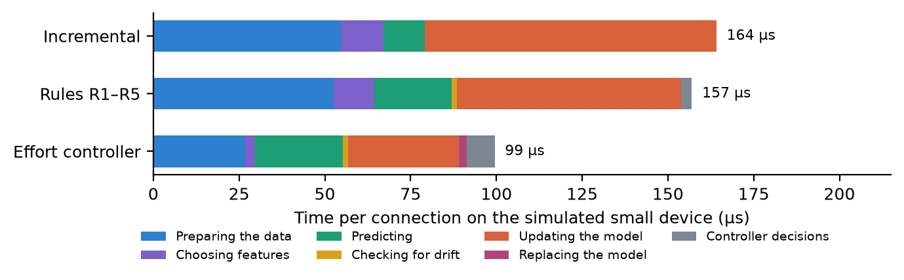
Figure 4.8: Where the Time per Connection Goes
With the effort controller the two big stages shrink to a combined 59 %, prediction rises to 26 % and the controller’s own decisions cost 8 %. One caution: these shares hold for this implementation, in Python with River, where the scaler is updated one input at a time in a dictionary. A compiled implementation could well show a different split.

4.3.3 The review’s rules and the effort controller on Wednesday’s traffic
Wednesday’s traffic (300,000 connections, with four dated attack periods) is the stretch the effort controller was designed on, so I treat it as a development result. Table 4.3 and Figure 4.9 show it.
Table 4.3: Wednesday’s Traffic on the Simulated Devices
Device | Method | Errors | κ-temporal [95 % interval] | µs per connection | Against the budget
Small (100 µs) | Incremental | 2,472 | 0.69 [0.53, 0.81] | 165 | no budget control
Small (100 µs) | Rules R1–R5 | 2,275 | 0.71 [0.59, 0.79] | 160 | 100 µs: 60 % over
Small (100 µs) | Effort controller | 1,660 | 0.78 [0.71, 0.83] | 102 | 100 µs: at budget
Small (100 µs) | ARF (reference) | 589 | 0.92 [0.90, 0.94] | 1,368 | no budget control
Micro (50 µs) | Incremental | 78,655 | −8.20 [−15.10, −4.08] | 85 | no budget control
Micro (50 µs) | Rules R1–R5 | 2,638 | 0.65 [0.52, 0.74] | 90 | 50 µs: 79 % over
Micro (50 µs) | Effort controller | 3,099 | 0.60 [0.43, 0.71] | 47 | 50 µs: within
Micro (50 µs) | ARF (reference) | 599 | 0.92 [0.90, 0.94] | 1,365 | no budget control

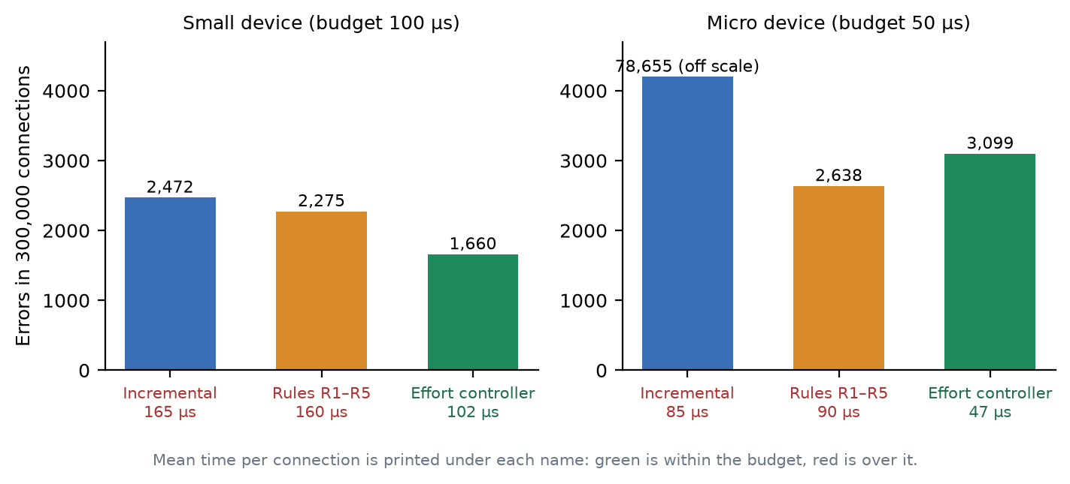
Figure 4.9: Wednesday’s Traffic on the Small and Micro Devices
On the small device the rules controller overshoots the 100 µs budget by about 60 % (160 µs), while the effort controller stays within 2 % of it (102 µs) and makes 615 fewer errors, which is 27 % fewer (1,660 against 2,275). A paired comparison on the same rows, in blocks of 10,000 connections, gives a difference of −563 errors with a 95 % interval of −966 to −148. On the micro device the effort controller meets the 50 µs budget (47 µs), where the rules run at 90 µs, but it makes 17 % more errors than the rules, 3,099 against 2,638. Plain incremental learning on the micro device collapses to 78,655 errors, because the 1 MiB model limit prunes its tree. Adaptive Random Forest remains far more accurate, at 589 errors, but needs about 1,370 µs per connection, thirteen times the effort controller’s.

4.3.4 Two days not used in the design
Thursday and Friday played no part in designing, calibrating or checking the effort controller. I used Wednesday for the design and Tuesday for calibrating the cost model, and I changed nothing after seeing these two days. Table 4.4 and Figure 4.10 show the outcome. The rules controller and the effort controller each ran with three seeds. For the copy baseline the errors were 6,188 on Thursday and 5,104 on Friday, and plain incremental learning on the small device made 4,119 and 3,566.
Table 4.4: Thursday and Friday: Days Not Used in the Design
Day, device | Rules R1–R5: errors | Effort: errors | Paired difference, effort − rules, with 95 % interval | µs per connection, rules → effort
Thursday, small | 2,327 | 2,377 | +50 [−139, +282] | 153 → 75
Thursday, micro | 3,698 (2,389–4,388) | 2,331 | −2,057 [−3,231, −1,015]; −58 [−382, +248]; −1,985 [−3,225, −890] | 97 → 48
Friday, small | 1,982 (1,958–2,030) | 1,632 | −326 [−683, +1] | 142 → 89
Friday, micro | 2,597 (2,169–2,970) | 2,002 | −167 [−699, +390]; −651 [−1,325, −59]; −968 [−1,595, −397] | 76 → 57

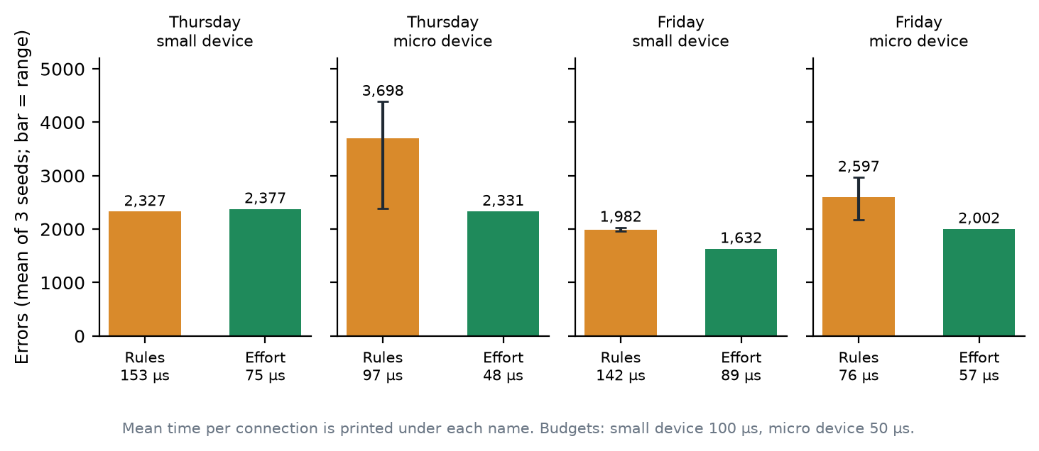
Figure 4.10: Thursday and Friday: the Days Not Used in the Design
The cost result holds on both days. On the small device the effort controller runs at 75 and 89 µs against the 100 µs budget, and the rules at 153 and 142 µs. On the micro device it runs at 48 µs on Thursday, within the 50 µs budget, and at 57 µs on Friday, which is 14 % over, because the cost model under-predicts there. The quality result is more modest than Wednesday suggested. On the small device, Thursday is a tie (+50 errors, an interval that spans zero) and Friday favours the effort controller (−326, an interval that only just touches zero). So “fewer errors than the rules” does not hold as a general claim. “Equal or fewer errors, at about half the cost” does. On the micro device the effort controller was better in four of six paired comparisons and tied in two. The rules controller’s own results on that device swung widely between runs on identical data, from 2,389 to 4,388 errors on Thursday, which leads into Section 4.5.

4.3.5 What each part of the effort controller is worth
To see which parts earn their place, I removed them one at a time on the small device and counted the extra errors (Table 4.5, Figure 4.11). The activity signal, the fast model switch, the price of compute, the skipping of updates on easy rows, the live feature ranking and the sampled scaler statistics each cost between 484 and 1,105 extra errors when removed. Removing narrow preprocessing, the damping of repeated alarms or the feature gate changed little. The feature gate never came into play on this device, so its removal gave identical results. Without the price, the controller also went more than half over the time budget, which is what that part is for.
Table 4.5: What Removing Each Part of the Effort Controller Costs
Part removed | Errors | Change vs. full | κ-temporal [95 % interval] | µs per connection
Full effort controller | 1,660 | — | 0.78 [0.71, 0.83] | 102
Activity signal | 2,765 | +1,105 | 0.64 [0.50, 0.72] | 101
Fast model switch | 2,645 | +985 | 0.65 [0.50, 0.75] | 108
Price of compute (budget control) | 2,472 | +812 | 0.67 [0.53, 0.76] | 154
Skipping updates on easy rows | 2,426 | +766 | 0.68 [0.55, 0.77] | 95
Live feature ranking | 2,342 | +682 | 0.69 [0.58, 0.76] | 106
Sampled scaler statistics | 2,144 | +484 | 0.72 [0.61, 0.79] | 87
(Reads measured time, not modelled cost) | 1,847 | +187 | 0.76 [0.66, 0.82] | 78
Narrow preprocessing | 1,741 | +81 | 0.77 [0.70, 0.82] | 106
Damping of repeated alarms | 1,683 | +23 | 0.78 [0.70, 0.83] | 125
Feature gate | 1,660 | +0 | 0.78 [0.71, 0.83] | 122

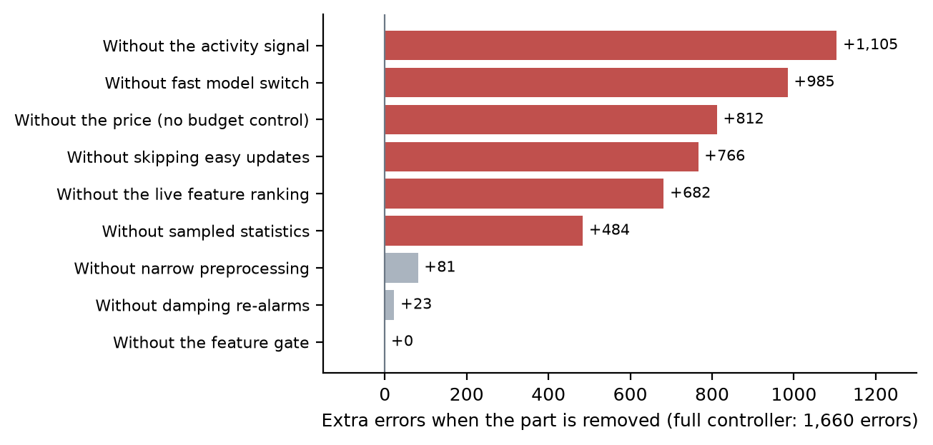
Figure 4.11: What Each Part of the New Controller Is Worth
One result I cannot yet explain: skipping the model update on easy rows lowers the cost, as expected, but also lowers the errors. I have a guess, that fewer updates keep the model steadier, but I have not tested it, so I leave it as an open question.

4.3.6 The memory rule
In the first experiments the memory rule (R5) never fired. The model stayed near 52 KB against a limit of 2 MiB, because River’s own size cap pruned the tree first. I switched that cap off for the rules controller and added a memory-only tier with a 256 KiB limit. On the whole week, R5 then held the model within its limit at 99.1 % of the memory checks, against 54 % without it (Table 4.6). Holding the limit costs detection quality: the κ-temporal falls from 0.75 to 0.57. This is the memory version of the trade-off that the time budget showed. All three seeds gave identical results, because with no timer-based budget the controller’s decisions do not depend on machine load.
Table 4.6: The Memory Rule (R5) on a Memory-Limited Device
Setting (256 KiB model limit) | κ-temporal [95 % interval] | µs per connection | Largest model | Memory checks over the limit
With R5 | 0.57 [0.47, 0.66] | 107 | 392 KB | 19 of 2,118 (0.9 %)
Without R5 | 0.75 [0.70, 0.79] | 148 | 1,377 KB | 960 of 2,099 (46 %)

4.3.7 When the true answers arrive late
This is the result that did not work. With each label arriving 1,000 connections late, both controllers do badly (Figure 4.12). The rules controller makes 60,387 errors and the effort controller 56,712, while plain incremental learning, which never resets, makes 9,602. My analysis of the saved runs found that most of the rules controller’s errors come shortly after its own model resets: after a reset the new model is blind for a thousand connections, because its first labels have not arrived yet. The repair I built for the effort controller, which keeps the old model until the new one has learned from enough labels, made things worse: without it, the effort controller makes 39,973 errors. A variant I added afterwards, after seeing this result, does better (43,792) but still not as well as removing the repair, and I mark it as an after-the-fact experiment, not a finding. Late labels remain the main open problem of this work.
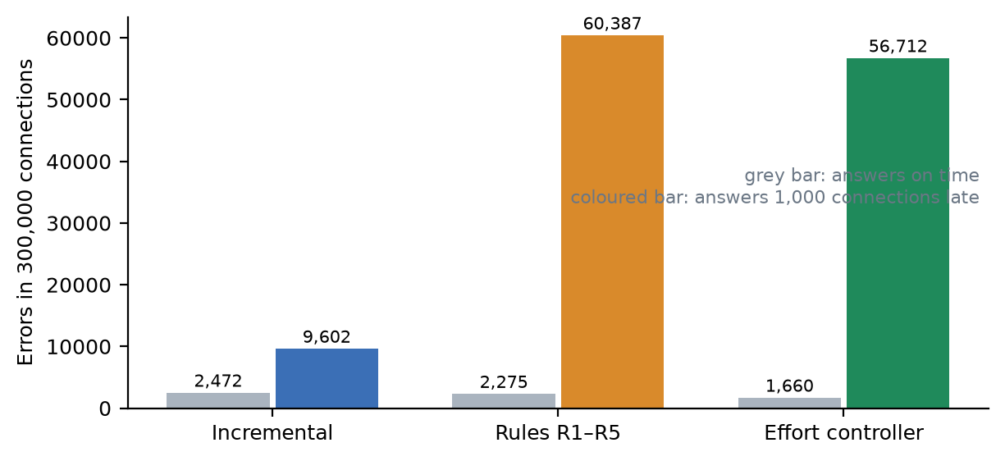
Figure 4.12: Errors When True Answers Arrive Late

4.4 Feature-wise Results
Table 4.7: Feature-wise Implementation Outcome
Feature | Status | How it was checked
Adaptive pipeline with stage timers | Implemented | Stage times sum to row time; unit and engine tests
Live demonstration and experiment runner | Implemented | Backend tests; saved runs can be re-run and compared by prediction hash
Corrected CIC-IDS2017 preparation | Implemented | Archive and outputs pinned by checksum; 2,099,976 rows, 22 attack periods; tests on ordering and labels
Constant-memory stream reader | Implemented | Whole file read in about 28 s and 89 MB; whole-week trials peak at 152–164 MB
Fairer scoring (κ-temporal, per attack, per period) | Implemented | Hand-computed test cases; confidence intervals from block resampling
Cost terms of the review’s formula | Implemented | Terms sum to the measured time per row; communication reported as not applicable
Simulated device tiers | Implemented (placeholder budgets) | Controllers keep to the budgets in the runs of this chapter, with the exceptions stated
Rules controller (R1–R5) | Implemented | One test per rule; memory rule verified on the memory-limited tier
Effort controller | Implemented | 23 tests; Wednesday; Thursday and Friday with three seeds; ablations
Late and missing labels | Implemented | Tests; the result is a failure of both controllers (Section 4.3.7)
Protocol, statistics and report generator | Implemented; full protocol not run | Expansion and statistics tested against SciPy; a short protocol run built a report end to end
Testbed page and Findings page | Implemented | Demonstration run started from the page and finished; Findings reads numbers from saved reports
Real edge device; energy measurement | Not done | Out of scope; stated as a limit

4.5 Reliability Observations
The effort controller is repeatable. On Thursday and Friday, three seeds gave identical predictions on each day and device, and two runs of one setting on Wednesday gave the same prediction hash. This is by design, since it decides from a modelled cost and has no random parts. The rules controller is not repeatable, because its decisions read a timer. On the micro device on Thursday its three runs on identical data made 2,389, 4,316 and 4,388 errors. In an earlier experiment the same rules setting scored a κ-temporal of −0.03 in one run and 0.58 in another, which made its ablations look like noise. For this reason, “three seeds” for the effort controller means three identical runs, and tells us nothing about variation. Only the differences between days do.
Measured times also move with the machine’s load. The same effort setting ran at 102 and 99 µs in two repeats on Wednesday, and the rules controller, whose decisions follow the timer, ranged from 75 to 121 µs on Thursday’s micro device. I therefore read the time figures as a good guide to the order of magnitude and to the ranking of the methods, not as exact values. The ensembles, the full-week runs and some of the early runs shared the laptop with other jobs, which adds to this.

4.6 Discussion
The first lesson is about evaluation. On a stream with long runs of one label, accuracy hides almost everything, and a method can look excellent while doing no better than copying. Any reader of a security paper on streams should ask what a method that repeats the last answer would score.
The second is about cost. Where the time goes is not where one would first look. Drift detection, the part the literature spends most of its words on, is cheap. Preparing the data and updating the model are what cost, and that is where a controller should aim.
The third concerns the review’s rules. They are reasonable and they work when resources are plentiful. Under a real budget, the rule that cuts inputs first overshoots the budget on a small device, and in my tests its worst failures came from a timing flaw (it fired before the feature ranking had seen any attack), not from a limit of the idea. That is a good example of why an untested proposal had to be tested.
The fourth is that the effort controller helps, but less than the design day suggested. On the small device it matches or beats the rules at about half the time. On the micro device it meets the budget and is more stable, but it is not clearly more accurate. The most accurate methods in the literature stay well ahead on accuracy, so what the controller offers is the best result inside a budget, not the best result. And with late labels it does not yet work.

4.7 Limitations
- The devices are simulated. The budgets are placeholders enforced in software on a laptop, and no real edge device or energy meter was used.
- The main experiments use one data set from one lab network over one week. Thursday and Friday are held out from the design, but they come from the same week and network.
- The effort controller’s Wednesday result is a development result. The held-out days support the cost result and a weaker quality result.
- Most results are single runs on one laptop, and several shared it with other jobs. The cost model under-predicts on some stretches, which is why the micro device ran 14 % over its budget on Friday.
- The full protocol (333 trials) was not run; the experiments reported here are the parts that were.
- The finding that preparing the data dominates the cost may be partly specific to Python and River.
- Late labels are unsolved, and the rarest attack types are missed or caught unreliably.
Table 4.8: Defects Identified and Resolved During Development
# | Defect | How it was found | Resolution
1 | Features were cut after the ranking had seen only normal traffic; four poorly chosen inputs were kept for 2.1 million rows | Analysis of a tight-budget run | The effort controller ranks live and cuts only after both classes were seen. The rules controller is kept as the baseline
2 | The memory rule never fired | Model was 52 KB against a 2 MiB limit | River’s size cap switched off for the rules controller; a memory-only tier added
3 | The deadline rule and the memory rule undid each other’s feature cuts | Test run: features halved 56→28 eight times | The deadline rule now restores only its own cuts
4 | Ablation results looked like noise because decisions read a timer | Same setting gave κ-temporal −0.03 and 0.58 | The effort controller decides from a modelled cost; repeats give identical predictions
5 | The old dataset form offered column-swap drift for the intrusion data, which refuses it | First check of the large data set | The form hides large data sets and points to the Testbed
6 | The stress harness broke when preprocessing gained an argument (three tests failed) | Test suite | The call was adapted; all tests pass
7 | A server started before the new method existed rejected the demonstration run | Running the demo from the page | Restart; the presentation guide now says to restart after a code change
8 | The planned repair for late labels made them worse (56,712 errors against 39,973 without it) | Late-label run on Wednesday | Reported as an open problem; a later variant is marked as an after-the-fact experiment

4.8 Summary
A complete system was built and checked: the platform, the real-data testbed and the two controllers. Its measurements show that accuracy is a poor yardstick on this stream, that preparing the data and updating the model are where the time goes, that the review’s rules overshoot a small device’s budget, and that a controller which prices computing time stays at the budget, with equal or fewer errors on the small device and better stability on the smaller one. They also show that late labels are not solved. Feature outcomes appear in Table 4.7 and the eight resolved defects in Table 4.8.

CHAPTER 5
CONCLUSION AND FUTURE SCOPE

5.1 Conclusion
This report described Adaptive ML Studio, the system I built to test a proposal from our review paper. The review argued that an adaptive pipeline should react to changing data and to a device’s limited resources at the same time, and gave five rules for doing so. It left them untested. This project gave them a test bench and a real case: 2.1 million network connections, 22 dated attack periods, and simulated devices with a time and memory budget.
The test bench shows several things. Accuracy cannot rank methods on this stream, because copying the previous answer scores 98.7 %, and the gain over that copy baseline can. Preparing the data and updating the model, not drift detection, take most of the time. The review’s rules keep quality but overshoot the time budget of a small device by about 60 %. A controller that puts a price on computing time, and does less work on easy stretches, kept to the budget and made equal or fewer errors on the small device, on three days of traffic. It is also repeatable, which the rules are not. It does not work when true answers arrive late, and it is not clearly more accurate on the smaller device.
Along the way I found and dealt with eight defects, three of which were mistakes in how the rules interact or fire, and the system now passes 162 backend and 42 frontend tests. I tried to report the results in the order of how much I trust them, and to say which ones depend on a stretch of data I had already looked at.

5.2 Key Learnings
- A good baseline matters more than a good method. The copy-the-last-answer baseline changed how I read every other number.
- Measure before optimising. The belief that drift detection is the expensive part was wrong, and only the stage-by-stage costs showed it.
- A rule that works on paper can fail through timing. The feature-cutting rule failed because it fired before the ranking had seen an attack, not because the idea was bad.
- Make decisions repeatable. Controllers that read a timer produce results that cannot be compared, and a modelled cost fixed that.
- A negative result is still a result. The late-label failure is the most useful thing for the next piece of work.
- Keep the development data and the test data apart from the start. I did this late, and it was the right call.

5.3 Limitations of the Present Work
The limits listed in Section 4.7 apply. In short, the devices are simulated, one data set from one network was used for the main experiments, most results are from single runs on one laptop, the full protocol has not been run, and two problems are open: late labels, and the rarest attack types, which are missed or caught unreliably.

5.4 Future Scope
Table 5.1: Limitations and Corresponding Future Work
Present limitation | Proposed extension
Late labels break both controllers | Make adaptation aware of the delay from the start; test a label-free drift signal, such as disagreement between a cheap and a strong model
Simulated devices with placeholder budgets | Run on a Raspberry Pi class device, measure real time and memory, and add energy measurement
One data set, one network | Repeat on a second data set from a different network, such as an IoT traffic set, and on the other corrected intrusion data
Held-out days are from the same week | Test on data recorded in a different period
Single runs, a shared laptop | Run the full protocol on a quiet machine, one trial at a time, with all ten seeds
Cost model under-predicts on some stretches | Recalibrate per tier, and compare with a compiled implementation of the pipeline
The rarest attack types are missed or caught unreliably | Use cost-sensitive learning or active labelling for rare classes
The controller uses fixed thresholds | Learn the effort levels online, as the review’s configuration-search question suggests

5.5 Summary
The project built the system that the review called for and used it to test the review’s proposal. The proposal holds only in part, a better controller is possible and was built, and the main open problem is now clear. The limits in Section 5.3 mark where the work should go next.

REFERENCES
Sources are ordered alphabetically by author, or by the responsible organisation where a work has a corporate author.
Arp, D. et al. Dos and don’ts of machine learning in computer security. Proc. 31st USENIX Security Symposium, 2022.
Bifet, A. and Gavaldà, R. Learning from time-changing data with adaptive windowing. Proc. 7th SIAM International Conference on Data Mining (SDM), 2007, pp. 443–448. https://doi.org/10.1137/1.9781611972771.42
Bifet, A., Holmes, G. and Pfahringer, B. Leveraging bagging for evolving data streams. ECML PKDD 2010, Lecture Notes in Computer Science, vol. 6321, Springer.
Candanedo, L. M. and Feldheim, V. Accurate occupancy detection of an office room from light, temperature, humidity and CO2 measurements using statistical learning models. Energy and Buildings, vol. 112, 2016, pp. 28–39.
Demšar, J. Statistical comparisons of classifiers over multiple data sets. Journal of Machine Learning Research, vol. 7, 2006, pp. 1–30.
Disabato, S. and Roveri, M. Tiny machine learning for concept drift. IEEE Transactions on Neural Networks and Learning Systems, vol. 35, no. 6, 2024, pp. 8470–8481. https://doi.org/10.1109/TNNLS.2022.3229897
Domingos, P. and Hulten, G. Mining high-speed data streams. Proc. 6th ACM SIGKDD International Conference on Knowledge Discovery and Data Mining, 2000, pp. 71–80.
Engelen, G., Rimmer, V. and Joosen, W. Troubleshooting an intrusion detection dataset: the CICIDS2017 case study. IEEE Security and Privacy Workshops, 2021, pp. 7–12. https://doi.org/10.1109/SPW53761.2021.00009
FastAPI. FastAPI documentation. https://fastapi.tiangolo.com/.
Gama, J., Žliobaitė, I., Bifet, A., Pechenizkiy, M. and Bouchachia, A. A survey on concept drift adaptation. ACM Computing Surveys, vol. 46, no. 4, 2014, article 44.
Gomes, H. M. et al. Adaptive random forests for evolving data stream classification. Machine Learning, vol. 106, no. 9–10, 2017, pp. 1469–1495. https://doi.org/10.1007/s10994-017-5642-8
Gomes, H. M., Read, J. and Bifet, A. Streaming random patches for evolving data stream classification. Proc. IEEE International Conference on Data Mining (ICDM), 2019. https://doi.org/10.1109/ICDM.2019.00034
Grzenda, M., Gomes, H. M. and Bifet, A. Delayed labelling evaluation for data streams. Data Mining and Knowledge Discovery, vol. 34, no. 5, 2020. https://doi.org/10.1007/s10618-019-00654-y
Harries, M. Splice-2 comparative evaluation: electricity pricing. Technical report, University of New South Wales, 1999.
Harris, C. R. et al. Array programming with NumPy. Nature, vol. 585, 2020, pp. 357–362.
Hoi, S. C. H., Wang, J., Zhao, P. and Jin, R. Online feature selection for mining big data. Proc. 1st International Workshop on Big Data, Streams and Heterogeneous Source Mining (BigMine), 2012, pp. 93–100. https://doi.org/10.1145/2351316.2351329
Hunter, J. D. Matplotlib: a 2D graphics environment. Computing in Science & Engineering, vol. 9, no. 3, 2007, pp. 90–95.
Liu, L., Engelen, G., Lynar, T., Essam, D. and Joosen, W. Error prevalence in NIDS datasets: a case study on CIC-IDS-2017 and CSE-CIC-IDS-2018. Proc. IEEE Conference on Communications and Network Security (CNS), 2022, pp. 254–262.
Lourenço, A., Rodrigo, J., Gama, J. and Marreiros, G. DFDT: dynamic fast decision tree for IoT data stream mining on edge devices. Proc. AAAI Conference on Artificial Intelligence, vol. 40, no. 29, 2026, pp. 24053–24060. https://doi.org/10.1609/aaai.v40i29.39583
Meta Open Source. React documentation. https://react.dev/.
Montiel, J. et al. River: machine learning for streaming data in Python. Journal of Machine Learning Research, vol. 22, no. 110, 2021, pp. 1–8.
Morales, G. D. F. SAMOA: a platform for mining big data streams. Proc. 22nd International Conference on World Wide Web Companion, 2013, pp. 777–778.
Petri, I., Chirila, I., Gomes, H. M., Bifet, A. and Rana, O. F. Resource-aware edge-based stream analytics. IEEE Internet Computing, vol. 26, no. 4, 2022, pp. 79–88.
Piaseczny, A., Shisher, M. K. C., Wang, S. and Brinton, C. G. RCCDA: adaptive model updates in the presence of concept drift under a constrained resource budget. Advances in Neural Information Processing Systems (NeurIPS), 2025. arXiv:2505.24149.
Pydantic. Pydantic documentation. https://docs.pydantic.dev/.
Sharafaldin, I., Lashkari, A. H. and Ghorbani, A. A. Toward generating a new intrusion detection dataset and intrusion traffic characterization. Proc. 4th International Conference on Information Systems Security and Privacy (ICISSP), 2018, pp. 108–116.
Shikha, S., Kumar, U., Bansal, A. and Kumari, N. Adaptive machine learning pipelines for evolving data streams: a comprehensive review. Revised manuscript, Paper 159, 2026.
uPlot. uPlot: a small, fast chart library for time series. https://github.com/leeoniya/uPlot.
Virtanen, P. et al. SciPy 1.0: fundamental algorithms for scientific computing in Python. Nature Methods, vol. 17, 2020, pp. 261–272.
Vite. Vite: guide, modes and build options. https://vite.dev/guide/.
Žliobaitė, I., Bifet, A., Read, J., Pfahringer, B. and Holmes, G. Evaluation methods and decision theory for classification of streaming data with temporal dependence. Machine Learning, vol. 98, no. 3, 2015. https://doi.org/10.1007/s10994-014-5441-4

APPENDIX A — RUNNING THE SYSTEM
No database has to be prepared. Once the packages are installed, the backend serves the API at http://localhost:8000 and the frontend serves the interface at http://localhost:5173, with the endpoint documentation at /docs.

A.1 Installing
Python 3.11 or later is needed, because River requires it. Run these from the project folder:
python3.11 -m venv backend/.venv
backend/.venv/bin/pip install -e "backend[dev]"
cd frontend && npm install

A.2 Starting from source
Two terminals are needed. Start the backend first.
cd backend && PYTHONHASHSEED=0 .venv/bin/uvicorn adaptiveml.api.app:app --port 8000

cd frontend && npm run dev # second terminal
After any change to the backend code, restart the backend, or a method added since it started will be refused.

A.3 Preparing the data sets
backend/.venv/bin/python scripts/prepare_kaggle.py
backend/.venv/bin/python scripts/prepare_cicids2017.py
The first command downloads and checks ELEC2 and the room occupancy data. The second downloads the corrected CIC-IDS2017 archive (about 344 MB), checks it against the pinned checksum and writes the prepared stream and the attack schedule. Both stop with a message if a checksum does not match. The licence of the corrected archive is not stated on its download page, and the original data asks users to cite its authors, so check the terms before sharing the data.

A.4 Running experiments and building reports
cd backend && PYTHONHASHSEED=0 .venv/bin/python -m adaptiveml.experiments.run \
../research_testbed/presets/phase2_core.yaml

backend/.venv/bin/python research_testbed/scripts/protocol.py run --quick --workers 1
backend/.venv/bin/python research_testbed/scripts/report.py --quick
Use one worker for timings that count. More workers run trials in parallel and add contention to every timing, which the saved run records.

A.5 A short demonstration
Open the Testbed page, press “Use demo settings” and then “Run testbed experiment”. The run takes about 40 seconds and opens a results page when it finishes. Nothing in it needs the network.

A.6 Tests
cd backend && .venv/bin/python -m pytest -q # 162 tests
cd frontend && npx vitest run # 42 tests

